**IS6025 – Design Thinking for Business Analysis**

**Final Project Report: Enhancing TravelCorp’s EcoVoyage Platform with Design Thinking**

**Group 19**

**Team Members:**

**Rohitash Mishra – 124107533 Rajshekar Jha - 124112758**

**Rishika Jaiswal – 124113779 Rushikesh Badgujar – 124115292**

**Krish Ankola – 124111257**

**Executive Summary**

This report presents a comprehensive account of applying the Design Thinking process to reimagine and transform TravelCorp’s EcoVoyage platform. The project aimed to address critical challenges in usability, affordability, and personalization within the sustainable travel market. Through an iterative approach involving empathy-driven research, ideation, prototyping, and data-driven validation, we developed a solution that leverages AI-driven personalization and user-centric design to enhance EcoVoyage’s market positioning.

Our final solution integrates insights from primary and secondary research, incorporates user and stakeholder feedback, and reflects a clear understanding of industry trends and competitor gaps. This document outlines the design artifacts created, the iterative development process, and a robust implementation plan aimed at positioning EcoVoyage as a leader in sustainable travel.

Key outcomes include:

1. **Enhanced User Experience**: Streamlined booking interfaces that prioritize ease of use and personalization.
2. **Market Differentiation**: A platform uniquely combining affordability, eco-consciousness, and tailored recommendations.
3. **Strategic Alignment**: Solutions aligned with TravelCorp’s sustainability goals and customer values.

The report emphasizes the value of Design Thinking in bridging user needs with innovative, business-aligned solutions and provides actionable insights for scaling EcoVoyage’s offerings.

**Empathy Phase: Understanding User Needs**

**Objective**

The goal of the empathy phase was to uncover the frustrations, behaviors, and aspirations of EcoVoyage users and stakeholders through qualitative and quantitative insights. These findings laid the foundation for framing a clear problem statement and guiding subsequent phases of the Design Thinking process.

**Primary Data Collection**

1. **Interviews**:

* **Travelers**: Users expressed dissatisfaction with the current platforms, citing challenges such as fragmented information, unintuitive booking systems, and limited affordable eco-friendly options. Authenticity and affordability emerged as key decision-making factors.
* **Internal Stakeholders**: Interviews with marketing and sustainability teams revealed operational inefficiencies in promoting EcoVoyage’s unique selling points, including insufficient integration of eco-certifications and real-time data.

1. **Key Insights**:

* **Affordability Barrier**: Many eco-conscious travelers struggle to balance their sustainability preferences with budget constraints.
* **Complex Booking Processes**: Users found existing workflows cumbersome, deterring repeat engagement.
* **Demand for Transparency**: Travelers seek clearer metrics on the environmental impact of their choices, such as carbon offsets and community benefits.

**Secondary Research**

* **Industry Trends**: The global ecotourism market has experienced significant growth in recent years, driven by increasing environmental awareness and a desire for sustainable travel experiences. In 2023, the market was valued at approximately USD 216.49 billion and is projected to reach USD 759.93 billion by 2032, exhibiting a compound annual growth rate (CAGR) of 14.31% during the forecast period.(*Ecotourism Market Size, Share, Growth | Various Trends [2032]*, n.d.).
* **Regional Insights:** Europe: In 2023, Europe dominated the ecotourism market, holding a 38.87% share(*Ecotourism Market Size, Share, Growth | Various Trends [2032]*, n.d.). The region's rich natural landscapes and strong emphasis on sustainable practices attract a significant number of eco-conscious travelers.
* **Government Initiatives:** Policies and programs supporting sustainable tourism practices have bolstered the ecotourism sector. For instance, more than 50 countries signed a UN declaration in November 2024 to make global tourism more climate-friendly.(Strohecker, 2024)
* **Competitor Analysis**: Key competitors, such as Intrepid Travel (*Best Small Group Tours & Adventure Travel*, n.d.), G Adventures(*Adventure Tours & Small Group Trips - G Adventures*, n.d.), Natural Habitat Adventures (*Adventure Travel & Nature Tours | Natural Habitat Adventures*, n.d.), and Lindblad Expeditions (*Luxury Adventure Cruises & Travel | Lindblad Expeditions*, n.d.), excel in personalization and adventure-focused experiences but fall short in integrating robust sustainability metrics into their platforms​

**Empathy Phase –** In this phase we used the feedback of user interviews and synthesis of insights. The team conducted interviews for eco-conscious travellers, analyzed responses to develop patterns on preferences and pain points using empathy mapping tools like stakeholder maps, empathy and journey maps, etc. We were able to process the feedback data and distill actionable insights to understand the user needs and pain points.

*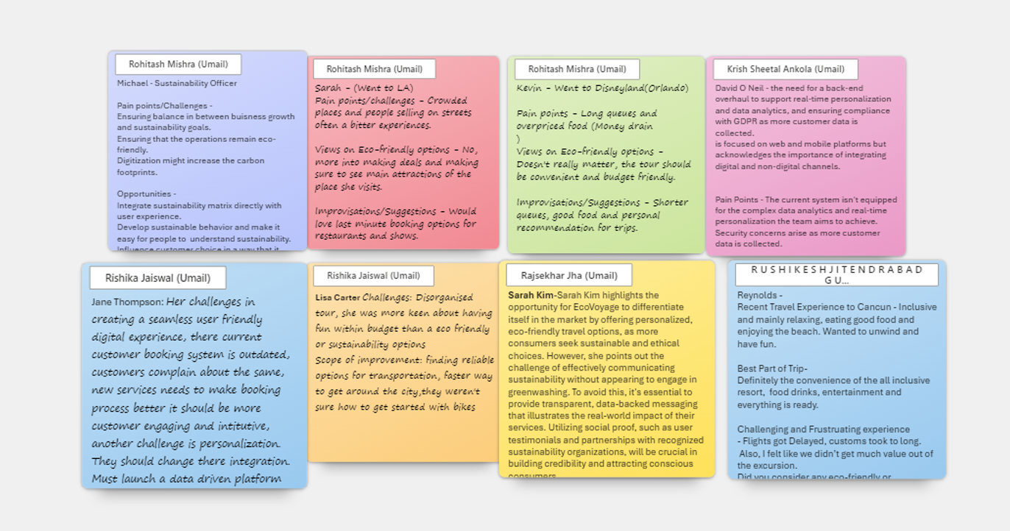Users Feedback*

**Artifacts Created**

1. **Stakeholder Maps**: **Highlighted dependencies**, such as partnerships with eco-lodges and the need for internal alignment between TravelCorp’s technology and sustainability teams.

*Stakeholder Map*

1. **Empathy Maps**: **Illustrated the needs, frustrations, and aspirations** of different user personas, such as budget travelers, eco-conscious families, and business professionals.

*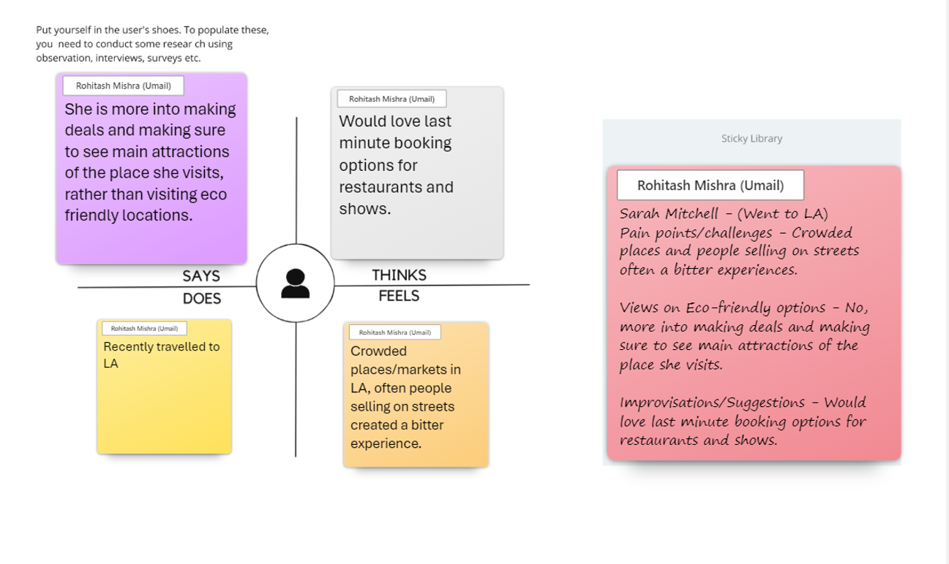Empathy Map*

1. A close-up of several text boxes

   Description automatically generated**Journey Maps**: Detailed user interactions with the EcoVoyage platform, **revealing bottlenecks like unclear navigation and the absence of real-time updates**, which increased user frustration​.

*Journey Map*

By synthesizing these insights, the empathy phase informed the development of a **user-centered problem statement**, creating a solid foundation for the ideation phase and driving the design of innovative, scalable solutions. This process showcases the effectiveness of Design Thinking in addressing real-world challenges and delivering impactful outcomes for both users and businesses.

**Definition Phase: Framing the Problem**

The Definition phase is a critical juncture in the Design Thinking process, where we consolidated insights from the empathy phase to articulate a clear, actionable problem statement. This stage involved synthesizing user pain points, contextual insights, and strategic business objectives to frame a problem that guides ideation and solution development.

**Problem Statement**

The problem statement emerged as a result of comprehensive user research and stakeholder engagement:  
**“How might we simplify the booking process and provide diverse, affordable, and authentic travel options while offering comprehensive destination information, personalized recommendations, and flexible last-minute booking solutions?”**

This statement serves as a focal point for aligning the team's efforts and provides a roadmap for subsequent phases.

**Insights Driving Problem Definition**

Insights were derived from multiple data-gathering methods, including interviews, surveys, empathy mapping, and competitor analysis. The following insights shaped the problem statement:

1. **Affordability Gap**:

* Budget-conscious travelers consistently identified cost as a barrier to adopting sustainable travel options. They emphasized the lack of affordable eco-friendly accommodations and transportation​
* Travelers expressed frustration over the inability to find budget-friendly packages that balance sustainability and experience quality.

1. **Need for Personalization**:

* Professionals and families, representing distinct demographics, highlighted a demand for tailored solutions.
* Business travelers sought efficiency in booking, while families required child-friendly options integrated with sustainability, reflecting diverse user personas

1. **Sustainability as a Core Value**:

* Stakeholders and eco-conscious travelers stressed the importance of transparent eco-metrics, such as carbon footprints and community impact.
* Insights from competitors, like Intrepid Travel and G Adventures revealed that users value visible sustainability certifications but often feel overwhelmed by inconsistent or unclear labelling​.

1. **Fragmented Information Ecosystem**:

* Travelers struggled to find comprehensive, centralized information about destinations, including eco-lodges, low-impact transport, and cultural insights.
* This fragmented landscape increased frustration and decreased trust in the booking process.

1. **Flexibility in Last-Minute Planning**:

* A significant number of travelers identified a lack of adaptable solutions for spontaneous trips, limiting their options for sustainable travel under tight schedules.

**Validation**

The problem statement underwent iterative validation to ensure alignment with user pain points, business objectives, and industry trends:

1. **User-Centric Alignment**:

* Feedback from empathy interviews confirmed that the problem addressed core frustrations, such as affordability and the lack of personalization.
* User personas and journey maps provided context for how these pain points affect decision-making​.

1. **Strategic Business Fit**:

* The statement aligns with **TravelCorp’s sustainability goals**, including their mission to achieve net-zero emissions by 2035
* By focusing on simplifying booking and integrating eco-conscious options, the problem statement positions EcoVoyage as a leader in the growing sustainable travel market​

1. **Market Validation**:

* Competitor analysis highlighted a gap in platforms effectively combining personalization, affordability, and sustainability. This validated the need for a solution tailored to this intersection​

**Key Learnings from the Definition Phase**

1. **Empathy-Driven Insights**:

* Real-world stories and challenges from users underscored the need for intuitive, affordable, and eco-conscious solutions.

1. **Cross-Stakeholder Engagement**:

* Incorporating feedback from users, stakeholders, and competitors ensured that the problem statement addressed diverse perspectives.

1. **Strategic Vision**:

* The statement provided clarity and direction, bridging user needs with EcoVoyage’s mission to pioneer sustainable travel solutions.

**Ideation Phase: Generating and Refining Innovative Solutions**

The ideation phase is the creative foundation for addressing the challenges identified during the empathy and definition stages. By employing diverse techniques such as brainstorming, mind mapping, SCAMPER, value proposition canvas and Crazy8s, the team generated and refined solutions aimed at simplifying sustainable travel booking processes and enhancing the overall travel experience.

*Value Proposition Canvas*

*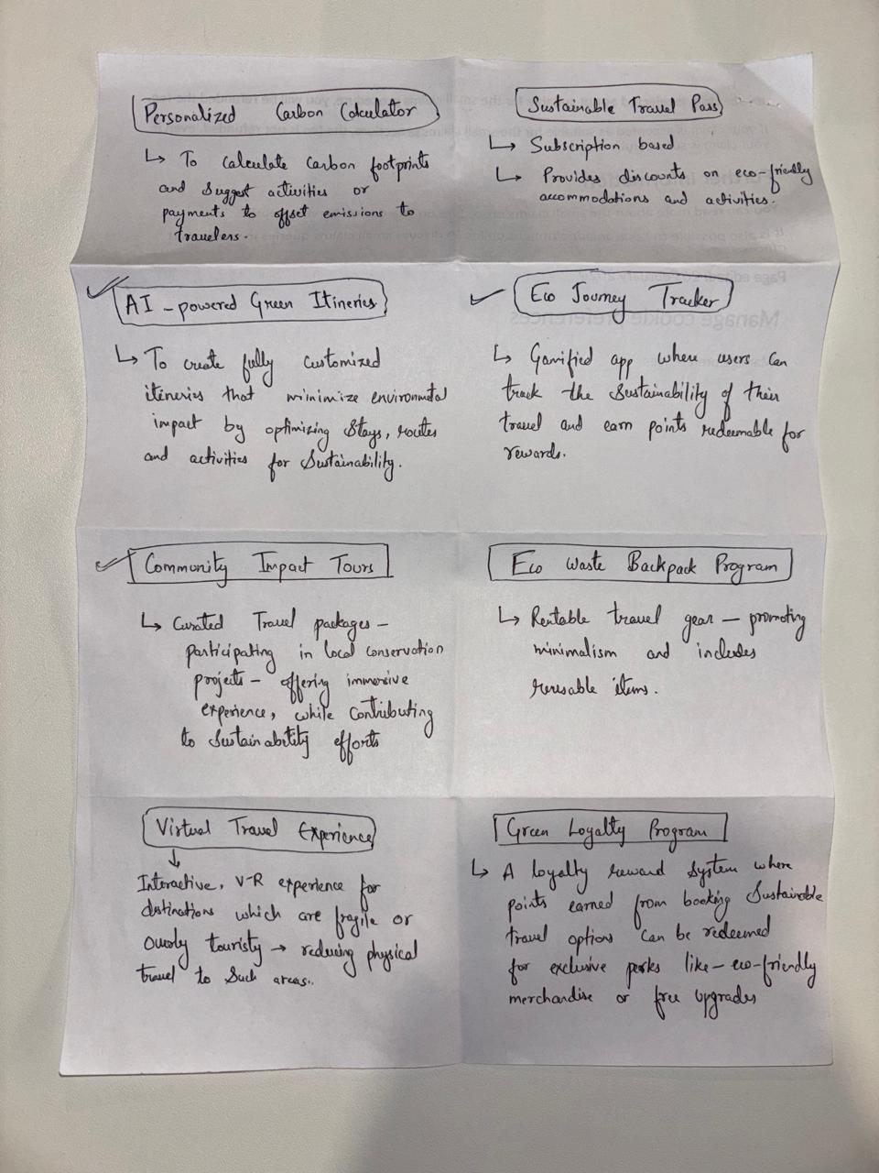Crazy8s*

**Exploring Diverse Ideas**

We began with brainstorming sessions, focusing on the problem statement:  
***"How might we simplify the booking process and provide diverse, affordable, and authentic travel options while offering comprehensive destination information, personalized recommendations, and flexible last-minute booking solutions?"***

These sessions encouraged free-flowing ideas, resulting in key concepts such as:

1. **AI-Driven Personalized Filters**:

* A dynamic system enabling users to customize travel plans based on eco-friendliness, budget, and availability.

1. **Eco-Loyalty Program**:

* A gamified system incentivizing sustainable choices, such as carbon offsetting and selecting eco-friendly accommodations.

1. **Community-Centric Information Hub**:

* A centralized platform offering detailed insights into local cultures, eco-attractions, and sustainable transportation options.

1. **Simplified Booking Interface**:

* Redesigned workflows to eliminate common frustrations, such as fragmented information and limited last-minute flexibility.

Using mind mapping, we visualized connections among themes like personalization, affordability, and sustainability. This exercise highlighted the critical challenge of balancing affordability with eco-conscious options.

**Competitor Analysis**

To ground our ideation in industry trends, we conducted a thorough competitor analysis. Key findings include:

1. **Intrepid Travel**:

* By focusing on carbon neutrality and adventure-based sustainability, Intrepid appeals to younger travelers who value both experience and ethics.

1. **G Adventures:**

* Provides a wide range of eco-friendly tours worldwide, promoting community-based tourism and environmental conservation, highlighting opportunities to combine sustainability with meaningful engagement.

1. **Lindblad Expeditions:**

* Focuses on expedition cruises to remote and pristine environments, emphasizing education and conservation but lacks standardization and transparency, leaving room for improved user trust.

**Divergent Thinking: Refining Concepts**

The team applied **SCAMPER** (Substitute, Combine, Adapt, Modify, put to another use, Eliminate, Reverse) to refine initial ideas:

* **Adapt**: Introducing gamification principles to engage eco-conscious travelers.
* **Combine**: Integrated user-generated reviews with AI-driven recommendations to provide authentic insights.
* **Modify**: Simplifying the search process by incorporating map-based visual booking options.

These exercises enabled innovative, practical solutions that resonate with the needs of modern travelers.

**Why We Chose AI-Driven Personalization**

The team selected the **AI-powered travel platform** for prototyping, based on:

1. **User-Centered Insights**: Through empathy research, there was a strong demand for simple, personalized experiences tailored towards sustainability values.
2. **Technological Viability**: AI integration is very relevant in the market. It facilitates real-time data analysis for customization.
3. **Market Differentiation**: Most competitor platforms usually focus on either personalization or sustainability but rarely combine the two effectively.
4. **Scalability**: The modular nature of AI ensures scalability while addressing diverse user needs.

**Prototyping - Next Steps**

The chosen solution was translated into a prototype with the following features:

* **Real-Time Filters**: Customization based on sustainability, budget, and availability.
* **Community-Driven Recommendations**: Integrating local insights for authentic experiences.
* A white grid of text

  Description automatically generated with medium confidence**User-Centric Interface**: Streamlined to intuitively navigate and improve the user experience.

*Product Value*

**Prototyping Phase: Turning Ideas into Action**

During the prototyping phase, we went from ideation to creating workable models of our ideas. This stage was all about creating practical versions of the features we wanted for the platform, testing them out, and improving them based on user feedback. We used tools like Figma to develop step-by-step prototypes, starting with rough sketches and evolving into polished, interactive designs.

**How We Built the Prototypes -** The prototyping was progressive; we started with simple layouts, which we improved upon taking feedback from the customers

1. **Starting Small with Sketches:**

* The initial drafts were low-tech, simple sketches showing basic layouts for booking process and dashboards.
* Those helped us to quickly map how the features could look and function without spending too much time upfront.

1. A screenshot of a website

   Description automatically generated**Adding Detail with Wireframes:** We went on to create the wireframe, which were pretty much the blueprint for the platform. It gave a better view of how users would navigate through the booking workflow and the different features.

*Low Fidelity Prototype 1*

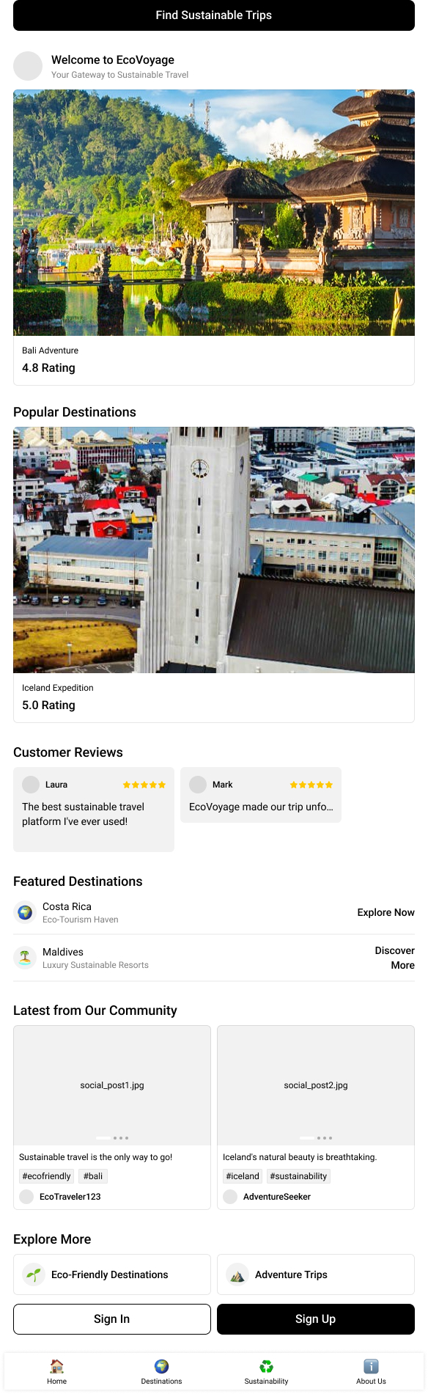

1. **High-Fidelity Prototypes:** Combining everything into detailed, interactive designs. These high-fidelity prototypes felt like real versions of the platform and were ready for users to test.

**Features We Focused On**

**To make the platform as useful and appealing as possible, we concentrated on three main features:**

1. **Personalized Dashboard:** This dashboard shows users travel options that match their preferences, like eco-friendly hotels or low-impact transport. Filters make it easy to tailor the experience to what matters most—sustainability, budget, or timing.
2. **Simpler Booking Process:** We redesigned the booking process to be seamless and free of frustration. Steps were combined, and users could have real-time information on available options and prices, avoiding guesswork.
3. **Eco-Metrics:** We added a feature that outlines the environmental footprint of travel choices. For instance, a user can view the carbon footprint of a trip or see how much of their money is going into local communities.

**Users feedback on Prototype -**

This phase wasn’t just about building—it was about improving. After creating prototypes, we tested them with users and adjusted based on their feedback:

1. **What Users Told Us:** Early testers liked the idea of personalized options but found the navigation a bit tricky. They also wanted more clarity on what the eco-metrics meant and how they were calculated
2. **What We Changed:** We improved navigation by simplifying the menu and making key features easier to find. Tool tips were added to explain the eco-metrics so that users could have an idea about the environmental impacts of their choices. The layout was cleaned up so that it looked much more modern and user-friendly.

**The Final Prototype**

**By the end of this phase, we had built a prototype that included:**

* Wireframes showing how the booking steps worked.
* Mock-ups of the personalized dashboard with options reflecting users' preferences.
* Interactive features like the calculation of the carbon footprint for every trip in real-time will provide instant feedback to users about the sustainability of their choices.

Prototyping was the bridge between ideas and reality. By focusing on user feedback and refining the design with each iteration, we created a platform that feels intuitive, helpful, and aligned with EcoVoyage's mission to make sustainable travel simple and accessible. The process really showed us the power of testing and improving toward a final product that will meet both user needs and business goals.

**Testing Phase: Validating the Prototype**

The Testing Phase is where we put our prototype in front of real users and stakeholders, making sure it delivers on its promise. This was focused on the validation of usability, functionality, and scalability. It aimed at uncovering any barriers to adoption and refining the design based on actionable feedback. In this way, testing would simulate real-world interactions, providing us with critical insights into how users would engage with the EcoVoyage platform.

**Testing Strategy**

The testing process was centered on three key objectives:

1. **Usability**: Assessing how easily users could navigate the platform and complete booking tasks.
2. **Functionality**: To ensure that features such as eco-metrics and personalized recommendations worked as expected.
3. **Scalability**: Ensuring the platform could handle diverse user scenarios and increased data demands, such as expanded filters or additional eco-friendly travel options.

**Methods Used**

A combination of qualitative and quantitative methods was used to gather comprehensive feedback:

1. **Usability Testing**:
   * Testing participants were given specific tasks, such as finding an eco-friendly accommodation within a budget or calculating the carbon footprint of a trip.
   * Observers recorded their navigation paths, time taken to complete tasks, and any moments of confusion.
   * This method highlighted bottlenecks in user workflows and areas needing improvement.
2. **Feedback Collection**:

* After usability tests, participants were interviewed to capture their impressions. Questions focused on their overall experience, ease of navigation, and suggestions for improvement.
* Structured interviews allowed for consistency, while open-ended questions allowed users to add other comments.

1. **Stakeholder Input**:
   * Key stakeholders, including TravelCorp’s marketing and sustainability teams, tested scalability by simulating high-traffic scenarios and diverse user filters (e.g., family-friendly and adventure-focused options).

**Key Findings -** Testing provided insight into the behavior of users, feature functionality, and the reception of the platform overall

1. **Positive Feedback**:
   * **Eco-Metrics Transparency**: Users loved seeing detailed carbon footprints and sustainability scores, which made them feel more informed and empowered in their decisions.
   * **Personalized Recommendations**: The AI-driven engine was praised for its accuracy and relevance, especially in tailoring options to individual preferences.
2. **Challenges Identified**:
   * **First-Time User Experience**: Most first-time users felt overwhelmed by the wealth of options and metrics. They suggested a guided tutorial to ease onboarding.
   * **Filter Expansion**: There was a need for specific filters targeting the needs of a family, such as child-friendly accommodations and activities.
   * **Interface Feedback**: A few testers mentioned that while the interface was clean, additional visual clues-tooltips or pop-ups-would be beneficial in explaining what the eco-metrics mean and other features of the site.
3. **Scalability Validation**:

* The stakeholders simulated heavy data loads and diverse use cases, confirming that the platform would scale well without any performance compromise.

**Proposed Enhancements -** Based on the findings, the following improvements were prioritized to address user and stakeholder feedback:

1. **First-Time User Guide**:
   * Implement an interactive onboarding experience, guiding new users through key features such as eco-metrics, filters, and the booking process.
   * Including optional video tutorials and tooltips for additional clarity.
2. **Enhanced Filters**:

* Increase the set of filters to include family-friendly options like child-safety amenities, kid-friendly activities, and accessible transportation.
* Adding a quick search for frequently used filters contributes to efficiency.

1. **Interface Refinements**:

* Adding visual tips, such as hover-over tooltips and info icons to explain eco-metrics more simply.
* Using coloured tags, such as color-coding green for Eco-friendly and blue for budget-friendly options, to make it easier to toggle between options.

1. **Scalability Measures**:
   * Optimize the AI engine to handle a higher volume of user queries and accommodate additional eco-metric data.
   * Prepare for integration with future features, such as multilingual support or localized eco-guides.

Testing demonstrated that the prototype of EcoVoyage was on par with user needs and business objectives, and it also revealed areas of refinement. By addressing the feedback through actionable enhancements, the platform will be more intuitive, scalable, and attuned to the diverse needs of its users. This phase not only confirmed the feasibility of the solution but also underscored the importance of continuous iteration in delivering a user-centered product.

**Business Analytics and AI Integration**

The integration of business analytics and AI technologies was a cornerstone for delivering a seamless, data-driven, and personalized user experience. This phase focused on leveraging predictive algorithms and dynamic data models to empower decision-making, enhance customer satisfaction, and align the platform with TravelCorp's strategic goals. By aligning with frameworks such as IBM's Team Essentials for AI, we ensured our approach was user-centric, ethical, and scalable.

**AI Integration: Enhancing Personalization and Efficiency**

Our AI integration strategy revolves around incorporating advanced algorithms to analyze user data and predict preferences, ensuring tailored travel recommendations. Key AI elements include:

1. **Predictive Algorithms:**
   * These algorithms can analyze user inputs, such as past bookings, preferences, and budget constraints, to recommend the most relevant travel options.

* These predictions will not only aim at user satisfaction but also consider eco-metrics such as carbon footprint scores in their analysis, hence aligning with sustainability goals.

1. **Dynamic Pricing Models:**
   * AI-powered pricing can dynamically update with changes in demand, supply, and even users' budgets.
   * Economy-conscious travelers enjoy the added benefit of real-time discounts that make their experiences accessible, without sacrificing either quality or eco-friendliness.
2. **Real-Time Data Processing:**

* The AI engine takes huge chunks of data from user interactions to enhance suggestions on the go.
* It adapts to shifts in user behaviors and therefore guarantees a unique experience not only for the repeat but also first-time users.

**Business Analytics Integration: Driving Insights and Optimization**

Business analytics tools can be integrated to extract actionable insights from platform usage and user behavior. These tools will provide the foundation for continuous improvement and strategic decision-making.

1. **Data Visualization:**
   * Interactive dashboards will display metrics like user engagement rates, most-used features, and eco-metrics adoption.
   * Stakeholders could monitor platform performance in real time, identifying areas for growth and addressing potential bottlenecks.
2. **Optimization Insights:**
   * By analyzing user behavior—such as navigation paths, time spent on features, and drop-off points—the platform will continually refine its recommendation algorithms.
   * Heatmaps and behavioral flow data will reveal which filters and eco-metrics users interacts with most, guiding feature prioritization.
3. **Trend Identification:**
   * Identification of emerging trends, such as increased demand for family-friendly filters or seasonal preferences for sustainable accommodations.
   * These insights will help in informed marketing strategies and the development of additional features.

**Impact of AI and Business Analytics Integration -** The combined use of AI and analytics significantly enhanced the platform’s value proposition by delivering a user-centric experience while aligning with TravelCorp’s broader business goals:

* Personalized User Experience
* Informed Decision-Making
* Scalability and Adaptability
* Strategic Differentiation

**Ethical AI and Sustainability**

Incorporating principles from IBM’s Team Essentials for AI, we ensured our AI systems were transparent, fair, and user-focused:

* Transparency: Clear explanations of eco-metrics and pricing algorithms fostered trust among users.
* Fairness: Designing the personalization and pricing models to prevent bias from occurring equalled fair access to features across demographics.
* Sustainability: AI-powered insights directly contributed to TravelCorp's sustainability aims, highlighting and promoting eco-friendly options.

The integration of AI and business analytics transformed EcoVoyage into a state-of-the-art platform that knitted personalization with sustainability. The solution delivers value to the users through tailored recommendations, dynamic pricing, and actionable insights that address user needs and market demands. This strategic approach strengthens EcoVoyage's leading position in sustainable travel solutions while improving the user experience. It results in a scalable, ethical, and future-ready platform aligned with TravelCorp's mission and vision.

**Implementation Plan**

The Implementation Plan for the EcoVoyage platform outlines actionable steps to transition from prototype to a fully operational product. This plan addresses short-term and long-term objectives, with a focus on maintaining quality, scalability, and alignment with business goals. By incorporating risk mitigation strategies, we aim to deliver a seamless, user-centric platform that aligns with TravelCorp’s mission to lead in sustainable travel.

**Short-Term Tasks -** The immediate focus is on refining and validating the prototype to ensure functionality and usability before a broader rollout.

1. **Finalize the Prototype:**

* **Objective:** Address feedback from usability tests and integrate enhancements like clearer navigation and expanded filters.
* **Actions:**

Add tooltips and tutorials for first-time users.

Refine eco-metrics dashboards based on user preferences for transparency and simplicity.

Conduct additional testing to ensure all adjustments meet user expectations.

1. **Pilot Testing in Select Markets:**

* **Objective:** Validate the platform’s functionality, user experience, and AI features in real-world scenarios.
* **Actions:**

Identify target markets with high eco-tourism demand (e.g., Southeast Asia, Europe).

Engage local travel partners for feedback on content accuracy and eco-offerings.

Use pilot testing results to refine features and address potential issues.

1. **Data Integration:**
   * **Objective:** Implement AI-powered personalization and eco-metrics features to deliver tailored, impactful experiences.

* **Actions:**

Collaborate with data analysts to integrate predictive algorithms for travel recommendations.

Ensure real-time updates for dynamic pricing and eco-metrics tracking.

Test data pipelines for speed, accuracy, and reliability.

**Long-Term Tasks -** Long-term objectives focus on expanding the platform’s reach, enhancing its features, and fostering sustainable partnerships.

1. **Market Expansion:**
   * **Objective:** Extend the platform to emerging eco-tourism markets, leveraging rising global interest in sustainable travel.
   * **Actions:**

Research markets to identify high-potential regions, such as Latin America and Africa.

Localize features, including language support and culturally relevant eco-metrics.

Design marketing campaigns highlighting TravelCorp's unique eco-friendly offerings.

1. **Gamification Features:**
   * **Objective:** Encourage eco-conscious behavior through interactive and rewarding user experiences.
   * **Actions:**

Develop eco-rewards programs offering points for sustainable choices, such as carbon offset and choosing eco-lodges.

Leaderboards, badges, and milestones are included.

Partner with brands for tangible rewards, such as discounts or actual eco-products.

1. **Community Partnerships:**
   * **Objective:** Collaborate with local communities to offer authentic and sustainable travel experiences.
   * **Actions:**

Establish partnerships with eco-lodges, cultural organizations, and local artisans.

Create a "give-back" program where part of the user's booking supports community projects.

Publish community impact metrics on the platform to build user trust and engagement.

**Risk Mitigation Strategies -** To ensure smooth implementation, the plan includes proactive measures to address potential challenges**:**

1. **Stakeholder Alignment:**
   * **Objective:** Resolve competing priorities among internal teams and external partners.

* **Actions:**

Hold regular alignment meetings to review progress, address concerns, and adjust priorities.

Use a shared project management tool to enhance transparency and collaboration.

1. **Iterative Testing:**

* **Objective:** Maintain a continuous feedback loop for platform improvement.
* **Actions:**

Schedule periodic usability tests during each implementation phase.

Collect feedback from diverse user groups, including families, professionals, and solo travelers.

Incorporate findings into rolling updates and feature enhancements.

1. **Scalability Planning:**

* **Objective:** Ensure the platform can handle increased user demand and evolving feature sets.
* **Actions:**

Stress-test systems to simulate high traffic and data loads.

Optimize AI algorithms for faster processing and higher accuracy.

Plan phased server expansions to accommodate user growth.

This implementation plan provides a clear roadmap for launching and scaling the EcoVoyage platform. By focusing on user feedback, scalability, and strategic market positioning, the plan ensures that EcoVoyage not only meets current user needs but also evolves to lead the sustainable travel market. Each phase balances innovation with practicality, laying a strong foundation for long-term success.

**Conclusion**

This project demonstrated the transformational power of Design Thinking combined with business analytics to solve real-world problems. By focusing on user needs, embracing AI, and being sustainable, the redesigned EcoVoyage positions TravelCorp as an innovator in eco-tourism. A clear implementation plan was developed to ensure scalability and long-term success, aligning with the mission of TravelCorp to revolutionize sustainable travel.

**References**

*Adventure Tours & Small Group Trips—G Adventures*. (n.d.). Retrieved November 16, 2024, from https://www.gadventures.com/

*Adventure Travel & Nature Tours | Natural Habitat Adventures*. (n.d.). Retrieved November 12, 2024, from https://www.nathab.com/

*Best Small Group Tours & Adventure Travel*. (n.d.). Retrieved November 13, 2024, from https://www.intrepidtravel.com/en

*Ecotourism Market Size, Share, Growth | Various Trends [2032]*. (n.d.). Retrieved November 01, 2024, from https://www.fortunebusinessinsights.com/ecotourism-market-108700

*Luxury Adventure Cruises & Travel | Lindblad Expeditions*. (n.d.). Retrieved November 10, 2024, from https://world.expeditions.com/

Strohecker, K. (2024, November 20). More than 50 countries sign UN sustainable tourism declaration. *Reuters*. https://www.reuters.com/sustainability/more-than-50-countries-sign-un-sustainable-tourism-declaration-2024-11-20/