**IS6051: Business Data Analysis and Visualisation**

**Group Project Report**

**Group number 14**

Rohitash Mishra – 124107533 Rajshekar Jha - 124112758

Rishika Jaiswal – 124113779 Rushikesh Badgujar – 124115292

Krish Ankola – 124111257 Toshal Chaudhari -124107284

# **Introduction**

# This report explores Allied Irish Bank’s (AIB) contributions toward sustainable development, focusing on its alignment with Sustainable Development Goals (SDGs)—particularly with SDG 13 (Climate Action). The study analyses the Bank’s strategies, initiatives, and impacts through qualitative and quantitative evaluations of datasets derived from AIB’s Sustainability Reports and United Nations SDG data.

# AIB, as one of Ireland’s largest banks, has undertaken significant efforts to integrate sustainability into its operations and financial practices. By promoting green financing, reducing greenhouse gas emissions, and supporting small and medium enterprises, AIB demonstrates its commitment to Ireland’s transition toward a low-carbon, inclusive economy.

# This report also identifies key indicators, such as GHG emissions trends (Indicator 13.2.2), and analyzes AIB’s progress using robust data cleaning, normalization, and visualization techniques. These insights provide a framework to evaluate AIB’s sustainability performance and recommend strategies for further aligning its activities with national and global climate goals.

# **Client Overview and Needs**

The **Allied Irish Bank (AIB)** (*AIB Personal Banking – Allied Irish Banks*, n.d.) is one of the largest banks in Ireland which is diversified in all banking and financial activities. It aims at reengineering the banking processes towards being responsible whilst encouraging growth among its clients and the communities. Given the constant changes in the financial landscape, there is pressure on the Bank to become more sustainable. It desires to operate in a manner that does not contradict its aspiration of integrating sustainability into business. Its concerns include maintaining financial stability, enhancing the supportive environment for innovation, and encouraging de-carbonized and resilient lending and investment approaches.

## **Selection of SDG(s) and Targets**

The Bank’s sustainability program is deeply intertwined with its overarching goal of fostering responsible banking while enabling growth for its clients and communities. By aligning with three specific **Sustainable Development Goals** **(SDGs)** (*THE 17 GOALS | Sustainable Development*, n.d.) - **SDG 8** **(Decent Work and Economic Growth)** (*Goal 8 | Department of Economic and Social Affairs*, n.d.), **SDG 9** **(Industry, Innovation, and Infrastructure)** (*Goal 9 | Department of Economic and Social Affairs*, n.d.), and **SDG 13 (Climate Action)** (*Goal 13 | Department of Economic and Social Affairs*, n.d.) - the Bank integrates sustainability into its core business operations and strategy. Each SDG is uniquely tied to the Bank’s activities and objectives, ensuring alignment with its mission of driving sustainable financial growth.

**SDG 8 (Decent Work and Economic Growth) –** The Bank actively supports economic growth by promoting entrepreneurship, creating employment opportunities, and funding small and medium enterprises (SMEs). Some initiatives include **-** Providing accessible credit and tailored financial products to SMEs, enabling them to expand operations and contribute to local economic development.Italso supports community-driven projects that lead to skill enhancement and workforce development, addressing targets such as **8.3 (Promote development-oriented policies)** and **8.5 (Achieve full and productive employment and decent work for all)** (*Goal 8*, n.d.)**.** Offering sustainable investment options that prioritize economic inclusivity and long-term financial stability.This SDG aligns with the Bank’s focus on fostering economic resilience, supporting productive business activities, and ensuring inclusive economic participation.

**SDG 9 (Industry, Innovation, and Infrastructure) -** The Bank plays a pivotal role in supporting Ireland’s transition to a low-carbon economy by financing innovative projects and sustainable infrastructure development. Specific activities include - Promoting green financing for infrastructure projects, such as renewable energy facilities and eco-friendly transportation systems, directly aligning with **9.1 (Develop quality, reliable, sustainable infrastructure)** (*Goal 9 | Department of Economic and Social Affairs*, n.d.).Offering tailored funding solutions to industries adopting innovative, low-carbon technologies, addressing **9.4 (Upgrade infrastructure and industries for sustainability)**.These efforts highlight the Bank’s commitment to fostering industrial resilience and technological advancement in line with national and global sustainability agendas.

**SDG 13 (Climate Action) -** Acknowledging the urgent need for climate change mitigation and adaptation, the Bank aligns its financial strategies with environmental goals to ensure its operations support a sustainable future. Key contributions include - Increasing the allocation of funds toward renewable energy projects, sustainable agriculture, and energy-efficient housing, supporting target **13.2 (Integrate climate change measures into policies and planning)** (*Goal 13 | Department of Economic and Social Affairs*, n.d.).Actively engaging with clients to adopt green investment strategies, offering incentives for low-carbon initiatives, and promoting decarbonized lending practices.

By integrating these goals into its operational strategy, AIB ensures its activities contribute directly to Ireland’s sustainable development targets, demonstrating a measurable impact on economic empowerment, industrial sustainability, and climate resilience.

## **SDG Indicators and Rationale**

Several SDG indicators have been selected to assess the Bank’s contributions:

For Goal 8, AIB supports Indicator 8.5.2 (Unemployment rate, by gender and age) by providing affordable credit to Small and Medium Enterprise (SMEs), enabling job creation, and funding programs which promote hiring women, youth, and under-represented groups.

For Goal 9, indicators like 9.4.1 (CO2 emissions per unit of value added) will help evaluating AIB’s efforts in engaging in carbon emission reduction and promoting green industrial development via green credit provision.

AIB aligns with indicator 13.2.2 (Total greenhouse gas emissions per year) by reducing its operational emissions (49% reduction since 2019) (*Sustainability in Ireland, Sustainable Finance Ireland*, n.d.) and committing to net zero by 2030. It promotes green financing through a €30 billion Climate Action Fund, targeting 70% of new lending for green or transition-related projects, and aims for a net zero lending portfolio by 2040.

These indicators will provide actionable insights to AIB towards its contributions to sustainable development, helping track its (AIB’s) impact on employment, economic growth, climate action, and environmental sustainability.

## **Analysis**

The Bank’s engagement towards SDGs 8, 9, and 13 confirms the institution’s commitment towards achieving economic growth, advancement of technology and climate protection. By using relevant indicators, the Bank can assess its impact on Ireland’s economy and environment while leading the transition toward sustainability in the financial sector. These indicators demonstrate the Bank’s support for employment, promoting activities that support the environment and the response to climate change, ensuring its pivotal role in Ireland’s sustainability objectives.

**Dataset Identification** (**Rationale for Dataset Choice**)

We have chosen two datasets, namely – AIB’s dataset has been made from its Sustainability report (*Sustainability in Ireland, Sustainable Finance Ireland*, n.d.)and the SDG data from United Nations (UN) (*UNSDG*, n.d.) website because it directly aligns with our goal to understand the effectiveness of AIB’s efforts in Ireland’s journey towards achieving SDG targets. The UN dataset is readily available, accessible and compatible which makes it easier to do comparison and analysis with AIB’s data and performance. The chosen dataset also has sufficient level of accuracy, completeness, and consistency, which makes it more reliable and insightful. The dataset provides a rich level of detail for our chosen SDG targets – specifically SDG 13 (indicator 13.2.2) that allows for comprehensive analysis, including detailed insights on SDG indicators, making it highly suitable for qualitative and quantitative analysis. Furthermore, the data is ethically sourced in terms of privacy, consent, transparency, and fairness, ensuring compliance with data privacy regulations.

**Qualitative Description of Dataset**

The dataset derived from AIB Sustainability report presents a qualitative overview of AIB's commitment to sustainability, highlighting the bank's strategies and initiatives related to SDG goals. The data originates from AIB's internal sustainability initiatives (*Sustainability-Strategy-2023-Progress.Pdf*, n.d.) and performance metrics, compiled to showcase its commitment towards meeting the SDG goals. Purpose of the dataset is to provide the transparency on AIB’s sustainability agenda, showcase its progress toward net zero targets, and outline how the bank integrates sustainability into its operations, lending practices, and governance. It also aims to inform AIB’s efforts to support the transition to a low-carbon economy. The UN SDG 13 (*UNSDG*, n.d.) dataset provides qualitative insights into global and national climate action efforts, including greenhouse gas (GHG) emissions, climate adaptation strategies, and financial mobilization for low-carbon development. In relation to AIB, this dataset offers benchmarks for assessing the bank’s green financing initiatives, such as its €30 billion Climate Action Fund and net-zero commitments. Key indicators like GHG emissions trends (13.2.2) can enable AIB to measure its impact, align with national targets, and refine its sustainability efforts to support Ireland’s transition to a low-carbon economy. Climate metrics, including **Scope 1 emissions** (direct emissions from operations) (*Sustainability in Ireland, Sustainable Finance Ireland*, n.d.), **Scope 2 emissions** (indirect emissions from purchased energy), and **financed emissions** (emissions linked to loans and investments), are critical for tracking progress toward **SDG 13, Indicator 13.2.2 (Total greenhouse gas emissions per year)**. These metrics will help AIB measure and reduce their carbon footprint, support green projects, and align with national and global emission reduction goals.

**Preliminary Analysis of Issues in Dataset**

Several potential issues could affect the analysis of the chosen datasets. The dataset derived from AIB Sustainability Report (*Sustainability in Ireland, Sustainable Finance Ireland*, n.d.), particularly in Scope 3 emissions (which include emissions from supply chains, investments, business travel, etc.) are often reported by agencies or countries a year, in arrears. This time-lag could mean **missing or incomplete** **data** for the most recent year. This can lead to the underestimation of the company’s progress toward net zero goals. **Outliers** pose another challenge, the reported data suggests significant reductions in Scope 1 and 2 emissions since 2019, including a 17% reduction in operational emissions in 2023 (*Sustainability-Strategy-2023-Progress.Pdf*, n.d.). Such rapid reductions might suggest potential outliers, especially if they are due to extraordinary factors like temporary building closures during COVID-19 or large-scale investments that may not be replicated annually. These outliers may distort trends in AIB’s SDG efforts, leading to overestimation of its progress toward net zero. Finally, there may be inconsistencies in data collection when calculating greenhouse gas emissions for different years or regions (Ireland vs. the UK). Changes in reporting standards could lead to inconsistent figures between reporting periods.

**Handling Data Issues**

To estimate missing values, imputing values based on historical trends or sector benchmarks can provide estimates for unreported figures. Outliers can be identified through statistical techniques and either adjusted or excluded depending on their impact on the analysis. Furthermore, **data normalization** (scaling data to a specific range, typically 0 to 1, making different variables comparable without altering their relationships) and **standardization** (transforming data to have a mean of 0 and a standard deviation of 1) are required to reconcile inconsistencies across the datasets, especially when comparing economic and environmental variables.

This project focuses on data cleaning and processing datasets on greenhouse gas (GHG) across developed countries from 2000 to 2021 (*Goal 13 | Department of Economic and Social Affairs*, n.d.). The dataset, developed countries’ greenhouse emissions(GHG), is compiled by the UNSDG (*UNSDG*, n.d.) and is publicly available under a Creative Commons license (Nations, n.d.). The dataset developed countries’ greenhouse emissions include country-level emissions data in Million Tons of CO2 Equivalent (MT_CO2E) for GHG spanning a total of 22 years. Data values are recorded annually in Excel format (.xlsx) by United Nations and partner agencies and consist of several variables critical for analysis, such as country names, year, and reporting type (global). These emissions units are recorded in MT_CO2E, offering a standardized measurement for comparison across nations. Data cleaning and processing were primarily conducted in Microsoft Excel, supporting transformation and computed columns, essential for Sustainable Development Goal (SDG) 13: Climate Action (*THE 17 GOALS | Sustainable Development*, n.d.) to do a comparative analysis with Allied Irish Bank (AIB) Emission targets (*Sustainability in Ireland, Sustainable Finance Ireland*, n.d.).

**Data Cleaning**

The cleaning process included managing missing values, outliers, and variable transformations to prepare the dataset for analysis. For **missing values** in AIB dataset for the year 2020; created from (*Sustainability in Ireland, Sustainable Finance Ireland*, n.d.), the dataset was subjected to forward-filling, i.e., carrying forward the last year's value for short-term gaps, assuming relatively stable trends in the emissions of successive years. This idea of forward filling allowed us to maintain data integrity without significant gaps that might distort trends. Additionally, non-relevant and empty columns in developed countries’ greenhouse emission dataset like Time_Coverage, Upper_Bound, Lower_Bound and Base_Period were removed to streamline our analysis. For **data uniformity**, we standardized emissions values to a single unit of measurement, Million Tons of CO2 Equivalent (MT_CO2E), enabling consistent comparisons across all countries and years.

**Data Processing**

Data processing steps included computing columns to facilitate trend analysis. The data processing ensured that the data is properly structured for Sustainable Development Goal (SDG) (*THE 17 GOALS | Sustainable Development*, n.d.) analysis, specifically for our chosen SDG indicator 13.2.2 (*Goal 13 | Department of Economic and Social Affairs*, n.d.). The **country names** (Geo Area Name) and **codes** (Geo Area Code) in the dataset were **standardized** to maintain consistency and eliminating duplicates. We also verified the unit consistency (MT_CO2E) in the dataset developed countries’ emission dataset, applying conversions wherever necessary. Standardization enables comparisons across the emission sources, consolidating total environmental impact. Standardization is crucial for tracking emissions reductions against net-zero targets (*Goal 13 | Department of Economic and Social Affairs*, n.d.), providing AIB with a clear framework to monitor and demonstrate progress toward sustainable practices and SDG 13 (Climate Action) compliance. A **cumulative emissions** column was created for each country in the dataset, aggregating emissions year-by-year. This column helped in evaluating the total emissions’ footprint over time, critical for understanding long-term impacts and cumulative contributions to global greenhouse gases. To simplify trend analysis in developed countries’ greenhouse emission dataset, a derived column calculating **year-over-year (YOY) percentage change** was created using the formula:

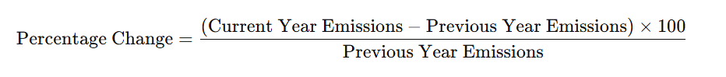

The YOY change highlights the immediate shifts in emissions, allowing for a clear understanding of whether annual adjustments or policies are leading to measurable reductions. This metric enables AIB to assess the effectiveness of specific climate initiatives in near real-time, providing insights into areas where adjustments may be needed to meet long-term targets.

**Quantitative Analysis**

To quantitatively characterize the datasets for AIB created using AIB Sustainability Report (*Sustainability in Ireland, Sustainable Finance Ireland*, n.d.) and SDG 13 (*Goal 13 | Department of Economic and Social Affairs*, n.d.), we applied descriptive statistics. **Measures of central tendency**—**mean**, **median**, and **mode**—were computed to understand typical emission levels across countries and years in developed countries’ greenhouse emission dataset. The mean provided an overall emissions average, while the median helped identify the midpoint value, reducing skew from outliers. The mode, though less informative due to continuous data values, was calculated to confirm no frequently repeating values. **Measures of dispersion** were also key: the **standard deviation** measured variability in emissions, highlighting the extent of fluctuations across years and regions. **Variance**, as the square of the standard deviation, further depicted the distribution spread, with high values indicating greater emissions’ variability, particularly amongst the developed countries with varied climate policies.

**Outliers**, primarily identified through boxplot visualizations in Excel (figure 1.1), indicated unusually high or low emission values in developed countries’ greenhouse emissions dataset. The outliers were typically linked to data entry errors or exceptional circumstances, such as temporary closures during COVID-19 (which might have reduced emissions significantly) in AIB dataset or significantly smaller emission values in small countries in the developed countries’ emission dataset. We removed these anomalies cautiously to ensure they did not skew the analysis, especially in year-over-year trend calculations.

This processing approach yielded a clean, standardized dataset, providing a robust foundation for analyzing AIB's climate actions in line with SDG 13 objectives (*Goal 13 | Department of Economic and Social Affairs*, n.d.). By maintaining statistical consistency and addressing data quality issues, our team ensured the dataset was ready for further quantitative and qualitative assessments (*ChatGPT*, n.d.).

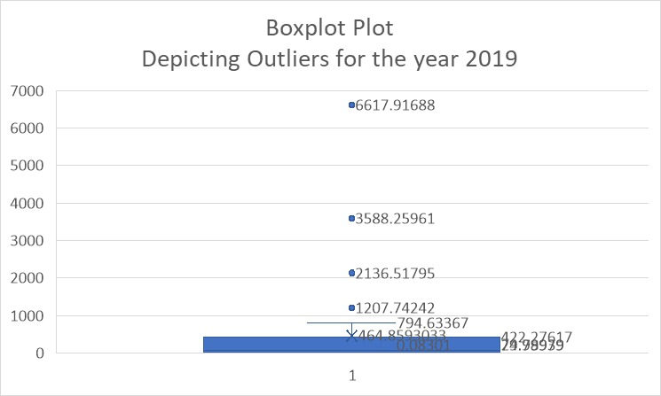

*Figure 1*

**Data Analysis and Recommendations**

**Data Analysis**

The analysis of greenhouse gas emissions data (*UNSDG*, n.d.) from developed countries (2000–2021) revealed key trends aligned with Sustainable Development Goal (SDG) 13: Climate Action(*Goal 13 | Department of Economic and Social Affairs*, n.d.). The year-over-year emissions change highlighted both progress and setbacks, with a general trend of emissions reduction in many countries, particularly post-2015, corresponding to the Paris Agreement(*The Paris Agreement | UNFCCC*, n.d.). However, variability in reduction rates suggests uneven implementation of climate policies. Standardized emissions data in metric tons of CO₂ equivalent (MT CO₂E) allowed for direct comparisons across countries and emission sources. High-emission countries like the United Kingdom, Canada and Australia showed a slower rate of decline, while smaller economies, such as Scandinavian nations, demonstrated significant reductions, attributed to advanced renewable energy adoption and stringent policy enforcement.

The cumulative emissions analysis underscored the disproportionate contributions of certain countries to global emissions. Year Over Year Percentage Change displays fluctuations in annual emissions change, revealing critical periods of increased or decreased efforts.

**Recommendations for Allied Irish Bank (AIB) -**

**Develop a Comprehensive Emission Tracking System**

**Recommendation:** AIB should establish a centralized system that tracks and reports greenhouse gas emissions from its different operations using standardized metrics, such as MT CO₂E.

**Rationale:** This ensures comparability across departments and geographies, aligning with global sustainability reporting standards.

**Action Plan:**

Advanced analytics tools need to be integrated for the automation of data collection and processing.

Use dashboards for real-time monitoring of emissions trends and progress.

**Align Goals with SDG 13 Targets**

**Recommendation:** AIB should adopt specific, measurable, and time-bound targets for reducing emissions, aligning with global frameworks like SDG 13 and the Paris Agreement.

**Rationale:** Clear alignment ensures accountability and positions AIB as a leader in climate action within the financial sector.

**Action Plan:**

Break down global targets into departmental goals for clearer accountability.

Monitor year-over-year (YoY) emissions changes and prioritize areas showing setbacks.

**Learn from High-Performing Nations**

**Recommendation:** AIB should study best practices from countries with significant emissions reductions, such as Scandinavian nations, and incorporate these into their sustainability strategies.

**Rationale:** High-performing nations have demonstrated the efficacy of renewable energy adoption and policy enforcement, which can be adapted to AIB’s operations.

**Action Plan:**

Conduct benchmarking studies to identify policies and technologies applicable to the financial services industry.

Collaborate with renewable energy providers to ensure sustainable operations.

**Regular Reporting and Transparency**

**Recommendation:** Implement regular reporting of emissions data and sustainability progress, both internally and publicly, to ensure transparency and stakeholder engagement.

**Rationale:** Regular updates build trust and help track progress effectively.

**Action Plan:**

Publish quarterly sustainability updates in line with the AIB Sustainability Report.

Use visual dashboards (like Power BI) to present progress clearly.

**Scenario Analysis and Risk Assessment**

**Recommendation:** Perform scenario analysis to understand potential risks associated with climate variability and emissions trends.

**Rationale:** Anticipating challenges ensures better preparedness and informed decision-making.

**Action Plan:**

Use predictive analytics to model emissions trends and their impacts on AIB operations.

Develop contingency plans for periods of increased emissions or policy setbacks.

**Initial Visualizations**

The visualizations provide strong, detailed insights into emissions trends, country contributions, and year-over-year (YoY) changes, with actionable insights:

**Pie Chart - Emission Contribution by Developed Countries**

*Figure 2*

**Insight:** Highlights the proportional emissions contributions of different developed countries from 2000-2021. The United Kingdom (9.73%), Canada (11.75%), and Australia (8.69%) emerge as significant contributors.

**SDG Connection:** Aligns with SDG 13 (Climate Action) by identifying countries that require targeted emission reduction policies.

**Recommendation:** Encourage higher contributors like the United Kingdom and Canada to adopt stricter emission controls and promote renewable energy adoption.

**Line Chart - Cumulative Emissions by Years**

*Figure 3*

**Insight:** Illustrates a decline in cumulative emissions over the years, with a notable dip after 2010, suggesting effective emission control policies or economic shifts.

**SDG Connection:** Progress towards SDG 13, though further efforts are needed to sustain and accelerate the downward trend.

**Recommendation:** Enhance international collaboration to maintain this trend, focusing on sectors where emissions remain persistent.

**Line Chart - YoY Percentage Change**

*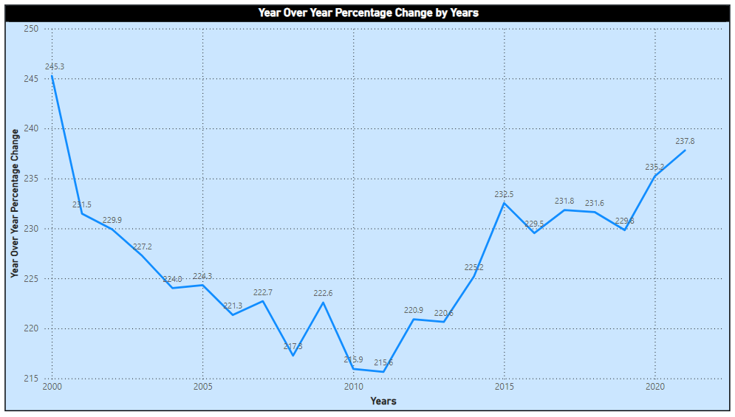Figure 4*

**Insight:** Displays fluctuations in annual emissions change, revealing critical periods of increased or decreased efforts.

**Recommendation:** Focus on periods of increased emissions (e.g., post-2005) to understand and mitigate causes of spikes.

**Comparison Charts - Ireland Emissions vs. Mean Emissions**

*Figure 5*

**Insight:** Ireland’s emissions show a general decline, closely following the trend of mean emissions across countries.

**Recommendation:** Ireland should continue implementing sustainable policies while leveraging the best practices from other nations with a steeper decline.

**Overlay Chart - Ireland vs. Mean Emissions**

**Insight:** Provides a direct visual comparison of Ireland’s emissions against the mean, emphasizing the country’s alignment with global averages.

**Recommendation:** Ireland should aim to outpace the mean decline rate by adopting more aggressive carbon-neutral policies.

*Figure 6*

**Dashboard Design**

The dashboard is well-structured to provide clear and intuitive insights into greenhouse gas emissions data from 2000 to 2021, with specific focus on Ireland's performance and overall trends in developed countries. Here's how the design choices enhance user interpretation:

**Layout and Organization -** The dashboard uses a **4-panel grid layout**, effectively dividing the information into separate but related visualizations:

**Top Left:** Cumulative emissions trends across all years.

**Top Right:** Ireland-specific emissions trends.

**Bottom Left:** Year-over-year (YoY) percentage change trends.

**Bottom Right:** Mean emissions trends across all countries.

Logical placement ensures that users can easily compare Ireland's emissions with cumulative and mean trends across developed nations.

**Clear and Intuitive Design**

**Color-Coding** - Different background colors (blue and pink) serve to differentiate global trends from Ireland-specific trends, aiding quick comprehension.

**Chart Titles** - Each of the visualizations has a descriptive title that allows a user to know what is being focused on without needing additional context.

**Labeled Axes** - The axes in all charts are well-labeled, with appropriate scales for easy interpretation of changes over time.

**Interactive Slicer**

A Year Slicer is included, allowing users to dynamically filter the visualizations by distinct years or range of years. This adds interactivity and allows in-depth data investigation.

**Key Insights Highlighted**

**Cumulative Emissions by Years** - Highlights a declining trend in overall emissions after 2010, underlining the impact of various global climate agreements like the Paris Agreement.

**Ireland Emissions by Years** - Focuses on Ireland's specific trends, showing a decrease in emissions from 2010 until 2020, with a slight increase in 2021. The chart can be used to monitor Ireland's progress toward its sustainability goals.

**YoY Percentage Change** - Captures fluctuations in emission reduction rates over time, pinpointing years of significant progress or setbacks.

**Mean Emissions by Years** - Illustrates the average emissions trend across all countries, helping users benchmark Ireland's performance relative to the global mean.

**Design Choices to Enhance Interpretation**

**Data Points Displayed -** Line charts display key data points for each year, providing users with exact values for detailed analysis.

**Consistent Chart Type -** The use of line charts across all visualizations ensures consistency and avoids confusion when interpreting trends.

**Responsive Design -** The dashboard allows for additional filters and adaptations without losing clarity or visual appeal.

**Learnings as a Group**

Working on this project provided valuable insights and fostered significant learning experiences for our team. Key learnings include:

**Collaborative Problem-Solving**: We learned the importance of effective collaboration, leveraging diverse perspectives to tackle challenges in data analysis and sustainability reporting. Regular discussions helped us align our individual contributions with the project’s overarching goals, ensuring a cohesive and well-structured report.

**Data Analysis Techniques**: Handling real-world datasets highlighted the criticality of data cleaning, normalization, and standardization to ensure reliable and meaningful results. Working with indicators like GHG emissions trends (13.2.2) enhanced our ability to analyze and interpret quantitative data in the context of sustainability goals.

**Understanding Sustainability Frameworks**: The project deepened our understanding of Sustainability Goals, and how financial institutions can play a pivotal role in achieving these goals. It provided insights into the challenges and opportunities associated with transitioning to sustainable practices in the banking sector.

**Visualization and Communication Skills**: Creating clear and impactful visualizations using tools like Excel and Power BI refined our skills in presenting complex data effectively. We learned to craft visuals that convey actionable insights to diverse stakeholders, balancing technical detail with accessibility.

**Time Management and Role Allocation**: Managing tight deadlines while balancing individual workloads required us to prioritize tasks and delegate responsibilities effectively. Clearly defined roles helped us maintain productivity and accountability throughout the project.

**Critical Thinking and Adaptability**: Addressing data limitations, such as missing values and inconsistencies, encouraged innovative thinking and problem-solving. We adapted to challenges, including understanding scope limitations of datasets, by employing forward-filling techniques and deriving actionable insights.

This collaborative experience not only enhanced our technical and analytical skills but also strengthened our ability to work as a cohesive team, equipping us with valuable tools for future academic and professional projects.

**References**

*AIB Personal Banking – Allied Irish Banks*. (n.d.). AIB. Retrieved September 28, 2024, from <https://aib.ie>

*Goal 8 | Department of Economic and Social Affairs*. (n.d.). Retrieved September 25, 2024, from <https://sdgs.un.org/goals/goal8>

*Goal 9 | Department of Economic and Social Affairs*. (n.d.). Retrieved September 25, 2024, from <https://sdgs.un.org/goals/goal9>

*Goal 13 | Department of Economic and Social Affairs*. (n.d.). Retrieved September 25, 2024, from <https://sdgs.un.org/goals/goal13>

Nations, U. (n.d.). *Terms of Use*. United Nations; United Nations. Retrieved November 1, 2024, from <https://www.un.org/en/about-us/terms-of-use>

*Sustainability in Ireland, Sustainable Finance Ireland*. (n.d.). AIB. Retrieved November 3, 2024, from <https://aib.ie>

*Sustainability-strategy-2023-progress.pdf*. (n.d.). Retrieved September 24, 2024, from <https://aib.ie/content/dam/frontdoor/sustainability/sustainability-strategy-2023-progress.pdf>

*THE 17 GOALS | Sustainable Development*. (n.d.). Retrieved September 25, 2024, from <https://sdgs.un.org/goals>

*The Paris Agreement | UNFCCC*. (n.d.). Retrieved November 11, 2024, from <https://unfccc.int/process-and-meetings/the-paris-agreement>

*UNSDG*. (n.d.). Retrieved October 3, 2024, from <https://unstats.un.org/sdgs/dataportal/analytics/CompareTrendsOneSeries>

**Appendix: Use of Artificial Intelligence (AI) Tools**

In this research, the AI tool ChatGPT by OpenAI was used to assist in brainstorming ideas, refining arguments, and enhancing the clarity of specific sections. The use of AI was limited to providing suggestions for language refinement and structural organization. All content was verified and edited by the author to ensure accuracy and integrity of the work.

*ChatGPT*. (n.d.). Retrieved November 22, 2024, from <https://chatgpt.com/c/67277e73-3e98-8013-88bf-9305e9922610>