LOGISTICS DATA ANALYST INTERNSHIP
Week 3: Advanced Data Analysis and Visualization in Logistics
Using Python – Exploratory Data Analysis, Visualization and Business Insights
Prepared for: Yuva Intern
Role: Logistics Data Analyst Intern
Task: Week 3

1. Executive Summary
This report presents an advanced exploratory analysis of a hypothetical logistics dataset created specifically for the Yuva Intern Week 3 requirement. The dataset contains 1,500 simulated shipments covering delivery performance, shipment volume, route distance, transportation cost, warehouse processing time and delivery delays. Python was used to generate the data, calculate descriptive statistics and KPIs, identify relationships among logistics variables, and create decision-oriented visualizations.
The simulated analysis shows an average delivery time of 5.59 days, an average transportation cost of 247.72, and an overall delay rate of 9.3%. The results indicate that route distance and shipment volume are important cost drivers, while transport-mode characteristics influence delivery performance.

2. Objective
The objectives are to perform thorough EDA, examine central tendencies and distributions, study correlations, create multiple logistics visualizations, interpret operational patterns, identify possible bottlenecks and propose data-driven recommendations.

3. Dataset Simulation and Variables
A hypothetical logistics dataset was simulated with a fixed random seed (42) to ensure reproducibility. The dataset includes 1,500 shipments, five regions and four transport modes.
Variable | Description | Type
shipment_date | Date of shipment | Date
region | Operating region | Categorical
transport_mode | Road, Rail, Air or Sea | Categorical
shipment_volume_kg | Shipment weight/volume proxy | Numeric
distance_km | Route distance | Numeric
warehouse_processing_days | Warehouse handling time | Numeric
promised_delivery_days | Committed delivery duration | Numeric
actual_delivery_days | Observed simulated delivery duration | Numeric
delivery_delay_days | Actual minus promised duration | Numeric
transportation_cost | Simulated transportation cost | Numeric

4. Methodology
- Generated a reproducible hypothetical logistics dataset using NumPy and Pandas.
- Checked distributions and descriptive statistics for key numeric variables.
- Calculated mean, median, standard deviation, minimum and maximum values.
- Created delivery-time, cost, trend, scatter, correlation and delay visualizations.
- Interpreted each visualization from a logistics operations perspective.
- Converted analytical results into operational insights and recommendations.

5. KPI Summary
KPI | Value
Total Shipments | 1,500.00
Average Delivery Time (Days) | 5.59
Median Delivery Time (Days) | 5.35
Average Transportation Cost | 247.72
Delivery Delay Rate (%) | 9.33
Average Distance (km) | 618.79
Total Transportation Cost | 371,580.62

6. Exploratory Data Analysis
Average delivery time is 5.59 days and median delivery time is 5.35 days. The difference between mean and median indicates the presence of some longer delivery observations. Transportation cost varies by mode and generally rises with route distance and shipment volume.
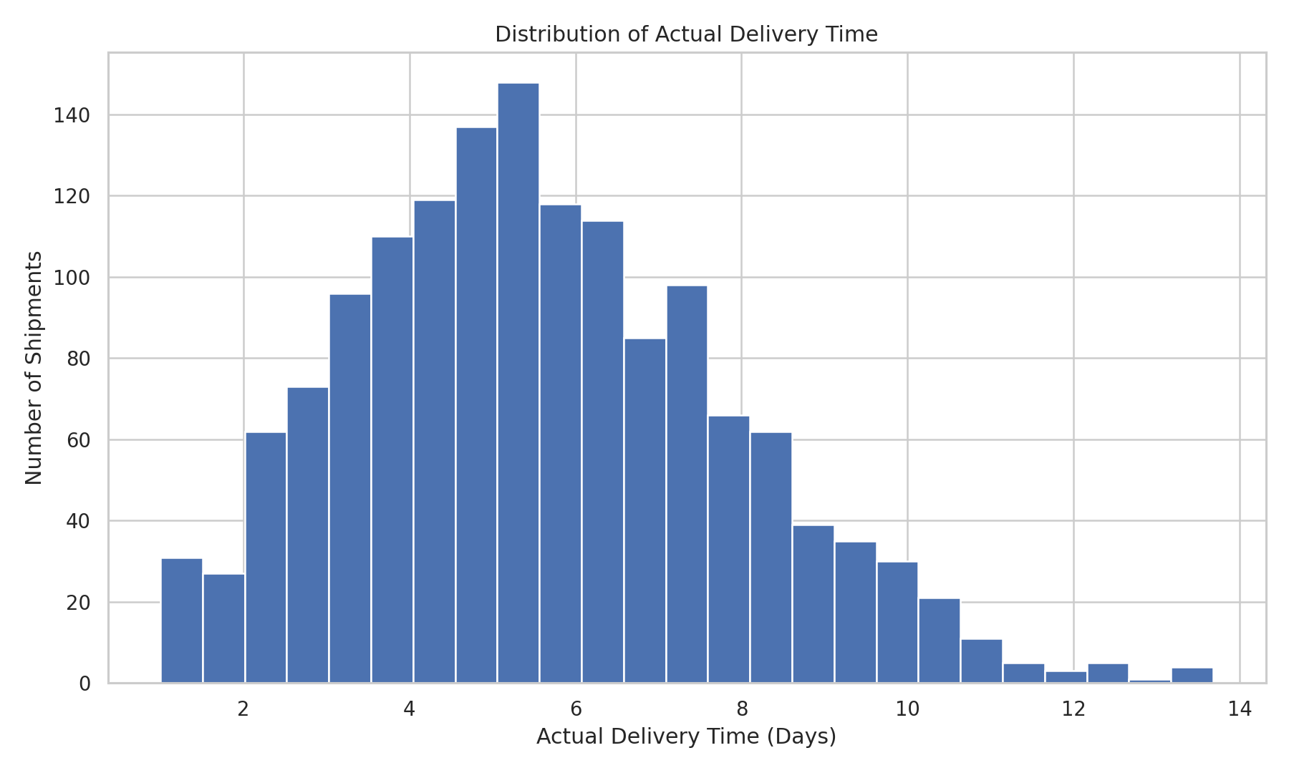
Figure 1. Distribution of actual delivery time. The histogram is useful for identifying the typical delivery range and unusually long deliveries.

7. Transportation Cost Analysis
The box plot compares transportation cost across transport modes. It is appropriate because it displays the median, spread and potential outliers for each mode. Cost differences can support transport-mode selection and route planning.
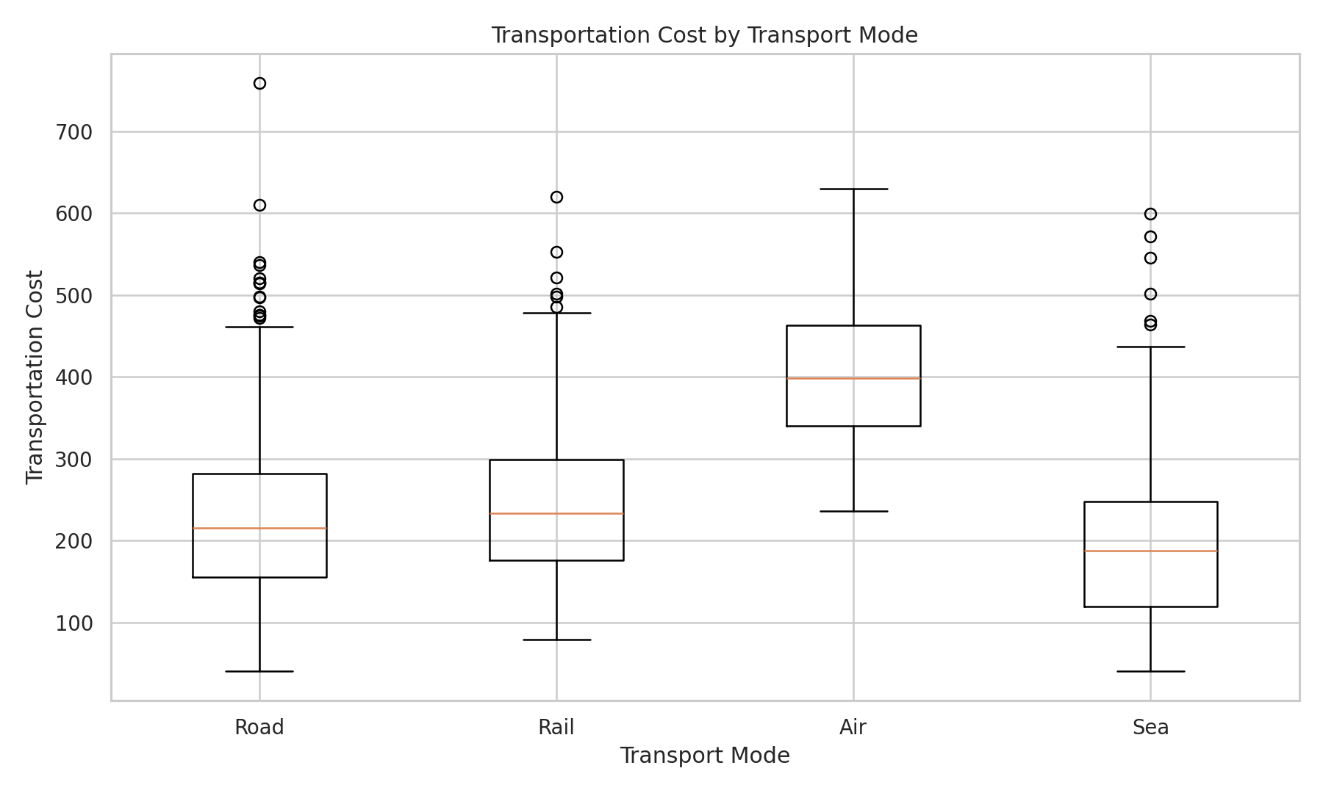
Figure 2. Transportation cost distribution by transport mode.

8. Shipment Volume Trend
The monthly trend chart helps logistics teams identify periods of higher or lower shipment activity. Such patterns can support staffing, fleet planning, warehouse capacity and carrier allocation.
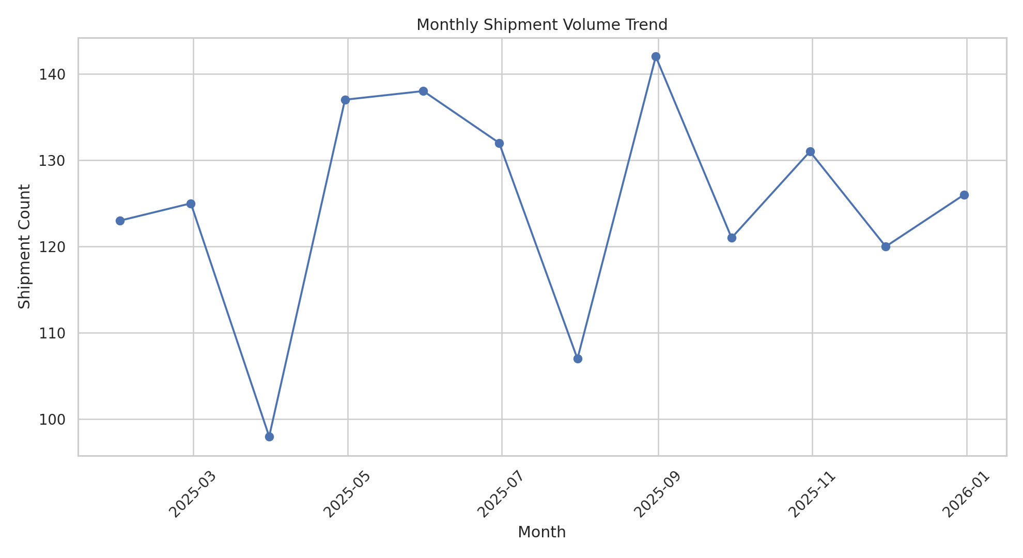
Figure 3. Monthly shipment volume trend.

9. Relationship Between Distance and Cost
The scatter plot demonstrates the positive association between distance and transportation cost. The calculated correlation is 0.67. This suggests that longer routes generally require higher transportation expenditure, although transport mode and shipment volume also contribute.
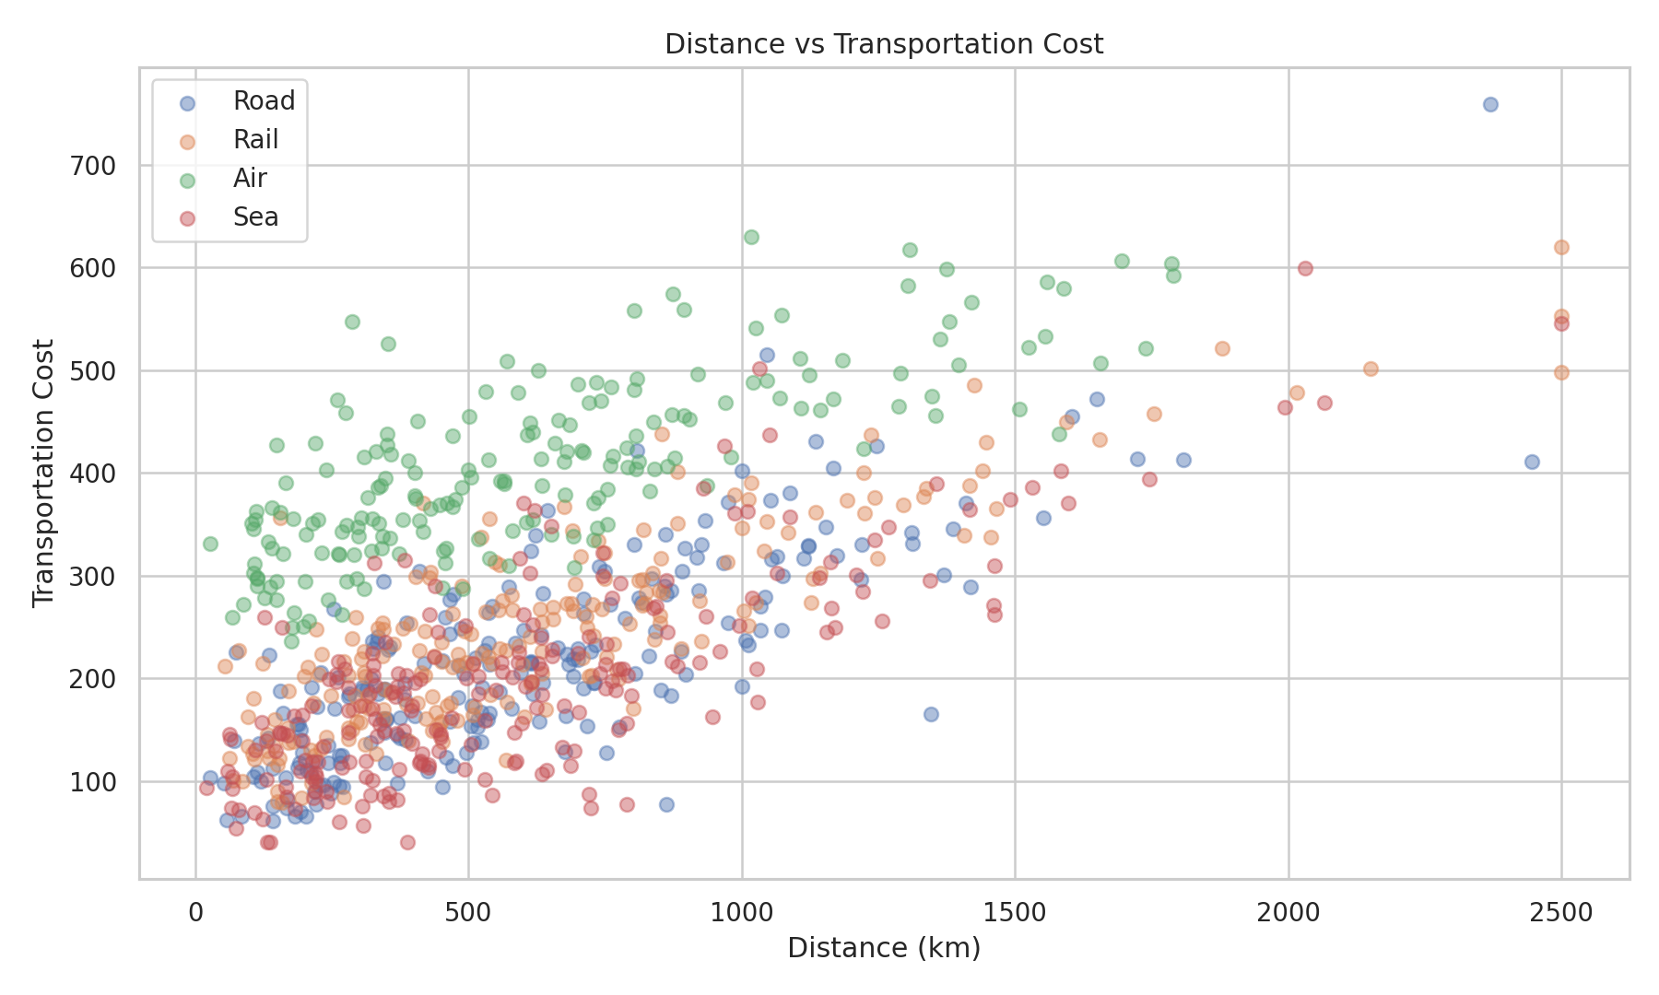
Figure 4. Distance versus transportation cost.

10. Correlation Analysis
The correlation matrix was used to examine linear relationships among shipment volume, distance, delivery time, transportation cost, delivery delay and order value. Correlation does not establish causation; it is used here to identify variables that deserve further operational investigation.
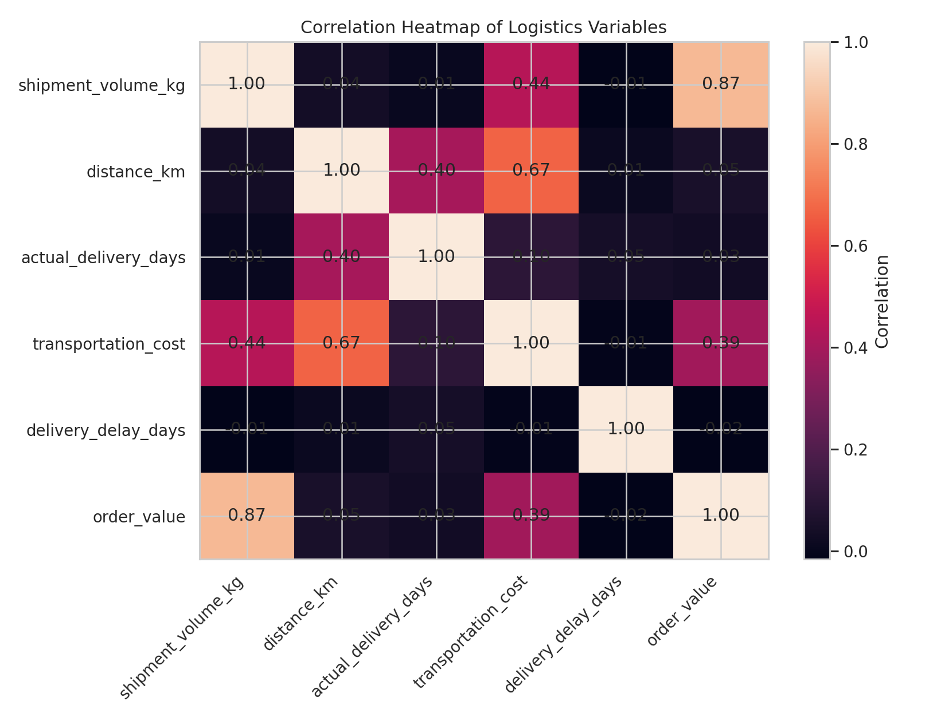
Figure 5. Correlation heatmap.

11. Delivery Delay Analysis
The overall simulated delay rate is 9.3%. The mode-level chart highlights differences in delay rates and can help managers investigate whether particular transport modes require changes in scheduling, carrier allocation or service-level buffers.
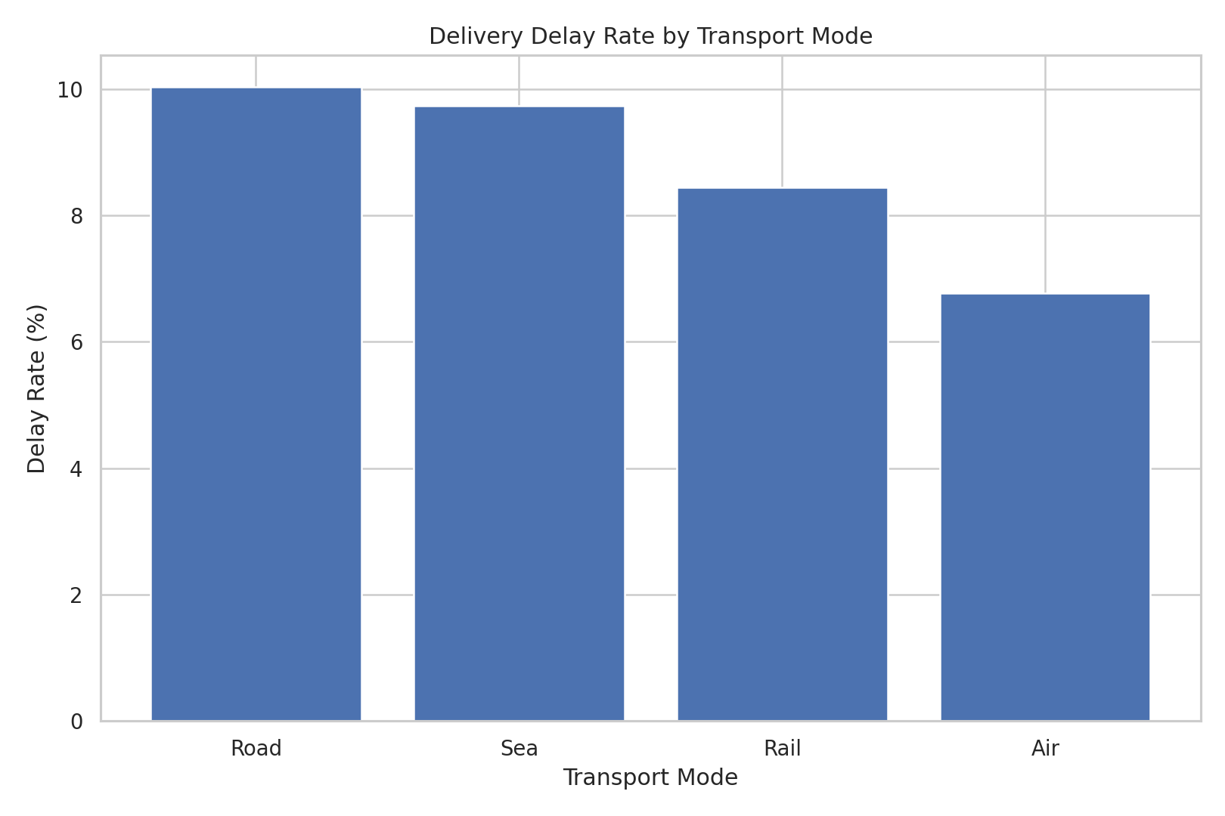
Figure 6. Delivery delay rate by transport mode.

12. Analytical Insights
- The simulated dataset contains 1,500 shipments across five regions and four transport modes.
- Average actual delivery time is 5.59 days and the median is 5.35 days.
- The overall simulated delivery delay rate is 9.3%.
- Average transportation cost is 247.72, with total simulated transportation cost of 371,580.62.
- Distance and transportation cost have a correlation of 0.67, indicating that longer routes are an important cost driver.
- Shipment volume and transportation cost have a correlation of 0.44, showing that heavier shipments tend to increase logistics cost.
- Road has the highest simulated delay rate at 10.0% among the transport modes.

13. Operational Recommendations
- Monitor route distance and shipment volume together when estimating transportation budgets.
- Use transport-mode performance dashboards to identify modes with higher delay exposure.
- Set delivery promises using historical route and mode performance rather than a single standard buffer.
- Track warehouse processing time as an early operational indicator because internal handling contributes to total delivery time.
- Review high-cost routes and investigate consolidation opportunities for heavier shipments.
- Repeat the analysis monthly using actual operational data to detect changes in cost and service performance.

14. Python Tools and Techniques
Pandas was used for tabular data creation, transformation and aggregation. NumPy was used for reproducible data simulation and numerical calculations. Matplotlib was used to create the charts. The analysis demonstrates descriptive statistics, grouping, correlation analysis, time-series resampling and visualization.

15. Conclusion
The Week 3 analysis demonstrates how exploratory data analysis and visualization can convert logistics data into actionable operational information. Delivery time, transportation cost, shipment volume, distance and delay are interconnected performance dimensions. A repeatable Python workflow allows logistics teams to monitor these metrics consistently and investigate potential bottlenecks before they affect service levels.

Appendix A – Key Python Code Excerpt
df["delivery_delay_days"] = np.maximum(
df["actual_delivery_days"] - df["promised_delivery_days"], 0
)
df["delayed"] = (df["delivery_delay_days"] > 0.2).astype(int)
corr = df[
["shipment_volume_kg", "distance_km",
"actual_delivery_days", "transportation_cost",
"delivery_delay_days"]
].corr()

