LOGISTICS DATA ANALYST – WEEK 4
Predictive Modeling and Optimization in Logistics using Python
Yuva Intern – Logistics Data Analyst Internship

1. Executive Summary
This Week 4 project applies predictive analytics to a simulated logistics environment. A hypothetical shipment dataset was created with operational variables including shipment volume, route distance, transportation cost, transport mode, fuel price, traffic level, weather condition and shipment priority. Delivery time in days was selected as the target variable. Three regression models—Linear Regression, Decision Tree Regression and Random Forest Regression—were trained on an 80/20 train-test split. Model performance was assessed using Mean Absolute Error (MAE), Root Mean Squared Error (RMSE) and R-squared (R²). The analysis also translated model and exploratory findings into practical logistics optimization recommendations.

2. Objective
The objective is to demonstrate how predictive modeling can forecast a key logistics metric and how the resulting insights can support resource allocation, route planning, delivery-time management and transportation cost control.

3. Problem Definition
The analytical problem is to predict delivery time for a shipment from known operational conditions. Accurate estimates can help logistics teams set realistic delivery expectations, identify potentially delayed shipments and plan resources before service performance is affected.

4. Data Simulation and Variables
A reproducible hypothetical dataset of 1,200 shipments was generated using a fixed random seed. The simulation was designed to reflect realistic directional relationships: longer distance, higher shipment volume, high traffic and adverse weather tend to increase delivery time, while express priority reduces expected time. Transportation cost was simulated from distance, shipment volume, fuel price and transport mode.
Variable | Type | Purpose
Shipment_Volume | Numeric | Number/volume of items in shipment
Distance_km | Numeric | Route distance
Transport_Mode | Categorical | Road, Rail, Air or Sea
Transportation_Cost | Numeric | Estimated transport cost
Fuel_Price | Numeric | Fuel price input
Traffic_Level | Categorical | Low, Medium or High
Weather_Condition | Categorical | Clear, Cloudy, Rainy or Storm
Priority | Categorical | Standard or Express
Delivery_Time_Days | Target | Predicted logistics outcome

5. Data Preparation
Categorical variables were one-hot encoded through a scikit-learn ColumnTransformer, while numerical variables were passed through unchanged. The preprocessing and model were combined in a Pipeline to reduce the risk of inconsistent transformations between training and testing. The data was split into 80% training and 20% testing observations using random_state=42 for reproducibility.

6. Model Selection
Linear Regression was included as an interpretable baseline. Decision Tree Regression was used to capture non-linear relationships and interactions. Random Forest Regression was included as an ensemble method that can model more complex relationships while reducing the instability of a single decision tree.

7. Evaluation Metrics
MAE represents the average absolute prediction error in days. RMSE gives greater weight to larger errors. R² measures the proportion of target variance explained by the model. For model comparison, lower MAE and RMSE are preferable, while a higher R² indicates stronger explanatory performance.

8. Model Results
Model | MAE (days) | RMSE (days) | R²
Linear Regression | 1.272 | 1.596 | 0.972
Random Forest | 1.714 | 2.151 | 0.949
Decision Tree | 2.152 | 2.769 | 0.915
Within this fixed simulated train-test experiment, Linear Regression produced the lowest RMSE and was therefore selected for the main predictive discussion. This selection is specific to the simulated dataset and test split; it should not be treated as evidence that the same model will always be best on real logistics data.

9. Visualization and Analytical Findings
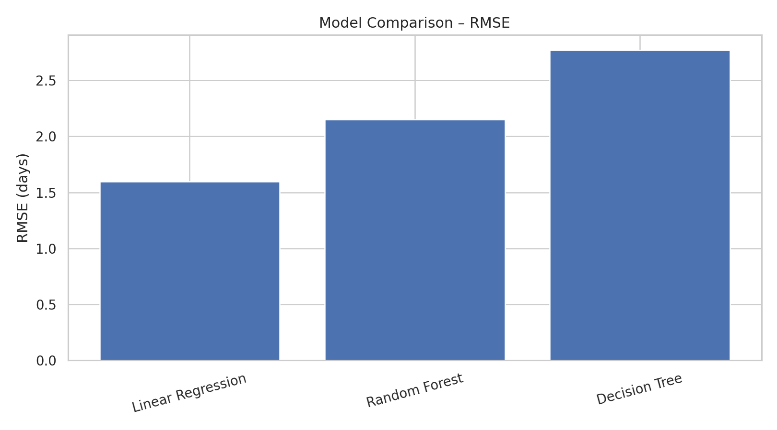
Figure 1: Comparison of model RMSE values.
The model comparison chart provides a direct view of predictive error. It is useful for choosing a model based on a measurable validation criterion rather than intuition alone.
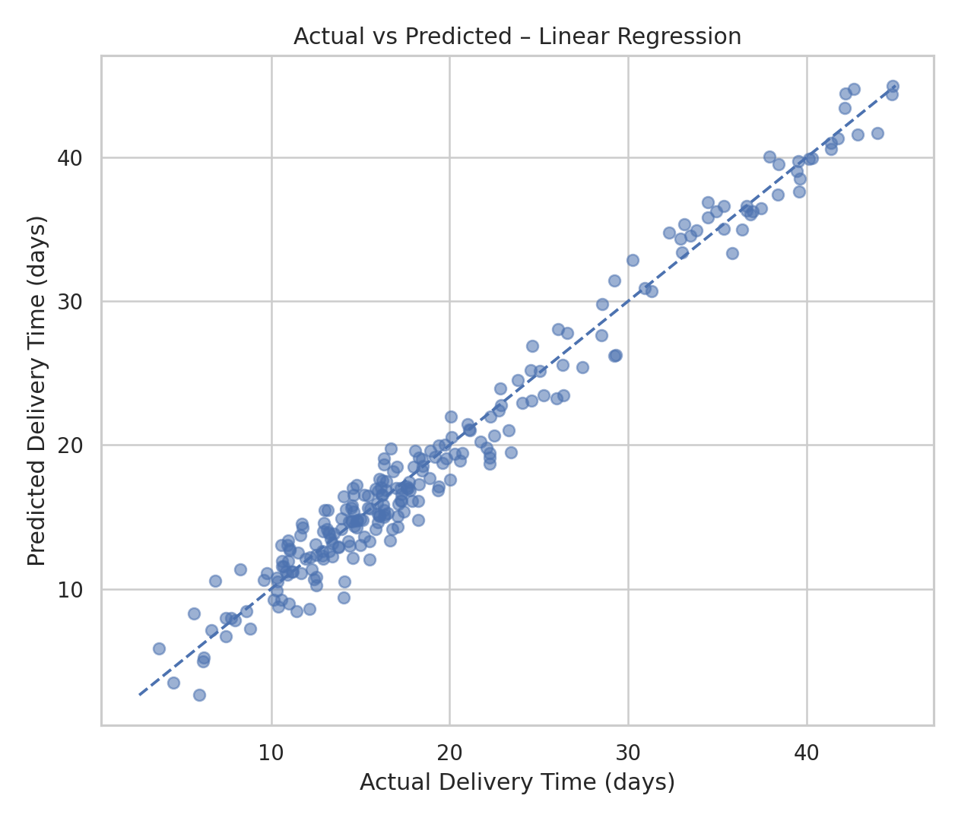
Figure 2: Actual versus predicted delivery time for the selected model.
Points closer to the diagonal reference line indicate smaller prediction errors. This visualization helps identify whether predictions systematically deviate from actual delivery times.
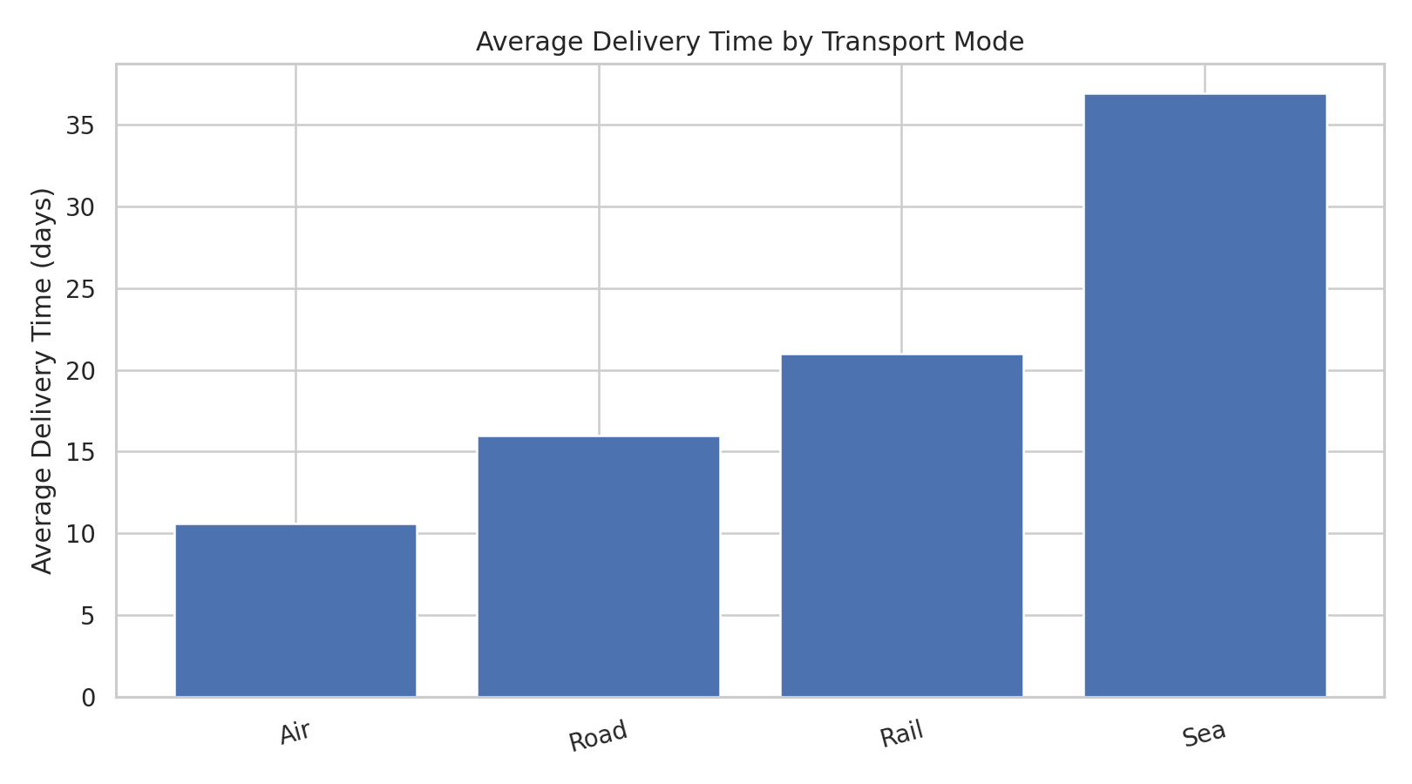
Figure 3: Average delivery time by transport mode.
In the simulation, Sea has the highest average delivery time and Air has the lowest average. The chart can support mode-specific planning, but operational decisions should also consider service requirements and cost.
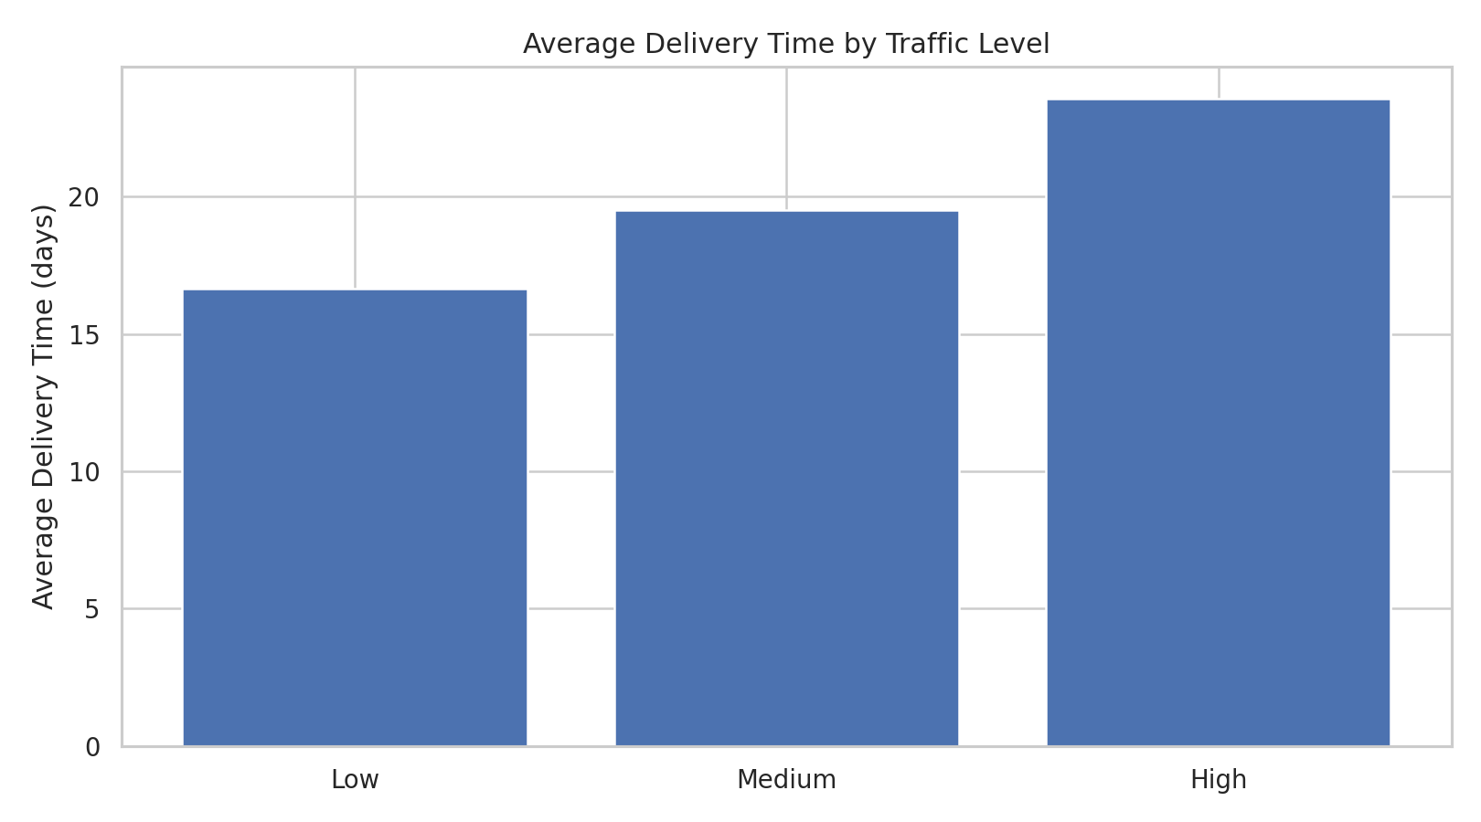
Figure 4: Average delivery time by traffic level.
The simulated results show increasing delivery time as traffic moves from low to high. This suggests that traffic conditions should be incorporated into delivery planning and exception management.
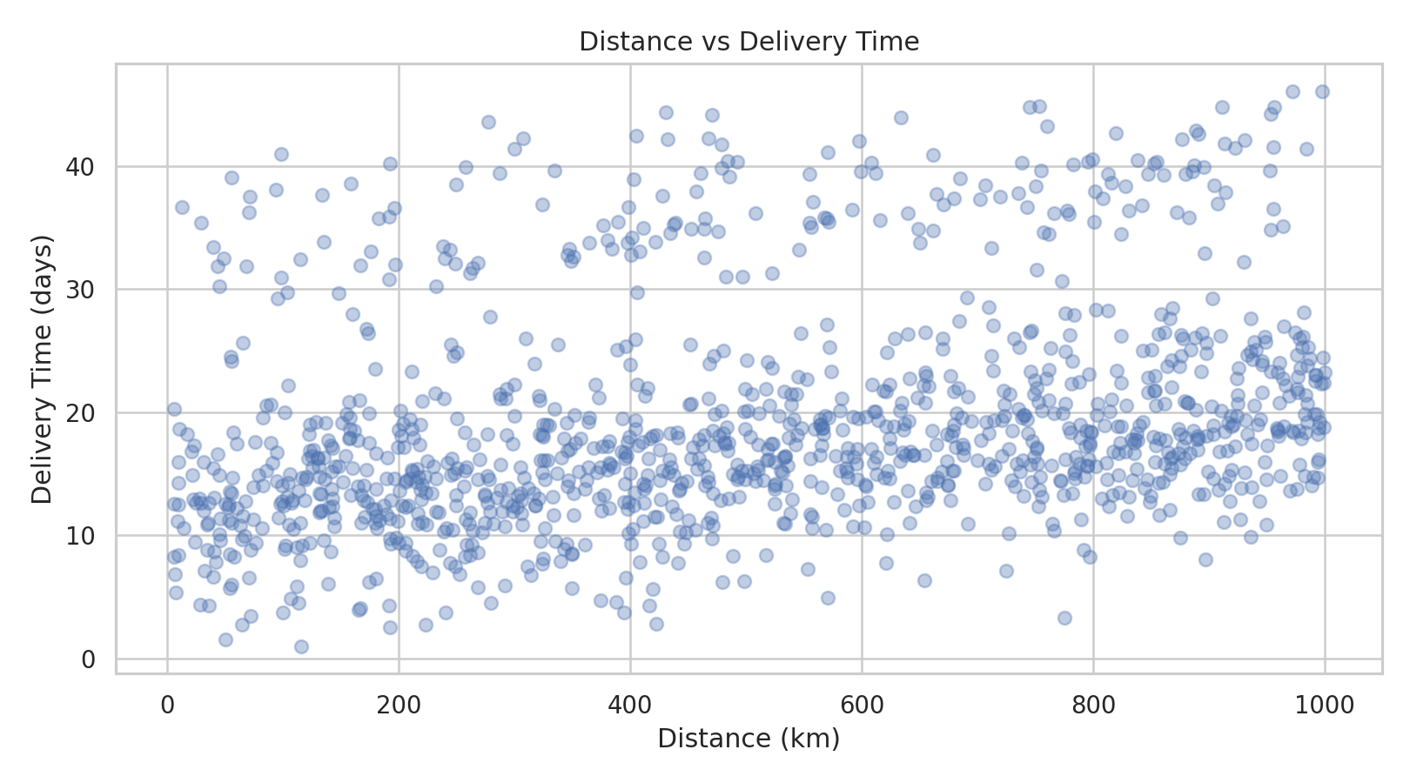
Figure 5: Relationship between distance and delivery time.
The scatter plot shows a positive directional relationship between route distance and delivery time. Longer routes should therefore receive appropriate time buffers when setting service expectations.
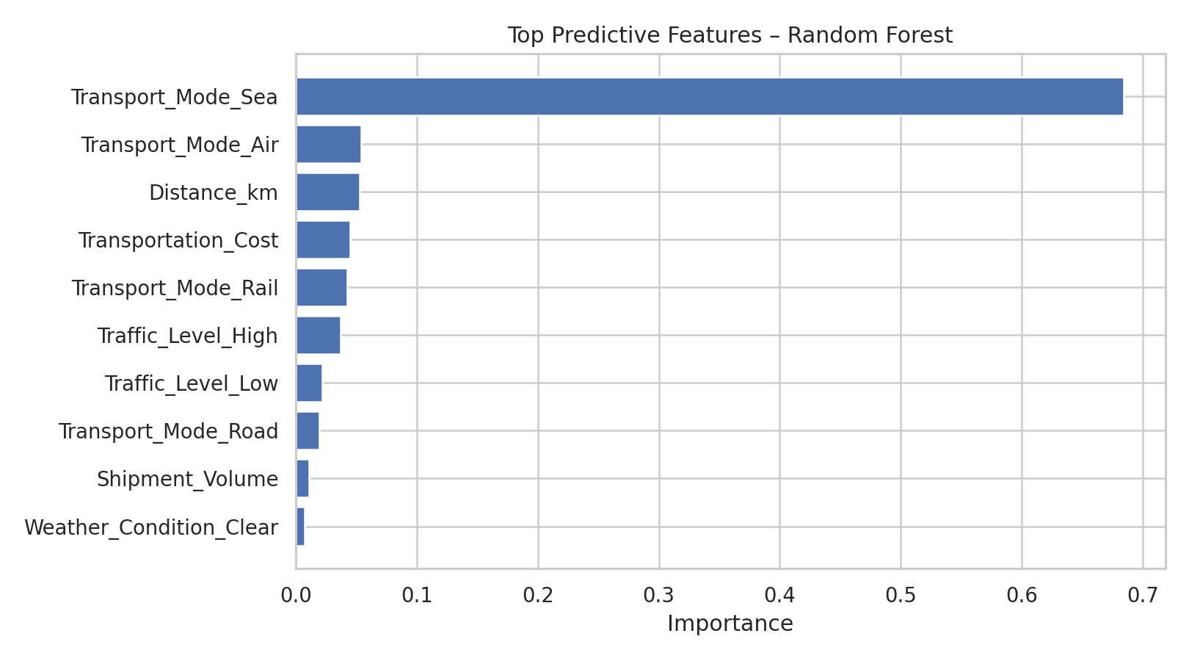
Figure 6: Top predictive features from the Random Forest model.
Feature importance is used as an explanatory aid to identify variables that contributed most to the Random Forest predictions. Importance does not by itself prove causation, so operational teams should validate these relationships with real-world process data.

10. Optimization Strategies
- Route planning: use distance and traffic information to prioritize efficient routes and realistic time buffers.
- Resource allocation: allocate additional operational capacity to shipments with high predicted delivery time.
- Transport mode planning: compare expected delivery time and transportation cost before selecting a mode.
- Exception management: flag shipments with high predicted delay for early intervention.
- Weather-aware planning: increase buffers or adjust schedules when adverse weather conditions are expected.
- Cost control: jointly monitor transportation cost and predicted delivery performance instead of optimizing cost alone.
- Model monitoring: periodically retrain and validate the model as real operational patterns change.

11. Limitations
The dataset is hypothetical and was generated for internship analysis. It is not a substitute for real operational data. The random train-test split is suitable for this demonstration, but a production forecasting system should also use time-based validation where appropriate. Model performance can change when real data, new routes, seasonal effects or operational policies are introduced.

12. Conclusion
The Week 4 project demonstrates a complete predictive analytics workflow for logistics: problem definition, data simulation, preprocessing, model training, evaluation, visualization and optimization recommendations. Among the tested models, Linear Regression achieved the lowest RMSE on the simulated test set. The analysis shows how predicted delivery time and operational drivers can be converted into practical planning actions. For real-world deployment, the next step would be to validate the approach using historical logistics data, time-aware testing and ongoing model monitoring.

13. Reproducibility
The repository includes the simulated CSV dataset, Python modeling script, requirements file, model comparison results, KPI summary, analytical insights and visualization outputs. The fixed random seed (42) allows the simulation and train-test split to be reproduced.

