Q:1
Problem Statement:-
You are provided with a file "main.csv" in the input folder. Following operation needs to be provided on the file:-Q1Create an output file "filteredCountry.csv" inside a folder named "output". This file should contain only those records where country contains the word USA.

import java.io.*;
import java.util.Scanner;

public class algorithmsarray {
public static void main(String[] args) throws IOException {
Scanner sc = new Scanner(new File("/home/ubuntumsd/Downloads/main.csv"));
sc.useDelimiter("\\n");
FileWriter fr=new FileWriter("/home/ubuntumsd/Downloads/filecountry.csv");
BufferedWriter br1=new BufferedWriter(fr);

while(sc.hasNext())
{

String h=sc.next();
System.out.println(h);
if(h.contains("USA"))
{
br1.write(h);
br1.newLine();

}

}

}
}
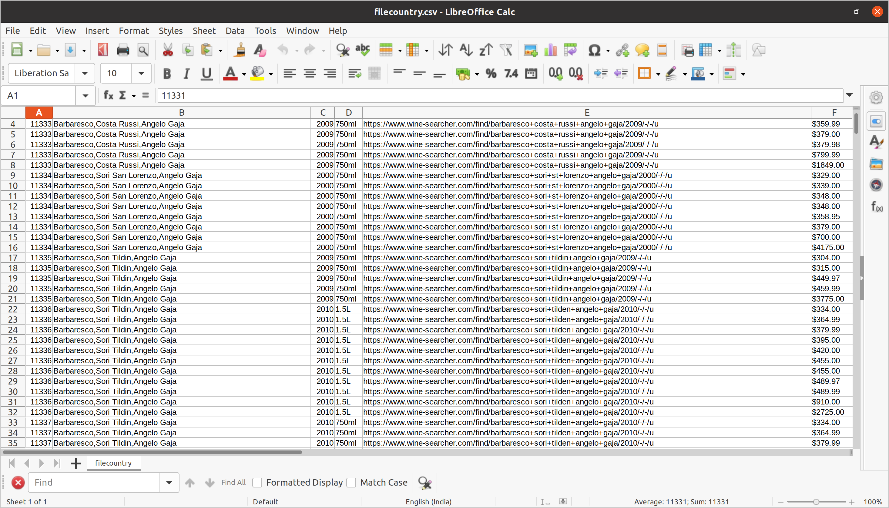

Q2:Now consider "filteredCountry.csv" as the input file. For each group of "SKU" find 2 minimum prices and store this result in "lowestPrice.csv" inside a folder named "output"

import com.sun.xml.internal.ws.policy.privateutil.PolicyUtils;

import java.io.*;

import java.util.*;

public class modified {
public static void main(String[] args) throws IOException {
Scanner sc = new Scanner(new File("/home/ubuntumsd/Downloads/filecountry.csv"));
sc.useDelimiter("\\n");
Map<Integer,String> map=new HashMap<>();
while (sc.hasNext()) {
float fmin = Float.MAX_VALUE;
float smin = Float.MAX_VALUE;
String h = sc.next();
String k[] = h.split(",");
int val = 0;
int temp = 0;
int count = 0;
for (String i : k) {
if (count == 0) {
val = Integer.parseInt(i);
count++;
} else if (i.matches("^\\$[0-9]+\\.[0-9]+")||(i.matches(".+\\?$"))){
i = i.replaceAll("\\$|\\.0*|\\,|\\?", "");

temp = Integer.parseInt(i);
//System.out.println(temp);

}

}
if(!map.containsKey(val))
{
String m=temp+" "+Integer.MAX_VALUE;

map.put(val,m);
}
else{
String f[]=map.get(val).split(" ");
int x=Integer.parseInt(f[0]);
int y=Integer.parseInt(f[1]);
ArrayList<Integer> al=new ArrayList<>();
al.add(x);
al.add(y);
al.add(temp);
Collections.sort(al);
String r=al.get(0)+" "+al.get(1);
map.put(val,r);
al.clear();

}

}
for(Map.Entry<Integer,String> e:map.entrySet())
{

String n[]=e.getValue().split(" ");
int x=Integer.parseInt(n[0]);
int y=Integer.parseInt(n[1]);
String d=x+","+y;
map.put(e.getKey(),d);
if(y==Integer.MAX_VALUE)
{
String h=x+","+x;
map.put(e.getKey(),h);
}

}
File f=new File("/home/ubuntumsd/Downloads/lowprice.csv");
f.createNewFile();
FileWriter f1=new FileWriter(f);
BufferedWriter br1=new BufferedWriter(f1);

for(Map.Entry<Integer,String> e:map.entrySet())
{
String p=e.getKey()+","+e.getValue()+"";
System.out.println(p);
br1.write(p);
br1.newLine();

}
br1.close();

}
}

Output:
