CS352 Assignment-1

Krishanu Saini

190001029

# Write a program using glut library to draw the

# following diagrams:

# Problem 1: Tree

# Solution

Draw 3 overlapping isosceles triangles from bottom to top with green color.

Draw the tree trunk with brown color.

Draw the points at the corners in black.

# 

# Code

#include <GL/glut.h>

/*

* Name: Krishanu Saini

* Roll: 190001029

* Ques: Problem 1) Tree

* Date: 13/01/22

*/

void Draw() {

glClear(GL_COLOR_BUFFER_BIT);

glPointSize(10);

/*-------- corners --------*/

glColor3f(0,0,0);

glBegin(GL_POINTS);

glVertex2i(0,0);

glVertex2i(0,800);

glVertex2i(800,800);

glVertex2i(800,0);

glEnd();

/*-------- Leaves --------*/

glColor3f(0.1,0.8,0.1);

glBegin(GL_POLYGON);

glVertex2i(400, 450);

glVertex2i(220, 250);

glVertex2i(580, 250);

glEnd();

glBegin(GL_POLYGON);

glVertex2i(400, 550);

glVertex2i(240, 350);

glVertex2i(560, 350);

glEnd();

glBegin(GL_POLYGON);

glVertex2i(400, 650);

glVertex2i(260, 450);

glVertex2i(540, 450);

glEnd();

/*-------- wood --------*/

glColor3f(0.6,0.3,0);

glBegin(GL_POLYGON);

glVertex2i(350, 100);

glVertex2i(350, 250);

glVertex2i(450, 250);

glVertex2i(450, 100);

glEnd();

glFlush();

}

int main(int argc, char *argv[]) {

glutInit(&argc, argv);

glutInitWindowPosition(100, 100);

glutInitWindowSize(800, 800);

glutInitDisplayMode(GLUT_RGB);

glutCreateWindow("Assignment 1");

gluOrtho2D(0, 800, 0, 800);

glClearColor(1,1,1,0.0);

glutDisplayFunc(Draw);

glutMainLoop();

return 0;

}

# Output

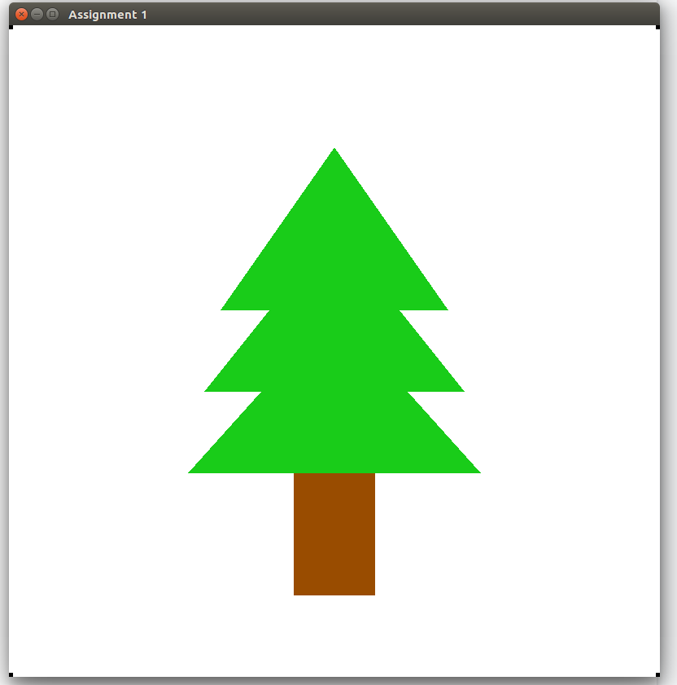

# Problem 2: House

# Solution

Draw the house in layers.

Draw the wall rectangle.

Draw the roof as a triangle.

Draw the windows square and door rectangle.

Draw the door knob as a rounded point.

# 

# 

# Code

#include <GL/glut.h>

/*

* Name: Krishanu Saini

* Roll: 190001029

* Ques: Problem 2) House

* Date: 13/01/22

*/

void Draw() {

glClear(GL_COLOR_BUFFER_BIT);

glPointSize(10);

/*-------- big_rectangle --------*/

glColor3f(0.5, 0.3, 0);

glBegin(GL_POLYGON);

glVertex2i(200, 100);

glVertex2i(200, 400);

glVertex2i(600, 400);

glVertex2i(600, 100);

glEnd();

/*-------- roof_triangle --------*/

glColor3f(0.5, 0.3, 0.5);

glBegin(GL_POLYGON);

glVertex2i(100, 401);

glVertex2i(400, 700);

glVertex2i(700, 401);

glEnd();

/*-------- door --------*/

glColor3f(0, 0.2, 0.6);

glBegin(GL_POLYGON);

glVertex2i(360, 150);

glVertex2i(360, 320);

glVertex2i(440, 320);

glVertex2i(440,150);

glEnd();

/*-------- door_knob --------*/

glColor3f(0, 0, 0);

glEnable(GL_POINT_SMOOTH);

glHint(GL_POINT_SMOOTH_HINT, GL_NICEST);

glBegin(GL_POINTS);

glPointSize(10);

glVertex2i(370, 240);

glEnd();

/*-------- window_left --------*/

glColor3f(0.2, 0.8, 1);

glBegin(GL_POLYGON);

glVertex2i(240, 240);

glVertex2i(240, 320);

glVertex2i(320, 320);

glVertex2i(320, 240);

glEnd();

/*-------- window_right --------*/

glColor3f(0.2, 0.8, 1);

glBegin(GL_POLYGON);

glVertex2i(480, 240);

glVertex2i(480, 320);

glVertex2i(560, 320);

glVertex2i(560, 240);

glEnd();

glFlush();

}

int main(int argc, char *argv[]) {

glutInit(&argc, argv);

glutInitWindowPosition(100, 100);

glutInitWindowSize(800, 800);

glutInitDisplayMode(GLUT_RGB);

glutCreateWindow("Assignment 1");

gluOrtho2D(0, 800, 0, 800);

glClearColor(1,1,1,0.0);

glutDisplayFunc(Draw);

glutMainLoop();

return 0;

}

# 

# Output

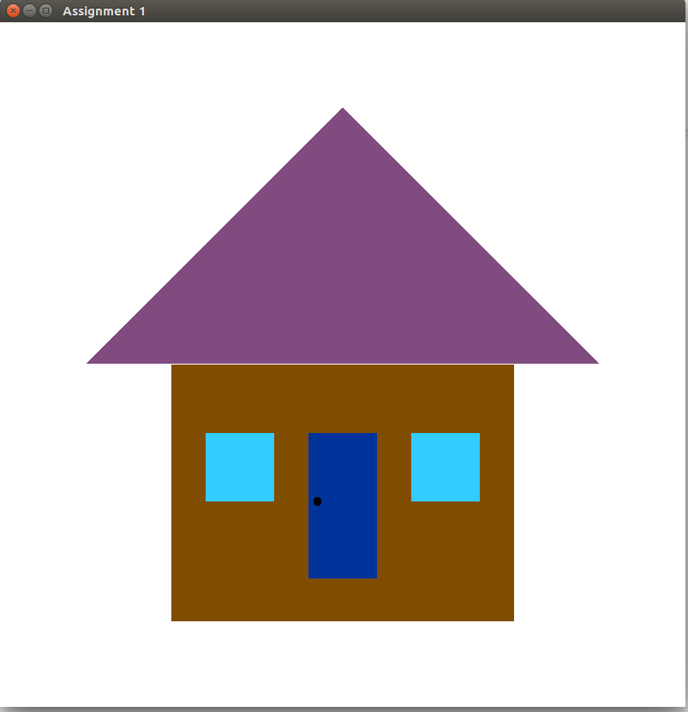

# Problem 3: Bicycle

# Solution

We will draw the bicycle in parts.

Draw base parallelogram and 2 lines through it.

Draw wheels as circles with the center at the bicycle frame.

Draw a seat as trapesium.

Draw handle as 45 degrees inclined.

# 

# 

# Code

#include <math.h>

#include <GL/glut.h>

/*

* Name: Krishanu Saini

* Roll: 190001029

* Ques: Problem 3) Bicycle

* Date: 13/01/22

*/

void DrawCircle(float cx, float cy, float r, float num_segments) {

glBegin(GL_LINE_LOOP);

for (int ii = 0; ii < num_segments; ii++) {

float theta = 2.0f * 3.1415926f * float(ii) / float(num_segments);//get the current angle

float x = r * cosf(theta);//calculate the x component

float y = r * sinf(theta);//calculate the y component

glVertex2f(x + cx, y + cy);//output vertex

}

glEnd();

}

void Draw() {

glClear(GL_COLOR_BUFFER_BIT);

glPointSize(10);

/*-------- bars --------*/

glColor3f(0.1,0.1,0.8);

glLineWidth(2);

glBegin(GL_LINE_LOOP);

glVertex2i(200, 300);

glVertex2i(400, 600);

glVertex2i(600, 600);

glVertex2i(400, 300);

glVertex2i(200, 300);

glEnd();

glBegin(GL_LINES);

glVertex2i(400, 300);

glVertex2i(400, 600);

glEnd();

glBegin(GL_LINES);

glVertex2i(600, 600);

glVertex2i(600, 300);

glEnd();

/*-------- seat --------*/

glColor3f(0.5,0.2,0);

glLineWidth(4);

glBegin(GL_POLYGON);

glVertex2i(380, 600);

glVertex2i(450, 600);

glVertex2i(450, 630);

glVertex2i(380, 620);

glEnd();

/*-------- handle --------*/

glBegin(GL_LINES);

glColor3f(0.4,0.4,0.4);

glLineWidth(4);

glVertex2i(600, 700);

glVertex2i(550, 650);

glVertex2i(550, 650);

glVertex2i(650, 550);

glVertex2i(650, 550);

glVertex2i(700, 600);

glEnd();

/*-------- tires --------*/

glColor3f(0.2,0.2,0.2);

glLineWidth(5);

DrawCircle(200, 300, 120, 100);

DrawCircle(600, 300, 120, 100);

glFlush();

}

int main(int argc, char *argv[]) {

glutInit(&argc, argv);

glutInitWindowPosition(100, 100);

glutInitWindowSize(800, 800);

glutInitDisplayMode(GLUT_RGB);

glutCreateWindow("Assignment 1");

gluOrtho2D(0, 800, 0, 800);

glClearColor(1,1,1,0.0);

glutDisplayFunc(Draw);

glutMainLoop();

return 0;

}

# 

# Output

