Cloud Computing Lab 1
Setting Up a Virtual Machine with Oracle VirtualBox
Name | Krishanu Ghosh
Roll Number | UG/02/BTCSE/2023/115
Date | 22 August 2026
Hypervisor | Oracle VirtualBox 7.2.16
Guest OS | Ubuntu 25.04 (Plucky Puffin), 64-bit

Objective
The objective of this lab is to install an open-source hypervisor, create a virtual machine, configure its CPU, RAM, storage and network settings, attach a guest operating system ISO image, boot the VM, complete the guest OS installation, and verify that the VM runs successfully.

Tools Used
- Hypervisor: Oracle VirtualBox 7.2.16
- Guest OS image: ubuntu-26.04-desktop-amd64.iso
- Host OS: Windows

Step 1 — Download and Install VirtualBox
Oracle VirtualBox was downloaded from the official website (virtualbox.org). The platform package for Windows hosts was selected, along with the VirtualBox Extension Pack, which was accepted under the PUEL license.
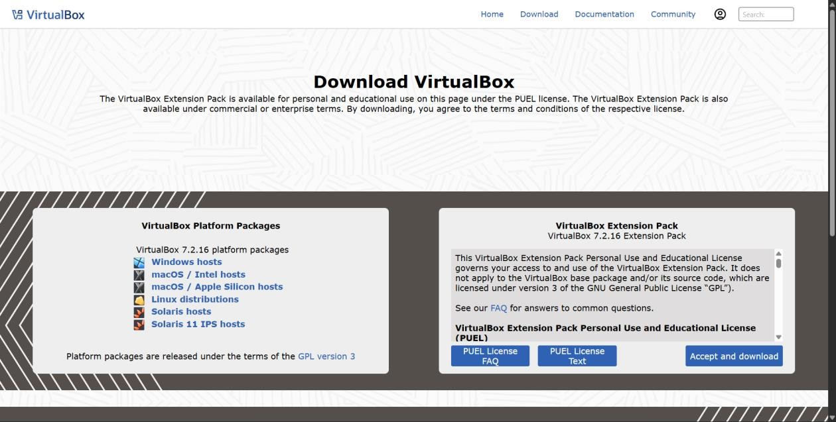
Figure 1: VirtualBox download page showing platform packages and the Extension Pack.
The downloaded installer was then run, and the installation wizard completed the setup, including installing the required network filter drivers.
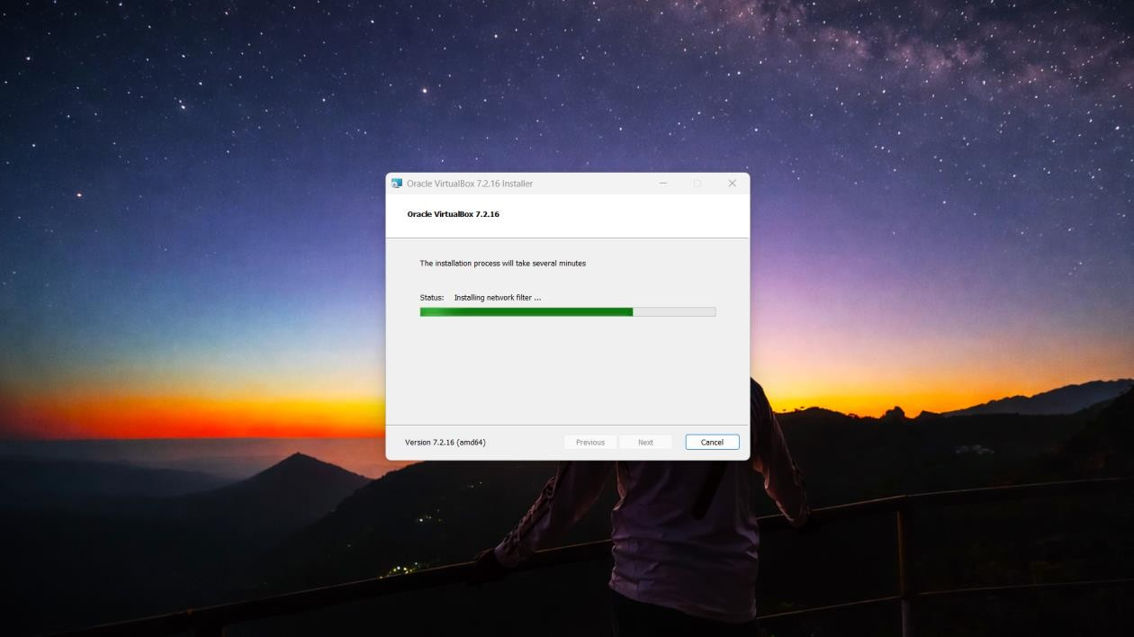
Figure 2: Oracle VirtualBox 7.2.16 installer in progress.

Step 2 — Launch VirtualBox Manager
After installation, Oracle VirtualBox Manager was launched. On first run, the Experience Mode selection screen appeared; Expert Mode was selected to access all configuration options while creating the VM.
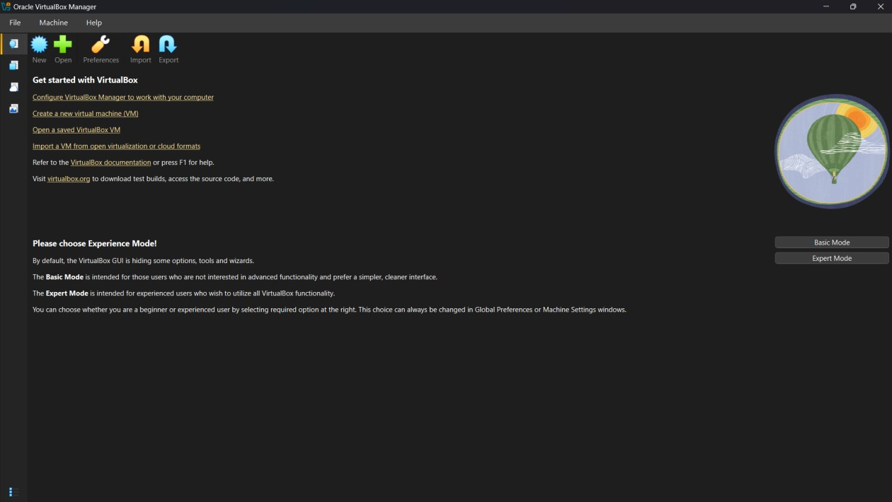
Figure 3: Oracle VirtualBox Manager home screen with Experience Mode selection.

Step 3 — Create a New Virtual Machine
A new VM was created using the "New" wizard. The VM was named Ubuntu_VM, and the downloaded Ubuntu ISO image (ubuntu-26.04-desktop-amd64.iso) was attached as the installation medium. The guest OS type was automatically detected as Ubuntu 25.04 (Plucky Puffin), 64-bit. Unattended installation was skipped so that the OS could be installed manually.
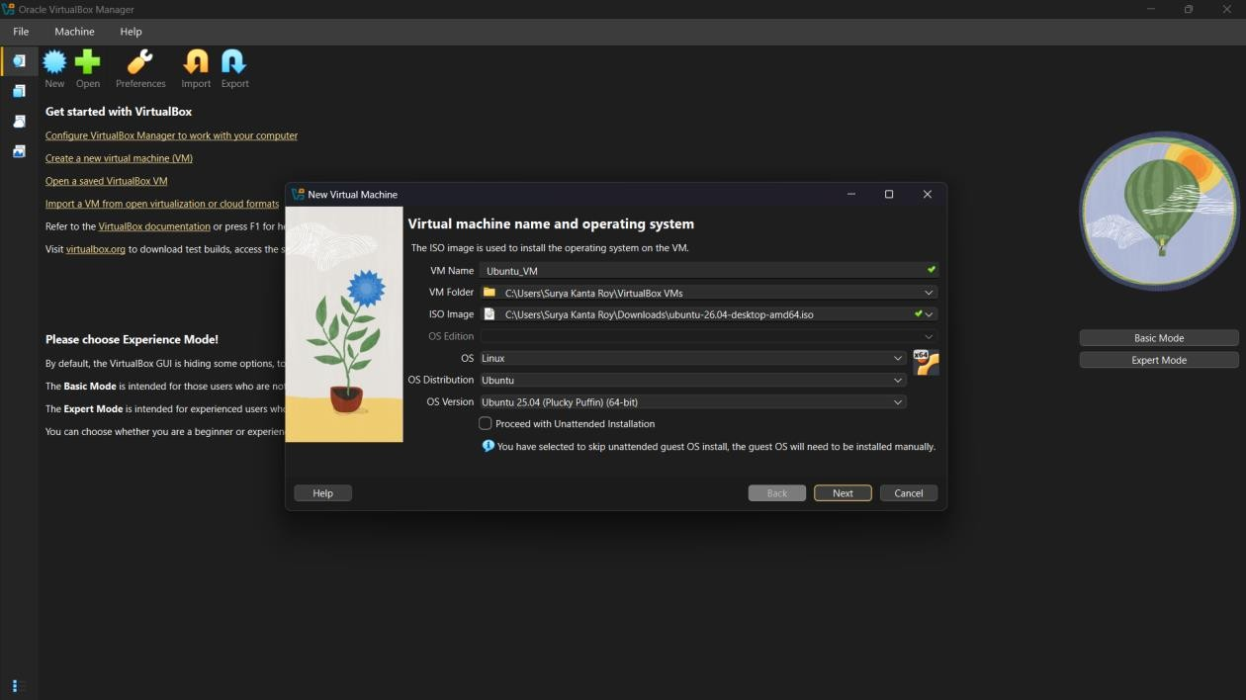
Figure 4: New Virtual Machine wizard — VM name, folder, and ISO image attached.

Step 4 — Configure CPU, RAM, and Storage
The virtual hardware was configured as follows: Base Memory (RAM) was set to 4096 MB, the number of virtual CPUs was set to 2, and a virtual hard disk of 25.00 GB was allocated for the guest OS.
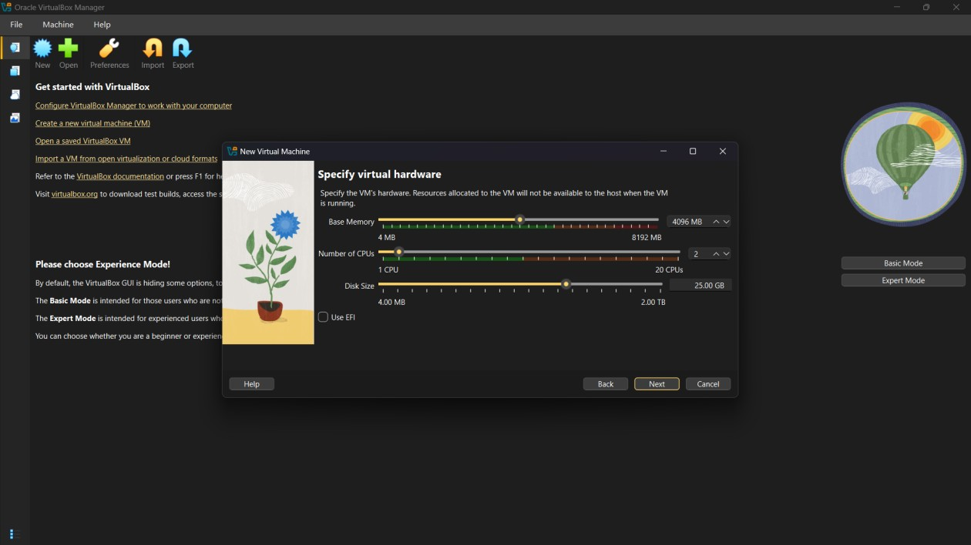
Figure 5: Specifying virtual hardware — base memory, CPU count, and disk size.

Step 5 — Review Configuration Summary
Before creation, the wizard displayed a summary of the chosen configuration: VM name, folder location, attached ISO image, guest OS type, base memory (4096 MB), 2 processors, and a 25.00 GB hard disk. The configuration was confirmed and the VM was created by clicking Finish.
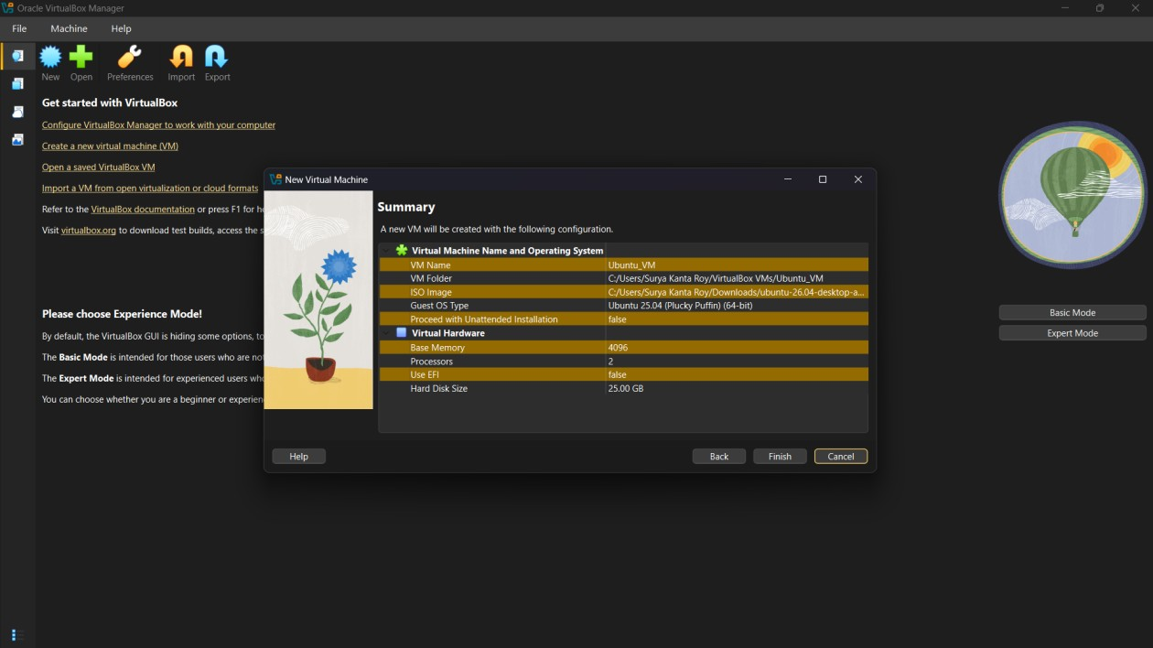
Figure 6: Summary screen showing the final VM configuration.

Step 6 — Verify Network and General Settings
The VM's Settings dialog was opened to review and verify the configuration, including base memory, boot device order (Floppy, Optical, Hard Disk), and the pointing device (USB Tablet). The network adapter was also verified to be enabled under the Network settings tab so that the VM would have internet access once booted.
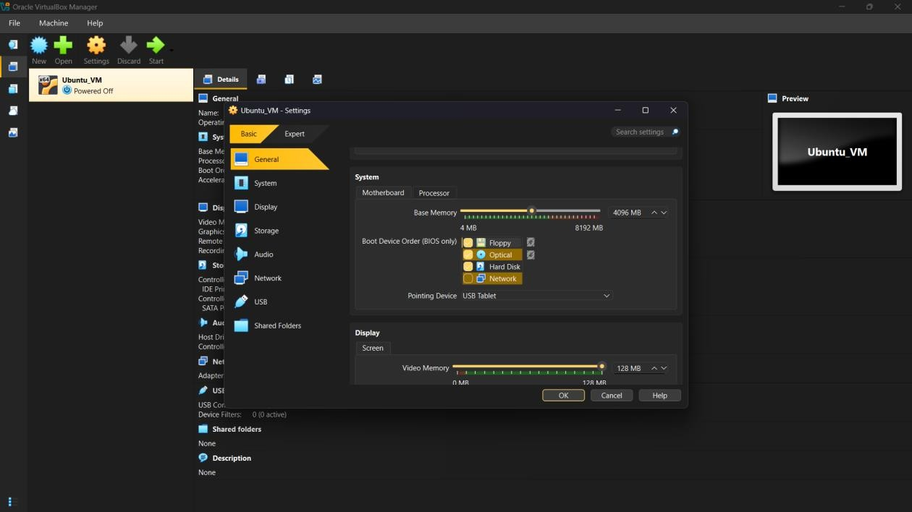
Figure 7: VM Settings — General/System configuration review.

Step 7 — Boot the VM and Install the Guest OS
The VM was started, which booted from the attached Ubuntu ISO image. The Ubuntu installer was completed, and the VM successfully booted into the Ubuntu desktop environment, confirming that the guest OS installation was successful and the VM is fully functional.
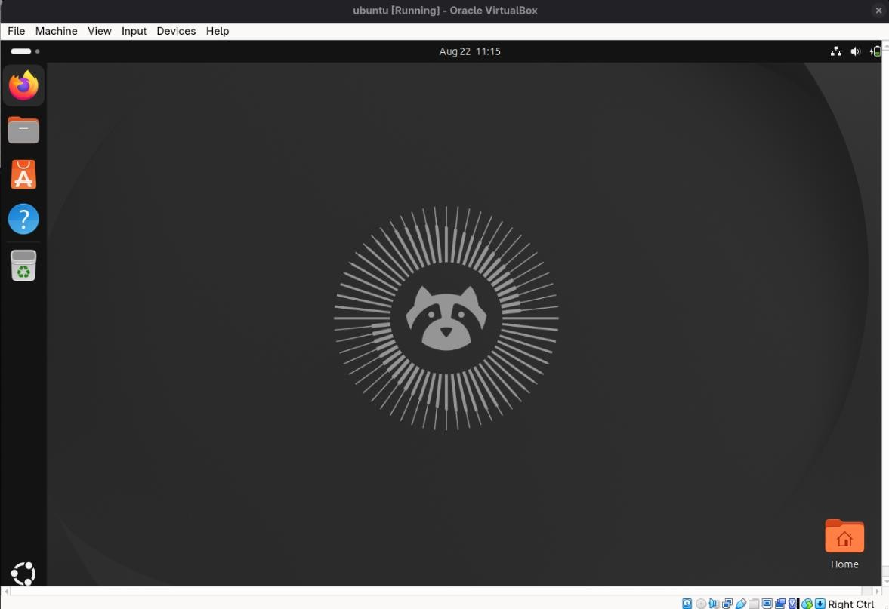
Figure 8: Ubuntu desktop running successfully inside the VirtualBox VM.

Step 8 — Install Build Tools and Kernel Headers
Once the VM was running, a terminal was opened inside the Ubuntu guest and the package index was updated. The buildessential package and the Linux kernel headers matching the running kernel were then installed using the following commands:
sudo apt update
sudo apt install -y build-essential linux-headers-$(uname -r)
This ensures the VM has the compiler toolchain and kernel headers required for building kernel modules and Guest Additions.

Verification
- VirtualBox 7.2.16 installed successfully on the host machine.
- A new VM (Ubuntu_VM) was created with 4096 MB RAM, 2 CPUs, and a 25 GB virtual disk.
- The Ubuntu ISO image was attached and the guest OS was installed.
- The VM booted successfully into the Ubuntu desktop environment.
- Build tools and kernel headers were installed inside the guest OS.

Conclusion
This lab demonstrated the complete workflow of setting up virtualization on a local machine: installing a hypervisor (Oracle
VirtualBox), creating and configuring a virtual machine's CPU, memory, storage, and network resources, attaching a guest OS image, booting the VM, and completing the guest OS installation. The successfully running Ubuntu VM confirms that the virtualization environment is correctly configured and ready for further cloud computing lab exercises.

