

FACULTY OF TECHNOLOGY AND ENGINEERING

**THE MAHARAJA SAYAJIRAO UNIVERSITY, BARODA**

YEAR 2013-2014

A PROJECT REPORT ON

**RAILWAY RESERVATION**

**MANAGEMENT SYSTEM**

PROJECT BY:

1.PATEL NABIL (486)

2. ROHAN ATHAVALE(457)

3.GOR MADHUR (466)

4.JAYSWAL HIREN (467)

**INDEX**

|  |  |
| --- | --- |
| **1** | **PROJECT PROFILE** |
| **2** | **INTRODUCTION** |
| **3** | **WORKING OF APPLICATION** |
| **4** | **MODULES** |
| **5** | **DATA DICTIONARY** |
| **6** | **ER DIAGRAM** |
| **7** | **CLASS DIAGRAM** |

**Project Profile**

1. ***Project Overview :***

Our application has various kind of information about railway trains and facility for a user to book railway ticket.

A user can book a ticket, cancel a ticket and also can get information about train’s route, fare by this application.

1. ***Objectives :***
2. To create a database of trains
3. To search train’s arrival and departure timings, distance between source and destination
4. To check availability of seats
5. To calculate fare
6. To book a ticket and cancel if necessary
7. ***Development requirements*** :
8. Java
9. Oracle
10. Java (forehand): java language is used to develop this application.

Features :

1. Frame

2. Button

3.Labels

4. Exception Handling

5.JDBC

6.RMI

7.Client Server Architecture

* SE7 version of Java is used

1. Oracle (backhand): Oracle is use to create database about trains and other information.

* Oracle 10g is used for Database management.

1. **Introduction**

**This Project is about a Railway Management System which allows passengers to book tickets online. It also gives details about their pnr status ,the routes of trains and ability to view their booking history as well.**

**We have implemented this system using RMI(Remote Method Invocation) feature of java. It uses oracle 10g as the back-end.**

**3)Working of Application**

**a)Login Page**

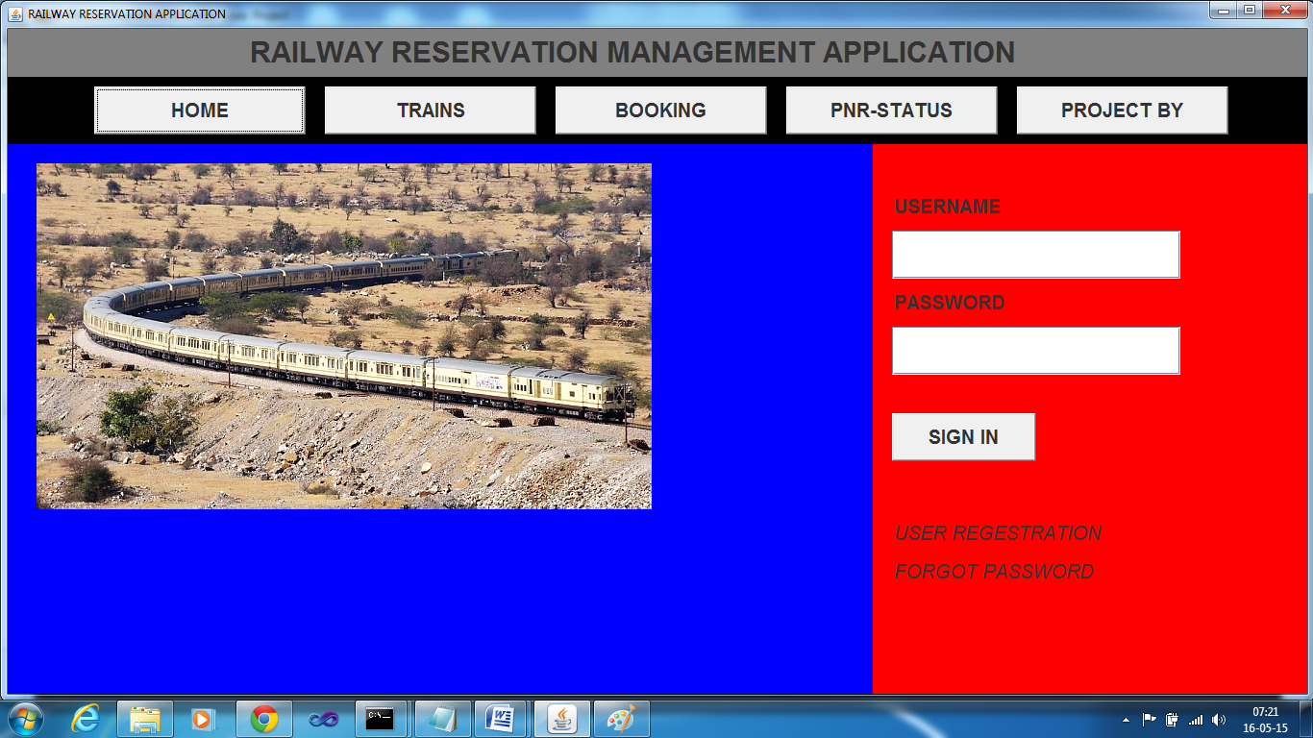

1. **Registration Page**

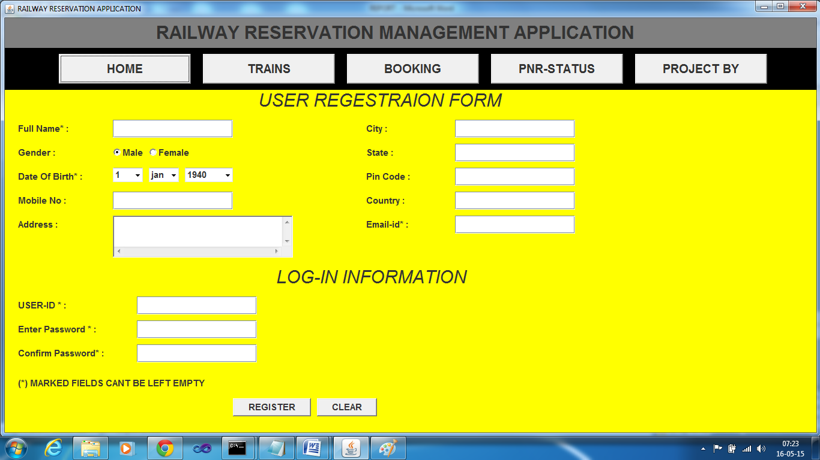

c) User Homepage

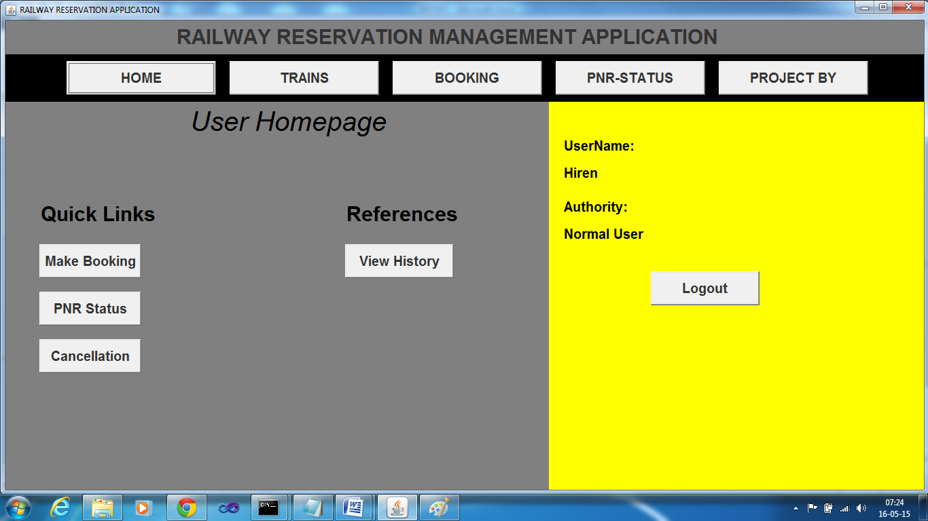

1. Booking Page

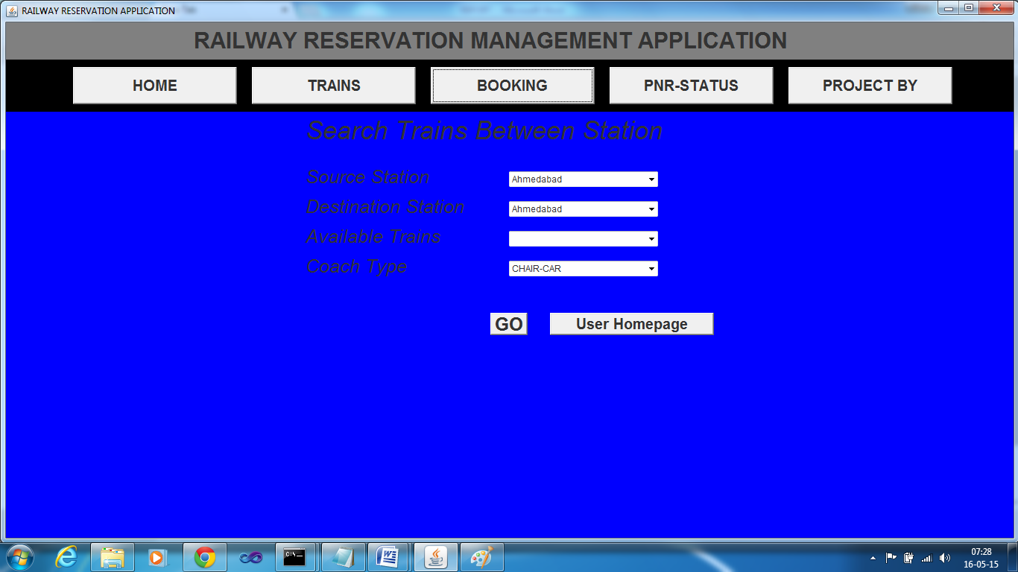

1. Train’s Search Page

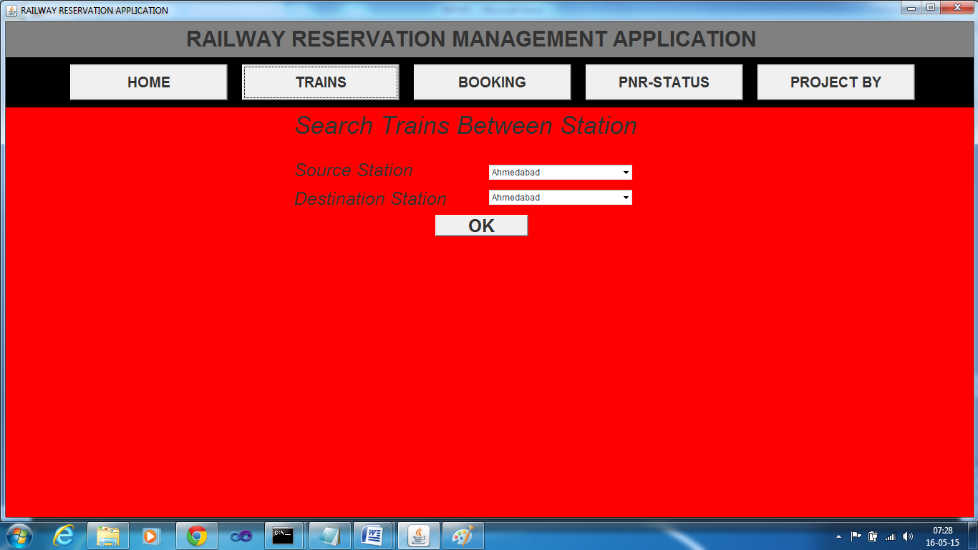

6)Pnr Status Page

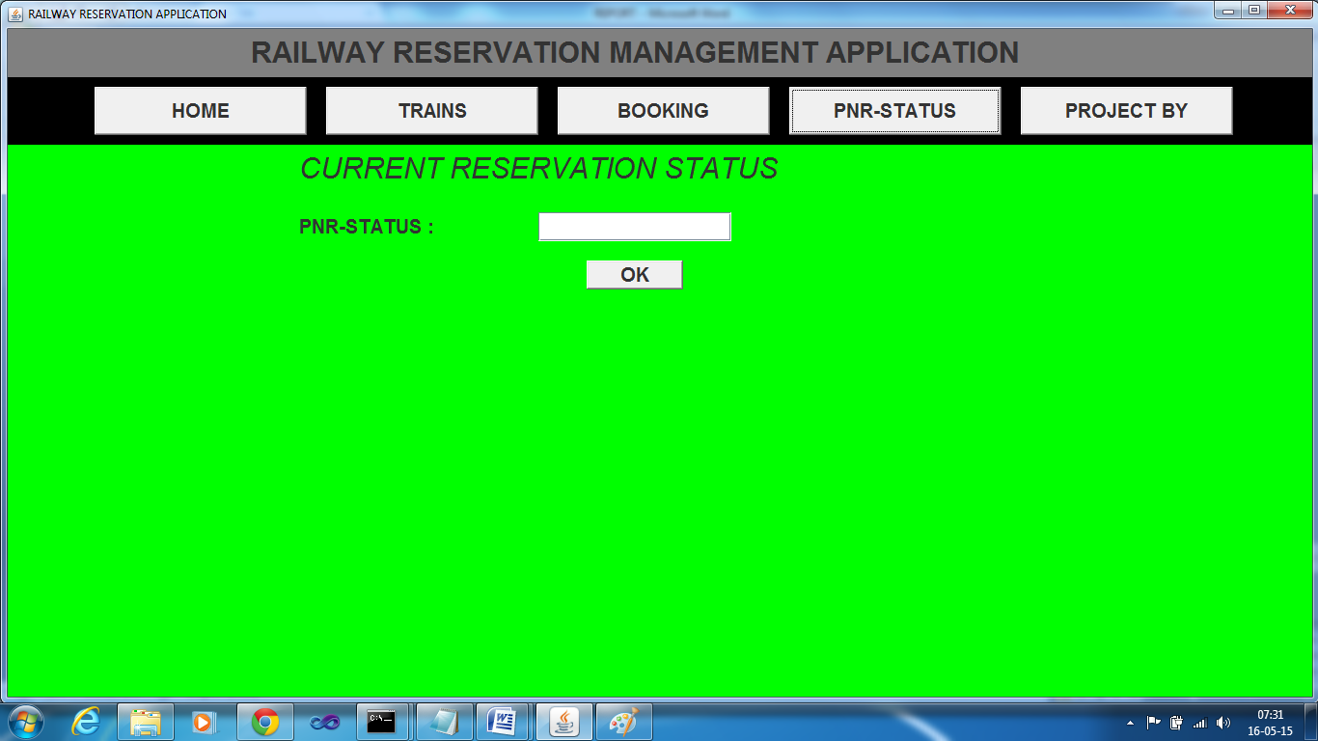

7) Cancellation Page

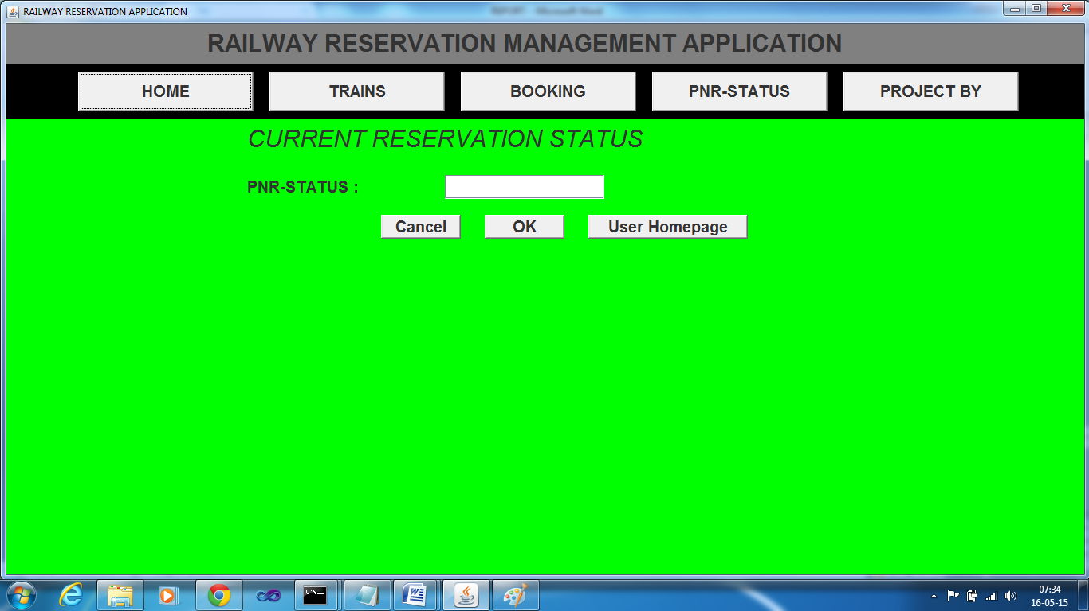

1. Modules

a)Login Module

This Module allows Registered users to login to their accounts. If not Registered,a registration link has been provided which allows the user to register to our servers.

This module also contain links that an unregistered user can check. However ,to book tickets, it is necessary to be logged in.

b)Registration Module

Clicking on the Registration link takes the user to this module. This Module contains the registration form that allows the user to register.

1. User Homepage Module

This is the User’s Homepage. It contains the user’s history of transactions like his booking records,allows him to book tickets and also check his pnr status.

d)Pnr and Cancellation Module

This is the module that allows the user to check the pnr status and allows him to cancel his booked tickets as well.

**5 DATA DICTIONARY**

1. TABLE USER0

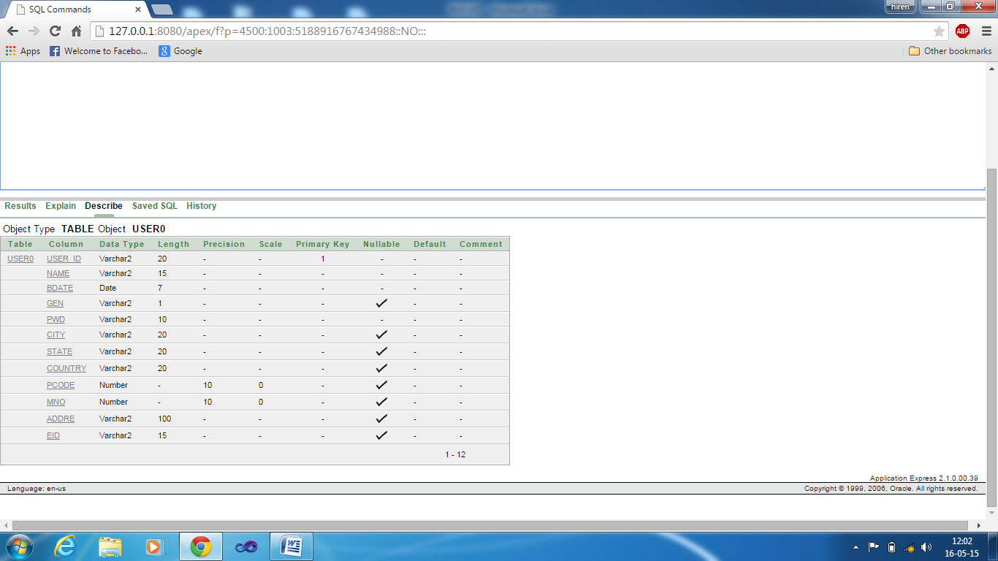

1. TABLE ticket 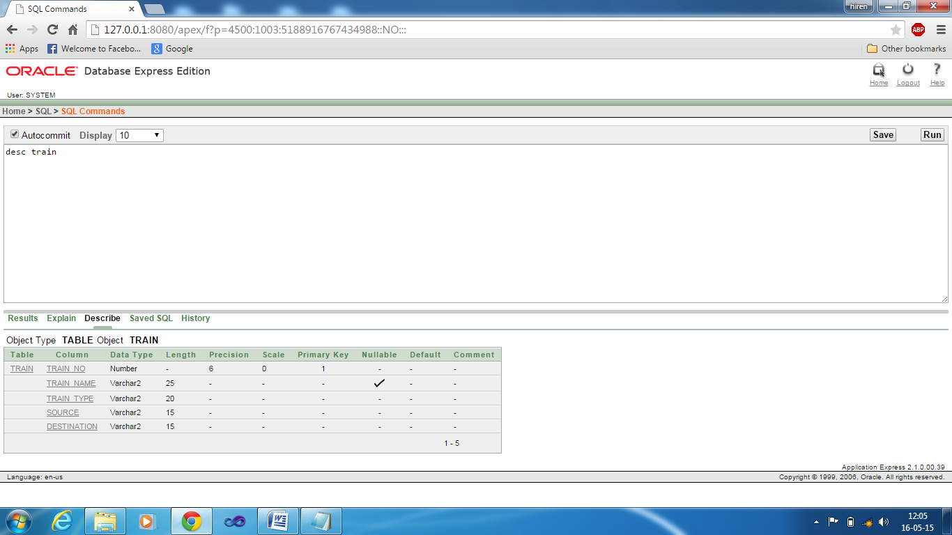
2. Table station

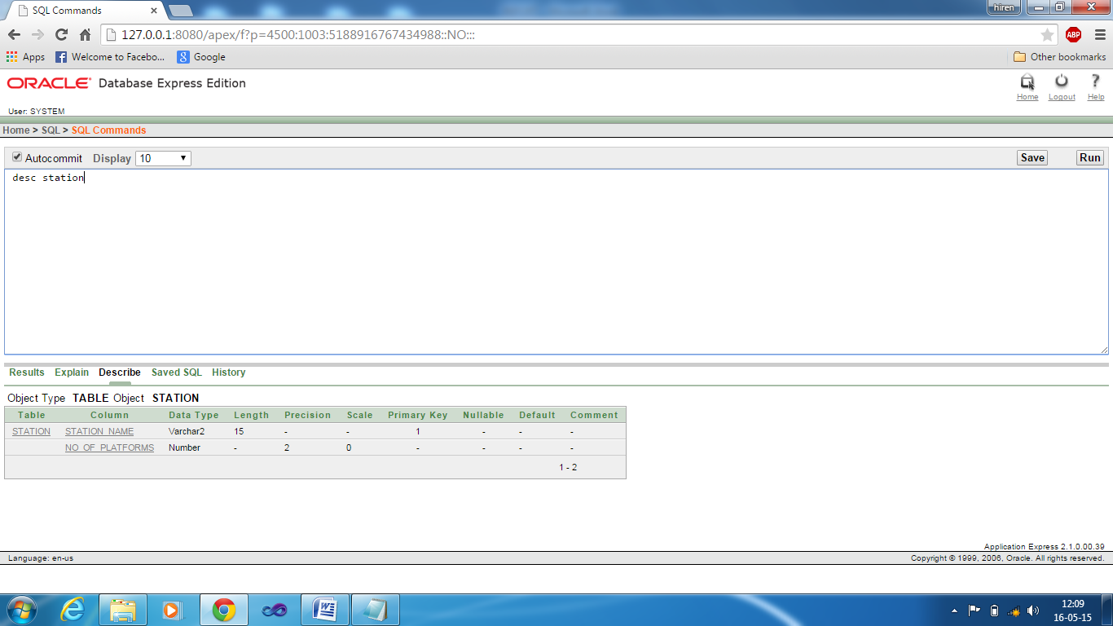

4.table route

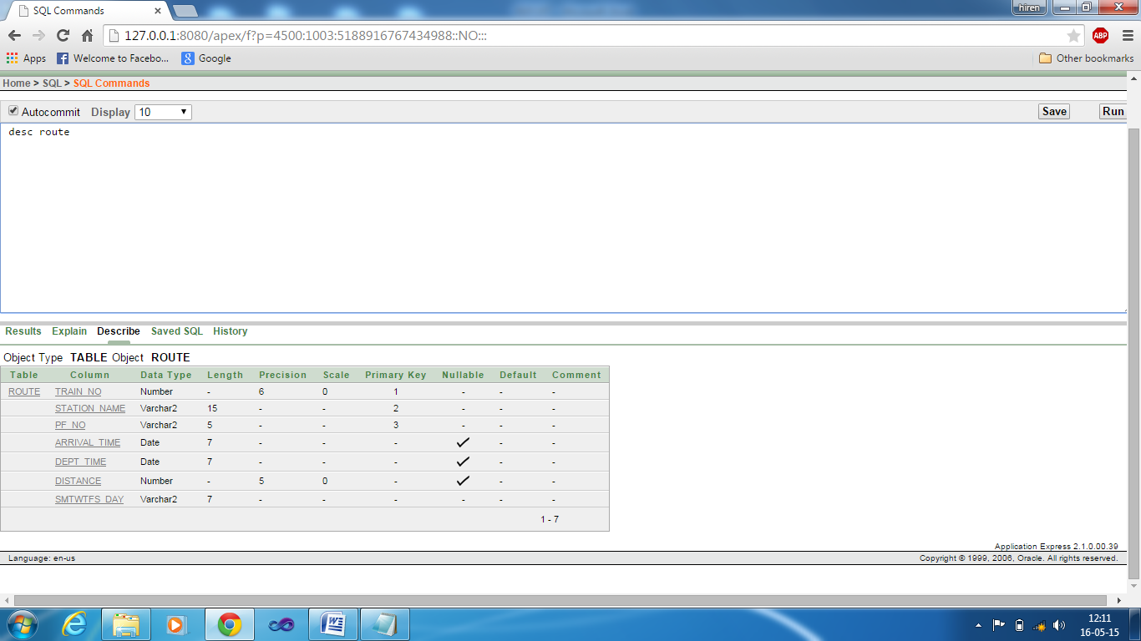

5.table coach

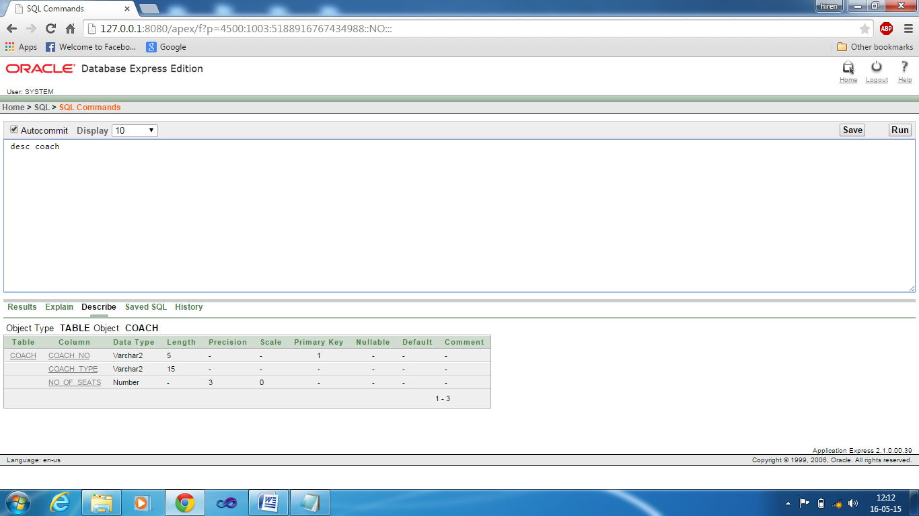

6.table container

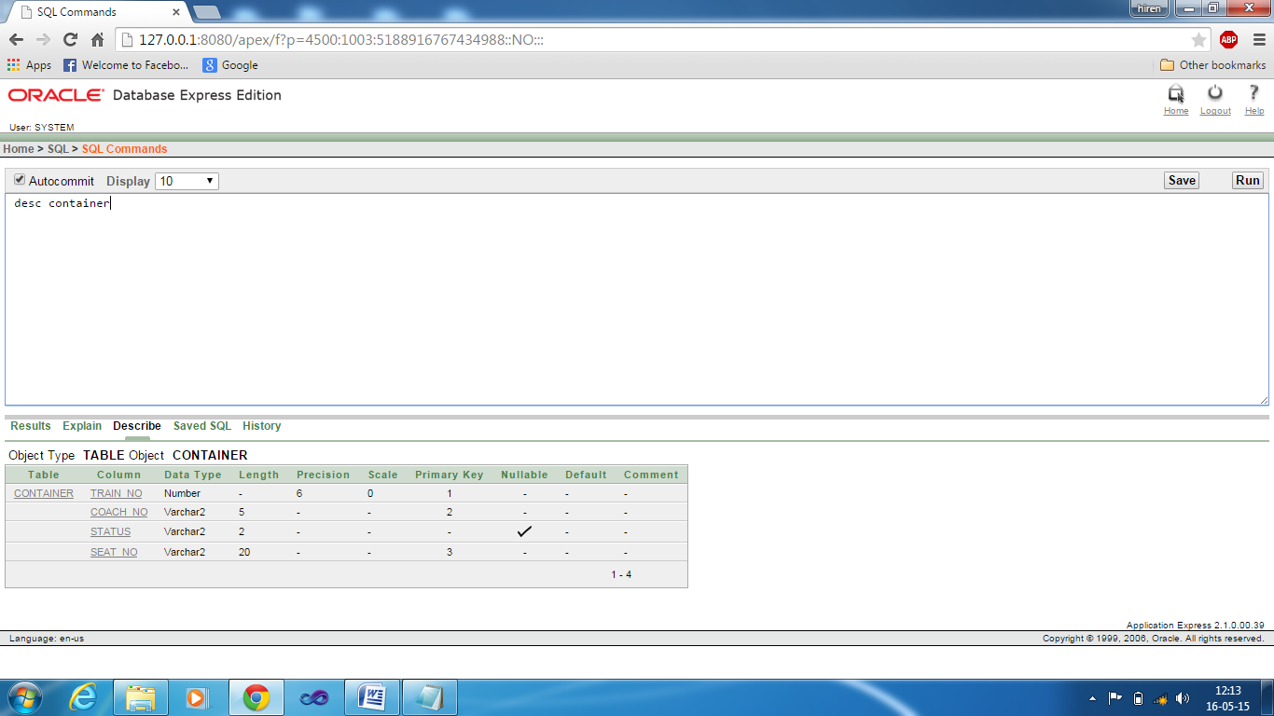

7.table fare

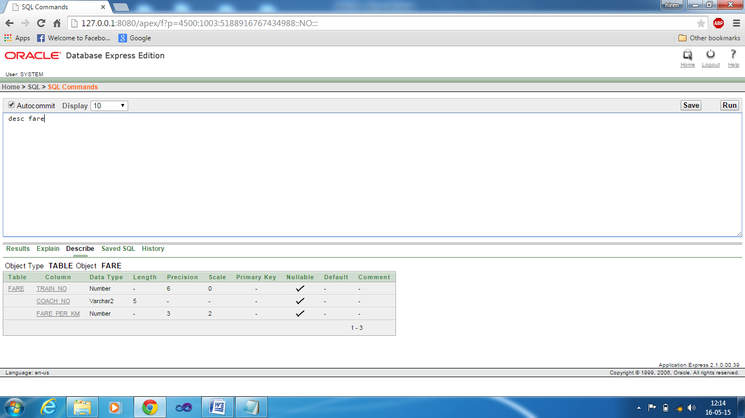

8. table passenger

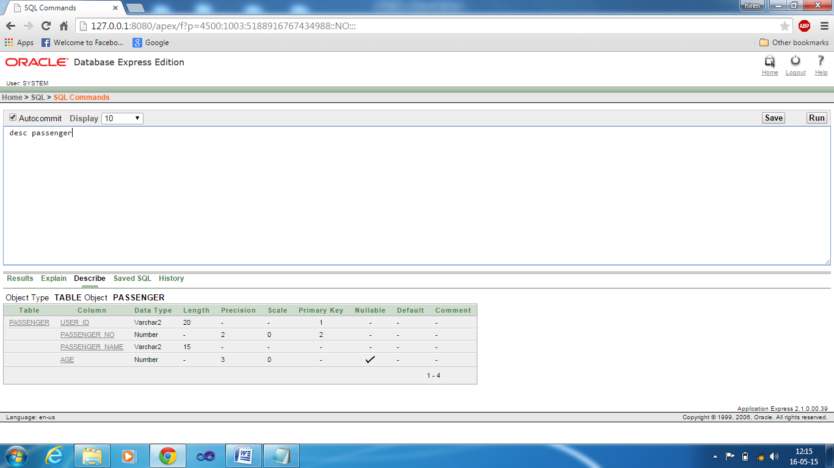

9. table ticket

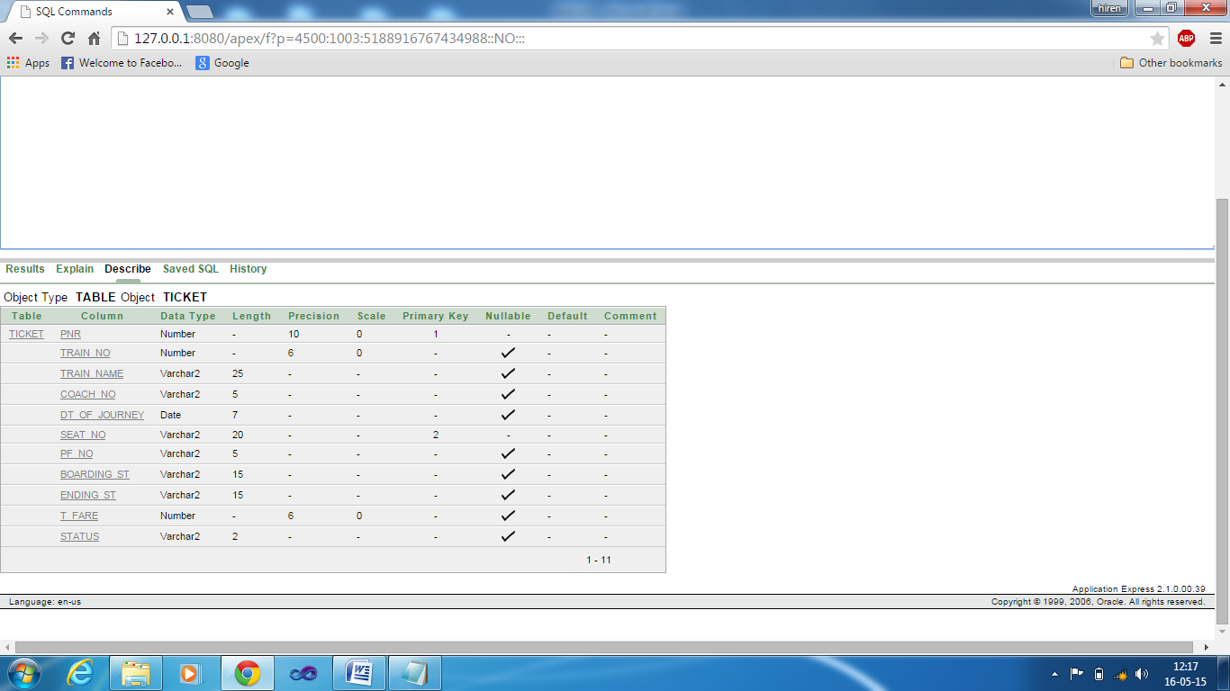

10. table payment

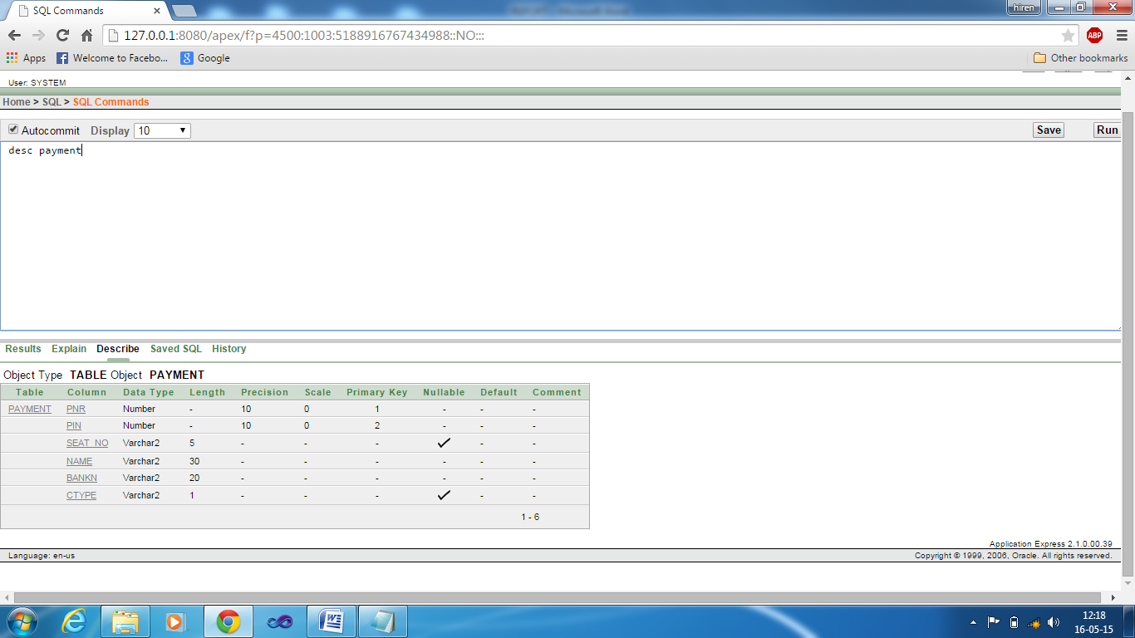

11) table books_for :

