**Topic – SQL**

**Task-1**

**TABLE: - Employee**

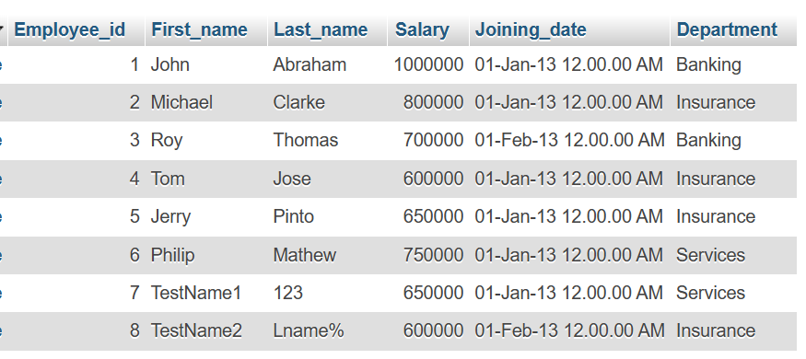

**TABLE: - Incentives**

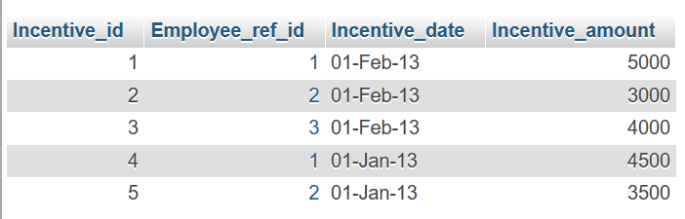

**a) Get First_Name from employee table using alias name “Employee Name”.**

**Query:-**

SELECT First_name as "Employee Name" FROM employee;

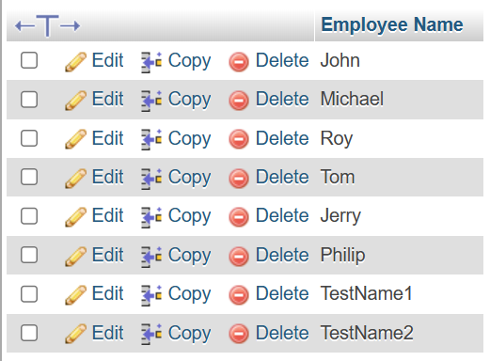

**b) Get FIRST_NAME, Joining year, Joining Month and Joining Date from employee table.**

**Query:-**

SELECT First_name,Joining_date,Salary FROM employee;

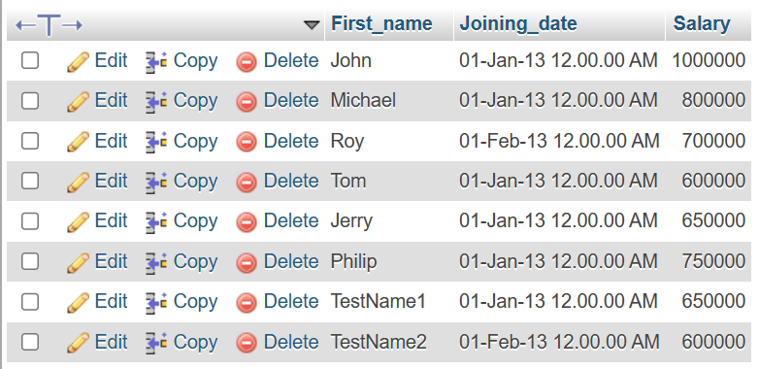

**c) Get all employee details from the employee table order by First Name Ascending And Salary descending?**

**Query:-**

SELECT * FROM employee ORDER BY First_name ASC, Salary DESC;

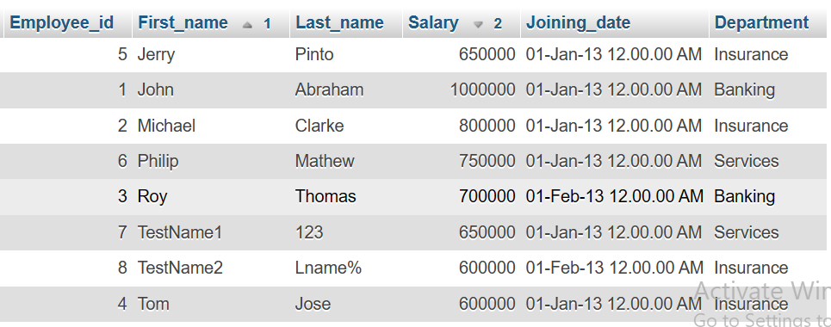

**d) Get employee details from employee table whose first name contains „o‟.**

**Query:-**

SELECT * FROM employee WHERE First_name LIKE ‘„o‟’; 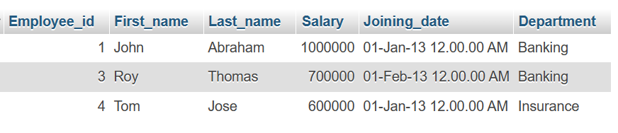

**e) Get employee details from employee table whose joining month is “January”.**

**Query:-**

Select * from employee where Month (Joining_date)="Jan";

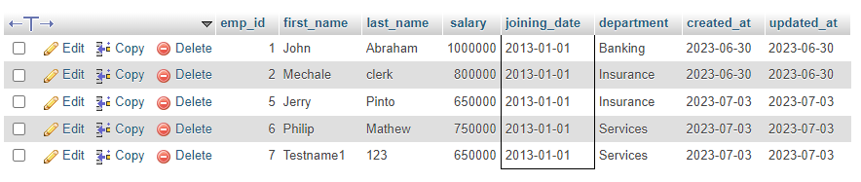

**f) Get department, total salary with respect to a department from employee table order By total salary descending.**

**Query:-**

Select Department, SUM (Salary) FROM employee GROUP BY Department ORDER BY DESC (Salary);

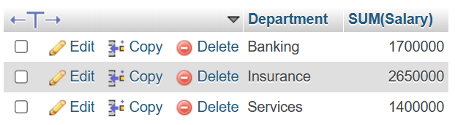

**h) Select first_name, incentive amount from employee and incentives table for those employees who have incentives and incentive amount greater than 3000.**

**Query:-**

SELECT First_name ,Incentive_amount FROM employee A INNER JOIN incentive B ON A.Employee_id=B.Employee_ref_id AND Incentive_amount >3000;

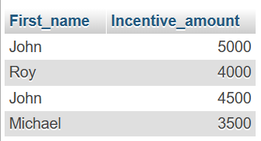

**i) Select 2nd Highest salary from employee table.**

**Query:-**

SELECT MAX (Salary) FROM employee WHERE Salary < (SELECT MAX(Salary)FROM employee);

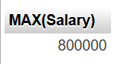

**j) Select first_name, incentive amount from employee and incentives table for all Employees who got incentives using left join.**

**Query:-**

SELECT First_name,NVL(Incentive_amount,0) FROM employee A LEFT JOIN incentive B ON A.Employee_id=B.Employee_ref_id;

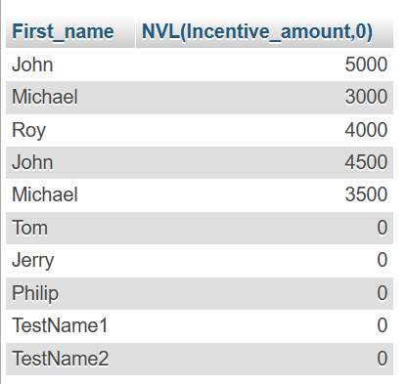

**k) Create View OF Employee table in which store first name ,last name and salary only.**

**Query:-**

SELECT Employee_id, First_name, Department FROM employee LEFT JOIN incentive ON incentive_id = incentive_id;

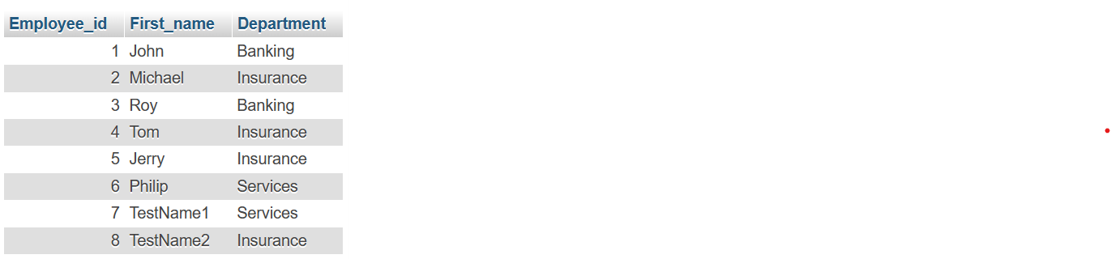

**m) Create After Insert trigger on Employee table which insert records in view table.**

**Query:-**

CREATE TRIGGER 'after insert' AFTER INSERT ON 'employee' FOR EACH ROW INSERT INTO Views (id,first_name,last_name,salary,joining_date,department) values (new.Employee_id,new.First_name,new.Last_name,new.Salary,new.Joining_date,new.Department);

