**Task-2**

**TABLE – SALES PERSON**

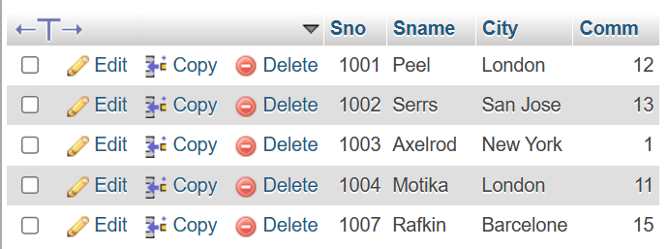

**TABLE – CUSTOMER**

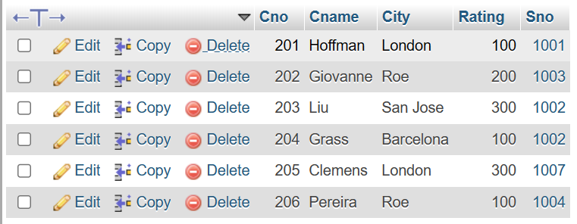

**TABLE – ORDER**

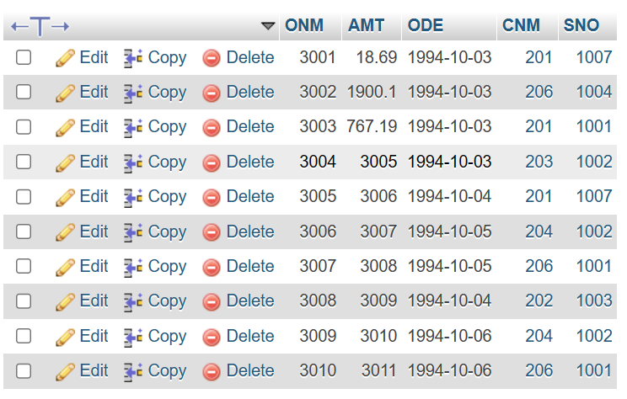

**a) All orders for more than $1000.**

**Query:-**

SELECT * FROM customer where RATING>100;

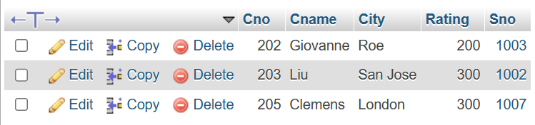

**b) Names and cities of all salespeople in London with commission above 0.10.**

**Query:-**

SELECT SNAME, CITY from salesperson WHERE CITY='London' AND COMM>10;

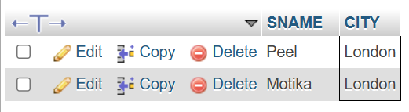

**c) All salespeople either in Barcelona or in London.**

**Query:-**

SELECT * from salesperson where CITY= 'barcelona' OR CITY= 'london';

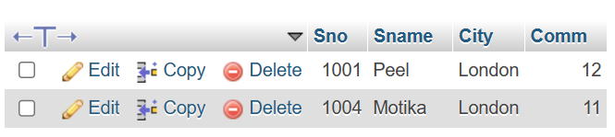

**d) All salespeople with commission between 0.10 and 0.12. (Boundary values should be excluded).**

**Query:-**

SELECT * from salesperson where COMM>10 and COMM<12;

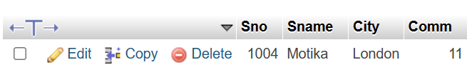

**e) All customers with NULL values in city column.**

**Query:-**

SELECT City FROM salesperson WHERE Sname = NULL;

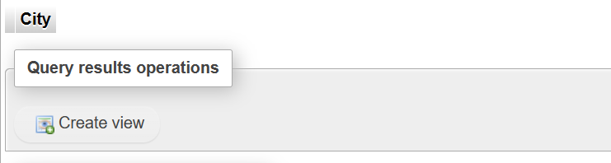

**f) All orders taken on Oct 3Rd and Oct 4th 1994.**

**Query:-**

Select * from begging where odate in (‘1994-10-03’,'1994-10-04’);

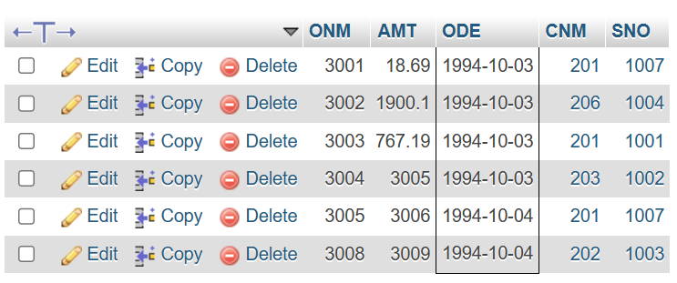

**g) All customers serviced by peel or Motika.**

**Query:-**

SELECT * FROM salesperson WHERE Sname="Peel" OR Sname="Motika";

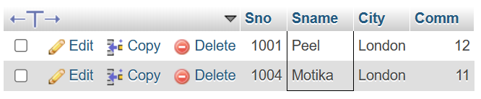

**h) All customers whose names begin with a letter from A to B .**

**Query:-**

SELECT Cname from customer where Cname LIKE 'A%' OR Cname LIKE 'B%' order by Cname;

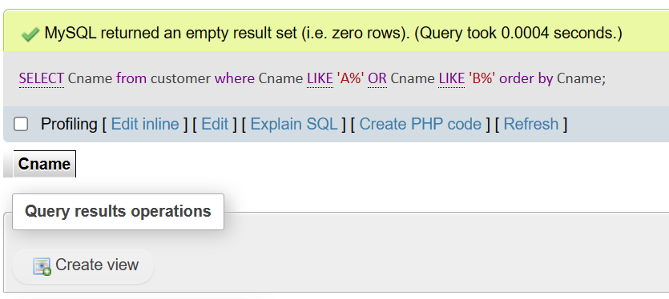

**i) All customers excluding those with rating <= 100 unless they are located in Rome.**

**Query:-**

SELECT * FROM CUSTOMER WHERE RATING>100 AND CITY !='ROM';

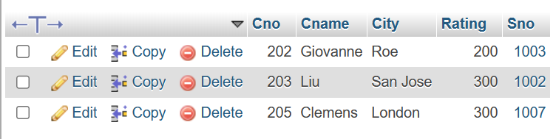

**j) All orders except those with 0 or NULL value in amt field.**

**Query:-**

Select ONM from begging where AMT ! = 0 or AMT is not null;

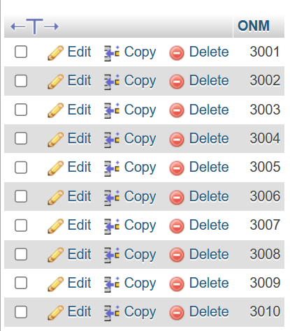

**k) Count the number of salespeople currently listing orders in the order table.**

**Query:-**

Select count(distinct SNO) from begging;

