1. **Overview of C Programming:**

🡪C language developed by **Dennis Ritchie** in the late 1960s and early 1970s.

🡪C is a high-level, general-purpose programming language.

🡪C is very powerful, fast and flexible language, it has been used to develop operation system, databases, applications etc.

**Importance of C Programming**

🡪 C has had a profound impact on the development of many other programming languages.

🡪 For example, C++, Java, Python, and many others are directly or indirectly influenced by C.

**Why C is Still Used Today:**

1. **Low-Level Access**:

🡪 C allows programmers to manipulate memory directly, giving them more control over how a program uses system resources.

1. **Speed and Performance**:

🡪 Programs written in C tend to execute faster because the language is compiled directly into machine code.

1. **Legacy Systems**:

🡪 A large portion of legacy systems, particularly operating systems (like UNIX, Linux), databases, and embedded systems, is written in C.

1. **Continued Development**:

🡪 This ensures that C remains up-to-date with modern programming needs while retaining its core strengths.

1. **Setting Up Environment**

**DevC++ installing step:**

**Step1:** Download DevC++ installer

**Step2:** VisittheDevC**++** website🡪 Go to the official DevC++ download page

**Step3:** Downloadtheinstaller: Click the green "Download" button to get the latest version of DevC++ for Windows. The file will usually be installer.

**Step4:** Installtheprogram: Follow the remaining steps in the installer and wait for the installation process to complete.

**Step5:** Open DevC++ from the Start Menu or desktop shortcut.

**Step6:** The IDE should launch, and you will be ready to write and compile C/C++ code.

**Step7:** Verify Installation

**Step8:** Create a simple C program in DevC++

#include<stdio.h>

main()

{

printf(“\n hello world!”);

}

**Step9:** Click the Execute menu, then Compile&Run (or press F11).

**Step10:** DevC++ will use the GCC compiler to compile the code and then run it in the output window.

**3. Basic Structure of a C Program**

**A. Including header:**

🡪These are lines that begin with # and are processed by the actual compilation starts.

🡪Headers provide access to predefined functions, constants, and types

**Ex:** #include<stdio.h> //Standard input-output library

**B. Main function:**

🡪Every C program must have a main() function.

🡪This is the entry point where execution begins.

**Ex:** main()

{

}

**C. Comments:**

🡪Comments are non-executable lines of text used to describe or explain code.

🡪This use for code more readable and understanding.

🡪There are two types of comments in C language:

**1.** **Single-line Comments:** Start with **“ // ”** and extend to the end of the line.

**2.** **Multi-line Comments:** Enclosed between **“ /* and */ ”**and can span multiple lines.

**Ex:** // This is a single-line comment.

/* This is a mu

lti-line comment that spans multiple lines */

**D.** **Data Types:**

🡪In C variables must be declared with a specific data type.

🡪There are many type of data type.

🡪Explain the basic data type in c language.

**1. int:** Used for integers (numbers).

**2. float**: Used for floating-point (decimal) numbers.

**3.** **char**: Used for single characters.

**4. double:** Used for double-precision floating-point numbers.

**5. void:** Used when a function does not return any value.

**Ex:** intage; // integer type variable

float height; // floating-point type variable

char grade; // character type variable

**E. Variables:**

**🡪**A variable in C is used to store data, and each variable has a type that defines what kind of data it can hold.

**Syntax:**

data_type variable_name;

**Ex:**

int age = 25; // Declare integer variable

float height = 5.9; // Declare float variable

char grade = 'A'; // Declare char variable

**Full example of a c program:**

#include<stdio.h>

main()

{

int age = 20;

float height = 4.9;

char initial = 'K';

printf("\n\t Age: %d\n", age);

printf("\n\t Height: %.2f\n", height);

printf("\n\t Initial: %c\n", initial);

}

**OUTPUT**:

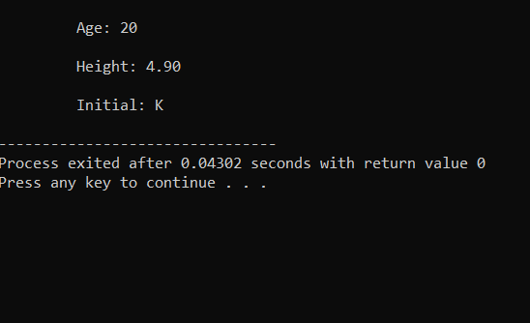

**4. Operators in C**

🡪There are many operators in c programing.

**🡪**Below is a detailed explanation of each type of operator, with examples.

**1. Arithmetic operators**

Arithmetic operators are used to perform mathematical operations such as addition, subtraction, multiplication, division, and modulus.

**List of Arithmetic operators:**

+ : Addition

- : Subtraction

* : Multiplication

/ : Division

% : Modulus

**Example:**

#include <stdio.h>

main()

{

int a = 10, b = 3;

printf("\n\t a + b = %d\n", a + b);

printf("\n\t a - b = %d\n", a - b);

printf("\n\t a * b = %d\n", a * b);

printf("\n\t a / b = %d\n", a / b);

printf("\n\t a %% b = %d\n", a % b);

}

**OUTPUT:**

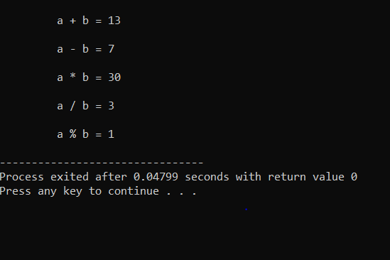

**2. Relational operators:**

**🡪**These operators are used to compare two values. They return either true (1) or false (0).

**==** : Equal to (checks if two operands are equal)

**!=** : Not equal to (checks if two operands are not equal)

**>** : Greater than (checks if the left operand is greater than the right)

**<** : Less than (checks if the left operand is less than the right)

**>=** : Greater than or equal to (checks if the left operand is greater than or equal to the right)

**<=** : Less than or equal to (checks if the left operand is less than or equal to the right)

**Ex:**

int a = 10, b = 20;

if (a < b)

{

printf(“\n\n\t a is less then b ”);

}

**OUTPUT:**

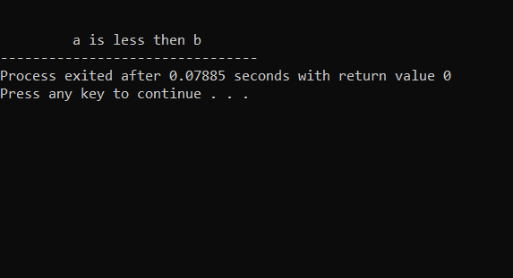

**3. logical operators**

Logical operators are used to perform logical operations, typically in conditional statements. They return Boolean values.

**&&** : Logical AND (e.g., a > 0 && b < 10)

**||** : Logical OR (e.g., a > 0 || b < 10)

**!** : Logical NOT (e.g., !a checks if a is zero)

**EX:**

#include<stdio.h>

main()

{

int a = 10, b = 5, c = 20;

if (a > b && c > a)

{

printf("\n\n\t Both conditions are true: a > b and c > a\n");

}

else

{

printf("\n\n\t At least one of the conditions is false\n");

}

}

**OUTPUT:**

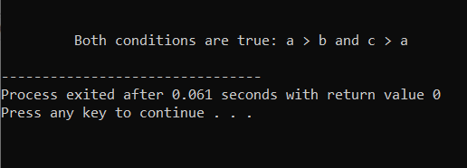

**4. Assignment operators**

🡪Assignment operators are used to assign values to variables.

**=** : Simple assignment (e.g., a = 5)

**+=** : Add and assign (e.g., a += 5 is equivalent to a = a + 5)

**-=** : Subtract and assign (e.g., a -= 5 is equivalent to a = a - 5)

**\*=** : Multiply and assign (e.g., a *= 5 is equivalent to a = a * 5)

**/=** : Divide and assign (e.g., a /= 5 is equivalent to a = a / 5)

**%=** : Modulus and assign (e.g., a %= 5 is equivalent to a = a % 5)

**Ex:**

#include <stdio.h>

main()

{

int a = 10, b = 5;

a = b;

printf("\n\n\t After simple assignment: a = %d", a);

}

**OUTPUT:**

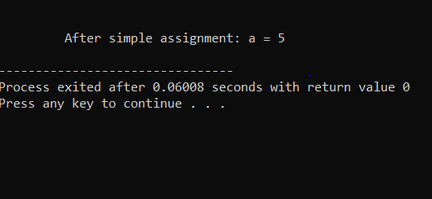

**5. Increment/decrement operators**

🡪These operators are used to increase or decrease the value of a variable by 1.

**++** : Increment (e.g., a++ or ++a)

**--** : Decrement (e.g., a-- or --a)

**EX:**

#include <stdio.h>

main()

{

int a = 5;

int b = a++;

printf("\n\n\t a = %d", a);

printf("\n\n\t b = %d", b);

}

**OUTPUT:**

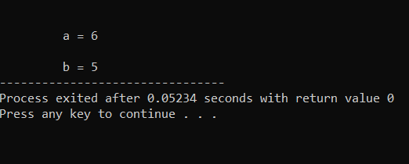

**6. bitwise operator**

🡪Bitwise operators operate on the individual bits of integers. They perform operations bit by bit.

& : Bitwise AND

| : Bitwise OR

^ : Bitwise XOR

~ : Bitwise NOT

<< : Left shift

>> : Right shift

**Ex:**

#include <stdio.h>

main()

{

int a = 5;

int b = 3;

int result = a & b;

printf("\n\n\t a & b = %d\n", result);

}

**OUTPUT:**

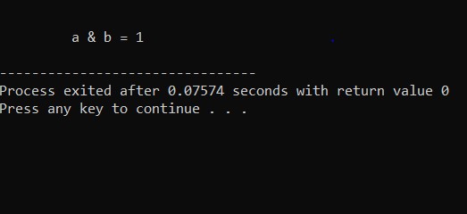

**7. conditional operator**

🡪The conditional (ternary) operator is a shorthand for if-else statements.

**Ex:**

#include <stdio.h>

main()

{

int num = 4;

const char* result = (num % 2 == 0) ? "Even" : "Odd";

printf("\n\n\t The number is: %s", result);

}

**OUTPUT:**

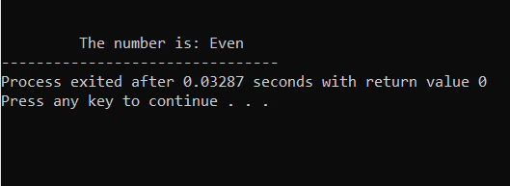

**5. Control Flow Statements in C**

🡪Explain the one by one statement:

**1. if statement:**

🡪The if statement allows you to execute a block of code only if a specified condition is true.

**Syntax:**

if (condition) {

// Code to be executed if the condition is true

}

**Ex:**

#include <stdio.h>

main()

{

int age = 18;

if (age >= 18)

{

printf("\n\t You are eligible to vote.\n");

}

}

**OUTPUT:**

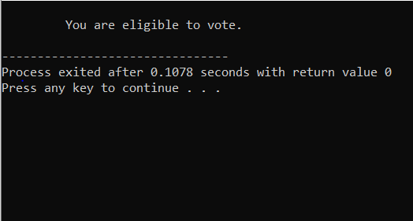

**2. else Statement**

🡪The else statement provides an alternative block of code to execute if the condition in the if statement is false.

**Syntax:**

if (condition) {

// Code to be executed if the condition is true

}

else

{

// Code to be executed if the condition is false

}

**Ex:**

#include <stdio.h>

main()

{

int age = 16; if (age >= 18)

{

printf("\n\t You are eligible to vote.\n");

}

else

{

printf("\n\t You are not eligible to vote.\n");

}

}

**OUTPUT:**

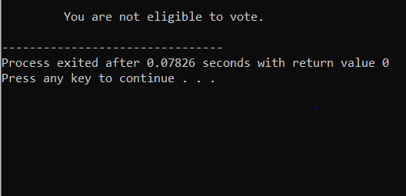

**3. else if statement**

🡪The else if statement is used when you want to check multiple conditions.

🡪If the first if condition is false, it will check the else if condition.

**Syntax:**

if (condition1) {

// Code to be executed if condition1 is

}

else if (condition2)

{

// Code to be executed if condition2 is true

}

else

{

// Code to be executed if neither condition1 nor condition2 is true

}

**Ex:**

#include <stdio.h>

main()

{

int score = 85;

if (score >= 90) {

printf("\n\t Grade A\n");

} else if (score >= 80) {

printf("\n\t Grade B\n");

} else if (score >= 70) {

printf("\n\t Grade C\n");

} else {

printf("\n\t Grade F\n");

}

}

**OUTPUT:**

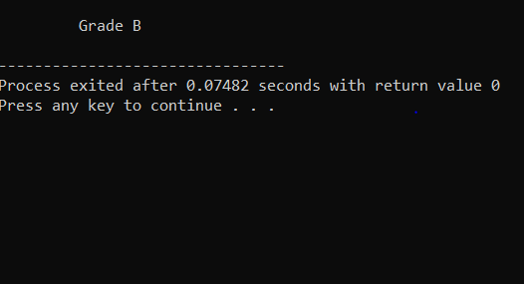

**4. Nested if Statements**

🡪You can also **nest** if statements inside another if, allowing for more complex decision-making.

**Syntax:**

if (condition1)

{

if (condition2)

{

// Code to execute if both condition1 and condition2 are true

}

}

**Ex:**

#include <stdio.h>

main()

{

int num = 10;

if (num > 0)

{

if (num % 2 == 0)

{

printf("\n\n\t The number is positive and even.\n");

}

else

{

printf("\n\n\t The number is positive but odd.\n");

}

}

else

{

printf("\n\n\t The number is not positive.\n");

}

}

**OUTPUT:**

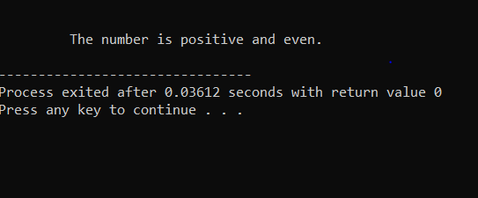

**5. Switch statement**

🡪It is typically used when you have multiple possible values for a single variable.

**Syntax:**

switch (expression)

{

case value1:

// Code to execute if expression == value1

Break;

case value2:

// Code to execute if expression == value2

Break;

default:

}

**Ex:**

#include <stdio.h>

main()

{

int day = 3;

switch (day)

{

case 1:

printf("\n\n\t Monday");

break;

case 2:

printf("\n\n\t Tuesday");

break;

case 3:

printf("\n\n\t Wednesday");

break;

case 4:

printf("\n\n\t Thursday");

break;

case 5:

printf("\n\n\t Friday");

break;

case 6:

printf("\n\n\t Saturday");

break;

case 7:

printf("\n\n\t Sunday");

break;

default:

printf("\n\n\t Invalid day");

}

}

**OUTPUT:**

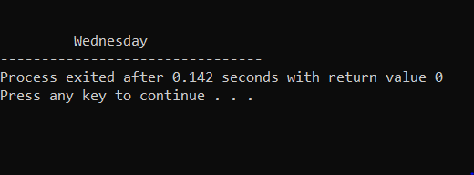

**6. Looping in C:**

1. **While Loop:**

**🡪**The condition is **checked before** executing the loop body.

🡪A **while loop** keeps repeating a block of code **while a condition is true**.

**Syntax**: while condition{#code to execute }

**Ex:**

#include<stdio.h>

main()

{

int r,c;

r=1;

while(r<=5)

{

c=1;

while(c<=r)

{

printf(" * ");

c++;

}

printf("\n");

r++;

}

}

**OUTPUT:**

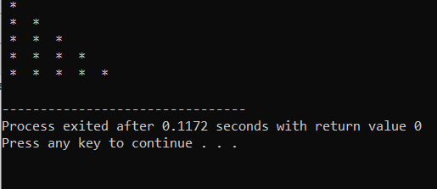

**2. For loop:**

🡪A forloop is a way to repeat a block of code multiple times.

🡪It automatically goes through a list, range, or sequence of items and executes the code for each item.

**Syntax:**

For(initialization ; condition ; inc/dec)

{

Block of code;

}

**Ex:**

#include<stdio.h>

main()

{

int r,c,num=1;

for(r=1 ; r<=4 ; r++)

{

for(c=1 ; c<=r ; c++)

{

printf(" %d",num);

num++;

}

printf("\n");

}

}

**OUTPUT:**

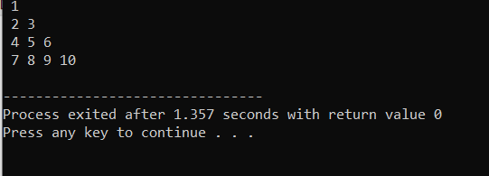

**3. do while loop:**

🡪A do**-**while **loop** runs the code first, then checks if it should keep running based on a condition.

🡪It always runs **at least once**

**Syntax:**

Initialization:

do

{

Block of code;

Increment/decrement;

}while(condition);

**Ex:**

#include<stdio.h>

main()

{

int r=1;

do

{

printf(" %d ",r);

r++;

}while(r<=10);

}

**OUTPUT:**

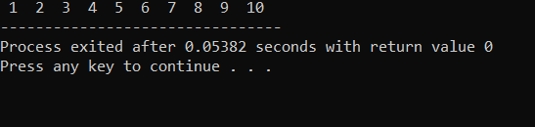

**7. Loop Control Statements:**

**1. Break statement:**

🡪The break statement is used to **exit** from a loop or a switch statement prematurely.

**Ex:**

#include<stdio.h>

main()

{

for(int i=1; i<=10; i++)

{

if(i==5)

{

break;

}

printf("%d ", i);

}

printf("\nLoop terminated.\n");

}

**OUTPUT:**

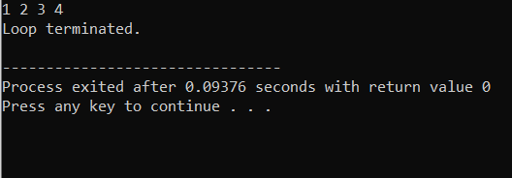

**2. Continue statement:**

**🡪**The continue statement is used to **skip the current iteration** of a loop and proceed with the next iteration.

**Ex:**

#include<stdio.h>

main()

{

for(int i=1; i<=5; i++)

{

if(i==3)

{

continue;

}

printf("%d ", i);

}

}

**OUTPUT:**

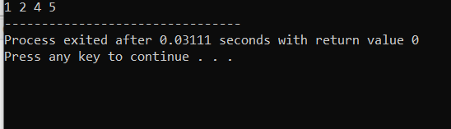

**3. goto statement:**

**🡪**The goto statement is used to **jump to another part** of the program, usually within the same function.

**Ex:**

#include<stdio.h>

main(){

int i=0;

start_loop:

i++;

if(i==3)

{

goto end_loop;

}

printf("%d ", i);

goto start_loop;

end_loop:

printf("\nLoop finished.");

}

**OUTPUT:**

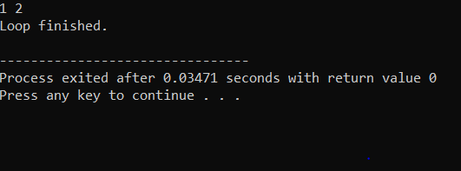

**8. functions in c:**

🡪 A function in C is a block of code that performs a specific task.

🡪In C programming, **functions** are blocks of code designed to perform a specific task.

**Syntax:**

return_type function_name(parameters_list);

{

// body of the function

}

**Ex:**

#include<stdio.h>

int add(int, int);

int main()

{

int num1, num2, sum;

printf("Enter two numbers: ");

scanf("%d %d", &num1, &num2);

sum = add(num1, num2);

printf("The sum of %d and %d is: %d\n", num1, num2, sum);

return 0;

}

int add(int a, int b)

{

return a + b;

}

**Output:**

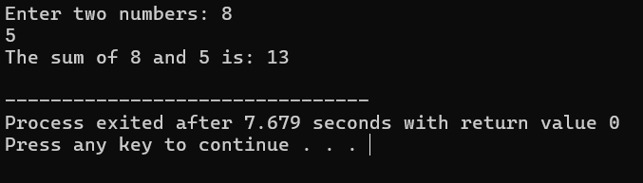

**9. Arrays in C:**

**What is an array?**

**🡪**An **array** is a collection of variables, all of the same type, that are stored in contiguous memory locations.

**One-dimensional array:**

**🡪** A **one-dimensional array** in C is just a simple list of values that are all of the same type (like integers, characters, etc.).

🡪 **One-Dimensional** means it is a single line or row of elements.

**Syntax:**

type arrayName[size];

**Ex:**

#include<stdio.h>

main()

{

int arr[10],i;

for(i=0;i<10;i++)

{

printf("\t enter any number [%d]:",i+1);

scanf("%d",&arr[i]);

}

}

Output:

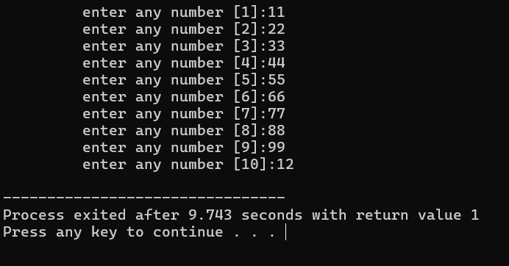

**2.multi-Dimensional arrays:**

* A **two-dimensional array** is an array of arrays. You can think of it like a matrix or grid with rows and columns.

**Syntax:**

data_type array_name[rows][columns];

**Example:**

#include<stdio.h>

main()

{

int arr[3][3];

int r,c;

for(r=0;r<3;r++)

{

for(c=0;c<3;c++)

{

printf("\n\n\t arr[%d][%d]",r,c);

scanf("%d",&arr[r][c]);

}

}

for(r=0;r<3;r++)

{

for(c=0;c<3;c++)

{

printf("%d",arr[r][c]);

}

printf("\n");

}

}

**Output:**

**arr[0][0]2**

**arr[0][1]3**

**arr[0][2]4**

**arr[1][0]5**

**arr[1][1]6**

**arr[1][2]7**

**arr[2][0]5**

**arr[2][1]3**

**arr[2][2]4**

**234**

**567**

**534**

**3.three-dimensional arrays:**

* A **three-dimensional array** can be thought of as an array of arrays of arrays.
* It is often used to represent data that can be described with three coordinates

**Syntax:**

data_type array_name[depth][rows][columns];

**Example:**

#include<stdio.h>

main()

{

int mat[3][3][3];

int m, r, c;

for(m=0;m<3;m++)

{

printf("\n\n\t Matrix [%d] : ", m+1);

for(r=0;r<3;r++)

{

for(c=0;c<3;c++)

{

printf("\n\n\t Input mat[%d][%d][%d] : ", m, r, c);

scanf("%d",&mat[m][r][c]);

}

}

}

for(m=0;m<3;m++)

{

printf("\n\n\t Matrix [%d] : \n\n", m+1);

for(r=0;r<3;r++)

{

for(c=0;c<3;c++)

{

printf(" %d", mat[m][r][c]);

}

printf("\n");

}

}

}

**Output:**

Matrix [1] :

Input mat[0][0][0] : 1

Input mat[0][0][1] : 2

Input mat[0][0][2] : 3

Input mat[0][1][0] : 4

Input mat[0][1][1] : 5

Input mat[0][1][2] : 6

Input mat[0][2][0] : 7

Input mat[0][2][1] : 8

Input mat[0][2][2] : 9

Matrix [2] :

Input mat[1][0][0] : 9

Input mat[1][0][1] : 8

Input mat[1][0][2] : 7

Input mat[1][1][0] : 6

Input mat[1][1][1] : 5

Input mat[1][1][2] : 4

Input mat[1][2][0] : 3

Input mat[1][2][1] : 2

Input mat[1][2][2] : 1

Matrix [3] :

Input mat[2][0][0] : 1

Input mat[2][0][1] : 2

Input mat[2][0][2] : 3

Input mat[2][1][0] : 4

Input mat[2][1][1] : 5

Input mat[2][1][2] : 9

Input mat[2][2][0] : 8

Input mat[2][2][1] : 7

Input mat[2][2][2] : 6

Matrix [1] :

1 2 3

4 5 6

7 8 9

Matrix [2] :

9 8 7

6 5 4

3 2 1

Matrix [3] :

1 2 3

4 5 9

8 7 6

Key differences between one-dimensional and multi-Dimensional arrays:

|  |  |  |  |  |  |  |  |  |
| --- | --- | --- | --- | --- | --- | --- | --- | --- |
| |  | | --- | | **Feature** |  |  | | --- | |  | | |  | | --- | | **One-Dimensional Array** |  |  | | --- | |  | | | **Multi-Dimensional Array** | | --- |  |  | | --- | |  | |
| Structure | |  | | --- | | A single row of elements |  |  | | --- | |  | | |  | | --- | | Multiple rows and columns (like a matrix or table) |  |  | | --- | |  | |
| Size | |  | | --- | | Defined by a single value (number of elements) |  |  | | --- | |  | | |  | | --- | | Defined by multiple values (e.g., rows and columns) |  |  | | --- | |  | |
| Indexing | |  | | --- | | Single index (e.g., arr[0]) |  |  | | --- | |  | | |  | | --- | | Multiple indices (e.g., matrix[0][0]) |  |  | | --- | |  | |
| Example | |  | | --- | | int arr[5] = {1, 2, 3, 4, 5}; |  |  | | --- | |  | | |  | | --- | | int matrix[2][3] = {{1, 2, 3}, {4, 5, 6}}; |  |  | | --- | |  | |
| |  | | --- | | Use Case |  |  | | --- | |  | | |  | | --- | | Storing a list of elements |  |  | | --- | |  | | Storing tables or grids of data (rows and columns) |

|  |  |  |
| --- | --- | --- |
|  |  |  |
|  |  |  |
|  |  |  |
|  |  |  |
|  |  |  |
|  |  |  |
|  |  |  |
|  |  |  |
|  |  |  |
|  |  |  |
|  |  |  |

**10.Pointers in C:**

🡪 In C, a pointer is a variable that stores the memoryaddress of another variable.

🡪 Instead of holding a data value (like an integer or a character), a pointer holds the location where the value is stored in the computer's memory.

**1. Declaring Pointers:**

🡪 To declare a pointer in C, you need to specify the type of data it will point to followed by an asterisk ‘*’.

**Syntax**:

data_type *pointer_name;

**Example:** int *ptr;

char *ch;

**2. Initializing Pointers:**

🡪 You can initialize a pointer by assigning it the address of an existing variable using the address-ofoperator (&).

**Syntax**:

pointer_name = &variable_name;

**Ex:**

#include <stdio.h>

main()

{

int num=10;

int *ptr;

ptr=&num;

printf("Value of num: %d\n", num);

printf("Address of num: %p\n", (void*)&num);

printf("Value of ptr: %p\n", (void*)ptr);

printf("Value pointed to by ptr: %d\n", *ptr);

}

**Output:**

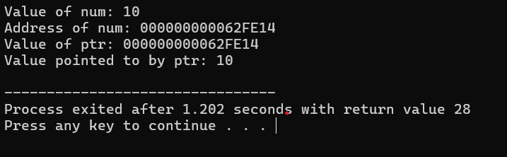

**1. Access Memory Directly**

🡪 Pointers give you the ability to directly access and change the values stored in memory.

🡪 This allows for better control over how data is managed.

1. **Make Programs Faster and More Efficient**

🡪 Instead of copying large amounts of data, you can pass a pointer (memory address) to a function, which is faster and uses less memory.

**3.Work with Arrays and Strings Easily**

🡪 Arrays and strings in C are treated as pointers, so you can use pointers to navigate through and modify these data structures more easily.

**4.Create Complex Data Structures**

🡪 Pointers let you create advanced data structures like linked lists, trees, and graphs, which are essential for many types of programs.

**5. Dynamic Memory Management**

🡪 Pointers allow you to allocate memory while the program is running, giving you more flexibility when working with large or unpredictable amounts of data.

**11. Strings in C:**

**1.strlen()**

🡪 **Purpose**: This function returns the number of characters in a string (excluding the null terminator \0).

**Syntax:**

size_t strlen(const char *str);

**Example:**

#include <stdio.h>

main()

{

char str[20];

int length = strlen(str);

printf("\n\n\t Enter the string : ");

scanf("%s",&str);

printf("\n\n\t Length of String : %d", strlen(str));

}

**Output:**

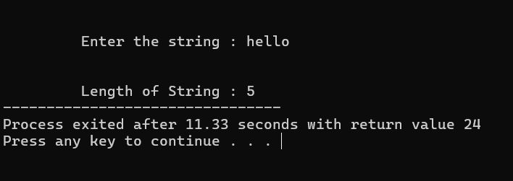

**2.strcpy():**

🡪 strcpy(destination, source): It copies the content of the source string into the destination string.

**Syntax:**

char *strcpy(char *dest, const char *src);

**Example:**

#include <stdio.h>

int main()

{

char str1[20], str2[20], str3[40];

printf("\n\n\t Enter a string1 : ");

gets(str1);

printf("\n\n\t Enter a string2 : ");

gets(str2);

strcpy(str3, strcat(str1, str2));

printf("\n\n\t String3 : %s", str3);

}

**Output:**

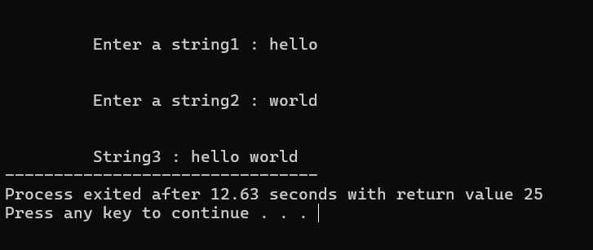

**3.strcat():**

🡪strcat(destination, source): It appends the content of the source string to the end of the destination string.

**Syntax:**

char *strcat(char *dest, const char *src);

**4.strcmp():**

🡪strcmp(str1, str2) compares the twostrings str1 and str2 character by character.

**Syntax:**

int strcmp(const char *str1, const char *str2);

**Example:**

#include <stdio.h>

int main()

{

char str1[20], str2[20],str3[40];

printf("\n\n\t Enter a string : ");

scanf("%s",&str1);

printf("\n\n\t Enter a string : ");

scanf("%s",&str2);

strcpy(str3, strcat(str1, str2));

printf("\n\n\t String3 : %s", str3);

if(stricmp(str1, str2)==0)

printf("\n\n\t Strings are equal.");

else

printf("\n\n\t Strings are not equal.");

}

**Output:**

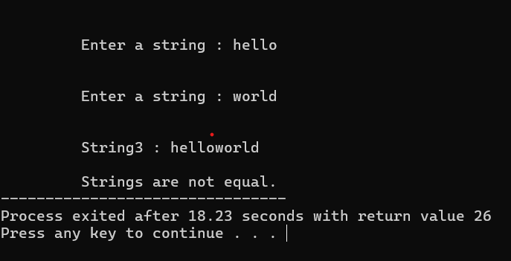

**5.** **strchr()**

🡪strchr(str, ch) searches for the first occurrence of the character ch in the string str.

🡪It returns a pointer to the first occurrence of ch in str.

**Syntax:**

char *strchr(const char *str, int ch);

**12. Structures in C:**

🡪A structure in C is a user-defineddatatype that allows you to group different types of variables under a single name.

**How to Declare a Structure?**

🡪To declare a structure, you use the struct keyword followed by the structure name and its members.

**Syntax:**

🡪 struct StructureName

{

dataType member1;

dataType member2;

};

**Example:**

#include <stdio.h>

struct Book

{

char title[50];

char author[50];

float price;

};

**How to Initialize a Structure?**

🡪 You can initialize the structure at the time of declaration or later when you create an instance of it.

**Example:**

struct Book book1 = {"C Programming", "Dennis Ritchie", 299.99};

**How to Access Structure Members?**

🡪 You can access the members of a structure using the dotoperator(.).

**Example:**

#include <stdio.h>

struct Book

{

char title[50];

char author[50];

float price;

};

main()

{

struct Book book1;

strcpy(book1.title, "C Programming");

strcpy(book1.author, "Dennis Ritchie");

book1.price = 299.99;

printf("Book Title: %s\n", book1.title);

printf("Book Author: %s\n", book1.author);

printf("Book Price: %.2f\n", book1.price);

}

**Output:**

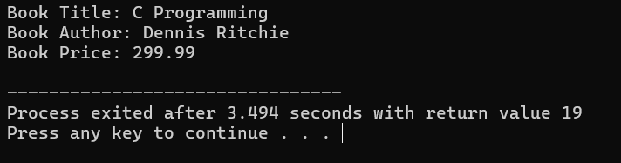

**13. File Handling in C:**

🡪 Explain the importance of file handling in C. Discuss how to perform file operations like opening, closing, reading, and writing files.

🡪 Savedata permanently for future use.

**1. Opening Files**

🡪 To work with a file, you need to open it first using the built-in open() function.

**Syntax:**

file = open('file.txt', 'r') # Open file in read mode

1. **Reading from a File**

🡪 Once a file is opened, you can read its contents using various methods:

🡪 **read()**: Reads the entire file into a single string.

**Syntax:**

content = file.read()

print(content)

**3. Writing to a File**

🡪 To write to a file, you need to open it in write ('w'), append ('a'), or exclusive creation ('x') mode.

🡪 **write()**: Writes a string to the file.

Python.

**Syntax:**

file = open('file.txt', 'w') # Open for writing file.write('Hello, World!\n')

**4. Closing a File**

🡪 After performing file operations, it’s important to close the file to free up resources.

🡪 This is done using the close() method.

**Syntax:**

file.close()

**5. Using with Statement (Context Manager)**

🡪 To avoid forgetting to close a file or handling exceptions properly, Python provides a with statement.

**Syntax:**

with open('file.txt', 'r') as file: content = file.read()

print(content)

**Example:**

#include <stdio.h>

main()

{

FILE*file;

file=fopen("example.txt", "w");

if(file==NULL)

{

printf("Error opening file for writing.\n");

return 1;

}

fprintf(file, "This is the first line of the file.\n");

fprintf(file, "This is the second line of the file.\n");

printf("Data written to file successfully.\n");

fclose(file);

file=fopen("example.txt", "r");

if(file==NULL)

{

printf("Error opening file for reading.\n");

return 1;

}

char ch;

printf("\n Reading file content:\n");

while((ch=fgetc(file))!=EOF)

{

putchar(ch);

}

fclose(file);

file=fopen("example.txt", "a");

if(file==NULL)

{

printf("Error opening file for appending.\n");

return 1;

}

fprintf(file, "This is an appended line to the file.\n");

printf("\n Data appended to file successfully.\n");

fclose(file);

file=fopen("example.txt", "r");

if(file==NULL)

{

printf("Error opening file for reading.\n");

return 1;

}

printf("\n Final content of the file:\n");

while((ch=fgetc(file))!=EOF)

{

putchar(ch);

}

fclose(file);

}

**Output:**



