1. What is software? What is software engineering?

* **Software:**

🡪Software is a set of instruction to be executed for specific task.

🡪 Software is a collection of data, programs, procedures, instructions, and documentation that perform various predefined tasks on a Computer system.

* **Software engineering:**

🡪Software engineering is a process to develop any software based on the engineering principles.

🡪 Software engineering is the branch of computer science that deals with the design**,** development**,** testing**,** andmaintenanceofsoftwareapplications.

2. Explain types of software?

🡪Software is a set of instructions, data or programs used to operate computers and execute specific tasks.

🡪There are many type of software:

1. **System Software**:

System software is a category of software designed to manage and control computer hardware and provide a platform for running application software.

1. **Application Software**:

Application software refers to programs designed to help users perform specific tasks or functions

1. **Development Software**:

In the context of software, "development" refers to the process of creating, designing, Building, testing, and maintaining software applications.

1. **Web-based Software**:

Applications that run in a web browser, accessible from any device with an internet connection e.g., web applications, SaaS products.

1. **Mobile Apps**:

Applications specifically designed for mobile devices e.g., Android and IOS apps.

1. **Game Software**:

Programs specifically designed for entertainment, including video games and educational games.

1. **Artificial Intelligence Software**:

Software that uses AI algorithms for tasks like data analysis, natural language processing, and machine learning.

🡪This chart below describes the type of software.

🡪Main 2 type in a software. Explain to the flowchart.

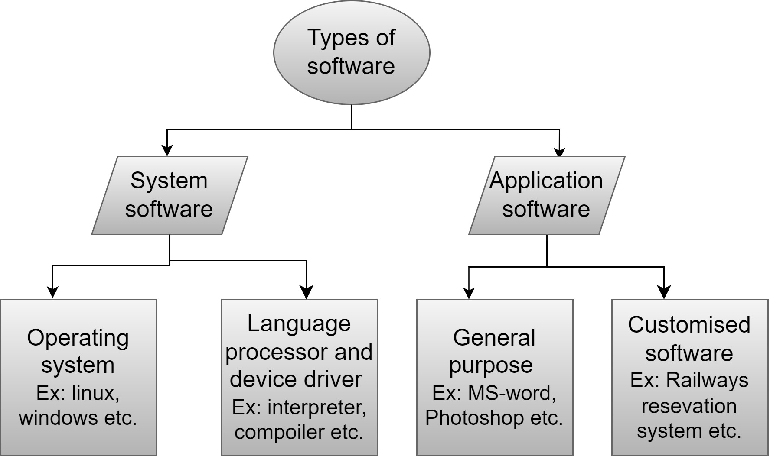

3. What is SDLC? Explain each phase of SDLC

🡪The full form of SDLC is a Software Development Life Cycle.

🡪SDLC is a step by step approach to develop any software with high quality, in shortest possible time and within the estimated budget.

🡪Most important to the time bound + budget + quality =successful software.

🡪There are 6 step in SDLC.

1. Planning /Requirement gathering (what)

2. Analysis (how)

3. Designing: DFD, ER Diagram, Flowchart, Use case.

4. Implementation/ Development/ Building

5. Testing (QA)

6. Maintenance

🡪Explain the SDLC chart:

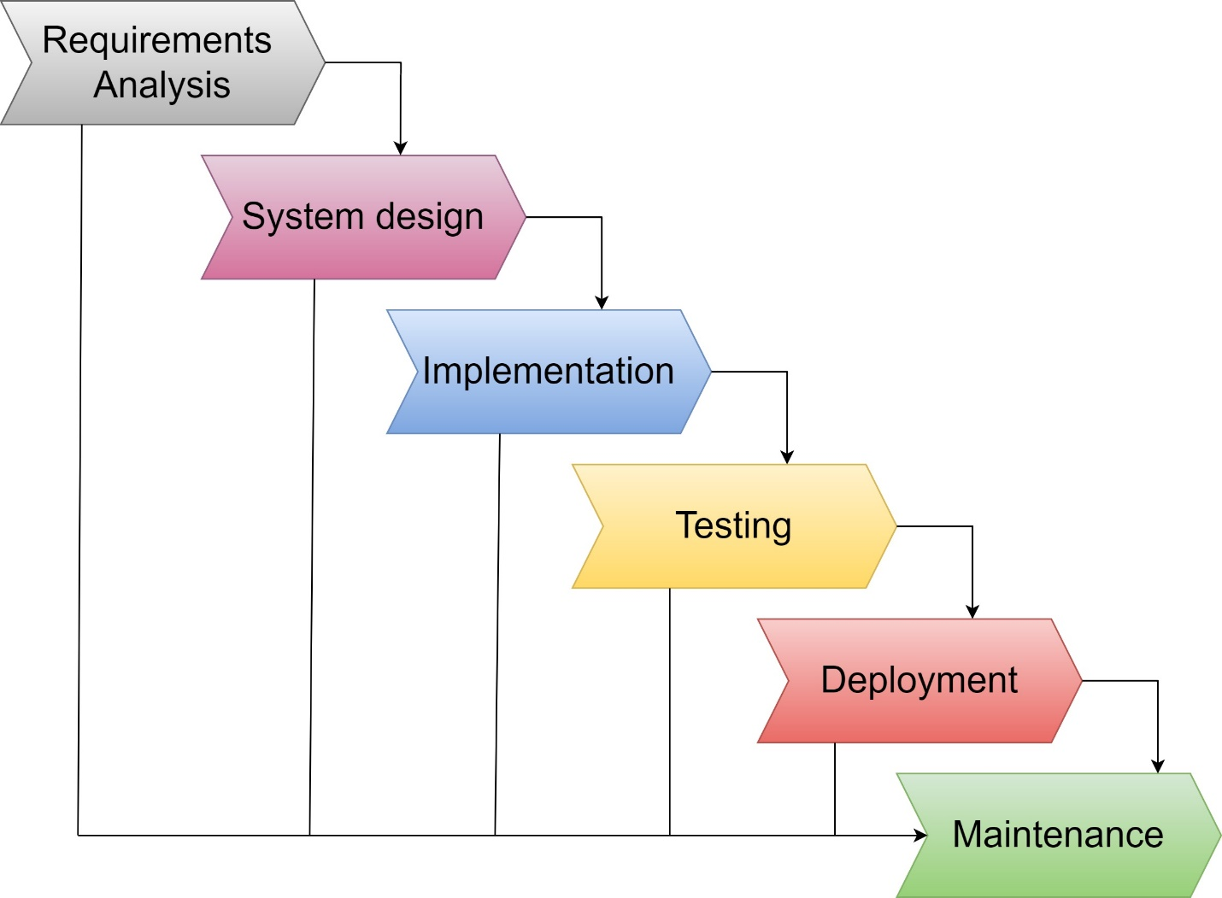

4. What is DFD? Create a DFD diagram on Flip kart.

🡪It's easy to understand the flow of data through systems with the right data flow diagram software.

🡪It uses defined symbols like rectangles, circles and arrows, plus short text labels, to show data inputs, outputs, storage points and the routes between each destination.

🡪 A Data Flow Diagram (DFD) is a visual representation used to illustrate how data moves through a system.

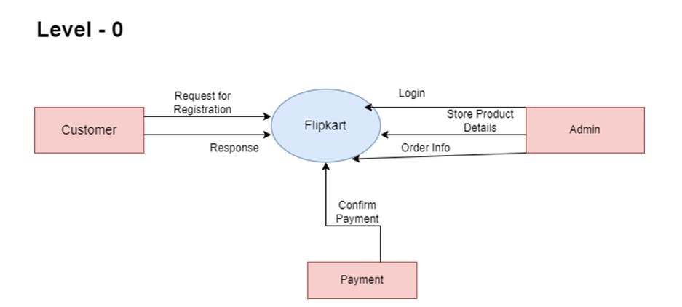

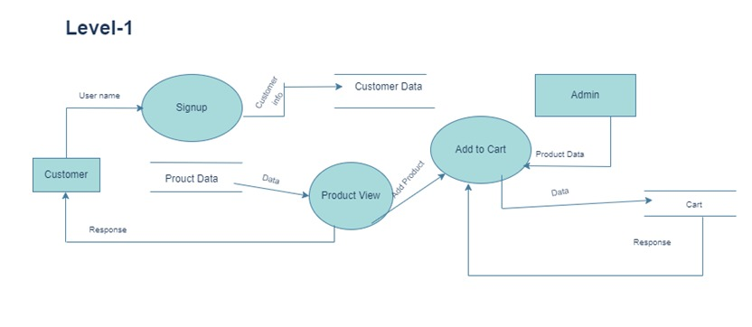

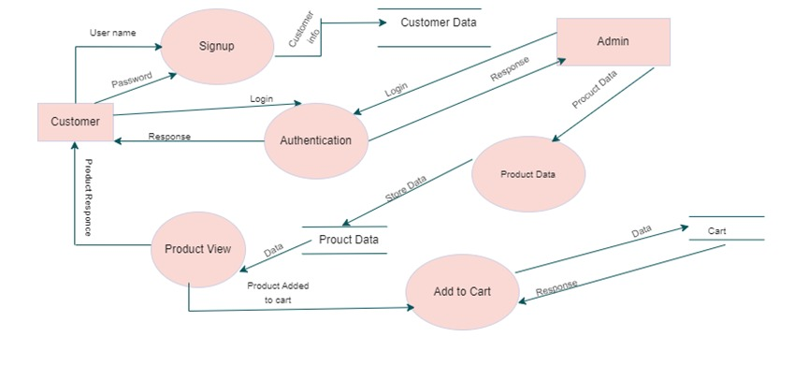

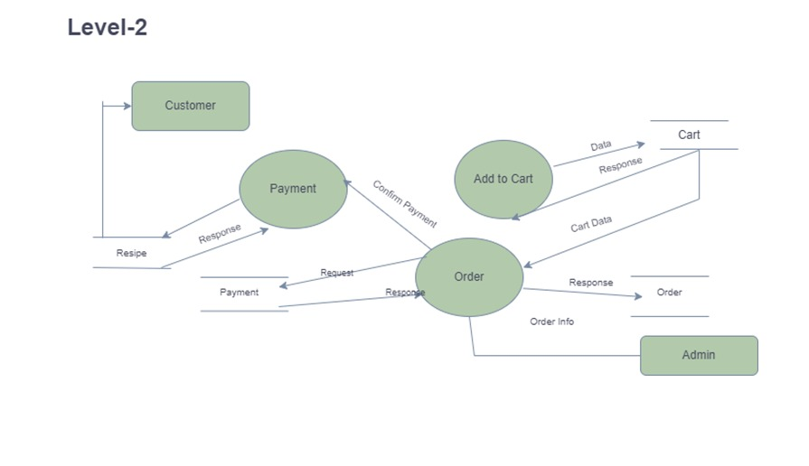

5. What is Flow chart? Create a flowchart to make addition of two numbers

🡪 A Flowchart is a type of diagram that represents a workflow of process. A step by step approach to solving a task.

🡪Flowcharts are nothing but the graphical representation of the data or the algorithm for a better understanding of the code visually.

🡪A flowchart is a picture of the separate steps of a process in sequential order.

🡪Explain to the flowchart to addition two number:

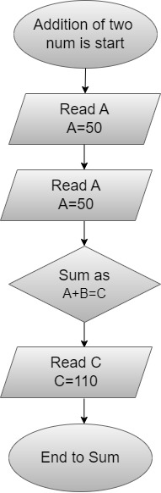

6. What is Use case Diagram? Create a use-case on bill payment on paytm.

🡪A use case diagram can summarize the details of your system's users and their interactions with the system.

🡪The use case is a sequence of actions performed by the actors.

🡪For e.g.

1. Purchase the product online.

2. Withdraw money from ATM

🡪Explain the use case diagram on bill payment on paytm.

