## GUJARAT TECHNOLOGICAL UNIVERSITY

**L. J. Institute of Engineering and Technology**

affiliated with Gujarat Technological University

A

Project report On

Quick Renting

Prepared as a part of the requirements for the subject of

DESIGN ENGINEERING – 2B

B. E. III, Semester –6(Computer Engineering)

Submitted by: Group:

|  |  |  |
| --- | --- | --- |
| Sr. | Name of student | Enrollment No. |
| 1. | Harpreet Mansata | 200320107175 |
| 2. | Pal Patel | 200320107171 |
| 3.  4. | Krisha Rajyaguru  Swasti Ajmera | 200320107143  200320107174 |

## Prof. Dipika Bavaliya

Internal Guide

## Prof. SHRUTI RAVAL

Head of the department

Academic year (2023-2024)

## CERTIFICATE

***This is to certify that project work embodied in this thesis entitled “Quick Renting” has been carried out by Harpreet Mansata(EnrolmentNo:200320107175),Pal Patel (EnrolmentNo:200320107171),Krisha Rajyaguru (EnrolmentNo:200320107143)And Swasti Ajmera (Enrolment No: 200320107174) at LJ Institute of Engineering & Technology Ahmedabad for partial fulfillment of Bachelor of Engineering Degree in Computer Engineering to be awarded by Gujarat Technological University for the term JULY-2020 to DEC-2029.***

This project work has been carried out under my supervision and is to the satisfaction of department.

**Date:**

**Place:** Ahmedabad

**Internal Guide: HOD:**

**Prof.Dipika Bavaliya Prof.SHRUTI RAVAL**

Assistant Professor, Head of the C.E. Dept.

LJIET,Ahmedabad LJIET,Ahmedabad

**Principal: Dr.Anil Suthar** LJIET,Ahmedabad

# ACKNOWLEDGEMENT

I am giving hearty thanks to L.J. Institute of Engineering & Technology for providing me this opportunity for taking this kind of practical project which would be an asset for me for my future carrier and I am also very thankful to all who have directly or indirectly supported me in completion of this project. Proper organization of concept and analysis of the system is due to keen interest and helping hand of my faculties and colleagues.

I am taking this opportunity to express my gratitude and to thank all they helped me in this project. The whole process of development was able to bring out much more than what was expected by me, out of me. “Learning is a continuous process” and at this moment, I hardly have enough words to express my gratitude toward those who were constantly involved with me during my project period.

The guide performs their role of path shower. Under the shade of proper guidance a person can shape his untouched talent. Thus, my special obligations remain due towards Prof. **Dipika** Guides with those valuable supports, guidance and inspiration, the completion of this project would not have been possible who has provided me and guided me through all the phases of my project work, and done much beyond my expectations to bring out the best in me.

Finally, I am thankful to my friends who were always there to support and help me whenever needed.

Harpreet Mansata (200320107175)

Pal Patel (200320107171)

Krisha Rajyaguru(200320107143)

Swasti Rajyaguru (200320107174)

# INDEX

|  |  |  |
| --- | --- | --- |
| **Sr No** | **Content** | **Page No** |
| 1. | Introduction to concept/idea |  |
| 2. | Canvases |  |
|  | 2.1 AEIOU canvas |  |
|  | 2.2 Mind Map |  |
|  | 2.3 Empathy Mapping Canvas |  |
|  | 2.4 Ideation Canvas |  |
|  | 2.5 Product Development Canvas |  |
|  | 2.6 Learning Need Matrix (LNM canvas) |  |
| 3. | Summary of Prior Art Search |  |
| 4. | User Feedback and Rough Prototypes |  |
|  | 3.1 Prototype and user feedback |  |
|  | 3.2 Feedback Analysis |  |
| 5. | Summary of validation process and refinement by feedback analysis with user |  |
| 6. | Design calculation parameters |  |
| 7. | Conclusion |  |
|  | References |  |

1. **Introduction**

### Design Thinking And Its Importance:

Design Engineering is basically the methodology used in the step by step analysis and design of a any product or system. You might be aware that material selection is the vital part for designing any product. Then, you will get to understand the stress/strain aspects which act on the parts of a component or existing ones. Also design engineering will include useful subjects such as Research Methodology, Process planning and equipment’s, analysis of mechanisms, etc. which gives you a detailed idea about the exact procedure and requirements for proper and efficient design of a system or a product.

### Domain: Quick Renting

In the world of technology the people are going away from their cities in the search of business and their further advancement in their specific domain so for their betterment we design this website which provide them proper facilities so they can give proper attention to their business. In our society even students are also leaving away from their parents for their education so to make them feel comfortable we have design this website which solve their problem of finding the place to stay.

# Canvases

### AEIOU canvas:

* **Environment:**

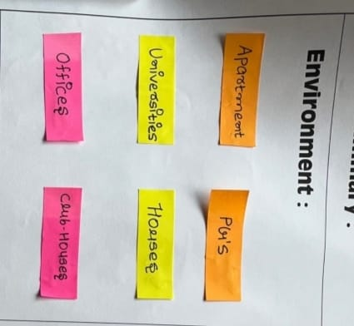

* + Apartment
  + Houses
  + Offices
  + Universities

### Activities:

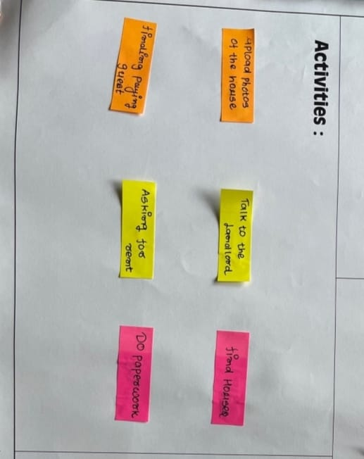

* + Talk to landlords.
  + Asking for rent.
  + Find Houses.
  + Photos of houses.
  + People asking for lift: People are asking for lift.
  + Eating food: Some people are eating food.

### Interactions:

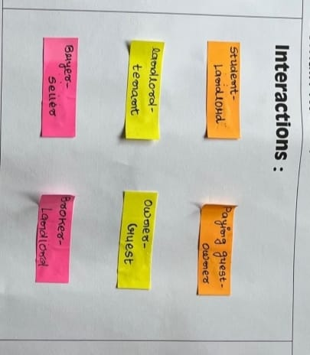

* + Owner Guest
  + People-tenaunt
  + People with traffic police
  + Buyer-seller

### Objects:

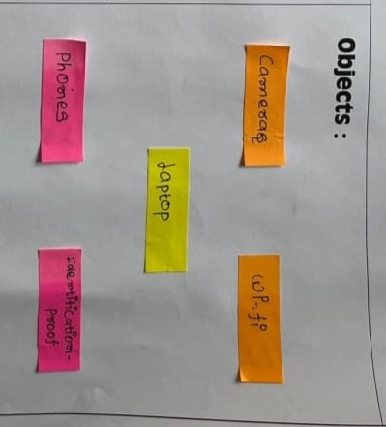

* + Paying rent.
  + Agreement
  + Paying rent.

### Users:

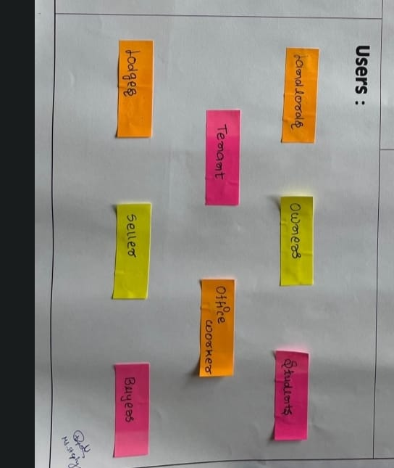

* + Students.
  + Office worker.
  + Tenaunts.
  + Lodges.
  + Buyers

### AEIOU canvas:

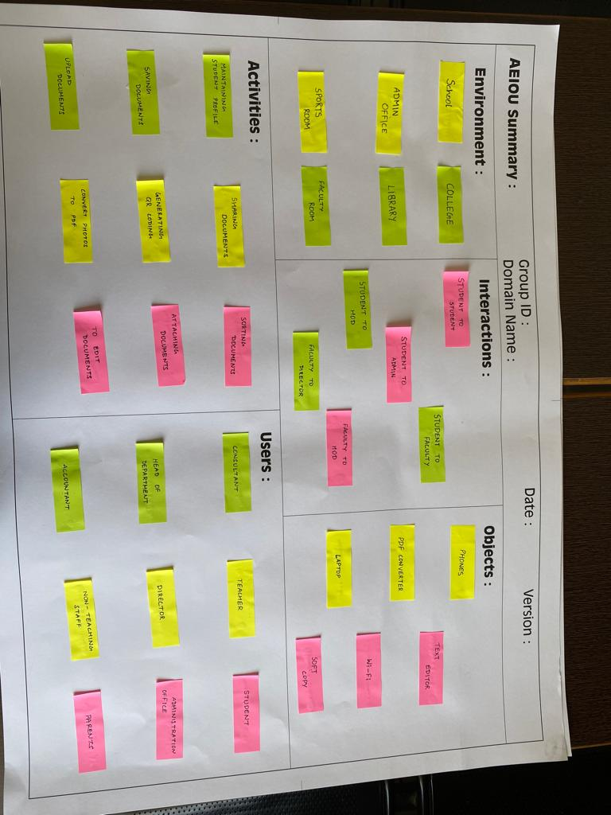

* 1. **Mind Map**

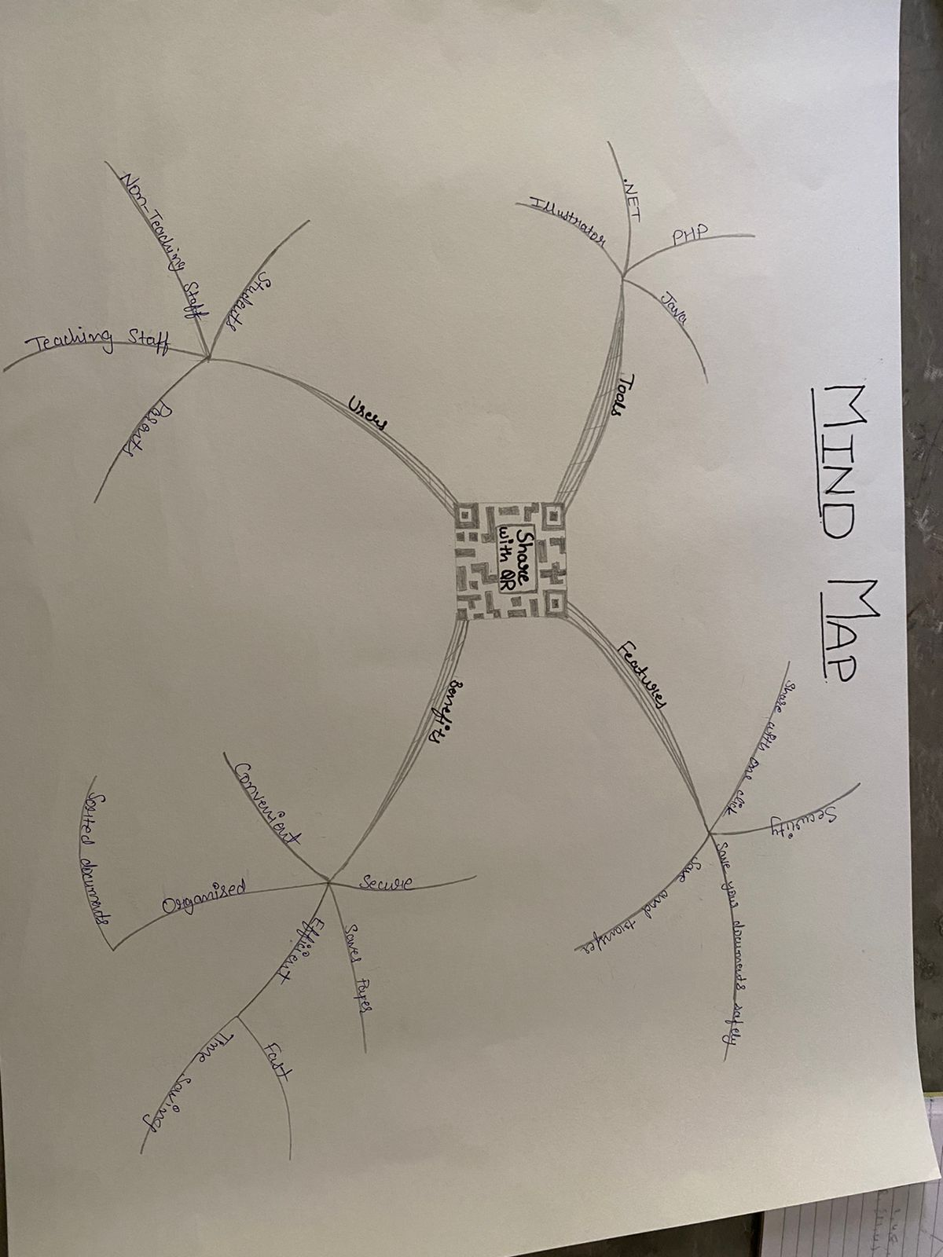

* 1. **Empathy Mapping Canvas**
* **User:**



* + Student: Going to school.
  + Buyerss.
  + Lodges.
  + Ownere.

### Stake Holders:

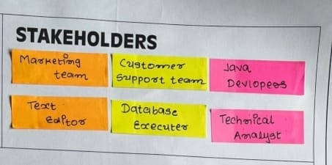

* + Java Developer.
  + DBMS: Manages database.
  + Text Editor.
  + Editors.

### Activities:

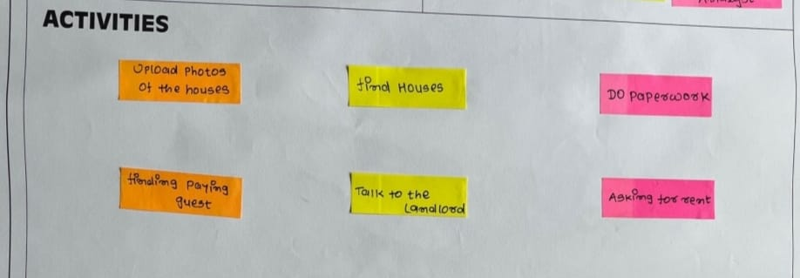

* + Booking pg
  + Finding Houses
  + Do paperwork
  + Finding paying guests.

### Story Boarding:

* **Happy Story 1:**

A businessman was not able to find the property with required facilities so he came to our website and we provided required facilities to make him feel like home.

### Happy Story 2:

Once a new student took his admission into college but at starting phase of his college he most of the time reached college late. So his friend suggested this app and he started staying nearby a result he reaches college on time.

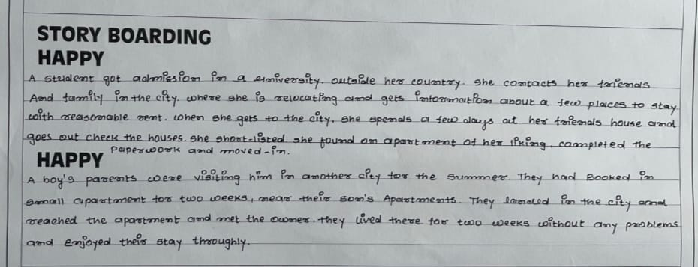

### Sad Story 1:

A student requested a user(driver student) and got accepted but due to the technical issue of the app it later on got canceled which was not done by the student. As a result he was not able stay at our paying guest facility.

### Sad Story 2:

For some reasons internet was banned for the welfare of public by government, as a result students were unable to find the place for their betterment.

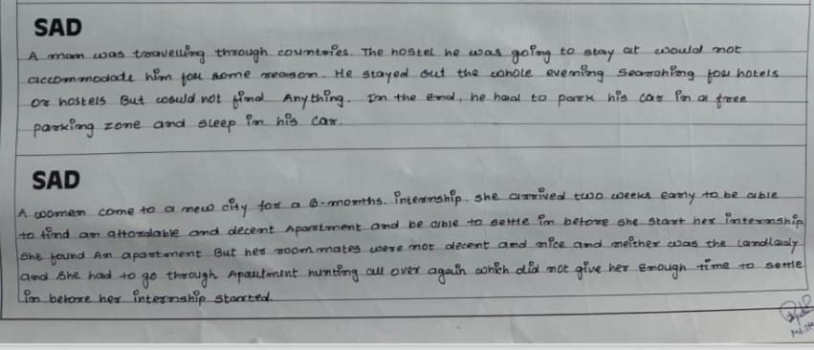

### Empathy mapping canvas:

* 1. **Ideation Canvas:**
* **People:**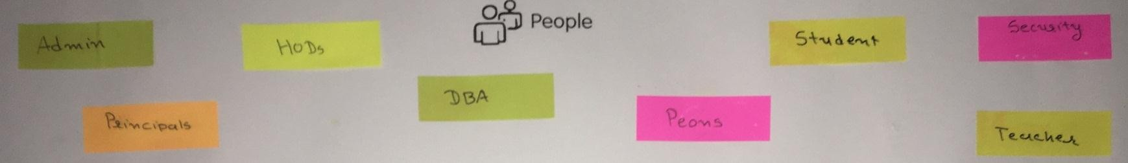
  + Admin: Manages application
  + HODs: Use application
  + Principals: Use application
  + DBA: Manages database of application
  + Peons: Use application
  + Student: Use application
  + Security: Use application
  + Teacher: Use application

### Activities:

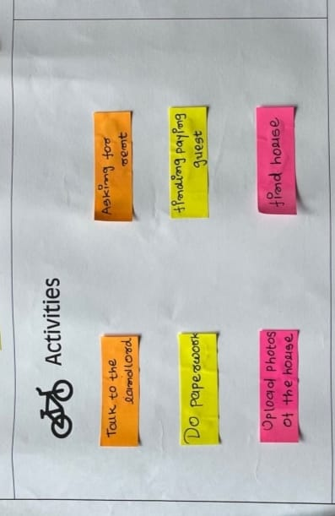

* + Login: User’s login into application.
  + Registering: User has to register to use this application.
  + Paper work.
  + Find Houses.
  + Location sharing: User has to share his/her location.
  + Requesting proper facilities.

### Situation/Context/Location:

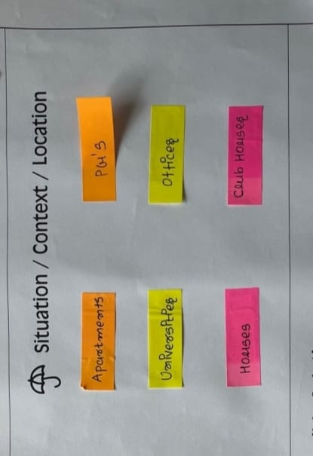

* + Apartment.
  + House: .
  + Offices.
  + Club Houses.
  + Universities.

### Props/Possible solutions:

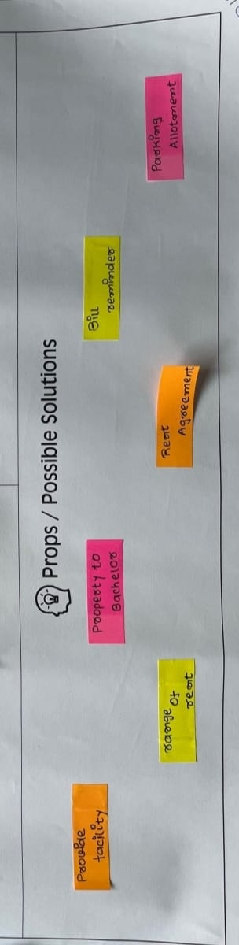

* + Rent Agreement.
  + Provide Facilities.
  + Property to Beachlor.
  + Bill Remindere.
  + Parking Allotment.

### Ideation Canvas:

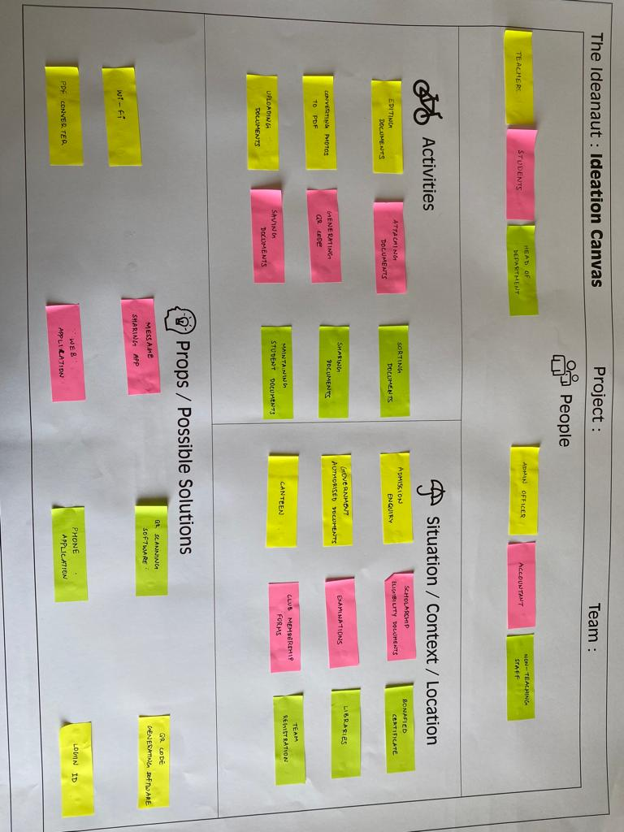

* 1. **Product Development Canvas**
* **Purpose:**

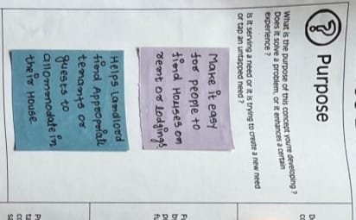

* **Purpose:**
  + Easy find better places.
  + Help landlord to find better places.

### People:

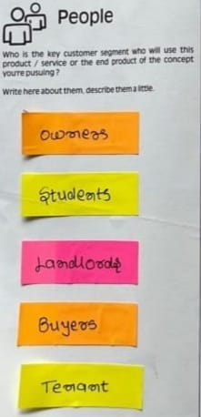

* + Owner.
  + Landlord.
  + Students.
  + Tenet.

### Product Experience:

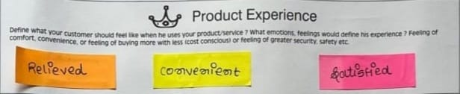

* + Convenient.
  + Satisfied.
  + Relieved.

### Product Functions:

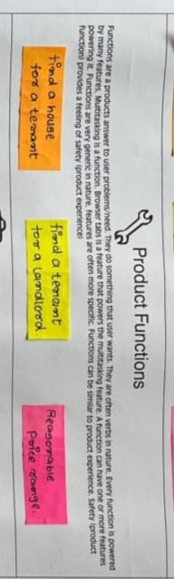

* + Verified people.
  + Easy for landlord.
  + Finding Houses.

### Product Features:

* + Remainder for rent.
  + Agreement.
  + Upload Image of House.

### Components:

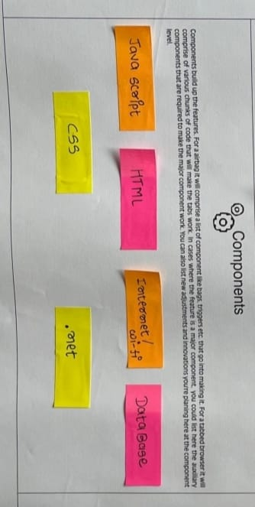

* + Internet Browser: Required to use this application
  + Android studio: Used to develop application.
  + Server: Used to provide 24x7 services.
  + Router: Used for networking.
  + Computer: Used to develop application.
  + Firebase: Real time database.
  + Internet: Required to use this application.
  + Ethernet cable: Used for networking.
  + Android phone: Required to use this application.
  + Vehicle: Required for ride.
  + Photoshop: Required for photo editing.

### Customer Revalidation:

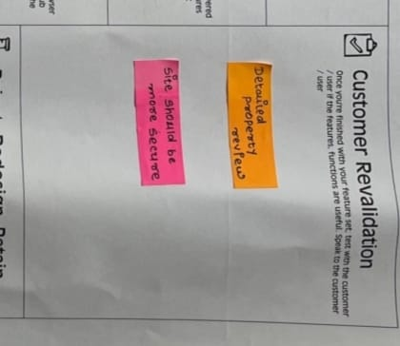

* + Detailed property reviews.
  + Site should be more secure.

### Reject, Redesign, Retain:

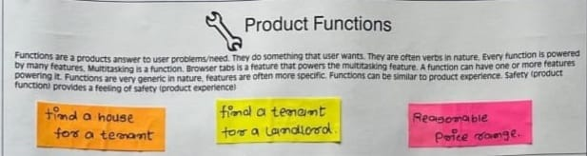

* + Review System: Some customers may reject review system.
  + Authentication of user: Some
  + GUI: GUI is improved.

### Product Development Canvas:

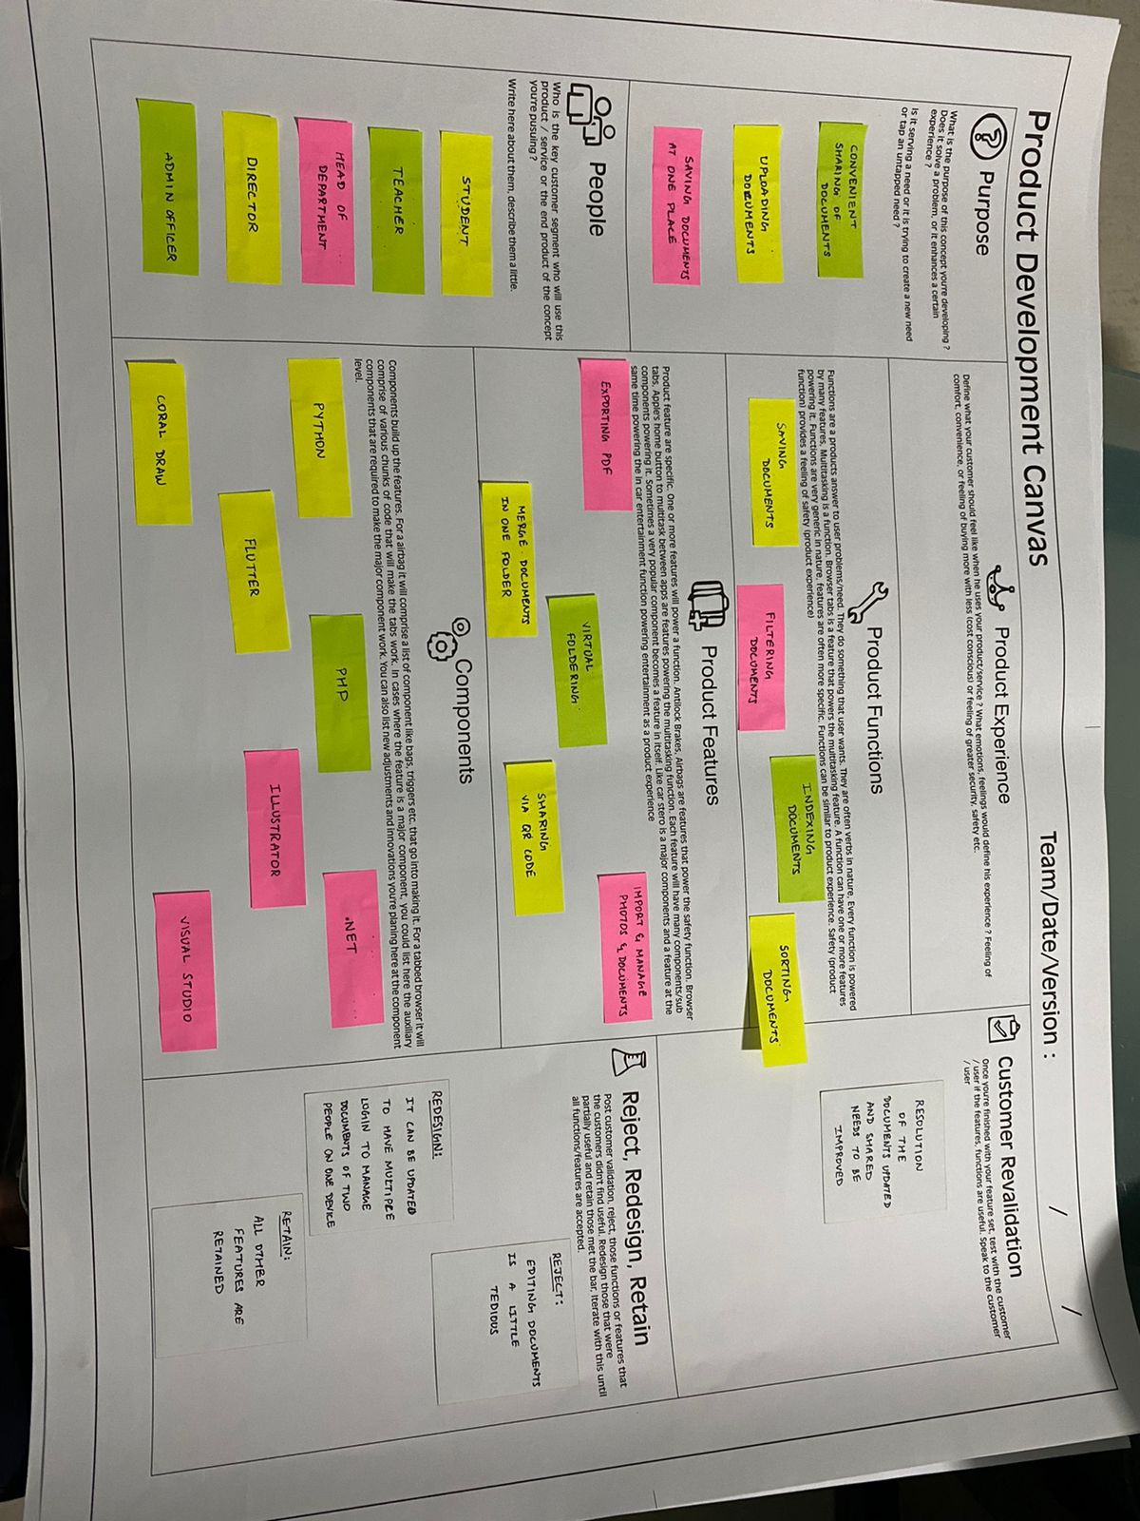

* 1. **Learning Need Matrix (LNM canvas)**

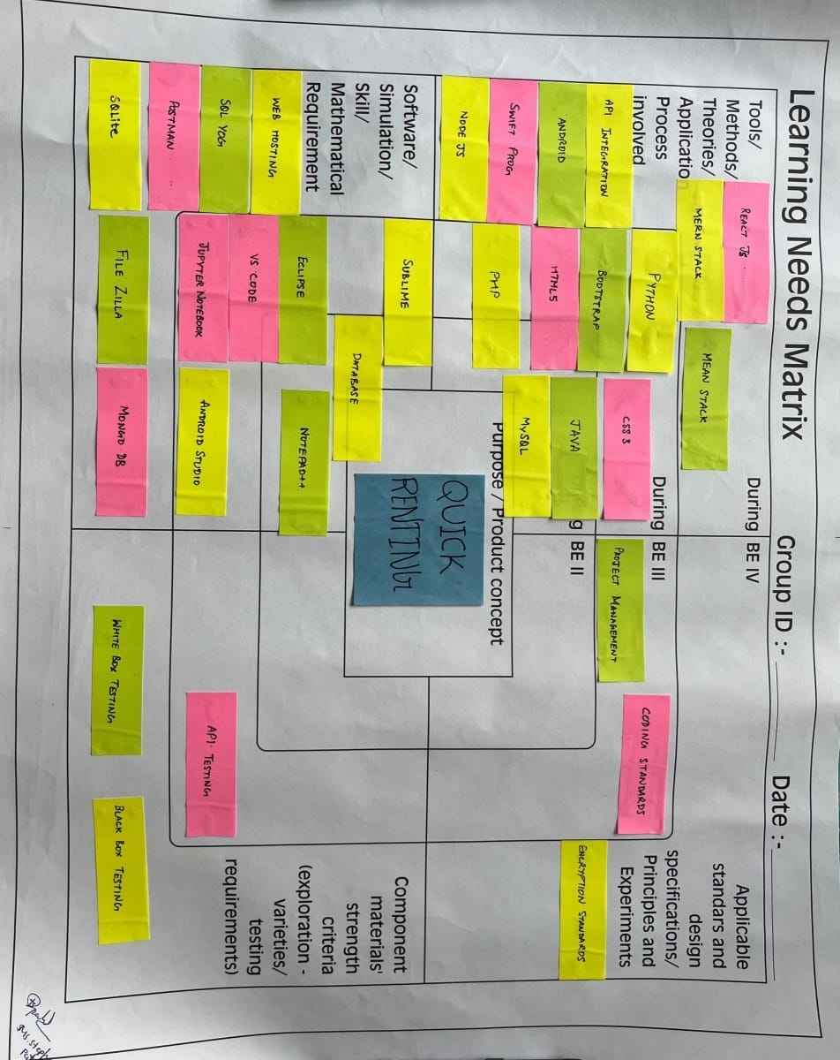

# 3. Summary of Prior Art Search

**[2.1]** [***https://www99acresr.com/en-IN/cities/ahmedabad/***](https://www99acresr.com/en-IN/cities/ahmedabad/)

One of the best renting place in the city which is known for its facilities .

1. **User feedback and Rough Prototypes**

**4.1 Prototype and user feedback:**

Better UI for using with simple smartphone and pc.

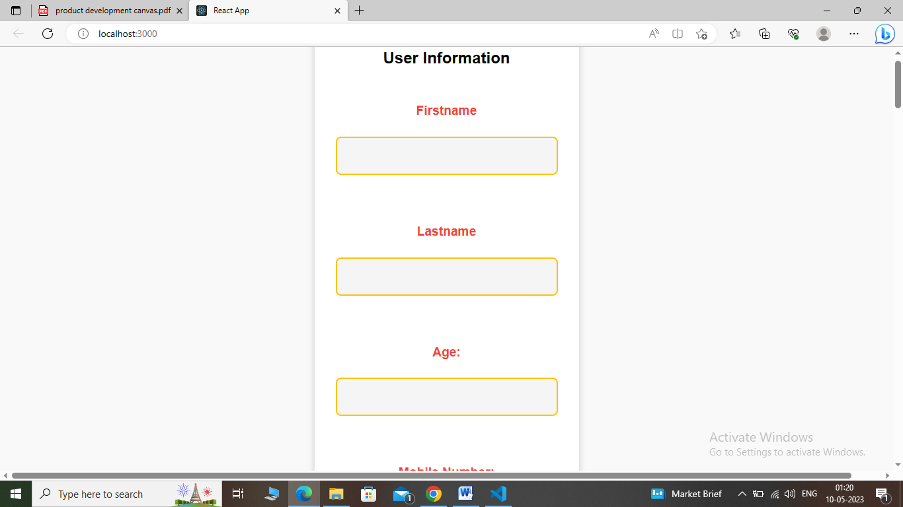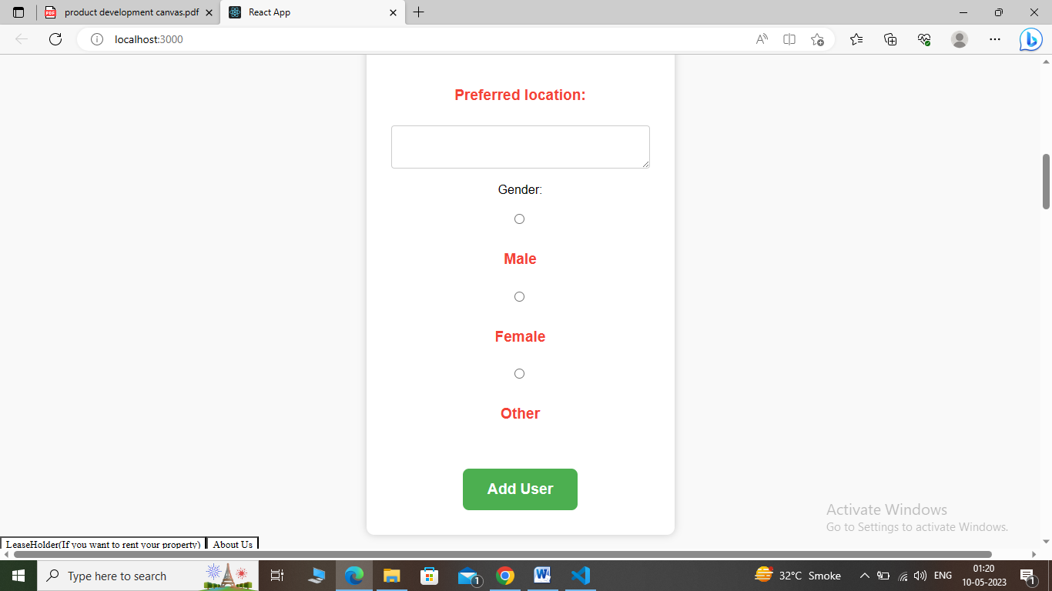

* + - In login page, users can log into our application if their account exists.
    - If not users can register themselves into registration page of our application after this they can perform login.

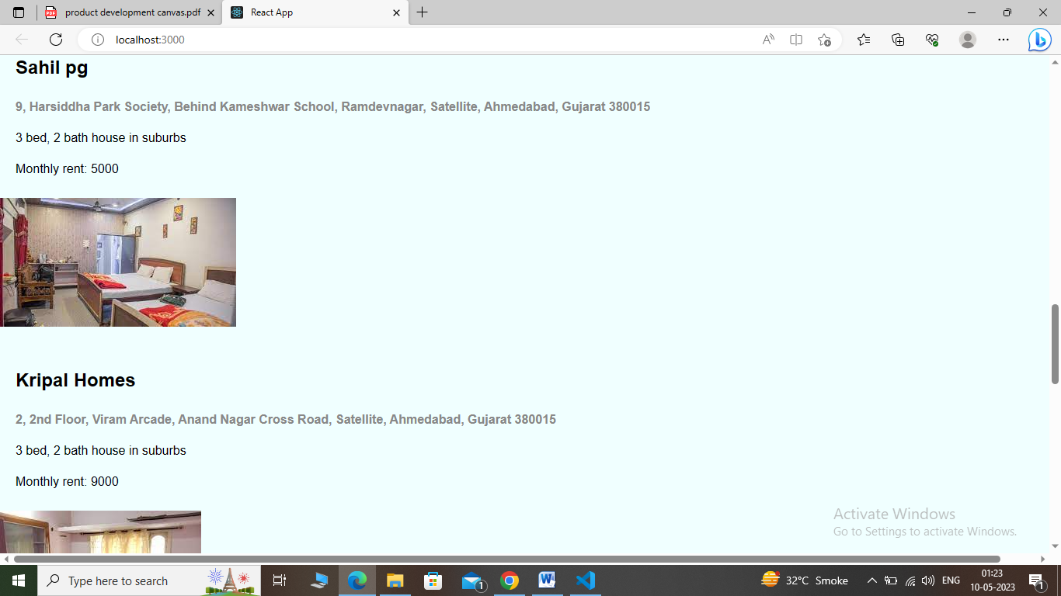 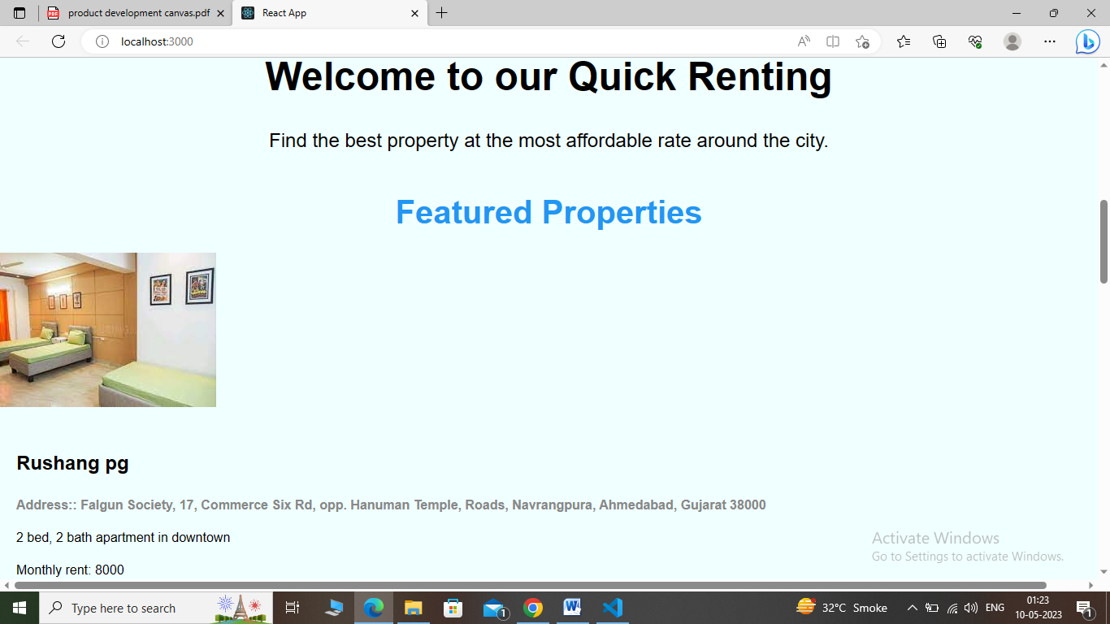

* + - In selection page, user can select from two options whether he/she wants to give a ride or wants to request a ride.
    - In request ride page, user needs to enter pickup point and pickup time if he/she selects request ride.

* + - * In Accept Login page, user can accept request from requesting user according to his/her choice.
      * In that page, user can choose one from different options like My account, , About and logout.

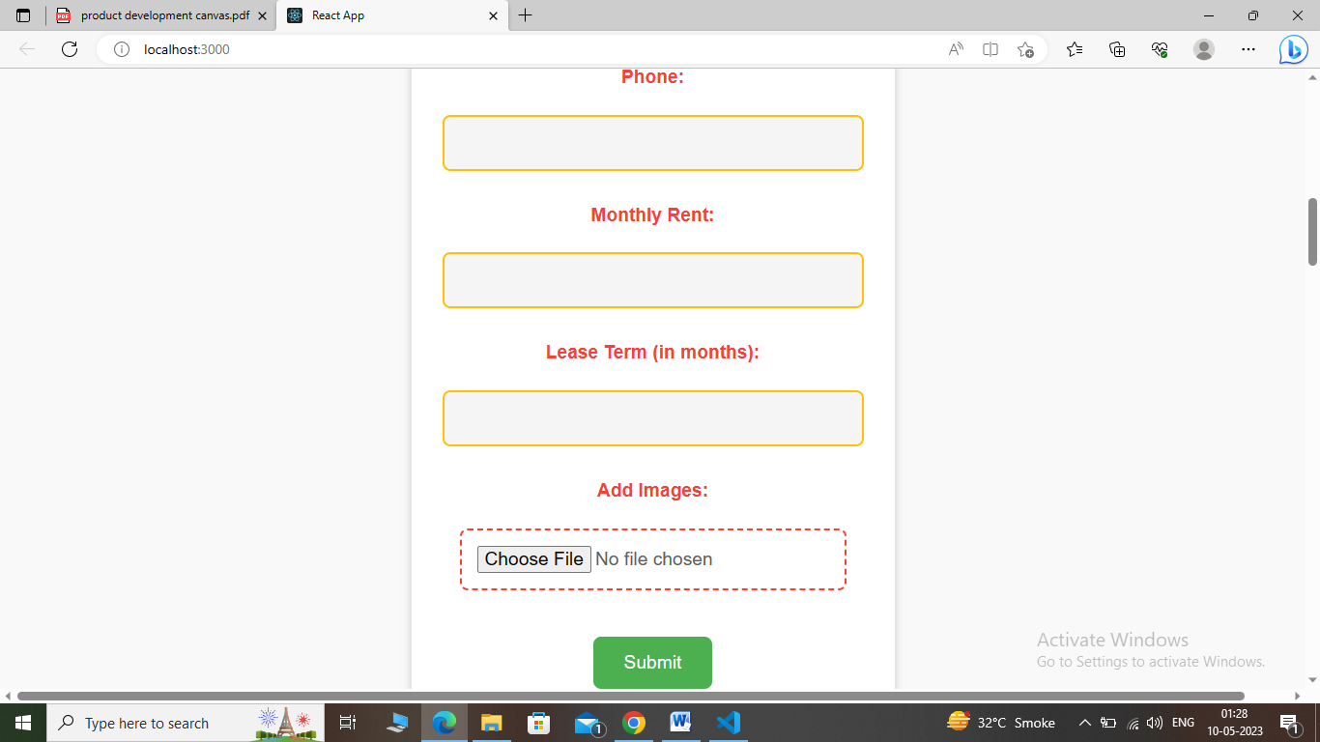 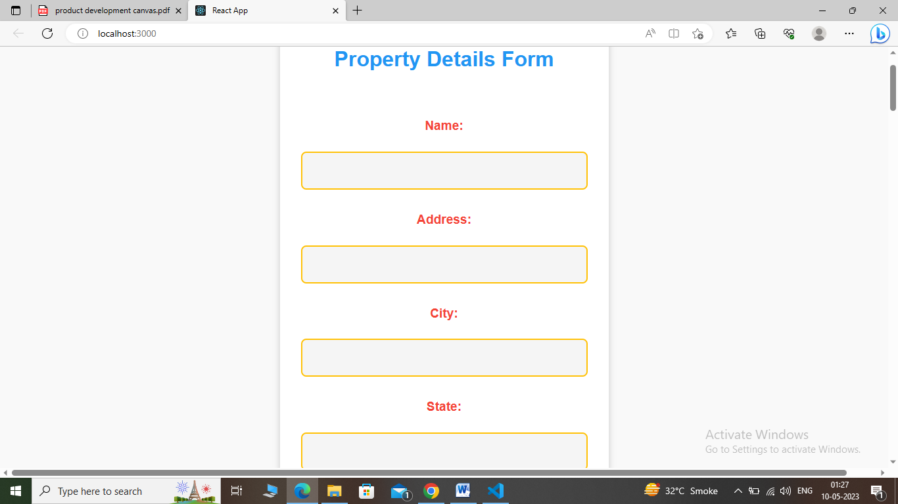

* + - * In My account page, user can see and edit his/her profile.
      * In Points page, user can check how many points he/she has.

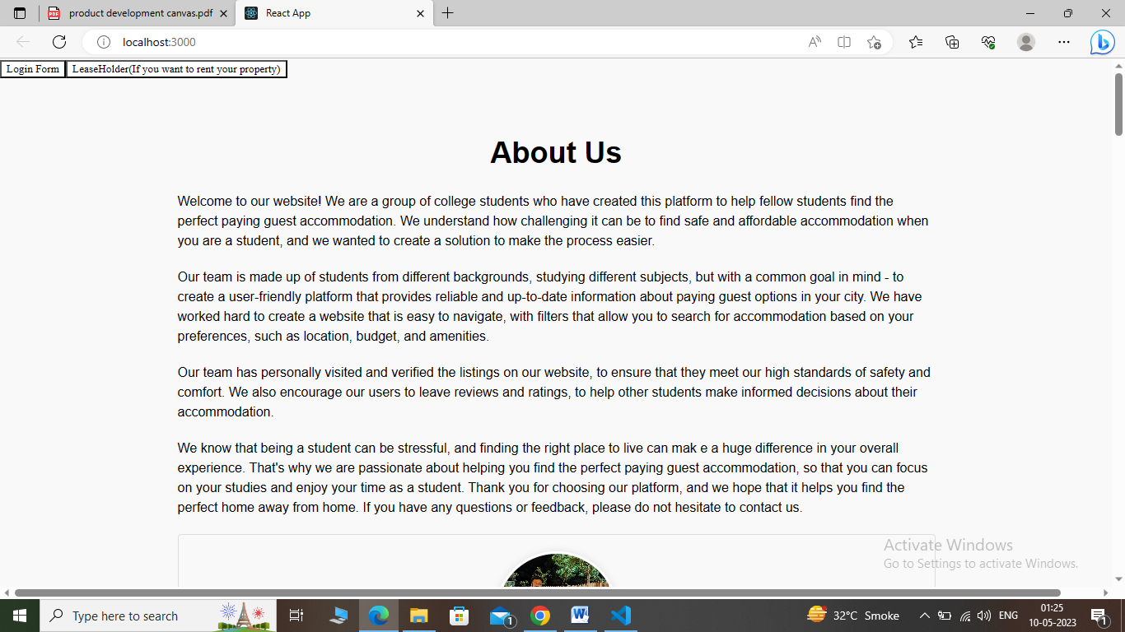

* + - * + In about page, user can check information about this application.

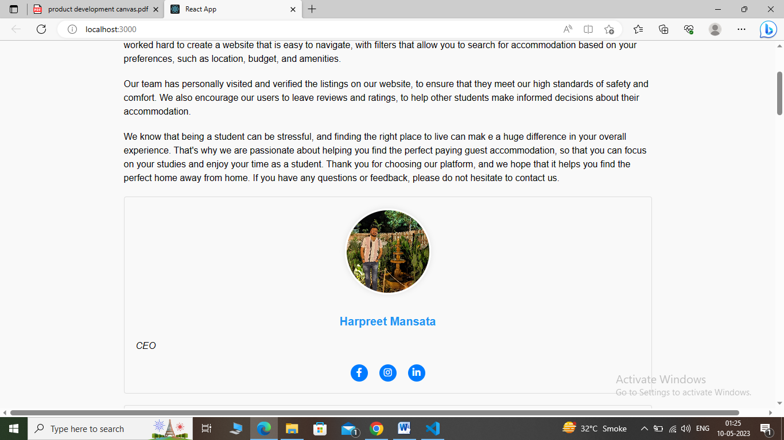

### 4.2 Feedback Analysis:

* There was no any web application that can help students for easy stay so we have made this web application for providing facilities to students.
* Other companies provides services but that are too expensive so we have made this web application for users to Signup free of cost.
* Due to some network problems, we have made this web application that can run on slow internet connection.
* Due to Connectivity problems, we have improvised Connectivity service.
* GUI, we have made user friendly, easy to use GUI.
* Due to some security issues, we have provided good security in our web application.

# Summary of validation process and refinement by feedback analysis with user

#### **5.1 Improvement needed for enhancement**

* Include login.
* Include OTP verification.
* Include Captcha confirmation.
* Optimization
* Property Renting button.
* Cookie

#### **5.2 Tools to learn for improvement and it's results**

#### HTML 5

#### CSS 3

#### Javascript

#### NodeJS

#### ExpressJS

#### MongoDB

#### **5.3 Advantages and facilities provided by final product after improvement.**

#### By including login using Google/Facebook, security of users can be improved.

#### By including OTP verification validity of users can be verified.

#### By including Captcha, confirmation of ride can be confirmed.

#### By making code efficient optimization of can be increased.

#### By including social share button user can share this app to others.

#### By adding friend button, user can add user to their friend list.

1. **Design calculation**

[Include all design parameters like reliability, scalability, asthetics, ergonomics, cost, maintenance, Modelling, Use, reuse and sustainability as per suitability of your project]

[Refer DE sem-6 guidelines to understand meaning of all these parameters]

# Conclusion

Our website focus on the people who want to stay for longer term at our facilities which provide a huge number of facilities which make them feel like home to the students as well as people who left their city and had came to work around.

# References

# [Include details of research papers and web links]

# Weblinks:

1. *https://www.99acres.com/articles/5-things-to-remember-before-converting-your-house-into-a-pg-accommodation.html*