**PBLJ_8.2**

**NAME: KRISH AORA UID: 24BCS80046**

**SECTION:23-FS_622B DATE: 28-OCT-2025**

**PART A: Login Route (POST /login):**

**Output:**

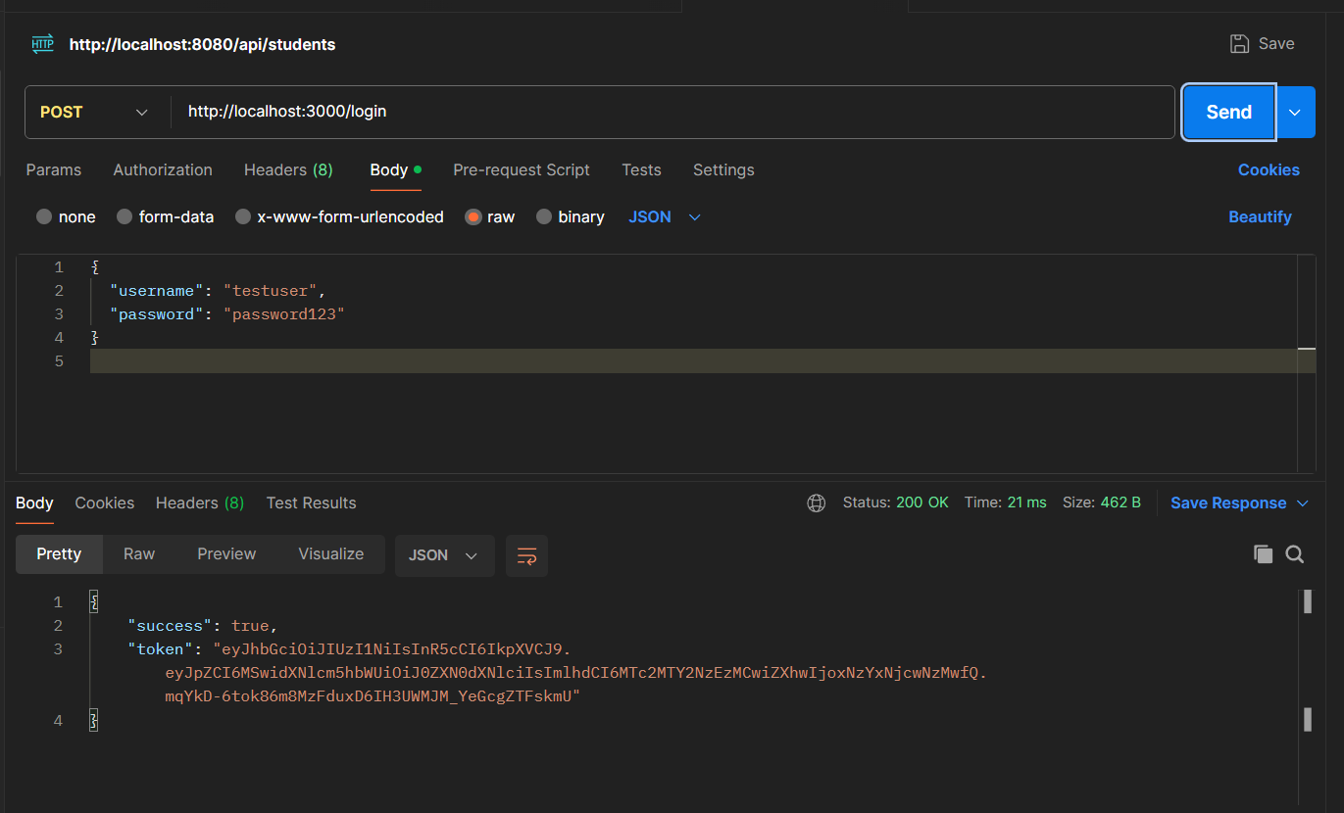

**Test Case (Failure: missing token)**

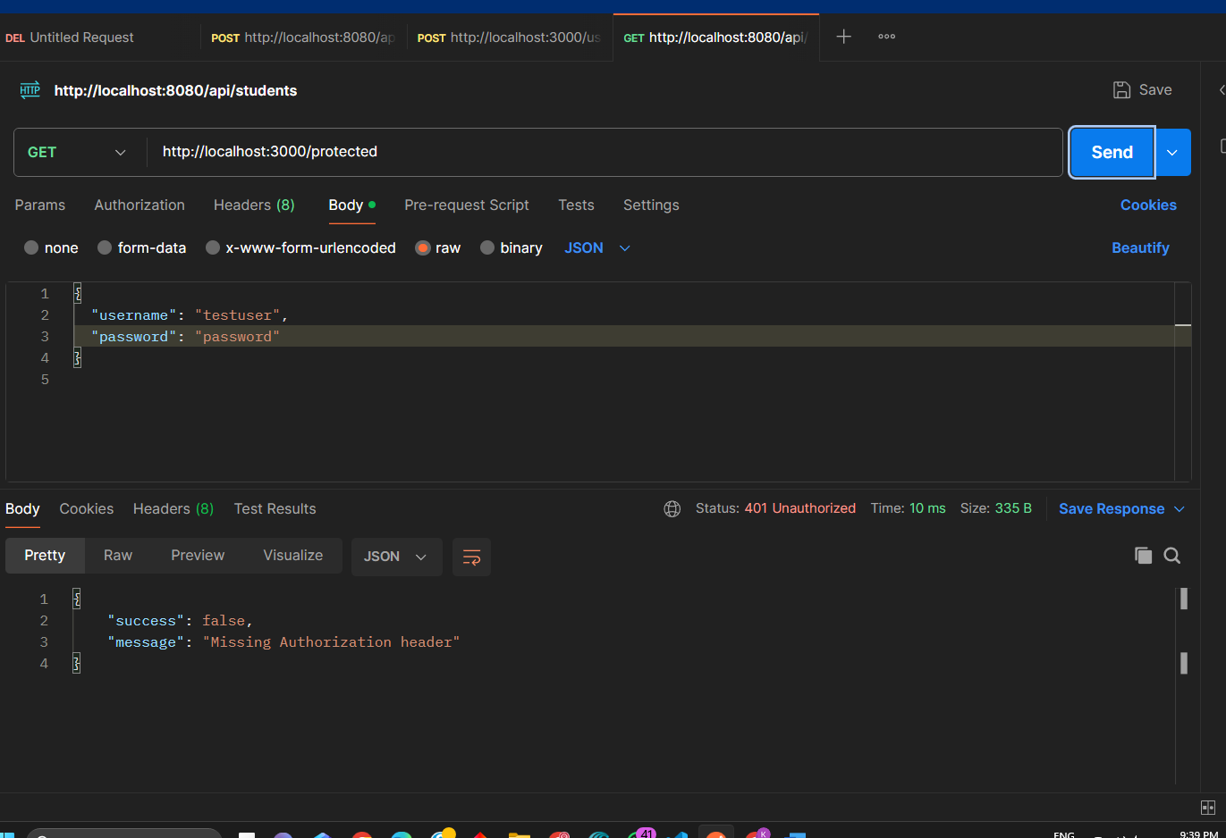

**PART B:  Protected Route (GET /protected):**

**Output:**

