Name- Krisha Samtani
Roll No- 2401099
Class- T22
Subject- Agile Software Development & DevOps

EXPERIMENT-2
Aim: To containerise an application using Docker
Theory
Docker
Docker is an open-source platform that allows developers to package an application along with all its required dependencies, libraries, configuration files, and environment settings into a single, standardized unit called a container. This ensures that the application runs identically across any computing environment, whether on a local laptop, a physical server, or a cloud platform.
Containerization
Containerization is an operating-system-level virtualization technique used to deploy and run applications isolated from one another without needing a full virtual machine (VM). Unlike traditional VMs, which require a full guest operating system, containers share the host machine's OS kernel. This makes them significantly lightweight, fast to boot, and highly resource-efficient, effectively eliminating the common "it works on my machine" problem.
Difference Between Image and Container
Parameter | Docker Image | Docker Container
Definition | A static, read-only blueprint or template. | A live, running instance instantiated from an image.
State | Immutable (does not change or execute by itself). | Dynamic (has an active process, state changes during runtime).
Programming Analogy | Class. | Object / Instance of a class.
Example | ubuntu image stored locally. | Container 3739c286b409 running bash shell.
Storage | Saved on disk in reusable read-only layers. | Has a thin writable layer added on top of the base image.

Procedure & Executed Commands
The following commands were executed sequentially in PowerShell / Command Prompt (Run as Administrator) with the Docker Engine active:
1. Basic Verification & Image Retrieval
# | Executed Command | Purpose / Description
1 | docker --version | Checks and confirms the installed Docker Engine version.
2 | docker images | Lists all Docker images stored locally on the system.
3 | docker search ubuntu | Queries Docker Hub for available public images related to Ubuntu.
4 | docker search ubuntu --filter stars=50 | Filters Docker Hub results to display images with 50 or more stars.
5 | docker pull ubuntu | Downloads the official ubuntu image from Docker Hub.
6 | docker images | Re-verifies local image storage to confirm the downloaded Ubuntu image.
7 | docker run -it ubuntu bash | Instantiates and launches an interactive container running /bin/bash.
8 | docker ps | Lists active/running containers showing Container ID, status, and assigned name.
2. Container Lifecycle & Advanced Operations
# | Executed Command | Purpose / Description
9 | docker exec -it <container_id> bash | Attaches an interactive bash session inside a running container.
10 | docker stats --no-stream | Displays real-time CPU, memory, and network utilization of running containers.
11 | docker inspect <container_id> | Outputs detailed low-level configuration and metadata of the container in JSON.
12 | docker logs <container_id> | Fetches console logs generated by the target container.
13 | docker ps -a | Lists all containers including active, exited, and stopped instances.
14 | docker stop <container_id> | Gracefully halts execution of the running container.
15 | docker start <container_id> | Restarts a previously stopped container.
16 | docker rm -f <container_id> | Forcefully removes and deletes the container.
17 | docker network ls | Lists all Docker network drivers configured on the host machine.
18 | docker volume ls | Displays all persistent storage volumes managed by Docker.
19 | docker system prune | Reclaims disk space by clearing stopped containers and unused cache.

Difference Between Image and Container
Parameter | Docker Image | Docker Container
Definition | A static, read-only blueprint or template. | A live, running (or stopped) instance instantiated from an image.
State | Immutable (does not change or execute by itself). | Dynamic (has an active process, state changes during runtime).
Programming Analogy | Class. | Object / Instance of a class.
Example | ubuntu image stored locally. | Container 3739c286b409 running bash shell.
Storage | Saved on disk in reusable read-only layers. | Has a thin writable layer added on top of the base image.

Workflow Explanation
- Environment Verification: Docker Engine version was verified (25.0.3), ensuring system readiness.
- Image Acquisition: Docker Hub was queried for the official Ubuntu base image. Using docker pull ubuntu, the image layer was fetched and stored locally (~100MB).
- Container Deployment: A container instance was created using docker run. Interactivity was tested via interactive shell mode (docker exec -it), allowing inside-container command execution.
- Lifecycle & Inspection: System performance was monitored using docker stats and inspected via docker inspect. The container lifecycle was completed by stopping, starting, and removing the container instance.
- System Cleanup: Unused dangling storage and stopped containers were purged using docker system prune

Observations
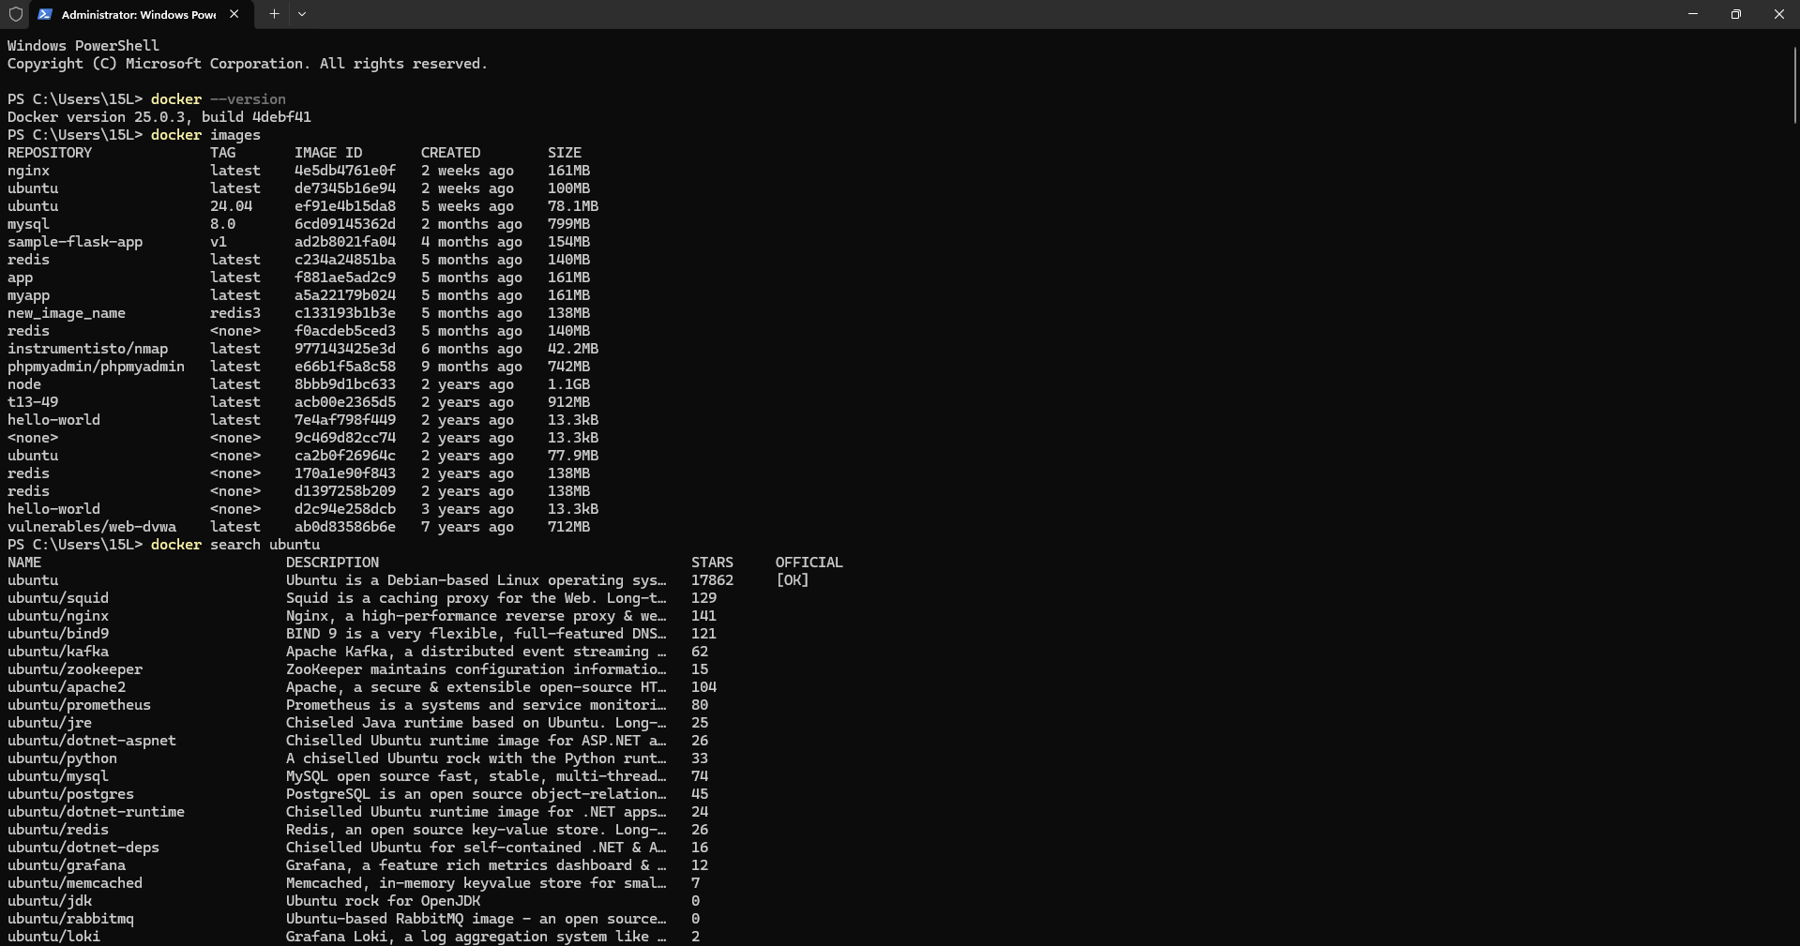
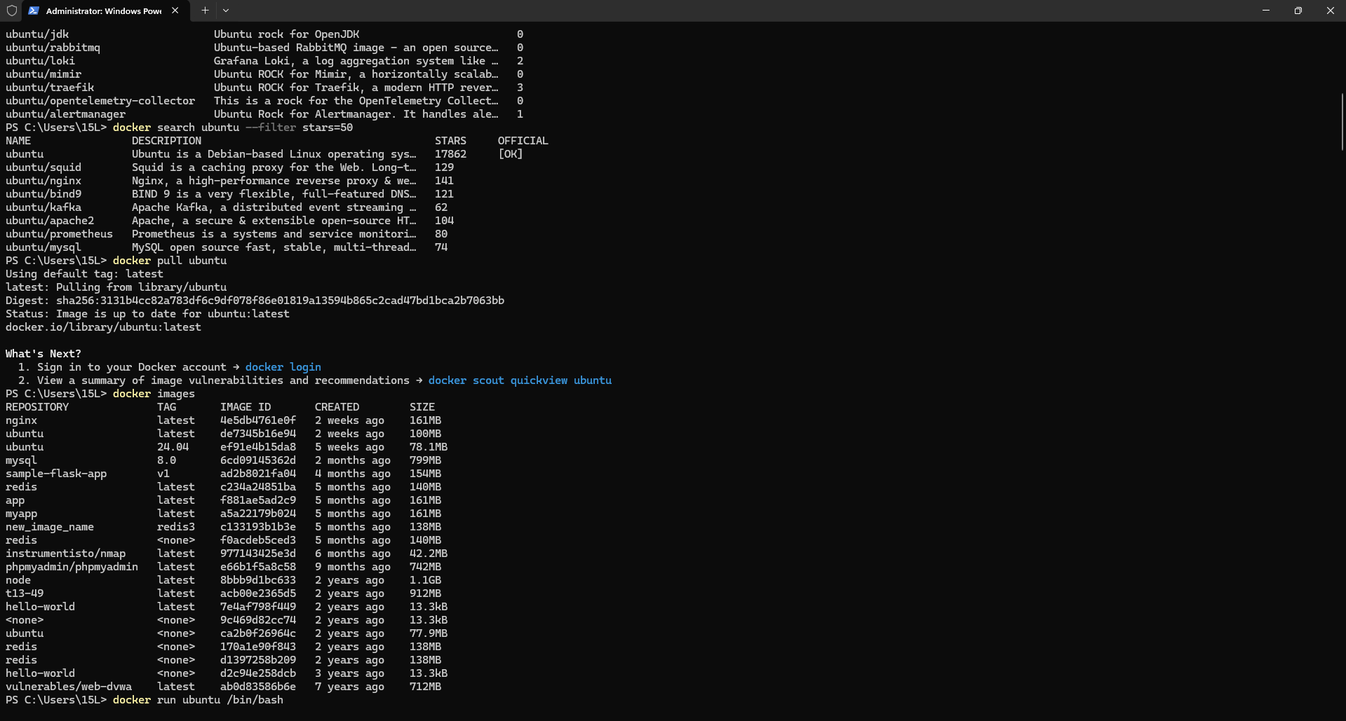
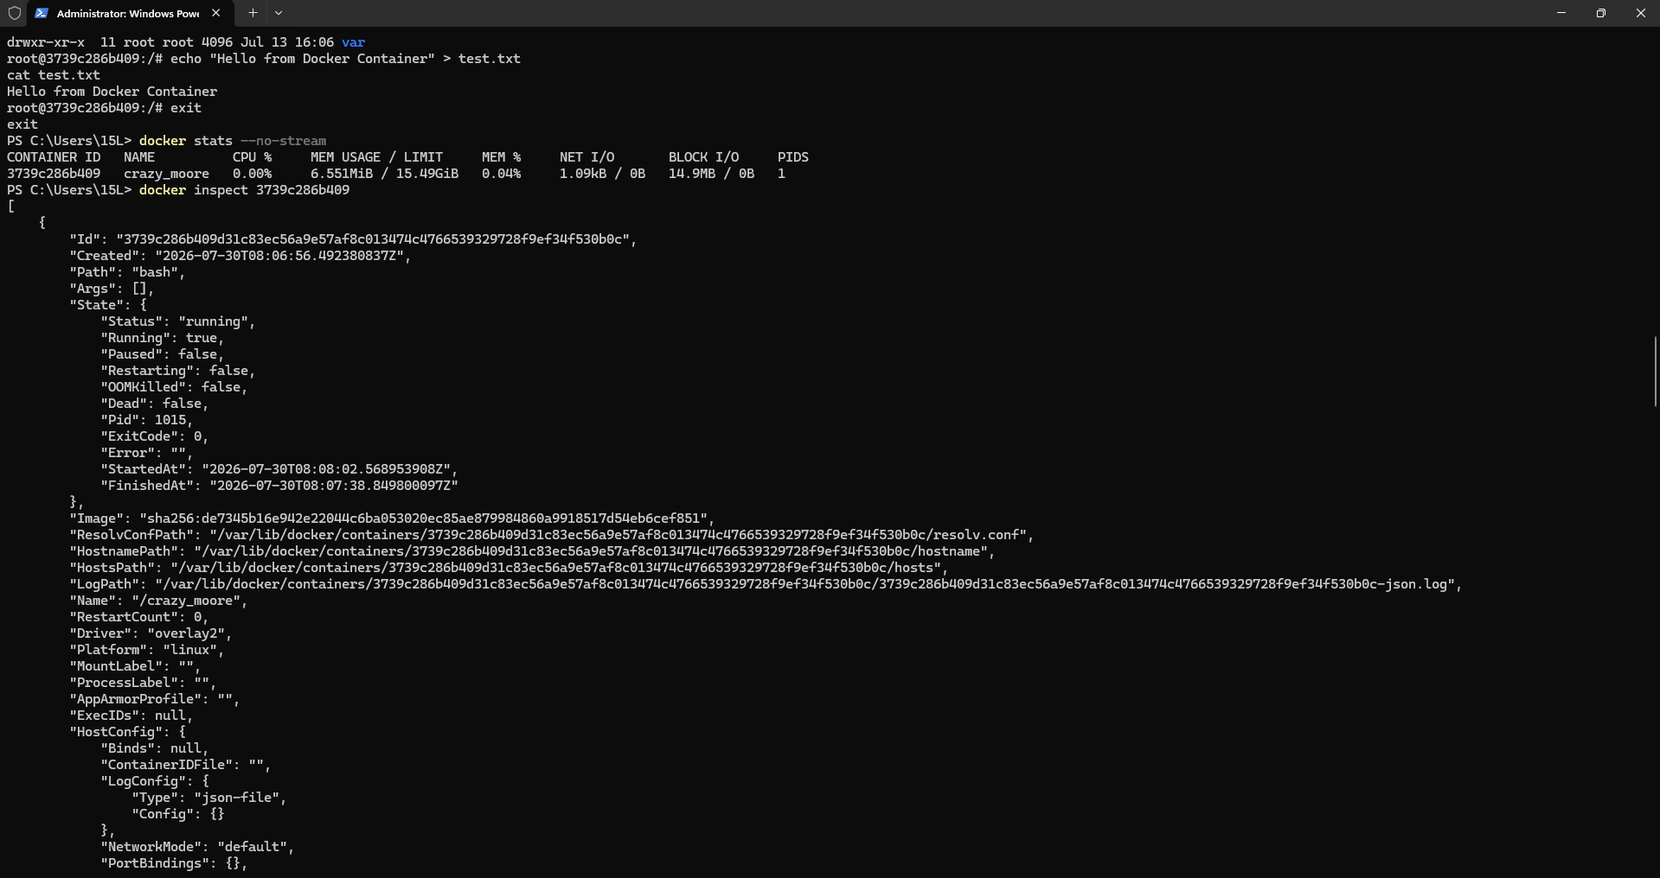
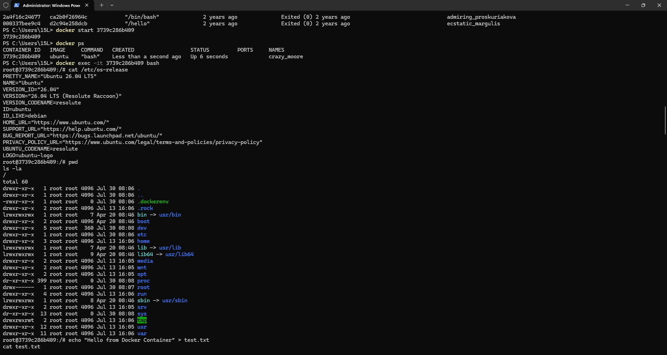
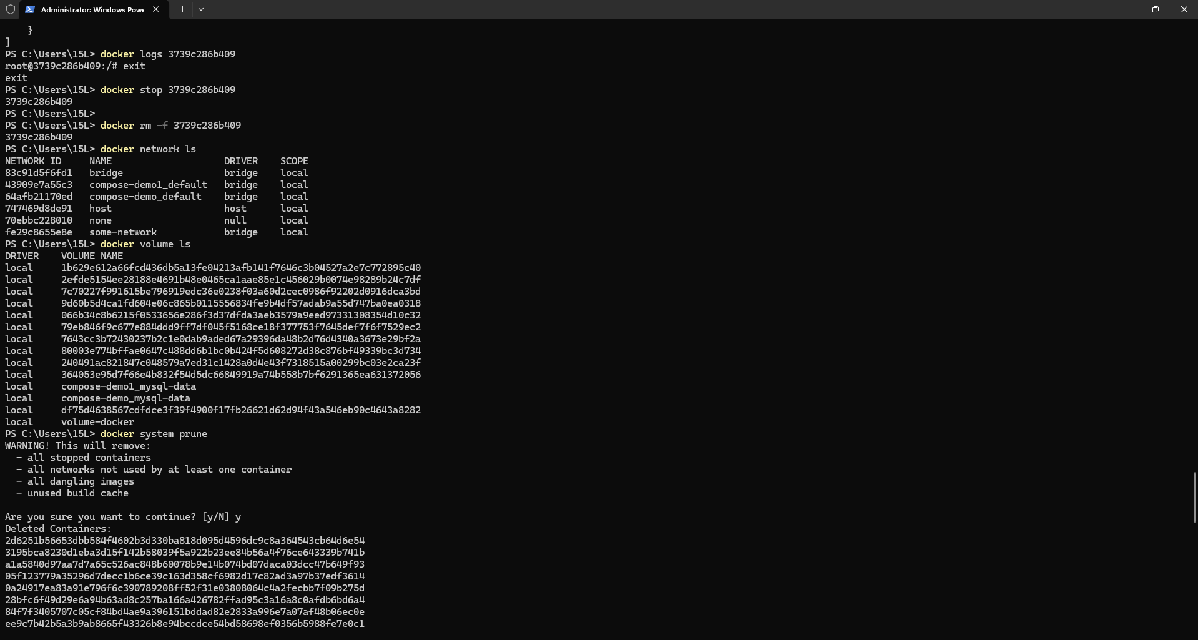
Conclusion
Through this experiment, Docker installation was successfully verified, and fundamental concepts of containerization were practically implemented. An official Ubuntu base image was pulled from Docker Hub, and an isolated container environment was managed through its complete lifecycle. The practical execution demonstrated how containerization simplifies application distribution, guarantees environment consistency across hosts, and streamlines software deployment.

