Name- Krisha Samtani
Roll No- 2401099
Class- T22
EXPERIMENT-3
AIM: To deploy and manage a multi-service application using Docker Compose by configuring and running Nginx, MySQL, and phpMyAdmin containers with a single docker-compose.yml file.

Theory:Docker Compose is a tool used to define, configure, and run multiple Docker containers as a single application. It allows developers to manage multi-container applications using a single YAML configuration file called docker-compose.yml.
In a multi-service application, different services such as a web server, database server, and management tools run in separate containers but communicate with each other through a common Docker network.
The docker-compose.yml file contains details about:
- Services – Defines the containers required for the application.
- Images – Specifies the Docker images used to create containers.
- Ports – Maps container ports to host machine ports.
- Environment variables – Configures service settings such as database credentials.
- Volumes – Provides persistent storage for data.
In this experiment, Docker Compose is used to deploy three services:
- Nginx – A web server used to serve web content.
- MySQL – A relational database server for storing application data.
- phpMyAdmin – A web-based interface for managing the MySQL database.
Using Docker Compose, all these services can be created, started, stopped, and managed using simple commands.

Procedure:
Step 1: Install and start Docker Desktop
- Install Docker Desktop and ensure Docker Engine is running.
- Verify Docker installation using:
docker --version
Step 2: Create a project directory
Create a folder for the Docker Compose project.
mkdir compose-demo
Move into the directory:
cd compose-demo
Step 3: Create Docker Compose configuration file
Create a file named:
docker-compose.yml
Add the required service configurations for:
- Nginx
- MySQL
- phpMyAdmin

Step 4: Start the multi-service application
Run:
docker compose up -d
This command downloads required images and creates containers in the background.

Step 5: Verify running containers
Check the status of containers:
docker compose ps

Step 6: Access services through browser
Open:
Nginx Web Server
http://localhost:8090
phpMyAdmin
http://localhost:8081
Login credentials:
Username:
student
Password:
student123

Step 7: View images and logs
Display images:
docker compose images
View application logs:
docker compose logs
Validate Compose configuration:
docker compose config

Step 8: Manage services
Stop services:
docker compose stop
Start services again:
docker compose start
Remove containers:
docker compose down

3. Docker Compose Commands Used
Sr. No. | Command | Purpose
1 | docker compose up -d | Creates and starts all services in detached mode
2 | docker compose ps | Displays running containers and their status
3 | docker compose images | Lists images used by the Compose application
4 | docker compose logs | Displays logs of all services
5 | docker compose config | Validates and displays Compose configuration
6 | docker compose stop | Stops running containers without removing them
7 | docker compose start | Starts stopped containers
8 | docker compose restart | Restarts all services
9 | docker compose down | Stops and removes containers
10 | docker compose down -v | Removes containers along with volumes/

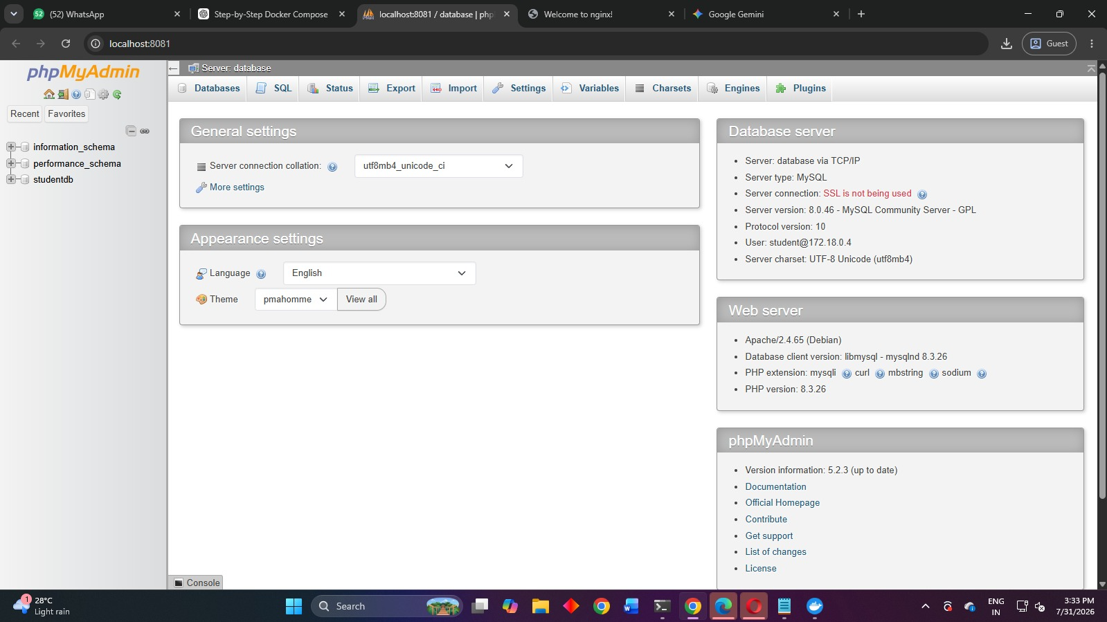
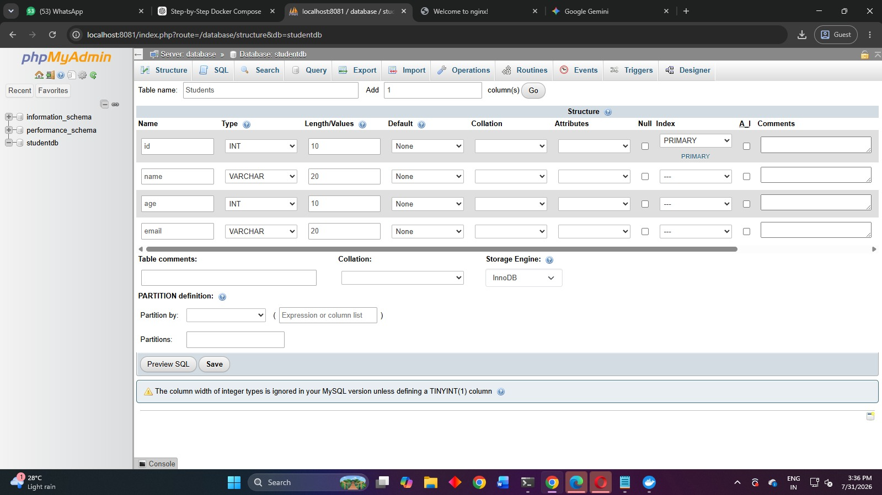
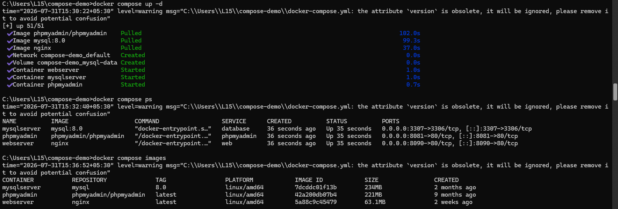

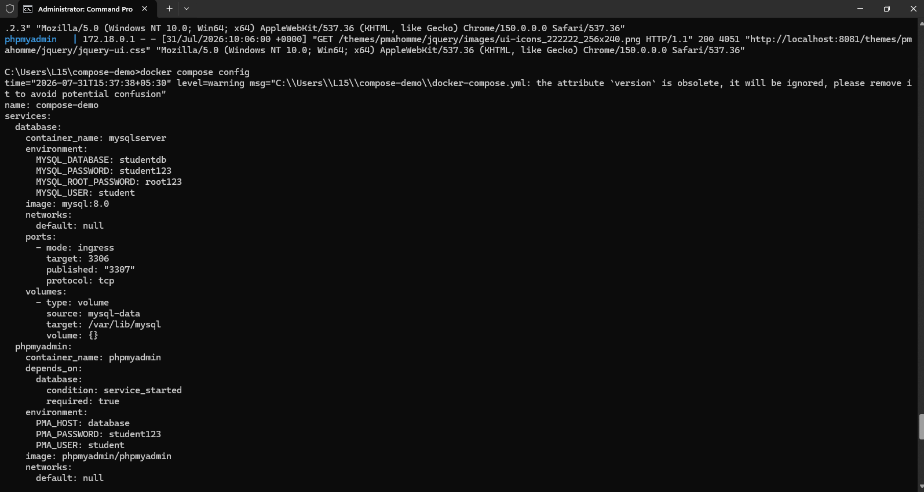
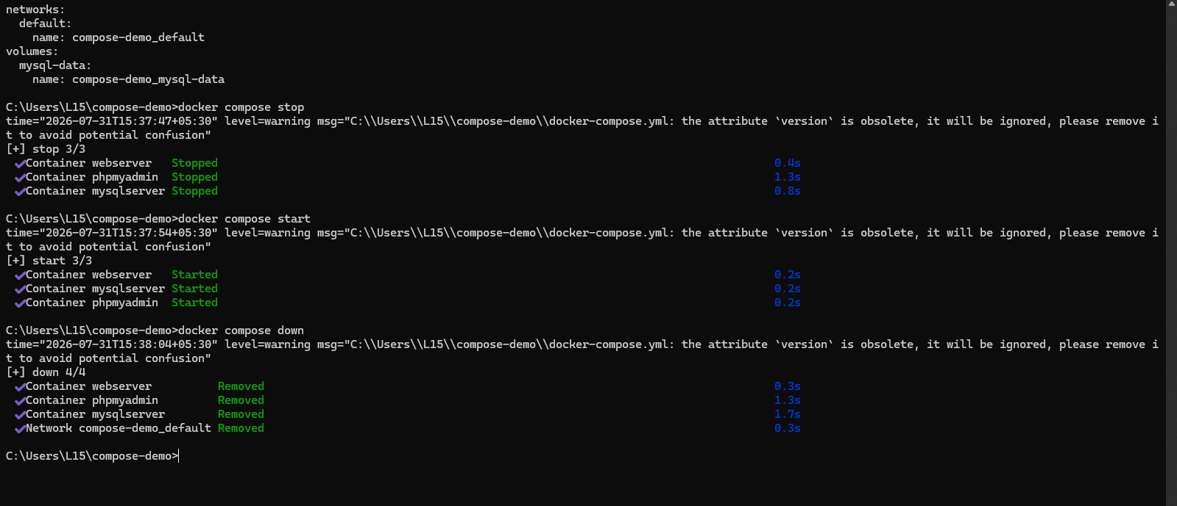
Observations
Sr. No. | Observation
1 | Docker Compose successfully created a multi-container application using a YAML configuration file.
2 | Nginx container was deployed successfully and accessed through port 8090.
3 | MySQL database container was created with persistent volume storage.
4 | phpMyAdmin container was deployed successfully and connected with the MySQL database.
5 | All services communicated through the Docker Compose network.
6 | Docker Compose commands successfully managed the lifecycle of containers.
7 | Images for Nginx, MySQL, and phpMyAdmin were downloaded and used successfully.

Conclusion
The multi-service application was successfully deployed using Docker Compose. The required services, including Nginx web server, MySQL database, and phpMyAdmin, were configured and executed using a single docker-compose.yml file. Docker Compose commands were used to create, start, monitor, and manage the containers efficiently. This experiment demonstrated how Docker Compose simplifies the deployment and management of multiple interconnected containers in a containerized environment.

