2. Docker
05 February 2026
11:26

What is Docker?
Docker is a containerization platform that provides easy way to containerize your applications, which means, using Docker you can build container images, run the images to create containers and also push these containers to container registries such as Docker Hub.
When you run:
docker run ubuntu
It feels like a full OS.
But actually:
  - It contains Ubuntu user-space files
  - It does NOT contain Ubuntu kernel
  - It uses host Linux kernel
So it is:
  - A minimal filesystem
  - Not a complete operating system
Docker downloads filesystem layers, not an OS.
These layers contain:
  - /bin
  - /lib
  - /usr
  - /etc
  - etc.
These are called user-space files.

Why we use Docker?
  - Isolated Environment
  - Rapid App-Development
  - Portability- run in any platform
  - Cost-Effective
  - Security
  - In-built Version Control System
  - Reduces Complexity
Architecture of Docker
Docker daemon - listens for Docker API requests and manages Docker objects such as images, containers, networks, and volumes.
Daemon – communicates with other daemon such as networking.
Docker client (docker)
  - way to interact with Docker.

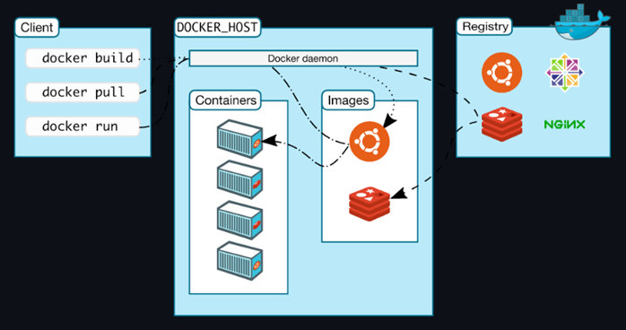
Docker Desktop – App to manage Docker and its services
Docker Desktop is an easy-to-install application for your Mac, Windows or Linux environment that enables you to build and share containerized applications and microservices. Docker Desktop includes the Docker daemon (dockerd), the Docker client (docker), Docker Compose, Docker Content Trust, Kubernetes, and Credential Helper. For more information, see Docker Desktop.
Docker registries - stores Docker images
Docker Hub is a public registry. You can even run your own private registry.
Dockerfile - a file where you provide the steps to build your Docker Image.
Images - read-only template with instructions for creating a Docker container.
An image is based on another image, with some additional customization.
For example, you may build an image which is based on the ubuntu image, but installs the Apache web server and your application, as well as the configuration details needed to make your application run.
Base Image – Foundation layer of every image
Components of Docker

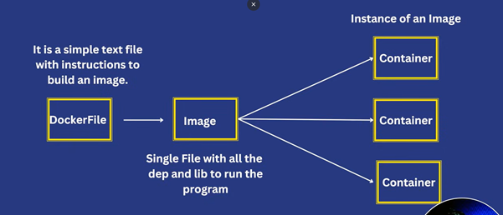
Limitations of Docker
  - Single Point of Failure(SPOF) – Docker Engine Fails, everything stops
  - Layers – which takes a lot of storage.
When a Docker Image is created from Dockerfile, layers are created.
  - Docker Daemon is executed only by root user.
  - It is a monolithic process – everything is managed by docker daemon.

1. Containerization
06 February 2026
10:44

Containerization
History
Started back in 2008, Linux kernel introduced control groups or C-groups.
What is Containerization?
A lightweight software deployment technique that packages an applications’ code, libraries and dependencies into a single, portable unit called “containers”.
Architecture of Containers and Virtual Machines

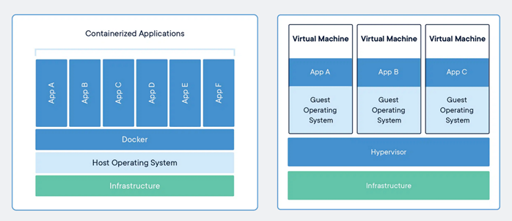
Illustration to explain this à
Assume we want to run a simple Node.js file.
Virtual Machine
  - Resources
  - We need Host OS + Hypervisor to run VM + (Guest OS + Librarys + Applications + Node.js Files)
  - So lot of resources is being utilized just to run a simple Node.js application.
Why the need of Containerization?

1) Faster Development & Deployment
In modern software:
  - Developers deploy many times per day
  - Apps scale quickly
  - Microservices architecture is common
VMs are too slow and heavy for this.
Containers:
  - Start instantly
  - Easy to scale
  - Easy to move between environments
2) Large Storage Size
  - OS files are big.
  - A single VM image can be 10–20 GB.
  - Containers are usually MBs, not GBs.
On a server with:
  - 16 GB RAM
You can run:
  - Maybe 4–5 VMs
  - But 50+ containers
Containers share the host OS → less memory waste.
3) Portability (Big Reason)
"Works on my machine" problem.
Containers package:
  - App
  - Dependencies
  - Libraries
  - Runtime
So it runs the same:
  - On Developer laptop
  - On Testing server
  - On Production server
VMs can do this, but they are large and slow to move.
4) Slow Startup Time
  - VM has to boot the full OS.
  - Booting takes 1–2 minutes.
Containers start in seconds.
5) More CPU & RAM Usage
Since every VM runs a full OS:
  - More background processes
  - More memory consumption
  - More CPU usage

Real-World Analogy
Imagine:
VM = Each app gets its own full apartment building
Container = Apps get separate rooms inside one building
If you need 100 small apps:
  - 100 buildings (too expensive)
  - 100 rooms in one building (efficient)
Question – Why not Dynamic allocation of resources using VM?

Short answer:
Yes, we can.
But it is inefficient.
Now let’s break it down clearly.
Yes, You Can Package Apps in VMs
You can create:
  - 1 VM
  - Install app + dependencies
  - Save it as a VM image
  - Deploy it anywhere
So technically — yes, VMs can package applications.
Then Why Not Just Use VMs?
Because of overhead.
Let’s compare what actually gets packaged.

What a Container Packages
App
Libraries
Dependencies
Runtime
That’s it.
It uses:
  - Host kernel
  - Host OS core
What a VM Packages
App
Libraries
Dependencies
Full Operating System
Kernel
System Services
Background Processes
You’re packaging an entire machine.
📊 Memory Difference (Real Reason)
Imagine:
Linux OS consumes ≈ 1–2 GB RAM.
If you create:
5 VMs
Each VM needs:
  - 1–2 GB for OS
  - app memory
That alone consumes 5–10 GB just for OS.
50 Containers
They share:
  - Same kernel
  - Same OS memory
Only app memory is separate.
👉 That’s why containers are more efficient.
Deep Technical Reason
VM virtualization = Hardware-level virtualization
Containerization = OS-level virtualization
VM must:
  - Emulate hardware
  - Run separate kernel
  - Maintain separate system processes
Container:
  - Just isolates processes
  - No hardware emulation
  - No extra OS boot
🏢 Real life Analogy
VM = Buying 10 separate laptops
Container = Creating 10 user accounts on 1 laptop
Both work.
But which uses less resources?
When VMs Are Better
Important point (balanced view):
VMs are better when:
  - You need different OS types
  - Strong security isolation
  - Kernel-level changes
Containers are better when:
  - Running microservices
  - CI/CD pipelines
  - High scalability
  - Cloud-native apps

🎯 Final Answer
Yes, VMs can package applications.
But:
  - VMs duplicate the entire OS each time.
  - Containers share the host kernel.
  - This reduces RAM usage.
  - This increases density.
  - This improves startup time.
Containers are not replacing VMs.
They are optimizing application deployment.

Containers VS Virtual Machine

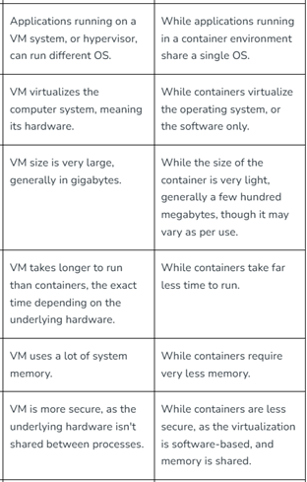

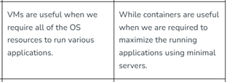
Why are containers light weight ?
Containers are lightweight because they use a technology called containerization, which allows them to share the host operating system's kernel and libraries, while still providing isolation for the application and its dependencies. This results in a smaller footprint compared to traditional virtual machines, as the containers do not need to include a full operating system. Additionally, Docker containers are designed to be minimal, only including what is necessary for the application to run, further reducing their size.
Example:
Below is the screenshot of official ubuntu base image which you can use for your container. It's just ~ 22 MB, isn't it very small ? on a contrary if you look at official ubuntu VM image it will be close to ~ 2.3 GB. So the container base image is almost 100 times less than VM image.

From <https://onevirtualoffice-my.sharepoint.com/personal/krish_modi_external_atlascopco_com/Documents/Desktop/Resources/Docker/Docker%20Complete%20Resource.docx>

3. Commands for Docker
19 February 2026
09:03

Dockerfile - General Commands
FROM - Base Image
WORKDIR – Working Directory
COPY – Copying all the files to
RUN – Run the following commands to install required dependencies or libraries
ENTRYPOINT – Will have non-override Values [Ex: “python3”]
CMD – Command run at the time of docker containers
Ex: CMD[“python3”, “myapp.js”]

Commands for Docker
  - docker build -t <tag-name/repo-name:tag or version>
Ex: docker build -t krish/my-first-docker:latest
  - docker run -d -p <localhost-port:container_port> -it --rm --name <name of the container> -e <Environment Variables> <image_id/image_name>
OR
docker run -d \
-p <localhost-port:container_port> \
-it --rm --name <name of the container> \
-e <Environment Variables> \
<image_id/image_name>

  - -d ==> detached mode(Running in Background)
  - -p ==> port binding
  - -it ==> interactive mode
  - --rm ==> auto-remove once stopped
  - --name ==> name of the container\
  - -e ==> Environment Variables
Ex: docker run -d -p 80:80 -it --rm --name first-container krish/my-first-docker:latest
  - docker images or docker image ls
  - docker ps
    - ps = process status
  - docker stop <container-name/container-id>
  - docker start <container-name/container-id>
  - docker rm <container-name/container-id> --> remove a container
  - docker rmi <image-name/image-id> --> remove an image
  - docker inspect <container-id> --> check the details of container
  - docker tag <old-image-name> <new-image-name> --> rename an image
  - Running command inside a running container
    - docker exec -it <container-name> /bin/bash
      - /bin/bash - running in bash script
  - docker logs <container-name/id> --> get the logs of running a container
  - docker attach <container-name/id> --> get the live updates happening on running a container

Commands to connect to Central Repository
  - docker login
    - Username
    - Password
  - docker push username/<image-tag>
  - docker pull username/<image-tag:version>
    - By default latest version is pulled

Commands for Docker Volume
  - docker volume create <volume-name>
  - docker volume ls
  - docker volume inspect <volume-name> --> all the details of the volume
  - docker volume rm <name1> <name2> ….
  - docker volume --help
  - docker -v <src:destination:other-parameters>
Ex: docker run -it --rm -v volume1:/myapp/ dhc-first-project
  - docker --mount source=<src>,target=<destination> <image-id>
Ex: docker run -it --rm --mount source=krish,target=myapp/ dhc-first-project

Docker Bind Mount
  - docker run -v <pwd>:/<target> <Image-id>
    - pwd = print working directory
    - target = bind to that file or folder
  - No new Volume is created

Docker Networking
  - docker network create -d <driver> <network-name>
    - drivers
      - bridge(default) - Bridge between host and container
      - host - Container and Host have same subnet or IP Address
      - User-defined(Custom) - Defined by user
      - none - Completely isolated, no internet, no interaction with any other container or host
      - overlay - connect multiple Docker daemons together.
      - ipvlan - Communicate over 2 IP Address(Cluster related)
      - macvlan - Communicate over 2 Mac Addresses(Cluster related)
  - docker run -d -it --net or --network <network name> <image-id>
  - docker network connect <network-name> <container-name> --> Adding a running container to specific network
  - docker network disconnect <network-name> <container-name> --> Removing a running container from specific network
  - docker network ls
  - docker network rm <network name>

Adding Ping command to any running container
Steps
  - Run docker image
  - docker exec -it <container-image> /bin/bash
  - apt update
  - apt-get install iputils-ping -y
  - ping -V
  - ping <IP Address of other containers>
  - docker inspect <container-id> --> Get the IP of that container under network

Docker-Compose
  - docker-compose -f <filename> --project-name <project/directory-name> up -d
  - docker-compose -f <filename> -p <project/directory-name> up -d
  - docker-compose -f <filename> --project-name <project/directory-name> down -d
  - docker-compose -f <filename> --project-name <project/directory-name> stop -d
  - docker-compose -f <filename> --project-name <project/directory-name> start -d
  - Barest Minimum --> In case of file name is docker-compose.yaml
    - docker-compose up

4. Multi-Stage Docker Build
19 February 2026
09:04

Why you need a multi-stage docker build?
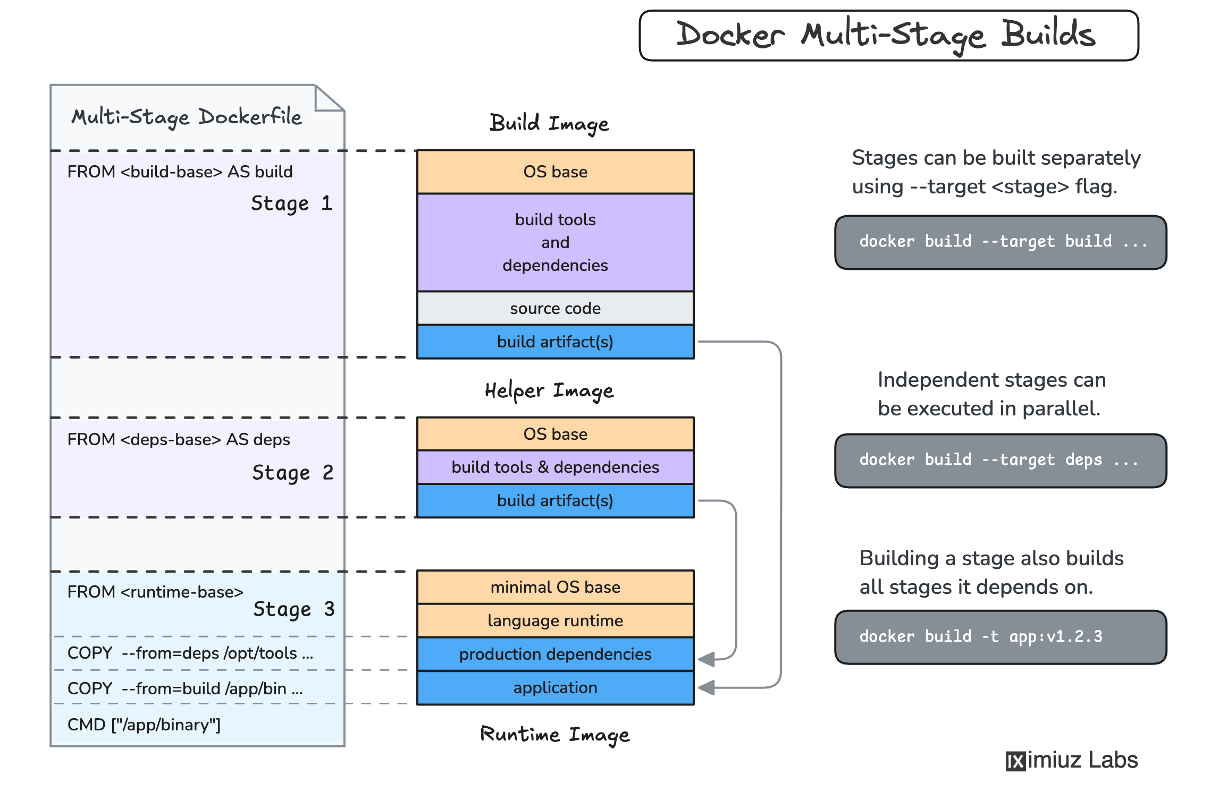

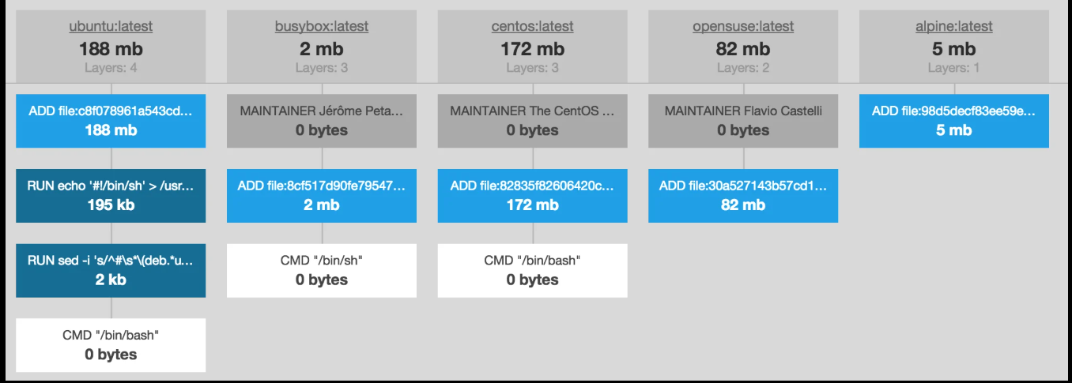

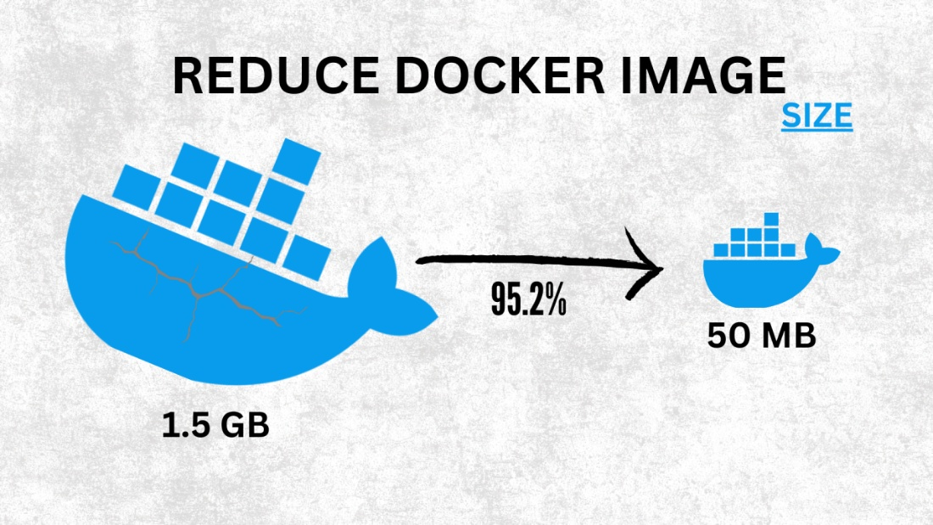
A multi-stage Dockerfile lets you use multiple FROM statements in one file to separate:
  - Build environment (compiler, npm, maven, etc.)
  - Runtime environment (only the app + minimal dependencies)
This feature is provided by Docker to solve real production problems.

Simple Analogy
Think of it like cooking:
  - Kitchen (build stage) → you prepare food
  - Dining table (runtime stage) → you only serve food
You don’t bring the stove and utensils to the table.

Distroless Image
  - Very minimalist and light-weight images that has only runtime environments.
  - It increases security as it doesn't have OS related vulnerabilities
  - Even ls,cd,mv etc basic commands won't work.

The Main Reasons We Need Multi-Stage Builds
To Reduce Image Size
Without multi-stage:
  - You install build tools (gcc, node, maven, etc.)
  - They stay inside the final image
  - Image becomes huge
With multi-stage:
  - Build tools exist only in the build stage
  - Final image contains only the compiled output
  - Result → smaller image (sometimes 70–90% smaller)
Smaller image = faster pull + faster deployment.

To Improve Security
Build tools are unnecessary in production.
If they remain:
  - More packages
  - More attack surface
  - More vulnerabilities
Multi-stage removes everything except what is strictly required.
👉 Fewer vulnerabilities in production.

To Separate Concerns (Clean Architecture)
Instead of:
One messy Dockerfile
You get:
Stage 1 → Build
Stage 2 → Runtime
This makes your container:
  - Cleaner
  - More professional
  - Easier to maintain

To Optimize CI/CD Pipelines
In CI systems:
  - Smaller images = faster push/pull
  - Less storage cost
  - Faster deployments in Kubernetes

Real Example (Without vs With Multi-Stage)
Without Multi-Stage (Bad for production)
FROM node:18
WORKDIR /app
COPY . .
RUN npm install
RUN npm run build
CMD ["npm", "start"]
Problem:
  - node_modules (dev dependencies)
  - Build tools
  - Unnecessary files
  - Big image

With Multi-Stage (Production-ready)
# Build stage
FROM node:18 AS builder
WORKDIR /app
COPY . .
RUN npm install
RUN npm run build
# Runtime stage
FROM nginx:alpine
COPY --from=builder /app/dist /usr/share/nginx/html
Final image:
  - No npm
  - No source code
  - No build tools
  - Only static files

When Is Multi-Stage Most Useful?
  - Go applications
  - Java (Maven/Gradle builds)
  - Node frontend builds
  - C/C++ apps
  - Production containers

Practical Implementation
Golang File
  - Without Multi-Stage

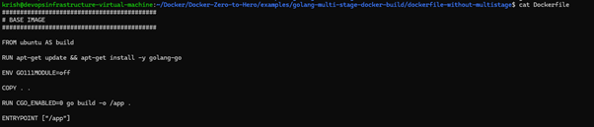

Storage used without Multi-Staged

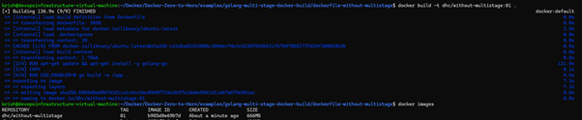

  - With Multi-Stage
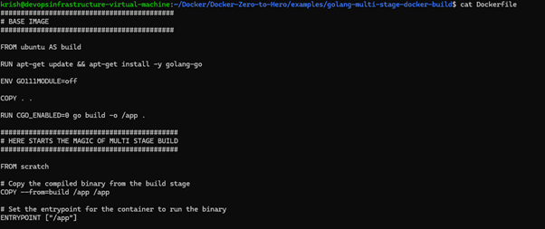
Storage used with Multi-Stage

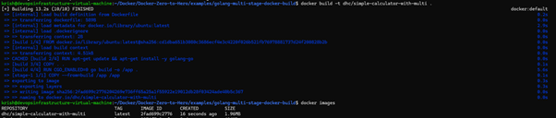

5. Docker Volumes
19 February 2026
09:04

Why we need it?
When you use Docker, containers are temporary. If you delete a container, all data inside it disappears — unless you use special ways to save that data outside the container.
Docker gives you two main methods to store data permanently so it survives even if the container is removed.
  - Docker Volume
Think of a volume like a special folder that Docker creates and manages for you.
  - In /var/lib/docker/volumes, the volumes are stored.
  - Volume can be assigned to one or more containers.
Easy way to think about it:
  - Your container is a laptop.
  - A volume is like plugging in an external hard drive.
  - Even if you throw away the laptop (delete the container), the external drive (volume) still holds the data.
Why use volumes?
  - They are safe, fast, and controlled by Docker.
  - Perfect for databases (Postgres, MySQL, MongoDB)
  - Docker Bind Mounts
A bind mount directly connects a folder on your computer (the host) to a folder inside the container.
On the host computer, a bind mount can be located anywhere.
Easy way to think about it:
  - Your container is a laptop.
  - A bind mount is like reading/writing files from a shared network folder on your main computer.
  - If you delete the laptop (container), your computer still has the files.
Why use bind mounts?
  - Great for development.
  - When you edit code on your machine, the container sees the changes instantly.

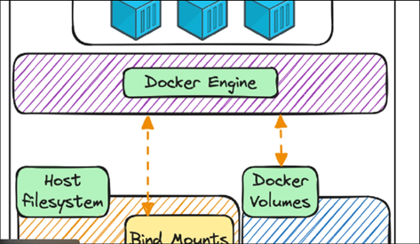

Practical Implementation Of Docker Volume
  - File Structure

  - Myapp.js

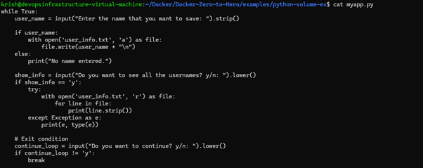
  - Dockerfile

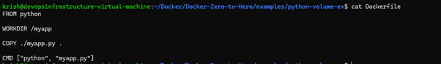

  - Creating Docker Image

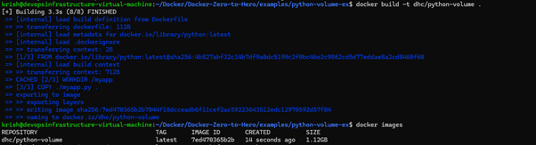

  - Running docker container

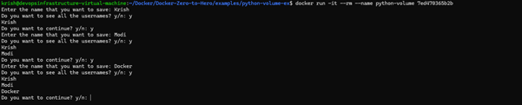

Contents of user_info while container is still running

User_info gets-empty once container is killed.
So cause of this, docker Volumes came into actions.
  - Creating Docker Volume

Running docker Container

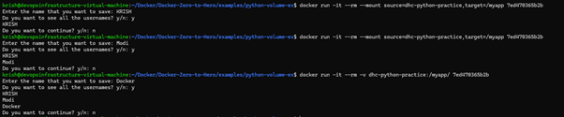
OR
Creating and running container at the same time

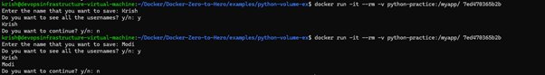

From <https://onevirtualoffice-my.sharepoint.com/personal/krish_modi_external_atlascopco_com/Documents/Desktop/Resources/Docker/Docker%20Complete%20Resource.docx>

6. Docker Bind Mount
19 February 2026
09:05

Use Case:
Used when we want changes made in our files or folders, reflect directly in our docker container without creating new docker image.
No new Volume is created.
Data is directly changed inside file
Syntax
Docker run -it -v <file-path>:/<workdir> <container-name>
Practical Implementation Of Docker Bind Mount
- Create a docker image
- Run the docker container with mount
Before Bind Mount

After Bind Mount
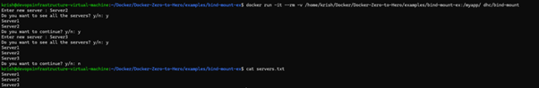

7. Docker Networking
19 February 2026
09:09

Bridge Networking
When Docker Engine on Linux starts for the first time, it has a single built-in network called the "default bridge" network.
When you run a container without the --network option, it is connected to the default bridge.
Why it is called Bridge Networking?
  - It is called a bridge network because a container has a different subnet and a host has different subnet, and using default network, container talks to host.
So it acts like a bridge between container and host.
  - This bridge is Virtual Ethernet (Veth)
  - If bridge is distorted or manipulated, the container becomes non-reachable.
Explanation of Docker Networking
Each student:
Has a name
Has an ID number
Can talk to others
Can also go outside the school (internet)
Now let’s break it down.
1. The Default Bridge Network (The Main School Hallway)
When Docker starts for the first time, it creates one main “hallway” called the default bridge network.
All containers (students) go into this hallway unless you tell Docker otherwise.
Inside this hallway:
Containers can talk to each other using IP addresses (like student ID numbers)
They cannot call each other by name
They can access the internet if the host computer can
Traffic flow:
Container → veth → docker0 → Host → NAT → Internet
Example:
docker run --rm -ti busybox ping -c1 docker.com
This means:
Start a small container
Ask it to check if docker.com is reachable
It works because it has internet access
2. Internet Access (Masquerading)
When containers go to the internet:
They don’t go directly
They go through the host computer
The host “pretends” to be them
This pretending is called masquerading.
It’s like:
A student asking the teacher to order pizza instead of calling the pizza shop directly.
3. User-Defined Networks (Private Friend Groups)
Now imagine you want:
One group of friends to talk freely
But not talk to other groups
You can create a custom network:
docker network create -d bridge my-net
Now containers inside my-net:
Can talk to each other
Can use names instead of IP addresses
Are separated from containers not in this network
Example:
docker run --network=my-net -it busybox
Now this container is inside your private group.
🧠 Simple Summary for You
Default bridge = One big common room
User-defined network = Private friend groups
Containers can access the internet by default
Custom networks allow name-based communication
Why User-Defined Networks Are Preferred
Service discovery via embedded DNS
Network-level isolation between stacks
Cleaner microservice architecture
No manual linking required
Better security boundaries
Practical Architecture Example
Imagine:
frontend container
backend container
database container
You would:
docker network create app-net
Attach all three to app-net.
Now:
frontend → backend (by name)
backend → database (by name)
No other containers can access them unless attached

Practical Implementation of Docker Networking
  - Bridge Networking
Container 1 à dhc-login
  - Running Docker container

  - Install ping
    - Docker exec -it dhc-login /bin/bash

  - Apt updates

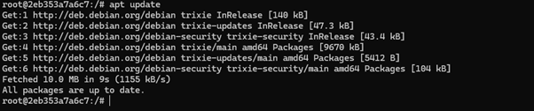

  - apt install iputils-ping -y

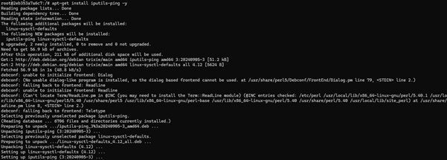

  - ping -V

Container 2 à dhc-logout
  - Running Docker container

  - Install ping
    - Docker exec -it dhc-login /bin/bash

  - Apt updates

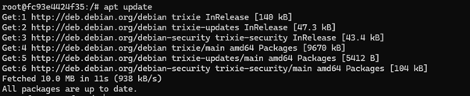

  - Apt-get install iputils-ping -y

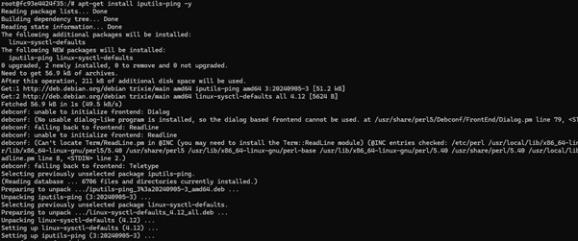

  - ping -V

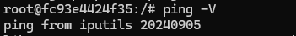

  - docker inspect dhc-login

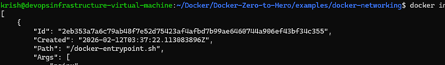

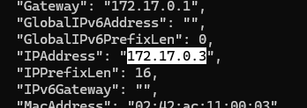

Docker inspect dhc-logout

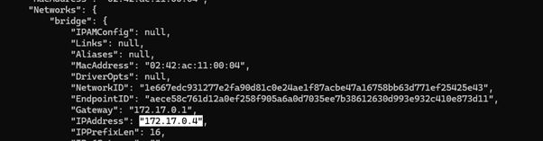

  - login container interacting with logout container

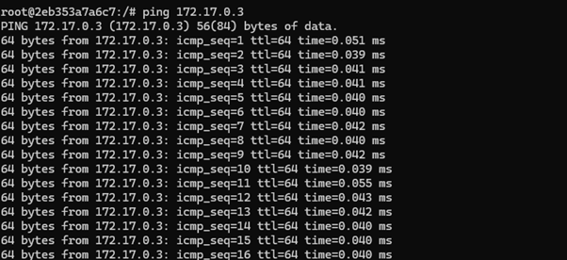
  - User-defined Networking
  - Create new network à security-network

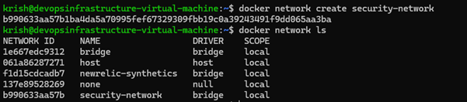
  - Creating a new container with the above network

  - Inspecting this container – type: security-network, IPAddress

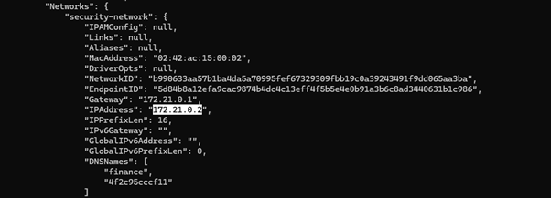
  - Trying to access this container from dhc-login container

  - Now adding dhc-login container to security-network

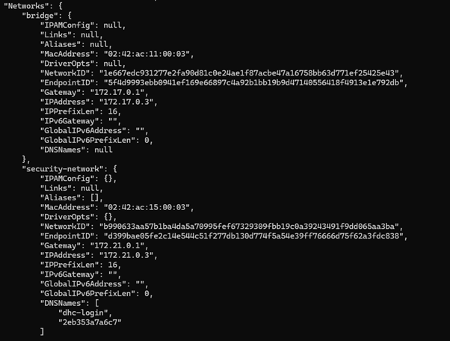
  - Login container interacting with finance container

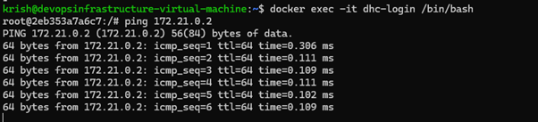
  - Disconnecting dhc-login from Security-network


  - Creating host driver-network

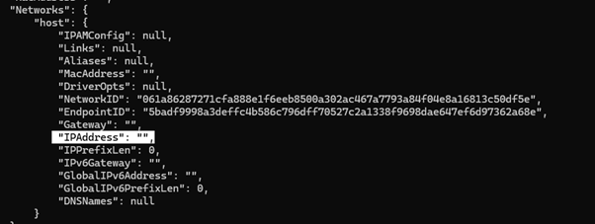

From <https://onevirtualoffice-my.sharepoint.com/personal/krish_modi_external_atlascopco_com/Documents/Desktop/Resources/Docker/Docker%20Complete%20Resource.docx>

8. Docker Compose
19 February 2026
09:10
What is Docker compose?
èDocker compose is a tool for defining and running multi-containers applications.
Why we need Docker Compose?
Illustration
èConsider we want to run E-commerce Website
Structured -
There are multiple containers to be build
  - Transactions
  - Payments
  - Login/app
  - Pytorch/App
  - DataBase
  - Catalogue
  - Caching
  - Also, there might be dependencies such as, Payments is only possible if Database is connected.
  - Also if Database is off, catalogue is not available.
Multiple Containers lifecycle
  - Start/ Stop all container
  - Delete all container
  - Rebuild a container
  - Status of running containers
As a result, we use Docker-Compose, as it helps maintaining multiple containers lifecycle.
  - Rapid Application Deployment – Dependency into consideration
  - Simplified Control – Running, Maintaining many containers, build and run
  - Efficient Collaboration – YAML File
  - Portability across Environments
  - Docker-Compose Supports variables
MAIN Advantage
  - Developer needs to know only one command
docker-compose -f <fileName> up -d
docker-compose -f <fileName> down
Commands
  - docker-compose --project-name <project-name> -f <filename> up -d
  - docker-compose -p <project-name> -f <filename> up -d
  - docker-compose -f <filename> down
  - docker-compose -f <filename> stop/start
Practical Implementation of Docker-Compose
  - Using Docker
Step 1: Create docker network
docker network create mongo-network
Step 2: start mongodb
docker run -d -p 27017:27017 -e MONGO_INITDB_ROOT_USERNAME=admin -e MONGO_INITDB_ROOT_PASSWORD=password --name mongodb --net mongo-network mongo
Step 3: start mongo-express
docker run -d -p 8081:8081 -e ME_CONFIG_MONGODB_ADMINUSERNAME=admin -e ME_CONFIG_MONGODB_ADMINPASSWORD=password --net mongo-network --name mongo-express -e ME_CONFIG_MONGODB_SERVER=mongodb mongo-express
NOTE: creating docker-network in optional. You can start both containers in a default network. In this case, just emit --net flag in docker run command

  - Using Docker-Compose

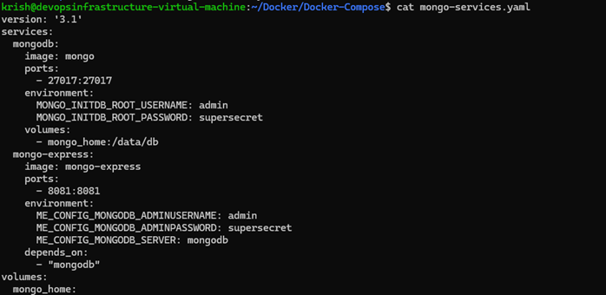
To start the application
Step 1: start mongodb and mongo-express
docker-compose -f mongo-services.yaml up -d
You can access the mongo-express under localhost:8080 from your browser
Step 2: open mongo-express from browser
http://localhost:8081

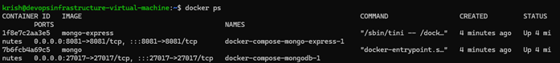

EXAMPLE 2 à Connecting my Own Web Application
Change in Docker-Compose File

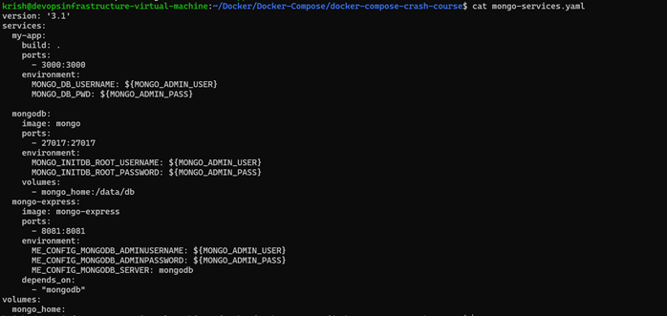

As mongo and mongo-express were already running, we run the compose file to that container directly.

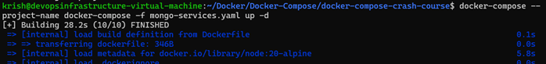
Docker Allows Variables

From <https://onevirtualoffice-my.sharepoint.com/personal/krish_modi_external_atlascopco_com/Documents/Desktop/Resources/Docker/Docker%20Complete%20Resource.docx>

19 February 2026
10:38

