Functional user test
Co-ordinator
Royal Softech College · School platform
Royal Softech College on the school platform. Every operation a Co-ordinator can do, end to end through the real screens, with a screenshot of each step. Second run, on 3 October 2026 (17 Ashwin 2083) against commit ef145bc on a fresh local school, after the first run's findings were fixed and the Co-ordinator's screens were redesigned in the Principal's design language (D-106). The Principal's FUT is in ../admin/.

Contents
Summary
How the test was run
1. First sign-in
2. Setup: the year, terminals and subjects
3. Setup: curriculum
4. Setup: classes
5. People: teachers
6. People: teaching assignments
7. Admissions: walk-ins
8. Admissions: the queue
9. Admissions: search
10. Attendance
11. Classwork and electives
12. Results: review, send back, verify and publish
13. Results: rechecks
14. Website: drafts for the Principal
15. Own account, and what a Co-ordinator must not do
16. A Co-ordinator for one section only
17. Phone, large text and the end of the run
Findings
What the Co-ordinator can do, and where it was tested
Not covered

Summary
- 156 steps with a screenshot each, in 17 areas, plus 19 server checks (things she must not do, and what a one-section Co-ordinator can reach).
- 156 steps behaved as expected.
- All 12 findings of the first run are fixed, and each is checked again here at the step named in Findings.
- No new findings in this run.
- Every forbidden action was refused by the server, and the Bachelor's-only Co-ordinator could reach nothing of +2. Permission is never left to the screens alone.

How the test was run
- School: a fresh local copy (wrangler dev, local D1), the Royal Softech pack provisioned. The Principal had made the sections (+2, Bachelor's), the programmes with their levels and grading (+2 Science and +2 Management: NEB GPA; BBS: percentage and division), and three staff: Co-ordinator Sita Sharma (whole school, the person under test), Co-ordinator Hari Prasad Yadav (Bachelor's only) and Accountant Gita Thapa (precondition P0).
- The Co-ordinator: every step was done in a real browser (Chromium through Playwright) on the real screens, signed in as Sita Sharma.
- Everyone else: work only another person can do (applicants, the Accountant, teachers, students, the Principal) was done through the same API their screens use, signed in as those people, each with their own first-sign-in password change. These are listed as preconditions P0 to P5 where they happen; they are not part of the Co-ordinator's test.
- Observed: the messages on screen at each step (notices, errors) were recorded as they appeared and are quoted under each screenshot.
- Screens: 1440 px wide unless noted. Times are Nepal time. All names, emails, phone numbers and passwords are made up.
- Re-running: the scripts are in scripts/; run-all.sh runs every area and precondition in order on a fresh school.

Test data
What | Made by | Detail
Year, terminals | Co-ordinator (02) | 2083, 1 Baisakh to 30 Chaitra; First terminal, Second terminal, Final
Subjects | Co-ordinator (02) | English, Nepali, Physics, Chemistry, Mathematics, Biology, Computer Science, Business English, Financial Accounting, Micro Economics, Moral Education
Curriculum | Co-ordinator (03) | +2 Science Grade 11: five subjects for all and a Science option (Biology or Computer Science, pick 1), theory and practical marks; Grade 12: five subjects; BBS Year 1: three subjects
Classes | Co-ordinator (04) | +2 Science Grade 11 A and B, Grade 12 A, BBS Year 1 (a +2 Management class made and deleted)
Teachers | Co-ordinator (05, 06) | Bikash Chaudhary, Anita Mandal, Suresh Karki, Kamala Rai (+2); Puja Singh, Rajan Sah (Bachelor's); Class Teachers Bikash (11 A), Kamala (11 B), Anita (12 A), Puja (BBS 1)
Students | Co-ordinator (07, 08) | 14 walk-ins (a second registration of Aarav Mandal was stopped as a duplicate) and two approved from the queue (Pooja Sharma, Ritu Gupta): 2083-00001 to 2083-00016
Applications | Public, Accountant (P1) | Pooja Sharma (approved), Rajesh Yadav (changes asked), Sunil Thapa (rejected), Sita Choudhary (possible duplicate, rejected), Ritu Gupta from the Accountant (approved)
Results | Teachers (P3), Co-ordinator (12) | Grade 11 A and BBS Year 1 first terminal published; two rechecks

1. First sign-in
The Principal made Sita Sharma a Co-ordinator for the whole school. She signs in with the temporary password and must choose her own.
# | Step | Observed on screen | Result
01-01 | The sign-in page | – | Pass
01-02 | A wrong password is refused without saying which part is wrong | The email or password is not correct. Check them and try again. | Pass
01-03 | First sign-in with the temporary password from the Principal: she must choose her own password | – | Pass
01-04 | The temporary password itself is refused | That is your temporary password. Choose a different one. | Pass
01-05 | Under 10 characters is refused | Use at least 10 characters. | Pass
01-06 | A common password is refused | That password is too common. Choose a less common one. | Pass
01-07 | A password containing her email name is refused | Do not use your email name in your password. | Pass
01-08 | A password containing the school's name is refused | Do not use your school's name in your password. | Pass
01-09 | Signed in: the Co-ordinator's dashboard on a school that has programmes but no year, classes or teachers yet | – | Pass

01-01 The sign-in page
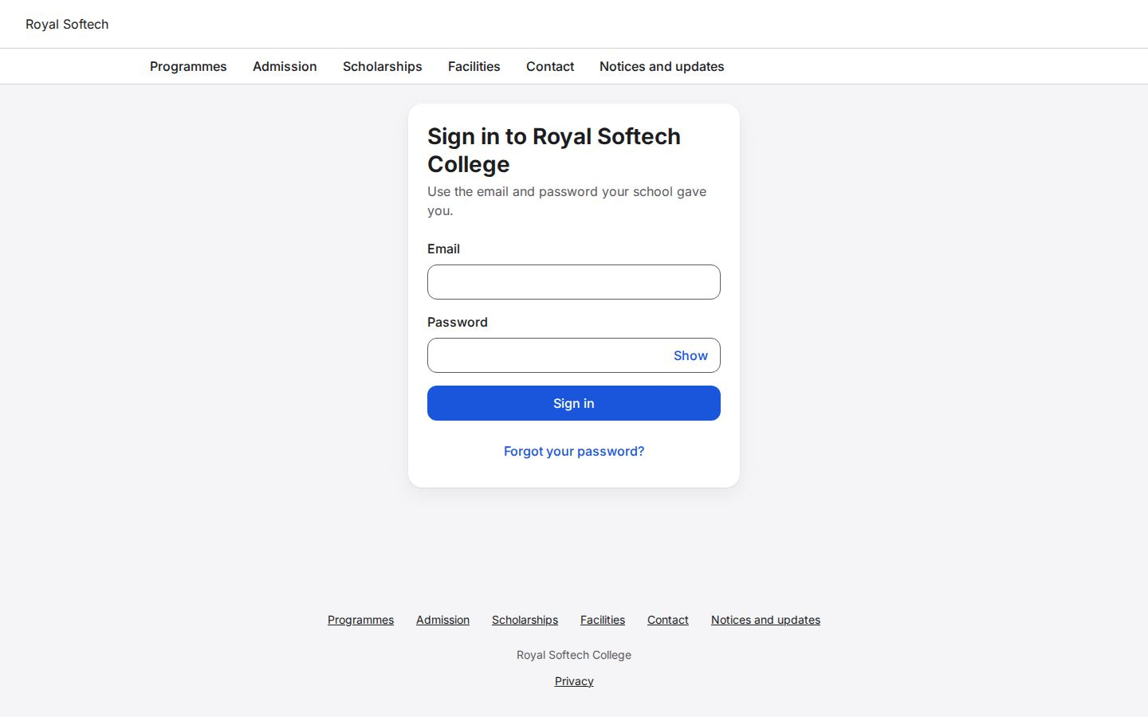
01-02 A wrong password is refused without saying which part is wrong
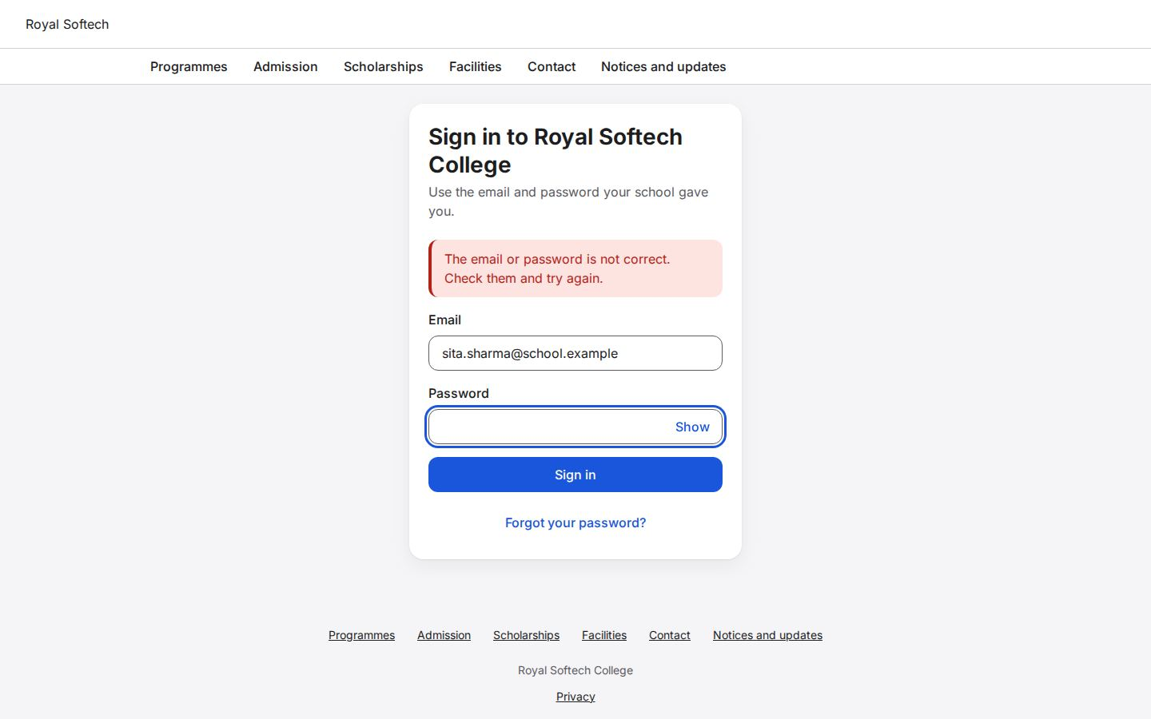
01-03 First sign-in with the temporary password from the Principal: she must choose her own password
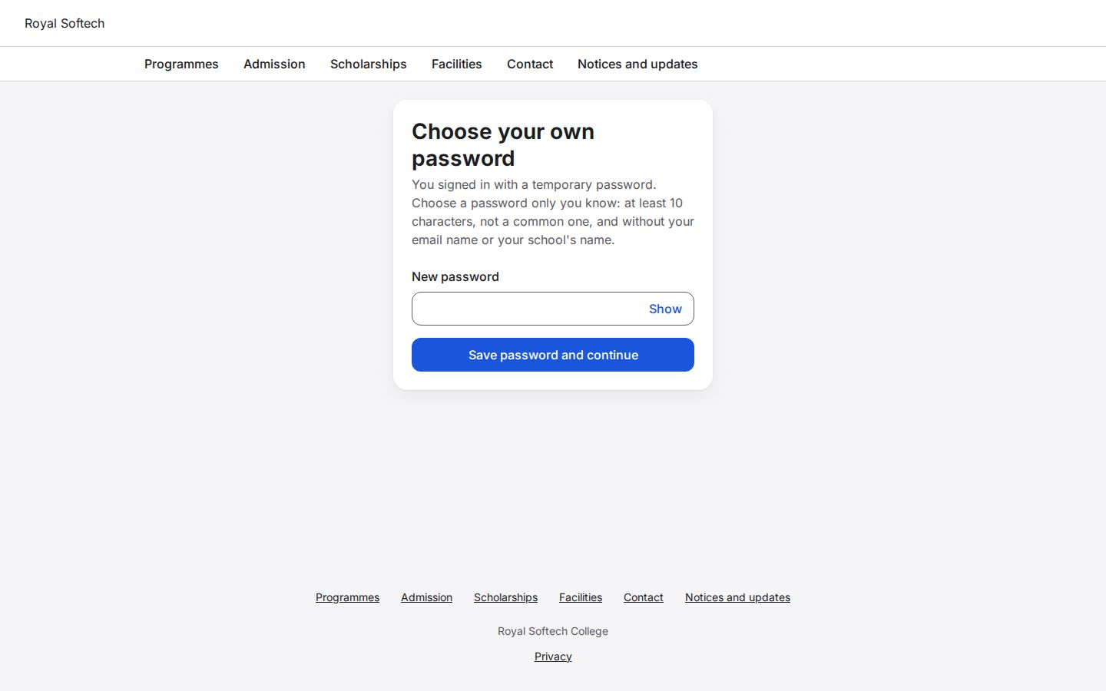
01-04 The temporary password itself is refused
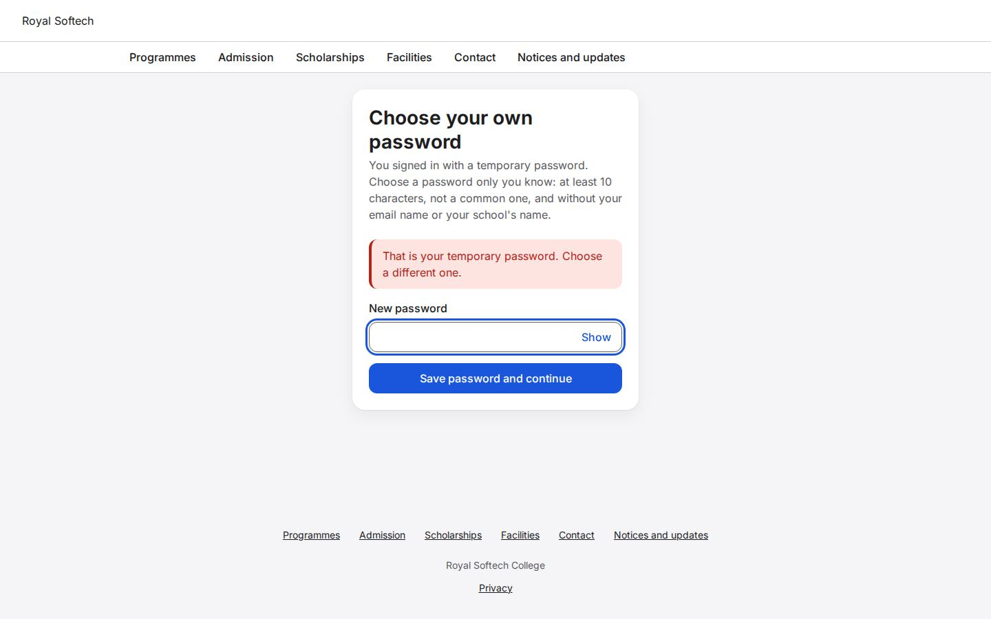
01-05 Under 10 characters is refused
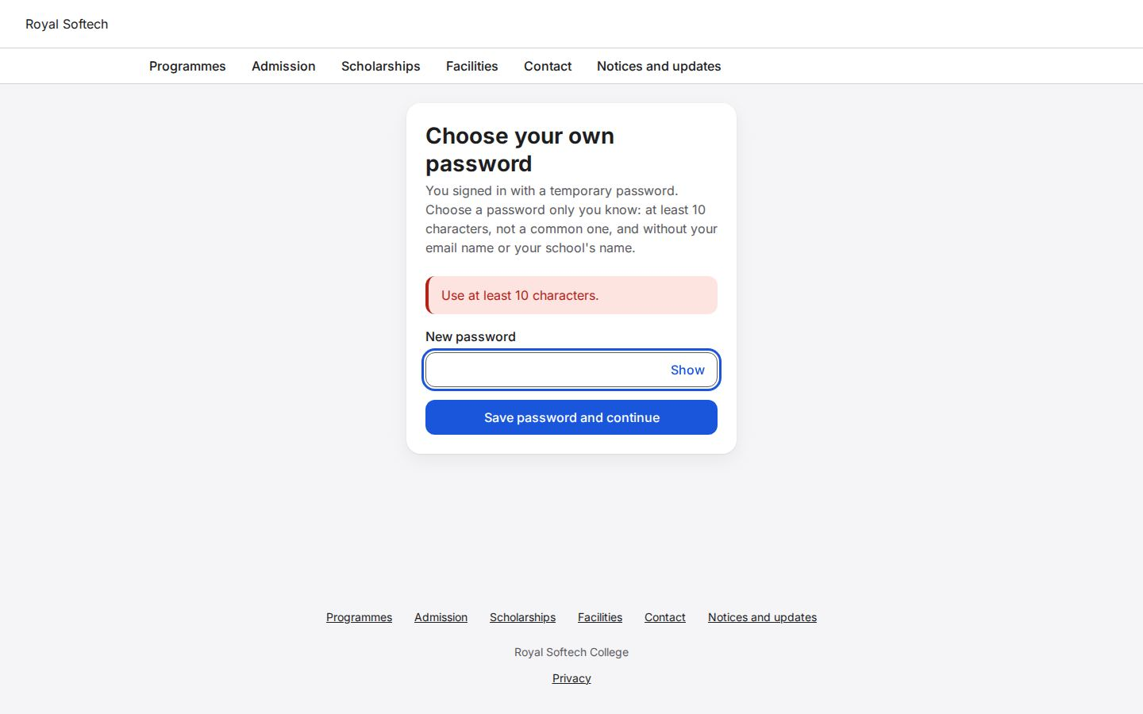
01-06 A common password is refused
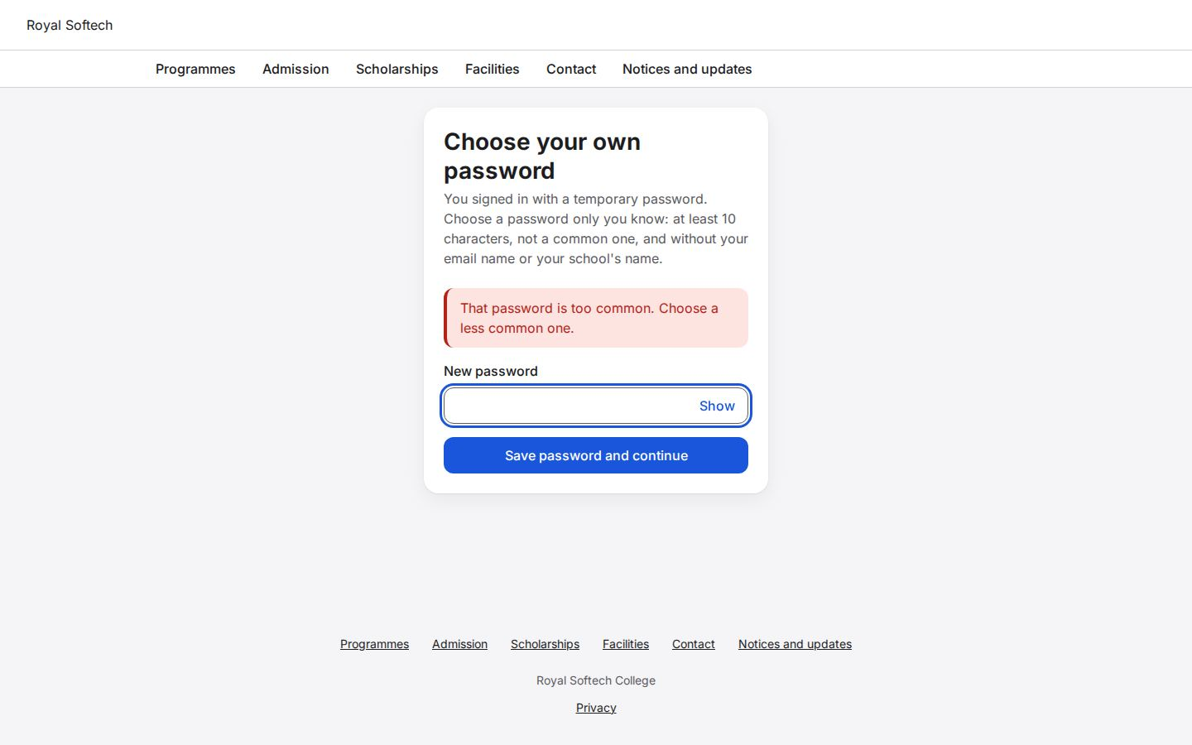
01-07 A password containing her email name is refused
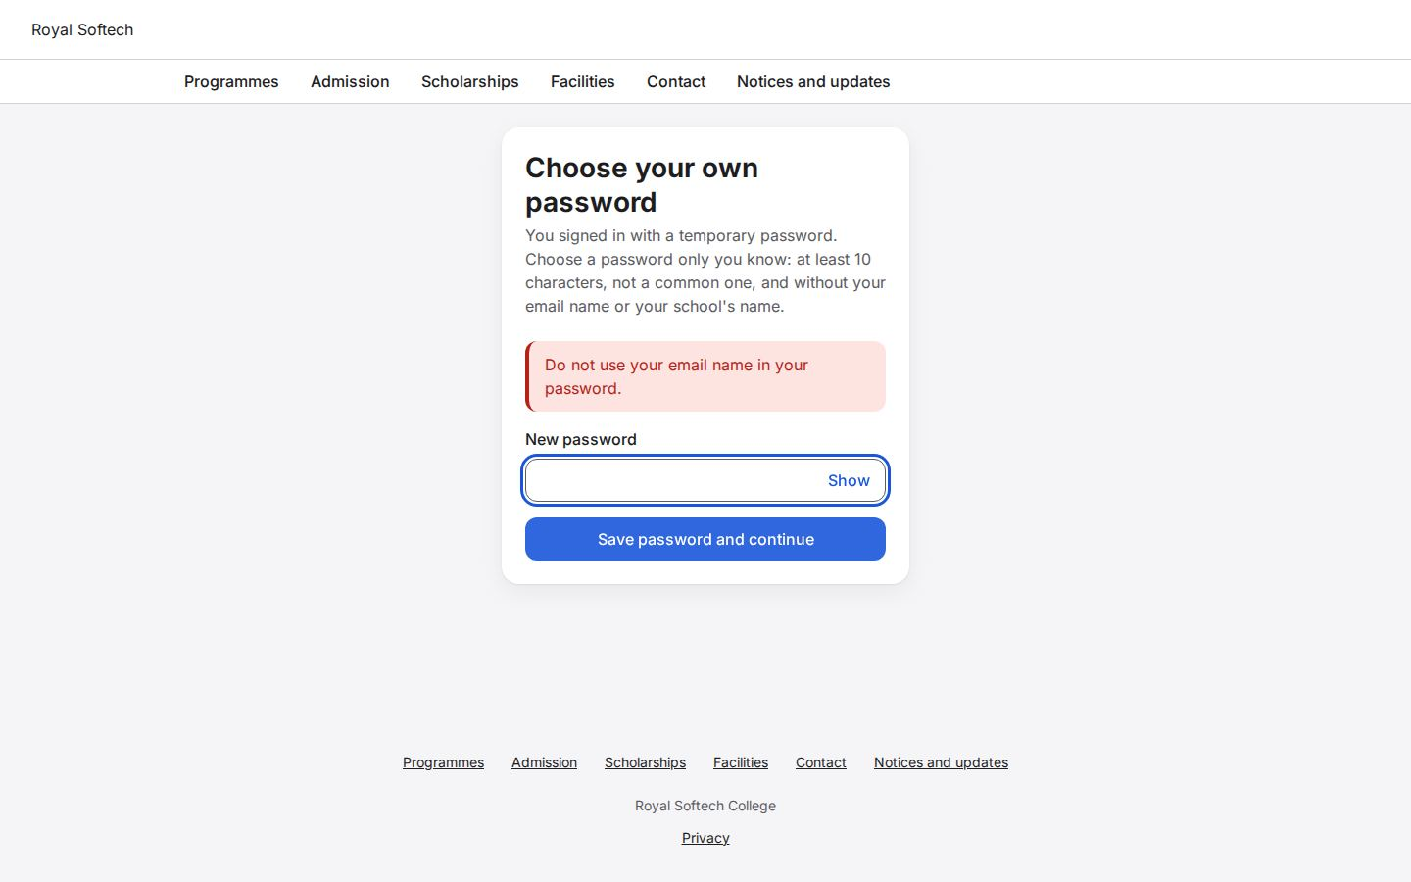
01-08 A password containing the school's name is refused
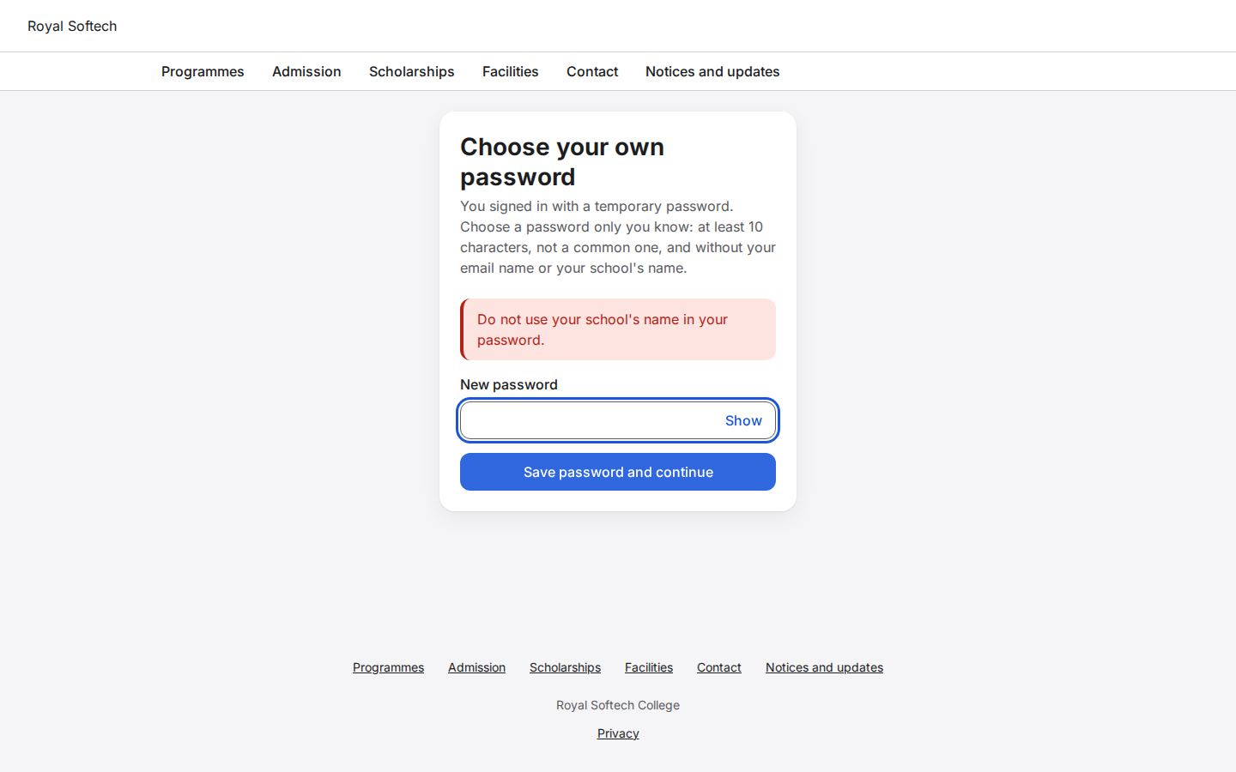
01-09 Signed in: the Co-ordinator's dashboard on a school that has programmes but no year, classes or teachers yet
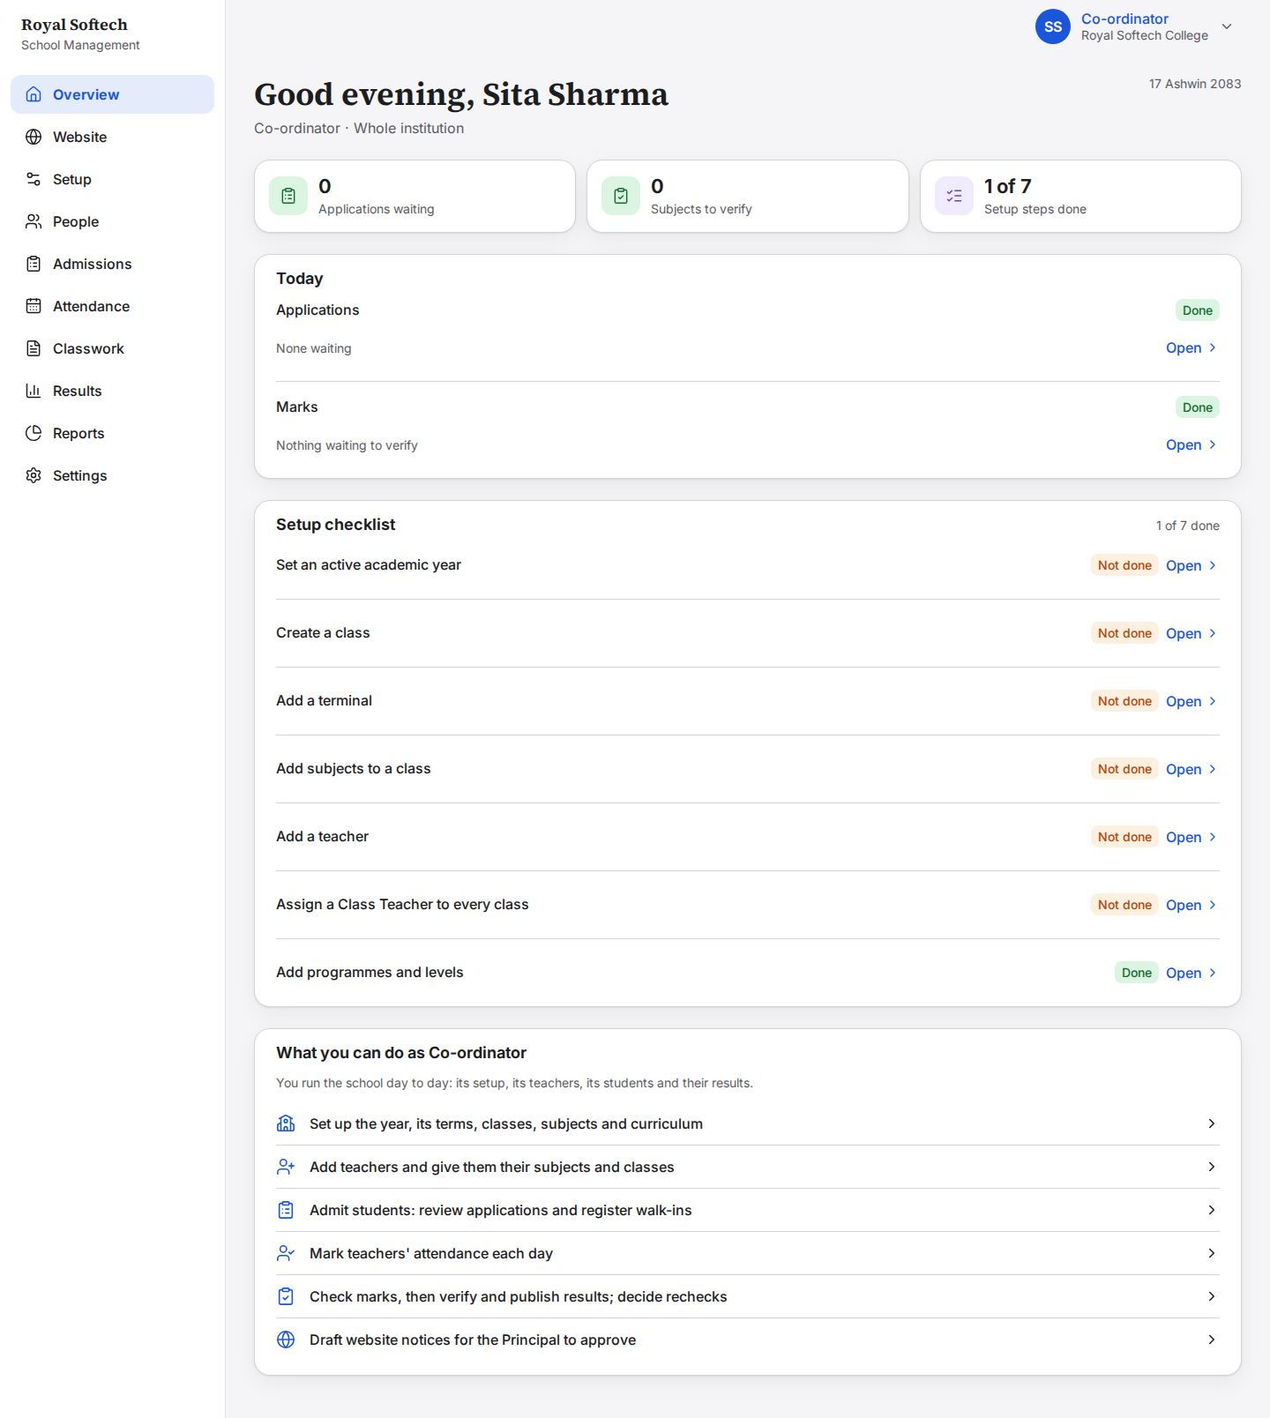

2. Setup: the year, terminals and subjects
The academic year with its dates, its three terminals, and the school's list of subjects.
# | Step | Observed on screen | Result
02-01 | Academic years: none yet | – | Pass
02-02 | Add a year with nothing filled in: each field is asked for | Enter the year as four digits, for example 2083. / Enter the first day of the year. / Enter the last day of the year. | Pass
02-03 | A year whose last day is before its first day is refused | The last day must come after the first day. | Pass
02-04 | BS 2090 is outside the verified calendar (2000 to 2083) and is refused | The calendar for that year has not been checked yet. | Pass
02-05 | Year 2083: from 1 Baisakh 2083 to 30 Chaitra 2083 | – | Pass
02-06 | Year 2083 added as a draft: it is not the current year until made so | Added. | Pass
02-07 | The same year twice is refused | That already exists. / Added. | Pass
02-08 | 2083 made the current year | Made the current year. | Pass
02-09 | Terminals of 2083: none yet | – | Pass
02-10 | Add a terminal with no name: refused | Enter a name. | Pass
02-11 | Three terminals, numbered in order | Added. | Pass
02-12 | Subjects: the school's list, empty | – | Pass
02-13 | Eleven subjects, most with a short code | Added. | Pass
02-14 | A second subject called English is refused | That already exists. / Added. | Pass

02-01 Academic years: none yet
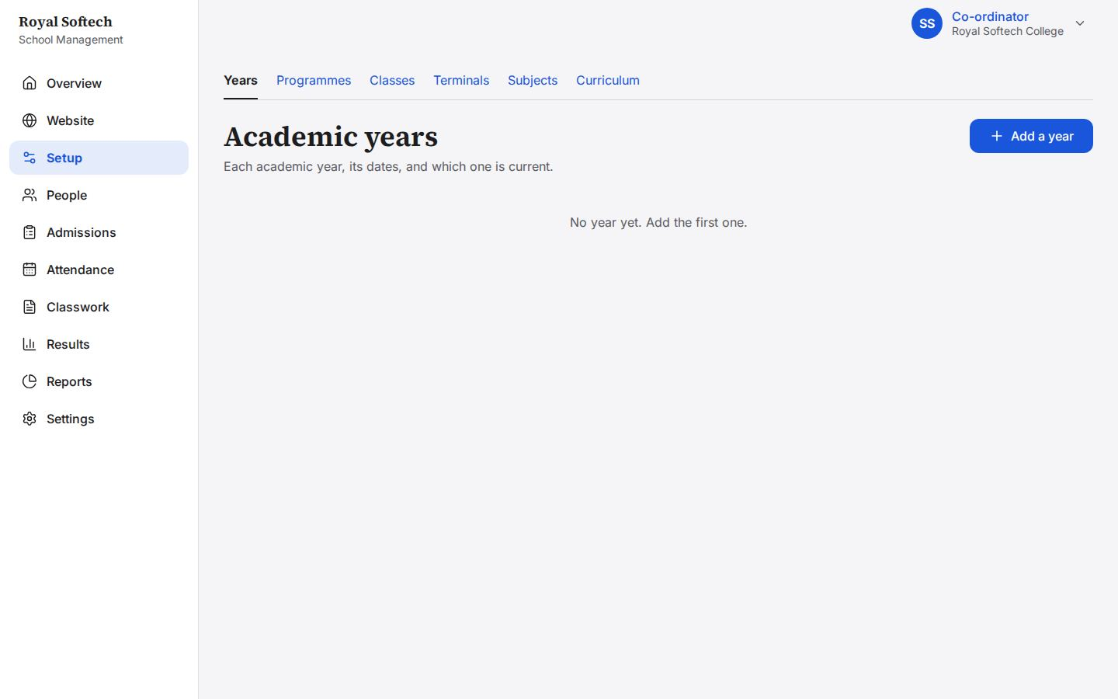
02-02 Add a year with nothing filled in: each field is asked for
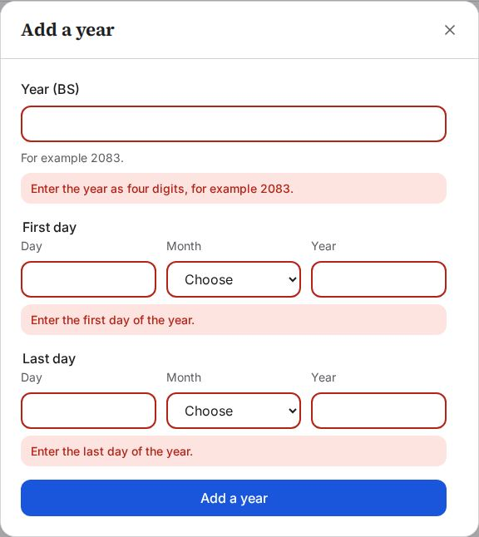
02-03 A year whose last day is before its first day is refused
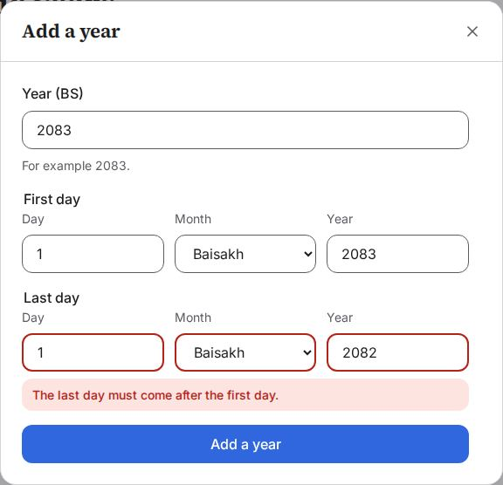
02-04 BS 2090 is outside the verified calendar (2000 to 2083) and is refused
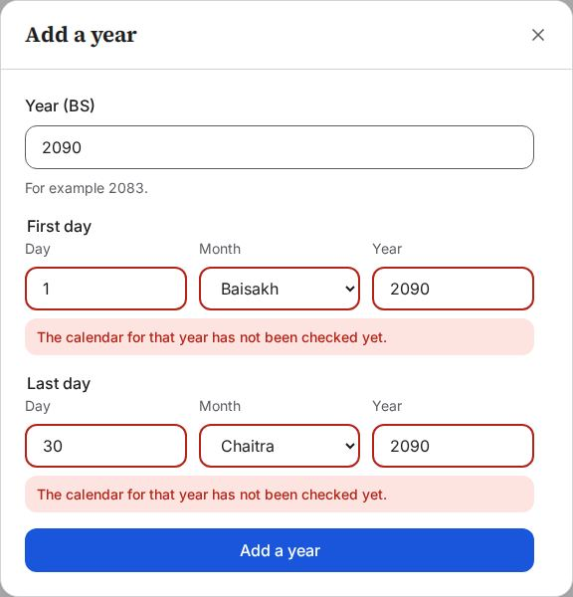
02-05 Year 2083: from 1 Baisakh 2083 to 30 Chaitra 2083
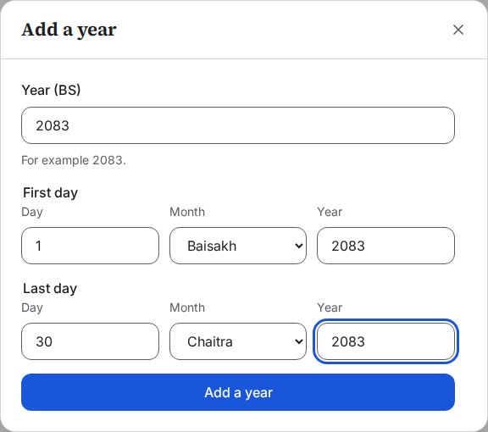
02-06 Year 2083 added as a draft: it is not the current year until made so
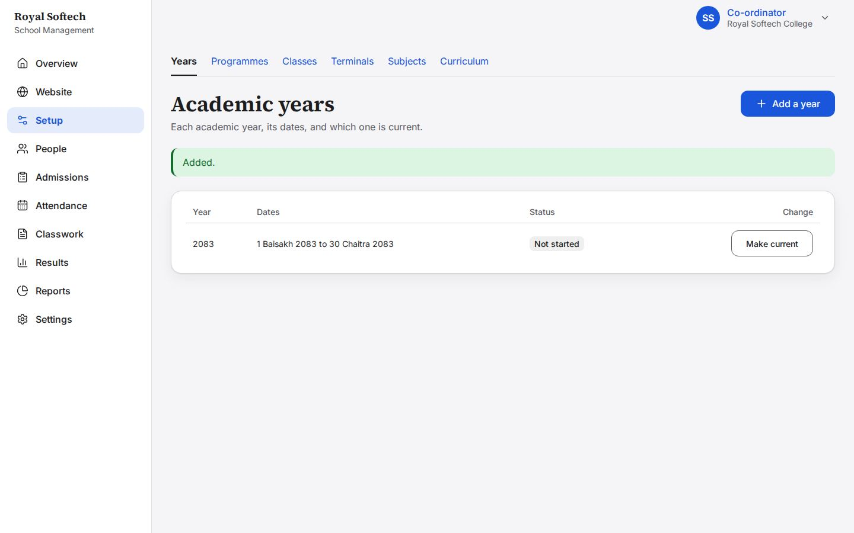
02-07 The same year twice is refused
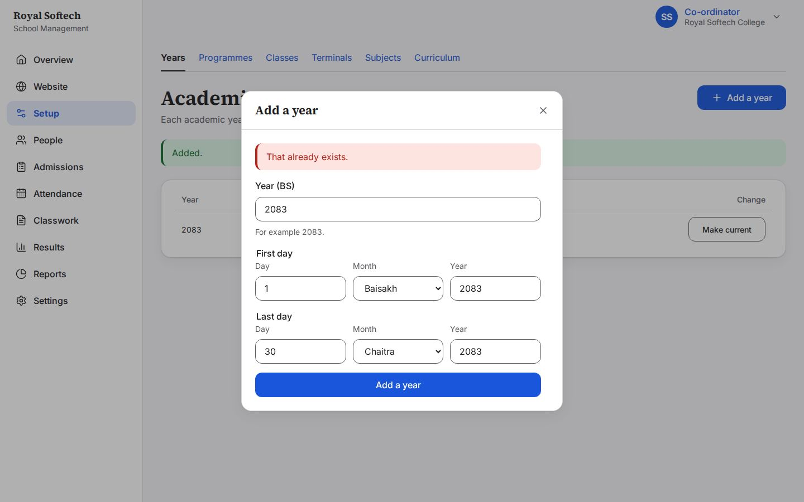
02-08 2083 made the current year
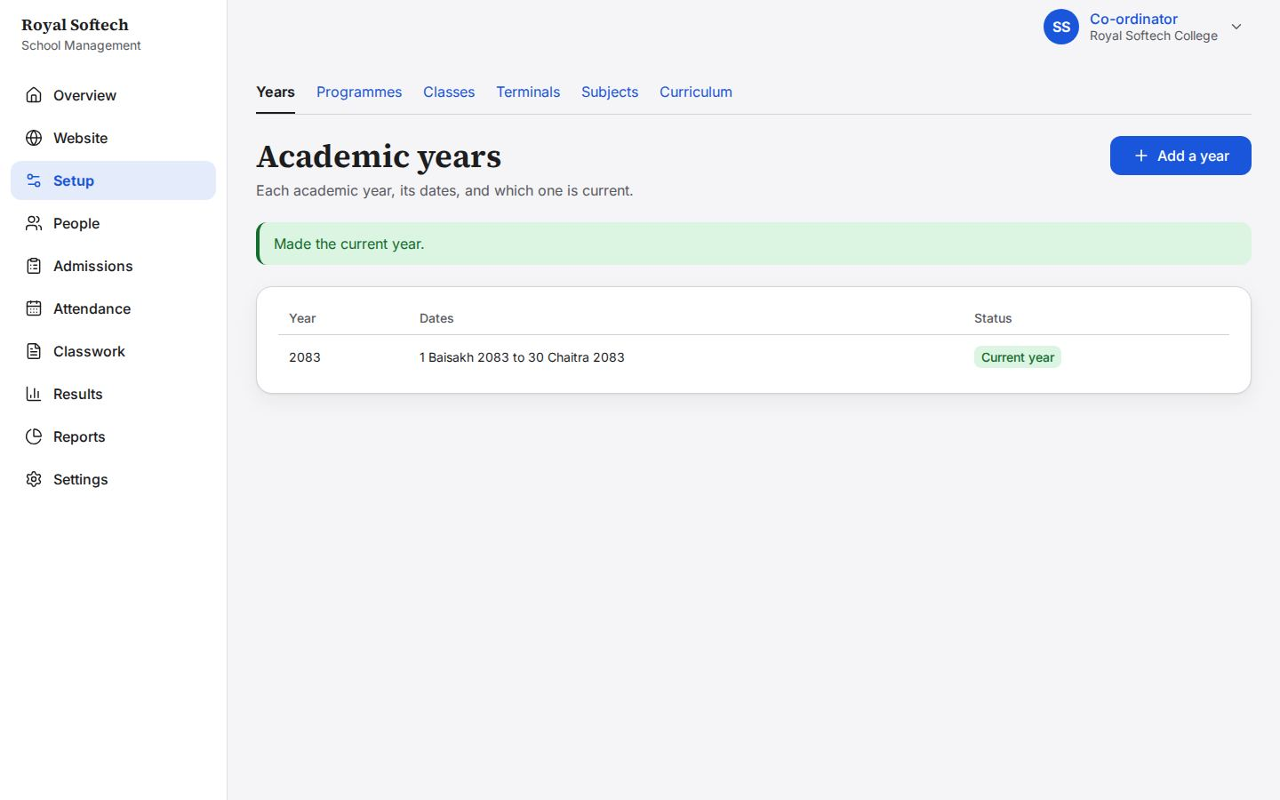
02-09 Terminals of 2083: none yet
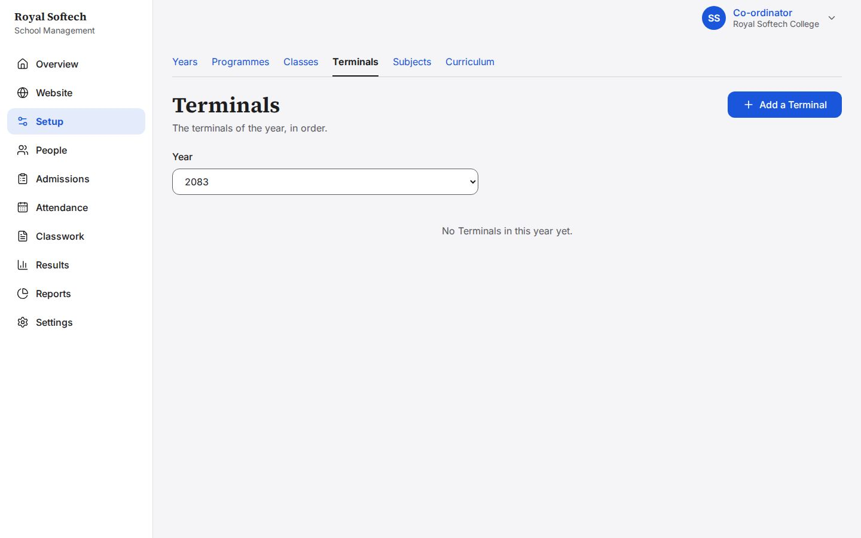
02-10 Add a terminal with no name: refused
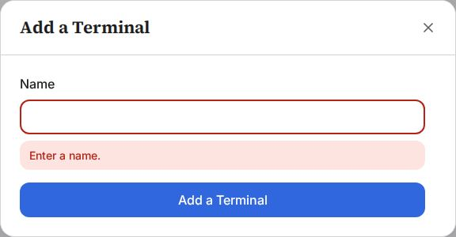
02-11 Three terminals, numbered in order
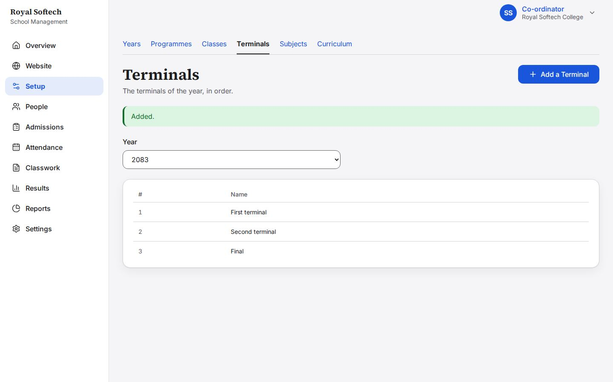
02-12 Subjects: the school's list, empty
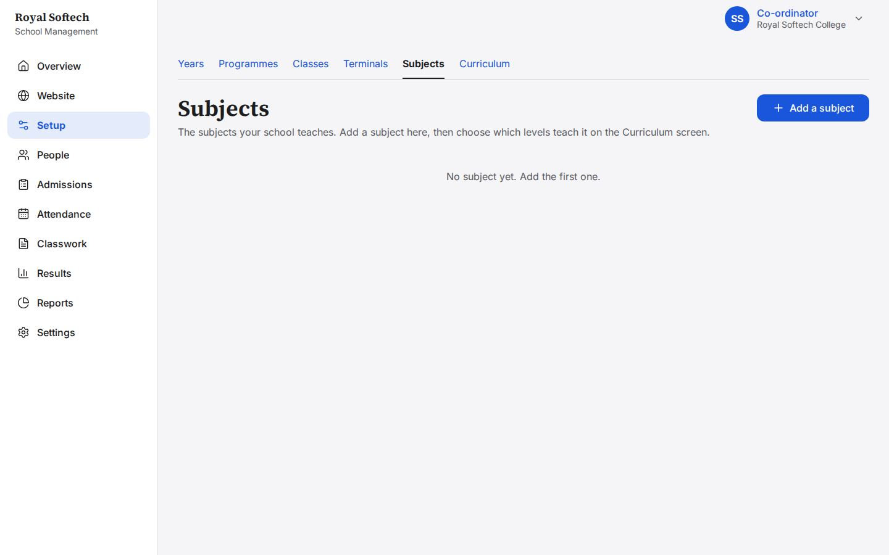
02-13 Eleven subjects, most with a short code
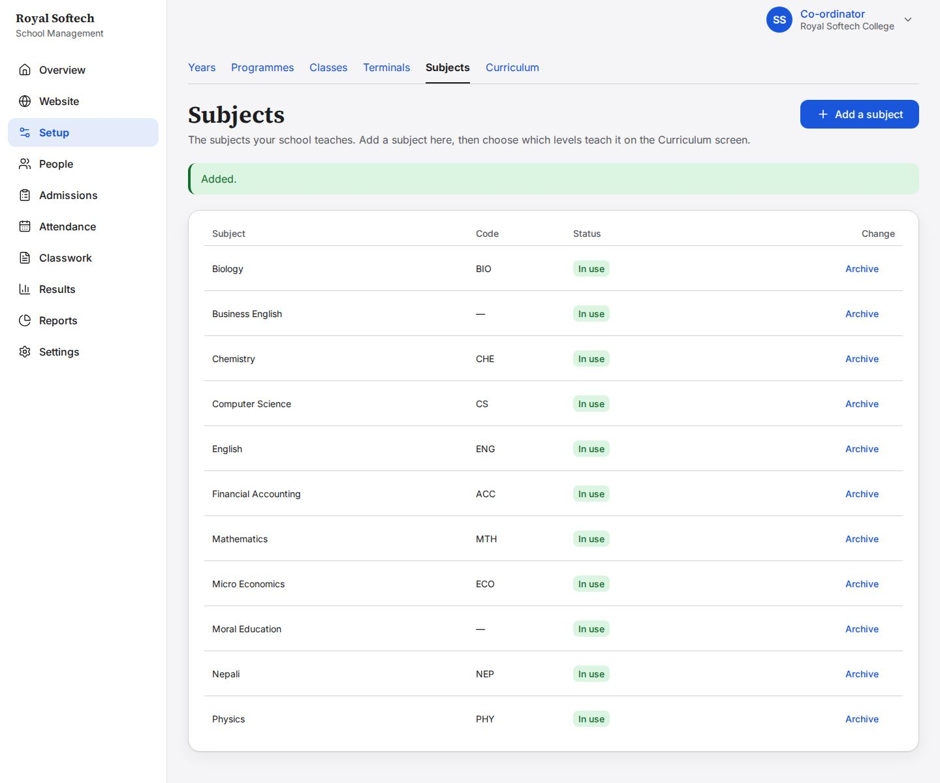
02-14 A second subject called English is refused
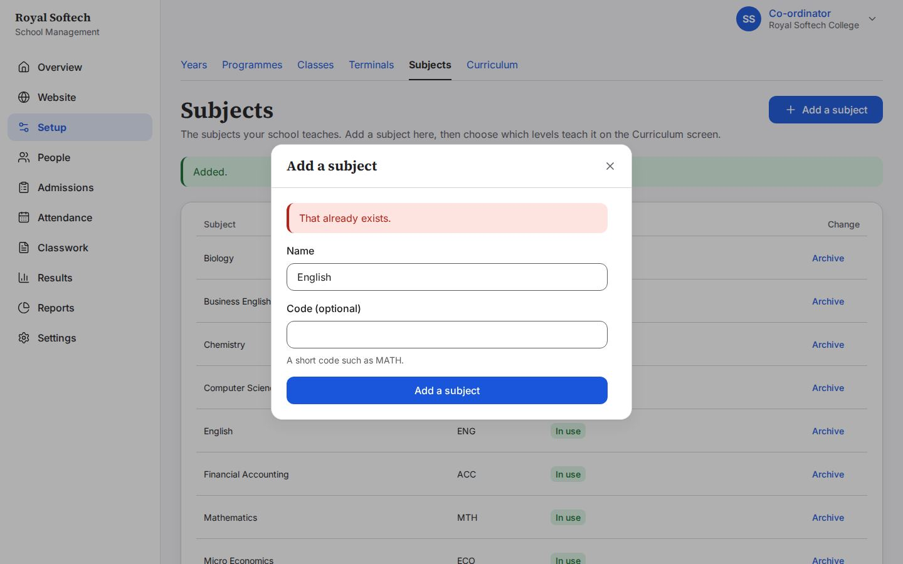

3. Setup: curriculum
What each level studies: subjects, credit hours, how each is marked, and an elective group.
# | Step | Observed on screen | Result
03-01 | Curriculum: the first level, +2 Science Grade 11, opens straight away | – | Pass
03-02 | +2 Science Grade 11: no elective groups and no subjects yet | – | Pass
03-03 | Add a subject without choosing one: Choose a subject | Choose a subject. | Pass
03-04 | An elective group, Science option: each student picks 1 | Added. | Pass
03-05 | In Physics's panel, a mark component with a maximum of 0 is refused | Added. / Enter the maximum marks as a number such as 75. | Pass
03-05b | Biology's panel: its code and credit hours, its elective group, theory and practical marks, and Switch off | Added. | Pass
03-06 | Grade 11: five subjects everyone takes, Biology or Computer Science as the Science option, credit hours, and theory and practical marks | Added. | Pass
03-07 | BBS Year 1: three subjects, each marked out of 100 | Added. | Pass
03-08 | Mathematics switched off on Grade 11: kept, and its panel and row say Switched off | Switched off. | Pass

03-01 Curriculum: the first level, +2 Science Grade 11, opens straight away
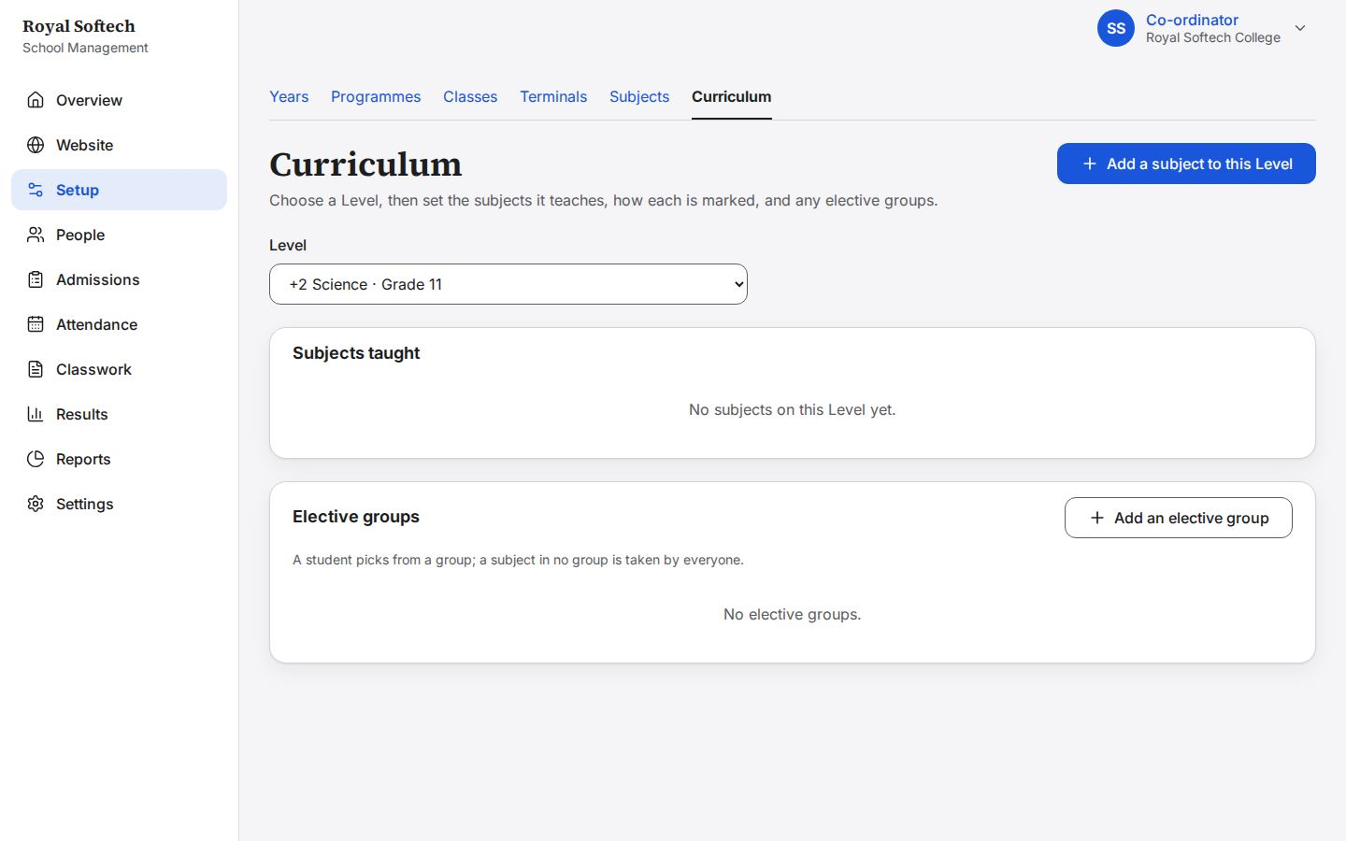
03-02 +2 Science Grade 11: no elective groups and no subjects yet
03-03 Add a subject without choosing one: Choose a subject
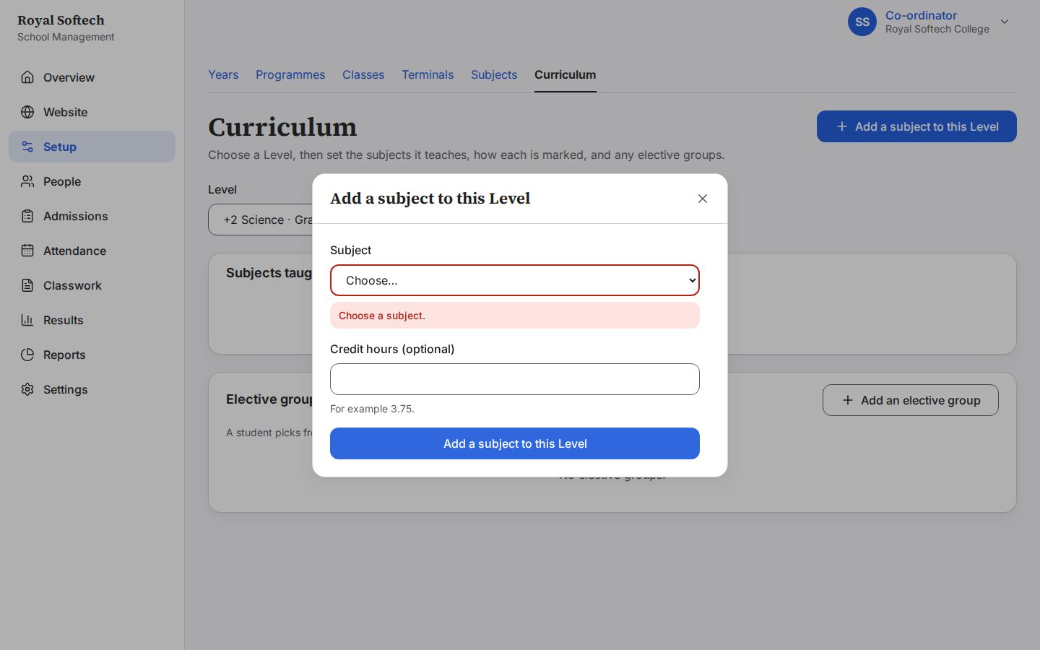
03-04 An elective group, Science option: each student picks 1
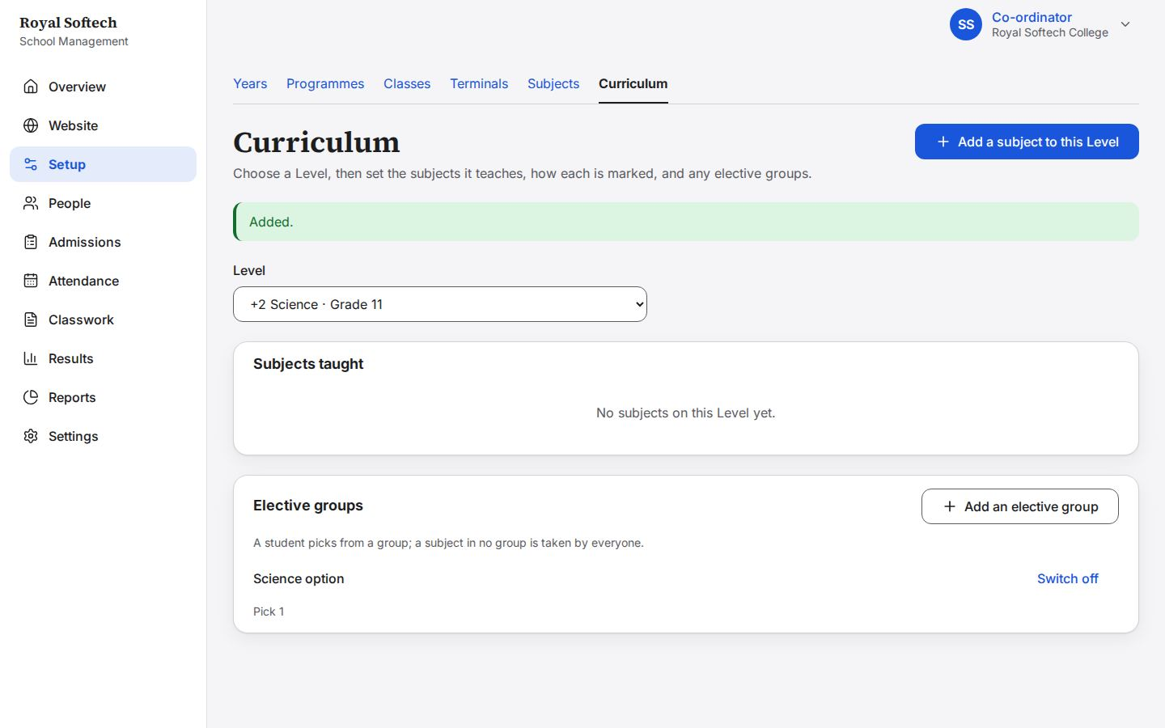
03-05 In Physics's panel, a mark component with a maximum of 0 is refused
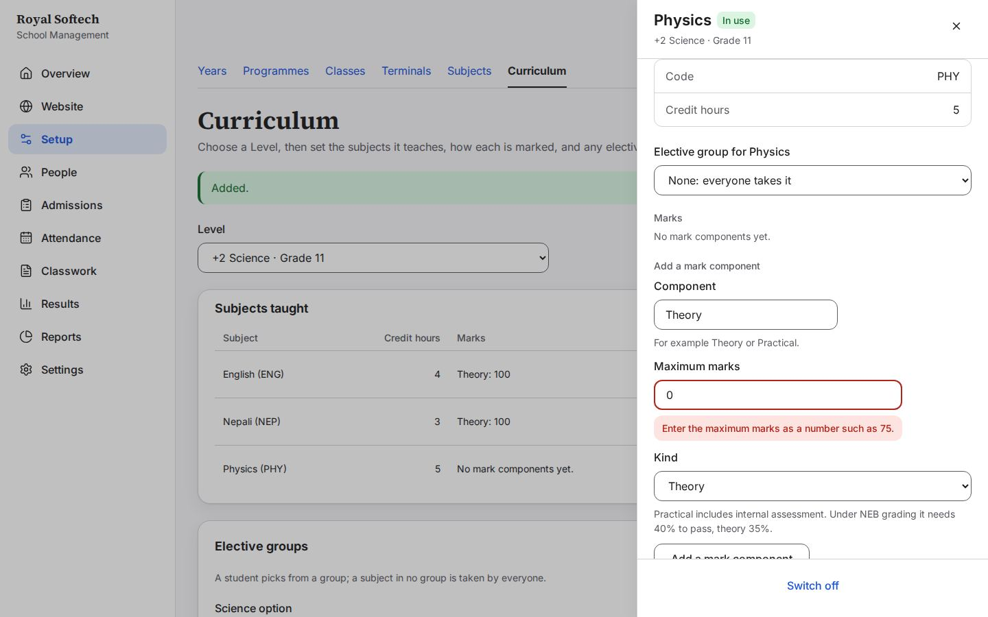
03-05b Biology's panel: its code and credit hours, its elective group, theory and practical marks, and Switch off
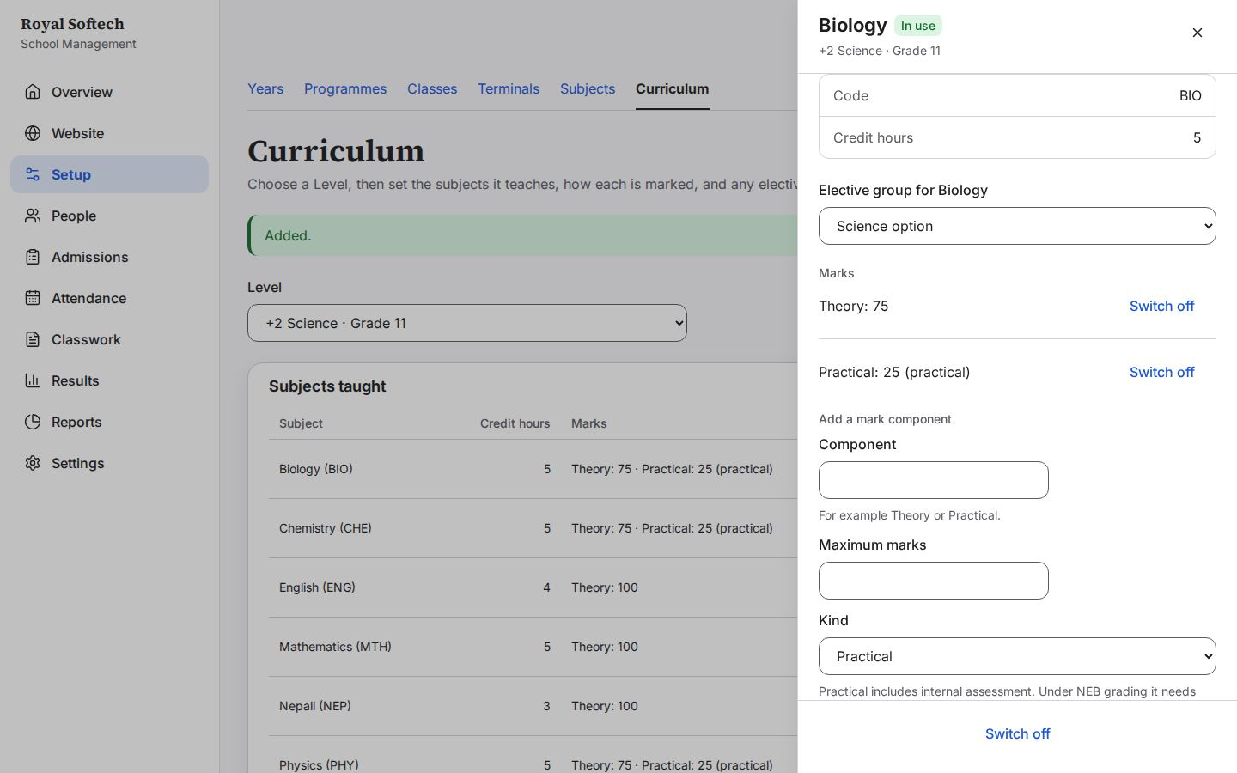
03-06 Grade 11: five subjects everyone takes, Biology or Computer Science as the Science option, credit hours, and theory and practical marks
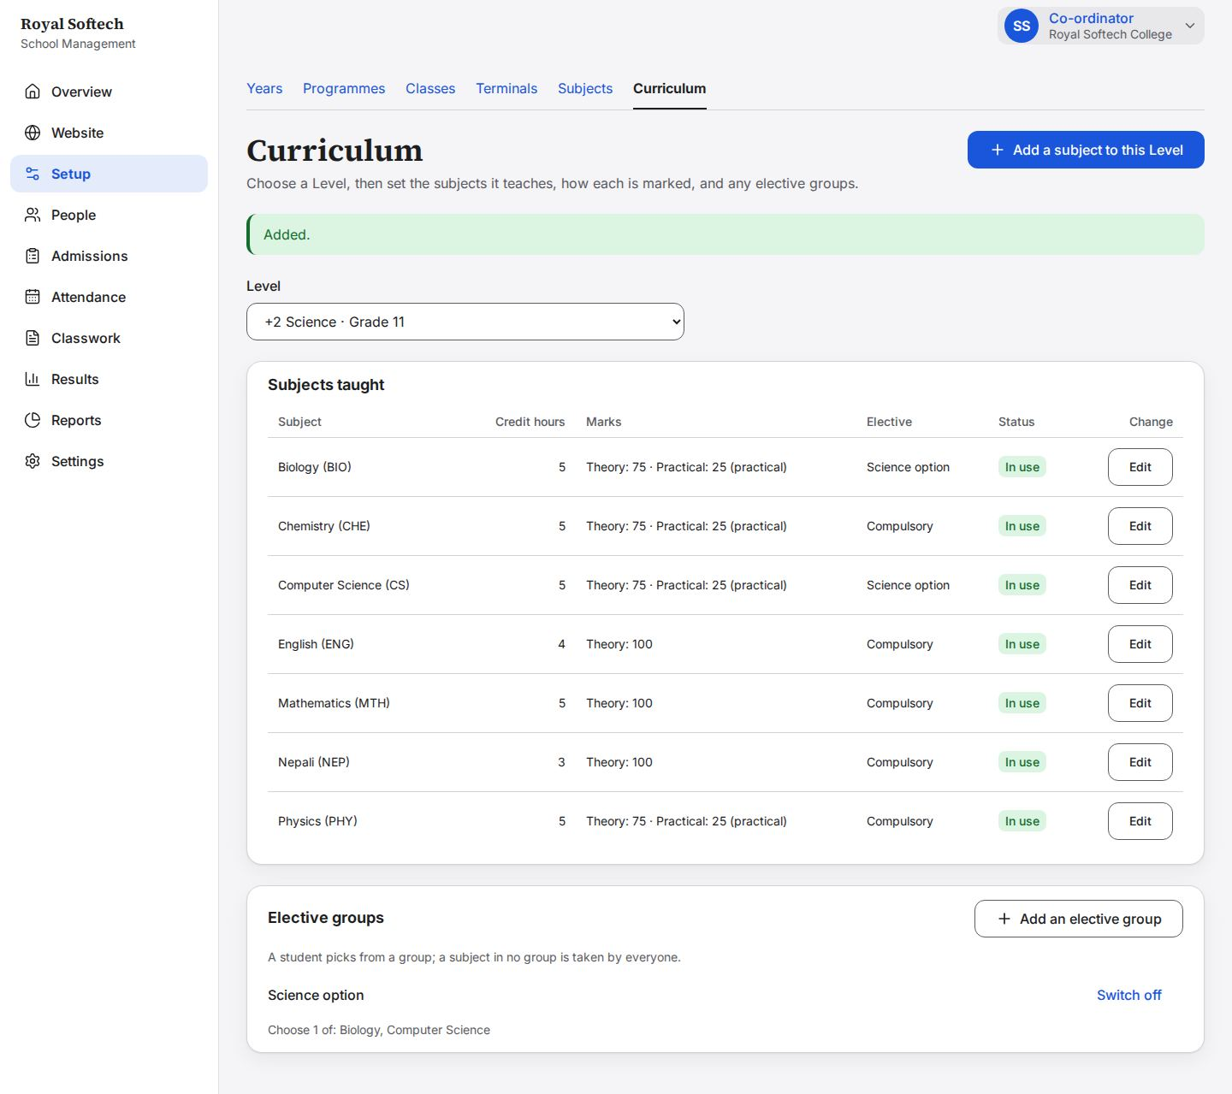
03-07 BBS Year 1: three subjects, each marked out of 100
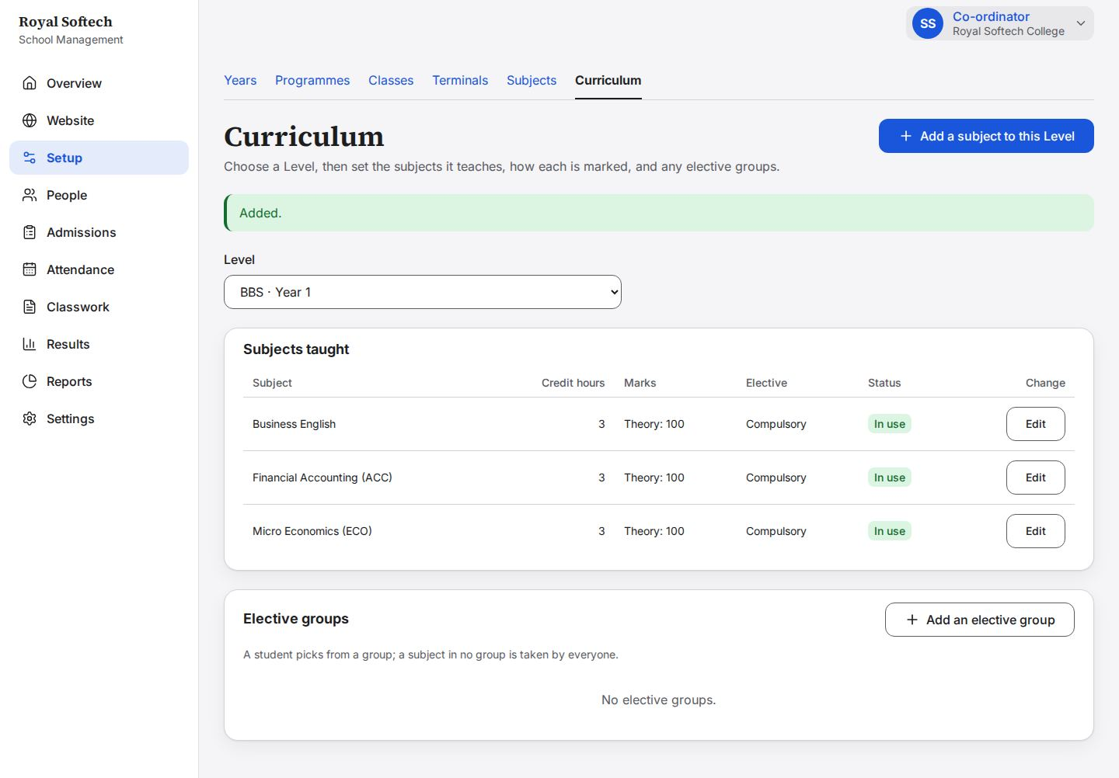
03-08 Mathematics switched off on Grade 11: kept, and its panel and row say Switched off
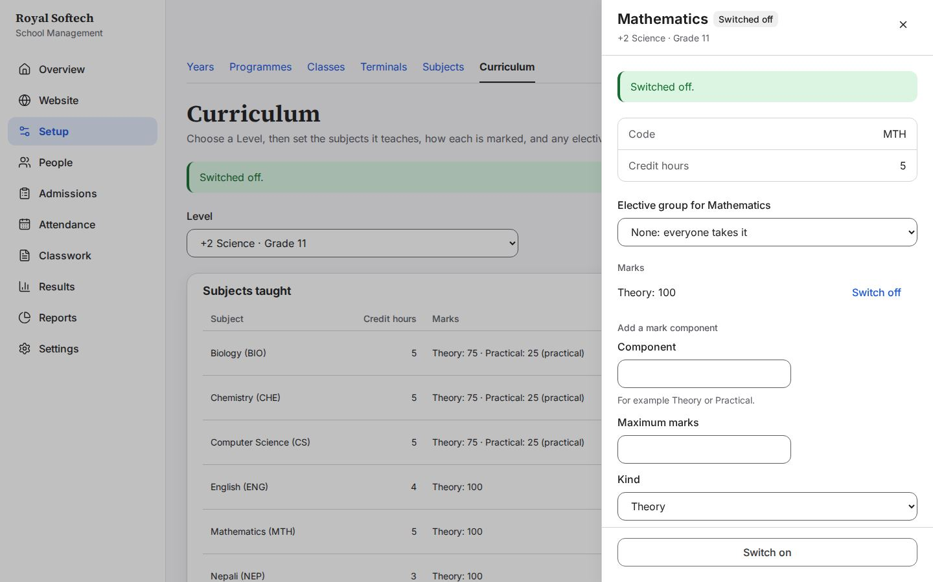

4. Setup: classes
The year's classes, a duplicate, switching off and deleting.
# | Step | Observed on screen | Result
04-01 | Classes of 2083: none yet | – | Pass
04-02 | Add a class without a level: refused | Choose a Level. | Pass
04-03 | Grade 11 of +2 Science, label A (a label like Morning or A is optional) | – | Pass
04-04 | Five classes for 2083 | Added. | Pass
04-05 | Grade 11 A a second time is refused | That already exists. / Added. | Pass
04-06 | The Management class switched off: kept, marked Switched off, not offered for new students | Switched off. | Pass
04-07 | Delete asks once more, because it cannot be undone (offered only while nothing is attached) | Switched on. | Pass
04-08 | The empty Management class is deleted; four classes remain | Deleted. | Pass

04-01 Classes of 2083: none yet
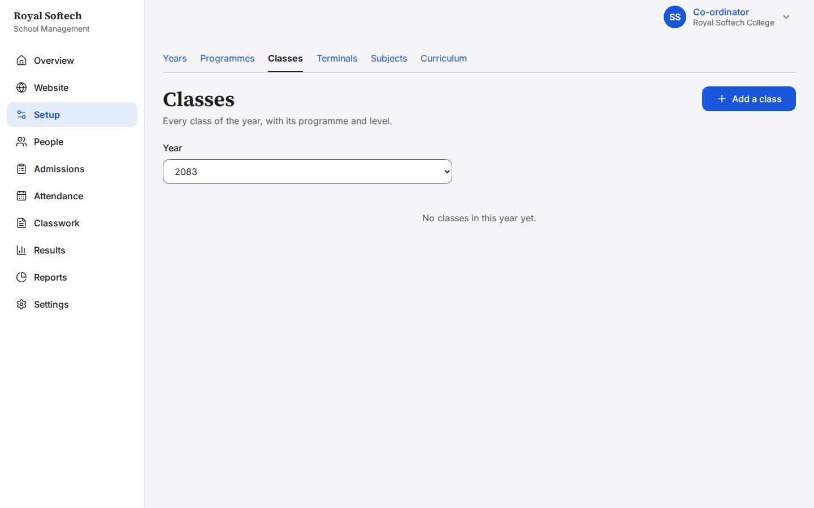
04-02 Add a class without a level: refused
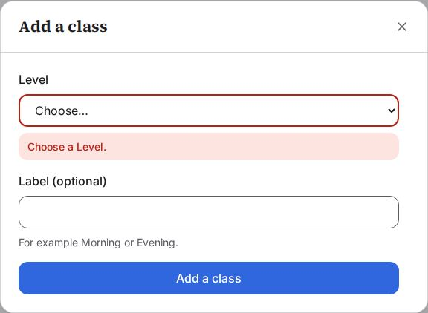
04-03 Grade 11 of +2 Science, label A (a label like Morning or A is optional)
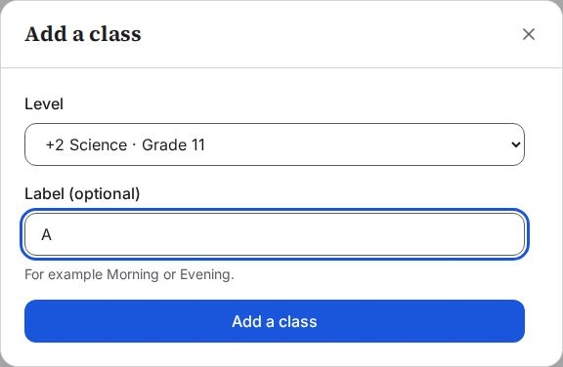
04-04 Five classes for 2083
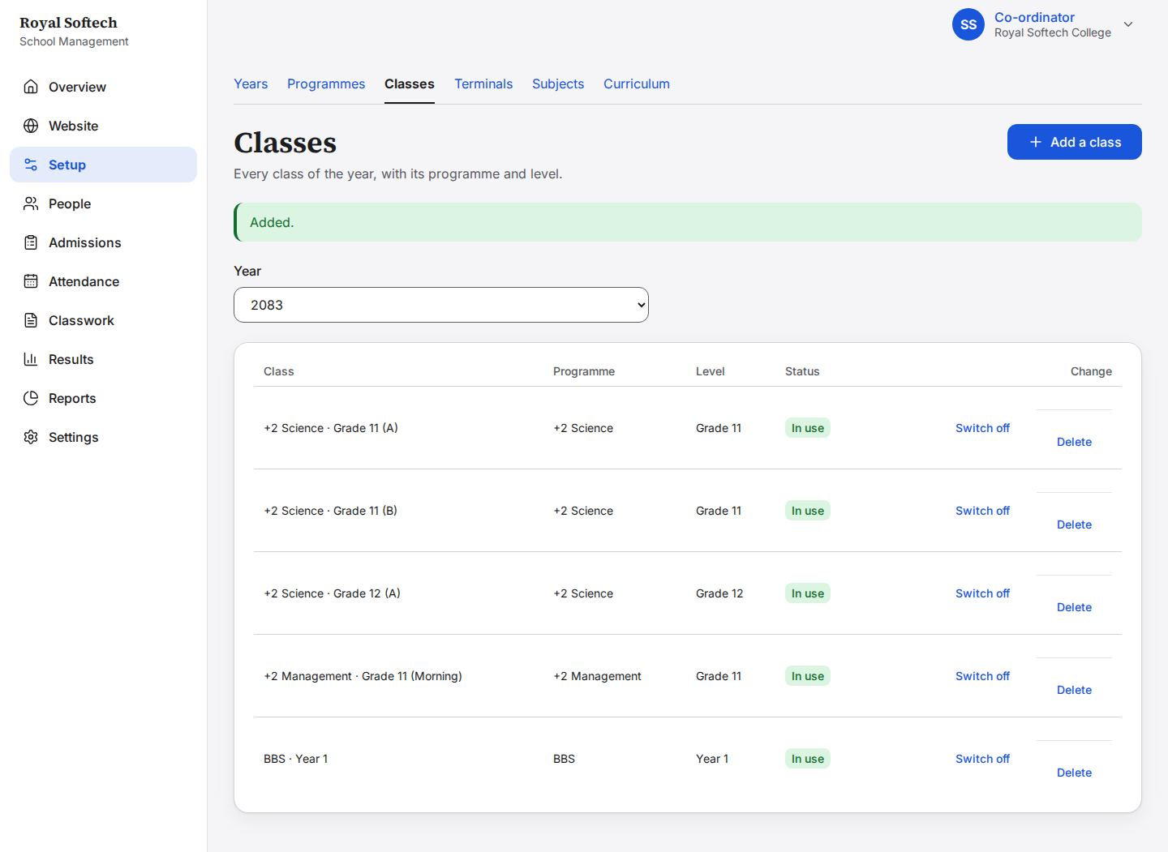
04-05 Grade 11 A a second time is refused
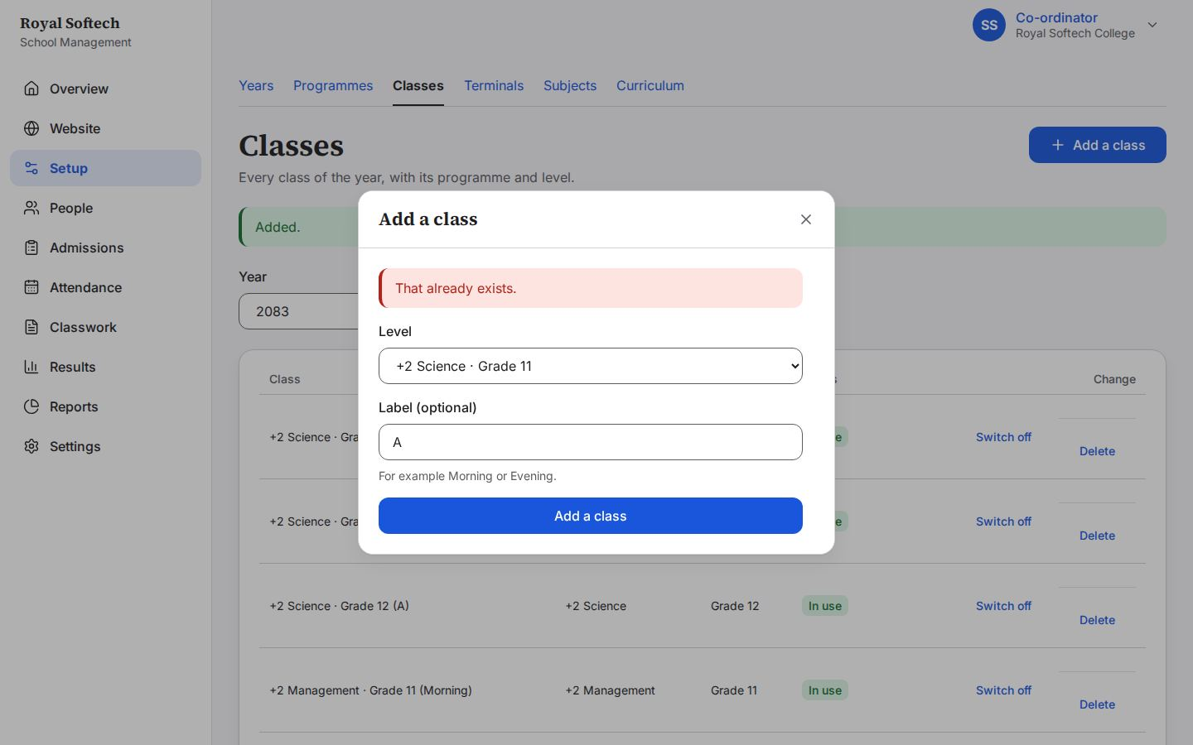
04-06 The Management class switched off: kept, marked Switched off, not offered for new students
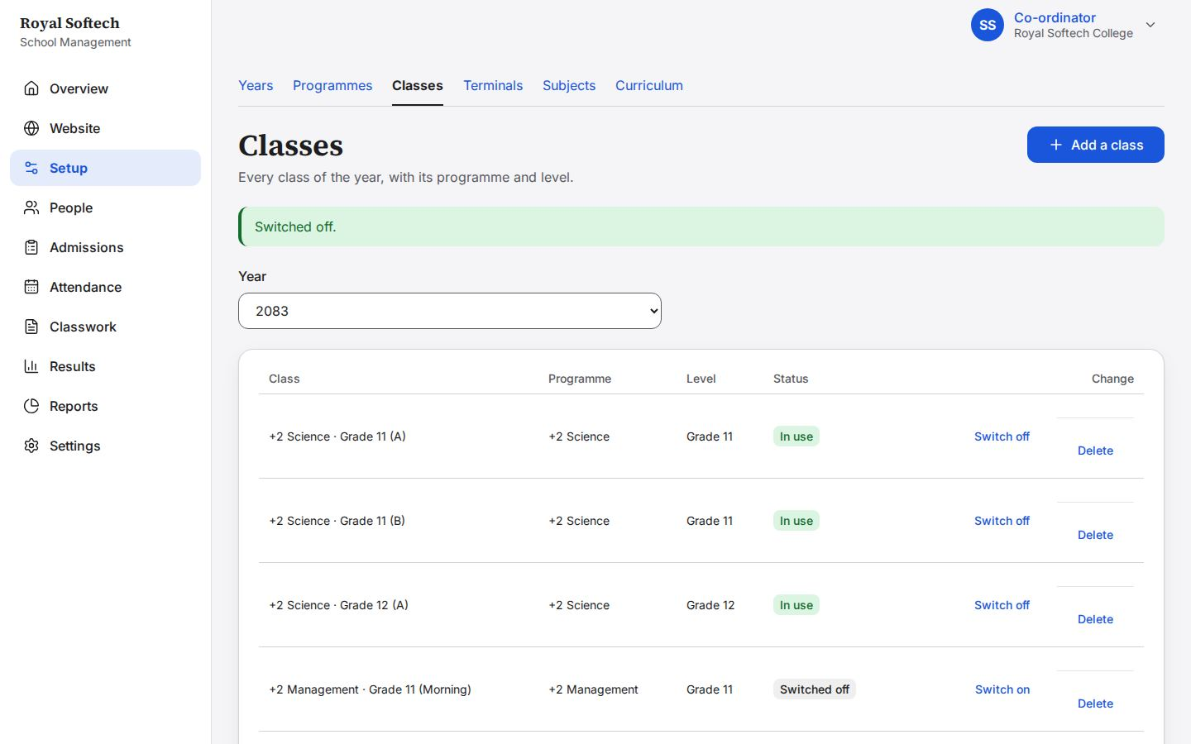
04-07 Delete asks once more, because it cannot be undone (offered only while nothing is attached)
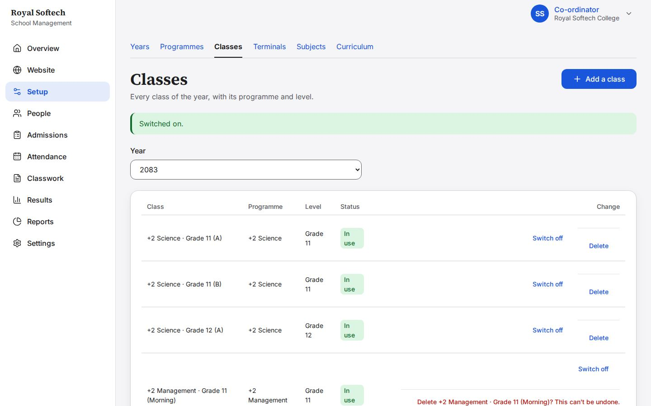
04-08 The empty Management class is deleted; four classes remain
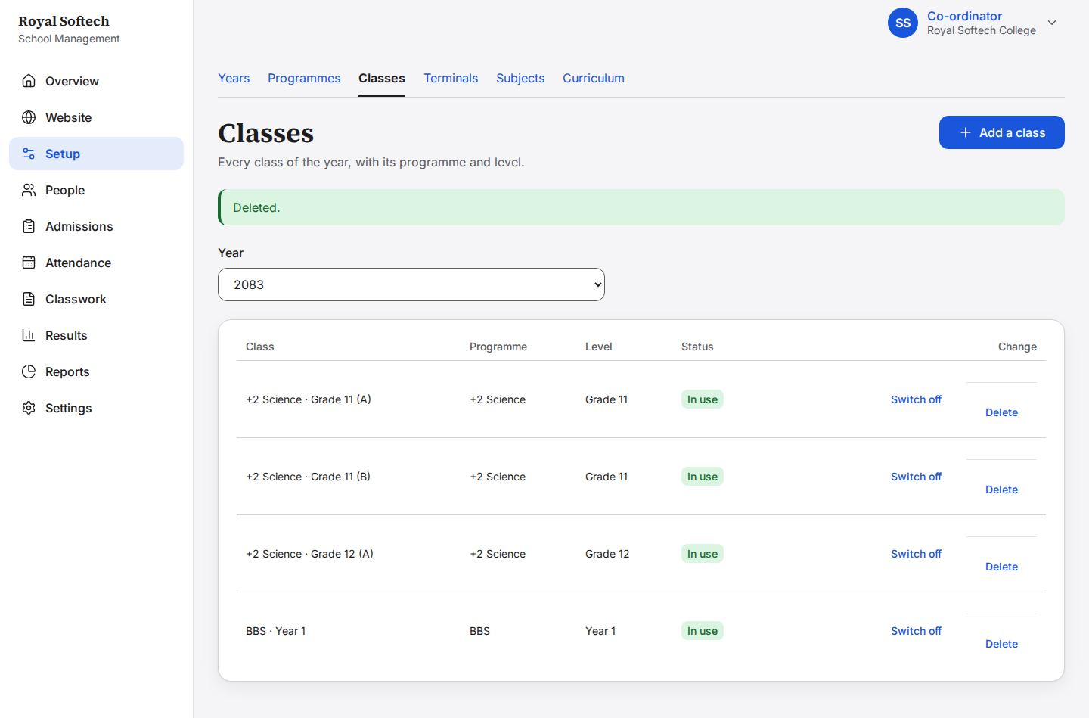

5. People: teachers
The Co-ordinator adds the teachers (only teachers), switches one off and on, and gives a new temporary password.
# | Step | Observed on screen | Result
05-01 | Staff, as the Co-ordinator sees it: only teachers, none yet | – | Pass
05-02 | Add a person: the role is fixed to Teacher; name, email, phone and home section | – | Pass
05-03 | Sent empty: the name and email are asked for | Enter the person's full name. / Enter a valid email address. / Choose the Section this teacher belongs to. | Pass
05-04 | A one-letter name and an incomplete email are each explained | Enter the person's full name. / Enter a valid email address. / Choose the Section this teacher belongs to. | Pass
05-05 | Bikash Chaudhary added: the temporary password is shown once, to give him in person | Temporary password for Bikash Chaudhary (password) Give this to Bikash Chaudhary in person or by phone. It is shown once and cannot be looked up again. They … | Pass
05-06 | Six teachers: four for +2 and two for Bachelor's, none signed in yet | – | Pass
05-07 | An email already in use is refused | Someone already uses that email address. | Pass
05-07b | Search narrows the list as she types: Kamala Rai | – | Pass
05-07c | Manage Kamala Rai: her details, a new temporary password, and Switch off | – | Pass
05-08 | Kamala Rai switched off: kept, marked Switched off, signed out and unable to sign in | Kamala Rai was switched off, and signed out. | Pass
05-09 | Kamala Rai switched on again | Kamala Rai was switched on. | Pass
05-10 | A new temporary password for Suresh Karki, shown once (the old one stops working) | Temporary password for Suresh Karki (password) Give this to Suresh Karki in person or by phone. It is shown once and cannot be looked up again. They must cho… | Pass

05-01 Staff, as the Co-ordinator sees it: only teachers, none yet
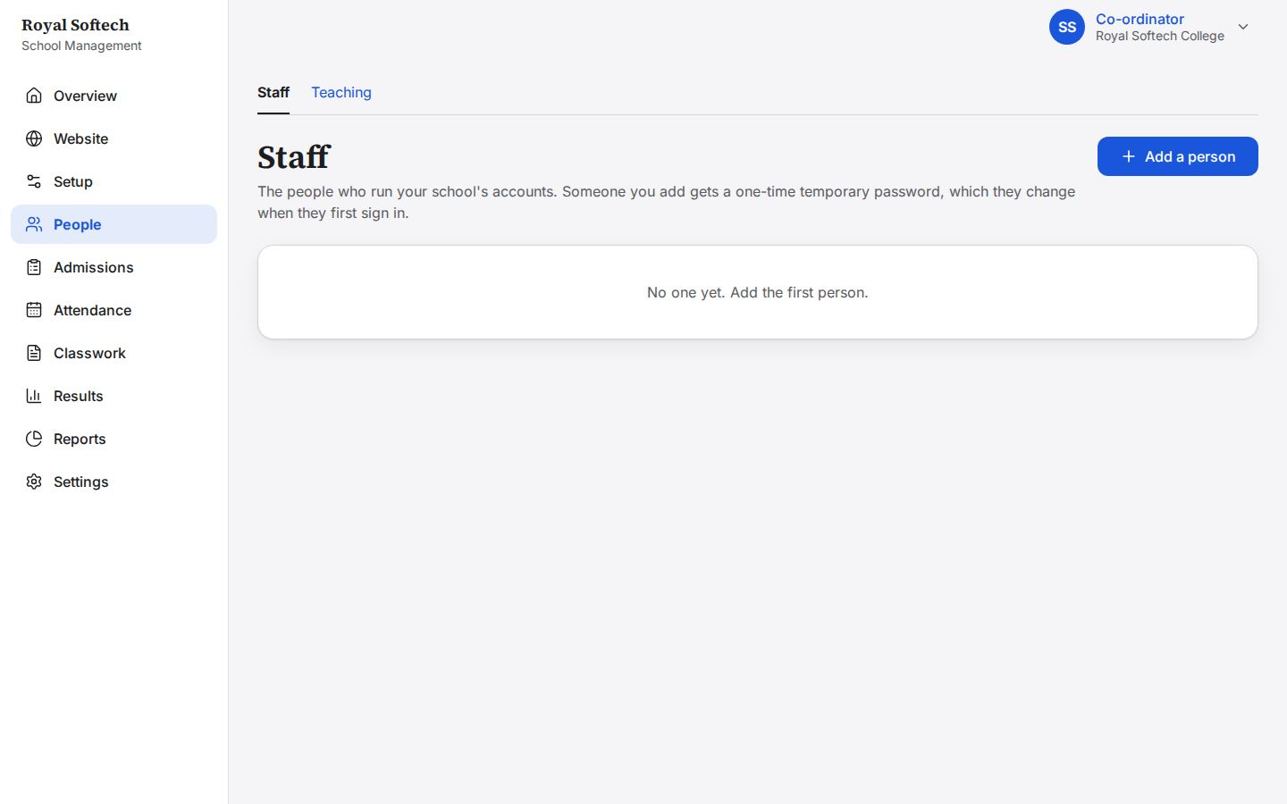
05-02 Add a person: the role is fixed to Teacher; name, email, phone and home section
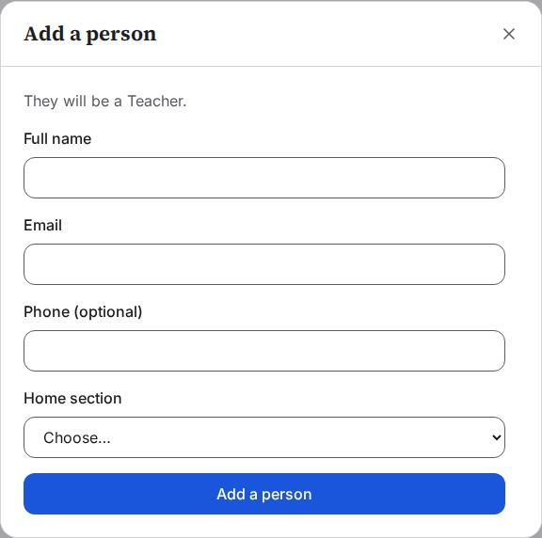
05-03 Sent empty: the name and email are asked for
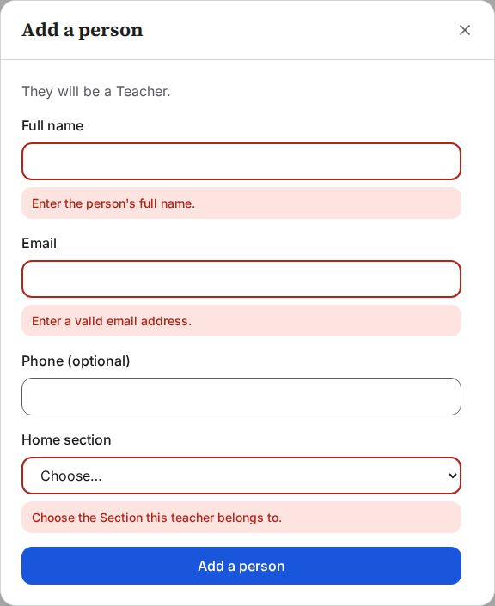
05-04 A one-letter name and an incomplete email are each explained
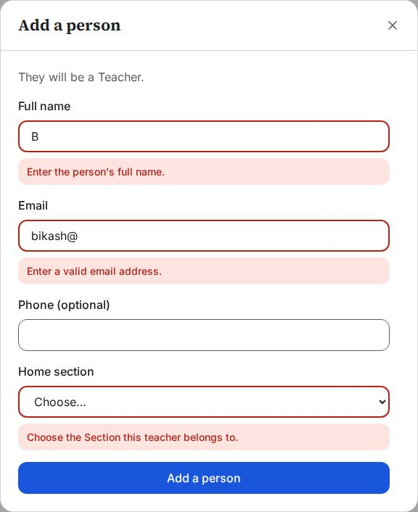
05-05 Bikash Chaudhary added: the temporary password is shown once, to give him in person
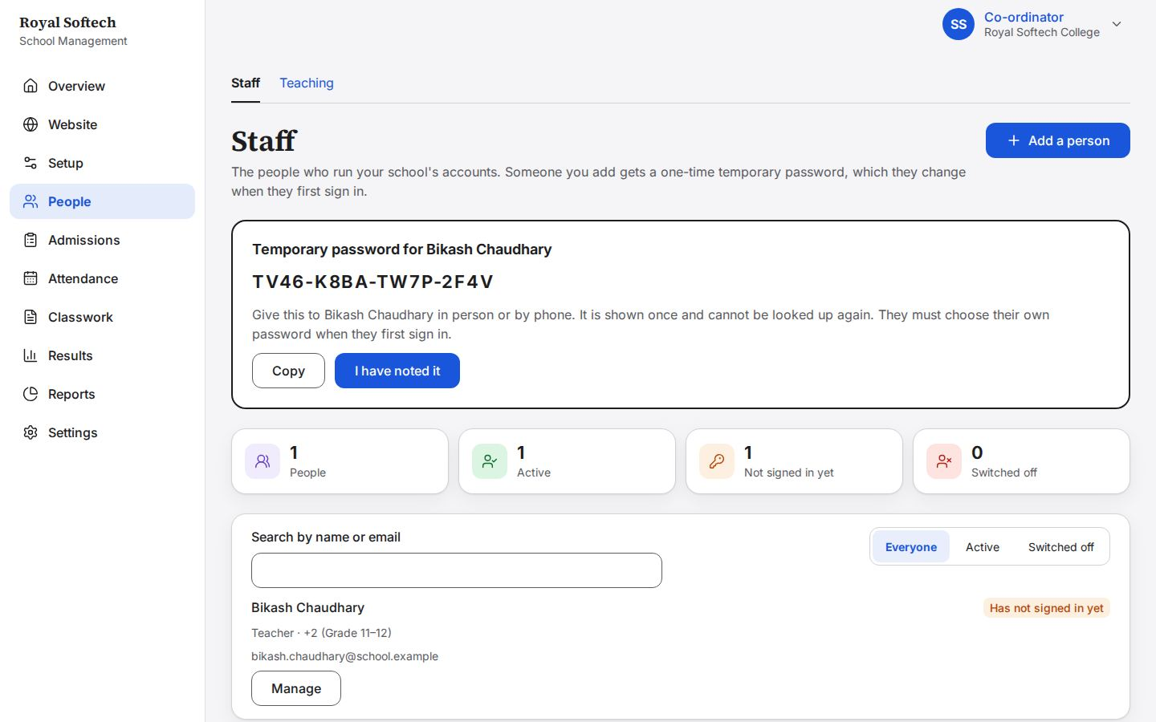
05-06 Six teachers: four for +2 and two for Bachelor's, none signed in yet
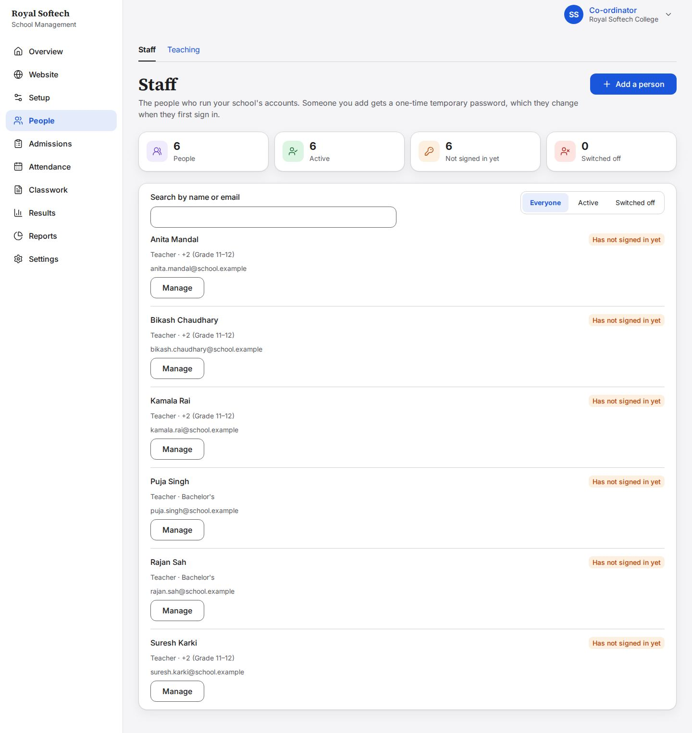
05-07 An email already in use is refused
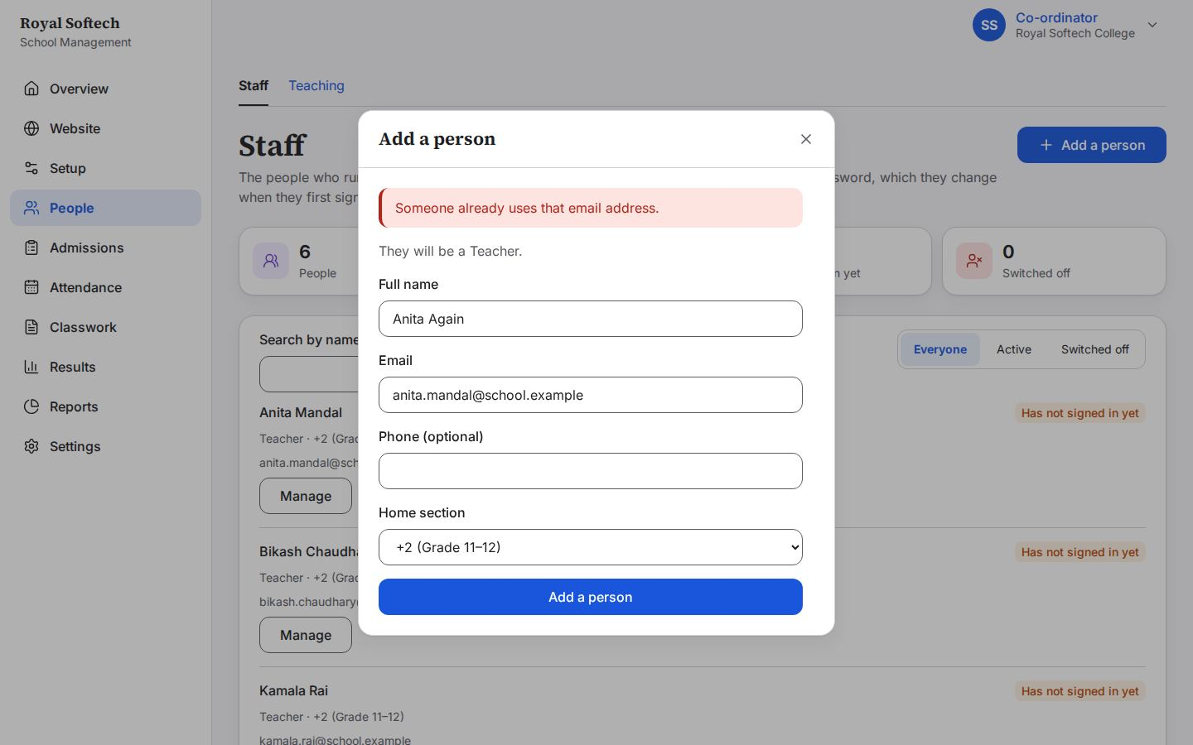
05-07b Search narrows the list as she types: Kamala Rai
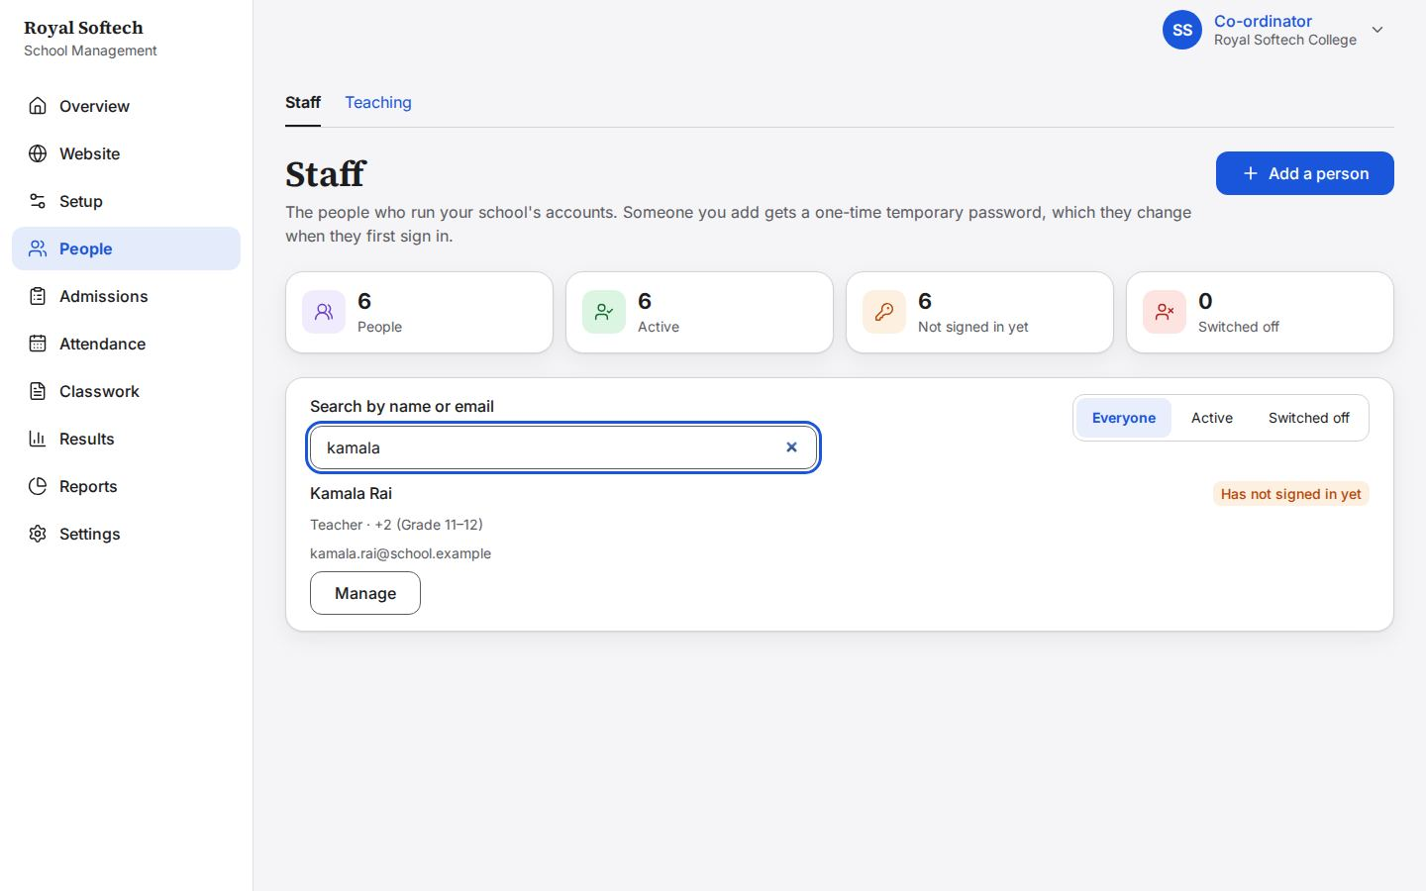
05-07c Manage Kamala Rai: her details, a new temporary password, and Switch off
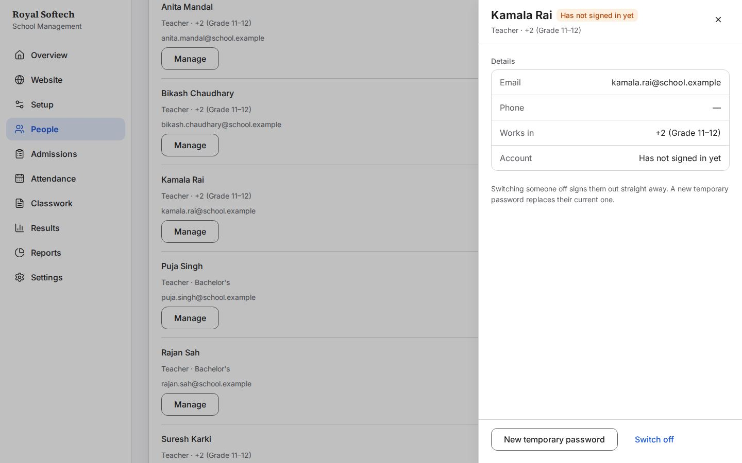
05-08 Kamala Rai switched off: kept, marked Switched off, signed out and unable to sign in
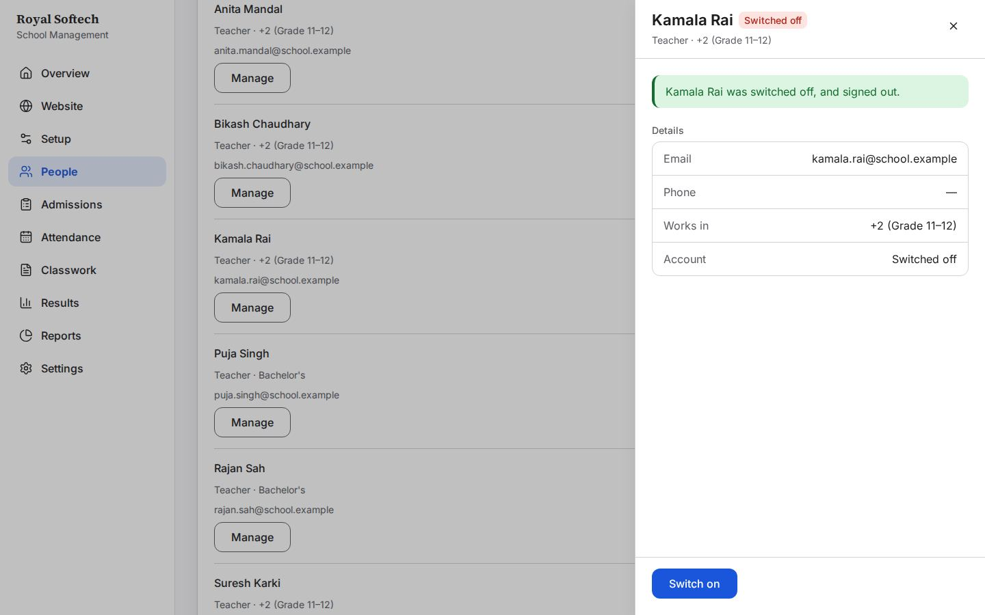
05-09 Kamala Rai switched on again
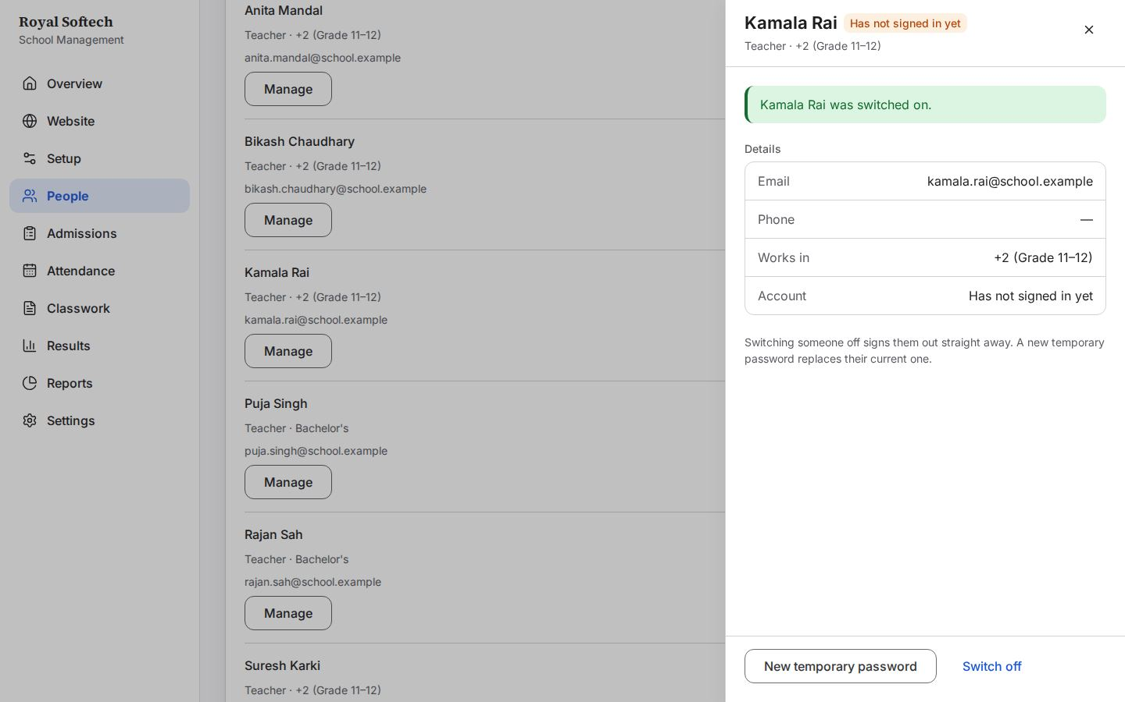
05-10 A new temporary password for Suresh Karki, shown once (the old one stops working)
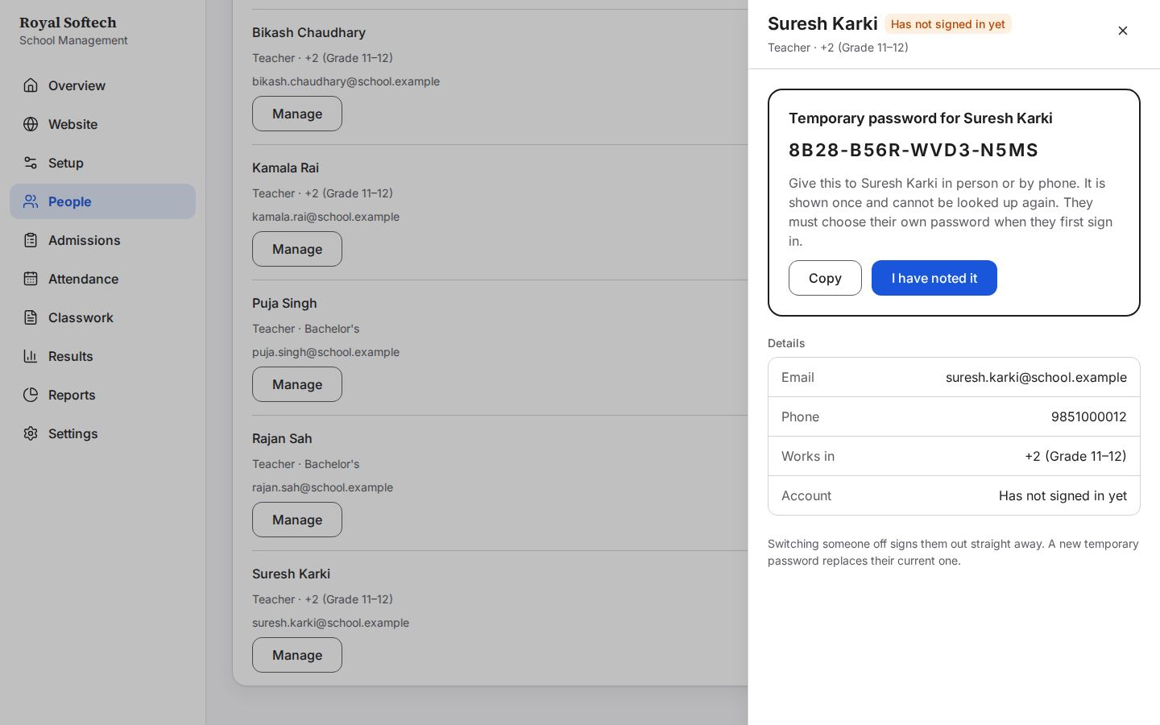

6. People: teaching assignments
A teacher for every subject of every class, and each class's Class Teacher.
# | Step | Observed on screen | Result
06-01 | Teaching: the current year and its first class open straight away | – | Pass
06-02 | Grade 11 A: a Class Teacher and one teacher per subject, none chosen yet | – | Pass
06-03 | Grade 11 A: Bikash Chaudhary is Class Teacher; each subject has its teacher, saved as it is chosen | Teacher assigned. | Pass
06-04 | BBS Year 1: Puja Singh is Class Teacher; Rajan Sah takes two subjects | Teacher assigned. | Pass
06-05 | Bikash Chaudhary as Class Teacher of a second class in the same year is refused: one class each | That teacher is already Class Teacher of another class this year. | Pass
06-06 | Grade 11 B Mathematics given to Anita Mandal instead of Bikash Chaudhary | Teacher assigned. | Pass
06-07 | Grade 11 B Biology left without a teacher for now | Teacher removed. | Pass
06-08 | The dashboard's setup checklist once the year, classes, terminals, subjects, teachers and Class Teachers are in place | – | Pass

06-01 Teaching: the current year and its first class open straight away
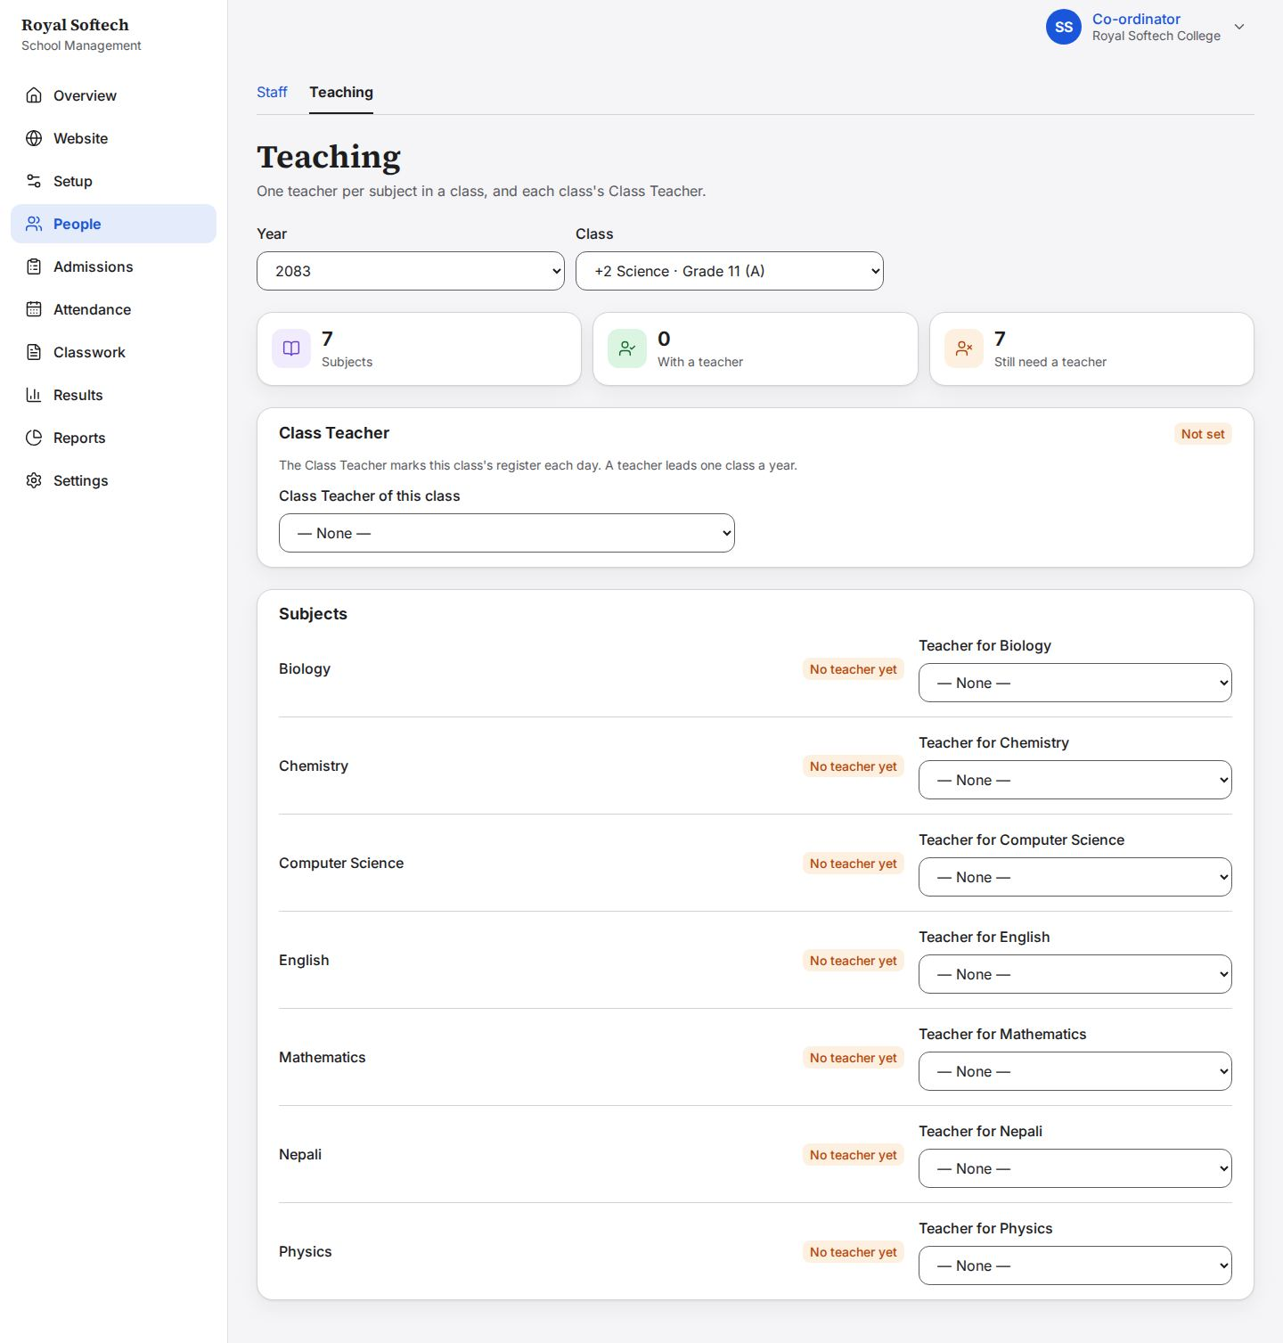
06-02 Grade 11 A: a Class Teacher and one teacher per subject, none chosen yet
06-03 Grade 11 A: Bikash Chaudhary is Class Teacher; each subject has its teacher, saved as it is chosen
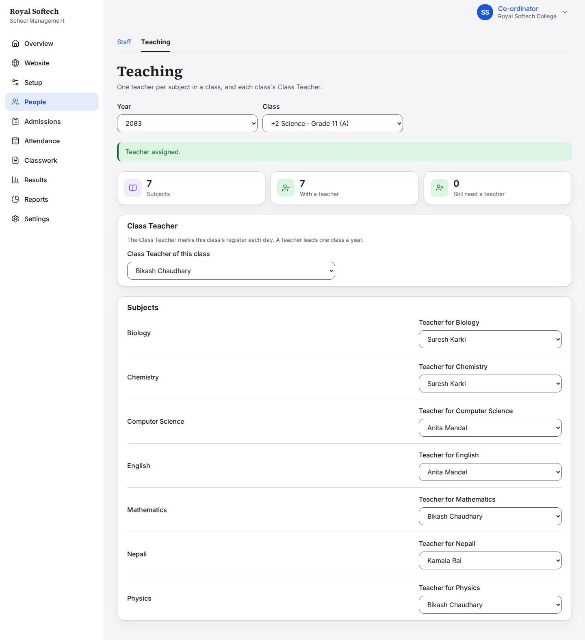
06-04 BBS Year 1: Puja Singh is Class Teacher; Rajan Sah takes two subjects
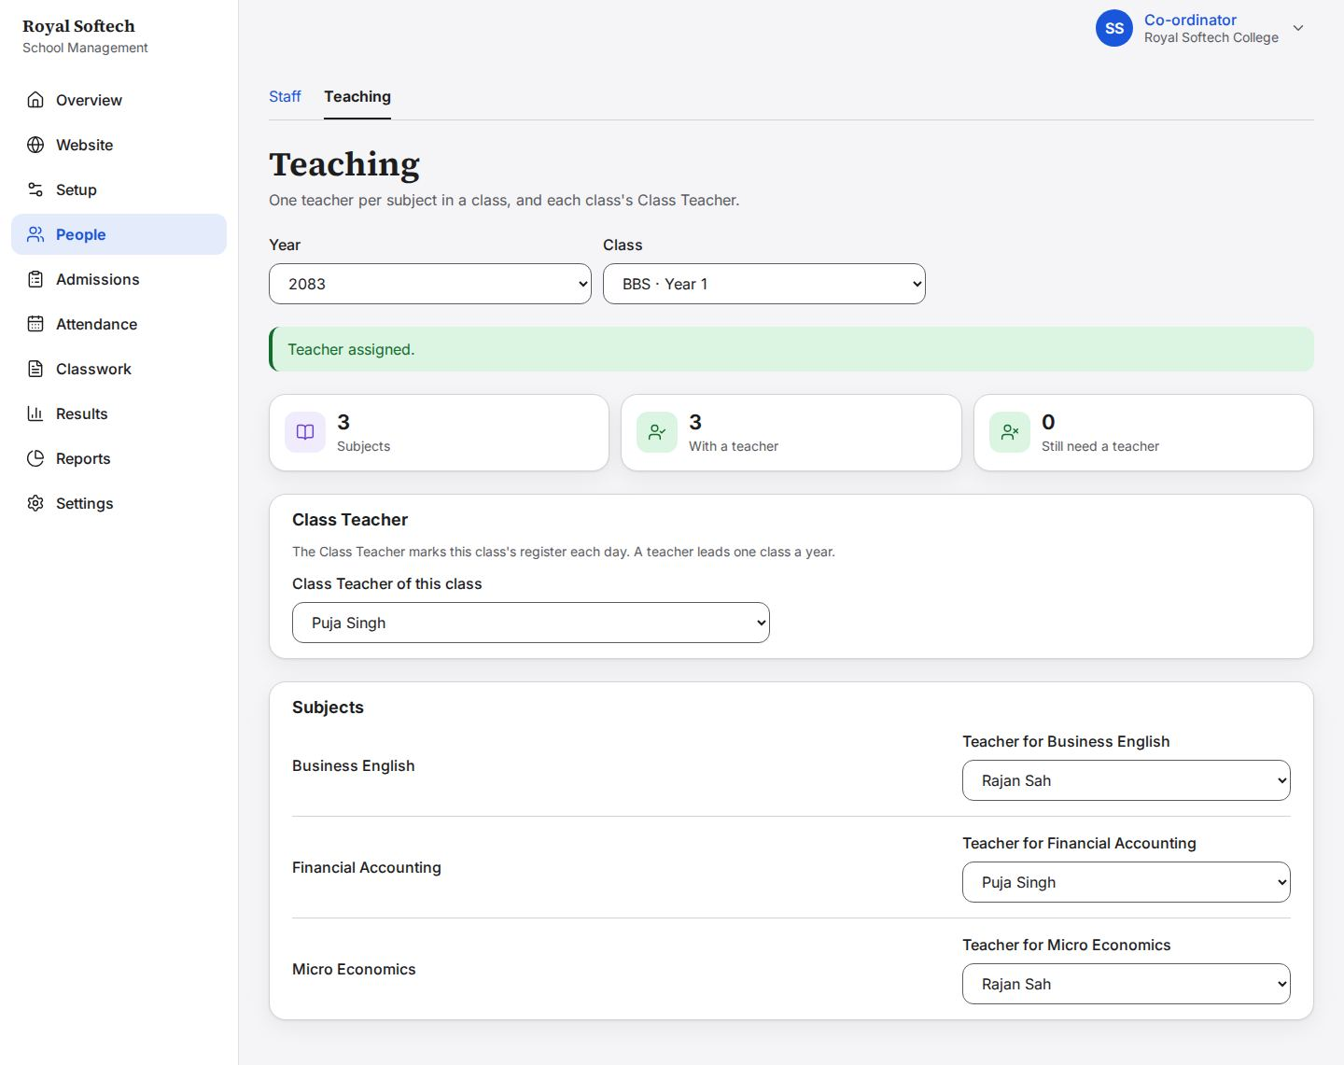
06-05 Bikash Chaudhary as Class Teacher of a second class in the same year is refused: one class each
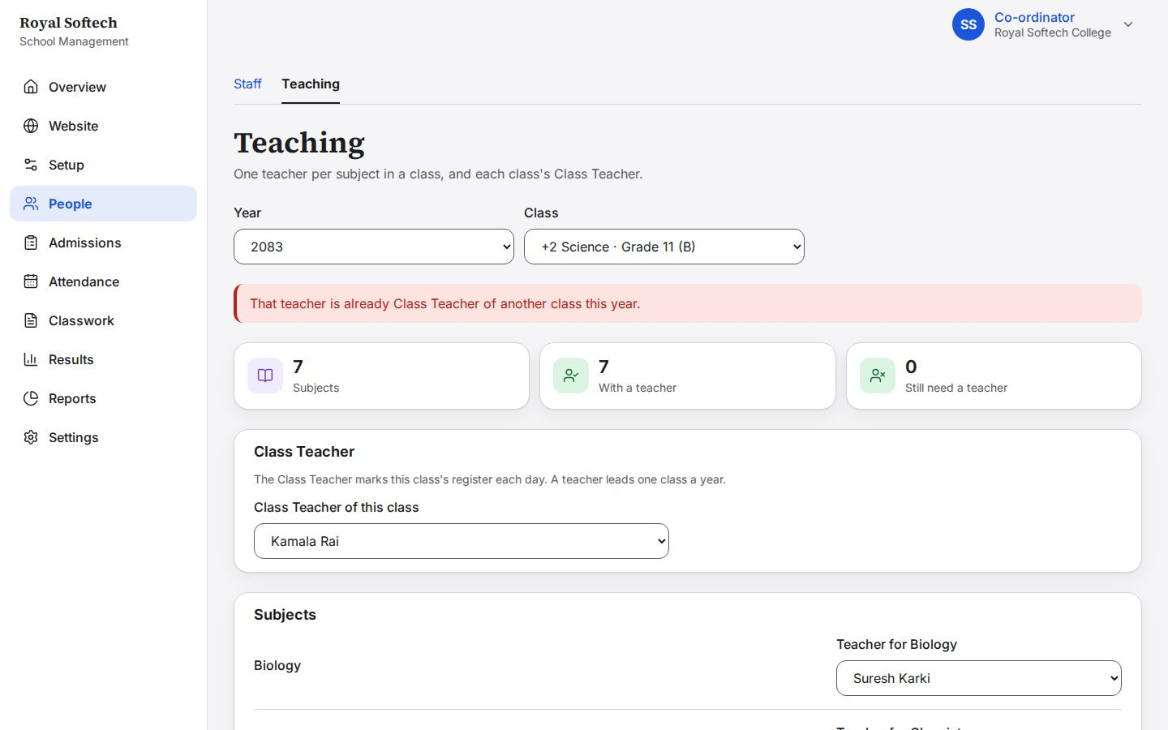
06-06 Grade 11 B Mathematics given to Anita Mandal instead of Bikash Chaudhary
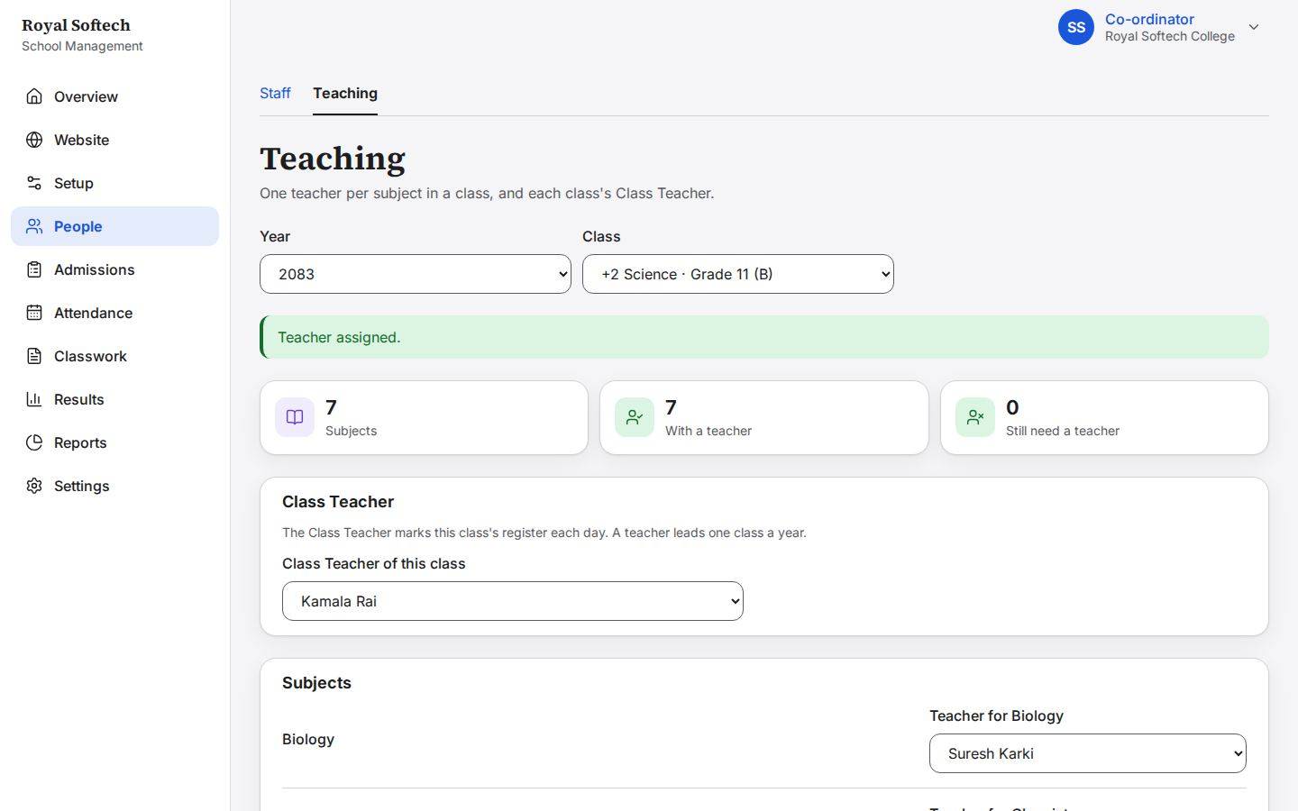
06-07 Grade 11 B Biology left without a teacher for now
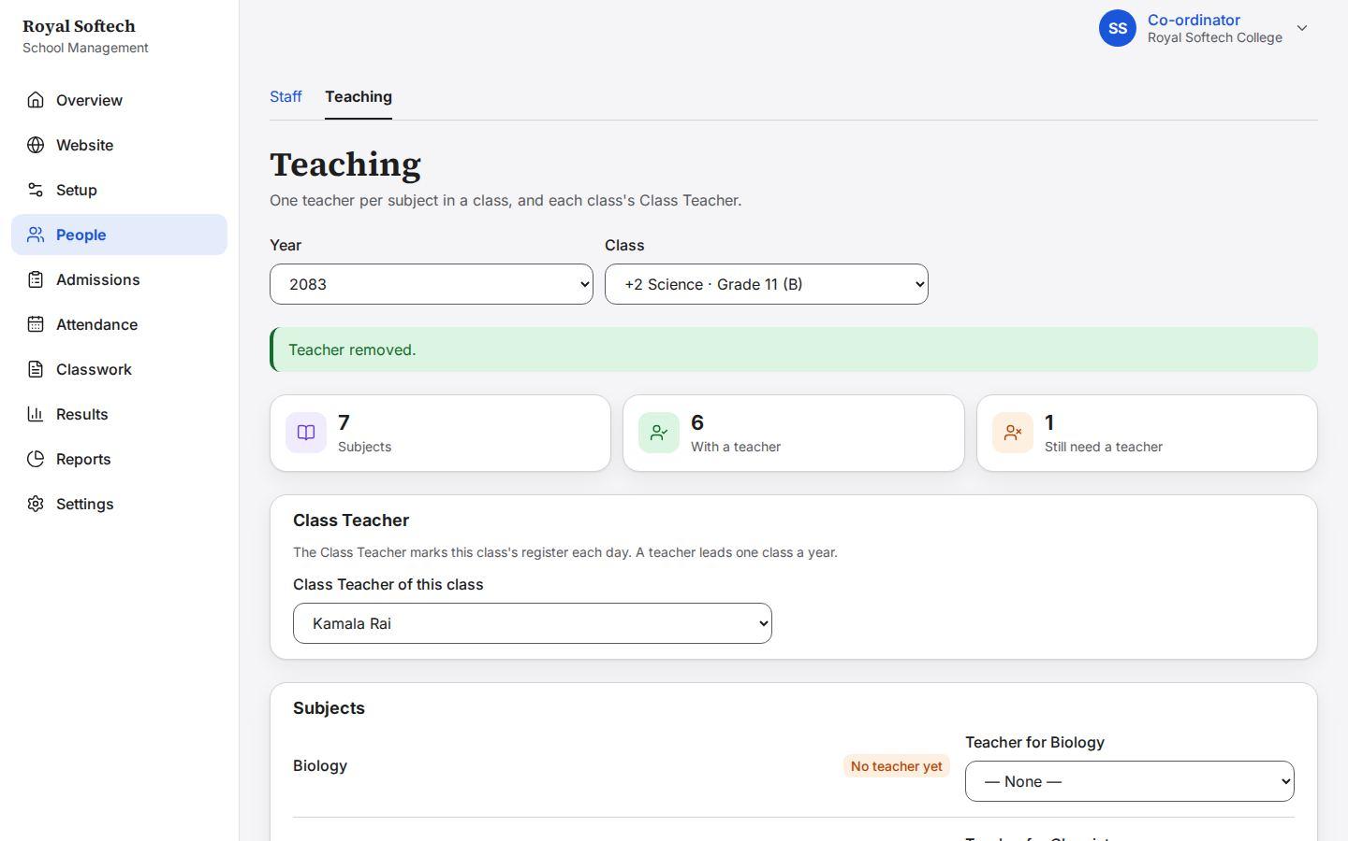
06-08 The dashboard's setup checklist once the year, classes, terminals, subjects, teachers and Class Teachers are in place
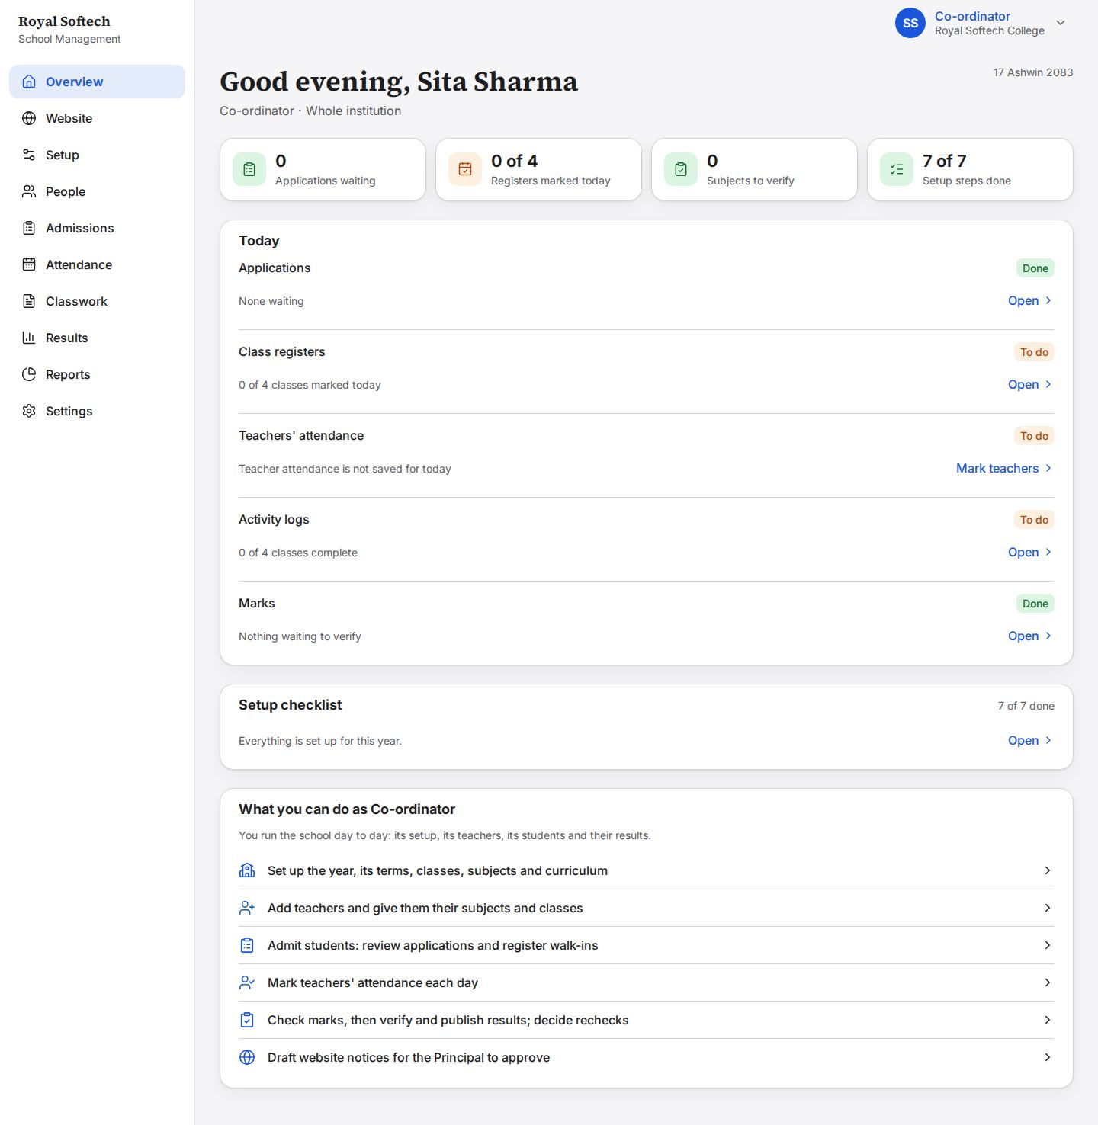

7. Admissions: walk-ins
Students the Co-ordinator registers herself are admitted at once.
# | Step | Observed on screen | Result
07-01 | Register a walk-in: the Co-ordinator's own registration is admitted at once (no queue) | – | Pass
07-02 | Admit with nothing filled in: each required field is asked for | This is required. / That does not look like a phone number. / That does not look like an email address. | Pass
07-03 | Aarav Mandal: born 12 Jestha 2066 (BS), Grade 11 of +2 Science, class A, with his previous school and who referred him | – | Pass
07-04 | Admitted at once: the new student ID, 2083-00001, and the temporary password, shown once (F-04 fixed) | Temporary password for Aarav Mandal (password) Give this to Aarav Mandal in person or by phone. It is shown once and cannot be looked up again. They must cho… | Pass
07-05 | The same name, date of birth and phone again: she is shown the student already admitted, and nobody is admitted twice unless she says so (F-03 fixed) | This may be a student already admitted: Aarav Mandal (2083-00001) Admit only if this is a different person. | Pass
07-06 | Bibek Shrestha admitted to BBS Year 1: the next number in the same school-wide sequence | Temporary password for Bibek Shrestha (password) Give this to Bibek Shrestha in person or by phone. It is shown once and cannot be looked up again. They must… | Pass

07-01 Register a walk-in: the Co-ordinator's own registration is admitted at once (no queue)
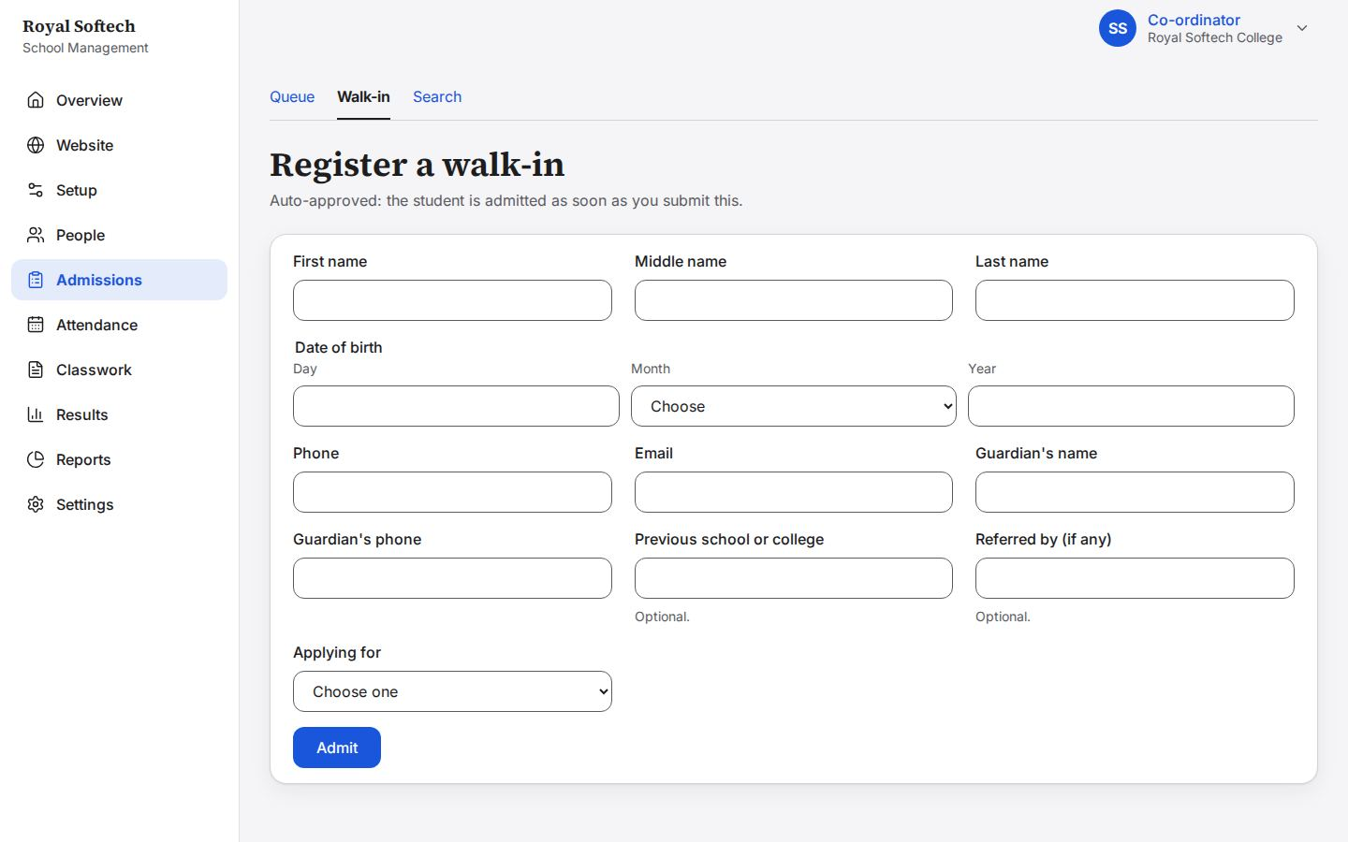
07-02 Admit with nothing filled in: each required field is asked for
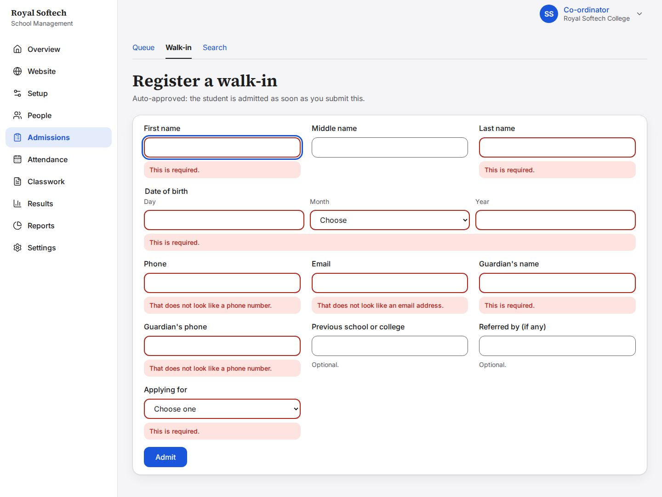
07-03 Aarav Mandal: born 12 Jestha 2066 (BS), Grade 11 of +2 Science, class A, with his previous school and who referred him
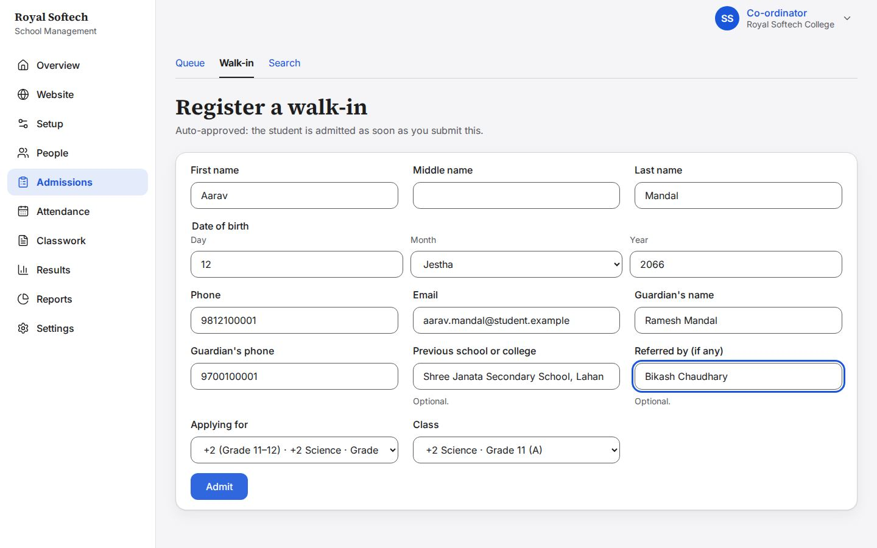
07-04 Admitted at once: the new student ID, 2083-00001, and the temporary password, shown once (F-04 fixed)
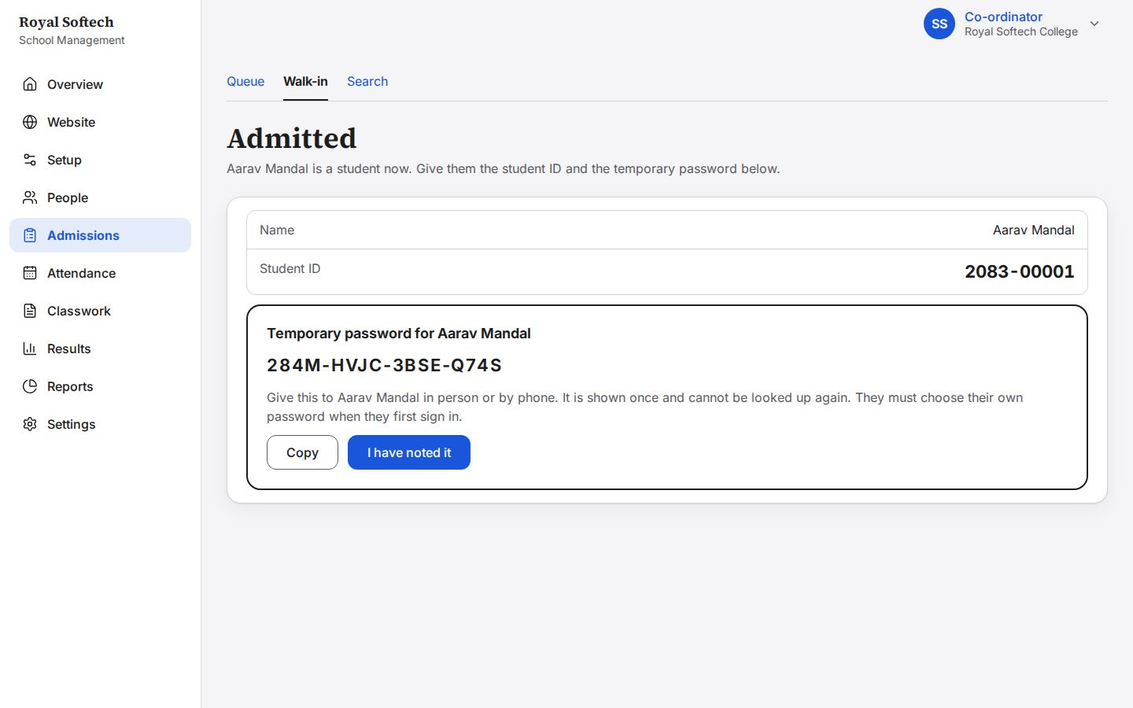
07-05 The same name, date of birth and phone again: she is shown the student already admitted, and nobody is admitted twice unless she says so (F-03 fixed)
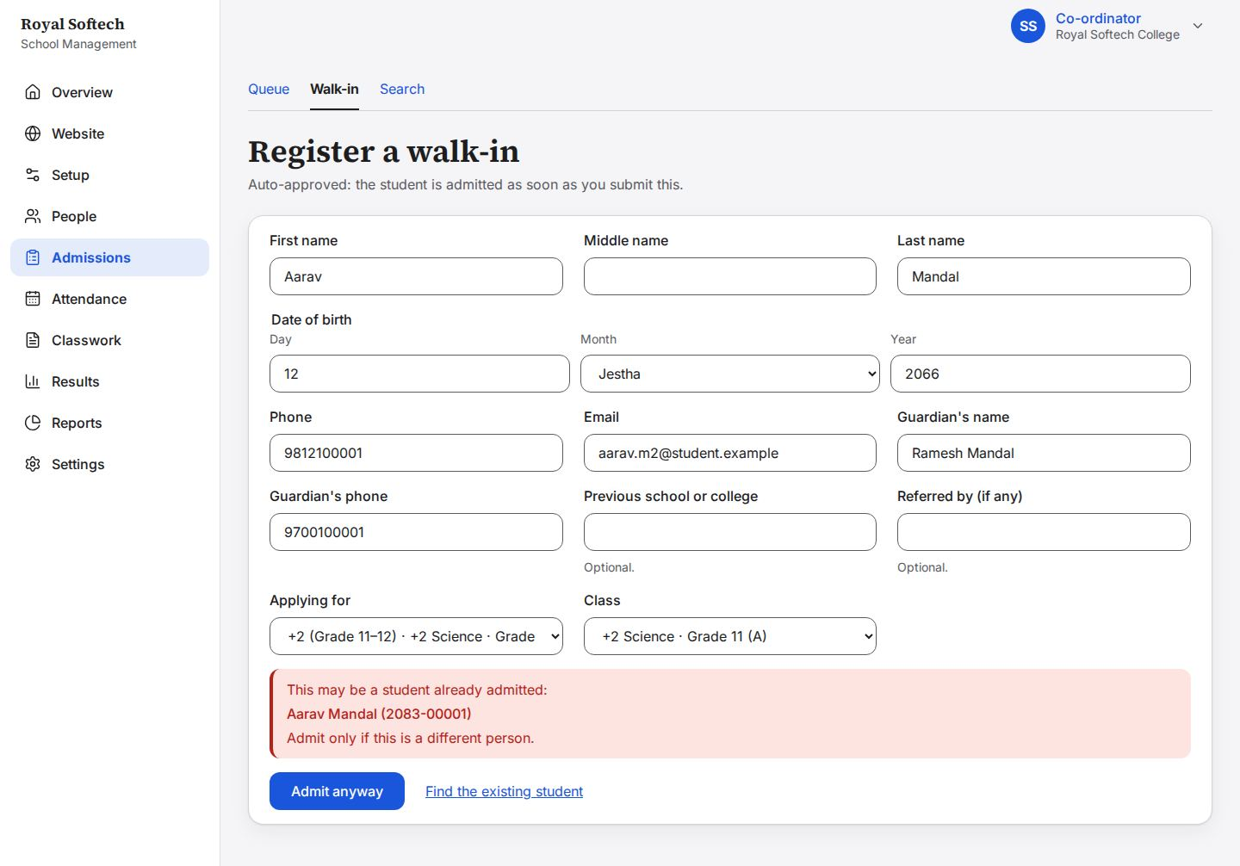
07-06 Bibek Shrestha admitted to BBS Year 1: the next number in the same school-wide sequence
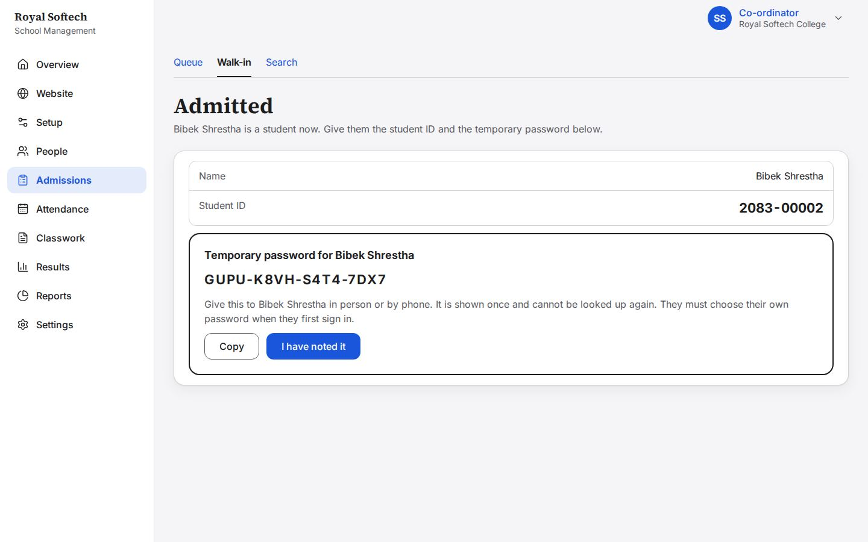

8. Admissions: the queue
Applications from the public website (confirmed by email) and from the Accountant: approve into a class, ask for changes, reject.
Precondition (P1): three applicants applied on the public website and confirmed their email; the Accountant registered one student.
# | Step | Observed on screen | Result
08-01 | The admissions queue: what is waiting, asked for changes and possibly a duplicate, then one card per application with the section's name (F-05 fixed) | – | Pass
08-02 | Reviewing Pooja Sharma in a side panel: her details, then Approve, Ask for changes or Reject | – | Pass
08-03 | Approve and admit with no class chosen: the class is asked for | Choose a class. | Pass
08-04 | Approve into +2 Science Grade 11 B: the message goes as soon as a class is chosen | – | Pass
08-05 | Approved: Pooja Sharma is a student, with her student ID and a temporary password shown once | Pooja Sharma is admitted as 2083-00015. / Temporary password for Pooja Sharma (password) Give this to Pooja Sharma in person or by phone. It is shown once an… | Pass
08-06 | Ask for changes with no reason: a reason is asked for | Give a reason. | Pass
08-07 | Changes asked of Rajesh Yadav: the application waits for him to fix it (the fix-it path, not a rejection) | – | Pass
08-07a | Sent: the panel closes into what happened, with no old message left behind (F-01 fixed) | Sent back to Rajesh Yadav to change. | Pass
08-08 | Rejecting Sunil Thapa, with the reason he will be told | – | Pass
08-09 | Rejected: final, the application leaves the queue for good | The application of Sunil Thapa is rejected. | Pass
08-10 | Sita Choudhary, flagged as a possible duplicate: the same phone and date of birth as Sita Chaudhary, already a student | This may be someone already known to the school. The phone number matches a student or another application. | Pass
08-11 | The Accountant's registration (Ritu Gupta) approved into Grade 12 A; the queue is down to what is still waiting | – | Pass

08-01 The admissions queue: what is waiting, asked for changes and possibly a duplicate, then one card per application with the section's name (F-05 fixed)
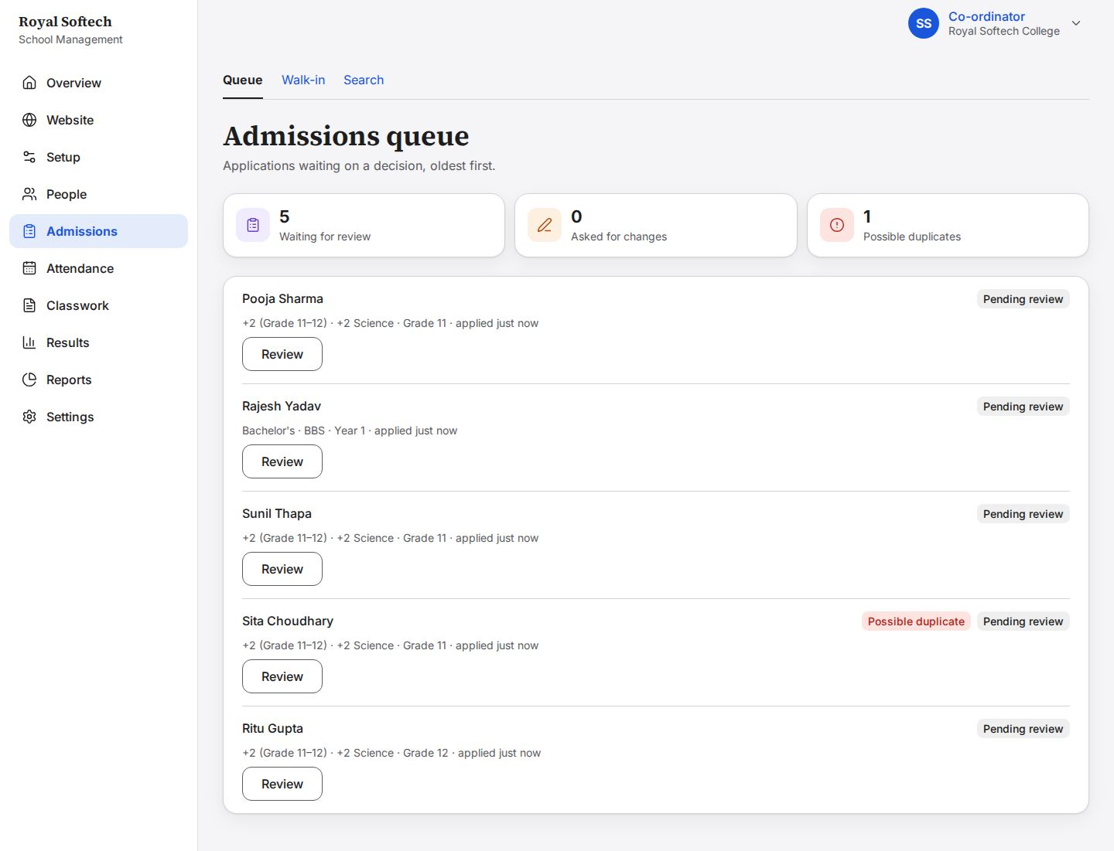
08-02 Reviewing Pooja Sharma in a side panel: her details, then Approve, Ask for changes or Reject
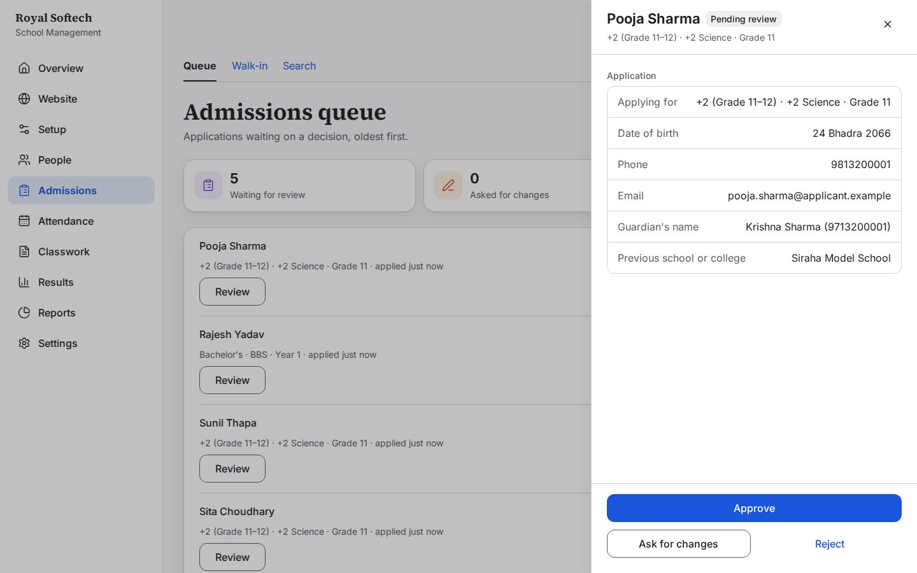
08-03 Approve and admit with no class chosen: the class is asked for
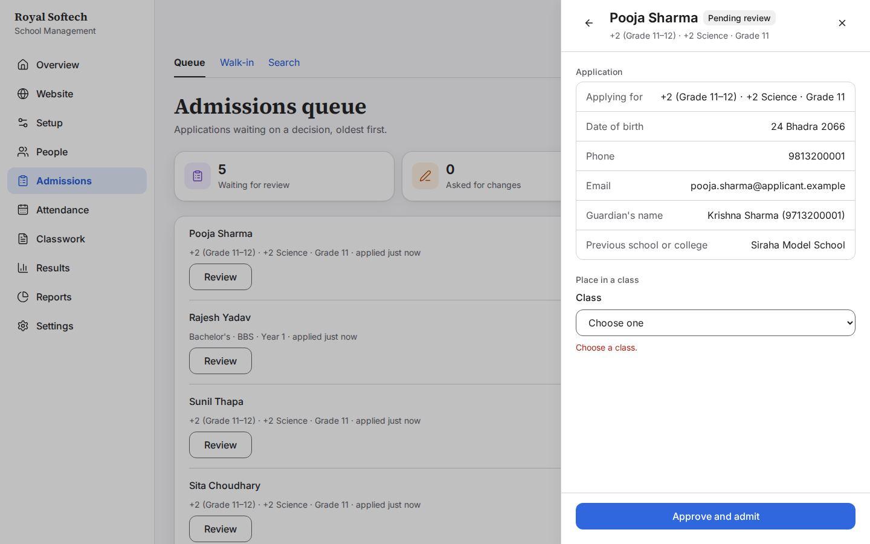
08-04 Approve into +2 Science Grade 11 B: the message goes as soon as a class is chosen
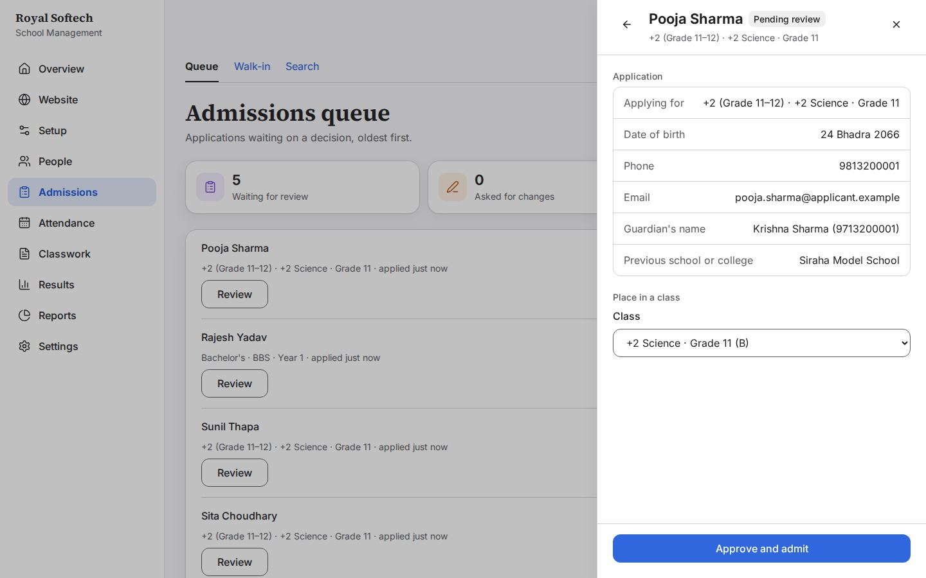
08-05 Approved: Pooja Sharma is a student, with her student ID and a temporary password shown once
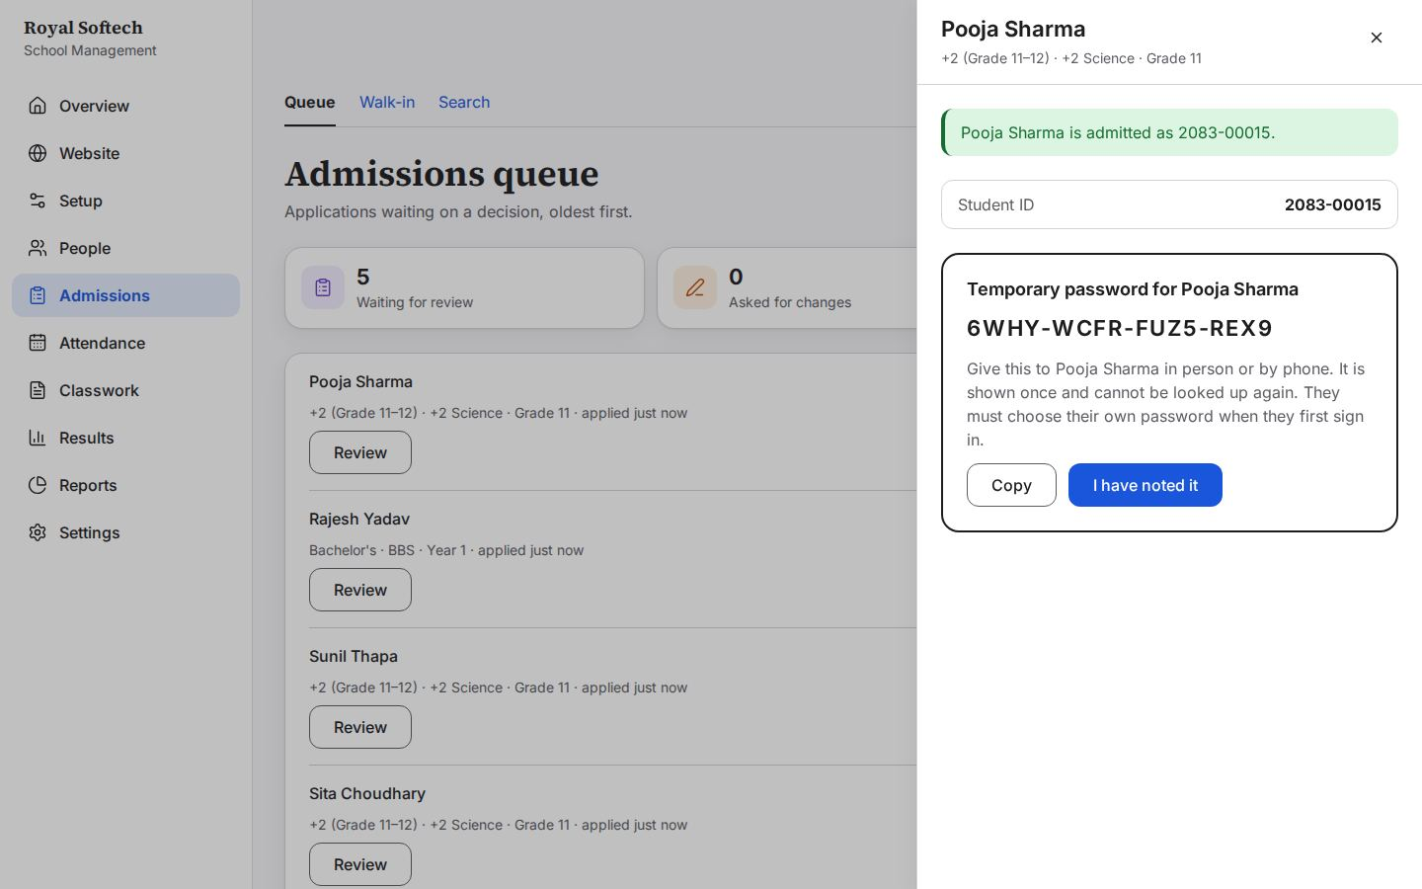
08-06 Ask for changes with no reason: a reason is asked for
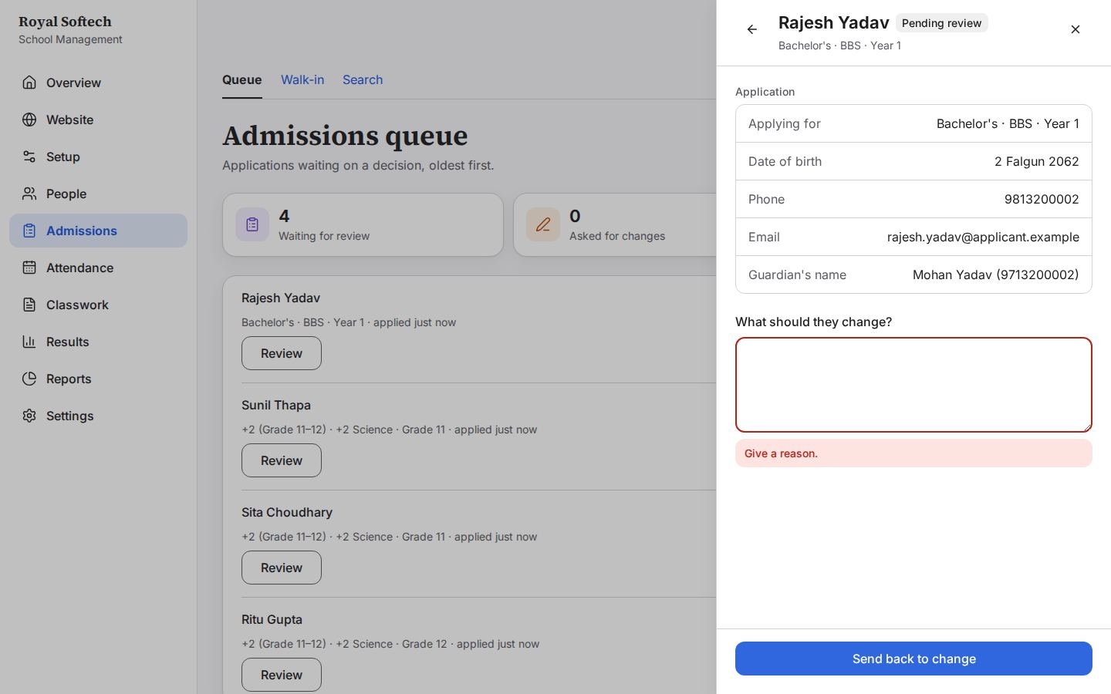
08-07 Changes asked of Rajesh Yadav: the application waits for him to fix it (the fix-it path, not a rejection)
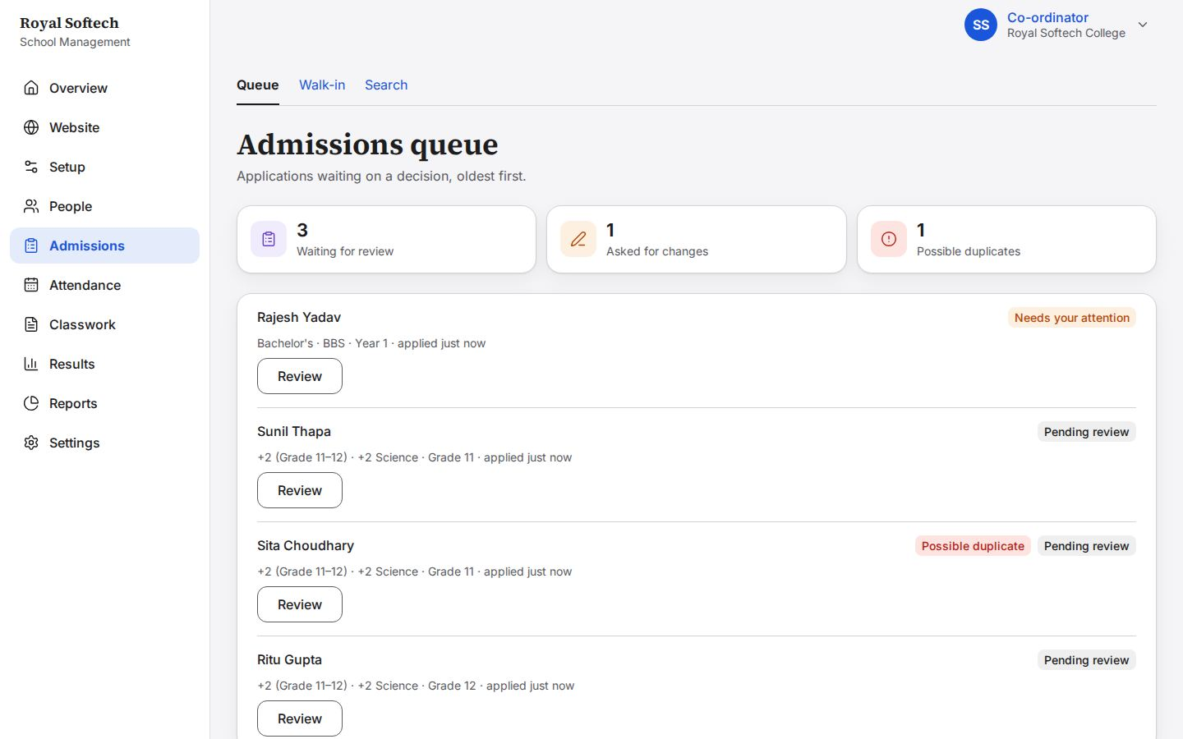
08-07a Sent: the panel closes into what happened, with no old message left behind (F-01 fixed)
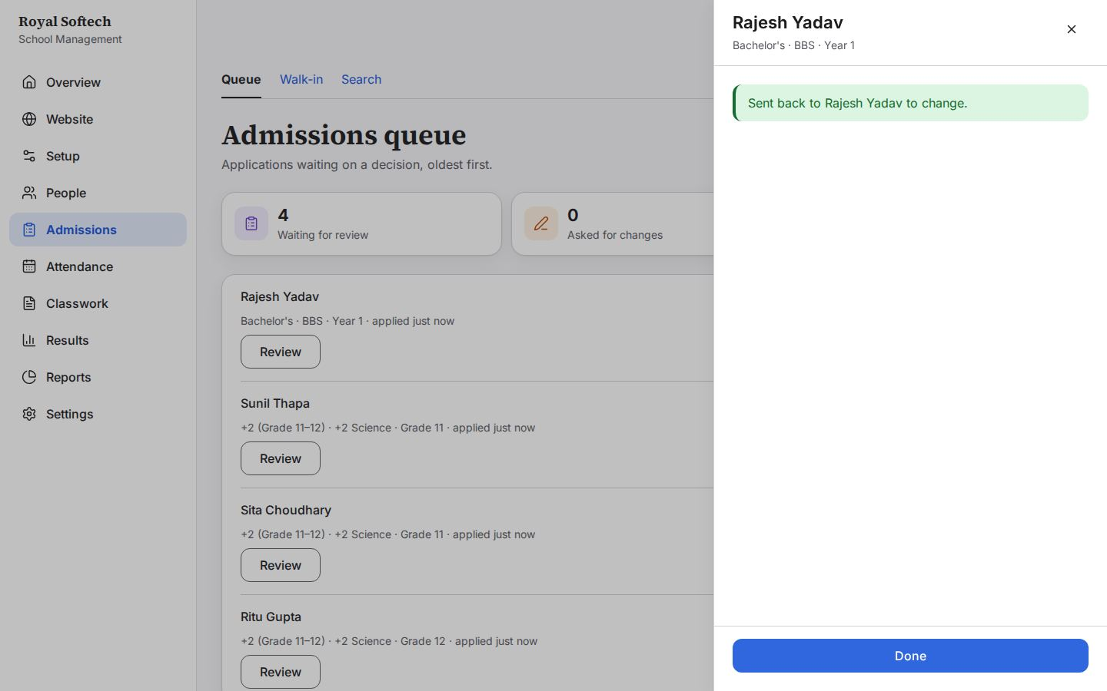
08-08 Rejecting Sunil Thapa, with the reason he will be told
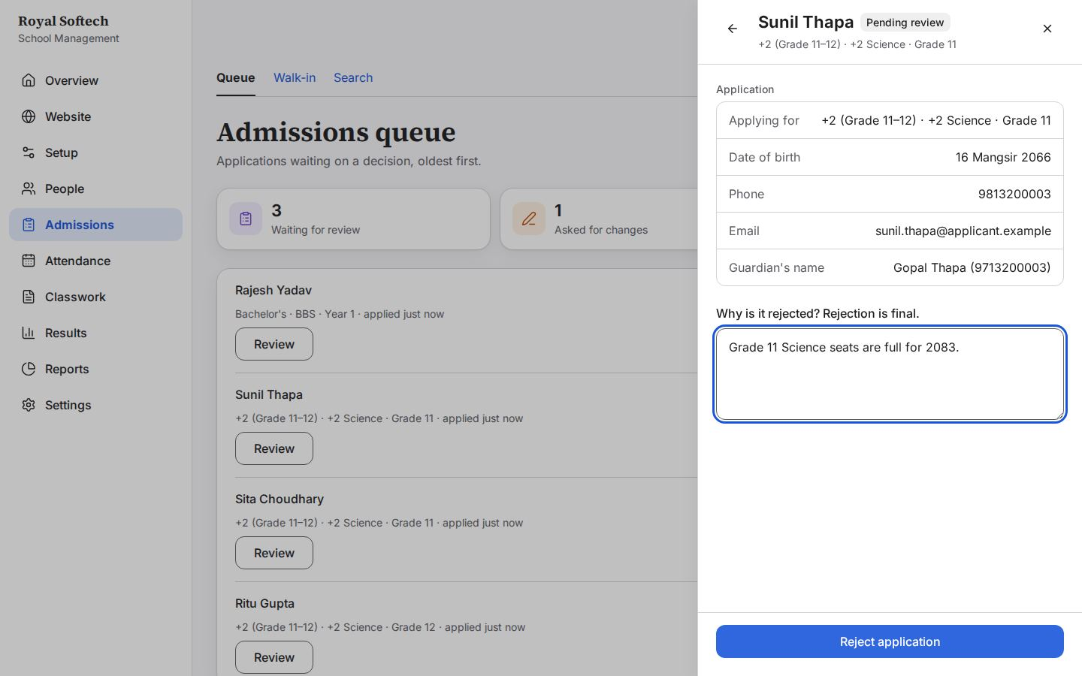
08-09 Rejected: final, the application leaves the queue for good
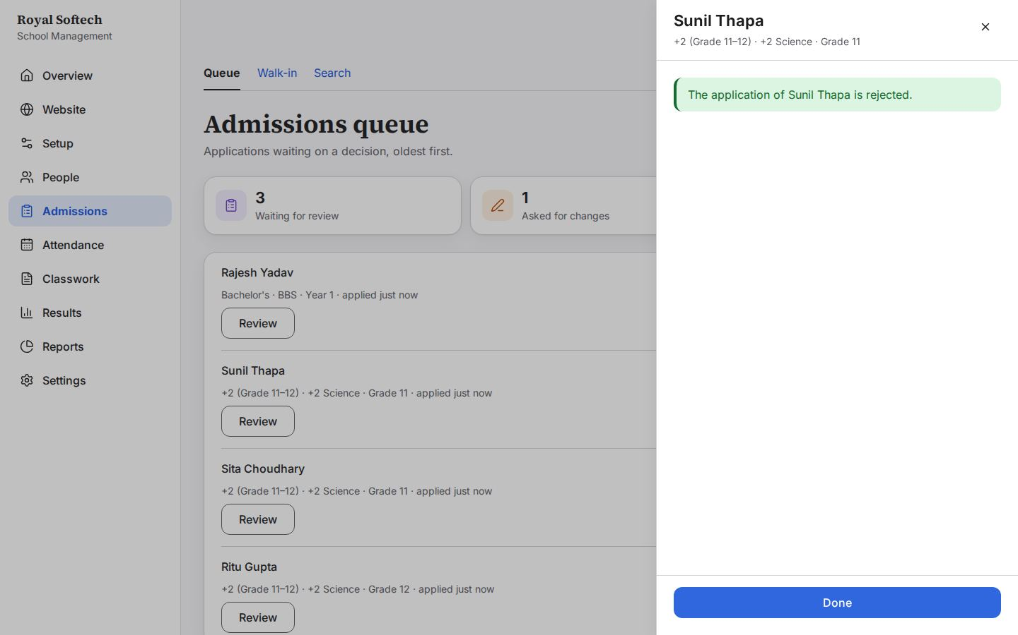
08-10 Sita Choudhary, flagged as a possible duplicate: the same phone and date of birth as Sita Chaudhary, already a student
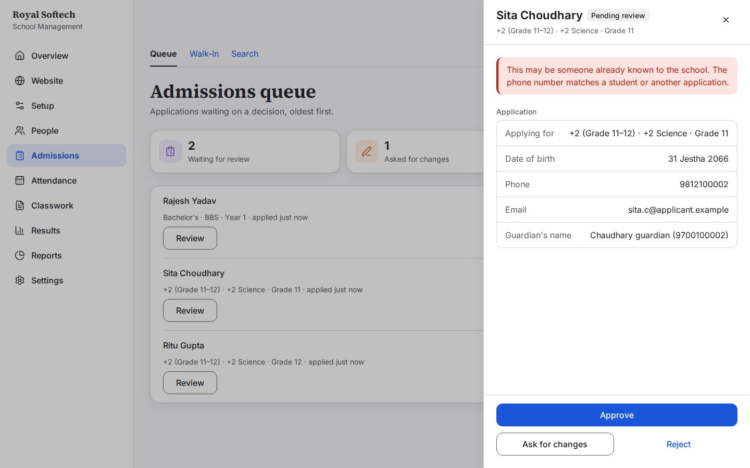
08-11 The Accountant's registration (Ritu Gupta) approved into Grade 12 A; the queue is down to what is still waiting
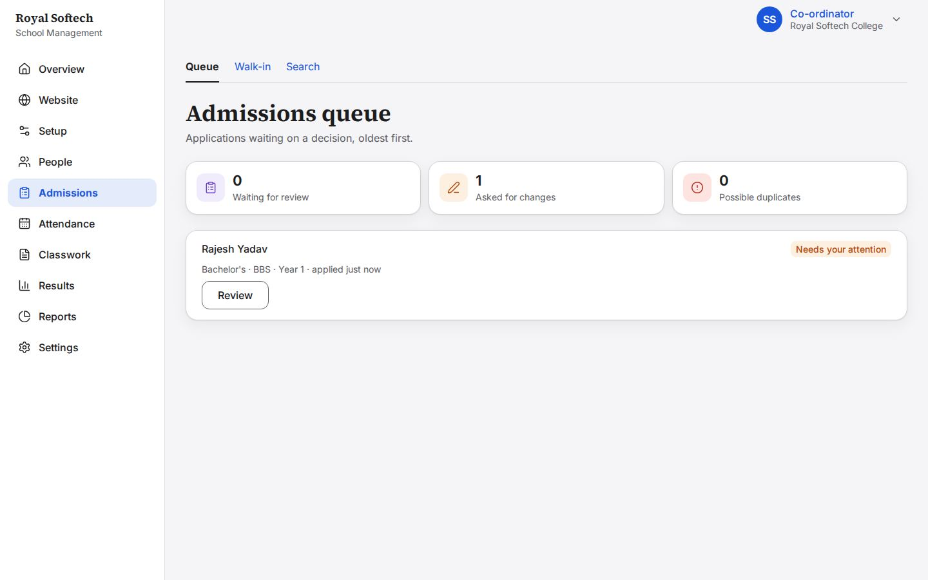

9. Admissions: search
Finding a student by name, student ID or phone.
# | Step | Observed on screen | Result
09-01 | Search by name: 'Sah' finds Rohan Sah and Manisha Sah, each with student ID and class, and each opens their record | – | Pass
09-02 | Search by student ID: 2083-00004 is Sita Chaudhary | – | Pass
09-03 | Search by phone: one Aarav Mandal, 2083-00001 (the second walk-in was stopped as a duplicate, F-03 fixed) | – | Pass
09-04 | Pooja Sharma, approved from the queue, is now a student in Grade 11 B | – | Pass
09-05 | Sunil Thapa was rejected, so he is not a student | – | Pass
09-06 | A search that finds no one | – | Pass
09-07 | Manisha Sah's record, opened from search, with Correct details (F-06 fixed) | – | Pass
09-08 | A correction without a reason is refused: the reason is kept in the audit trail | Say why the details are being corrected. | Pass
09-09 | Corrected: her guardian is now Ram Kumar Sah, the student ID unchanged; the audit trail keeps what changed and why | The corrections are saved, and the audit trail keeps what changed and why. | Pass

09-01 Search by name: 'Sah' finds Rohan Sah and Manisha Sah, each with student ID and class, and each opens their record
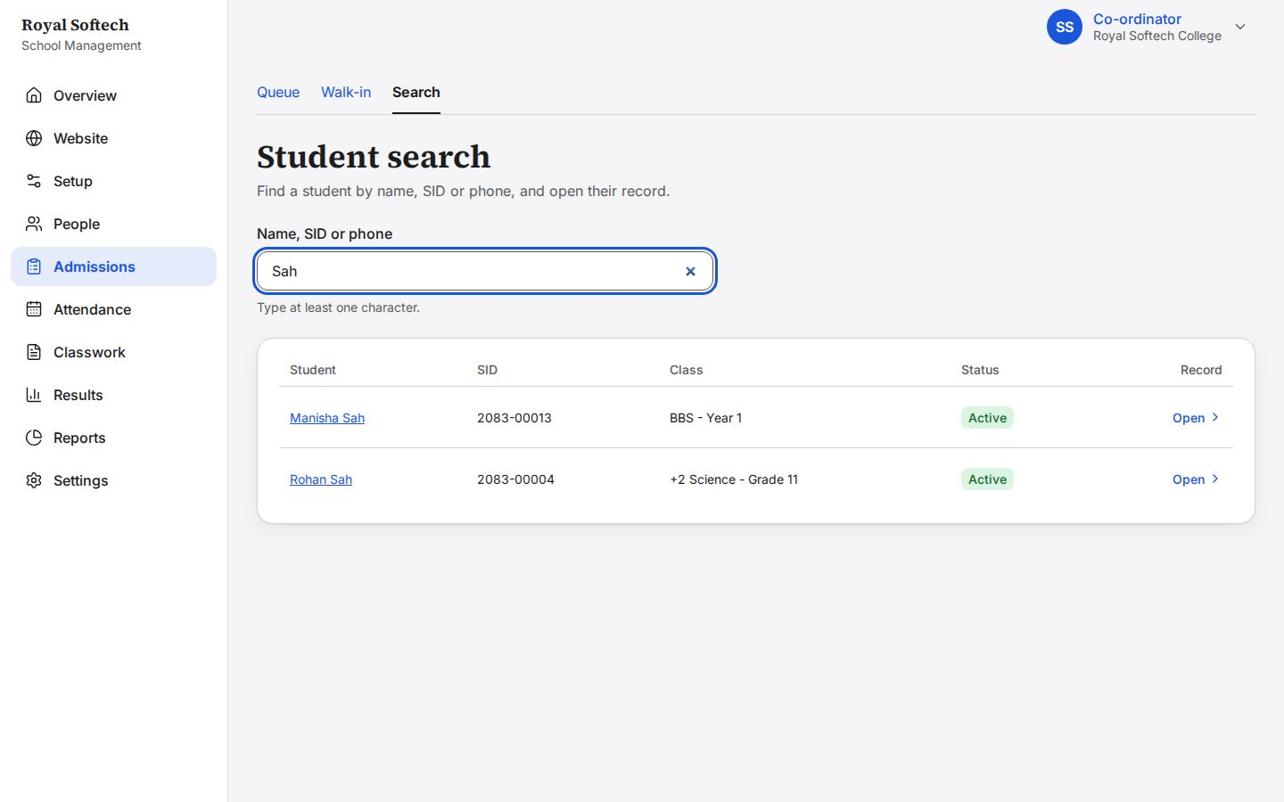
09-02 Search by student ID: 2083-00004 is Sita Chaudhary
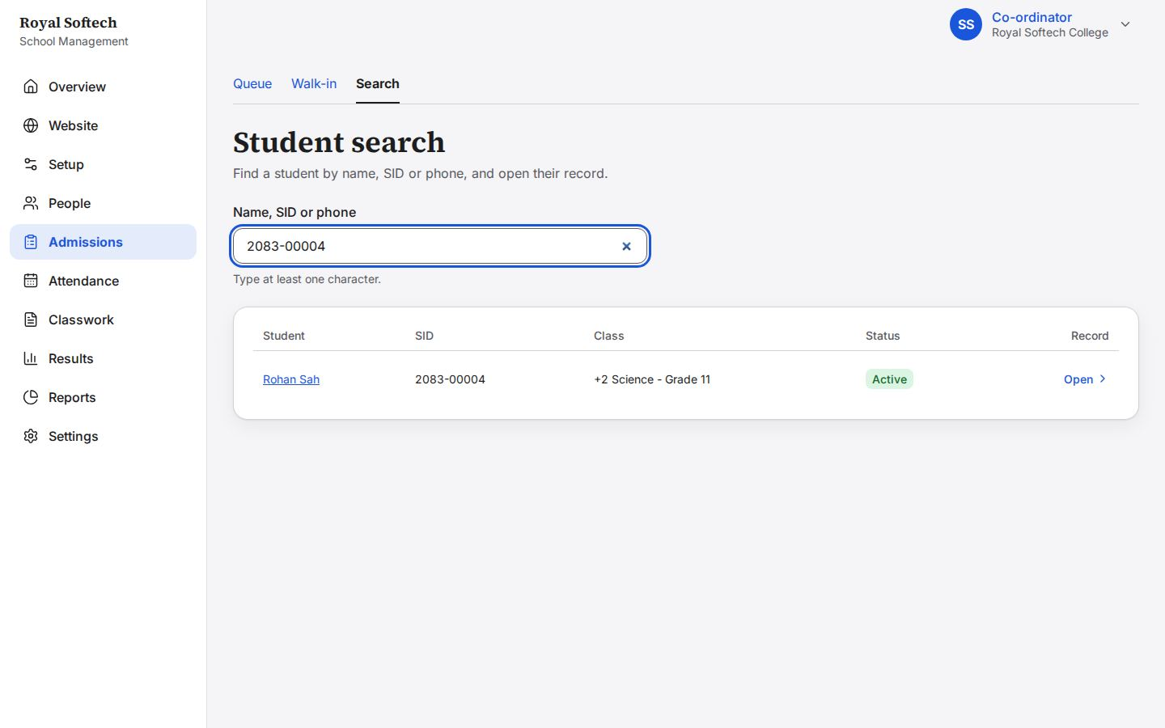
09-03 Search by phone: one Aarav Mandal, 2083-00001 (the second walk-in was stopped as a duplicate, F-03 fixed)
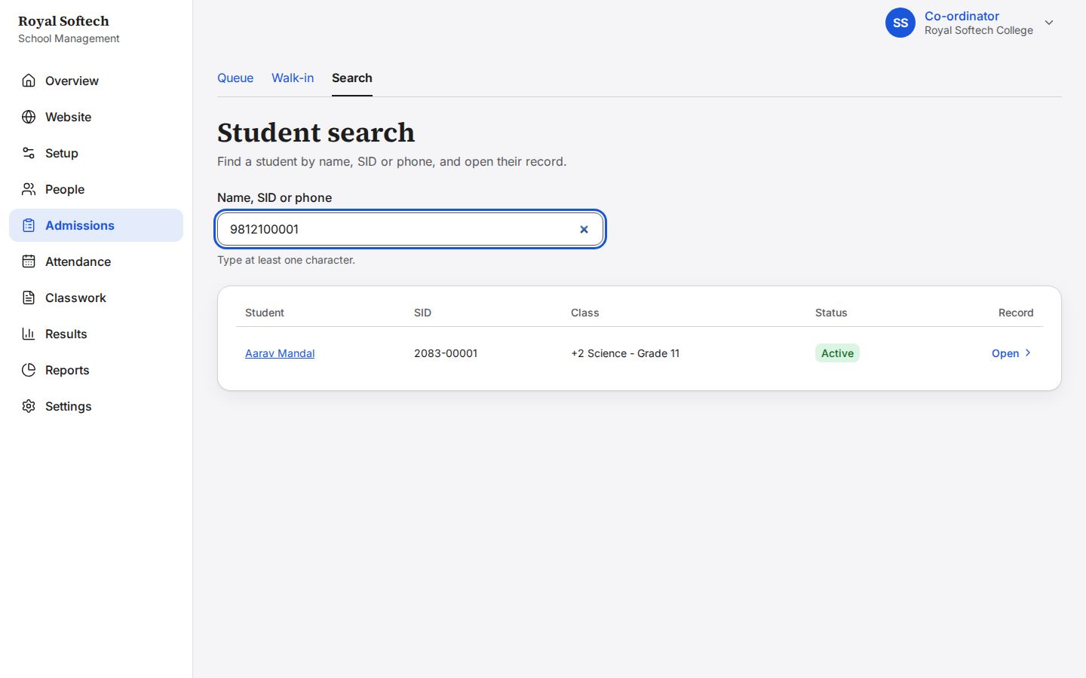
09-04 Pooja Sharma, approved from the queue, is now a student in Grade 11 B
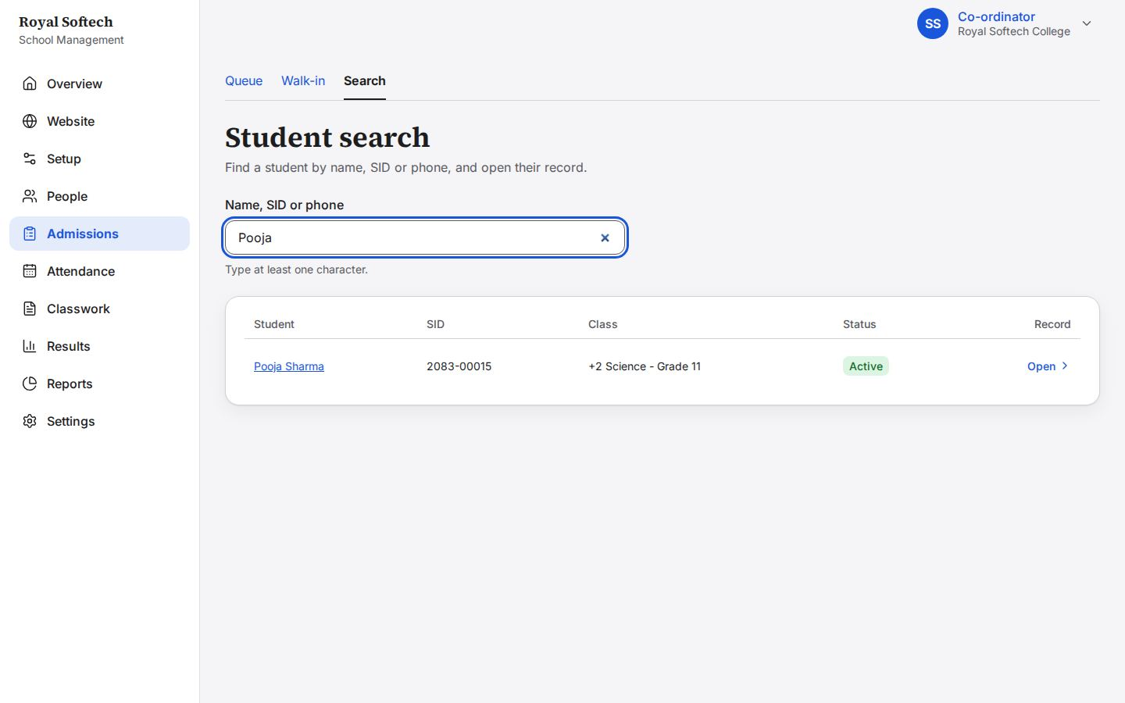
09-05 Sunil Thapa was rejected, so he is not a student
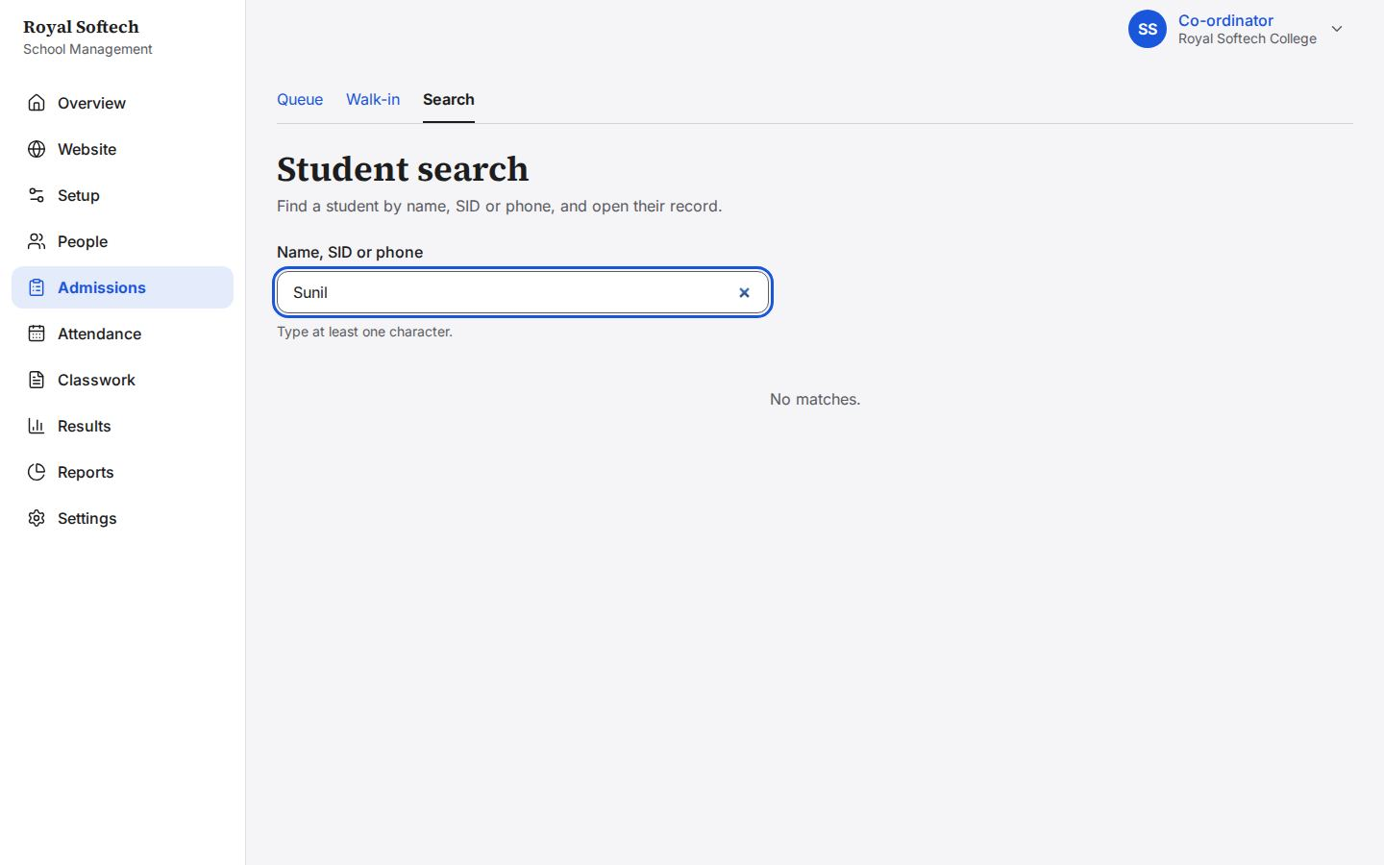
09-06 A search that finds no one
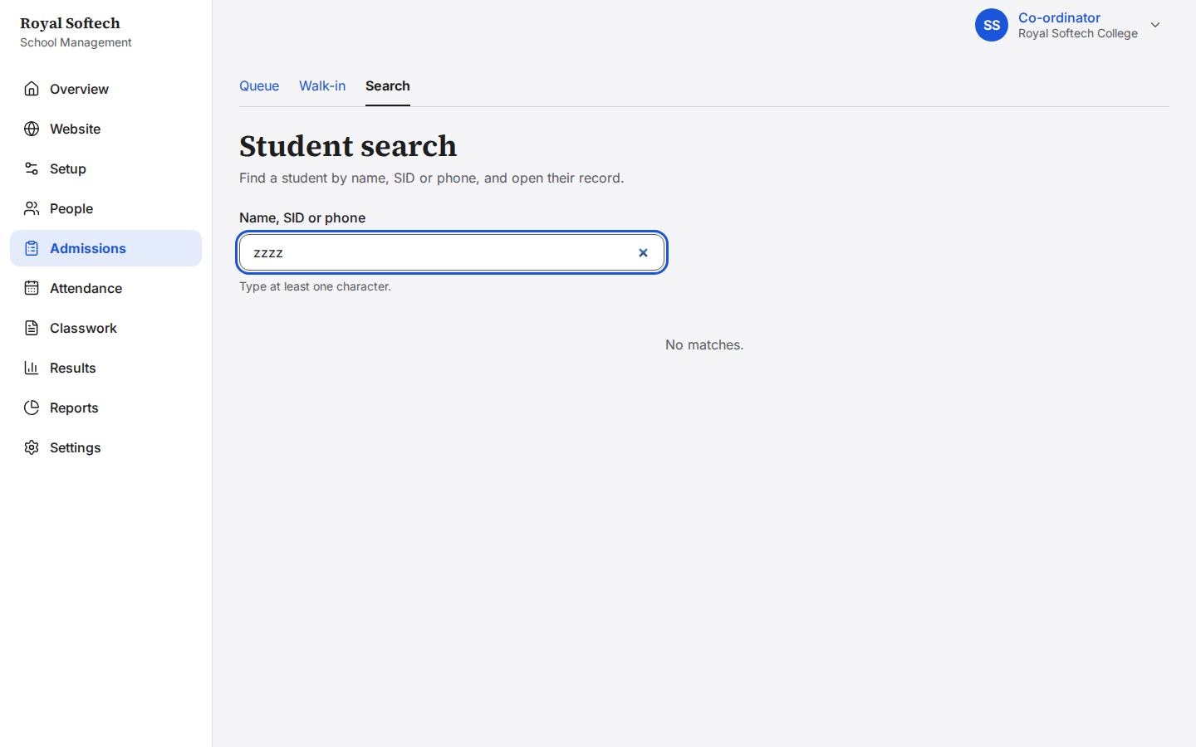
09-07 Manisha Sah's record, opened from search, with Correct details (F-06 fixed)
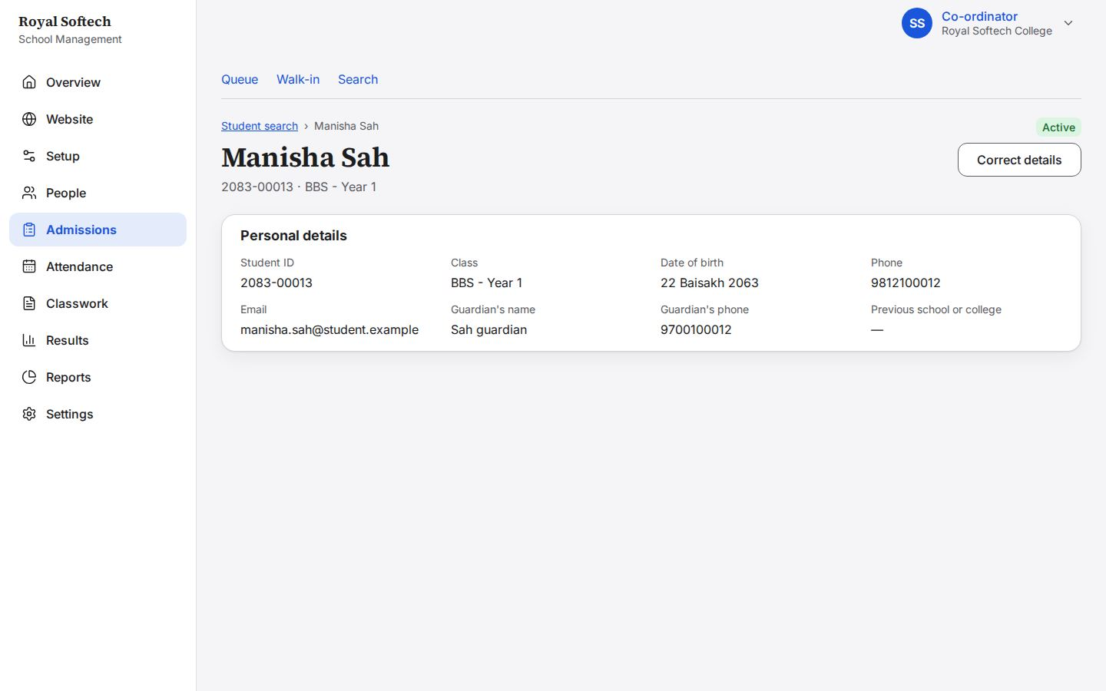
09-08 A correction without a reason is refused: the reason is kept in the audit trail
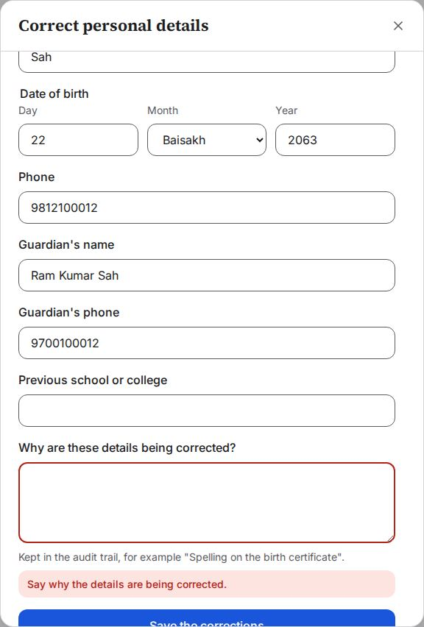
09-09 Corrected: her guardian is now Ram Kumar Sah, the student ID unchanged; the audit trail keeps what changed and why
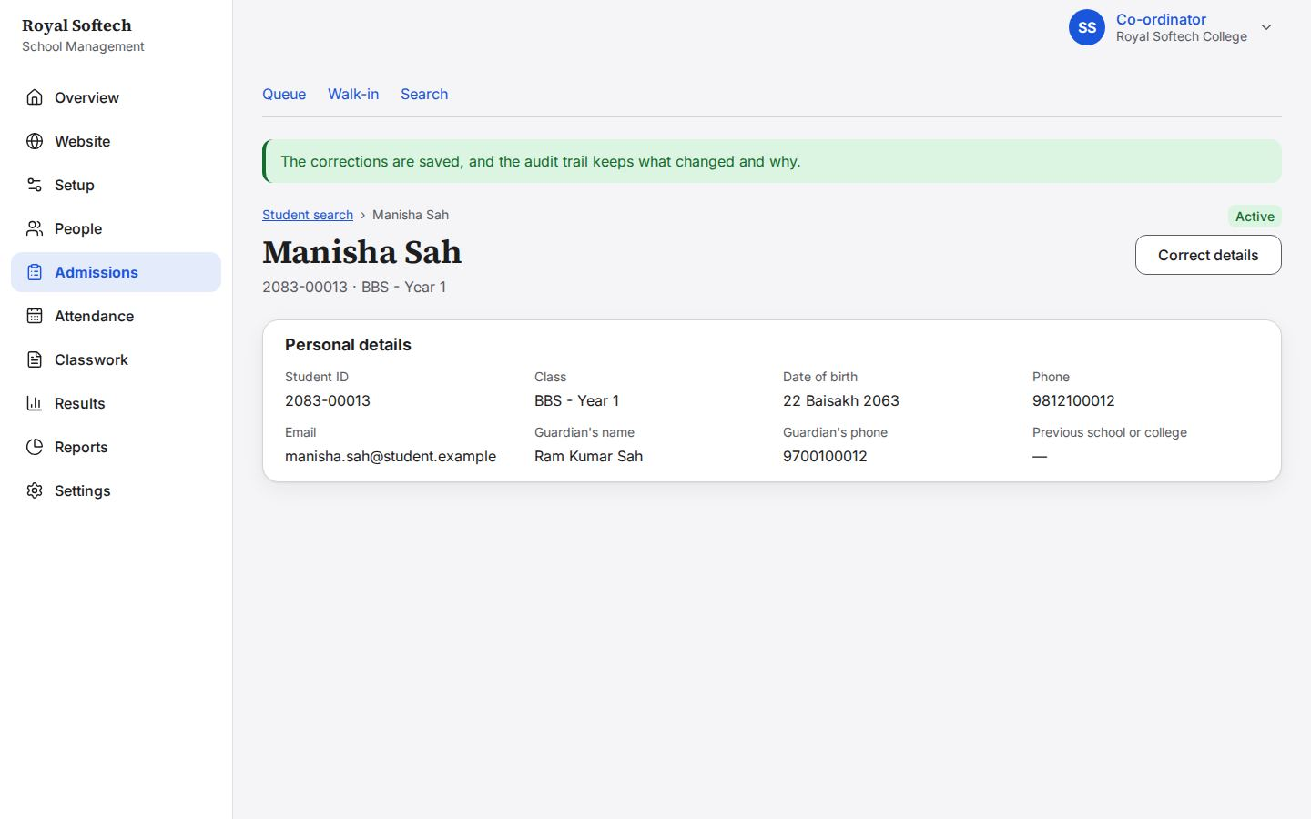

10. Attendance
Reading the students' registers, and marking teacher attendance for today and a past day.
Precondition (P2): each teacher signed in for the first time; the Class Teachers marked today's registers (Grade 12 left unmarked); three teachers wrote today's activity log.
# | Step | Observed on screen | Result
10-01 | Student attendance: today's register for every class; Grade 12 A has not been marked | – | Pass
10-02 | Grade 11 A today: two absent, marked by the Class Teacher; the Co-ordinator can look but not mark | – | Pass
10-03 | Grade 12 A: no register yet today | – | Pass
10-04 | Teacher attendance today: everyone starts as Present; the Co-ordinator records exceptions | – | Pass
10-05 | Suresh Karki on leave and Rajan Sah absent, each one tap; the figures follow as she marks | – | Pass
10-06 | Saved for today | Saved. | Pass
10-07 | A past day, 16 Ashwin: it can still be filled in, but a reason is needed | – | Pass
10-08 | Saving a past day without a reason is refused | Give a reason for changing a past day. | Pass
10-09 | Saved with the reason, which is kept with the change | Saved. | Pass

10-01 Student attendance: today's register for every class; Grade 12 A has not been marked
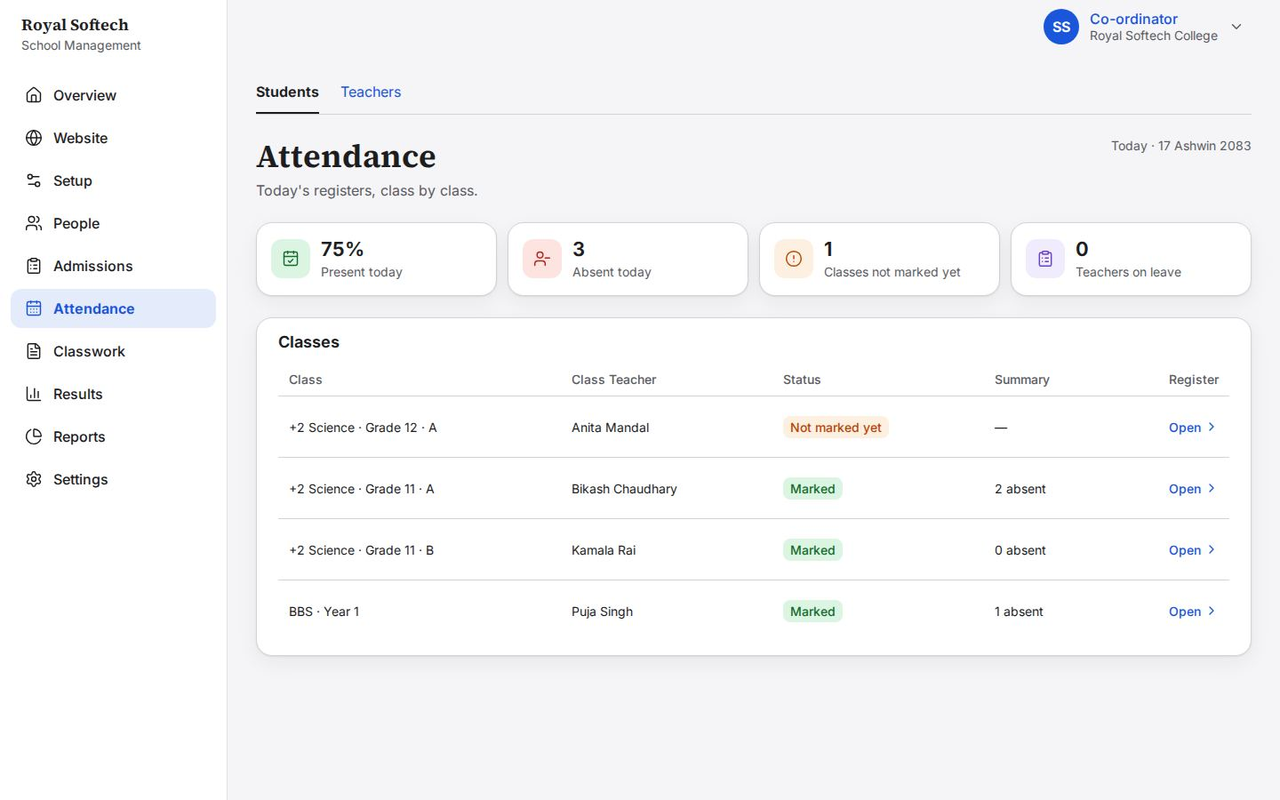
10-02 Grade 11 A today: two absent, marked by the Class Teacher; the Co-ordinator can look but not mark
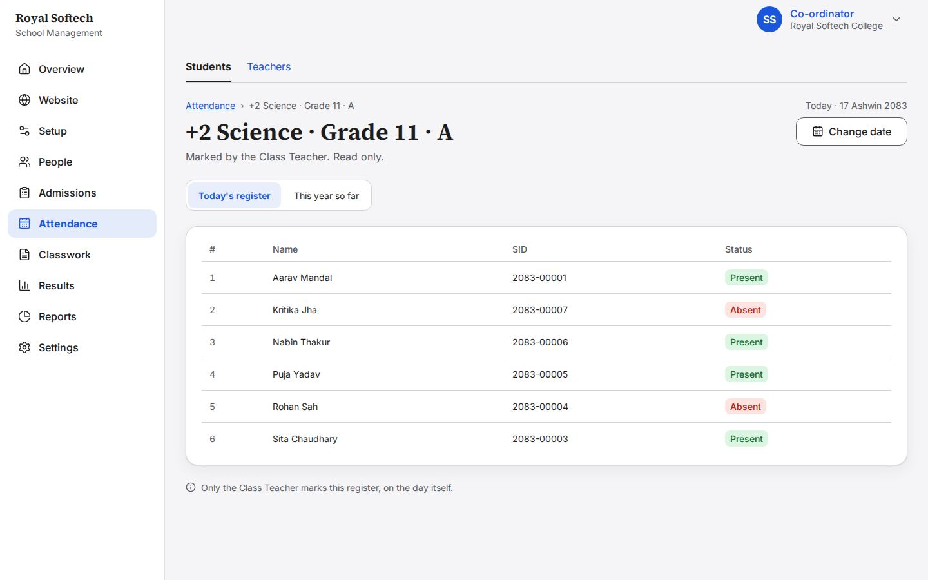
10-03 Grade 12 A: no register yet today
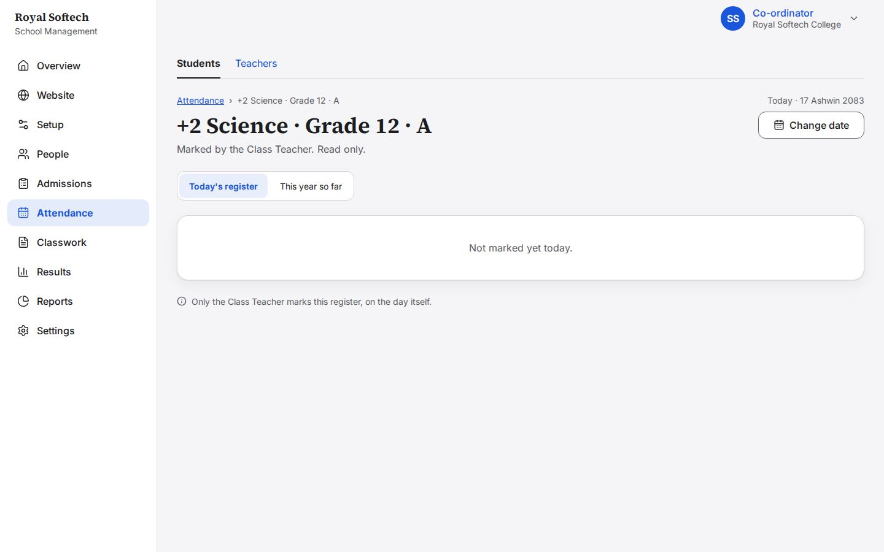
10-04 Teacher attendance today: everyone starts as Present; the Co-ordinator records exceptions
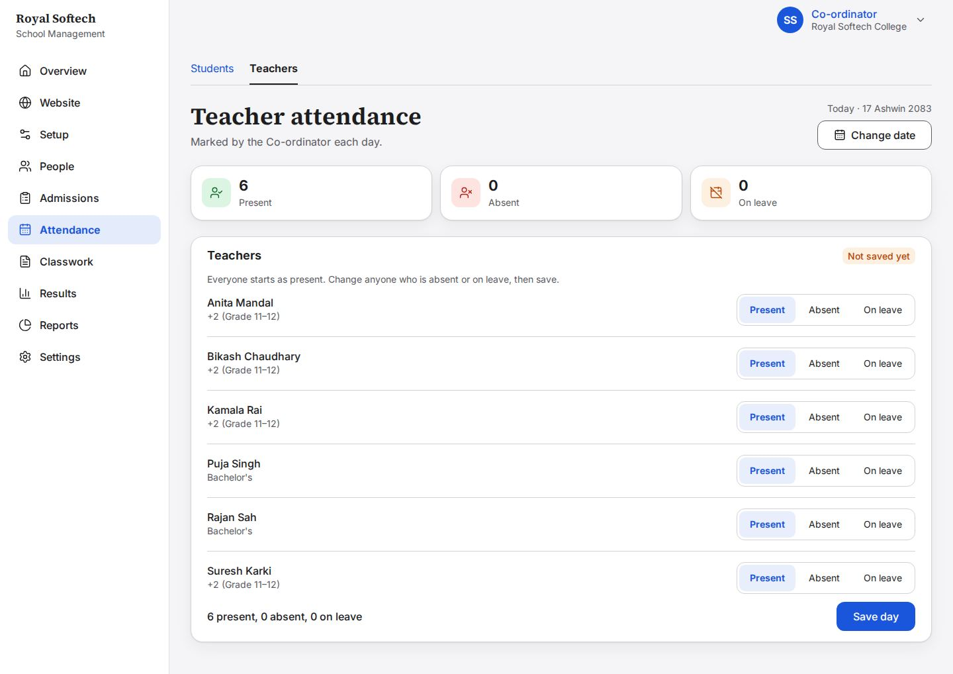
10-05 Suresh Karki on leave and Rajan Sah absent, each one tap; the figures follow as she marks
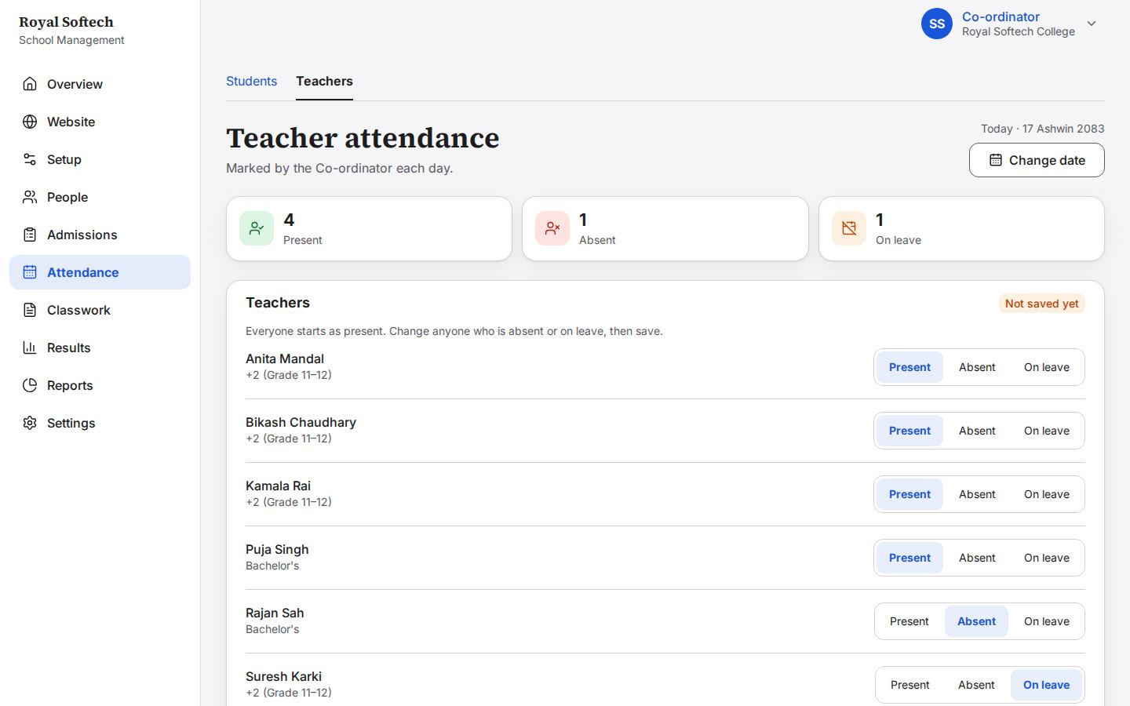
10-06 Saved for today
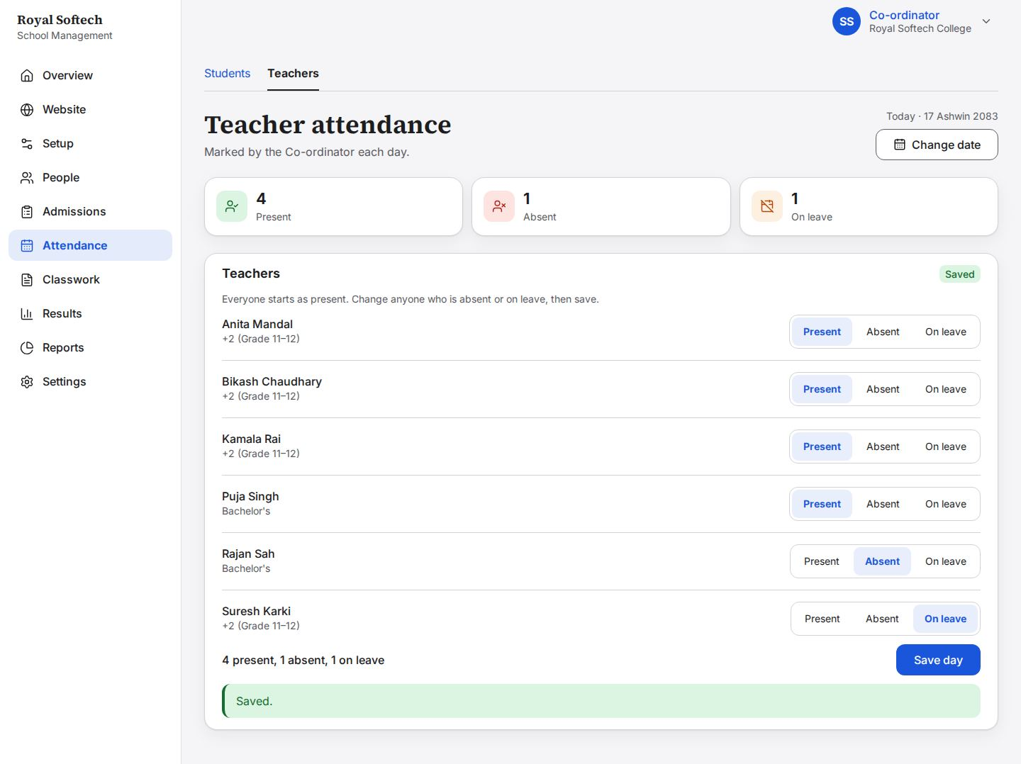
10-07 A past day, 16 Ashwin: it can still be filled in, but a reason is needed
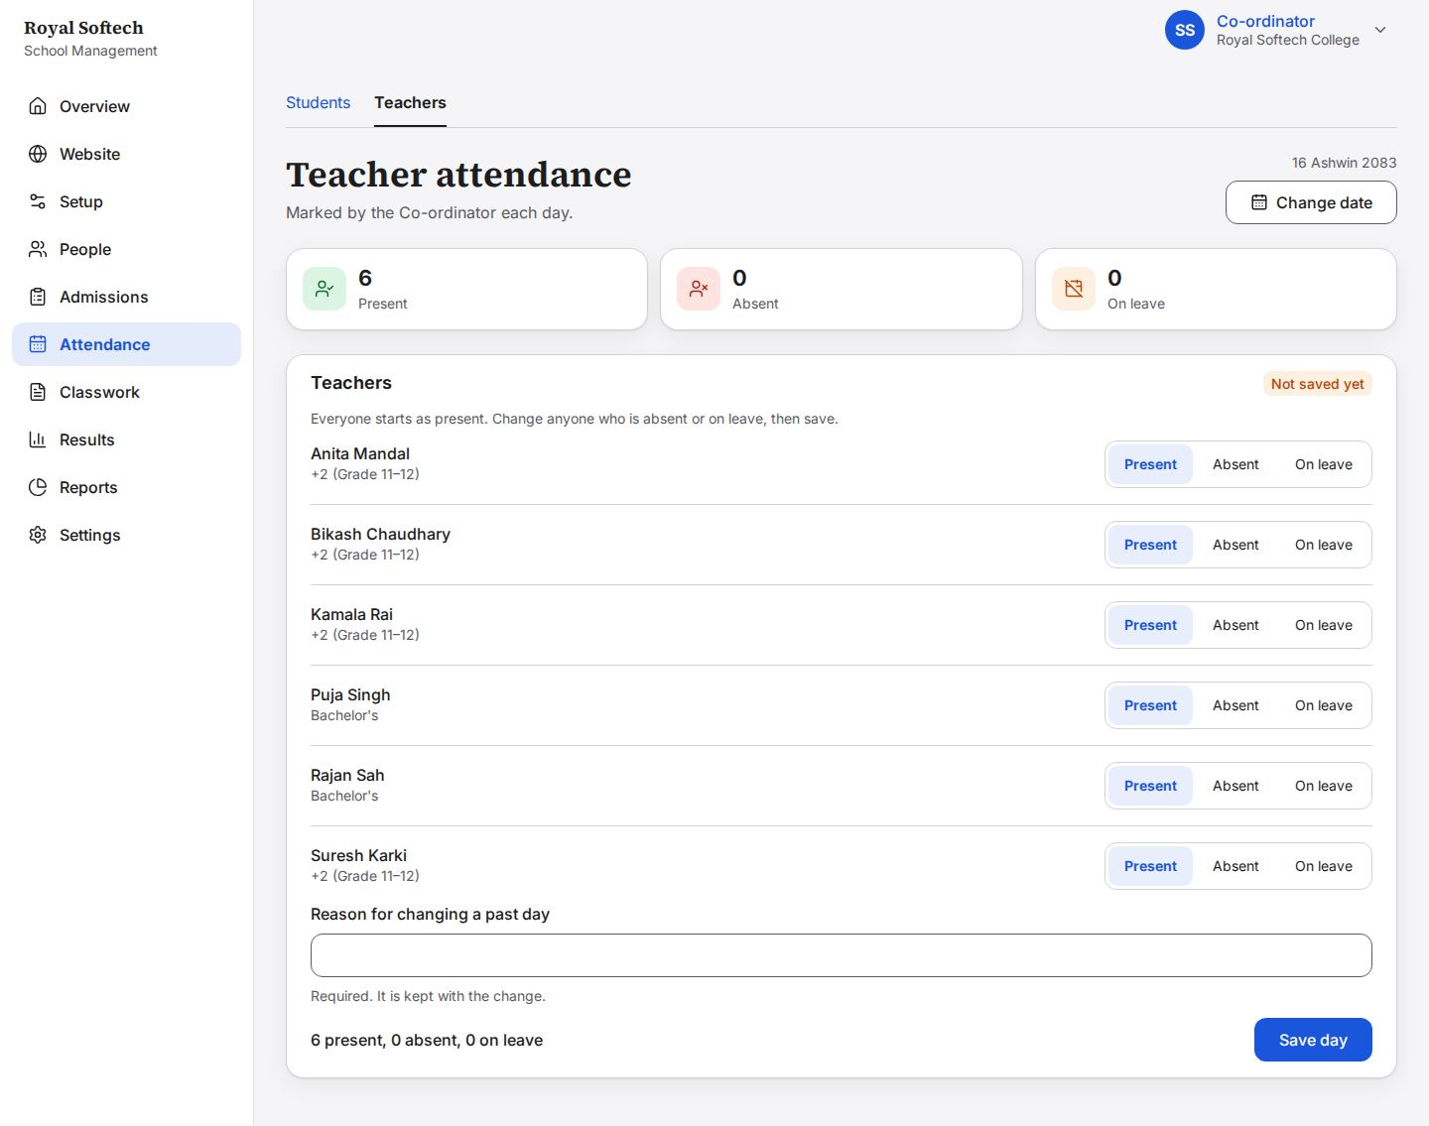
10-08 Saving a past day without a reason is refused
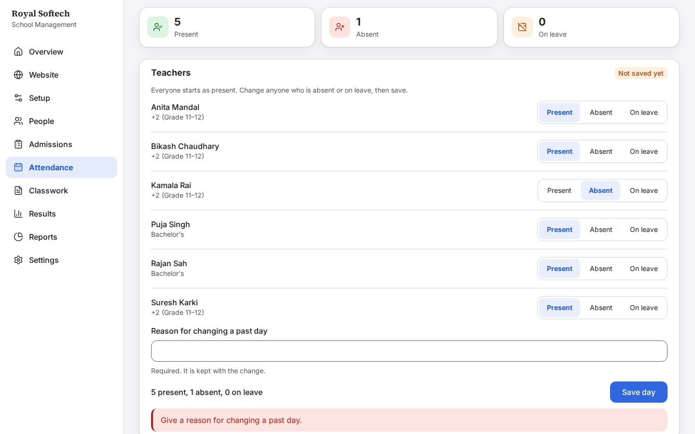
10-09 Saved with the reason, which is kept with the change
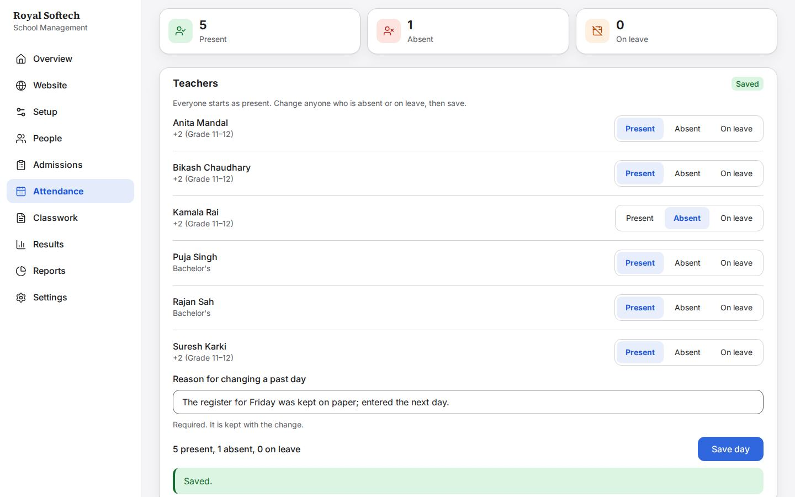

11. Classwork and electives
Reading the activity log, and recording each student's elective (Science option).
# | Step | Observed on screen | Result
11-01 | Classwork: today's activity log for each class, with how many subjects have written theirs | – | Pass
11-02 | Grade 11 A today: Physics and English written by their teachers; the other subjects have nothing yet | – | Pass
11-03 | Electives: the first class opens straight away, with how many students still have to choose | – | Pass
11-04 | Grade 11 A: every student's Science option is Not chosen yet | – | Pass
11-05 | Grade 11 A: each student's Science option chosen, saved as it is picked (Biology or Computer Science) | Saved. | Pass

11-01 Classwork: today's activity log for each class, with how many subjects have written theirs
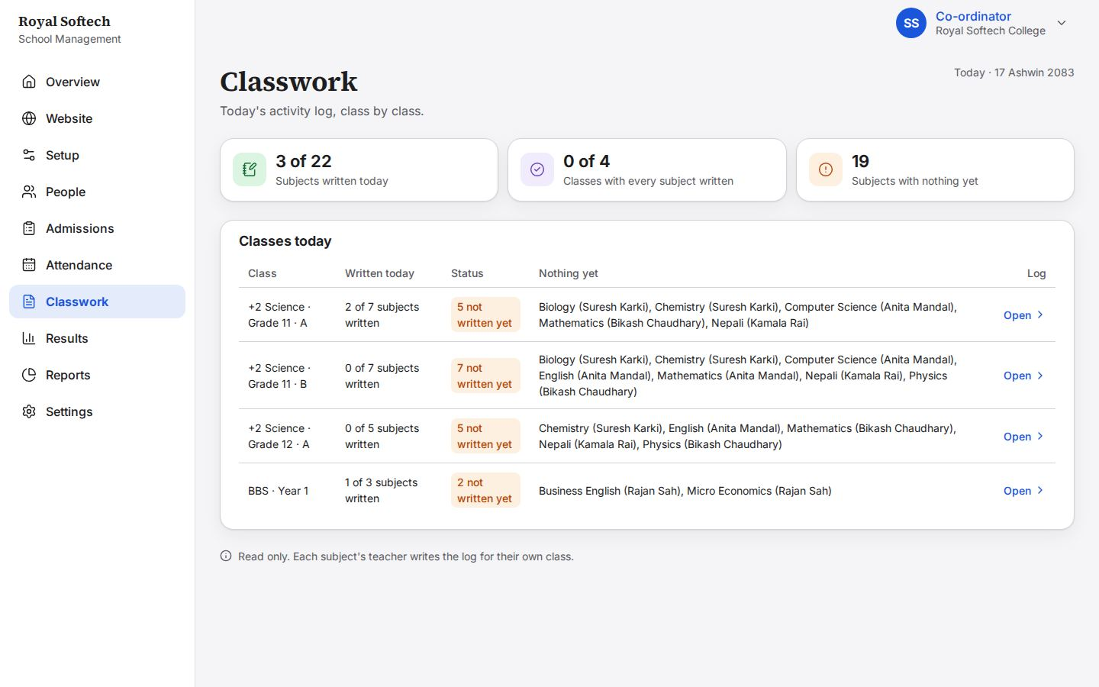
11-02 Grade 11 A today: Physics and English written by their teachers; the other subjects have nothing yet
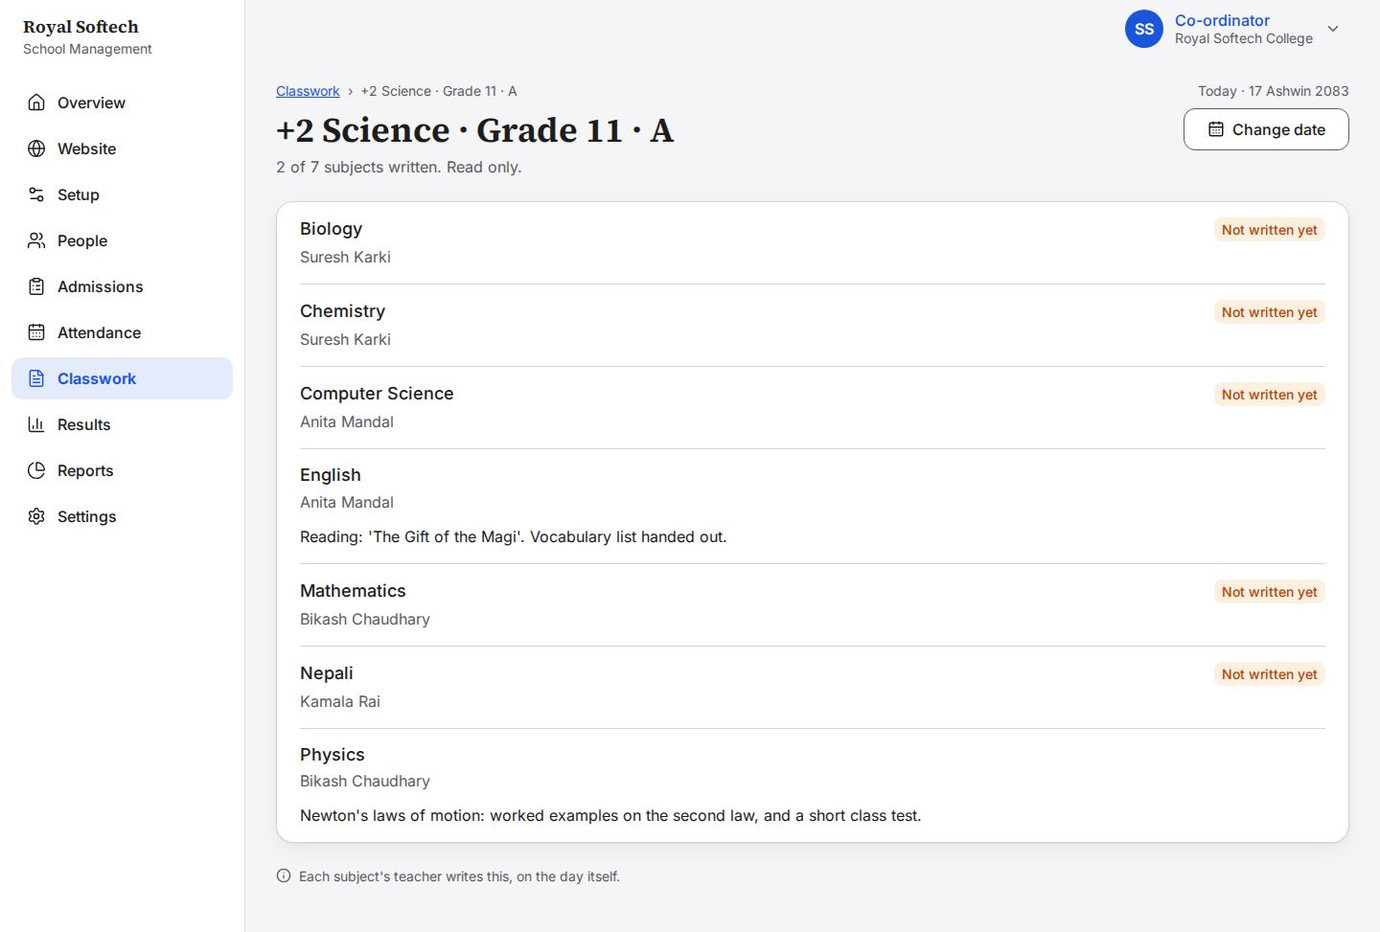
11-03 Electives: the first class opens straight away, with how many students still have to choose
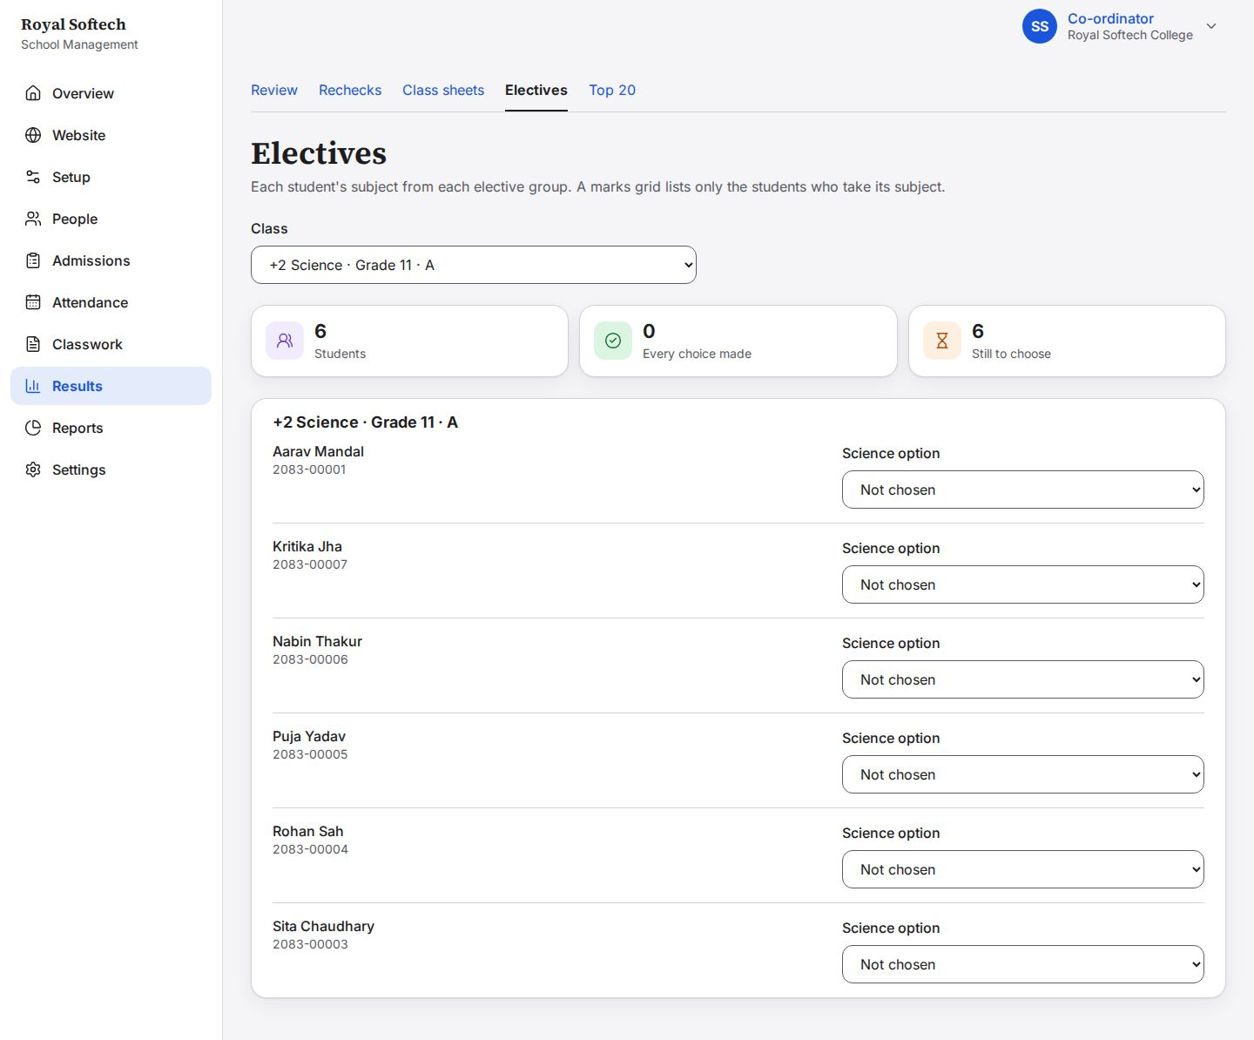
11-04 Grade 11 A: every student's Science option is Not chosen yet
11-05 Grade 11 A: each student's Science option chosen, saved as it is picked (Biology or Computer Science)
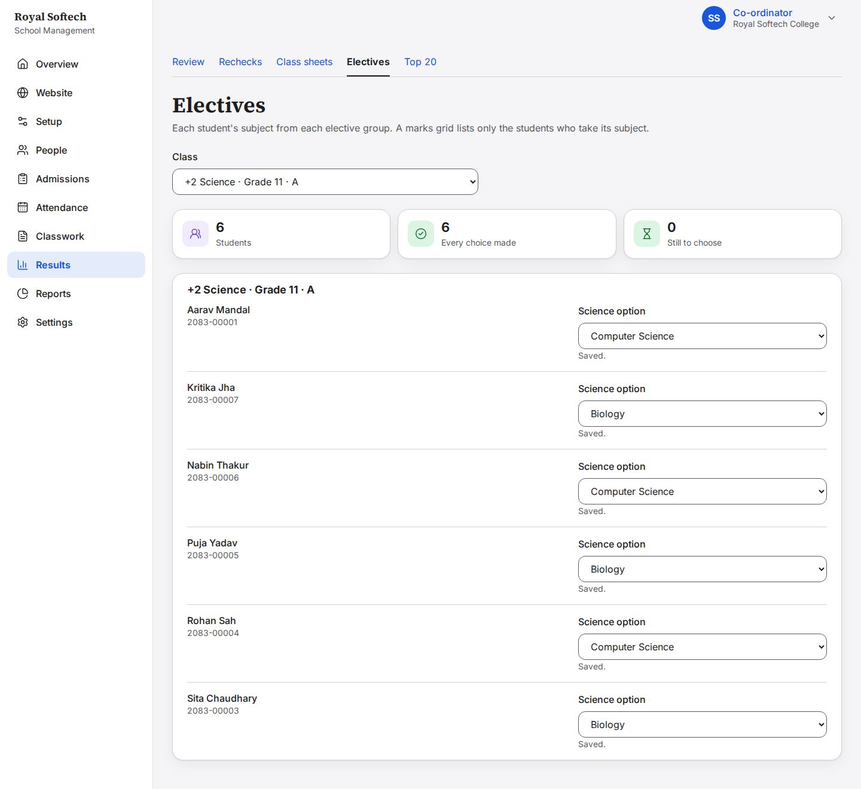

12. Results: review, send back, verify and publish
The first terminal from the teachers' marks to published results, a class sheet and Top 20.
Precondition (P3): the subject teachers entered the first terminal's marks; Nepali was left as a draft. Between the two halves (P3b), Anita Mandal corrected the English mark that was sent back and Kamala Rai sent Nepali.
# | Step | Observed on screen | Result
12-01 | Review results opens on the terminal in progress, the first terminal, where the marks are waiting (F-07 fixed) | – | Pass
12-02 | First terminal: Grade 11 A has six subjects under review and Nepali still a draft; BBS Year 1 is all under review; Publish waits for every subject | – | Pass
12-03 | Publish for Grade 11 A stays off and says what it is waiting for (Nepali is a draft, nothing is verified yet) | – | Pass
12-04 | Grade 11 A English, sent by Anita Mandal: every mark, ready to verify or send back | – | Pass
12-05 | Send back asks for a note for the teacher; it cannot be sent until one is written | – | Pass
12-06 | English sent back to Anita Mandal with the note; she can change marks again | Sent back to the teacher. | Pass
12-07 | Every Grade 11 A subject is now under review again, English with Kritika's mark corrected and Nepali sent | – | Pass
12-08 | All 10 subjects ticked: Verify selected verifies them together | – | Pass
12-09 | Every subject verified: Publish is now available for both classes | 10 verified. | Pass
12-10 | Grade 11 A first terminal published: a marks card is made for each student | Published. 6 marks cards made. | Pass
12-10b | BBS Year 1 published too; Grade 11 B and Grade 12 A have no marks yet | Published. 3 marks cards made. | Pass
12-11 | Grade 11 A class sheet: NEB letter grades per subject, GPA, result and rank; a student who failed a subject gets NG and no rank | – | Pass
12-12 | Kritika Jha's marks card, a snapshot of the published result | – | Pass
12-13 | Top 20 for the first terminal, ranked per section, from published results only | – | Pass

12-01 Review results opens on the terminal in progress, the first terminal, where the marks are waiting (F-07 fixed)
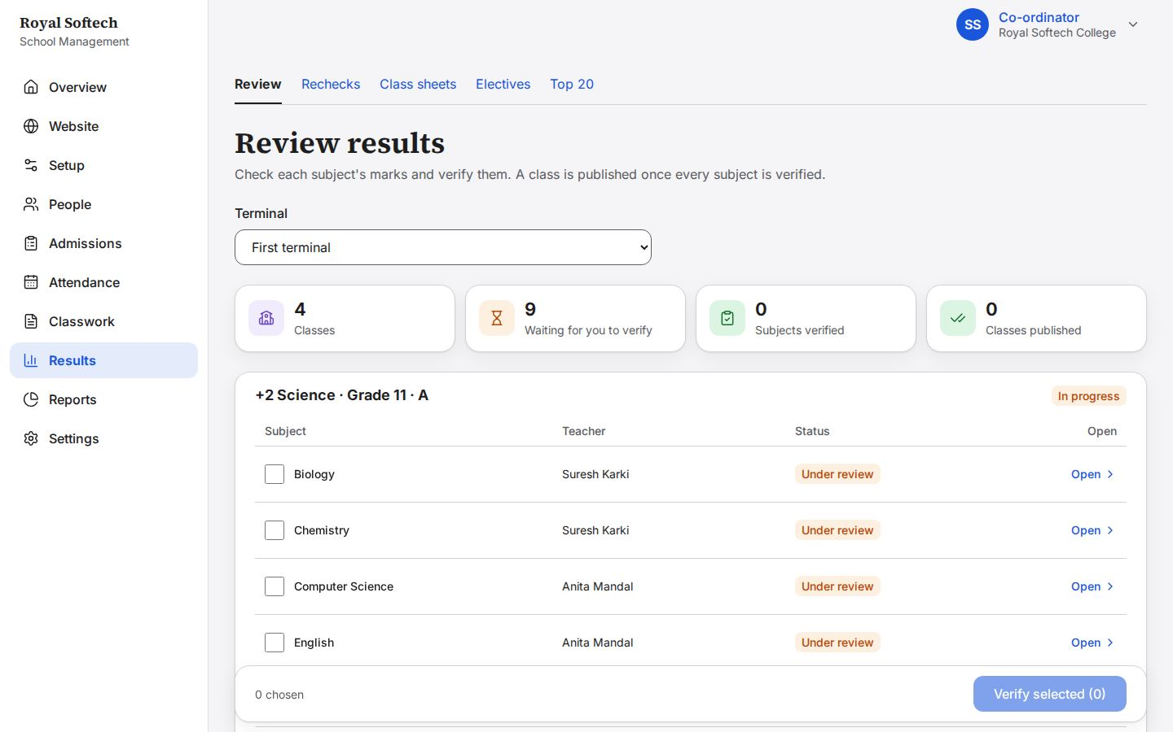
12-02 First terminal: Grade 11 A has six subjects under review and Nepali still a draft; BBS Year 1 is all under review; Publish waits for every subject
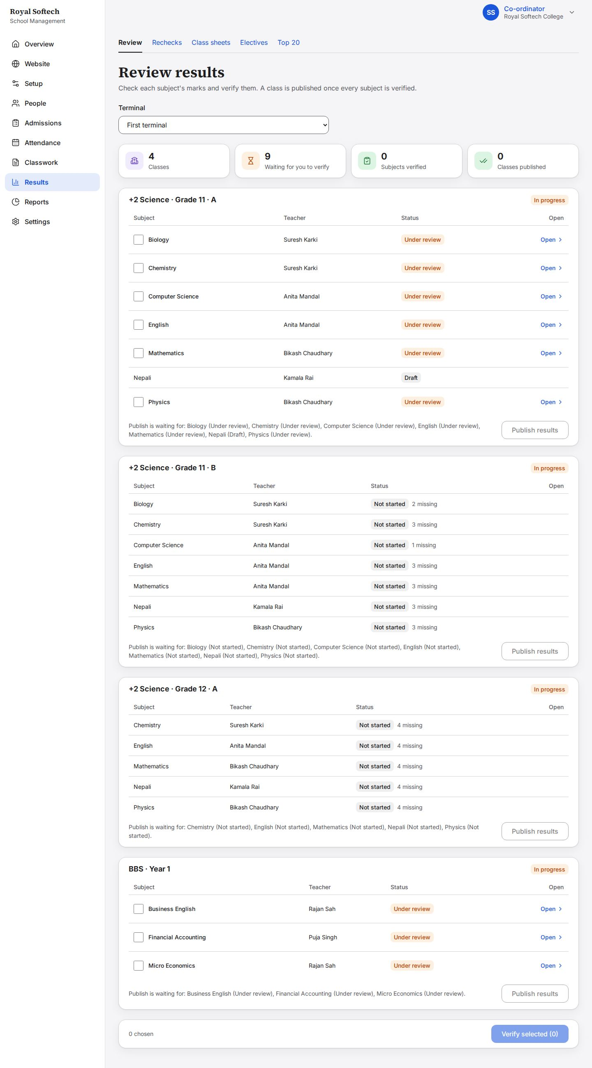
12-03 Publish for Grade 11 A stays off and says what it is waiting for (Nepali is a draft, nothing is verified yet)
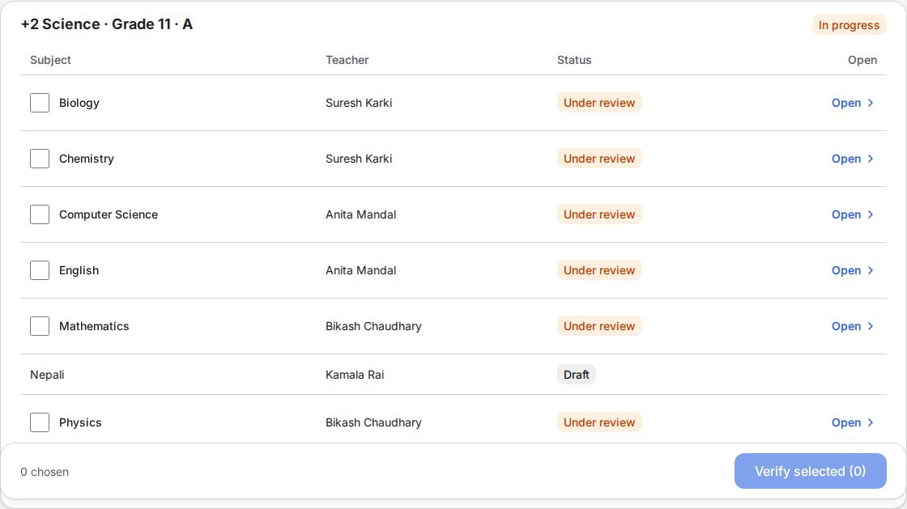
12-04 Grade 11 A English, sent by Anita Mandal: every mark, ready to verify or send back
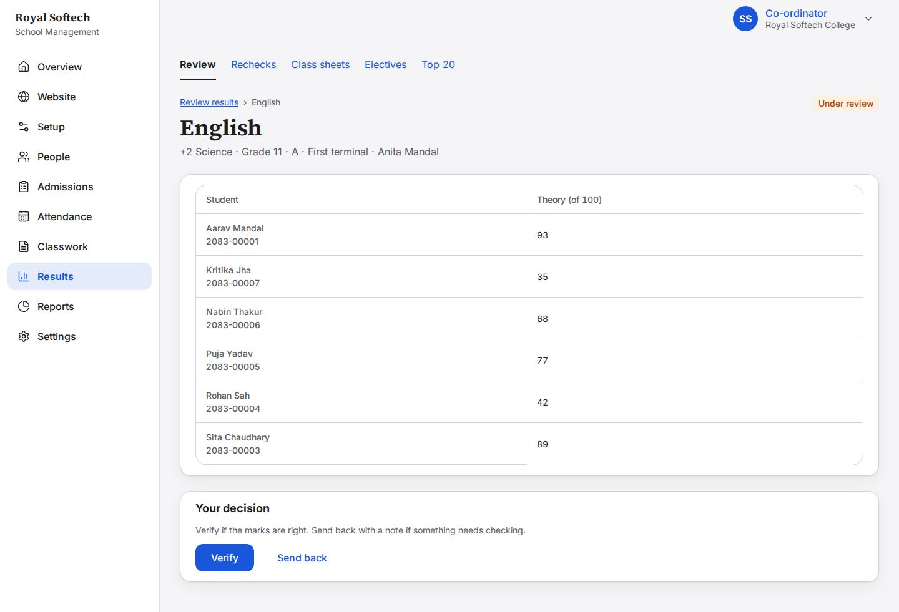
12-05 Send back asks for a note for the teacher; it cannot be sent until one is written
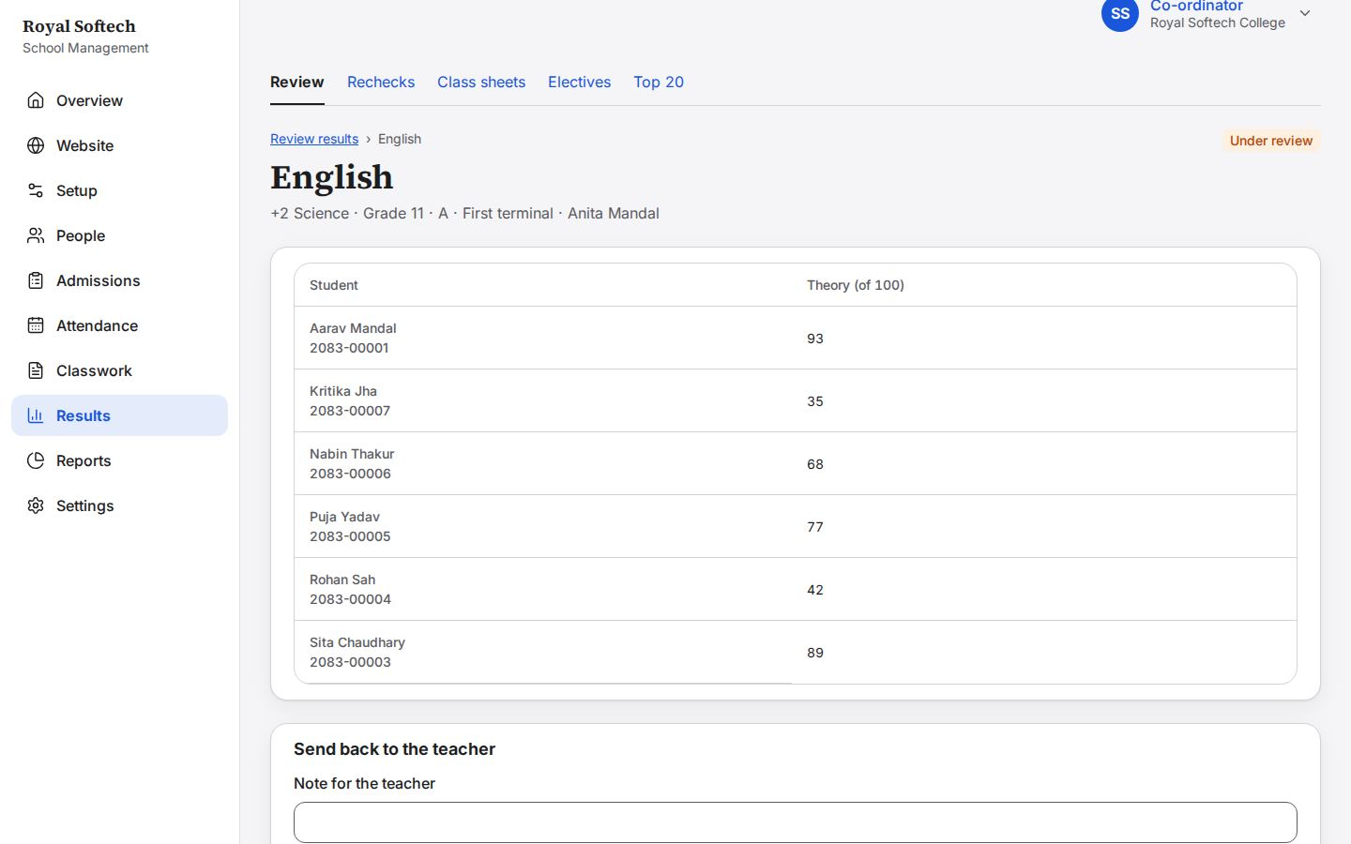
12-06 English sent back to Anita Mandal with the note; she can change marks again
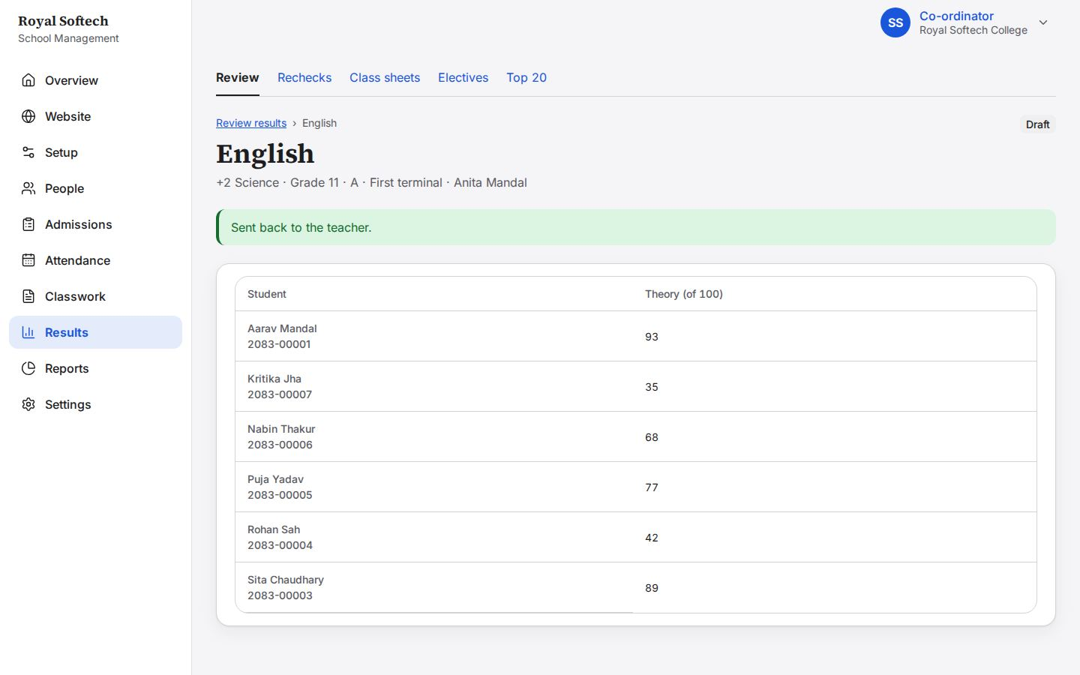
12-07 Every Grade 11 A subject is now under review again, English with Kritika's mark corrected and Nepali sent
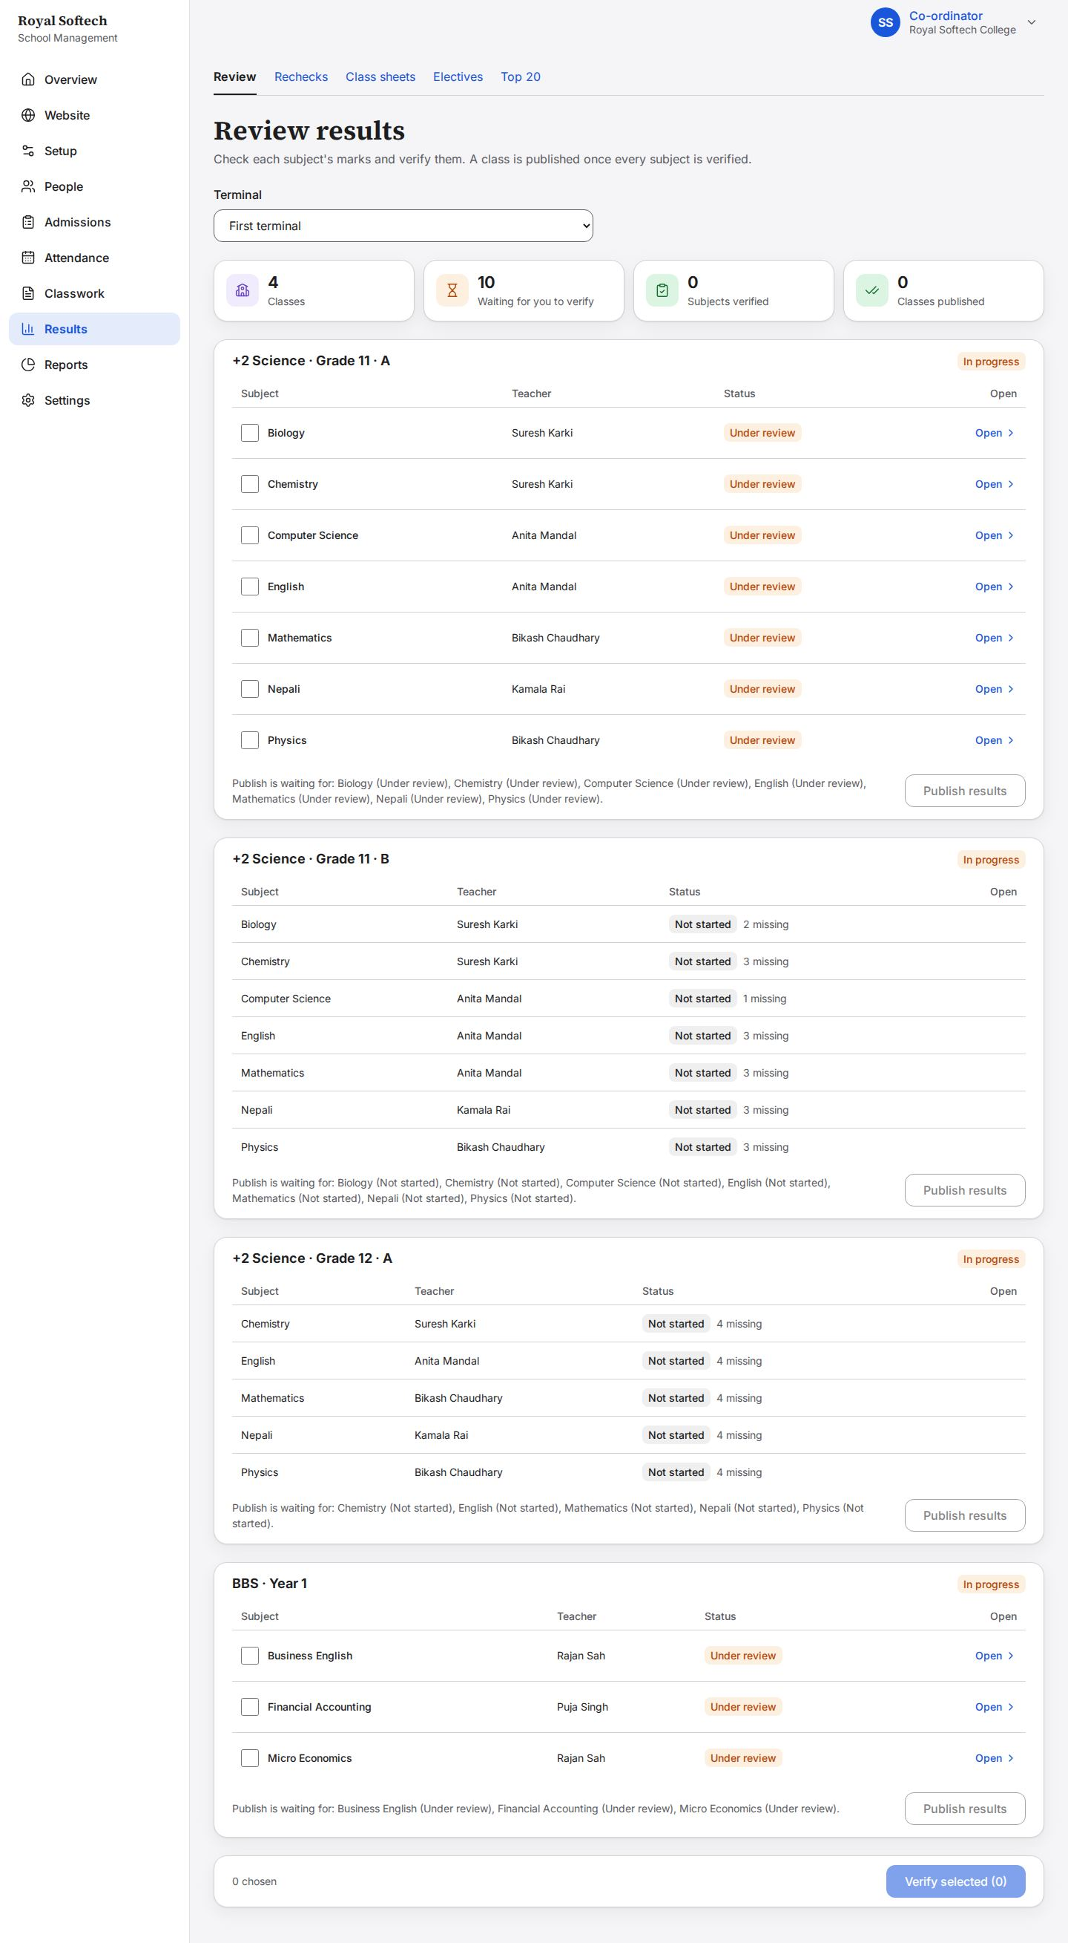
12-08 All 10 subjects ticked: Verify selected verifies them together
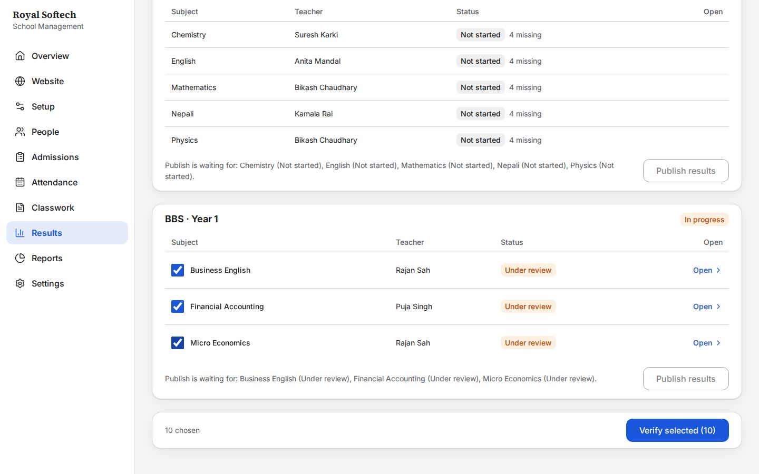
12-09 Every subject verified: Publish is now available for both classes
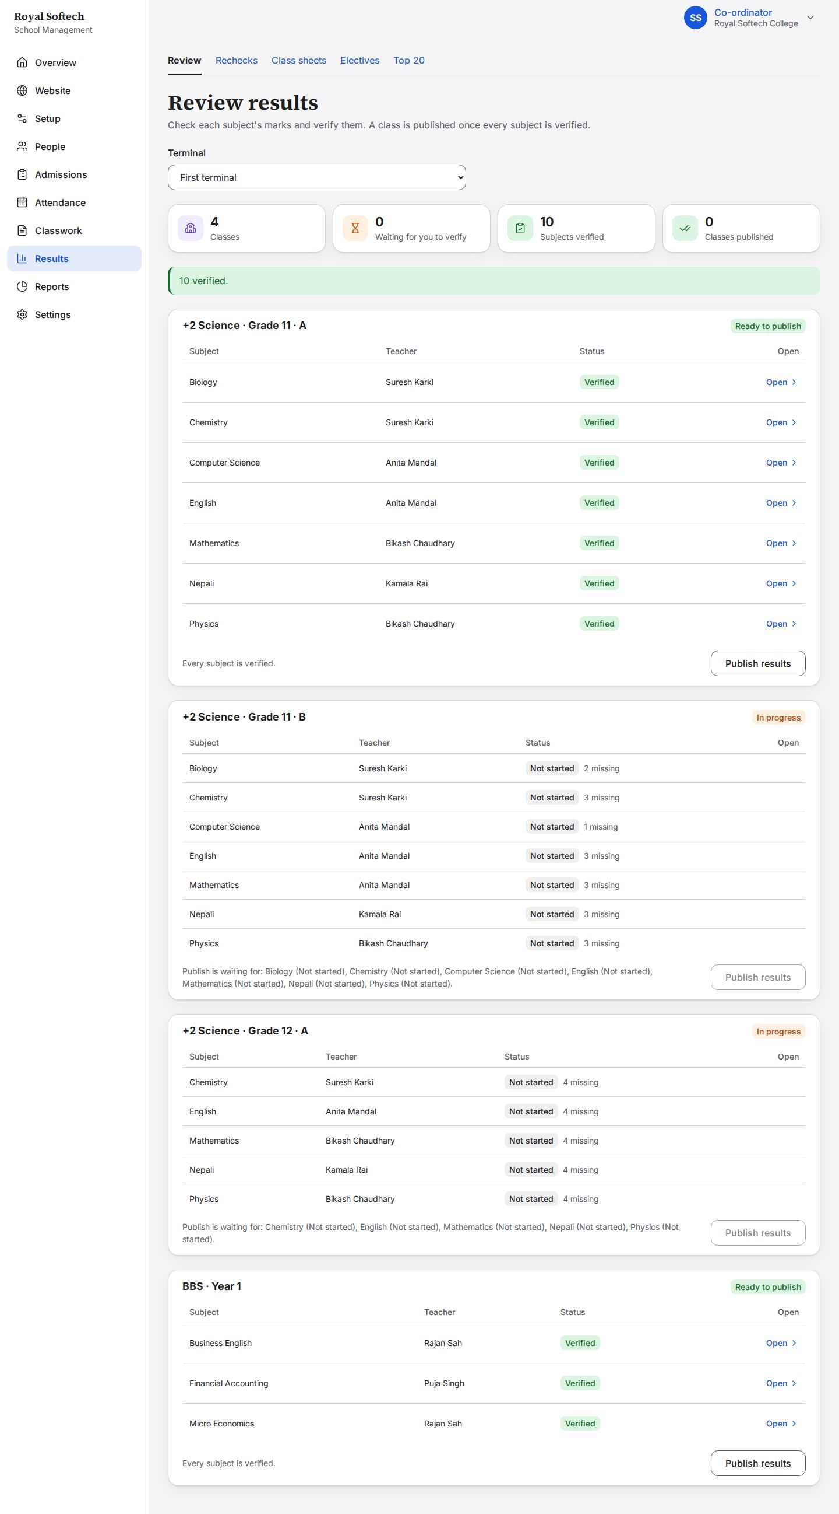
12-10 Grade 11 A first terminal published: a marks card is made for each student
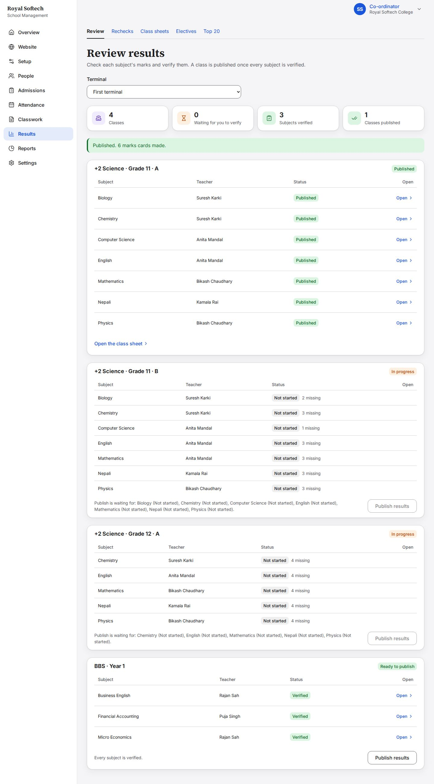
12-10b BBS Year 1 published too; Grade 11 B and Grade 12 A have no marks yet
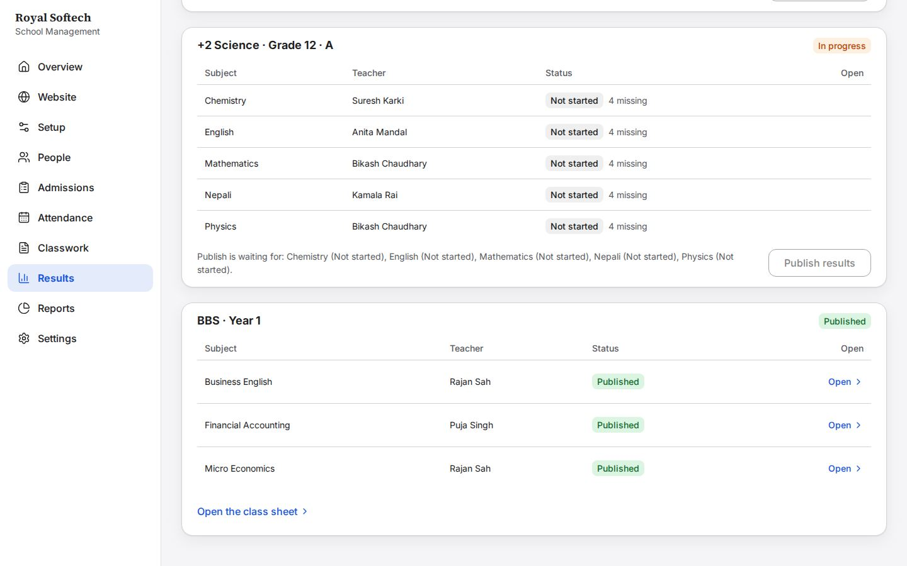
12-11 Grade 11 A class sheet: NEB letter grades per subject, GPA, result and rank; a student who failed a subject gets NG and no rank
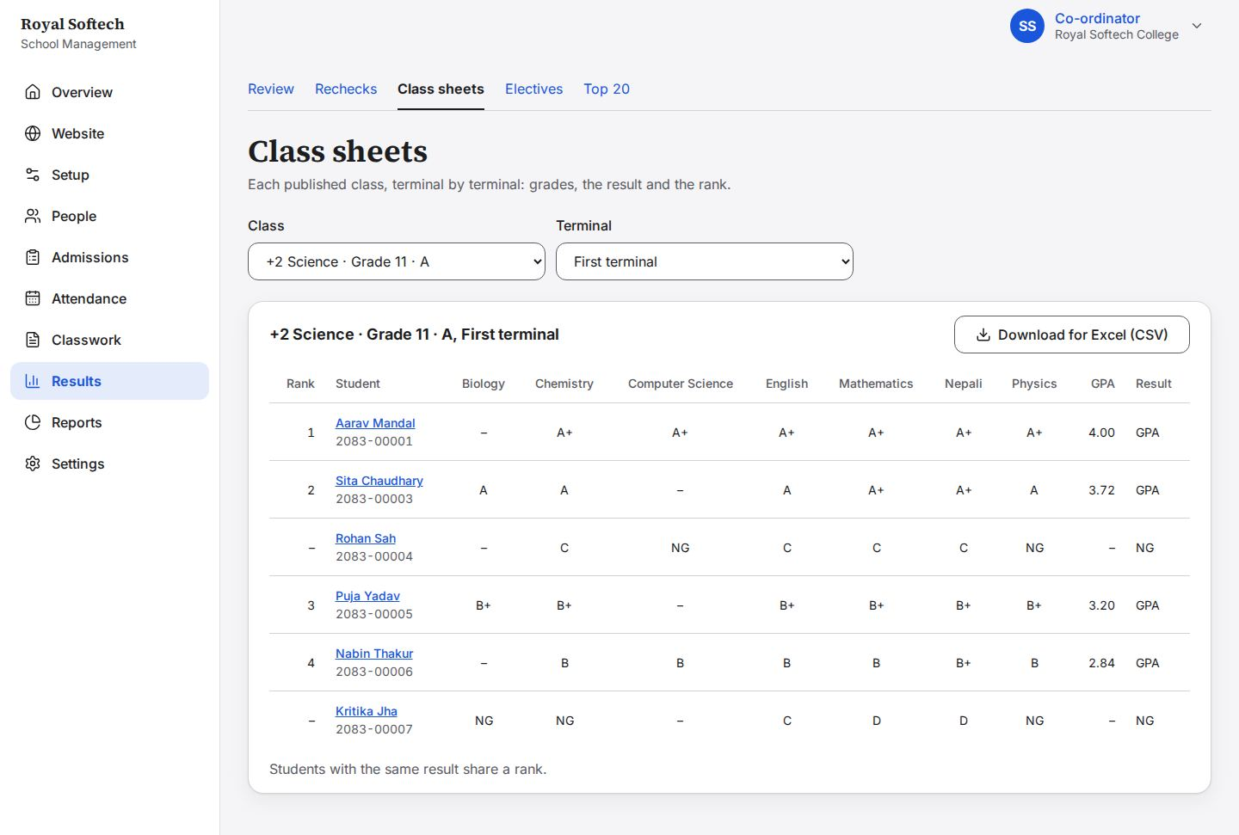
12-12 Kritika Jha's marks card, a snapshot of the published result
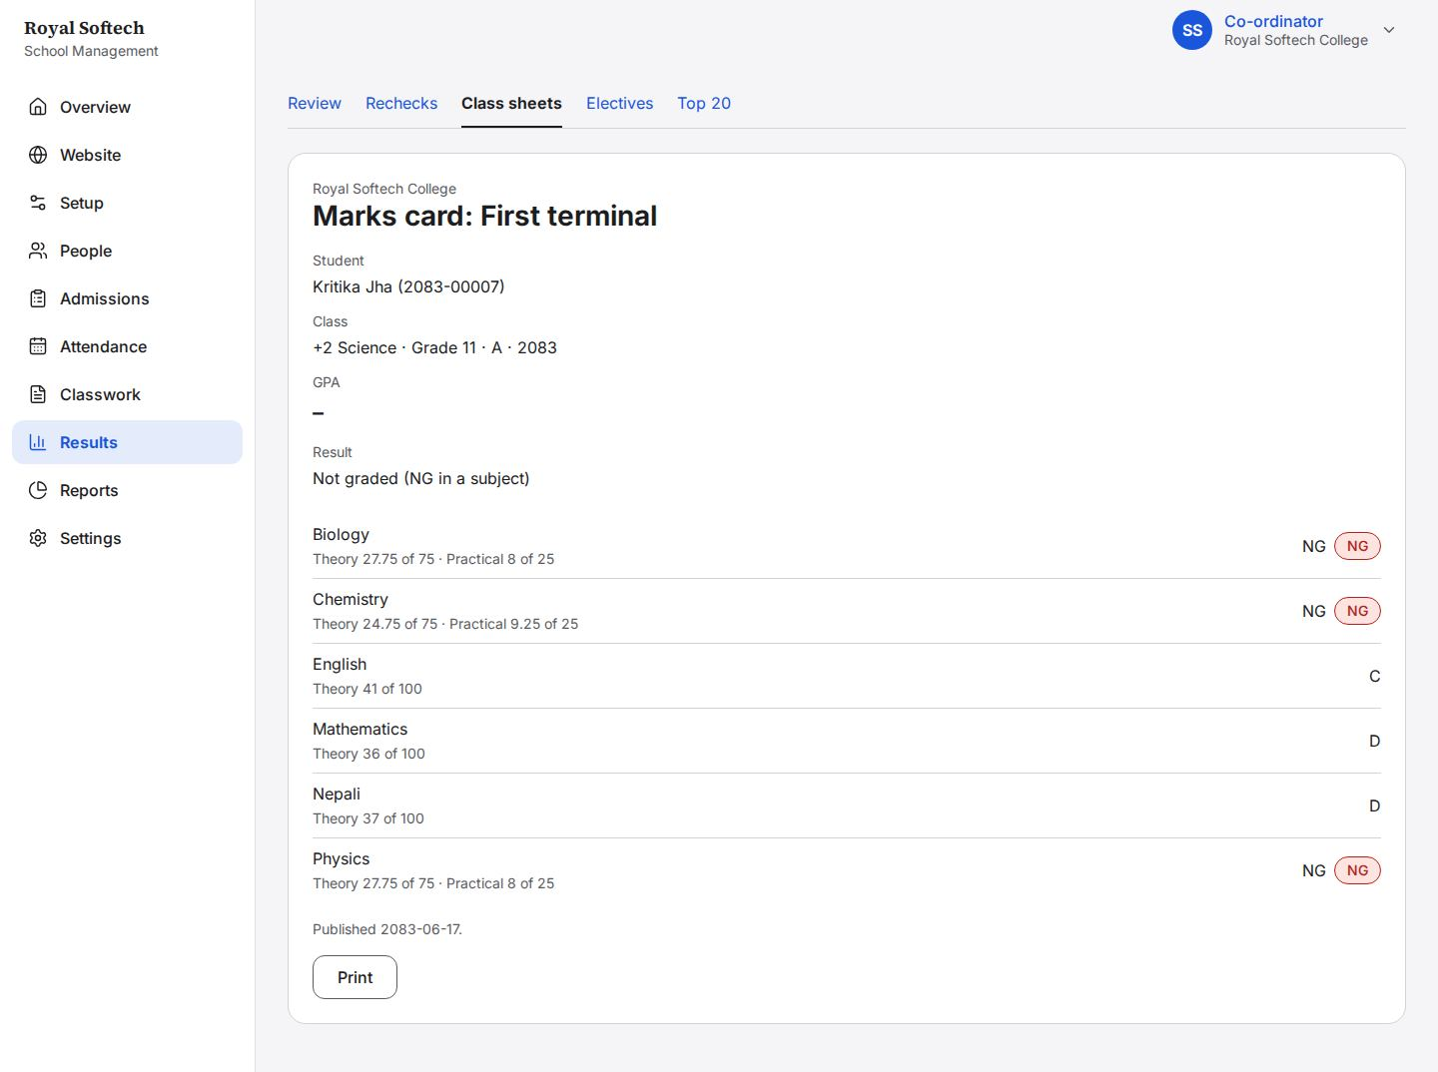
12-13 Top 20 for the first terminal, ranked per section, from published results only
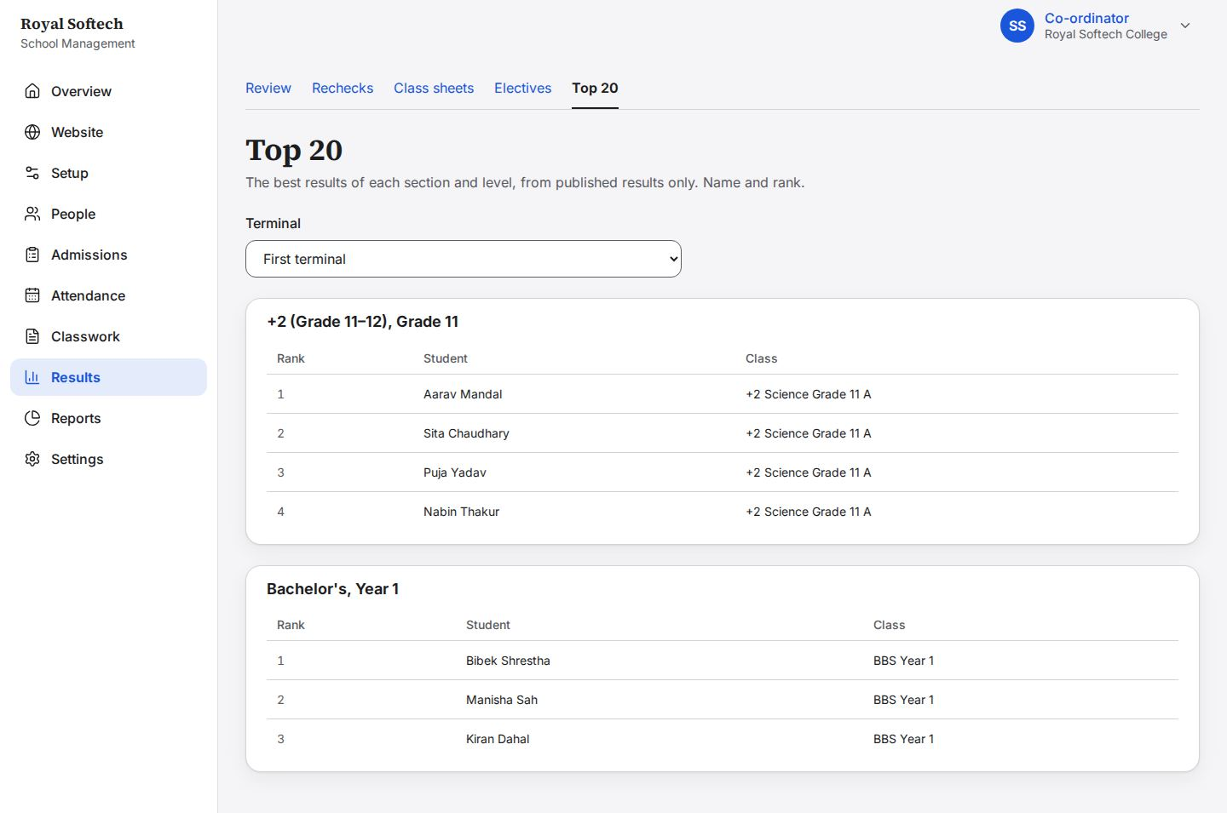

13. Results: rechecks
Two students ask for a recheck; one is unchanged, one changes a mark.
Precondition (P4): Kritika Jha and Rohan Sah, signed in as themselves, asked for rechecks.
# | Step | Observed on screen | Result
13-01 | Rechecks: two students ask about a published subject; the figures say two are waiting, and each has Decide | – | Pass
13-01b | Rohan Sah's recheck in a side panel: why he asked, the marks now, the marks to correct and a reason; No change stays off until a reason is written | – | Pass
13-02 | Rohan Sah's recheck closed with no change, and the reason | Saved. Rohan Sah's Physics marks stay as they were. | Pass
13-03 | Kritika Jha's Chemistry theory raised from 24.75 to 29.75: the button now saves a change, and a reason is still required | Saved. Rohan Sah's Physics marks stay as they were. | Pass
13-04 | Changed: the published result is updated, the marks card gets a new version, and the Principal is told of the change | Saved. Kritika Jha's Chemistry marks are corrected. | Pass
13-05 | The class sheet after the recheck: Kritika Jha's Chemistry grade reflects the new mark | – | Pass

13-01 Rechecks: two students ask about a published subject; the figures say two are waiting, and each has Decide
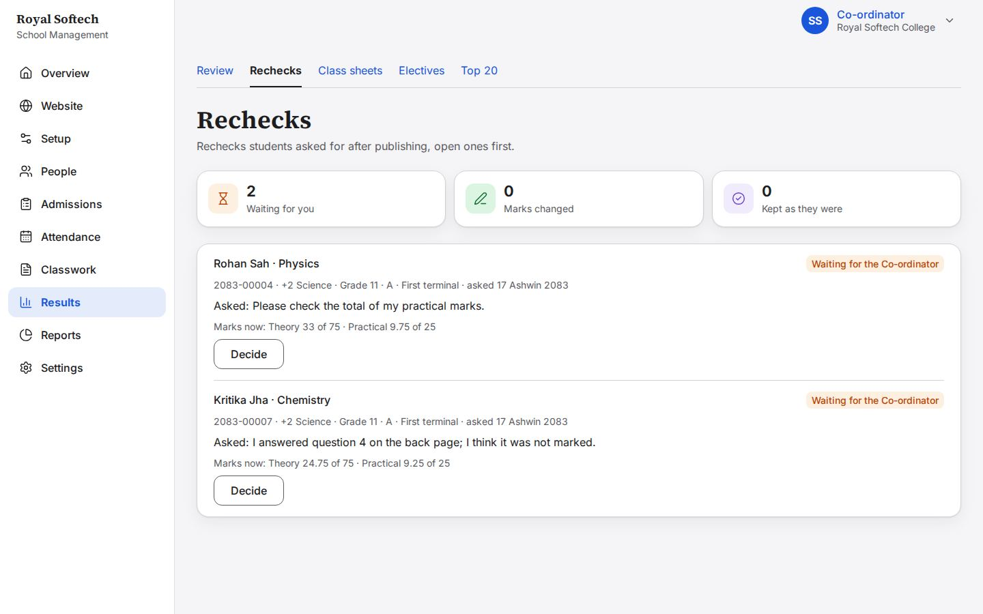
13-01b Rohan Sah's recheck in a side panel: why he asked, the marks now, the marks to correct and a reason; No change stays off until a reason is written
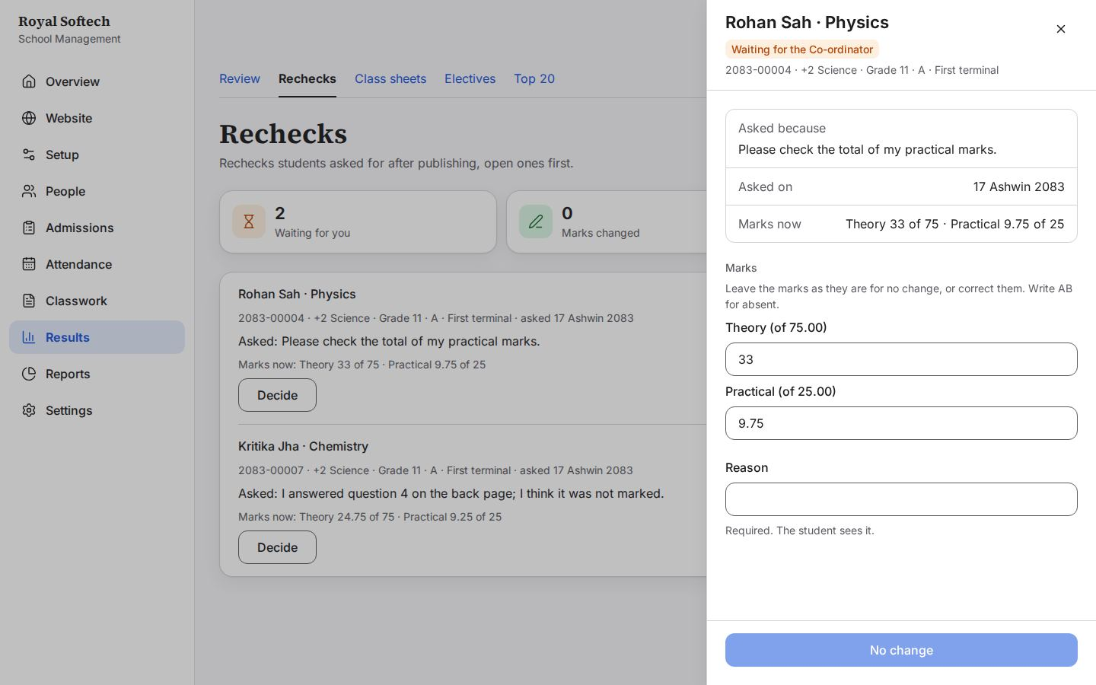
13-02 Rohan Sah's recheck closed with no change, and the reason
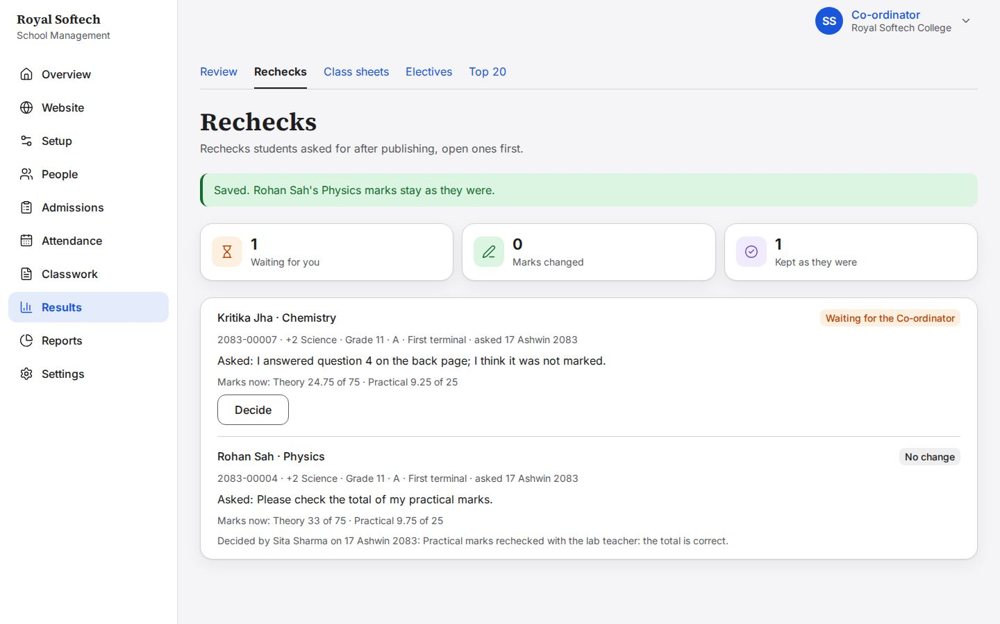
13-03 Kritika Jha's Chemistry theory raised from 24.75 to 29.75: the button now saves a change, and a reason is still required
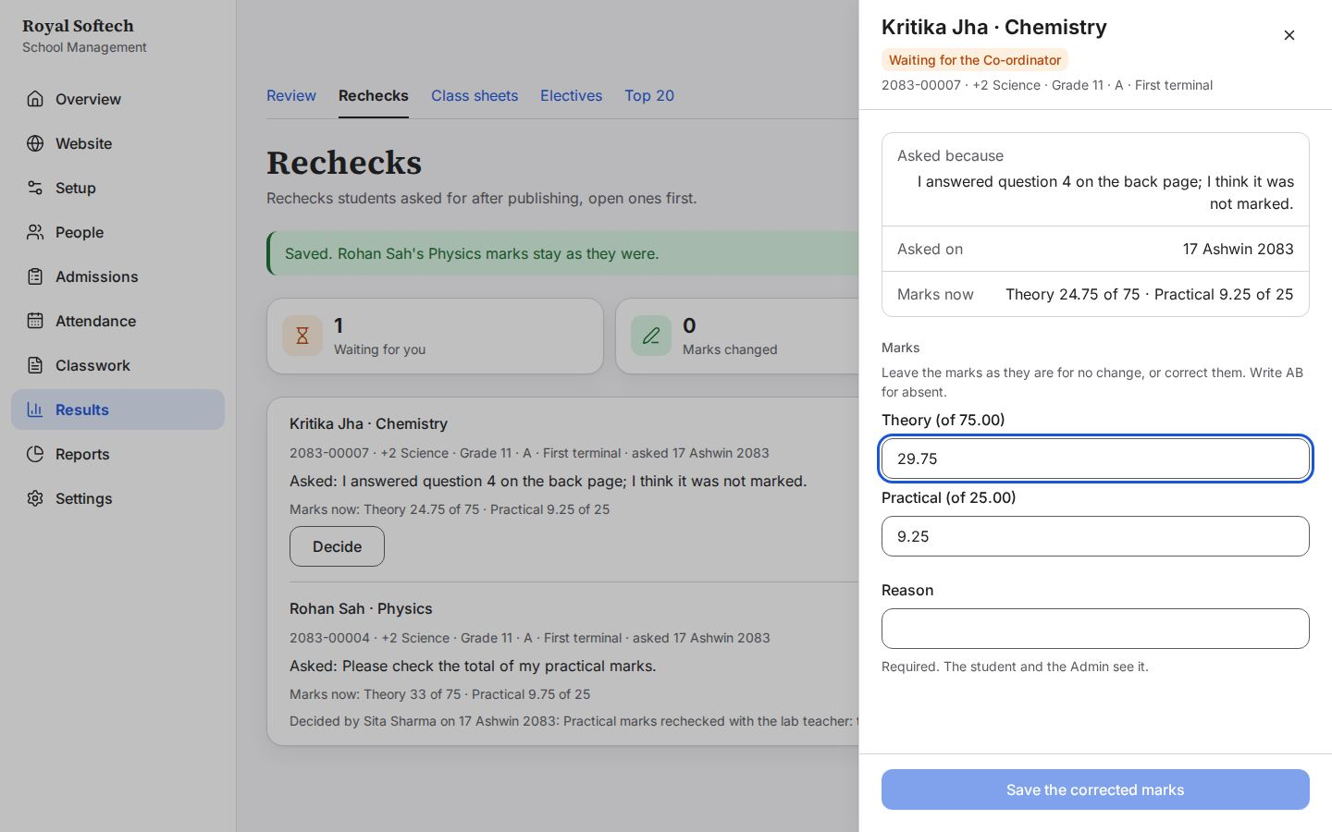
13-04 Changed: the published result is updated, the marks card gets a new version, and the Principal is told of the change
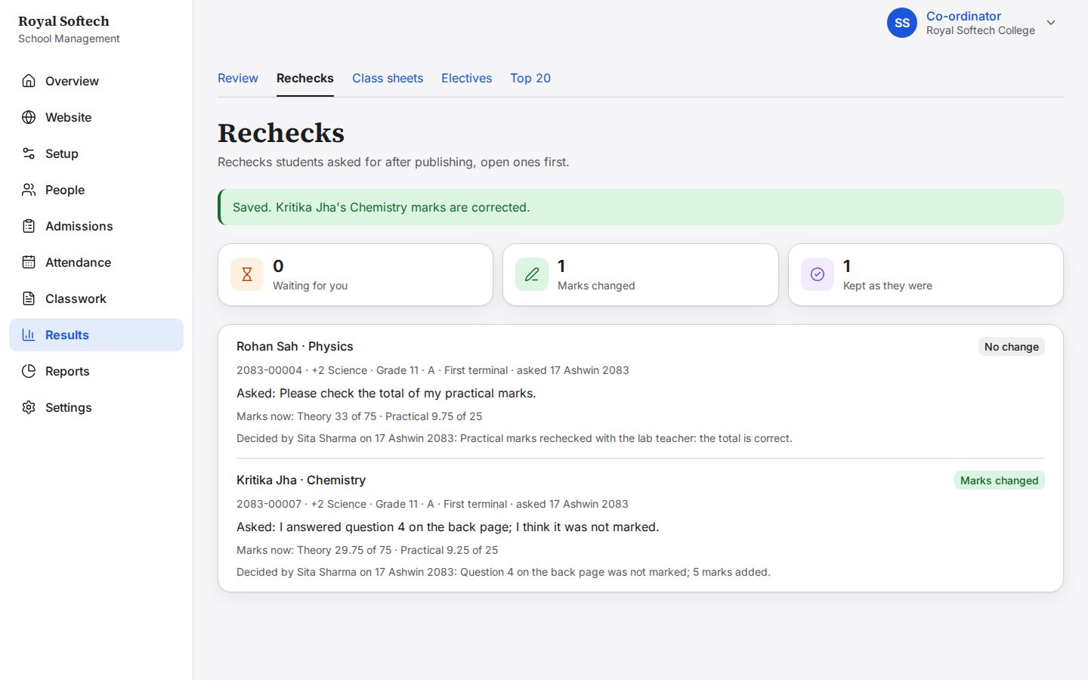
13-05 The class sheet after the recheck: Kritika Jha's Chemistry grade reflects the new mark
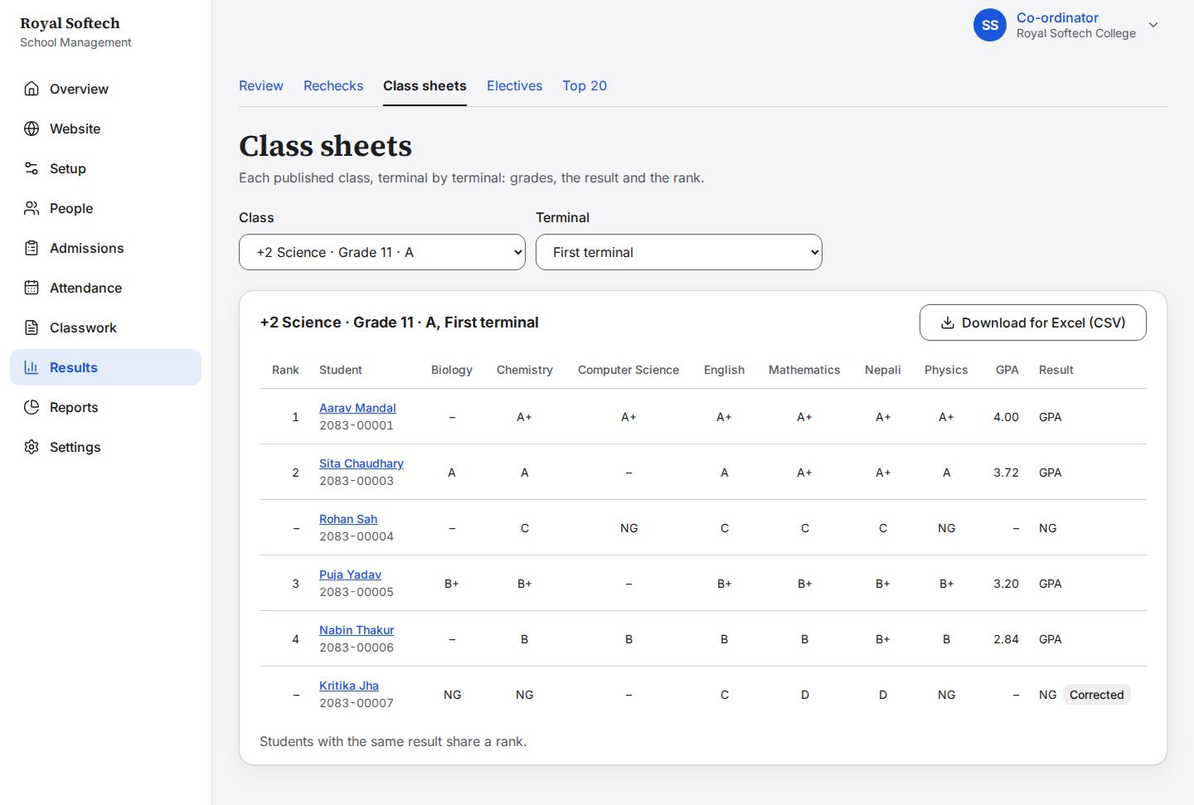

14. Website: drafts for the Principal
The Co-ordinator drafts website content and sends it to the Principal, who approves or declines it.
Precondition (P5): between the two halves, the Principal approved the notice and declined the Science exhibition with a reason.
# | Step | Observed on screen | Result
14-01 | Website Content as the Co-ordinator: the same list, plus Your requests; publishing is the Principal's | – | Pass
14-02 | A new notice drafted by the Co-ordinator: Save draft, or Send for approval in one step; there is no Publish for her (F-08 fixed) | – | Pass
14-03 | Saved as a draft: in the list, not yet sent to the Principal | Saved as a draft. Send it for approval when you are ready. | Pass
14-04 | The draft in the list, with Edit and Send for approval inside the table (F-09 fixed) | – | Pass
14-05 | Sent: the notice waits for the Principal and is listed under Your requests | Sent for approval: “Parents' meeting for Grade 11” now waits for an Admin. | Pass
14-06 | Three requests waiting for the Principal | Saved and sent for approval. It goes on the website once an Admin approves it. | Pass
14-07 | The Library hours request withdrawn by the Co-ordinator: back to a draft she can still edit | Withdrawn: “Information "Library hours during exams"” is a draft again. | Pass
14-08 | After the Principal decided: the notice is approved and on the website, the Science exhibition declined with a reason the Co-ordinator can read | – | Pass

14-01 Website Content as the Co-ordinator: the same list, plus Your requests; publishing is the Principal's
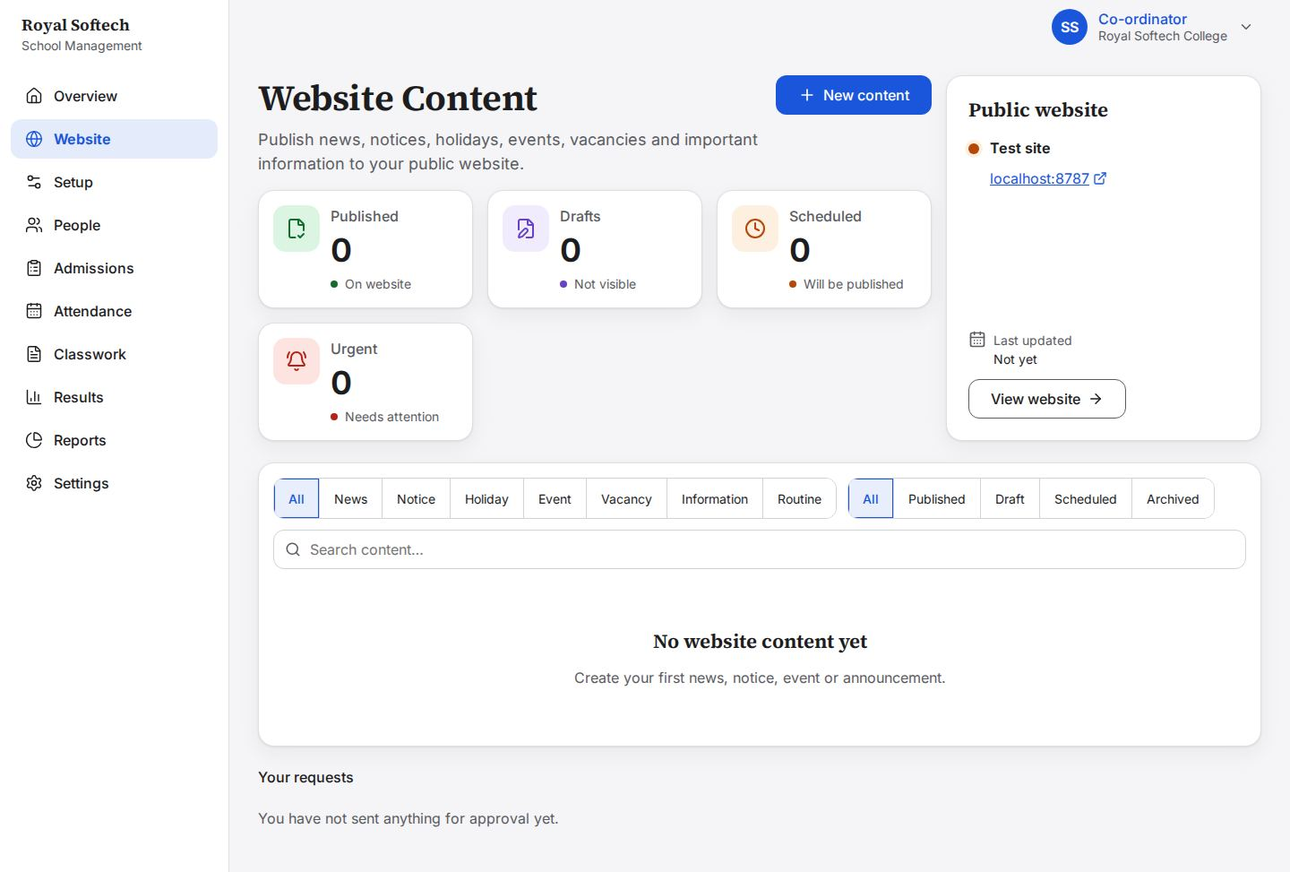
14-02 A new notice drafted by the Co-ordinator: Save draft, or Send for approval in one step; there is no Publish for her (F-08 fixed)
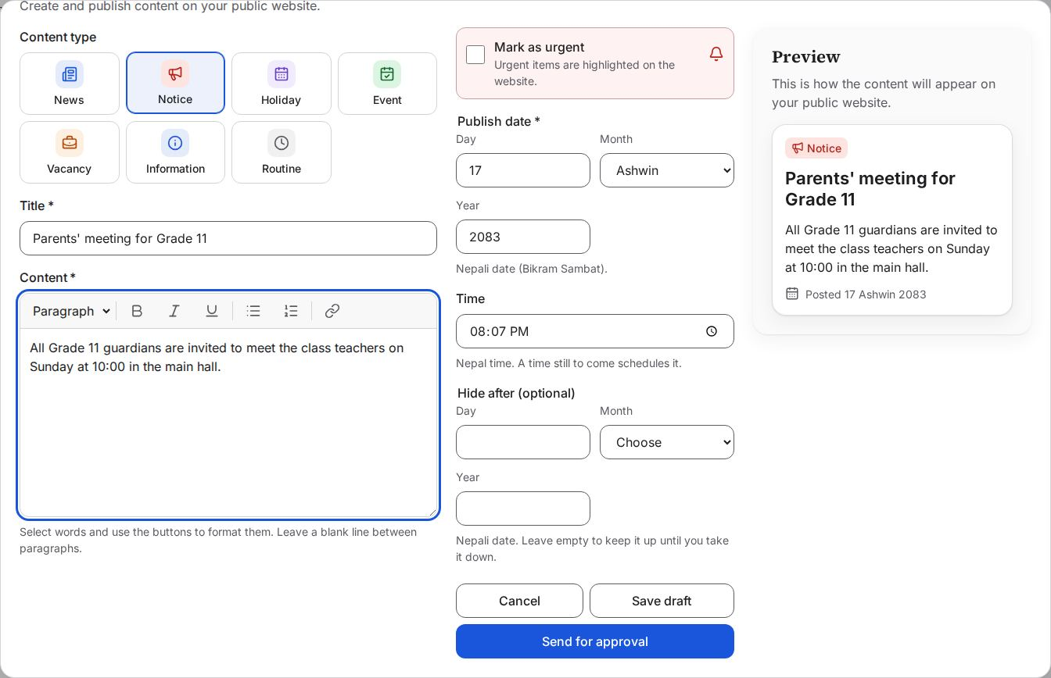
14-03 Saved as a draft: in the list, not yet sent to the Principal
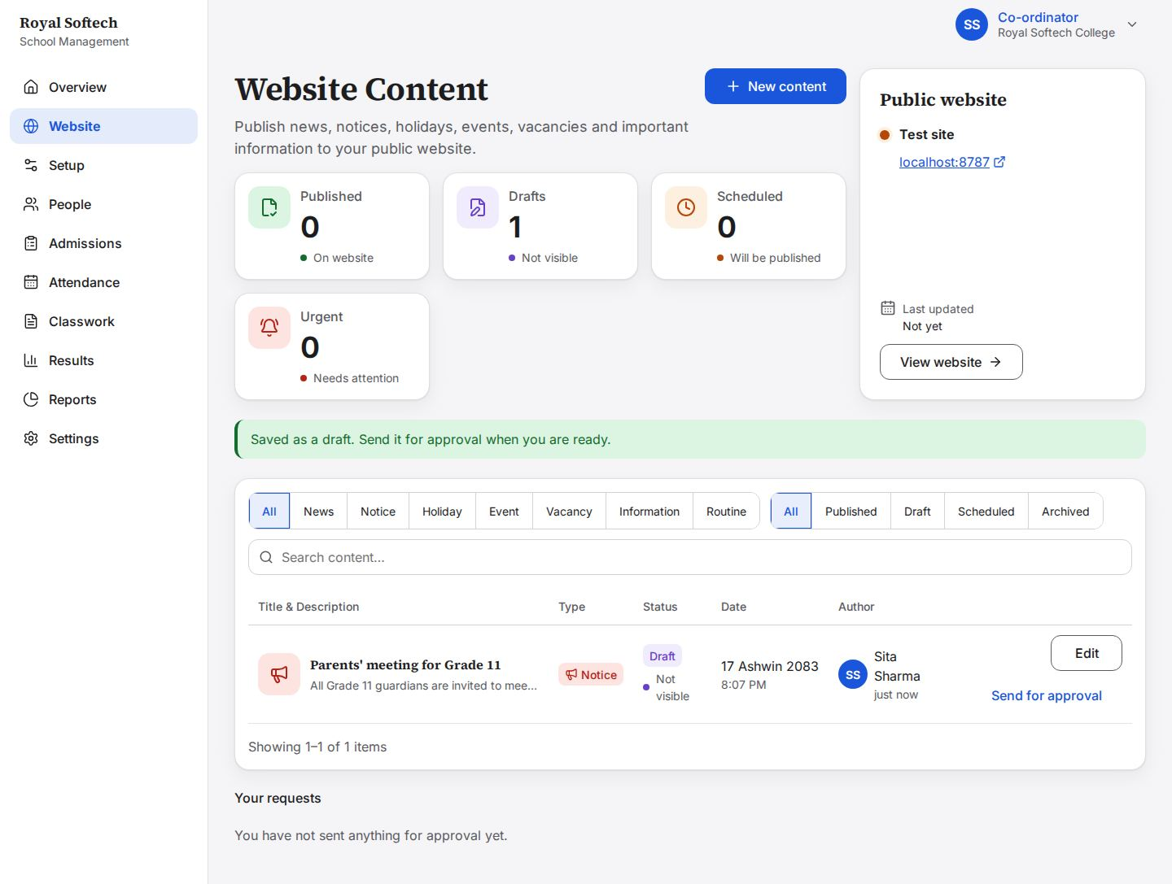
14-04 The draft in the list, with Edit and Send for approval inside the table (F-09 fixed)
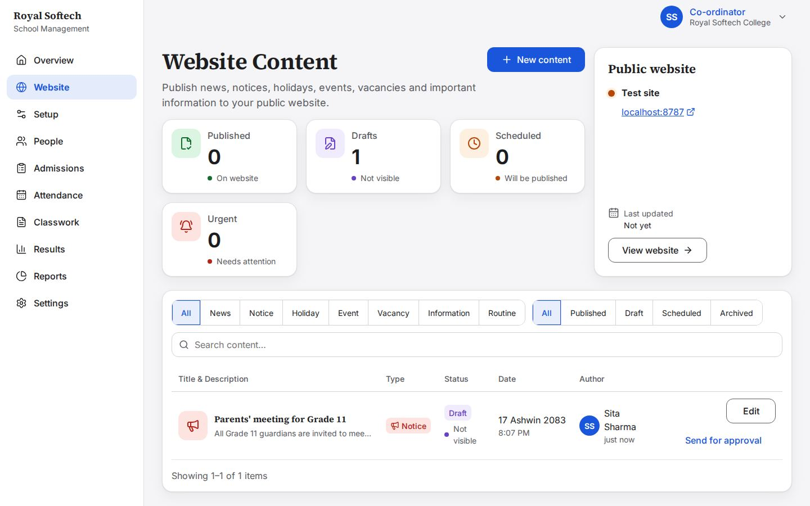
14-05 Sent: the notice waits for the Principal and is listed under Your requests
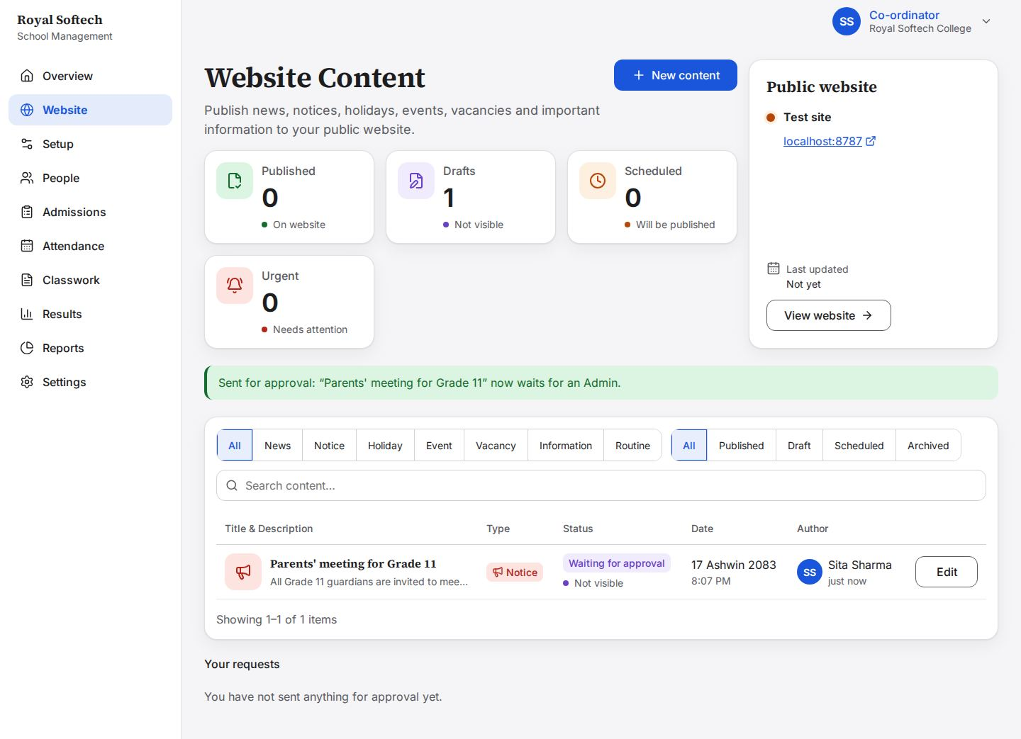
14-06 Three requests waiting for the Principal
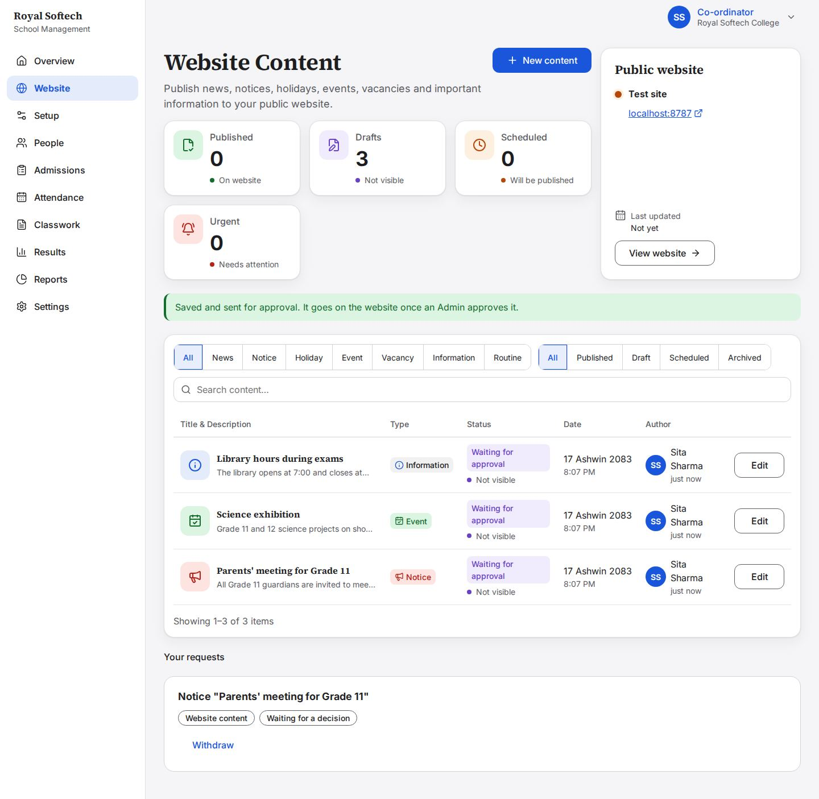
14-07 The Library hours request withdrawn by the Co-ordinator: back to a draft she can still edit
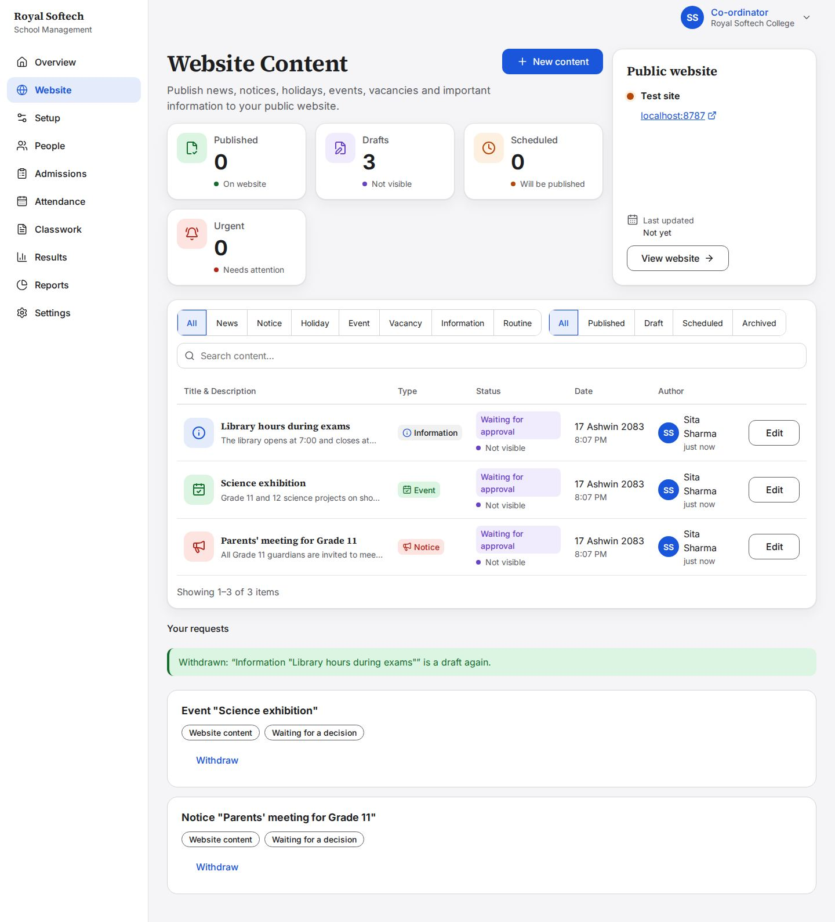
14-08 After the Principal decided: the notice is approved and on the website, the Science exhibition declined with a reason the Co-ordinator can read
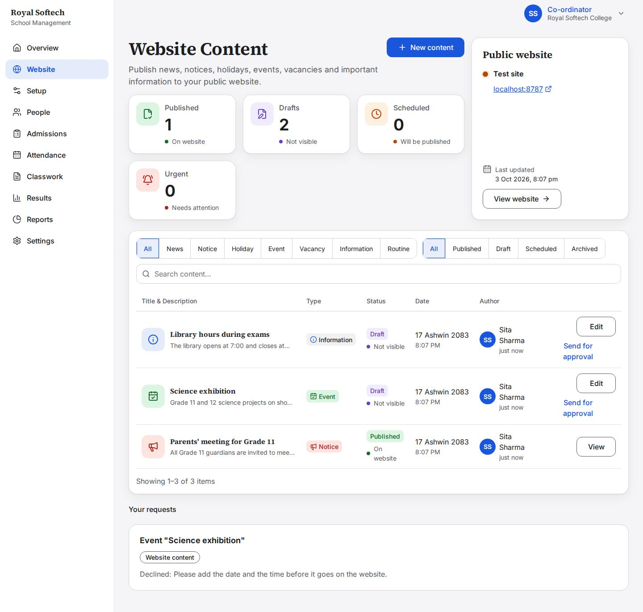

15. Own account, and what a Co-ordinator must not do
Profile, password and sign-out; other roles' pages opened by address; the server's answer to forbidden actions.
# | Step | Observed on screen | Result
15-01 | Settings: her profile, password and sign out | – | Pass
15-02 | Her phone corrected and saved | – | Pass
15-03 | Password changed (other devices are signed out) | Your password is changed. You stay signed in here; other devices are signed out. | Pass
15-04 | Fees (the Accountant's), opened by address: the Co-ordinator has no Fees view | – | Pass
15-05 | The Principal's Approvals inbox, opened by address | You no longer have permission to see this. Sign in again. | Pass
15-06 | Programmes: the Co-ordinator can look; sections and programmes are the Principal's | You can look at this, but only the Principal adds and changes programmes and their levels. | Pass
15-07 | Reports, now in her menu (F-10 fixed): school setup, students and results; money and oversight stay the Principal's | – | Pass
15-08 | A teacher's own attendance page, opened by address | You do not have access to this page. | Pass
15-09 | Signed out | – | Pass
15-10 | Signed in again with the new password: no second step for a Co-ordinator (only the Principal and Support use an authenticator app) | – | Pass

15-01 Settings: her profile, password and sign out
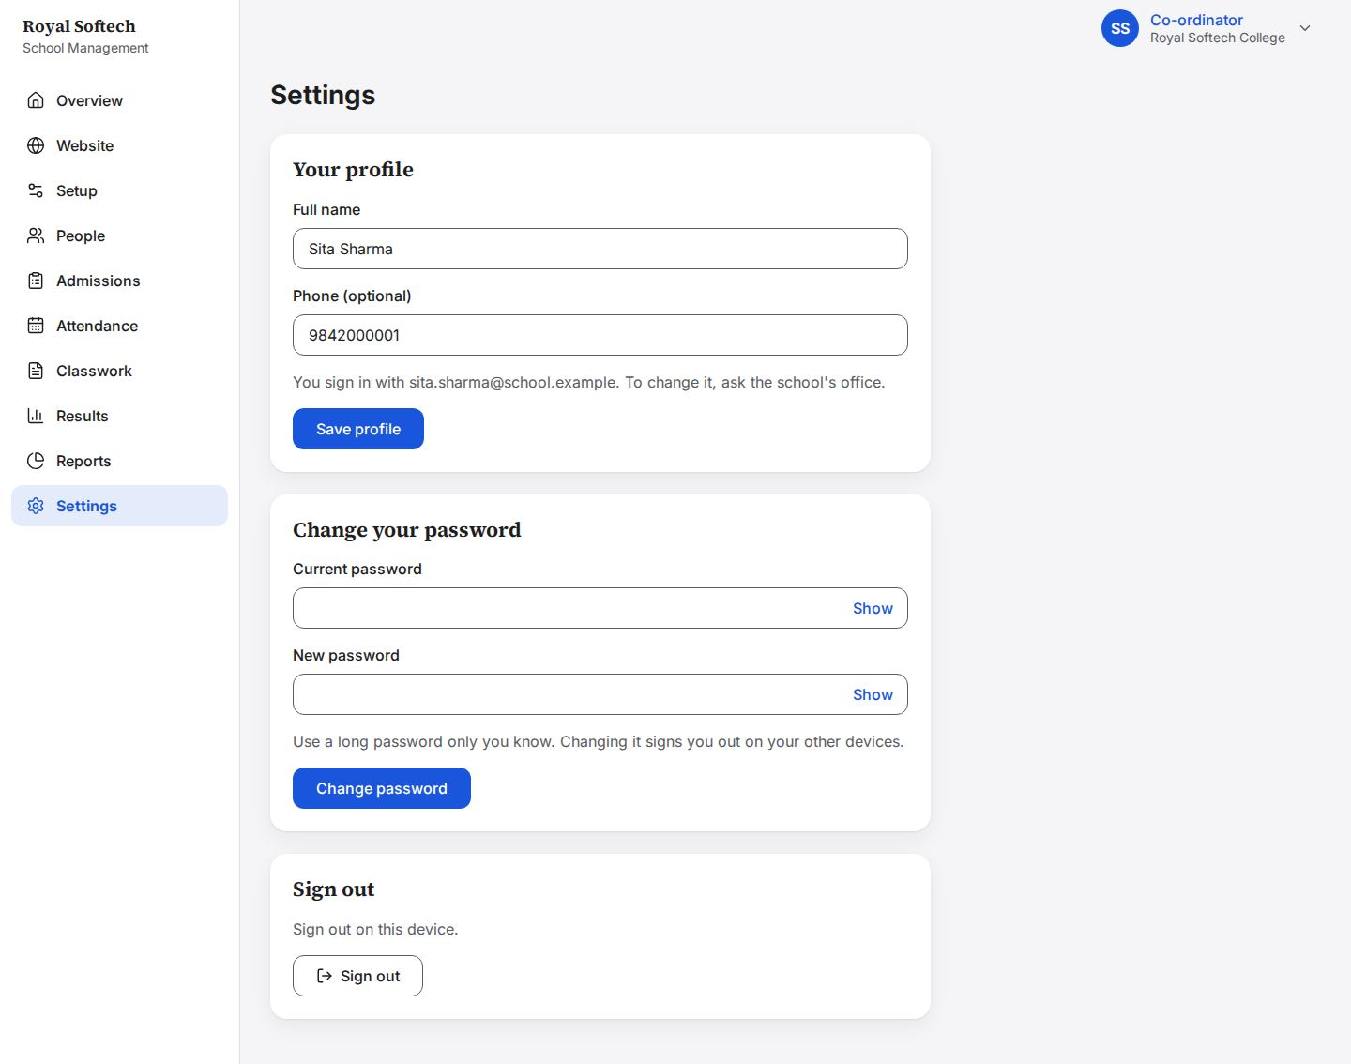
15-02 Her phone corrected and saved
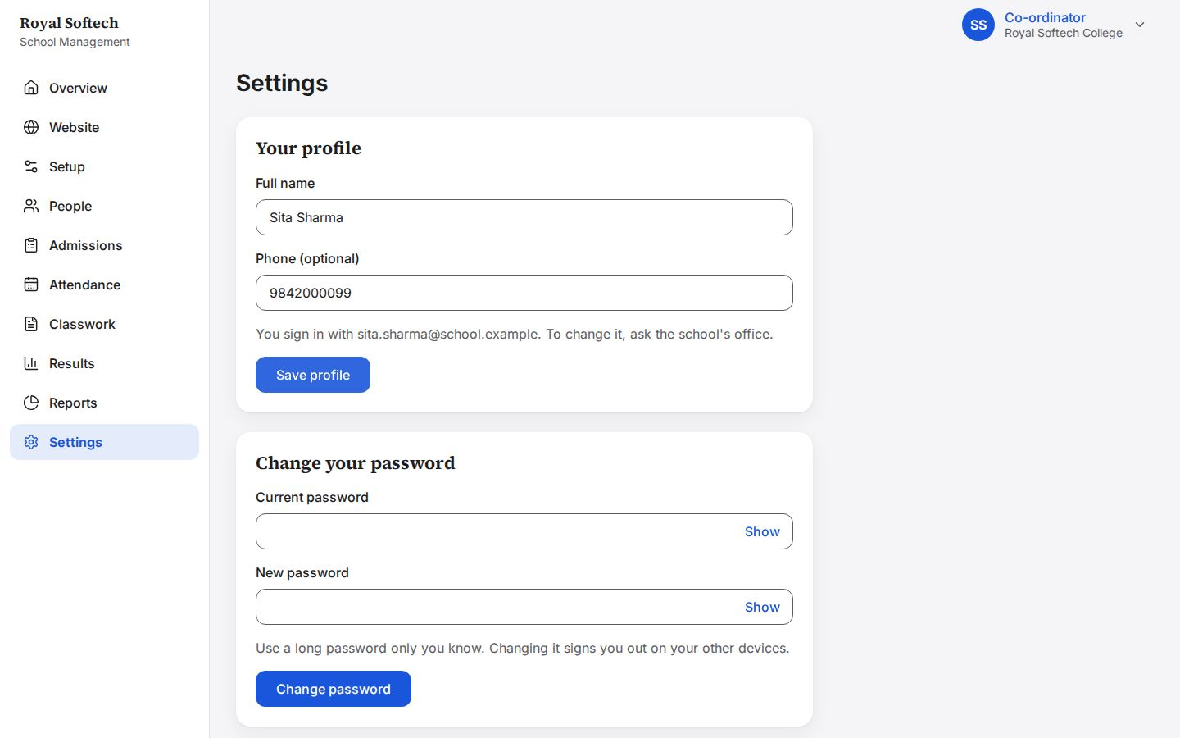
15-03 Password changed (other devices are signed out)
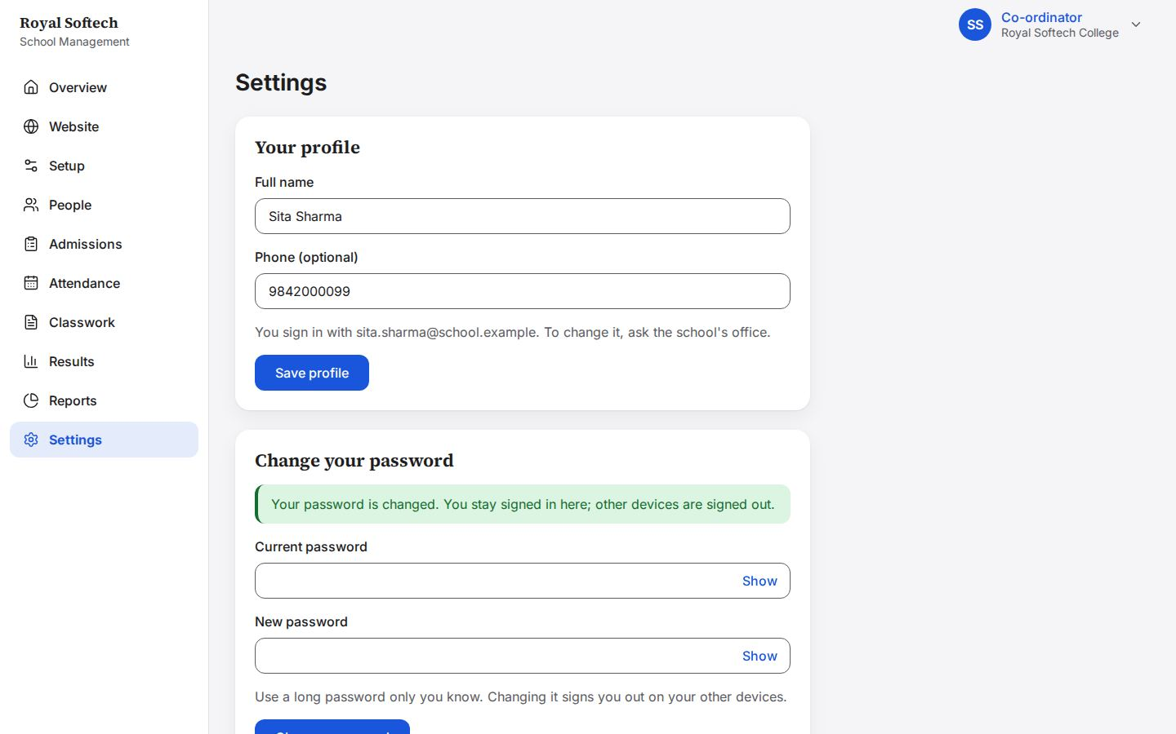
15-04 Fees (the Accountant's), opened by address: the Co-ordinator has no Fees view
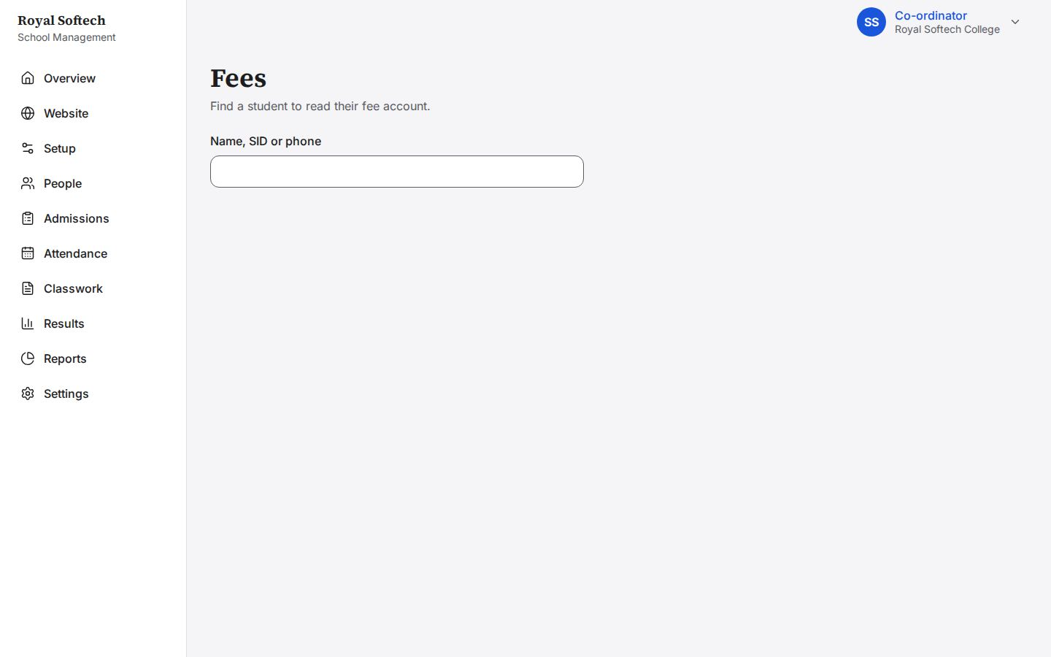
15-05 The Principal's Approvals inbox, opened by address
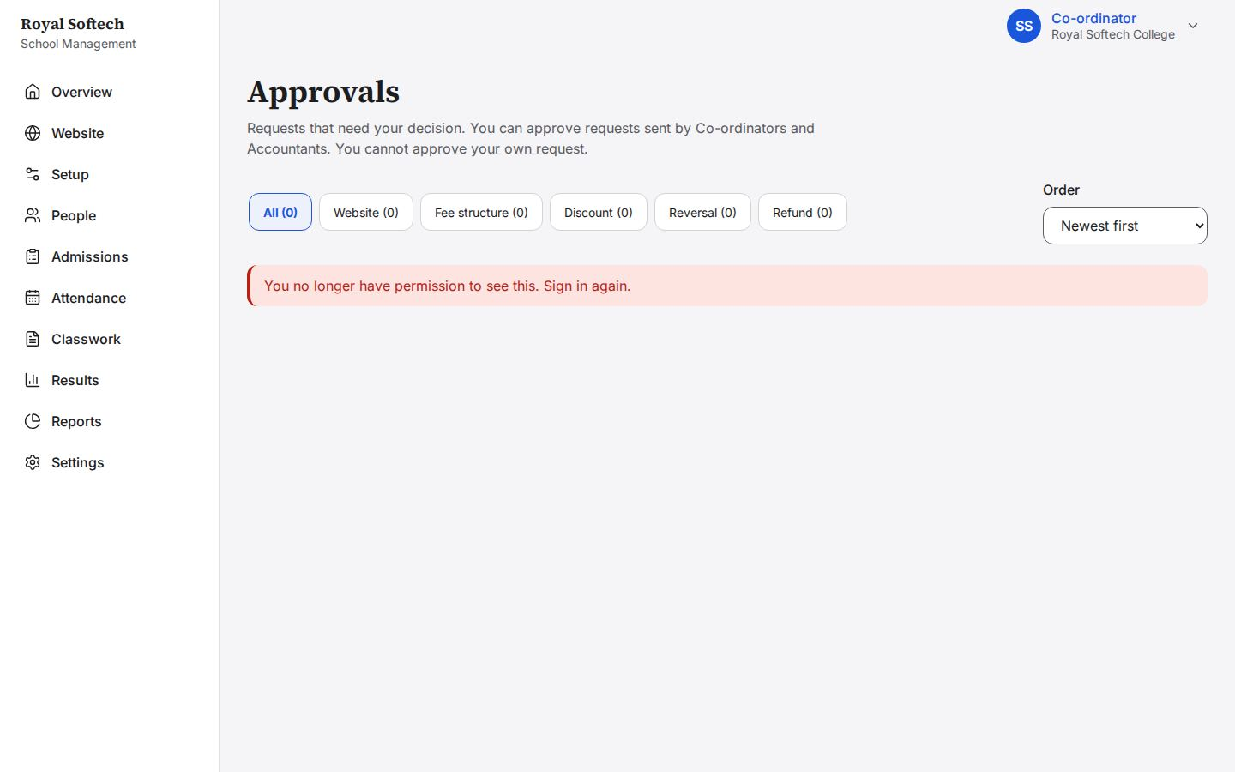
15-06 Programmes: the Co-ordinator can look; sections and programmes are the Principal's
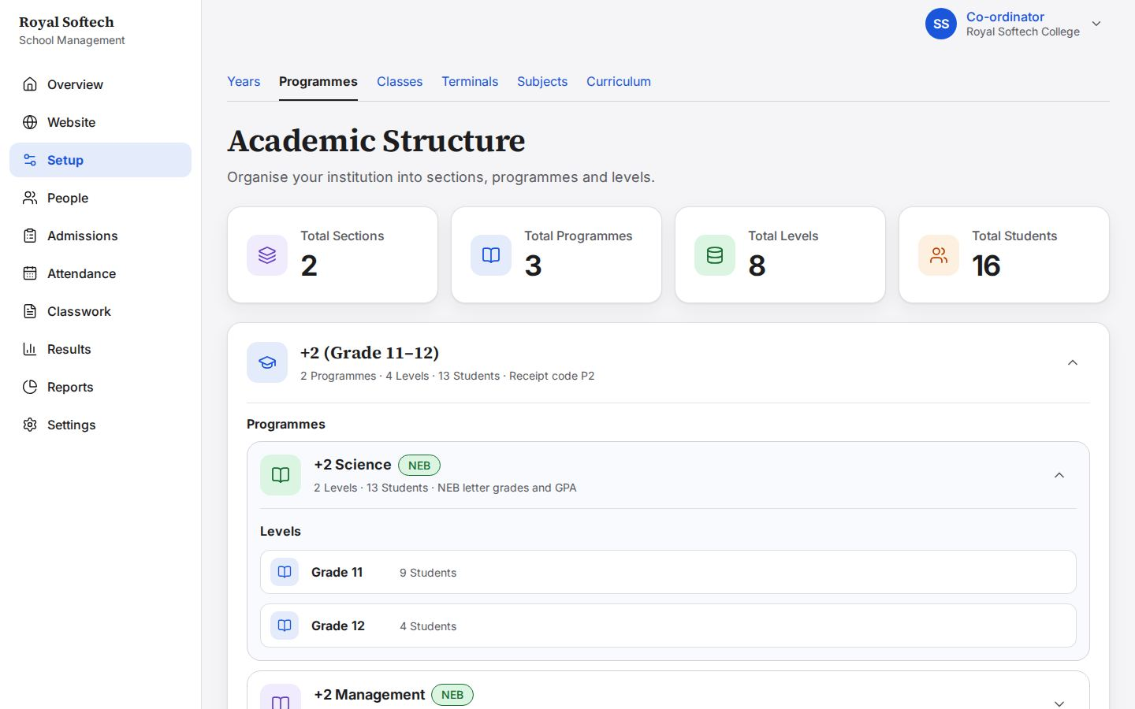
15-07 Reports, now in her menu (F-10 fixed): school setup, students and results; money and oversight stay the Principal's
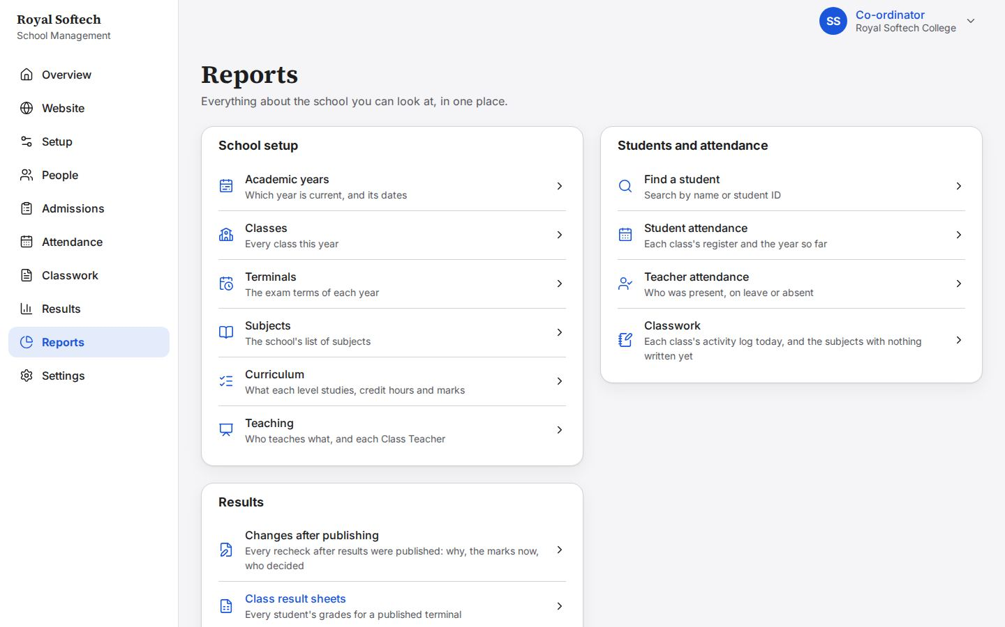
15-08 A teacher's own attendance page, opened by address
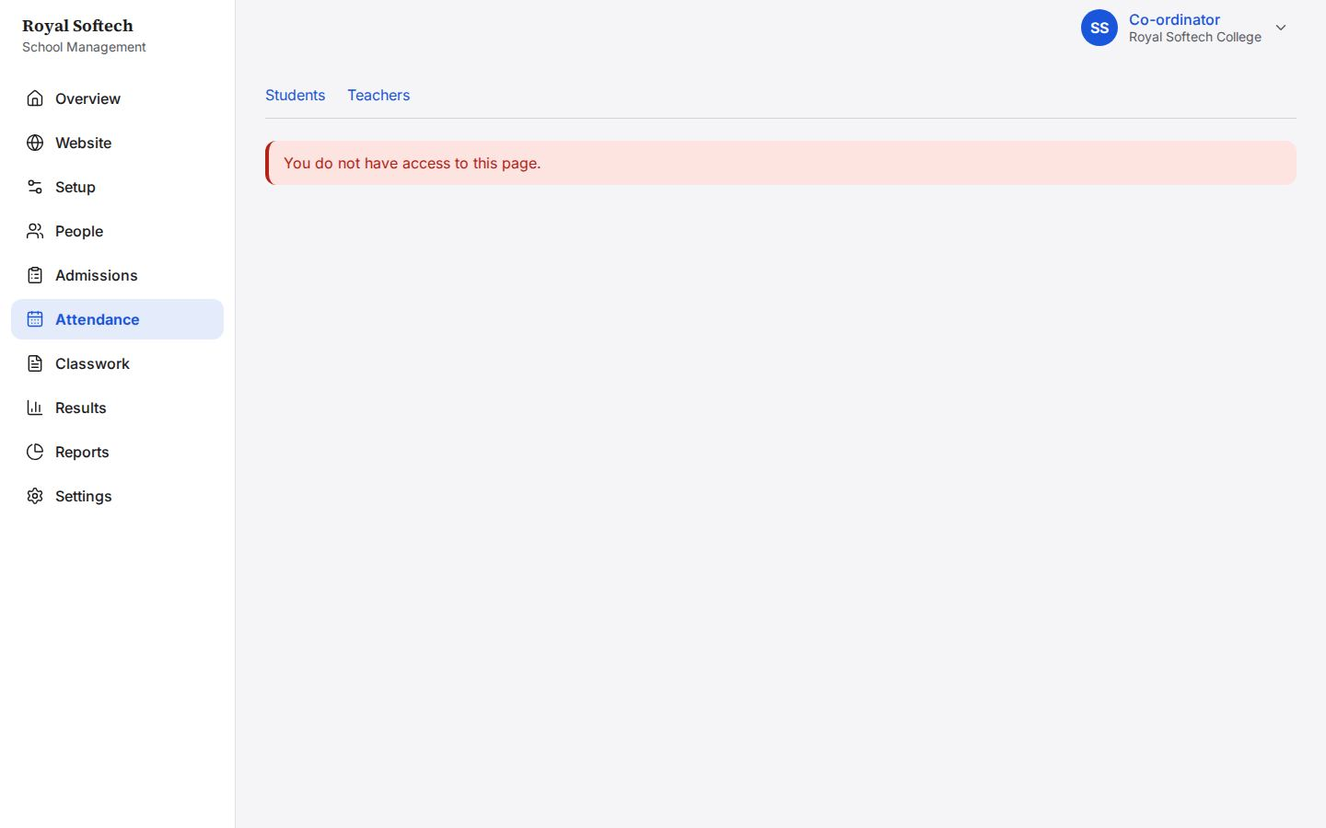
15-09 Signed out
15-10 Signed in again with the new password: no second step for a Co-ordinator (only the Principal and Support use an authenticator app)
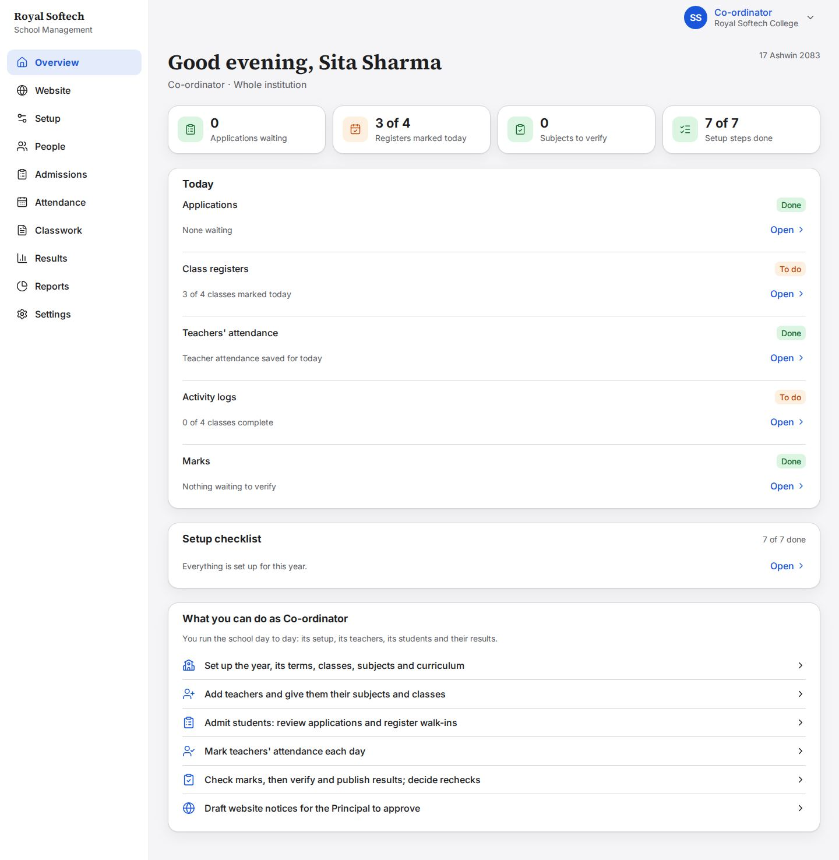

The server's answers
Each request was sent with Sita Sharma's own signed-in browser cookies, as a screen would send it.
What the Co-ordinator tried | Request | Answer
See the dues list (fees) | GET /api/fees/dues?classId={id} | 403 forbidden
Create an Accountant | POST /api/staff | 403 forbidden
Switch off a Co-ordinator (Hari) | PATCH /api/staff/{id} | 403 forbidden
Change a Co-ordinator's access | PATCH /api/staff/{id}/access | 403 forbidden
Add a section | POST /api/academics/sections | 403 forbidden
Publish website content directly | POST /api/content/{id}/publish | 403 forbidden
Decide an approval request | GET /api/approvals | 403 forbidden
Mark a class register | PUT /api/attendance/classes/{id}/today | 403 forbidden
Enter marks | PUT /api/results/classes/{id}/subjects/{id}/terminals/{id} | 403 forbidden
Read the Principal's dashboard | GET /api/dashboard/overview | 403 forbidden
Read the test mailbox | GET /api/dev/mailbox | 403 forbidden
Register a student for the queue (the Accountant's) | POST /api/admissions/register | 403 forbidden

16. A Co-ordinator for one section only
Hari Prasad Yadav's access reaches Bachelor's only. What he sees, and what the server answers when he reaches for +2.
# | Step | Observed on screen | Result
16-01 | Hari Prasad Yadav, a Co-ordinator for Bachelor's only: his dashboard counts only Bachelor's classes | – | Pass
16-02 | Attendance: only BBS Year 1 | – | Pass
16-03 | Results review: only BBS Year 1 | – | Pass
16-04 | Admissions queue: only the Bachelor's application (Rajesh Yadav) | – | Pass
16-05 | Staff: only the Bachelor's teachers | – | Pass
16-06 | Classes: what Hari sees of the year's classes | – | Pass
16-07 | Walk-in: Applying for offers only his section's 4 levels (F-11 fixed) | – | Pass

16-01 Hari Prasad Yadav, a Co-ordinator for Bachelor's only: his dashboard counts only Bachelor's classes
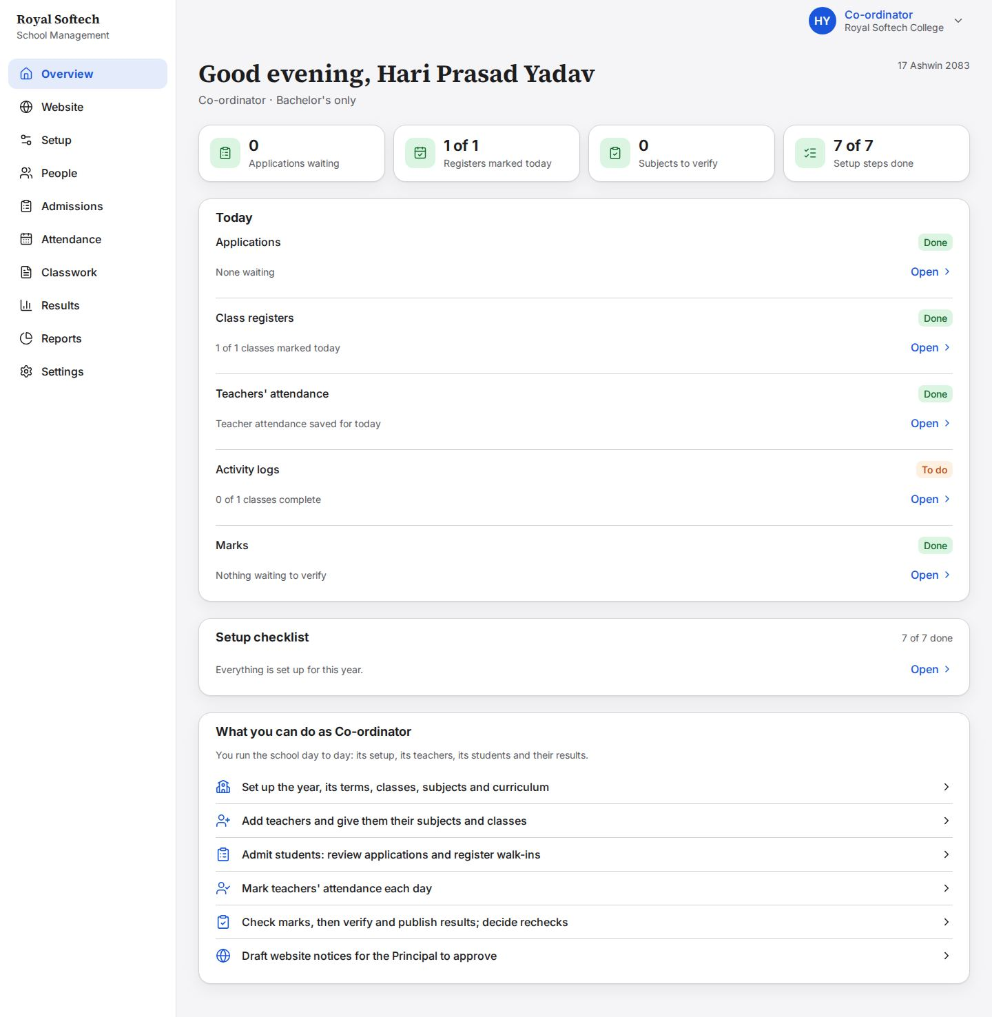
16-02 Attendance: only BBS Year 1
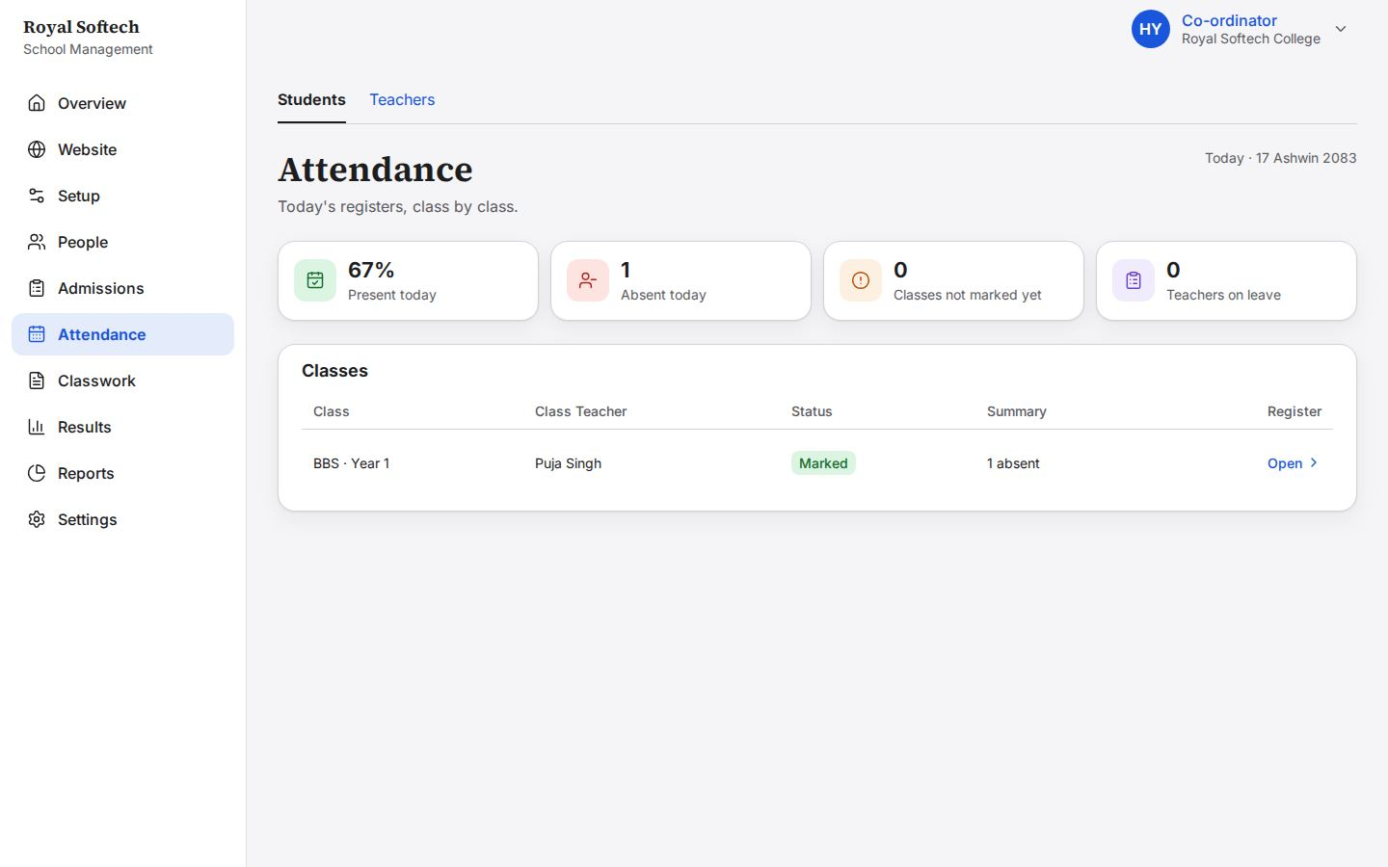
16-03 Results review: only BBS Year 1
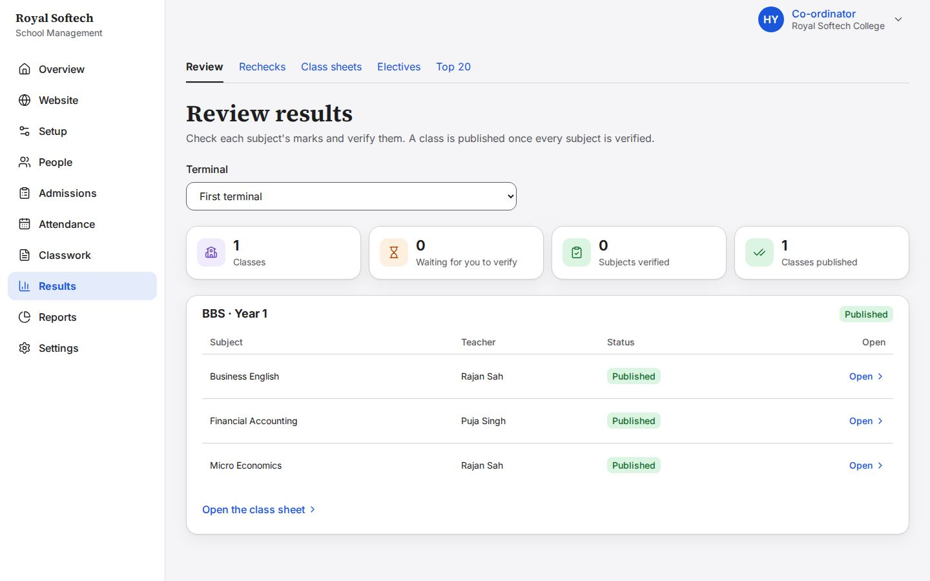
16-04 Admissions queue: only the Bachelor's application (Rajesh Yadav)
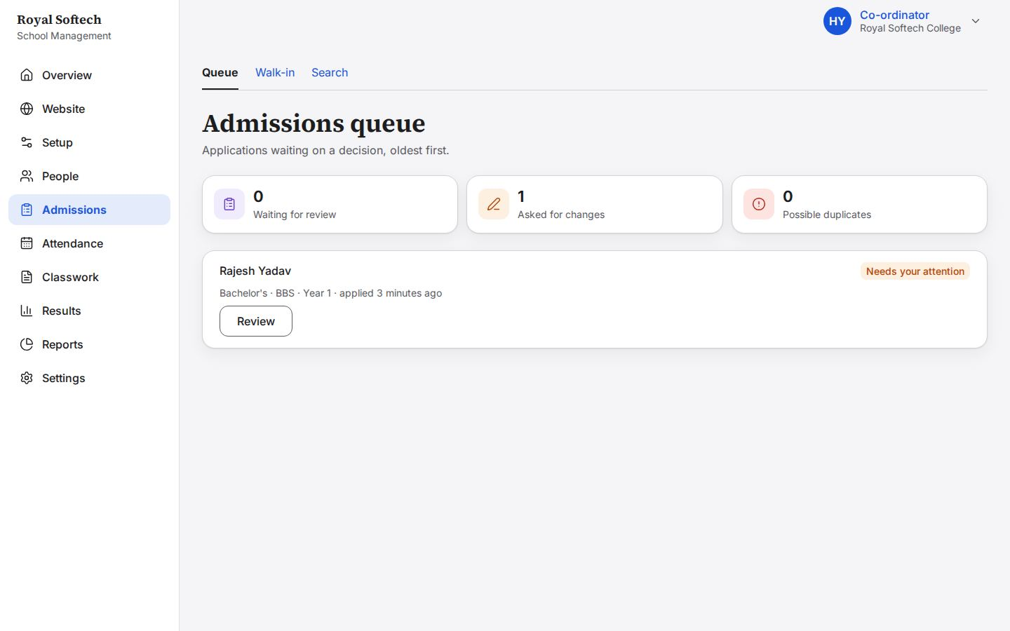
16-05 Staff: only the Bachelor's teachers
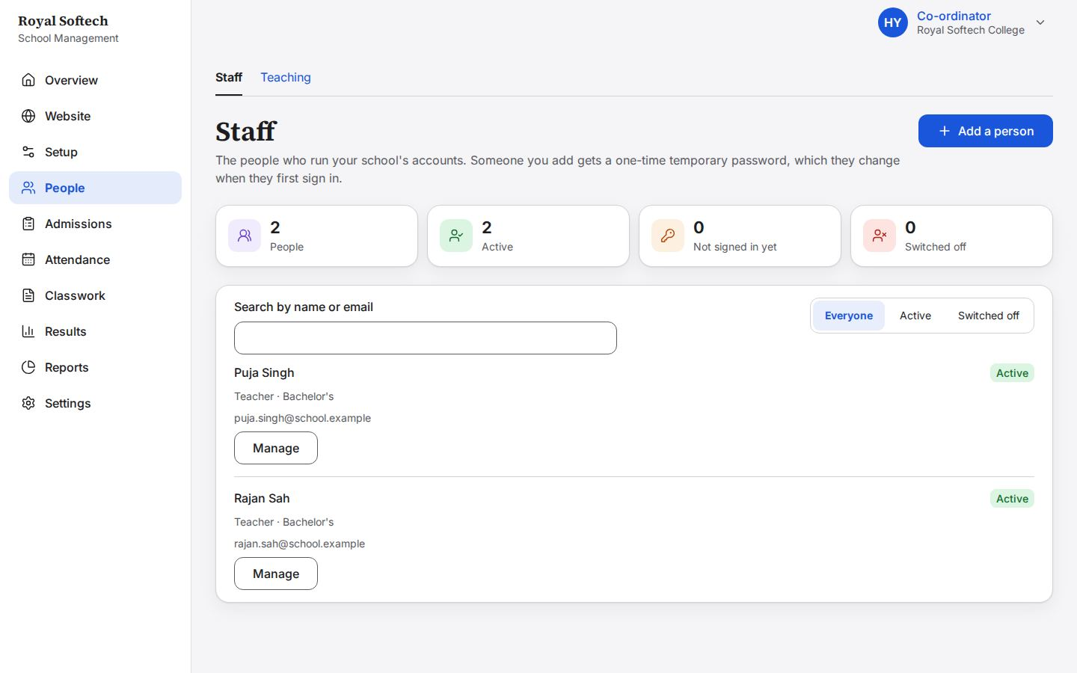
16-06 Classes: what Hari sees of the year's classes
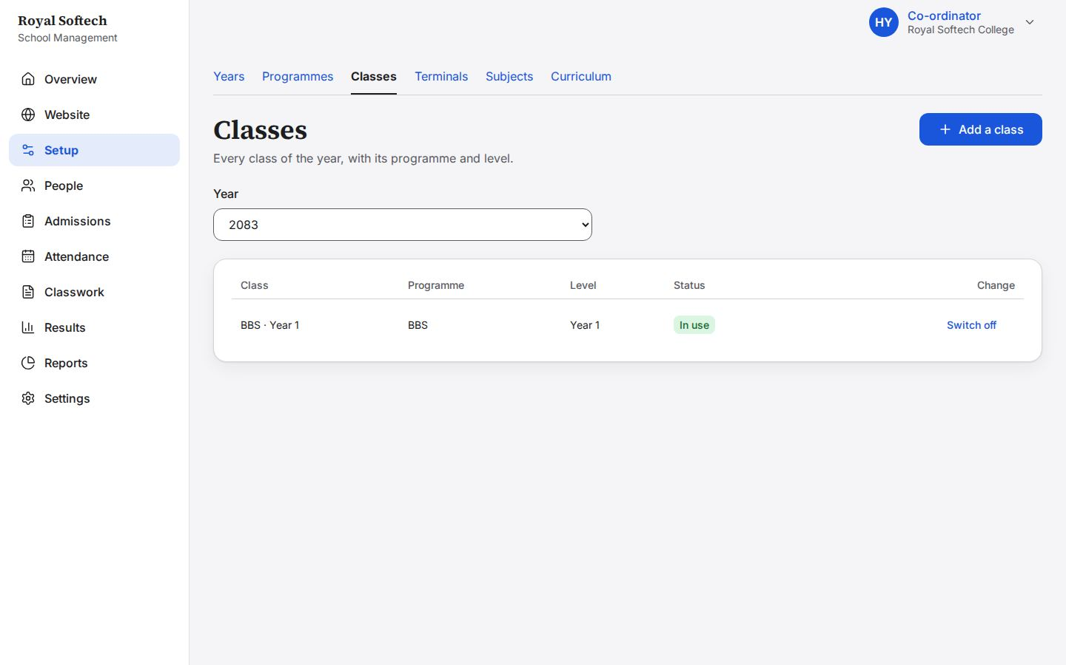
16-07 Walk-in: Applying for offers only his section's 4 levels (F-11 fixed)
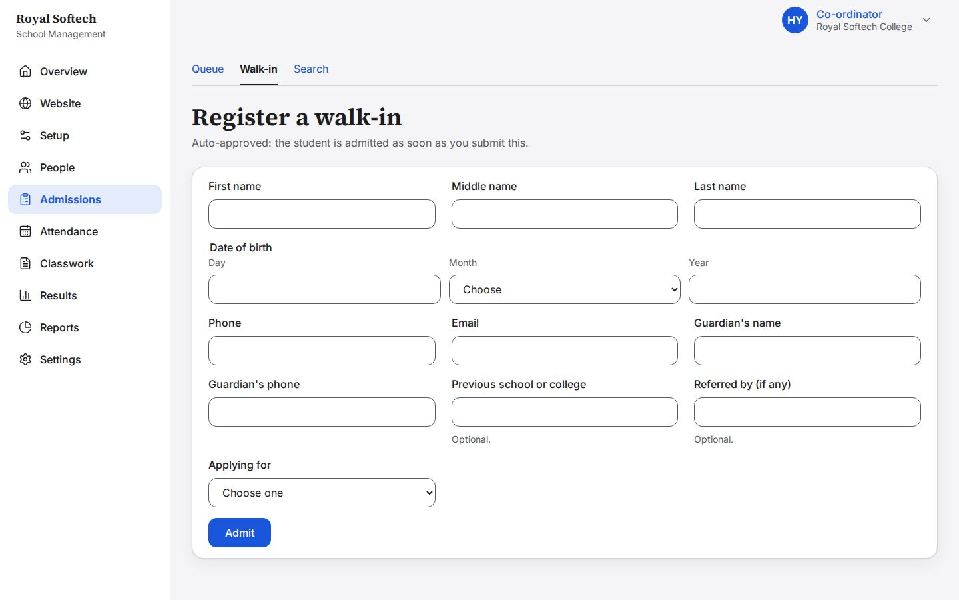

What Hari can reach, checked at the server
What Hari tried | Request | Answer
See Grade 11 A's register (+2) | GET /api/attendance/classes/{id}/day | 404 not found (outside his section)
See BBS Year 1's register (his section) | GET /api/attendance/classes/{id}/day | 200 (his section)
Read Grade 11 A's class sheet (+2) | GET /api/results/classes/{id}/terminals/{id}/sheet | 404 not found (outside his section)
Read BBS Year 1's class sheet (his section) | GET /api/results/classes/{id}/terminals/{id}/sheet | 200 (his section)
Set Grade 11 A's electives (+2) | GET /api/results/classes/{id}/electives | 404 not found (outside his section)
Publish Grade 11 A's second terminal (+2) | POST /api/results/classes/{id}/publish | 404 not found (outside his section)
Search students (only Bachelor's should come back) | GET /api/students?q=a | 200: Kiran Dahal (BBS - Year 1), Manisha Sah (BBS - Year 1), Bibek Shrestha (BBS - Year 1)

17. Phone, large text and the end of the run
The main screens at 375 px and at 320 px with text at 200%, and the dashboard at the end.
# | Step | Observed on screen | Result
17-01 | Phone (375 px): the Co-ordinator's dashboard | – | Pass
17-02 | Phone: More, for the places that do not fit in the tab bar | – | Pass
17-03 | Phone: the admissions queue | – | Pass
17-04 | Phone: teacher attendance | – | Pass
17-05 | Phone: results review | – | Pass
17-06 | Phone: curriculum | – | Pass
17-07 | 320 px, text at 200%: the dashboard | – | Pass
17-08 | 320 px, text at 200%: the admissions queue | – | Pass
17-09 | 320 px, text at 200%: Teaching | – | Pass
17-10 | The Co-ordinator's dashboard at the end: registers marked, teacher attendance saved, activity logs, and the setup checklist complete | – | Pass

17-01 Phone (375 px): the Co-ordinator's dashboard
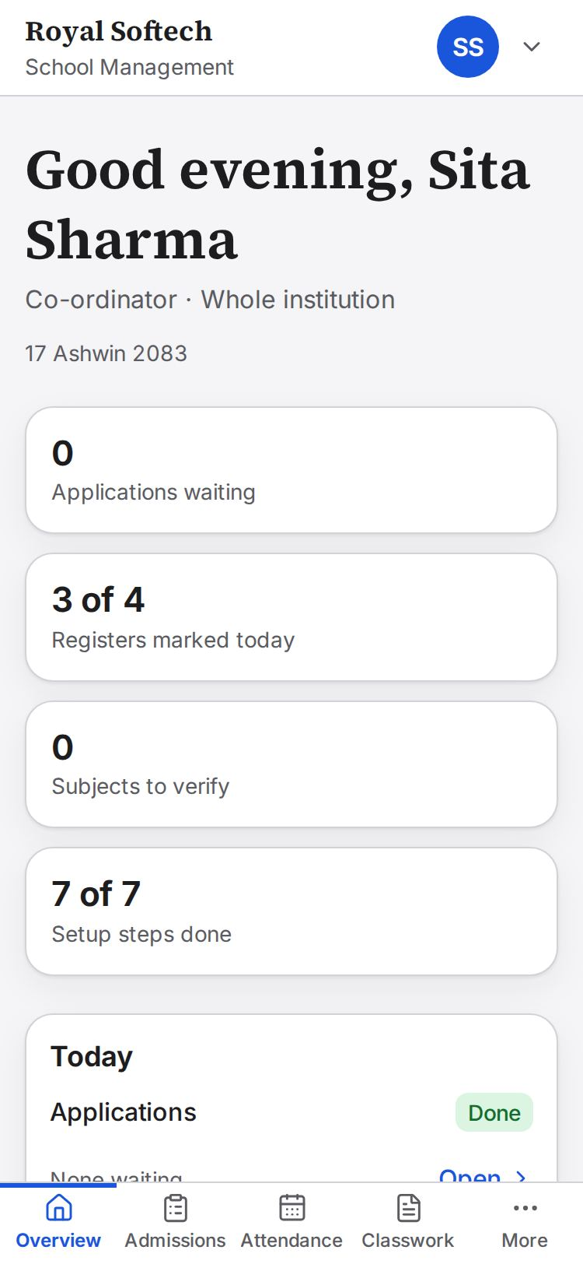
17-02 Phone: More, for the places that do not fit in the tab bar
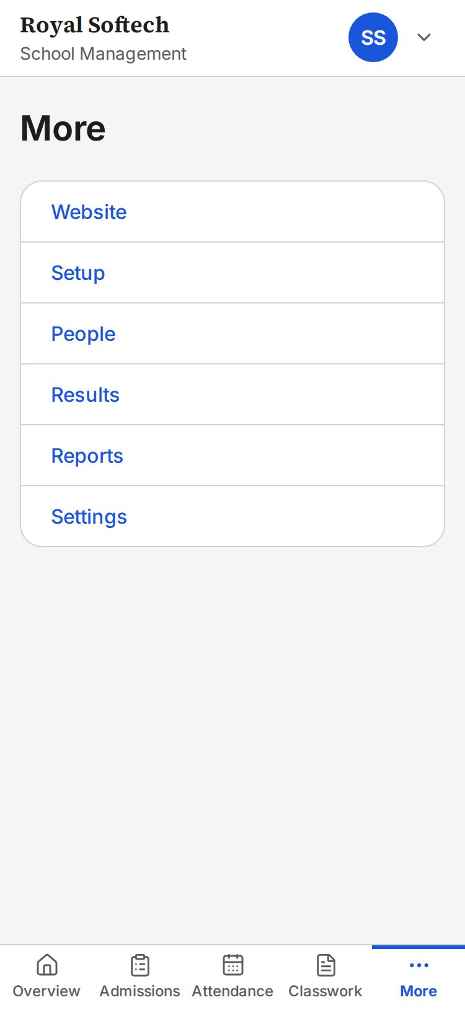
17-03 Phone: the admissions queue
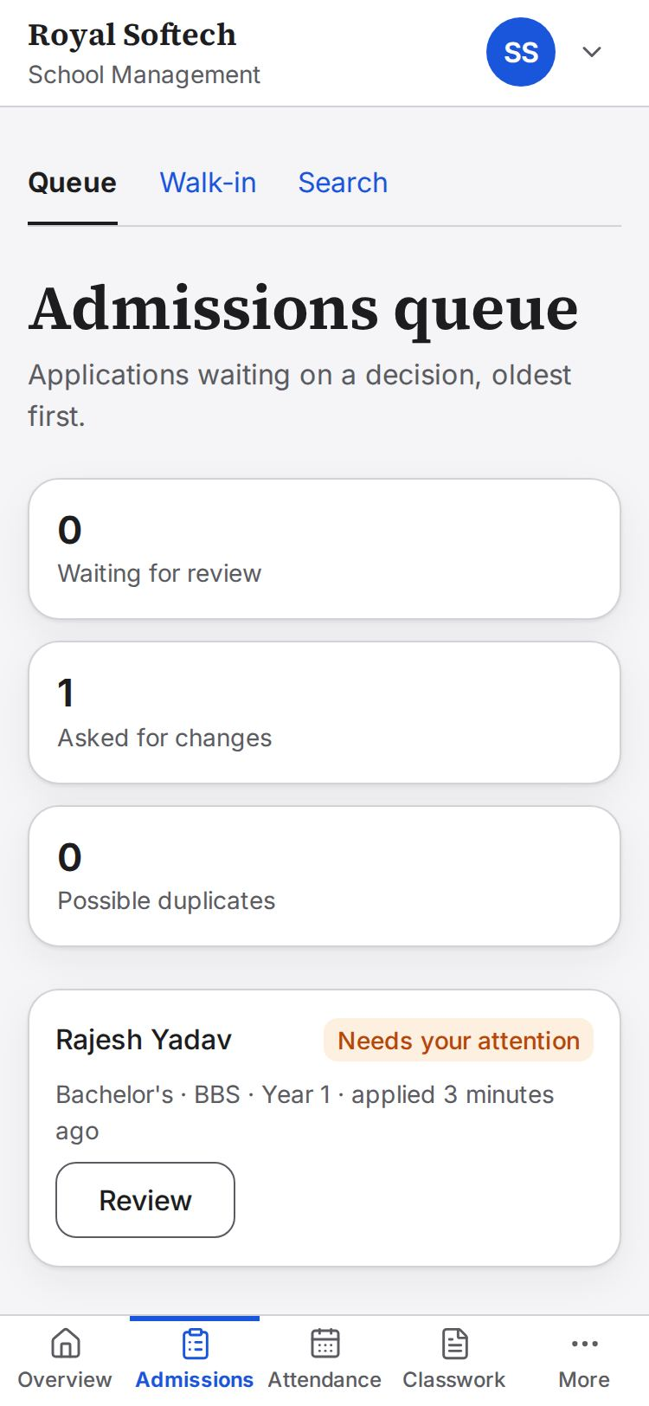
17-04 Phone: teacher attendance
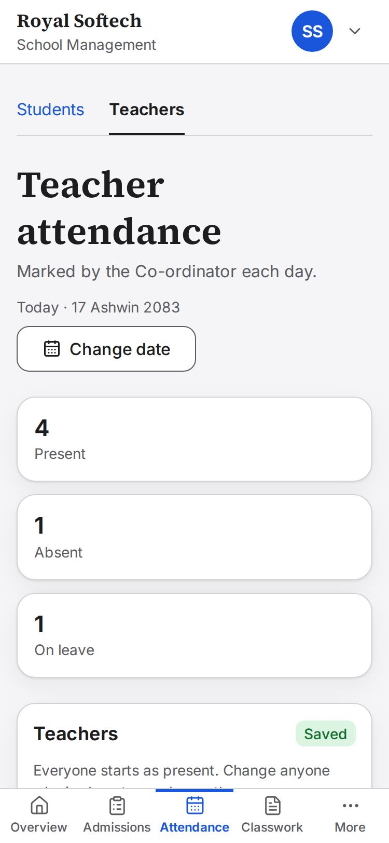
17-05 Phone: results review
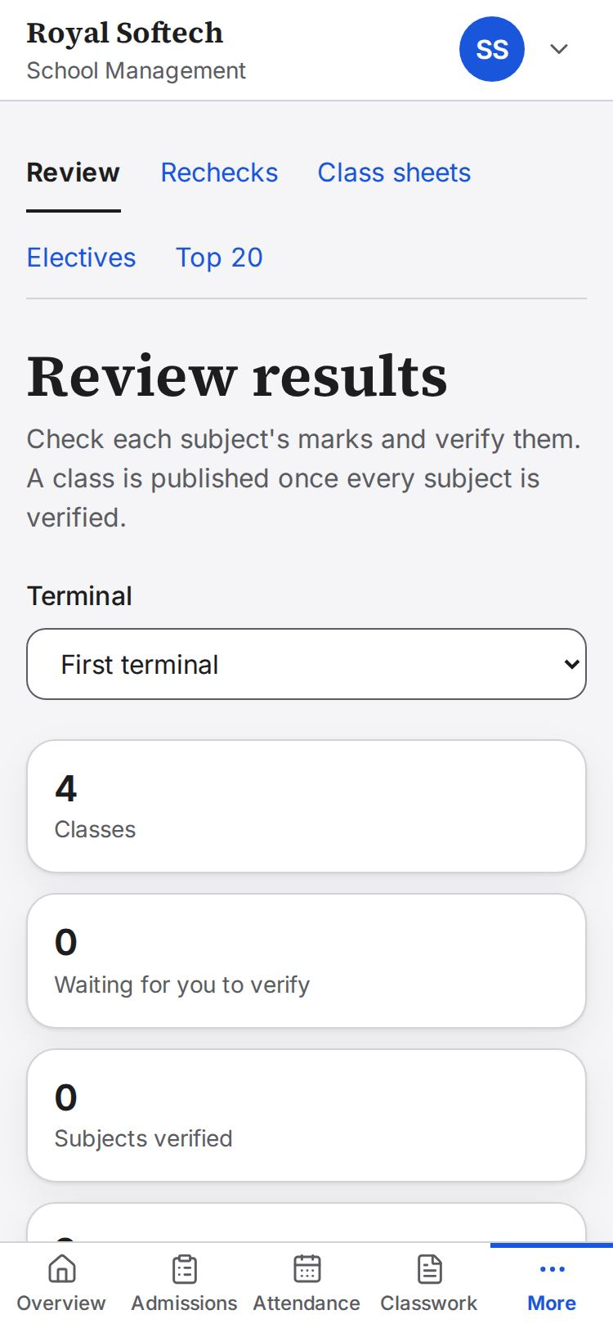
17-06 Phone: curriculum
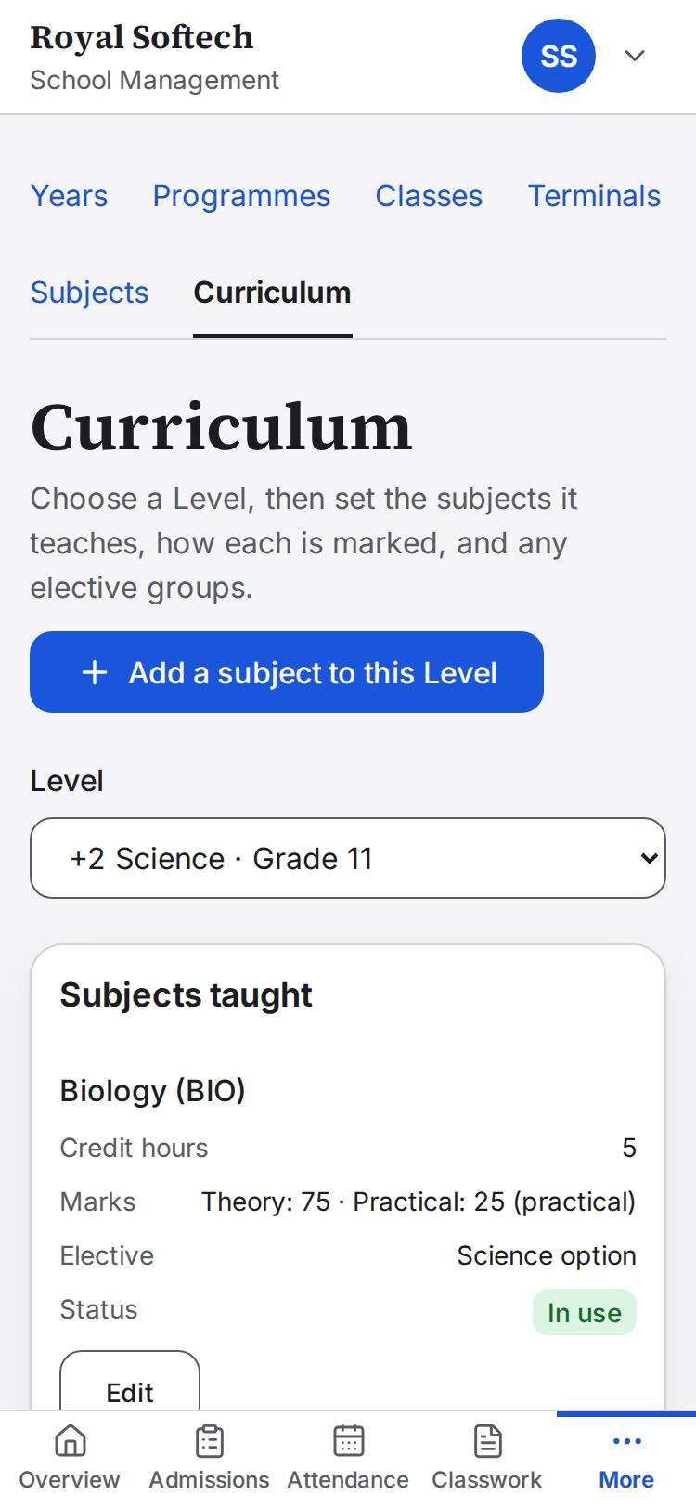
17-07 320 px, text at 200%: the dashboard
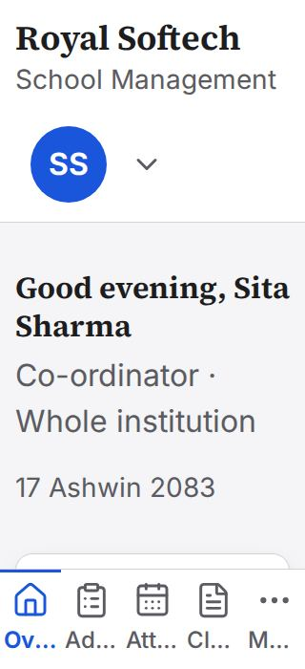
17-08 320 px, text at 200%: the admissions queue
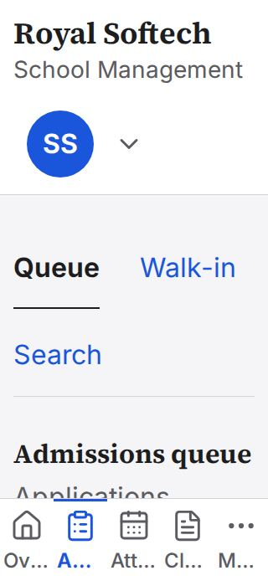
17-09 320 px, text at 200%: Teaching
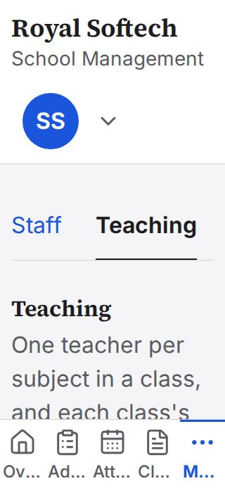
17-10 The Co-ordinator's dashboard at the end: registers marked, teacher attendance saved, activity logs, and the setup checklist complete

Findings

The first run's findings, fixed (D-106)
Severity as the first run gave it: Medium gave wrong or missing information on a real task, or left out something the role should be able to do; Low was confusing but had a way round; Cosmetic was appearance only.
ID | Severity | What the first run found | Now | Checked at
F-01 | Low | A field's error stayed after the field was corrected; a dialog reopened with its old error; Ask for changes stayed open after it went through. | Each opening of a pop-up is a fresh form, a field's message goes as soon as it changes, and the review closes into what happened. | 04-02, 07-02, 08-04, 08-07a
F-02 | Low | A year ending before it began was refused with a general message. | The form says the last day must come after the first. | 02-03
F-03 | Medium | The same person registered twice as a walk-in got two student IDs, with no warning. | The server stops it and names the existing student; Admit anyway is for real twins. | 07-05, 09-03
F-04 | Low | After Admit, only the temporary password was shown, not the new student ID. | The student ID is shown with the password. | 07-04
F-05 | Medium | The queue printed each section's internal key. | The section's name is shown. | 08-01
F-06 | Medium (gap) | A search result could not be opened, and no screen or route corrected a student's details. | A result opens the record, and Correct details saves changes with a reason in the audit trail (PATCH /api/students/{id}). | 09-07 to 09-09
F-07 | Low | The review board opened on the last terminal, and missing marks were counted per component. | It opens on the terminal in progress, and counts students. | 12-01, 12-02
F-08 | Medium | The Co-ordinator's form offered Publish, which she may never do, and it led nowhere. | The form offers Save draft and Send for approval in one step. | 14-02, 14-06
F-09 | Cosmetic | The row's Send for approval link ran past the table's edge at 1440 px. | The row's actions wrap, the second under the first, inside the table. | 14-04
F-10 | Low | Reports worked by address but had no menu entry. | Reports is in her menu, showing only the groups she may read. | 15-07
F-11 | Low | A Bachelor's-only Co-ordinator's walk-in form listed +2 levels. | Only his section's levels are listed. | 16-07
F-12 | Low | At 375 px the phone's tab bar wrapped onto a second row. | Checked: one row (fixed with the Principal's F-15). | 17-01

New in this run
None.

What the Co-ordinator can do, and where it was tested
Every action the Co-ordinator holds in the permission matrix (apps/api/src/core/permissions/matrix.ts):
Permission | What | Tested in
auth.sign_in | Sign in, change own password | 01, 15
account.profile.edit | Correct own name and phone | 15-02
accounts.teacher.create | Create a teacher | 05-02 to 05-07
accounts.deactivate (teachers) | Switch a teacher off and on | 05-08, 05-09
accounts.password.issue (teachers) | A new temporary password | 05-10
accounts.staff.view (teachers) | The staff list | 05, 16-05
content.draft / approvals.request / approvals.view.own | Draft website content, send it for approval, see her requests, withdraw | 14
setup.structure.manage / view | Years, terminals, classes | 02, 04
setup.subjects.manage / view | Subjects, curriculum, mark components, elective groups | 02-12 to 02-14, 03
setup.assignments.manage / view | Teacher for each subject, Class Teachers | 06
admissions.walkin.register | Register a walk-in | 07
admissions.review | Approve, ask for changes, reject | 08
students.search / students.personal.view | Find a student; view the record | 09
students.personal.correct | Correct a student's details | 09-07 to 09-09
students.status.set / students.rollover | Left or Graduated; year rollover | Not covered: Phase 8, not built
attendance.student.view / attendance.teacher.mark / view | Read registers; mark teachers, today and a past day | 10
activity.read | Read the activity log | 11-01, 11-02
results.electives.set | Each student's elective | 11-03 to 11-05
marks.verify / results.publish / results.view / results.top20.view | Verify, send back, publish, class sheet, Top 20 | 12
results.recheck.edit | Decide rechecks | 13
reports.students / reports.results | Reports | 15-07

Not covered
- Marking a student Left or Graduated, and the year rollover (Phase 8, not built).
- Uploads (an applicant's certificate): uploads are off until R2 is enabled (D-020).
- Real email and SMS: only the development mailbox exists.
- The teachers', students' and Accountant's own screens: they appear here only as preconditions; each role needs its own FUT.

