**Trailrush Mobile Application**

(User’s Manual & Screenshots)

**User’s Manual** (Mobile application)

1. Open the TR application.
2. Splash screen appears.
3. In the home tab – station enrollment occurs – enter the desired name of the station.
4. After entering the station name, it will then proceed to the scanning tab.
5. In Scan QR tab, tap the button scan to start scanning QR.
6. After scanning, an alert will display the information from the QR.
7. In result tab, when you tap the sync button, all the scanned results will be sent to the MongoDB database and displaying all sent results in a table.
8. Export button provides csv file.

**Screenshots**

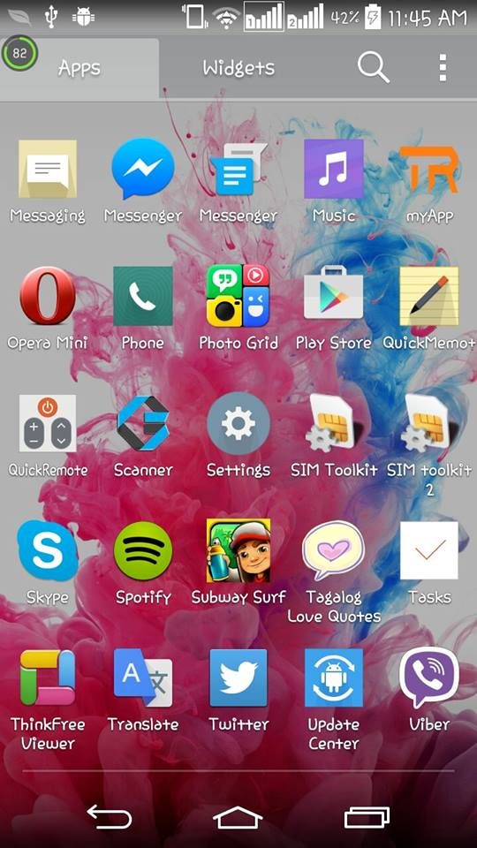

**Home Page in mobile phone**

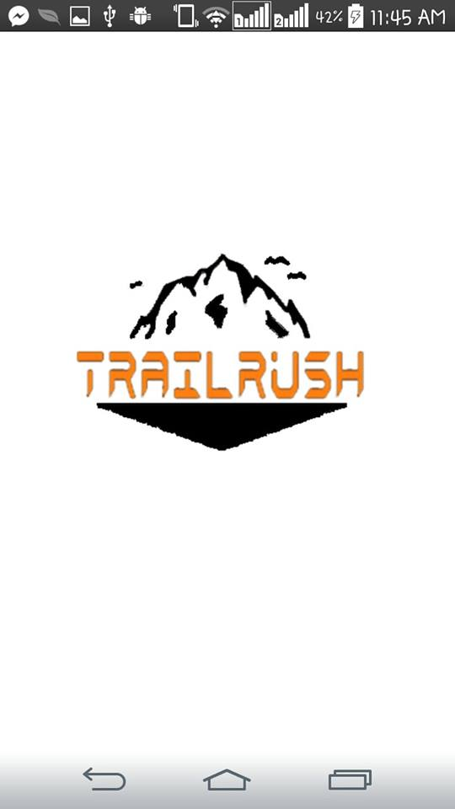

**Splash Screen**

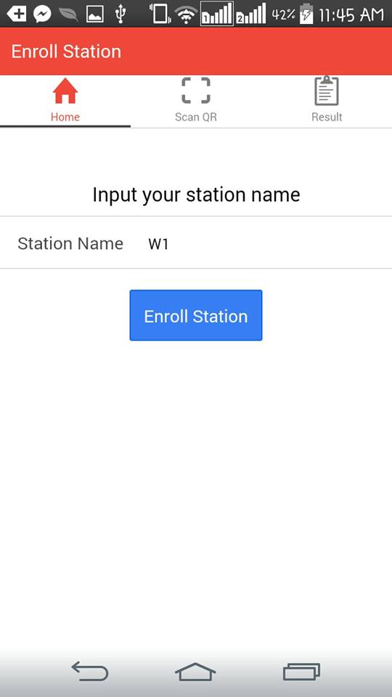

**Station tab**

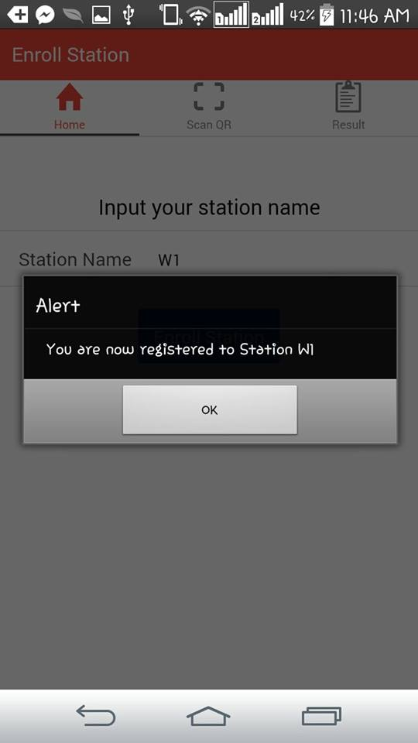

**Station registration confirmation**

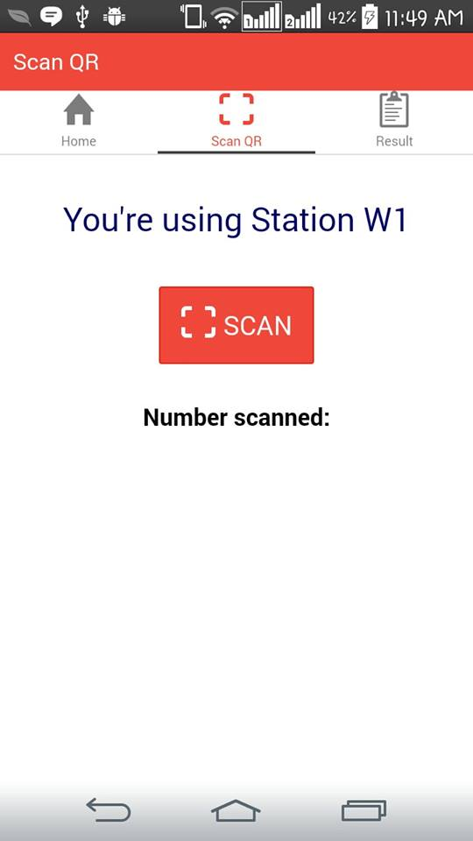

**Scanning Tab**

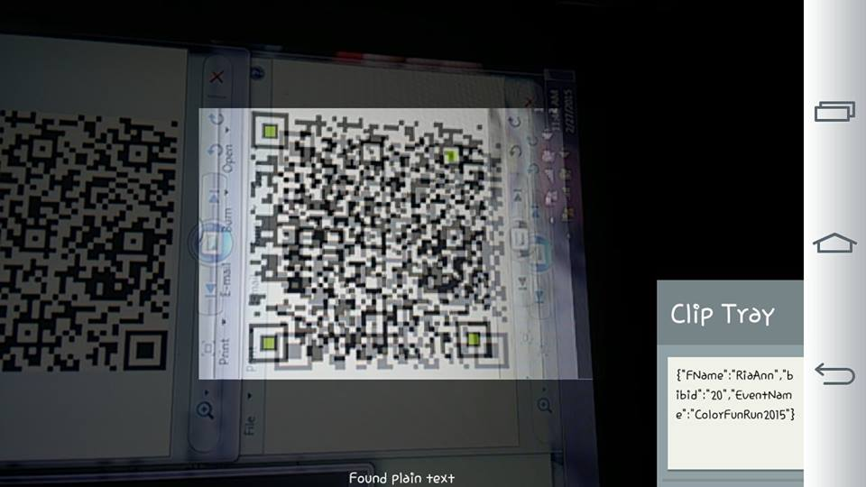

**Scanning Process**

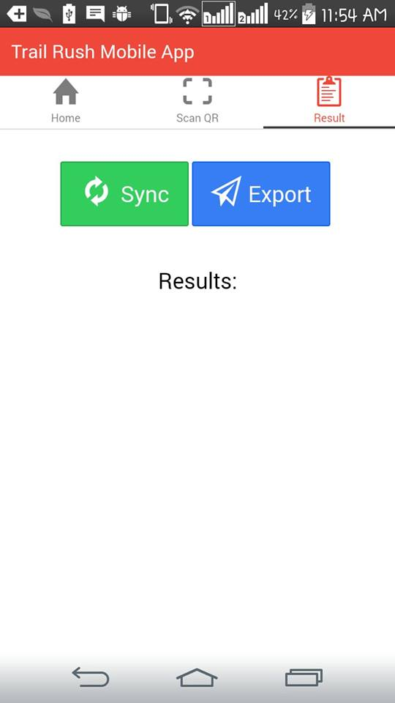

**Results Tab**

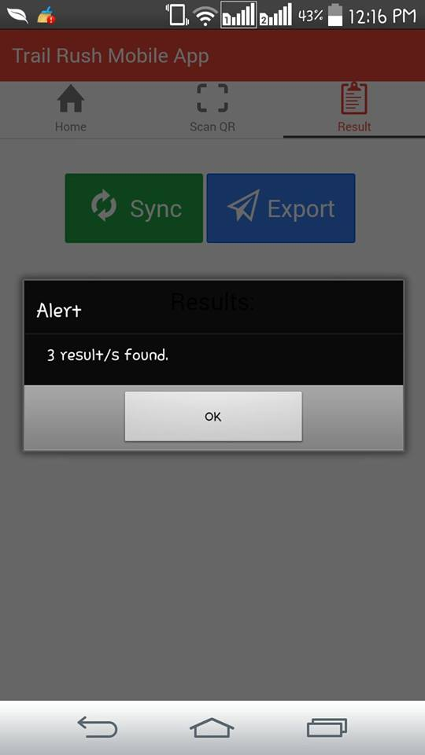

**Alert for the counter of the database**

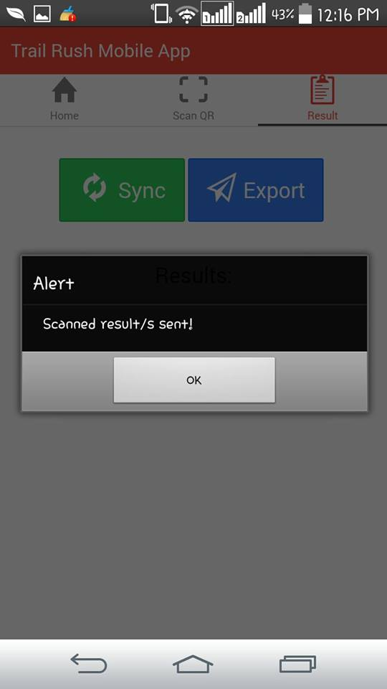

**Sent results confirmation**

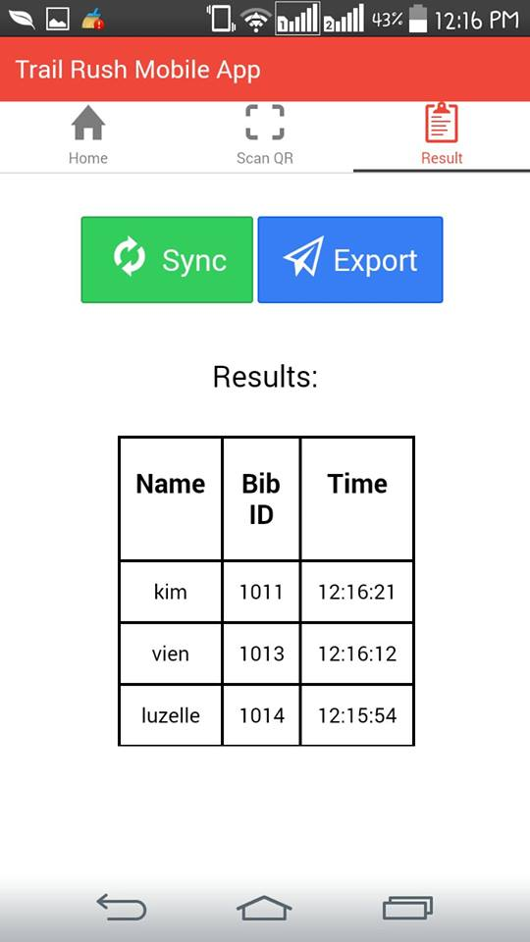

**Final Results Tab**