# CS 255 System Design Document Template

## UML Diagrams

### UML Use Case Diagram

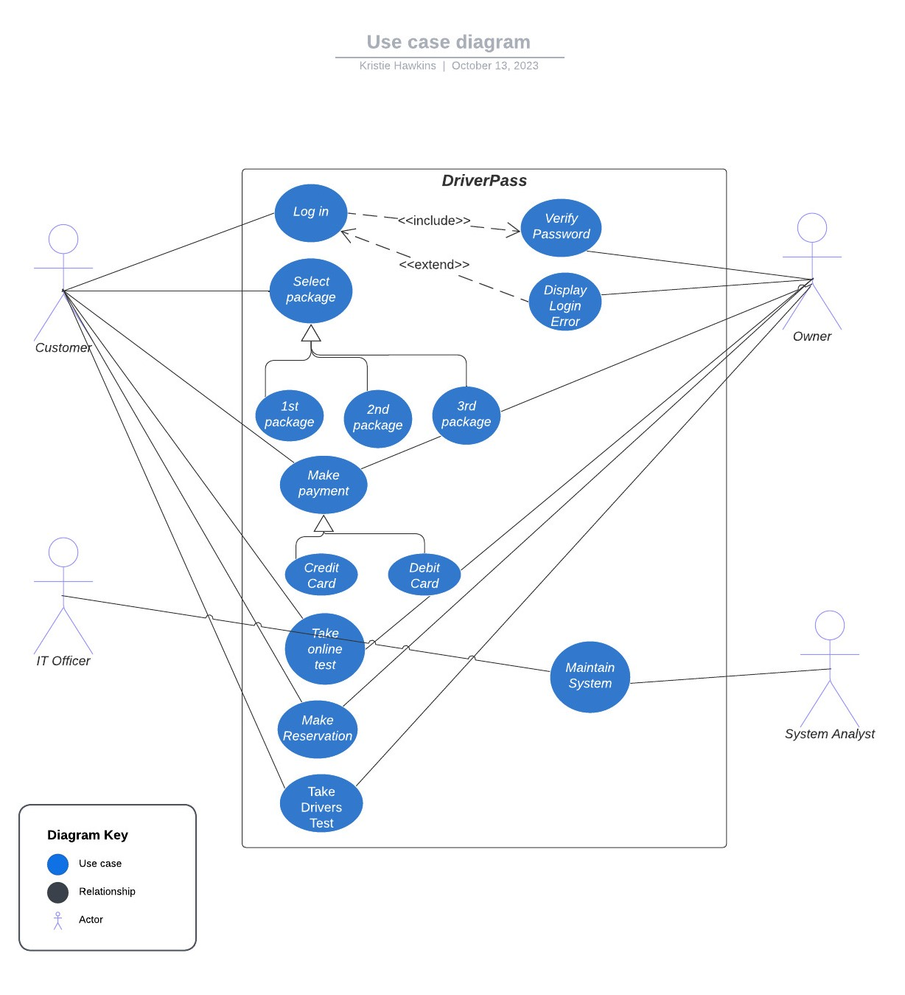

### UML Activity Diagrams

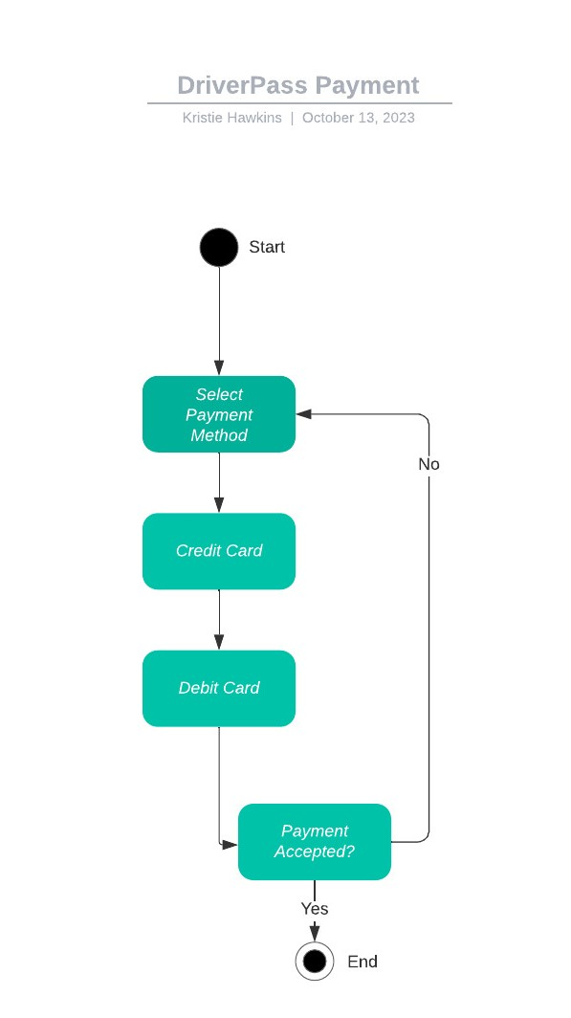

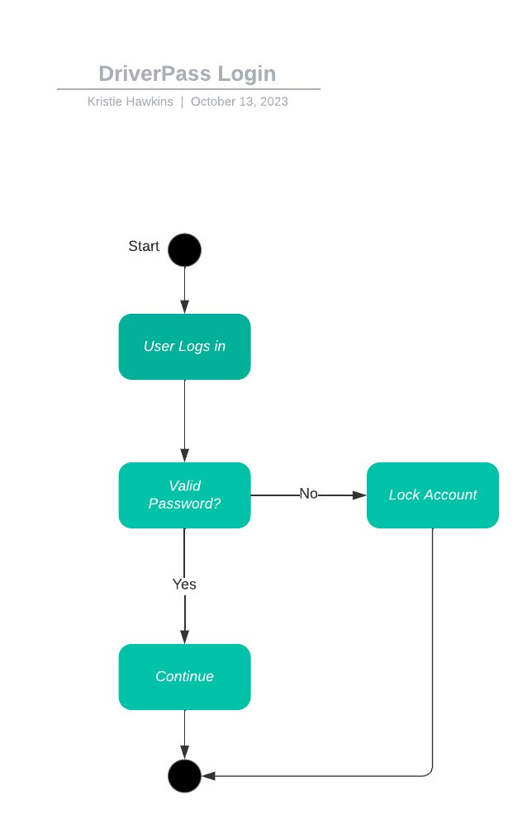

### UML Sequence Diagram

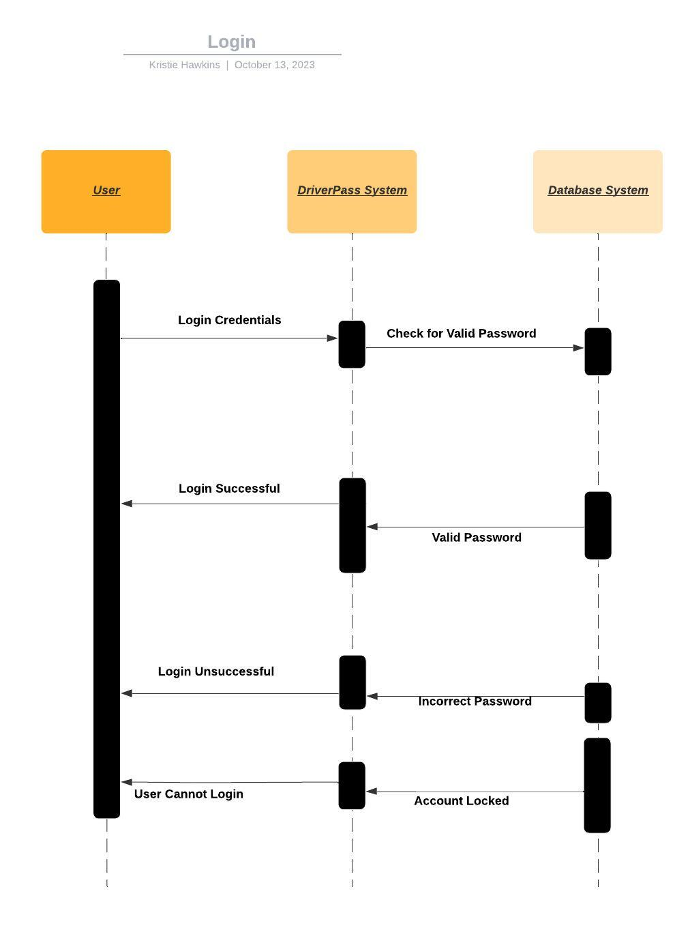

### UML Class Diagram

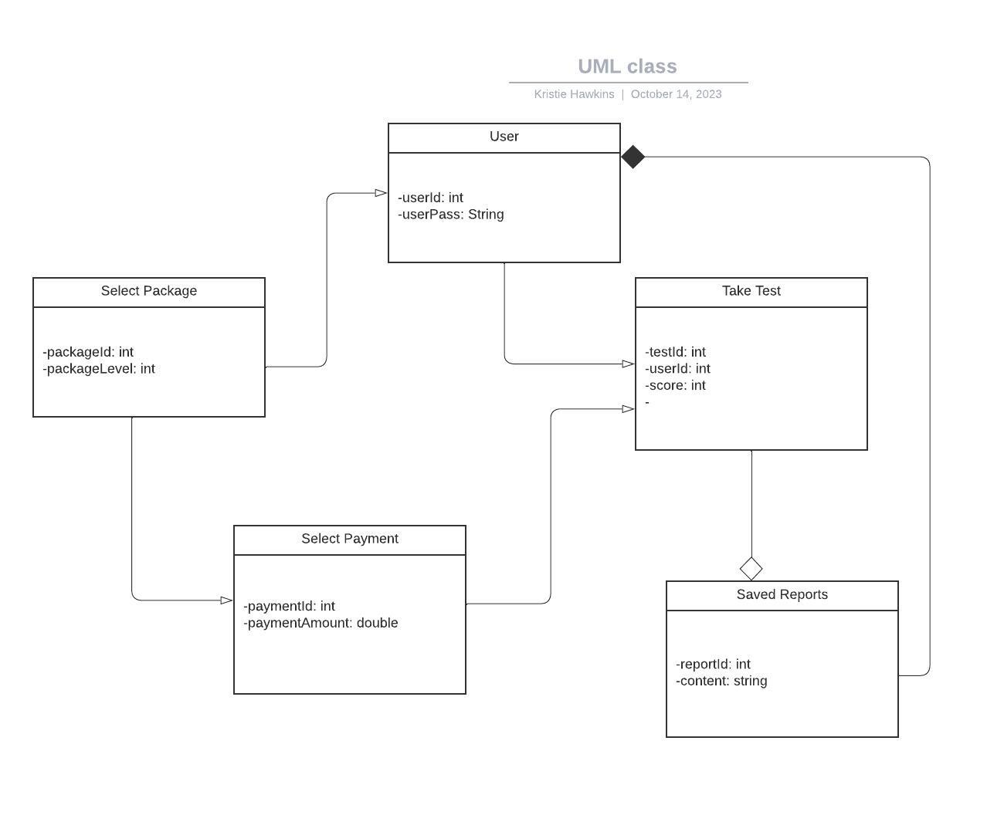

## Technical Requirements

The hardware for this system would be a Windows system, desktop or laptop and internet connection. Linux would be best for security and development process. We could use both and tackle two requirements at once. Using more than one operating system wouldn’t hurt, so I would use another along with Linux.