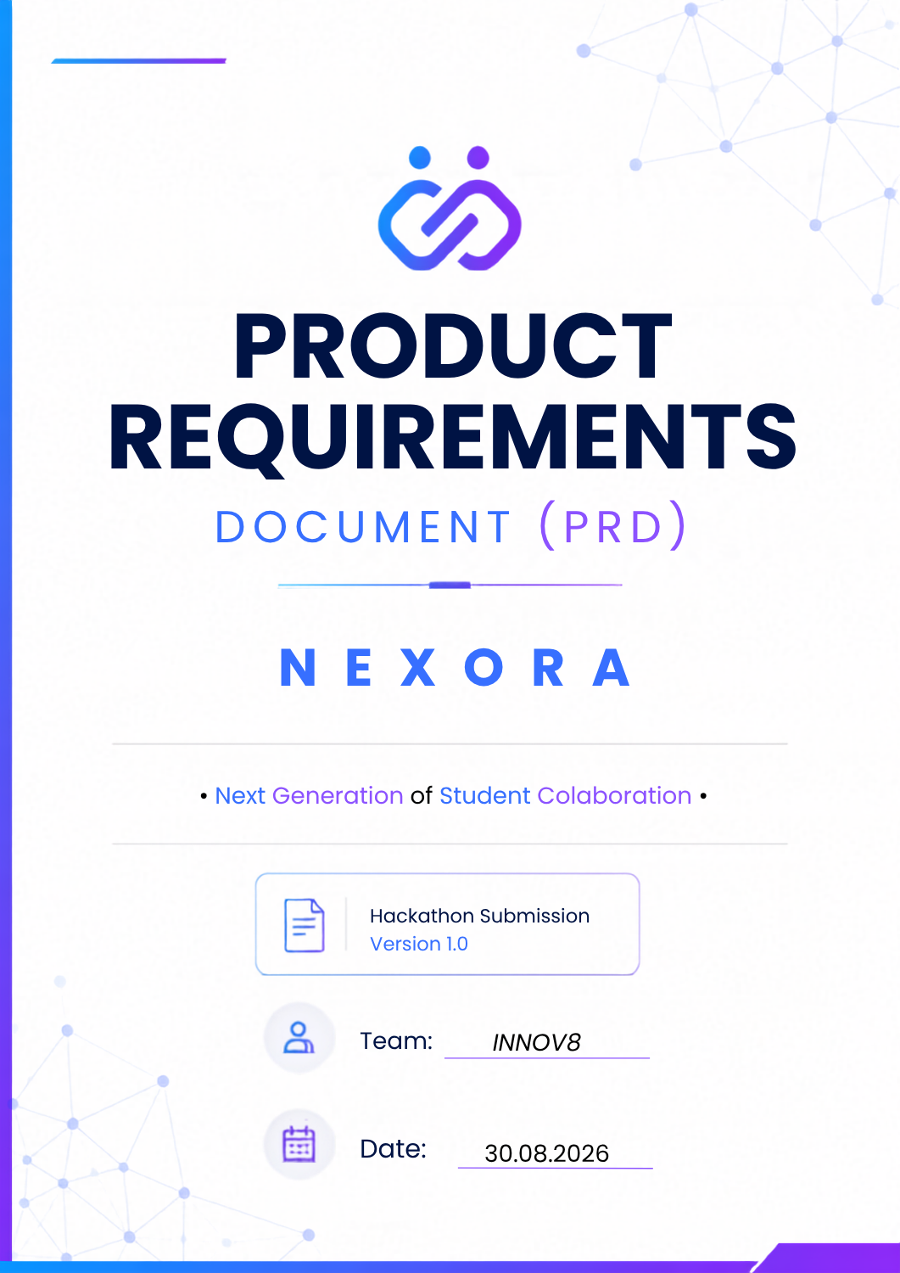
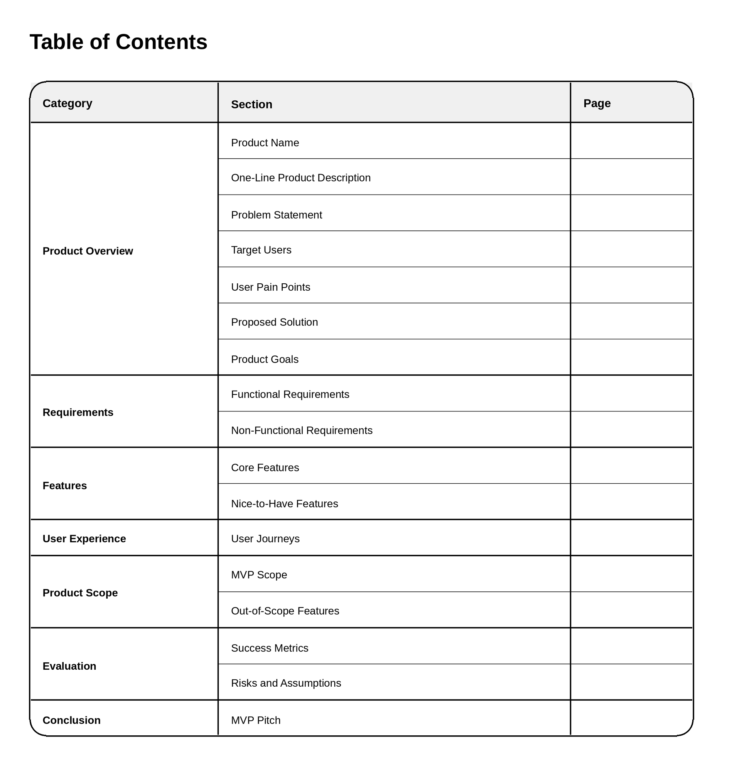
Table Of Contents;

PRODUCT OVERVIEW
1. Product Name ; NEXORA
2. One-Line Product Description
A smart campus talent network that helps students discover opportunities and form teams for projects, hackathons, and research based on skills, interests, experience, and availability.
3. Problem Statement
Students often struggle to find suitable teammates for hackathons, projects, research opportunities, and campus initiatives. Talent is scattered across the campus, making it difficult to identify people with the necessary skills, shared interests, and compatible schedules.
Most students rely on WhatsApp groups, personal networks, or word-of-mouth to find collaborators, resulting in missed opportunities, inefficient team formation, and limited collaboration beyond existing friend circles.
4. Target Users
Primary Users
• Undergraduate students
• Postgraduate students
• Hackathon participants
• Students seeking project teammates
• Students interested in research opportunities
Secondary Users
• Professors and research mentors
• Club representatives
• Student organization leaders
5. User Pain Points

Students
- Cannot easily find teammates with required skills.
- Don't know who is interested in similar domains.
- Struggle to discover research opportunities.
- Teams are often formed randomly.
- Difficult to connect with students outside their immediate network.
- Lack visibility into campus talent.

Professors
- Difficulty finding suitable students for research projects.
- No centralized platform for posting opportunities.

Clubs
- Difficulty reaching interested students.
- Recruitment and communication are often fragmented.

6. Proposed Solution
Create a verified student-only platform where users can build detailed profiles including:
- Skills
- Interests
- Availability
- Experience
- Certifications
- Achievements
- Preferred Roles
The platform helps students:
- Discover talent across campus
- Find teammates for projects, hackathons, and research
- View match scores with opportunities
- Identify missing skills within teams
- Communicate and collaborate with peers
- Explore clubs, events, and research opportunities
The goal is to create a single ecosystem that combines talent discovery, opportunity matching, collaboration, and knowledge sharing.

7. Product Goals
Primary Goals
• Help students discover suitable teammates.
• Improve team formation efficiency.
• Match students based on skills, interests, and availability.
• Promote collaboration across departments.
• Increase participation in projects, hackathons, and research.
Secondary Goals
• Centralize campus opportunities.
• Encourage knowledge sharing.
• Strengthen student communities.

8. Functional Requirements
Authentication: registration, login, institutional email verification.
Student Profiles: create/edit profile, skills, interests, availability, achievements, certifications.
Talent Discovery: browse, search, filter students, view profiles.
Team Formation: create projects, define skills, invite teammates, join teams.
Smart Matching: calculate match percentage, recommend teammates and projects.
Communication: direct messaging and team discussions.
Projects & Research: create opportunities, browse opportunities, apply.
Community Features: ask questions, answer questions, upvote responses.
Notifications: team invitations, project requests, announcements, messages.
9. Non-Functional Requirements
Performance
- Dashboard should load within a few seconds.
- Student search should be responsive.

Security
- Secure authentication.
- Data accessible only to authorized users.

Reliability
- User profiles and project data should not be lost.

Usability
- Beginner-friendly interface.
- Mobile-responsive design.

Scalability
- Support future expansion across multiple departments or institutions
10. Core Features
🎯 Talent Discovery & Team Formation
- Student discovery
- Teammate recommendations
- Team creation

📊 Smart Match Score
- Skill matching
- Interest matching
- Availability matching

✅ Missing Talent Detection
- Identify missing roles within teams

👤 Student Profiles
- Skills
- Interests
- Experience
- Availability

🔬 Projects & Research Hub
- Project listings
- Research opportunities

💬 Communication Center
- Messaging Team communication

⏰ Availability Matching
- Schedule compatibility

11. Nice-to-Have Features

📢 Events & Announcements
- Hackathons
- Workshops
- Campus events

🎭 Clubs Hub
- Club discovery
- Club recruitment

❓ Discussion Forum
- Q&A

🏆 Student Portfolio
- Projects
- Certifications
- Achievements

🔔 Real-Time Notifications

🔍 Advanced Search & Filtering

- Knowledge sharing

12. User Journeys
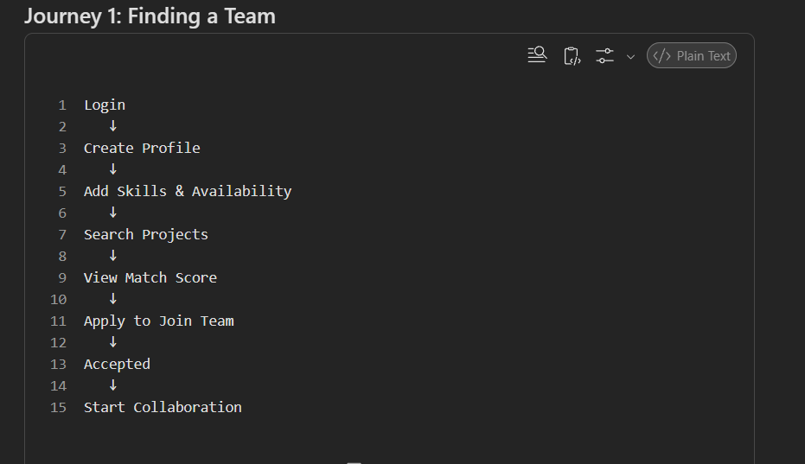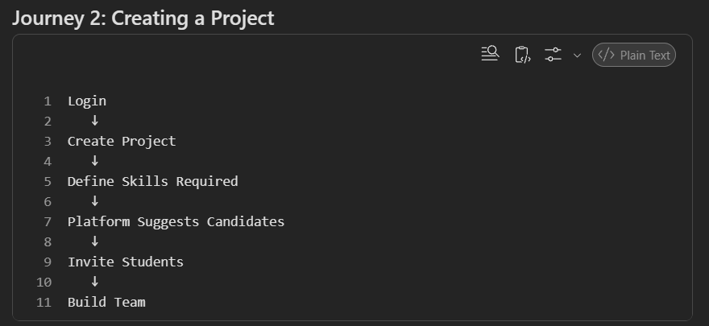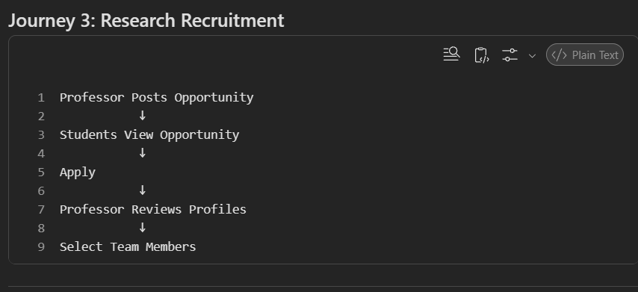
13. MVP Scope

Must Have (Hackathon Demo)
✅ Student Authentication
✅ Student Profiles
✅ Skills & Interests
✅ Availability Information
✅ Project Creation
✅ Team Formation
✅ Student Search
✅ Match Percentage
✅ Basic Messaging
✅ Team Dashboard

Demo Goal
Demonstrate that a student can:
- Create a profile.
- Create or join a project.
- Discover teammates.
- View match scores.
- Form a team.

14. Out-of-Scope Features
These should not be built during the hackathon:
❌ Full AI recommendation engine
❌ Video calling
❌ Resume builder
❌ Mobile application
❌ Internship marketplace
❌ Gamification system
❌ Cross-college networking
❌ Advanced analytics dashboard
❌ Large-scale social networking features

15. Success Metrics

Adoption Metrics
- Number of registered students
- Number of completed profiles

Engagement Metrics
- Number of projects created
- Number of team invitations sent
- Number of teams formed

Matching Metrics
- Number of successful matches
- Match acceptance rate

Collaboration Metrics
- Number of messages exchanged
- Number of project applications

16. Risks and Assumptions

Risks
- Students may not complete their profiles fully.
- Insufficient users may affect matching quality.
- Match percentage algorithms may produce weak recommendations if profile data is incomplete.
- Limited hackathon time may restrict implementation of advanced features.

Assumptions
- Students are willing to share skills and interests.
- Institutional email verification is available.
- Users actively seek projects, hackathons, and research opportunities.
- The MVP only needs to demonstrate the team formation workflow successfully.

MVP Pitch
A student-only talent network that helps users find compatible teammates for projects, hackathons, and research through skill-based matching, availability tracking, and intelligent team formation. Students can discover opportunities, connect with collaborators, and build impactful projects within a single campus ecosystem. 🚀

