DNG Quality Level Detection System

1. PROJECT OVERVIEW
1.1 Problem Statement
This project develops a method to detect and classify improvements in image detail levels for RAW buffers extracted from DNG (Digital Negative) files. The system analyzes structural, textural, and tonal enhancements to provide precise and consistent evaluations across 5 to 10 quality levels.
1.2 Key Objectives
- Develop a machine learning model to classify image detail levels (5-10 levels)
- Integrate seamlessly with multi-level classification for DNG processing
- Train on diverse datasets for accuracy across various imaging scenarios
- Support decoding, enhancing, and exporting RAW image buffers
1.3 System Architecture
Weighted Metric Optimization: Uses opposing metrics (e.g., sharpness vs. noise) with weighted values to determine the optimal quality level.

2. QUALITY ENHANCEMENT PIPELINE
2.1 Progressive Enhancement Strategy
The system generates 10 progressive quality levels from the base DNG image:
- Level 1: Minimal processing (near-original)
- Levels 2-4: Gentle unsharp masking with progressive strength (0.2 to 0.6) and radius (0.8 to 1.2)
- Levels 5-7: Moderate sharpening with increasing strength (0.6 to 1.2)
- Levels 8-9: Strong sharpening combined with CLAHE (Contrast Limited Adaptive Histogram Equalization)
- Level 10: Maximum enhancement using all techniques (unsharp mask, CLAHE, and high-pass filtering)

3. MATHEMATICAL FORMULAS
This section details all mathematical formulas used in the image quality metrics calculation.

3.1 MTF50 (Modulation Transfer Function at 50%)
Purpose: Measures spatial frequency response and optical sharpness using the slanted edge method.

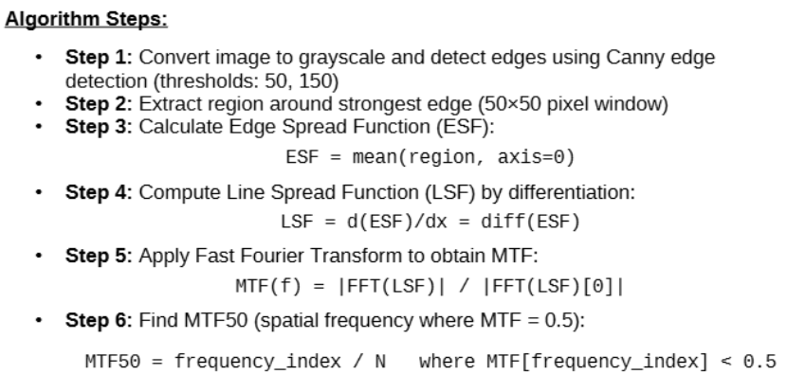

3.2 Noise Level Estimation
Purpose: Quantifies image noise using wavelet-based estimation combining two complementary methods.

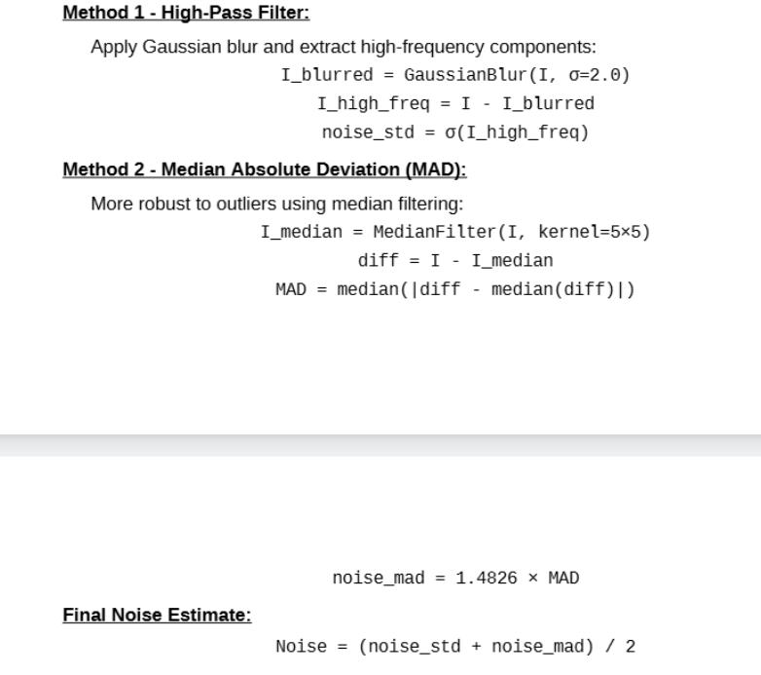

3.3 Gradient-Based Sharpness
Purpose: Measures local intensity changes using Sobel operators for edge detection.
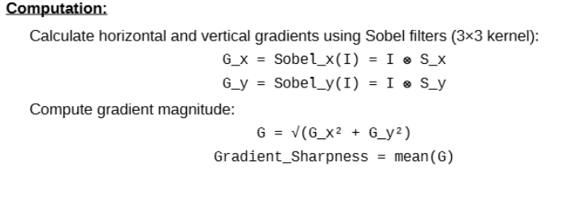

3.4 Laplacian Variance (Focus Measure)
Purpose: Measures image focus quality by detecting second-order derivatives (edges and details).

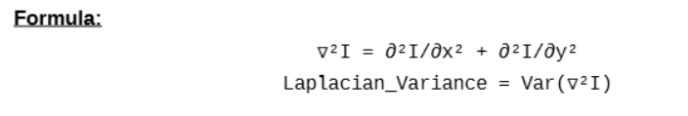3.5 Edge Density
Purpose: Quantifies the proportion of edge pixels using Canny edge detection.

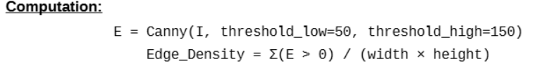3.6 Texture Complexity Score
Purpose: Measures local intensity variations to assess texture richness.

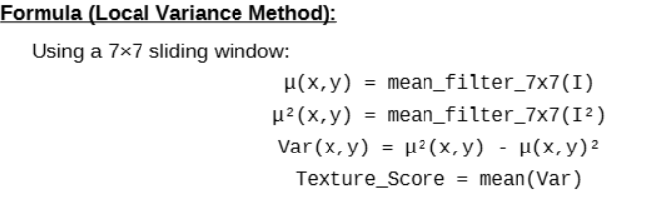3.7 Acutance (Perceived Sharpness)
Purpose: Measures perceived sharpness through gradient-based edge transitions.

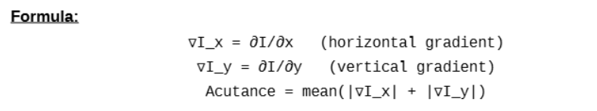

3.8 RMS Contrast
Purpose: Quantifies overall image contrast using root mean square deviation.

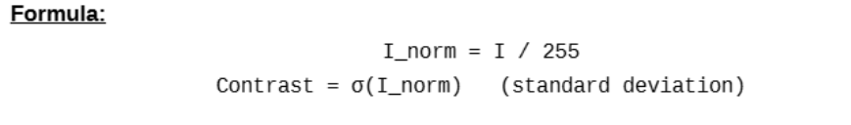4. IMAGE ENHANCEMENT TECHNIQUES

4.1 Unsharp Masking
Purpose: Enhances edges and fine details by subtracting a blurred version from the original.

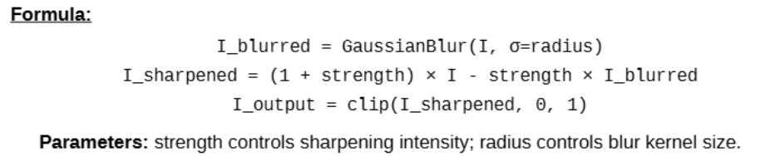4.2 High-Pass Filter Sharpening
Purpose: Isolates and amplifies high-frequency components (edges and textures).

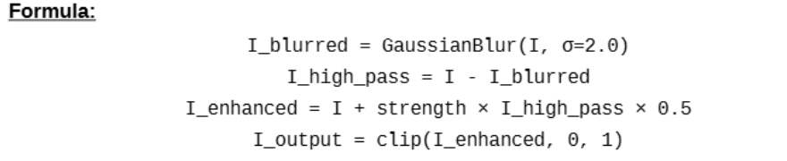4.3 CLAHE (Contrast Limited Adaptive Histogram Equalization)
Purpose: Enhances local contrast while preventing over-amplification of noise.
Algorithm:
- Convert RGB to LAB color space
- Apply CLAHE to L-channel with clip_limit and 8×8 tile grid
- Convert back to RGB color space
Parameters: clip_limit (1.5-3.0) controls contrast enhancement strength; higher values increase local contrast.

5. OPTIMAL QUALITY LEVEL SELECTION

5.1 Weighted Metric Optimization

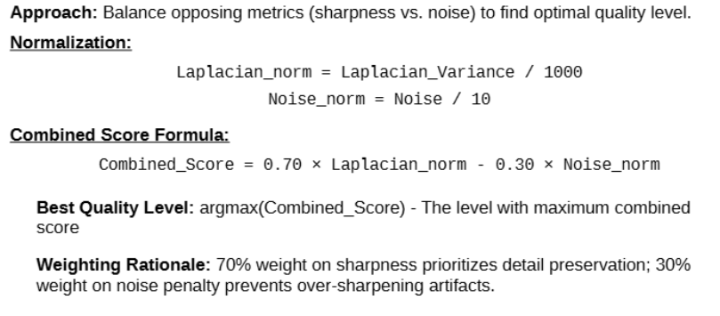6. SYSTEM OUTPUTS
6.1 Generated Files
- Enhanced Images: level_01.png through level_10.png (10 progressive quality levels)
- Metrics Data: metrics.csv (tabular format for analysis)
- ML-Ready Data: metrics.json (includes ground truth and best level for training)
- Visualizations: metrics_comparison.png (9 metric plots) and visual_comparison.png (side-by-side quality levels)
6.2 Metrics Output Structure
Each quality level includes the following 10 metrics:
- MTF50, Noise, Gradient_Sharpness, Laplacian_Variance
- Edge_Density, Texture_Score, Acutance
- Sharpness_Quality, Contrast, Combined_Score

7. PROCESSING PIPELINE
7.1 Pipeline Overview
The DNG Quality Level Detection System follows a structured pipeline that processes RAW images through multiple stages, from initial loading to final quality assessment and output generation. The pipeline is designed to be automated, reproducible, and scalable for batch processing of multiple DNG files.
7.2 Pipeline Stages
Stage 1: DNG Loading and Preprocessing
- Input: RAW DNG file from camera or processing software
- Process: Load DNG using rawpy library with camera white balance and standard sRGB gamma (2.222, 4.5)
- Output: Base RGB image normalized to [0, 1] float32 range
- Key Parameters: use_camera_wb=True, no_auto_bright=True, output_bps=8
Stage 2: Progressive Quality Level Generation
- Input: Base image from Stage 1
- Process: Generate 10 progressive enhancement levels using combinations of:
→ Unsharp masking with varying strength (0.2 to 1.5) and radius (0.8 to 1.5)
→ CLAHE for local contrast enhancement (clip limit: 1.5 to 3.0)
→ High-pass filtering for detail enhancement
- Output: 10 enhanced images (level_1 to level_10) stored in memory
Stage 3: Comprehensive Metrics Calculation
- Input: All 10 quality levels from Stage 2
- Process: For each level, calculate 9 metrics in parallel:
1. MTF50 (spatial frequency analysis)
2. Noise Level (dual-method estimation)
3. Gradient Sharpness (Sobel-based)
4. Laplacian Variance (focus measure)
5. Edge Density (Canny detection)
6. Texture Score (local variance)
7. Acutance (perceived sharpness)
8. Sharpness Quality (artifact detection)
9. Contrast (RMS measurement)
- Output: Metrics dictionary with 10 entries (one per level), each containing all 9 metrics plus combined score
Stage 4: Optimal Level Selection
- Input: Metrics from Stage 3
- Process: Calculate combined score for each level using weighted formula:
Score = 0.70 × (Laplacian/1000) - 0.30 × (Noise/10)
- Output: Best quality level = argmax(Score)
Stage 5: Results Export and Visualization
- Input: Enhanced images and metrics from previous stages
- Process: Generate multiple output formats:
→ Save 10 enhanced PNG images (level_01.png to level_10.png)
→ Export metrics to CSV for spreadsheet analysis
→ Generate JSON with ML-ready structure (includes best level)
→ Create metrics comparison plot (9 subplots showing metric trends)
→ Generate visual comparison grid with scores overlay
- Output: Complete results package in output directory
7.3 Pipeline Execution Flow
The pipeline executes in the following sequence:
DNG File → Load & Preprocess → Generate 10 Levels → Calculate Metrics → Select Best Level → Export Results
Each stage depends on the successful completion of the previous stage, ensuring data integrity and consistency throughout the processing workflow.
7.4 Batch Processing Capability
The pipeline is designed for easy batch processing of multiple DNG files. By wrapping the main execution in a loop, the system can process entire directories of RAW images, generating consistent quality assessments across large datasets. Each DNG file is processed independently, with results saved to separate subdirectories for organized output management.
The modular design allows for parallel processing of multiple files on multi-core systems, significantly reducing total processing time for large image collections.

8. CONCLUSION
This system provides a comprehensive framework for analyzing and classifying DNG image quality levels through rigorous mathematical metrics and progressive enhancement techniques. The weighted metric optimization method enables automated selection of optimal quality levels by balancing sharpness enhancement with noise control, making the system adaptable to various use cases in computational photography and machine learning applications.
The combination of 9 complementary metrics—ranging from spatial frequency analysis (MTF50) to perceptual sharpness (Acutance)—ensures robust quality assessment across diverse imaging scenarios. The progressive enhancement pipeline balances detail preservation with artifact prevention, making it suitable for training classification models on RAW image processing.
By utilizing a 70-30 weighted score that prioritizes sharpness while penalizing excessive noise, the system objectively identifies the optimal enhancement level from 10 progressive quality stages. This approach eliminates the need for manual reference images and provides consistent, reproducible results across different DNG files and imaging conditions.

