Assignment 1 Krish(102303470)

Question 1 DAXPY Loop

Inference
The results show a solid scaling trend that peaks at 13 threads with a 2.73x speedup, but performance falls off a cliff once you cross 16 threads. By the time you hit 20 threads, execution time skyrockets, making the code nearly 12 times slower than the single-threaded version. This "performance crash" happens because you've likely exceeded the system's physical core count, forcing the CPU into constant context switching and cache thrashing. Since DAXPY is memory-bound, adding more threads just creates a traffic jam on the memory bus rather than processing data faster. Essentially, the overhead of managing 20+ threads for such a tiny task completely swallows any benefit of parallel execution.
Result

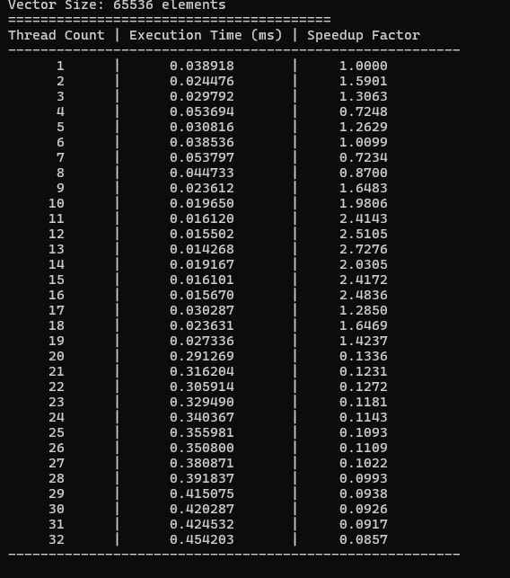

Graph

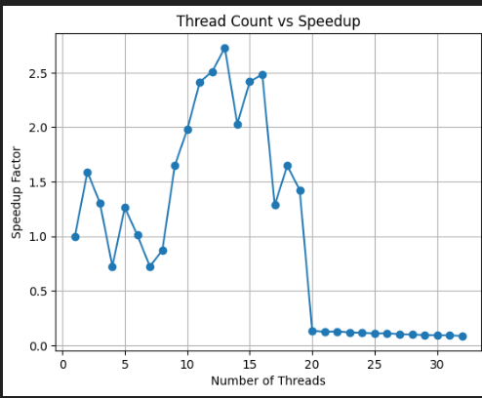
Question 2 Matrix Multiplication

Inference
In Approach 1, where a critical section is used to update the global sum, speedup increases steadily with the number of threads and reaches a maximum of about 8.02× at 32 threads. However, efficiency continuously decreases as threads increase because all threads must wait to enter the critical section, leading to serialization and synchronization overhead. While the computed value of π remains accurate for all thread counts with very small numerical error, the critical section becomes a performance bottleneck at higher threads, limiting scalability despite the increase in speedup.

In Approach 2, which uses the OpenMP reduction clause, speedup increases smoothly with the number of threads and reaches a maximum of about 8.38× at 31 threads. Compared to the critical section method, reduction provides better scalability because thread-local sums are combined efficiently without explicit synchronization. Although efficiency decreases as thread count increases due to overhead and hardware limits, the reduction approach avoids the major bottleneck seen in critical sections. The computed value of π remains accurate across all thread counts with very small

Result
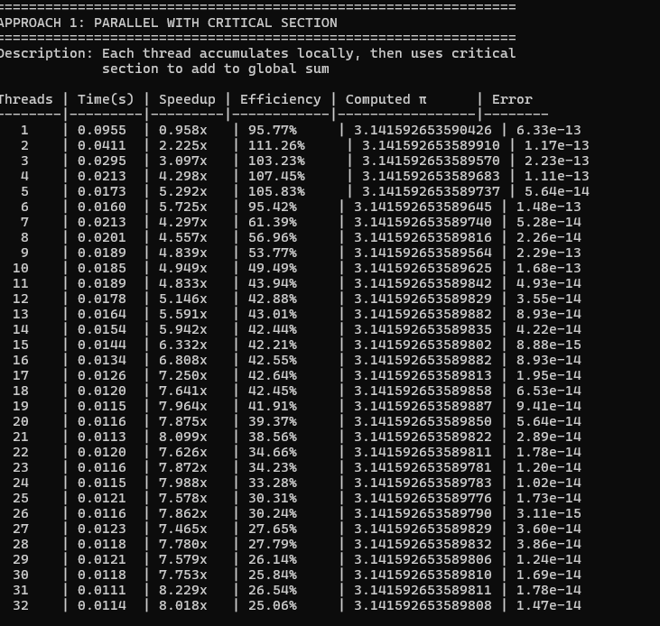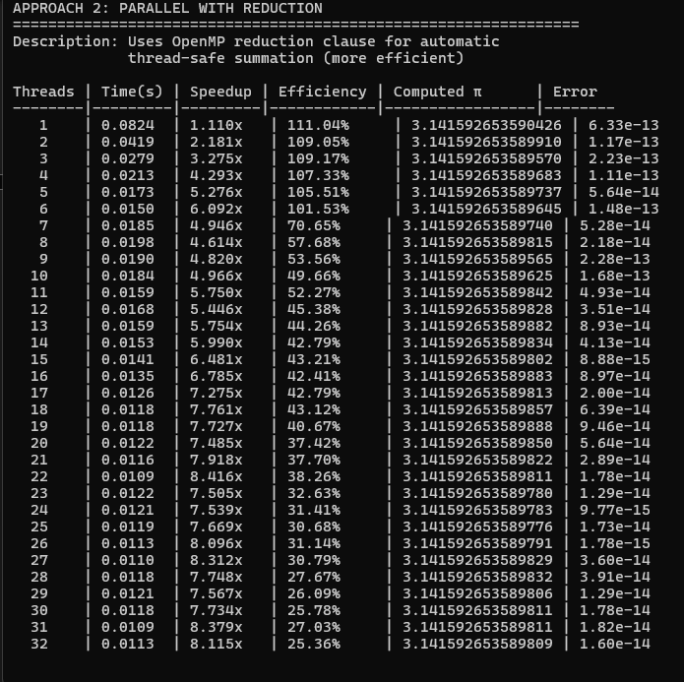

Graph

Approach 1->
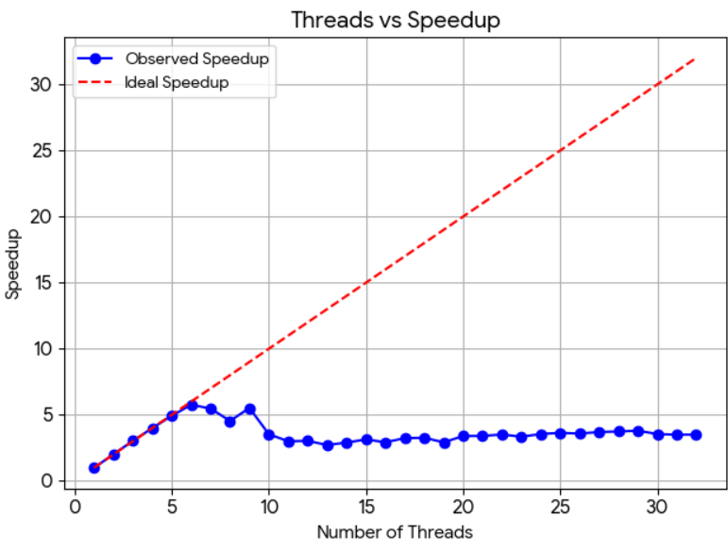

Approach 2->
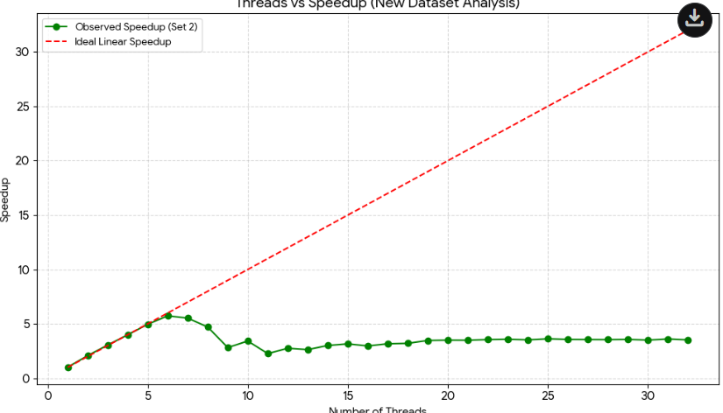

Question 3 (Calculation of π)
Inference
Using the sequential execution as the baseline, the parallel π computation shows steady improvement in performance as the number of threads increases. Speedup rises consistently and reaches a maximum of about 8.15× at 32 threads, while the efficiency gradually decreases due to parallel overhead and hardware limitations. Despite the drop in efficiency at higher thread counts, the execution time continues to reduce compared to the sequential case, and the computed value of π remains accurate for all thread counts with negligible error. This confirms effective parallelization, with diminishing returns beyond a certain number of threads.

Result
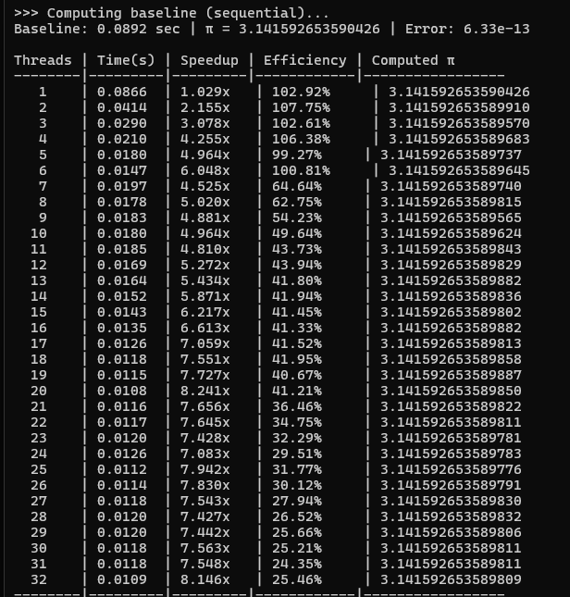

Graph
