Assignment 2 Krish(102303470)

Question 1 Molecular Dynamics – Lennard-Jones
Inference
The results show that the Lennard–Jones molecular dynamics code benefits from parallel execution, but with diminishing returns as thread count increases. Runtime decreases from 0.0029 s (1 thread) to 0.00112 s (8 threads), giving a maximum speedup of about 2.6×, while efficiency drops sharply from 100% to 32.5%, indicating overheads such as thread management and memory contention. This suggests the workload is not scaling linearly, likely due to shared-memory effects and limited parallelism in force calculations. The perf statistics reinforce this: a high instructions-per-cycle value (≈3–4 IPC) indicates good computational intensity, but a significant cache miss rate (≈28–50% of cache references) points to memory access as a bottleneck that limits scaling. Overall, the main trend is that parallelism improves performance initially, but memory behavior and overheads dominate beyond a few threads, constraining achievable speedup.

Result

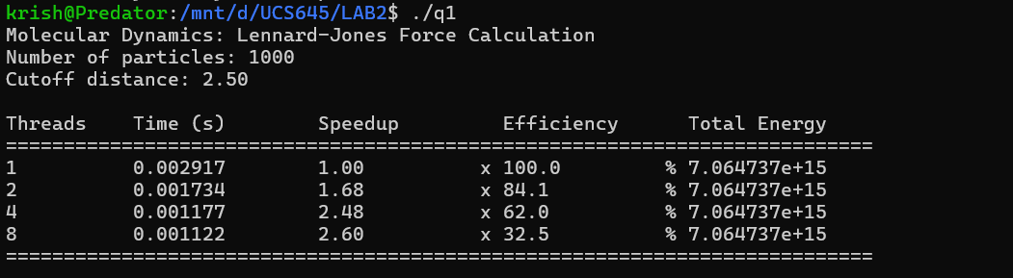
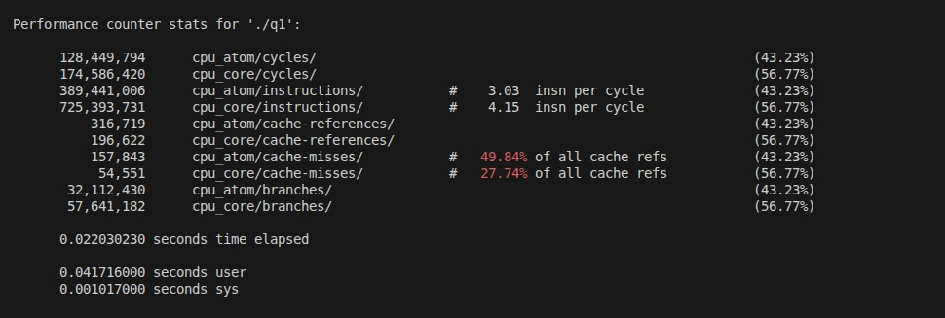

Graph
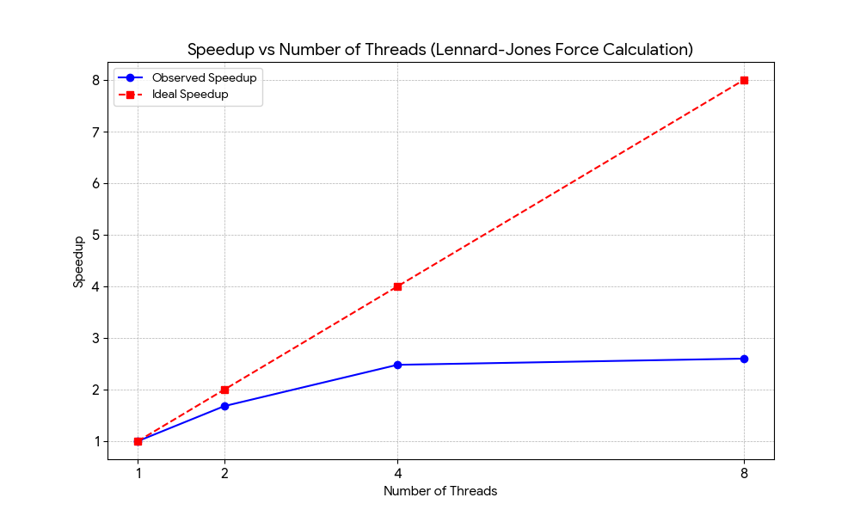

Question 2 Smith–Waterman

Inference
The DNA sequence alignment results show that parallel performance strongly depends on how data dependencies are handled. In the wavefront (anti-diagonal) approach, speedup improves from 1.0 to about 1.7× at 2–8 threads, but efficiency drops steadily, reflecting limited parallel work per anti-diagonal and increasing synchronization overhead as threads increase. In contrast, row-wise parallelization performs well up to 2–4 threads, reaching a higher speedup of about 2.7×, but collapses at 8 threads where performance becomes worse than serial, indicating severe dependency and scheduling overheads. The perf statistics support this behavior: relatively low IPC (≈1–1.5) shows the code is memory and dependency bound rather than compute-heavy, while low cache miss rates (~5–6%) indicate that data locality is good and not the primary bottleneck. Overall, the main trend is that algorithmic dependencies, not cache behavior, dominate scalability, making moderate thread counts effective while higher parallelism yields diminishing or negative returns.

Result
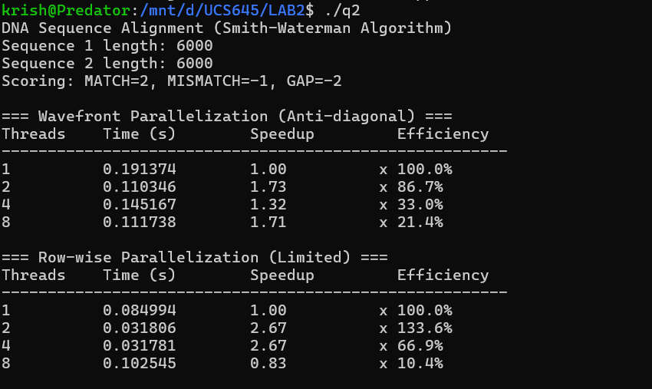
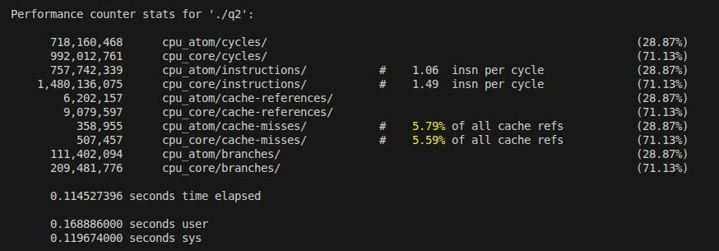

Graph
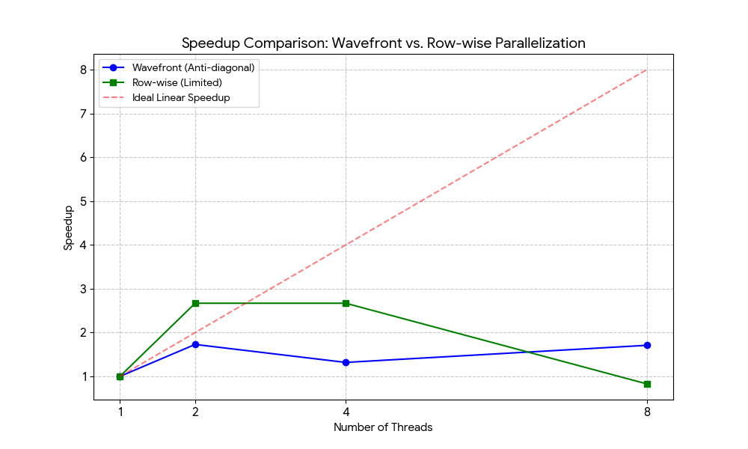

Question 3 2D Heat Diffusion Simulation

Inference
The heat diffusion experiment shows that scheduling policy has a strong impact on scalability for a regular, memory-intensive stencil computation. Static scheduling performs best at low thread counts, reaching a peak speedup of about 2.85× at 4 threads, but collapses at 8 threads where overhead and memory contention dominate, leading to sub-serial performance. Dynamic and guided scheduling introduce additional scheduling overhead; they scale more smoothly up to 4 threads but never outperform static scheduling, confirming that load imbalance is not the main issue for this uniform grid computation. Across all cases, the average temperature remains constant, validating numerical correctness. The perf results show high IPC values (≈3–4) and very low cache miss rates (<3%), indicating good cache locality and that the computation is efficient at the core level. Overall, the main trend is that the application is compute-heavy with good locality, but limited by memory bandwidth and threading overhead beyond moderate parallelism, making 2–4 threads the optimal operating point.
Result
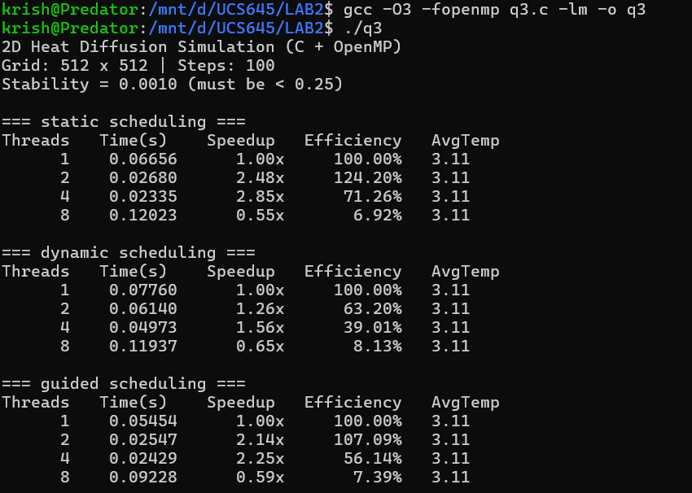

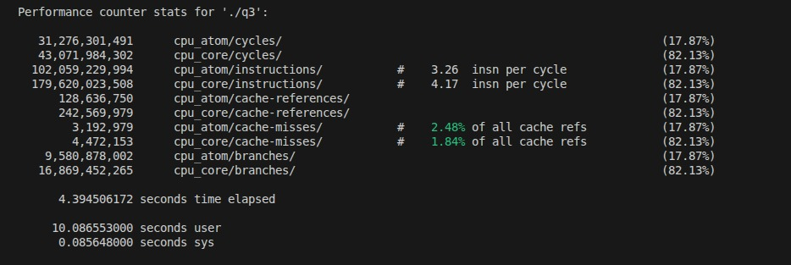

Graph

