

UNITREE GO2 EDU.

MAINTENANCE & TECHNICAL SERVICE REPORT

Company / Organization: Botbruz

Robo Dog Source / Origin: ADITYA’S Aquarium VANTARA

Robo Dog Model / Asset ID: Unitree Go2 Edu.

Date Received: 27/08/2026

Maintenance Performed By: Mr. Kushal Soni (Technician)

Reviewed / Approved By: Mr. Shubham Nemade (Supervisor)

Contents
1.0 Introduction 4
1.1 Purpose 4
1.2 Scope of Report 4
2.0 Unitree Go2 Edu. Unit Information 5
2.1 Unit Identification 5
2.2 Origin / Source Facility 5
2.3 Technical Specifications 5
2.4 Maintenance Provider Information 6
3.0 Corrective Maintenance Report 7
3.2 Problem Identified 7
3.3 Diagnostic Approach / Steps Taken 8
3.4 Solution Implementing 8
3.5 Parts & Materials Used 9
3.6 Complexities / Challenges Faced 9
3.7 Testing & Verification 9
3.9 Cost Summary 10

1.0 Introduction

1.1 Purpose
This report documents the corrective and preventive maintenance activities carried out on the Unitree Go2 (Edu Version) Robotic Canine Unit ("Robo-Dog") by BOTBRUZ. It captures the origin of the unit, the reported operational or hardware issues, the systematic diagnostic approach followed by the maintenance technicians, the resolution procedures implemented, the technical complexities encountered during servicing, and the final associated repair cost breakdown.

1.2 Scope of Report

Problem & Fault Diagnostics: Documenting reported fault conditions, error log entries, head LED indicator status codes, and abnormal sensor/joint behaviour.

Maintenance & Repair Execution: Detailed technical breakdown of hardware repairs, 12-DOF joint motor recalibrations, 4D LiDAR L1/optical cleaning, and firmware or SDK/API environment updates.

Servicing Complexities: Technical challenges encountered during servicing, such as high-density joint disassembly, IMU zero-point adjustments, or Edu-specific payload interface integration.

Financial & Resource Summary: Complete itemized cost breakdown of parts, labour hours, and overall maintenance expenditure.

2.0 Unitree Go2 Edu. Unit Information

2.1 Unit Identification
This section captures identifying details of the Robo-Dog unit undergoing maintenance.
Field | Details
Model / Variant | Unitree Go2 Edu Version
Manufacturer | Unitree Robotics
Firmware / Software Version | V1.0.4 / SDK 2.0
Client / Owning Facility | ADITYA’S Aquarium VANTARA
Assigned Operational Site | Field Testing Unit / Lab Deployment
Date Received for Maintenance | 27/08/2026

2.2 Origin / Source Facility
Details describing where the Robo-Dog unit came from prior to arriving at BOTBRUZ for maintenance are captured below.
Field | Details
Country / Region of Origin | India
Sending Facility / Site Name | ADITYA’S Aquarium VANTARA
Point of Contact at Sending Facility | Operations Lead
Condition on Arrival | Physical intact chassis; operational degradation in locomotion & 4D LiDAR rotation
Accompanying Documents | Maintenance Work Order & Intake Diagnostic Form

2.3 Technical Specifications
Specification | Value
Degrees of Freedom (Legs/Joints) | 12-DOF (12 High-Torque Aluminium Alloy Precision Motors)
Sensor Suite (LiDAR/Camera/IMU) | Unitree 4D LiDAR L1 (${360}^{∘}×{90}^{∘}$), Wide-Angle HD Front Camera, Foot Force Sensors, IMU
Onboard Computer / Processor | Secondary Development Board Support (Nvidia Jetson / Custom Compute Node)
Communication Module | Wi-Fi 6, Bluetooth, 4G / eSIM, Remote Controller Link
Ingress Protection (IP) Rating | Indoor / Dry Surface Operational Class (Non-Waterproof/Non-Dustproof)

2.4 Maintenance Provider Information
Details of the BOTBRUZ personnel who performed the maintenance work reported herein.
Field | Details
Maintenance Technician Name | Mr. Kushal Soni
BOTBRUZ Service Centre Location | Botbruz labs, HQ8R+GQ6, Adarsh Nagar, Vinayak Nagar, Pimple Nilakh, Pimpri-Chinchwad, Maharashtra 411027
Supervisor Manager | Mr. Shubham Nemade
Contact Number | 80553 33779
Email | botbruzrobotics@gmail.com

3.0 Corrective Maintenance Report
This section is the core maintenance record and documents the fault reported on the Robo-Dog unit, the technical description, root cause, resolution approach, and associated cost.

3.1Description of the Robo-Dog Condition

At intake, the Unitree Go2 Edu exhibited significant posture instability during start-up, leading to dynamic drift during forward walking gait. Mechanical squeaking and elevated noise were observed across both front leg assemblies (hip and knee actuators). Additionally, the top-mounted 4D LiDAR L1 module suffered from physical rotational friction, occasionally triggering perception system fault alarms. The outer chassis vinyl wrap showed severe wear, and internal cooling fan vents accumulated thermal dust buildup

3.2 Problem Identified

Problem

IMU Recalibration: Executed software-level calculation and dynamic zeroing to fix posture instability and gait drift.

Front Leg Maintenance: Disassembled, realigned, inspected, and re-torqued both Left Front and Right Front leg actuators.

4D LiDAR Servicing: De-rusted housing and applied protective thermal coating paint. Cleared internal debris and visors from the rotating assembly to resolve operational noise. Repaired the drive mechanism and optical housing, fully eliminating rotational binding and perception errors for smooth, unhindered rotation.

Chemical Decontamination: Deep-cleaned joint contacts using NSF-certified WD-40 Specialist Electrical Contact Cleaner.

Precision Lubrication: Applied high-temperature synthetic silicone grease to all moving joint pivots and bearings.

Vinyl Wrap Replacement: Replaced worn external body film with a new chassis protection wrap.

Cooling System Maintenance: Flushed and cleaned internal fan vents and ducts to restore nominal thermal regulation.

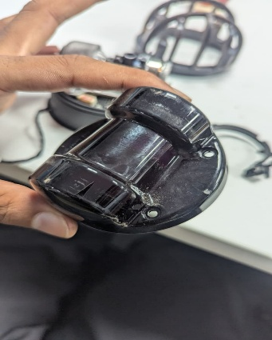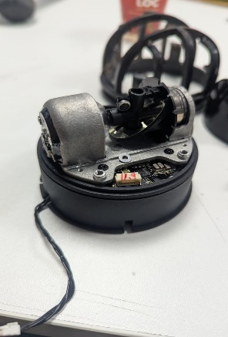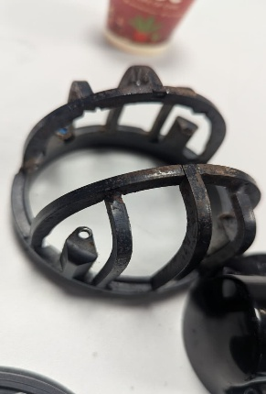

Condition of Lidar Before maintenance

Suspected / Confirmed Root Cause
Extended field deployment led to joint friction, debris accumulation in thermal ducts, mechanical misalignment in both front leg assemblies, and IMU zero-point shift

3.3 Diagnostic Approach / Steps Taken
- Step 1: Performed system boot telemetry check and error log analysis via the Unitree Go App interface.
- Step 2: Conducted physical teardown and visual inspection of front left and front right leg actuation assemblies
- Step 3: Executed rotational torque testing on the 4D LiDAR L1 head to isolate mechanical resistance
- Step 4: Ran full thermal and IMU diagnostic routines under static and dynamic gait load

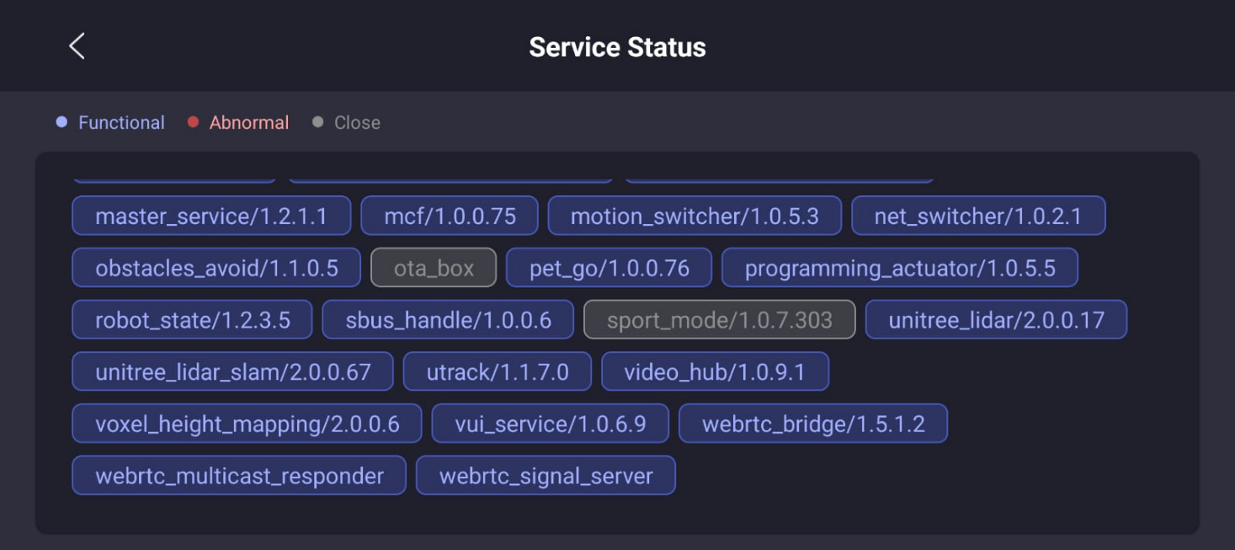
Diagnostic Test Readout (Unitree Go App Service Status)

3.4 Solution Implementing

IMU Recalibration: Performed complete zero-point software calculation and dynamic gait balancing.

4D LiDAR Repair: Serviced rotational drive mechanism to eliminate mechanical friction and clear optical path alerts.

Front Leg Assembly Overhaul: Conducted mechanical maintenance, teardown, alignment, and re-torquing for both Front-Left and Front-Right leg actuators.

Chemical Decontamination: Deep-cleaned joints and frame contacts using WD-40 Specialist Electrical Contact Cleaner.

Precision Lubrication: Applied high-temperature synthetic silicone grease to all pivot points, bearings, and moving joint interfaces.

Thermal System Servicing: Executed full cleaning and maintenance on internal cooling fan vents and heat conduits.

Chassis Protection Refresh: Replaced worn body vinyl wraps with new protective film.

3.5 Parts & Materials Used
Part # | Description | Manufacturer | Qty | Replacement Needed
BOT-PT-01 | WD-40 Precision Cleaner | Chemical Spec | 1 Unit | Consumable
BOT-PT-02 | Chassis Vinyl Protection Wrap Kit | BOTBRUZ | 1 Set | Yes
BOT-PT-03 | Front Leg Actuator Bearing & Fasteners Set | Unitree Robotics | - | Yes
BOT-PT-04 | High-Grade Thermal & Mechanical Silicone Grease | Chemical Spec | - | Consumable

3.6 Complexities / Challenges Faced
- Technical Complexity: Re-aligning the high-density joint actuators on both front legs while maintaining tight torque tolerances to ensure identical power delivery across both sides.
- Parts Availability / Logistics Complexity: Sourcing authentic Unitree mechanical tolerance components without causing project turnaround delays.
- Diagnostic Complexity: Isolating whether gait drift was caused purely by IMU calibration or physical gear backlash in the hip/knee joint assemblies.

3.7 Testing & Verification
Describe the post-repair functional tests performed to confirm the unit is fully operational
Test Performed: Full multi-gait verification suite (Prone-to-Stand, Flat Trot, 100m Distance Run, Obstacle Avoidance Scan, and Slope/Stair Navigation Test)
Test Result: PASSED. Robot achieved 100% operational balance, smooth locomotion without motor whine, zero LiDAR fault errors, and nominal thermal regulation.

3.8 References
- Unitree Robotics, Unitree Go2 Series User Manual & Operation Guide (V1.0.4), Hangzhou YuShu Technology Co., Ltd., 2024.
- Unitree Robotics, Unitree SDK 2.0 & Secondary Development Documentation, Official Developer Resources.
- Unitree Robotics, 4D LiDAR L1 Hardware Integration & Maintenance Specifications, 2023.
- WD-40 Company, Safety Data Sheet (SDS) & Technical Data Sheet: WD-40 Specialist Electrical Contact Cleaner, NSF Certified.
- ISO/TS 15066:2016 / ISO 10218-1, Robots and Robotic Devices — Safety Requirements for Industrial & Service Robots

3.9 Cost Summary
Breakdown of the total cost incurred for this maintenance activity.
Cost Head | Amount
Service Charges | _______________ ₹ 8,500 ___
Component Maintenance & Refurbishment | _______________ ₹ 3,500________
Diagnostic / Testing Charges | _______________ ₹ 3,800 ______
Consumables | _______________ ₹ 1,500 _____
Total Cost (Ext. GST) | ₹ 17,300
Transportation | _______________ -______

Note: All maintenance activities, spare parts utilization, and service charges detailed in this report have been executed in compliance with the approved Purchase Order (PO) terms. Final invoicing and technical sign-off have been submitted for processing and administrative settlement.

