Tittle:Analysis of the World Happiness Report:Exploring South Asia and Middle East Perspectives
Course:5CS037 – Concepts and Technologies of AI

- Introduction

Happiness plays a crucial role in our lives, often defined as a state of joy and satisfaction. Recent research highlights that personal happiness not only influences individuals but also affects the wider community. By examining the factors that contribute to happiness, we can develop strategies that promote overall well-being.

This paper will explore how acts of kindness can enhance happiness. It will discuss the positive effects of caring behaviors on individual joy and life satisfaction. Drawing on data from various studies, including insights from the Gallup World Poll, the aim is to reveal how caring actions correlate with happiness.

The structure of this paper will begin with an overview of current literature on happiness alongside the significance of caring behaviors. Following this, the methodology used for data collection and analysis will be described. Finally, the discussion will interpret the results and consider their implications for understanding happiness worldwide, while also acknowledging any limitations faced during the research process

Problem – 1
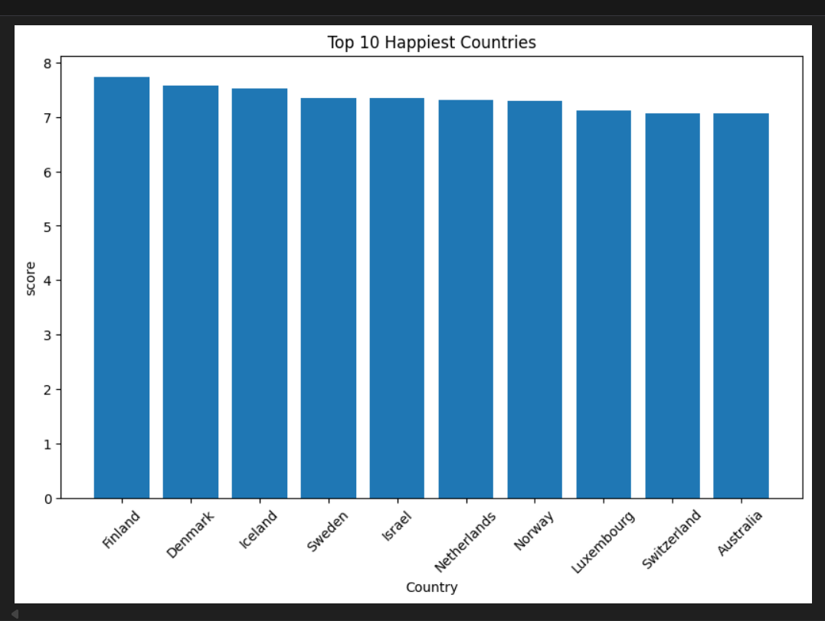

Bar plot

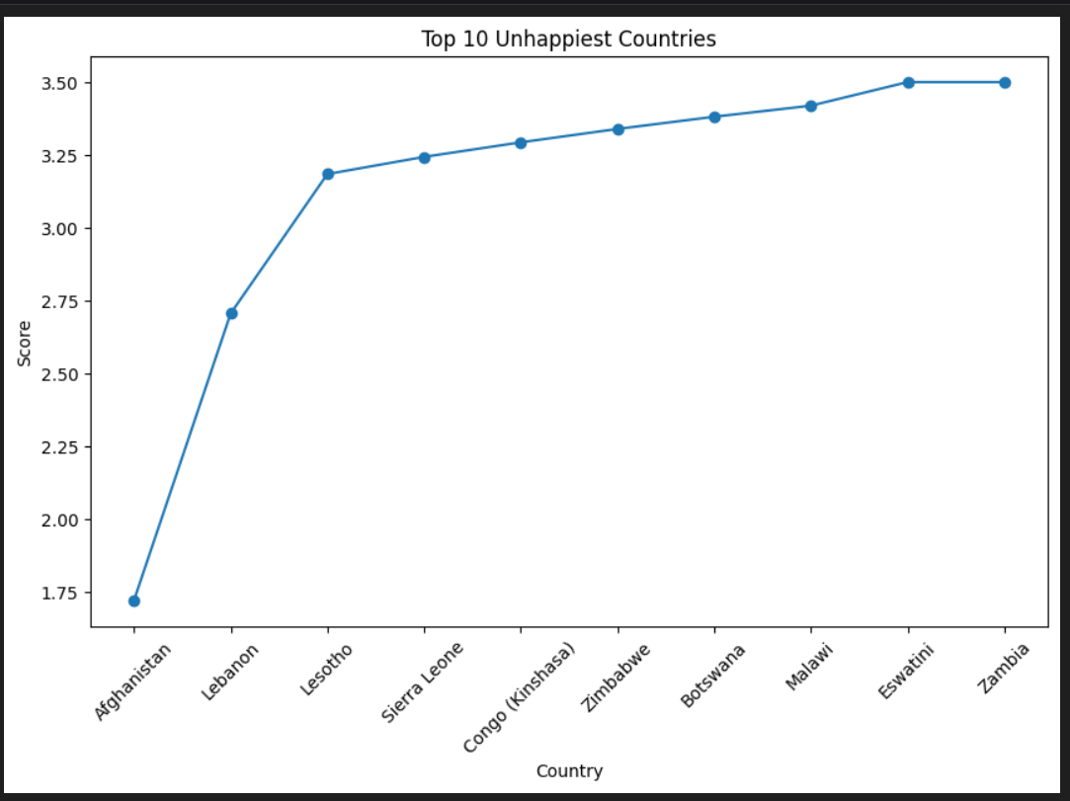

Line plot

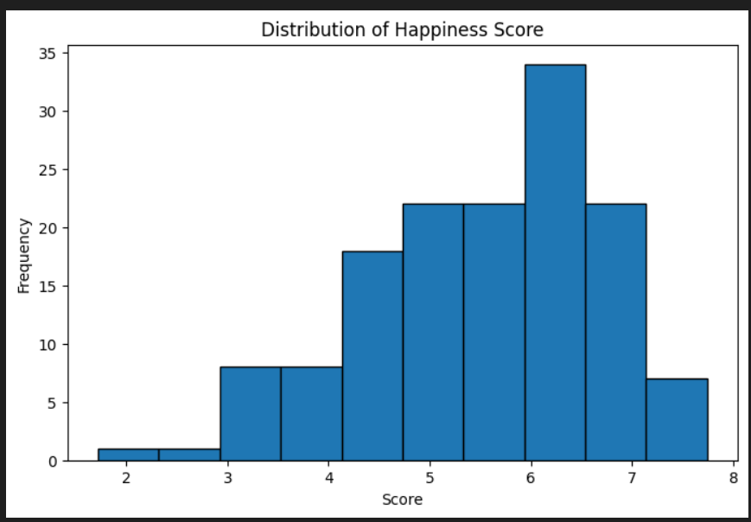

Histogram plot

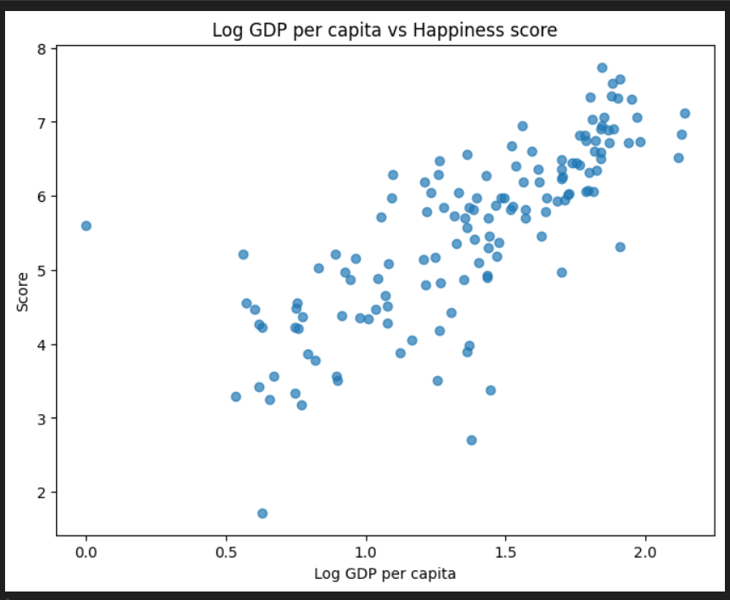

Scatter plot

I have inspected the dataset ( from the first 10rows)and I have calculated the
mean, median and standard deviation of the Score.The highest Scoring country
was X (Score Y) and the lowest scoring country was Z(score W). I have categorized
countries into Low/Medium/High and also I have created a bar plot,line plot
histogram plot,Scatter plots to visualize the patterns.

Problem – 2
I have filtered South Asian countries and created a Composite Score
(0.4*GDP + 0.3*Social + 0.3*Healthy) and ranked the Countries. I have
Used 1.5*IQR to detect outliers and calculated the correlations
between the Score and Freedom/Generosity And I have also computed
GDP-Score gaps to identify the mismatches between the wealth and
happiness.

Problem – 3
I have prepared a Middle East dataset and compared to
means,variability,top/bottom performers,and metric means between
the regions .BoxPlots and grouped bar charts illustrate the differences
and show which metrices vary most.

