Symbiosis Institute of Technology, Nagpur
Predictive Analytics – CA3 Project Report
RAINFALL PREDICTION USING MACHINE LEARNING
An End-to-End Predictive Analytics Approach Based on the KDD Process
Submitted by
Krish Dahake
PRN: 23070521076
Programme: B.Tech Computer Science
Course: Predictive Analytics
Assessment: CA3 – End-to-End Predictive Model Development
12 October 2026

Abstract
Accurate next-day rainfall forecasting supports agriculture, water management and weather-related planning. This project builds an end-to-end predictive model that classifies whether it will rain tomorrow (RainTomorrow = Yes/No) using the public weatherAUS dataset of about 145,000 daily observations from weather stations across Australia. The work follows the Knowledge Discovery in Databases (KDD) process: business understanding, data selection, data understanding, cleaning and preprocessing, transformation and feature engineering, data mining, and evaluation and knowledge presentation.
Preprocessing is built with scikit-learn Pipelines and a ColumnTransformer so that imputation, scaling and encoding are fitted on training data only. A chronological split by unique dates (first 80% of dates for training, the rest for testing) is used instead of a random split to mimic real forecasting. Three models were compared: a majority-class baseline, a class-weighted Logistic Regression and a class-weighted Random Forest. The Random Forest achieved the highest accuracy (0.847) and rain precision (0.767) but detected only 43.7% of rainy days. Logistic Regression achieved the best rain F1-score (0.612) with a rain recall of 0.736. A short location-based prediction demonstration is also included. The majority-class baseline reached 0.781 accuracy while detecting no rain at all. The results show that on imbalanced weather data, accuracy alone is misleading and models must be judged on rain-class recall and F1-score.
Keywords: rainfall prediction, KDD, Random Forest, Logistic Regression, class imbalance, scikit-learn pipeline

1. Introduction

1.1 Background
Rainfall strongly affects daily and economic activity. Farmers schedule sowing, irrigation and harvesting around it. Utilities and city authorities manage reservoirs and drainage, airlines plan operations, and emergency services prepare for floods. Conventional forecasting relies on numerical weather prediction (NWP), which solves physical equations of the atmosphere on supercomputers. NWP is powerful but computationally expensive. Machine learning offers a complementary, data-driven approach that learns the relationship between today's observations and tomorrow's weather directly from historical records, at very low computational cost once trained.

1.2 Problem Statement
Given daily meteorological measurements recorded at stations across Australia, predict whether it will rain tomorrow (RainTomorrow = Yes or No) reliably, without data leakage, and while accounting for the fact that rainy days are much rarer than dry days.

1.3 Aim and Objectives
The aim is to design, evaluate and demonstrate an end-to-end predictive pipeline for next-day rain forecasting following the KDD process. The specific objectives are:
- To explore the dataset and examine the class balance and the relationship between afternoon humidity and next-day rain.
- To clean and transform the data using pipelines fitted on training data only, preventing data leakage.
- To evaluate models with a chronological split that reflects real forecasting conditions.
- To train and compare a baseline, Logistic Regression and Random Forest, using class weighting to handle imbalance.
- To interpret the results using accuracy, rain precision, rain recall, rain F1-score and confusion matrices.
- To demonstrate the selected model by predicting rain for the day after the latest observation at a chosen location.

1.4 Research Questions
- Is the rain / no-rain target imbalanced, and how does this affect model evaluation?
- Can a machine learning model clearly outperform a simple majority-class baseline?
- Which model, Logistic Regression or Random Forest, gives the better balance of detecting rainy days and limiting false alarms?

1.5 Scope and Significance
The project covers binary next-day rain classification using station-level daily observations. It does not attempt rainfall amount prediction, multi-day forecasting or the use of satellite and radar data. The significance lies in showing a complete, reproducible and leakage-aware workflow that can be extended.

2. Literature Review

2.1 Weather Forecasting and Numerical Weather Prediction
Bauer, Thorpe and Brunet [1] describe how NWP has improved steadily over decades through better physics, observations and computing power, yet remains computationally demanding and limited in predictability over longer horizons. This cost and complexity motivates statistical and machine learning approaches that can produce fast, localised forecasts from historical data.

2.2 Machine Learning for Precipitation Prediction
Machine learning has been applied to rainfall prediction using classical models and, more recently, deep learning. Ravuri et al. [9] showed that deep generative models trained on radar data can produce skilful short-term precipitation nowcasts, demonstrating the potential of data-driven methods in this domain. For tabular station data such as that used here, tree ensembles and regularised linear models remain strong, interpretable and inexpensive choices [5].

2.3 Logistic Regression and Random Forests
Logistic Regression models the log-odds of a binary outcome as a linear function of the predictors and yields interpretable probabilities [7]. Random Forests, introduced by Breiman [2], build many decorrelated decision trees on bootstrap samples and average their votes. They capture non-linear relationships and feature interactions and tolerate mixed feature types, which makes them well suited to meteorological variables such as humidity, pressure and wind.

2.4 Class Imbalance
In rainfall data, dry days far outnumber wet days. He and Garcia [6] review the consequences: classifiers optimised for accuracy tend to favour the majority class and under-detect the minority class. Remedies include resampling methods such as SMOTE [3], cost-sensitive learning through class weights, and adjusting the decision threshold. Saito and Rehmsmeier [10] argue that precision-recall based measures are more informative than ROC analysis on imbalanced data, which supports the use of rain-class precision, recall and F1-score in this project.

2.5 Temporal Validation
Weather data are time-ordered, so a random train/test split lets the model see the future during training. Tashman [11] discusses out-of-sample evaluation for forecasting and the importance of testing on data that come after the training period. This project therefore uses a chronological split.

2.6 The KDD Process
Fayyad, Piatetsky-Shapiro and Smyth [4] define KDD as a multi-stage process covering selection, preprocessing, transformation, data mining and interpretation of patterns. This project is organised around these stages.

2.7 Research Gap Addressed
Many student and tutorial implementations on this dataset use random splits, fit imputers and scalers on the full dataset, and report accuracy alone, which can overstate performance. This project addresses these issues through a chronological split, pipeline-based preprocessing, class weighting, and evaluation using precision, recall, F1-score and confusion matrices.

3. Workflow / Predictive Modelling Process
The workflow follows the seven KDD stages implemented in the Jupyter Notebook (Figure 1).
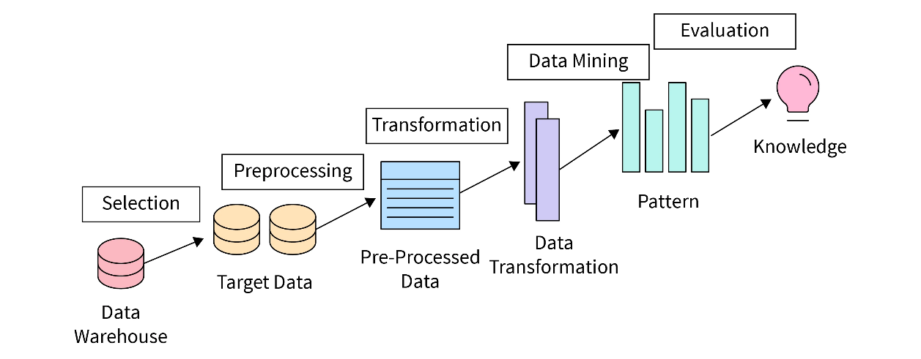
Figure 1: KDD workflow

3.1 Stage 1: Business Understanding
The goal is to forecast next-day rain to support agriculture, water management and weather-related planning. The target is binary (Yes = rain tomorrow, No = no rain tomorrow), so this is a supervised classification task. Because missing a rainy day is generally more costly than a false alarm, recall on the rain class is an important criterion alongside F1-score.

3.2 Stage 2: Data Selection
The dataset is weatherAUS.csv (Rain in Australia) [12], containing roughly ten years of daily observations from many Australian locations, compiled from Australian Bureau of Meteorology records. It has 145,460 rows and 23 columns. The target column is RainTomorrow, and Date is used to preserve chronological order. The features include location, minimum and maximum temperature, rainfall, evaporation, sunshine, wind gust and wind direction and speed at 9 am and 3 pm, humidity, pressure, cloud cover, temperature at 9 am and 3 pm, and RainToday.

3.3 Stage 3: Data Understanding (EDA)
The dataset was inspected for shape, sample records and missing values. The columns with the highest missingness are shown in Table 1 (the ten columns with the most missing values); all other columns have under about 3.1% missing values.
Column | Missing (%)
Sunshine | 48.01
Evaporation | 43.17
Cloud3pm | 40.81
Cloud9am | 38.42
Pressure9am | 10.36
Pressure3pm | 10.33
WindDir9am | 7.26
WindGustDir | 7.10
WindGustSpeed | 7.06
Humidity3pm | 3.10

Table 1: Columns with the most missing values
The target distribution was then examined after removing rows with an unknown target. Of the original records, 110,316 are No (75.84%), 31,877 are Yes (21.91%) and 3,267 (2.25%) have no target value. This is a class imbalance of roughly 3.5 : 1 in favour of dry days, which motivated class weighting and rain-class evaluation metrics (Figure 2).
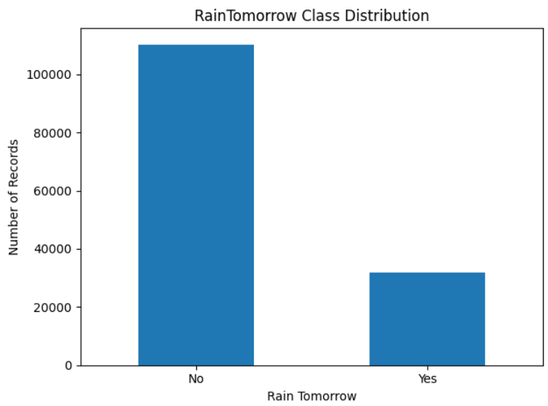
Figure 2: RainTomorrow class distribution
A boxplot of Humidity3pm against RainTomorrow was also produced to examine a simple relationship between afternoon humidity and next-day rain (Figure 3).
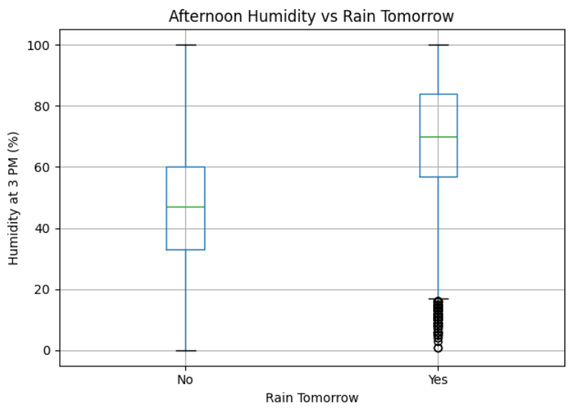
Figure 3: Afternoon humidity (3 pm) versus RainTomorrow

3.4 Stage 4: Data Cleaning and Preprocessing
- Rows with a missing RainTomorrow value were removed (3,267 rows), leaving 142,193 records. Imputing the target would create fabricated labels.
- Date was converted to a date format, rows with an unusable date would be removed, and the records sorted from oldest to newest.
- A possible RISK_MM column (next-day rainfall amount) is dropped if present, because it would leak information about the target. It is not present in this version of the dataset, so the model uses 23 features.
- Missing numeric values were filled using the median, which is robust to outliers.
- Missing categorical values were filled using the most frequent value.
All imputers and encoders are fitted on the training data only to reduce data leakage.

3.5 Stage 5: Data Transformation and Feature Engineering
- Month and Year were extracted from Date to represent seasonal and yearly patterns, and the Date column was then dropped.
- The target was converted to numeric labels (No = 0, Yes = 1).
- Categorical features (Location, wind directions, RainToday) were one-hot encoded, with handle_unknown set to ignore so unseen categories do not cause errors.
- For Logistic Regression, numeric features were also standardised with StandardScaler so that they use comparable ranges.
The records were split chronologically by unique dates: the earliest 80% of distinct dates form the training set and the remaining 20% form the test set, with the test period starting on 8 August 2015. Splitting by date (rather than by row) ensures that observations from the same date at different locations never appear in both sets. This gives 109,302 training records and 32,891 test records. The test set contains 25,680 dry days and 7,211 rainy days (about 21.9% rainy).

3.6 Stage 6: Data Mining (Model Building)
Three approaches were trained on the same training records, each wrapped in a scikit-learn Pipeline together with its preprocessing:
- Dummy Classifier (baseline): predicts the most frequent class (No) for every day. It sets the minimum performance a useful model must beat.
- Logistic Regression: a simple, interpretable model that estimates the probability of rain. Settings: max_iter 1000, class_weight balanced, random_state 42, with median imputation, scaling and one-hot encoding.
- Random Forest: combines many decision trees and can learn complex relationships. Settings: 100 trees, class_weight balanced, random_state 42, run in parallel, with median imputation and one-hot encoding (scaling is not required for tree models).
Class weighting (balanced) gives the rare rain class more influence during training, so the models do not simply favour the dominant dry class.

3.7 Stage 7: Evaluation and Knowledge Presentation
The models were compared on the same chronological test set using four measures:
- Accuracy: the proportion of all predictions that are correct.
- Precision (Rain): among predicted rainy days, how many were actually rainy.
- Recall (Rain): among actual rainy days, how many the model detected.
- F1-score (Rain): the harmonic mean of precision and recall.
A classification report for the best model (ranked by rain F1-score) and confusion matrices for all three models were also produced to show missed rainy days (false negatives) and false rain alarms (false positives).

3.8 Prediction Demonstration
To show how the final model can be used, the notebook asks for a location name, retrieves the most recent observation available for that location in the dataset, builds an input using exactly the training features, and predicts rain for the following day using the best model (selected by rain F1-score). This is a demonstration on historical data and not a live weather forecast.

3.9 Tools and Environment
Python, pandas, NumPy, scikit-learn [8] and Matplotlib, run in Google Colab (with the dataset loaded from Google Drive) and delivered as a Jupyter Notebook.

4. Results and Discussion

4.1 Model Comparison
Table 2 shows the results on the chronological test set (32,891 observations), ranked by rain F1-score.
Model | Accuracy | Rain Precision | Rain Recall | Rain F1-score
Logistic Regression | 0.795 | 0.523 | 0.736 | 0.612
Random Forest | 0.847 | 0.767 | 0.437 | 0.557
Baseline (Dummy) | 0.781 | 0.000 | 0.000 | 0.000

Table 2: Model performance on the test set (rain class = positive class)
Baseline. The dummy model reaches 0.781 accuracy simply by predicting no rain every day, yet it detects none of the 7,211 rainy days. This demonstrates why accuracy alone is a poor metric here and answers Research Question 1: because the target is imbalanced, models must be judged on rain-class measures.
Logistic Regression. With class weighting it detects about 74% of rainy days (recall 0.736) but with modest precision (0.523), meaning roughly half of its rain warnings are false alarms. Its accuracy is only slightly above the baseline (0.795), but the rain F1-score of 0.612 is the best of the three models.
Random Forest. It has the highest accuracy (0.847) and precision (0.767), so when it predicts rain it is usually right. However, its recall is only 0.437, so it misses more than half of the rainy days. Its rain F1-score (0.557) is therefore lower than that of Logistic Regression despite the higher accuracy.

4.2 Confusion Matrix Analysis
The confusion matrices (Figure 4) show the two kinds of error for each model. A false negative is an actual rainy day predicted as No Rain, meaning the model missed rain. A false positive is an actual dry day predicted as Rain, meaning a false alarm. The baseline produces only false negatives for rain. Logistic Regression produces fewer false negatives but more false positives; Random Forest produces fewer false positives but more false negatives. Which trade-off is preferable depends on the application: where missing rain is costly (for example irrigation planning or flood preparedness), higher recall is preferred, whereas where false alarms are costly, higher precision may be preferred.
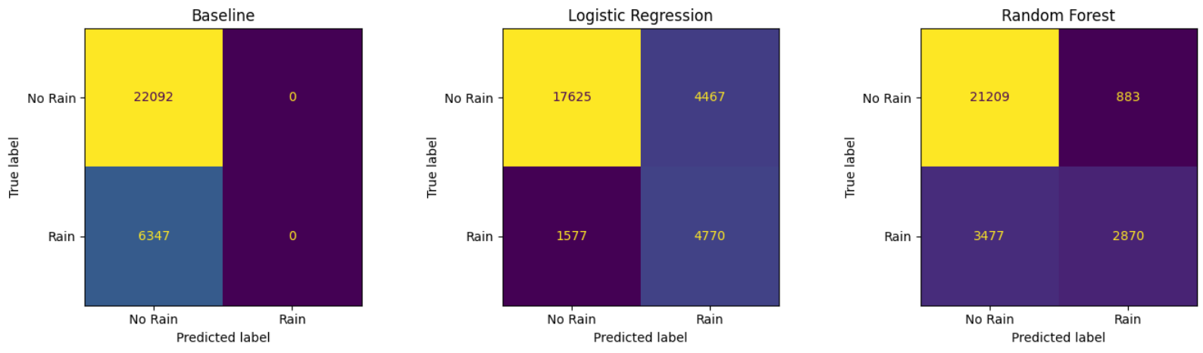
Figure 4: Confusion matrices for the Baseline, Logistic Regression and Random Forest

4.3 Discussion
- Model comparison (Research Questions 2 and 3): both machine learning models clearly beat the baseline on every rain-class measure. Among the models tested, Logistic Regression achieved the highest rain F1-score (0.612), giving the best balance between identifying rainy days and limiting false alarms.
- Interpretability versus complexity: Logistic Regression is simpler and easier to explain, and here it also gave the best F1. Random Forest can capture more complex patterns but is harder to explain and, at the default decision threshold, was conservative about predicting rain.
- Meteorological sense: the humidity boxplot (Figure 3) is consistent with the expectation that humid afternoons are more often followed by rain.

4.4 Prediction Demonstration
The notebook's demonstration was run for the location Sydney. The latest observation available for Sydney in the dataset is dated 25 June 2017, and the selected model (Logistic Regression) predicted NO rain for the following day (Figure 5). This shows that the trained pipeline accepts a raw observation and returns a prediction end to end. Because it uses historical data, it is a demonstration and not an operational forecast.
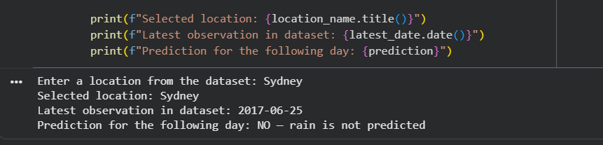
Figure 5: Prediction demonstration output for Sydney

4.5 Limitations
- Single split. Performance was measured on one chronological split. Time-series cross-validation would give a more reliable estimate.
- Default decision threshold. Both models use the default 0.5 threshold. The Random Forest in particular might achieve a better precision-recall balance if the threshold were tuned on a separate validation period.
- Limited hyperparameter tuning. Model settings were mostly defaults; a systematic search could improve results.
- Simple imputation. Median imputation was used for columns with up to 48% missing values (Sunshine, Evaporation, Cloud), which may weaken the signal from these variables.

5. Conclusion
This project developed an end-to-end rainfall prediction model following the KDD process on the weatherAUS dataset. The data were selected and explored, rows with a missing target were removed, and a leakage-aware pipeline was built using imputation, scaling (for Logistic Regression) and one-hot encoding. A short location-based prediction demonstration was also added. Evaluation used a chronological split by unique dates (training on earlier dates, testing from 8 August 2015 onwards).
The majority-class baseline reached 0.781 accuracy while detecting no rain at all, confirming that accuracy is a poor measure on this imbalanced problem. Among the models tested, Logistic Regression achieved the highest rain F1-score of 0.612, with a rain recall of 0.736 and precision of 0.523. The Random Forest achieved the highest accuracy (0.847) and precision (0.767) but a lower recall of 0.437, and so a lower F1-score of 0.557. Both machine learning models clearly outperformed the baseline on rain detection.

6. References
- P. Bauer, A. Thorpe and G. Brunet, "The quiet revolution of numerical weather prediction," Nature, vol. 525, pp. 47–55, 2015.
- L. Breiman, "Random forests," Machine Learning, vol. 45, no. 1, pp. 5–32, 2001.
- N. V. Chawla, K. W. Bowyer, L. O. Hall and W. P. Kegelmeyer, "SMOTE: Synthetic minority over-sampling technique," Journal of Artificial Intelligence Research, vol. 16, pp. 321–357, 2002.
- U. Fayyad, G. Piatetsky-Shapiro and P. Smyth, "From data mining to knowledge discovery in databases," AI Magazine, vol. 17, no. 3, pp. 37–54, 1996.
- T. Hastie, R. Tibshirani and J. Friedman, The Elements of Statistical Learning, 2nd ed. Springer, 2009.
- H. He and E. A. Garcia, "Learning from imbalanced data," IEEE Transactions on Knowledge and Data Engineering, vol. 21, no. 9, pp. 1263–1284, 2009.
- D. W. Hosmer, S. Lemeshow and R. X. Sturdivant, Applied Logistic Regression, 3rd ed. Wiley, 2013.
- F. Pedregosa et al., "Scikit-learn: Machine learning in Python," Journal of Machine Learning Research, vol. 12, pp. 2825–2830, 2011.
- S. Ravuri et al., "Skilful precipitation nowcasting using deep generative models of radar," Nature, vol. 597, pp. 672–677, 2021.
- T. Saito and M. Rehmsmeier, "The precision-recall plot is more informative than the ROC plot when evaluating binary classifiers on imbalanced datasets," PLOS ONE, vol. 10, no. 3, e0118432, 2015.
- L. J. Tashman, "Out-of-sample tests of forecasting accuracy: an analysis and review," International Journal of Forecasting, vol. 16, no. 4, pp. 437–450, 2000.
- J. Young and A. Young, "Rain in Australia (weatherAUS)," Kaggle dataset; source observations from the Australian Bureau of Meteorology, www.bom.gov.au.

