Explain the following questions in two simple sentences

1. **What is the use of the git add command?**

* The git add command stages changes in the working directory for the next commit. It tells git to include updates to a particular file or set of files in the next commit.

1. **Write the command to create a branch “feature-login”**

* git checkout -b feature-login

1. **What is a pull request? Write the steps involved in creating a pull request.**

* A pull request is a way to propose changes to a codebase, allowing others to review and discuss before merging. To create a pull request: push your branch to the remote repository, go to the repository on GitHub, navigate to the "Pull requests" tab, click "New pull request," and select the branch you want to merge into the base branch.

1. **How do you add collaborators?**

* To add collaborators, go to your repository on GitHub, click on "Settings," then "Collaborators & teams," and enter the username or email of the person you want to invite.

1. **What is the command used to commit our changes in github repo?**

* git commit -m “Message”

1. **Create a github account and repository to save all your assignment tasks. Example repository name: rg-assignments**

* <https://github.com/krishdalal/rg-assignments>

1. **Create a branch called feature-java(you can use it later to push all your java related tasks to this branch)**

* git checkout -b feature-java

1. **Install IntelliJ IDE. Create a simple java project displaying “Hello World!!”and share the screenshot.**

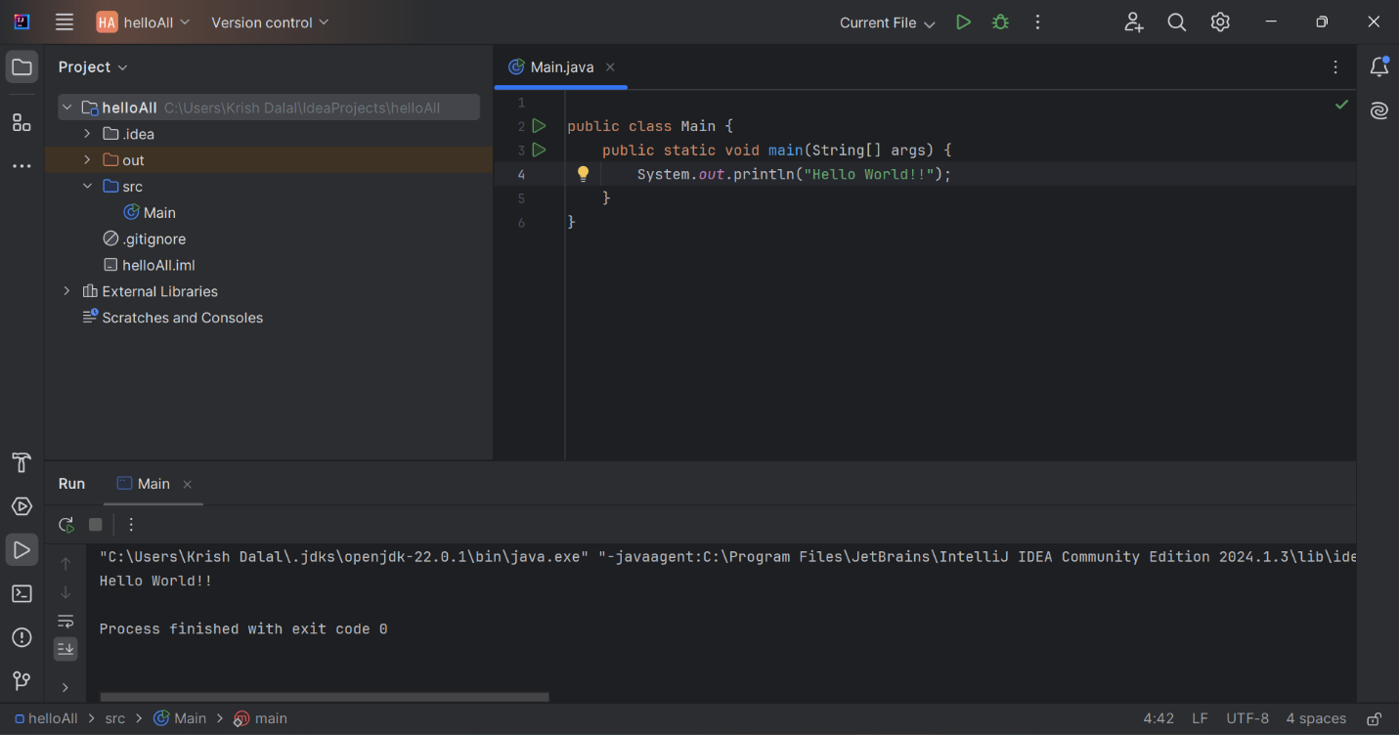

1. **In IntelliJ IDE, explore the shortcut keys for the following**
   1. **To run the project**
   * Shift + F10
   1. **To select a line**
   * Ctrl + W
   1. **To comment/uncomment a line**
   * Ctrl + /
   1. **To delete a line**
   * Ctrl + Y