INTEGRATED PROJECT SYPNOSIS ON

GIGZO
AI-Powered Parametric Insurance Platform

SUBMITTED TO
DEPARTMENT OF COMPUTER SCIENCE AND ENGINEERING
FOR
INTEGRATED PROJECT (22CS038)

Submitted by:
Krishan Kumar Sah (2310990467)
Armaanpreet Singh (2310991788)
Vinit Singh (2310992401)
Semester: VI
Session: Feb 2026 – May 2026



INDEX

S.No | Title | Page Number
1. | Introduction | 3
2. | Problem Statement | 4
3. | Objective and Key learning | 5
4. | Functional Requirements | 6-7
5. | Non-functional requirements | 8-10
6. | High Level Design | 11-13
7. | Low Level Design | 14-15
8. | Advantages/Disadvantages | 16
9. | Conclusion | 17
10. | Future Improvements and Bottlenecks | 18
11. | References | 19

Introduction

The rapid expansion of the gig economy has transformed the structure of modern employment by enabling flexible, on-demand work opportunities across sectors such as delivery services, ride- sharing, logistics support, and freelance digital platforms. Millions of workers now depend on daily task-based earnings rather than fixed monthly salaries, making them highly vulnerable to income instability caused by unpredictable external conditions. Despite their growing contribution to the digital economy, gig workers often remain outside the protection scope of traditional insurance systems due to complex enrollment procedures, delayed claim processing, and rigid policy structures.
Parametric insurance has emerged as a modern alternative to conventional insurance models by enabling automated compensation based on predefined environmental triggers instead of manual claim verification[1]. This approach eliminates the need for extensive documentation and accelerates payout timelines, making it particularly suitable for time-sensitive income protection scenarios. By integrating real-time environmental data sources such as weather conditions, air quality levels, traffic disruptions, and emergency restrictions, parametric systems can proactively identify risk conditions and initiate financial support mechanisms without requiring user intervention.
GigZo is designed as an AI-assisted parametric insurance platform that leverages real-time API integration, automated trigger detection mechanisms, and intelligent backend workflows to provide immediate financial protection to gig workers during disruption events. The platform continuously monitors external risk indicators and activates predefined compensation rules whenever threshold conditions are satisfied. This ensures transparency, consistency, and reliability in claim settlements while reducing administrative overhead and operational delays associated with traditional insurance frameworks.
The system follows a modular three-layer architecture consisting of a presentation layer for user interaction, an application layer for business logic processing, and a data intelligence layer responsible for environmental monitoring and predictive risk assessment. Cloud-based deployment further enhances scalability, availability, and adaptability of the platform across different geographic regions and workforce segments.

Problem Statement

Gig workers represent one of the fastest-growing segments of the modern workforce, yet they remain highly exposed to income uncertainty due to the absence of structured employment benefits and financial protection mechanisms. Unlike traditional employees who receive fixed salaries and insurance coverage through organizations, gig workers depend on daily task availability and uninterrupted operational conditions for their earnings. Any disruption caused by environmental, infrastructural, or regulatory factors can immediately affect their income stability.
Several external conditions directly influence the ability of gig workers to perform their tasks efficiently. These include extreme weather events such as heavy rainfall, storms, or heatwaves; rising pollution levels affecting mobility and health; government-imposed movement restrictions during emergencies; natural disasters; traffic congestion; and unexpected operational shutdowns on digital service platforms. Since these factors occur beyond the control of workers, they often lead to sudden income loss without any immediate financial support mechanism.
Traditional insurance systems are not designed to address such short-term and condition-based income disruptions[1]. They typically involve lengthy claim procedures, manual documentation requirements, verification delays, and dependency on intermediaries before compensation is approved. As a result, gig workers rarely benefit from conventional insurance products, especially in situations requiring instant financial assistance.
With the increasing dependence on gig-based employment models, there is a growing need for an intelligent and automated insurance solution capable of responding to real-time disruption conditions. Such a system should continuously monitor environmental risk indicators, detect trigger events automatically, and initiate compensation without requiring manual claim submission from users.
The system aims to reduce claim processing time, improve transparency in settlements, and ensure reliable income support during disruption events, thereby enhancing financial stability and resilience within the gig workforce ecosystem.

Objective & Key Learnings

The primary objective of the GigZo platform is to design and develop an automated parametric insurance system that provides timely financial protection to gig workers during external disruption events. The system focuses on integrating real-time environmental data, trigger-based claim processing, and scalable architecture to ensure fast, transparent, and reliable compensation support.

Objectives

- To develop an automated parametric insurance platform that provides financial protection to gig workers during disruption conditions without requiring manual claim submission
- To integrate real-time environmental data sources such as weather, air quality, and traffic APIs for continuous monitoring of external risk factors
- To reduce claim processing time and eliminate dependency on traditional documentation-based insurance workflows through system automation
- To enhance financial stability and income security for gig workers by providing timely and reliable compensation during operational interruptions

Key Learnings

- Understanding and implementing REST-based API integration for real-time environmental data acquisition
- Designing backend automation workflows for trigger detection, claim processing, and payout handling
- Developing rule-based risk prediction logic for disruption forecasting using external datasets

- Applying full-stack development practices using modern frontend, backend, and database technologies for building scalable web applications
- Gaining experience in designing modular system architecture for real-time decision-support platforms

Functional Requirements & Non-Functional Requirements

The GigZo system is designed with a set of user-centric and automation-driven functional capabilities that ensure seamless operation, minimal manual intervention, and real-time responsiveness. Each functional requirement contributes to building a robust parametric insurance workflow.

User Registration, Authentication, and Profile Management

The system provides a secure onboarding mechanism where users (gig workers) can register using credentials such as email, phone number, or third-party authentication (OAuth). Authentication is handled using secure protocols like JWT (JSON Web Tokens) or session-based authentication.
User profiles maintain essential data such as work type, location, insurance preferences, and payout details, enabling personalized insurance services.

Insurance Plan Selection and Customization

Users are offered multiple insurance plans based on predefined parameters such as coverage type, trigger conditions (e.g., rainfall threshold), and premium cost.
The system allows customization by enabling users to select:

    - Coverage limits

    - Trigger thresholds

    - Duration of insurance

This flexibility ensures that users can tailor plans according to their risk exposure and earning patterns.

Continuous Monitoring of External APIs

The platform integrates with external data providers such as weather, pollution, and traffic APIs. A background service continuously fetches real-time data using RESTful APIs and processes it at regular intervals. This ensures that the system always operates on live environmental data[4], which is critical for parametric insurance.

Trigger Condition Detection Based on Thresholds

A rule-based engine evaluates incoming data against predefined thresholds (e.g., rainfall > X mm, AQI > Y level). If conditions satisfy the trigger logic, an event is generated. This detection mechanism is highly optimized to ensure low-latency decision-making, enabling instant system response.

Automated Claim Initiation and Processing

Once a trigger condition is met, the system automatically initiates the claim process without requiring user intervention.
Smart contracts or backend logic calculate the payout based on:

    - Severity of the condition

    - Selected insurance plan

    - Predefined compensation rules

This eliminates traditional paperwork and significantly reduces claim processing time.

Real-Time Notifications and Updates

The system ensures user engagement and transparency through real-time notifications via:

    - Push notifications

    - SMS or email alerts

Users are instantly informed about:

    - Trigger activation

    - Claim status

    - Payout confirmation

Non-Functional Requirements

To ensure that GigZo operates efficiently under real-world conditions, several non-functional requirements are incorporated. These define the quality attributes and system performance standards.

Scalability

The system is designed using cloud-based infrastructure[3] (e.g., AWS, Vercel) to support horizontal and vertical scaling.
Microservices architecture and load balancing techniques ensure that the platform can handle:

    - Increasing number of users

    - High-frequency API calls

    - Large volumes of real-time data

Security

Security is a critical aspect of the system. It includes:

    - End-to-end data encryption (HTTPS, SSL/TLS)

    - Secure authentication (JWT, OAuth) [4]

    - Role-based access control (RBAC)

Sensitive data such as user credentials and financial information is protected using industry- standard practices.

Performance

The system is optimized for low latency and high throughput. Techniques such as:
    - Caching (Redis) [5]

    - Asynchronous processing

    - Efficient API handling

ensure that trigger detection and claim processing happen in near real-time.

Reliability

The platform ensures high availability using:

    - Redundant servers

    - Failover mechanisms

    - Continuous monitoring

This guarantees minimal downtime and consistent service even during peak loads or API failures.

Usability

The system is designed with a focus on user experience (UX):

    - Intuitive UI design

    - Minimal learning curve

    - Mobile responsiveness

This ensures accessibility for gig workers who may not have advanced technical knowledge.

5.6. Hardware and Software Requirements

Table 1 Software Requirements

Component | Specification
Processor | Intel i5 or equivalent
RAM | Minimum 8 GB
Storage | 256 GB SSD (recommended)
Internet | Stable broadband
Device | Laptop/Desktop

Table 2 Software Requirements

Software/Tool | Purpose
React.js | Frontend development
Node.js / Python | Backend development
MongoDB/PostgreSQL | Database management
VS Code | Code editor
Git/Github | Version control
APIs (Weather/AQI) | Data integration
Browser (Chrome) | Testing

High Level Design

The High-Level Design of GigZo defines the overall system architecture, major components, and their interactions. The system follows a layered and modular architecture to ensure scalability, maintainability, and separation of concerns.
GigZo is designed using a three-tier architecture, where each layer is responsible for a specific functionality in the system.

Presentation Layer (Frontend)

This layer is responsible for user interaction and provides an intuitive interface for gig workers.

    - Developed using modern frontend technologies such as React.js, HTML, CSS and JavaScript.
    - Provides features like user registration, dashboard view, insurance plan selection, and claim tracking.
    - Ensures responsive design and seamless user experience across devices.

Application Layer (Backend)

The application layer handles the core business logic and system operations.

    - Built using Node.js or Python (FastAPI) for efficient request handling
    - Manages user authentication, insurance logic, and claim processing workflows.
    - Implements trigger-based logic engine to evaluate real-time conditions
    - Ensures secure communication between frontend and data layer via REST APIs

Data & Intelligence Layer

This layer is responsible for data collection, processing, and intelligent decision-making.

    - Integrates with external APIs such as weather, pollution and traffic services.
    - Processes real-time data streams for monitoring environmental conditions.
    - Implements AI/ML Models for risk prediction and disruption forecasting[6]
    - Stores data in databases like MongoDB or PostgreSQL.

Cloud & Deployment Layer

To ensure scalability and availability, the system is deployed on cloud platforms.

    - Uses services like AWS or Vercel for hosting and deployment.
    - Supports scalability through cloud infrastructure and load balancing.
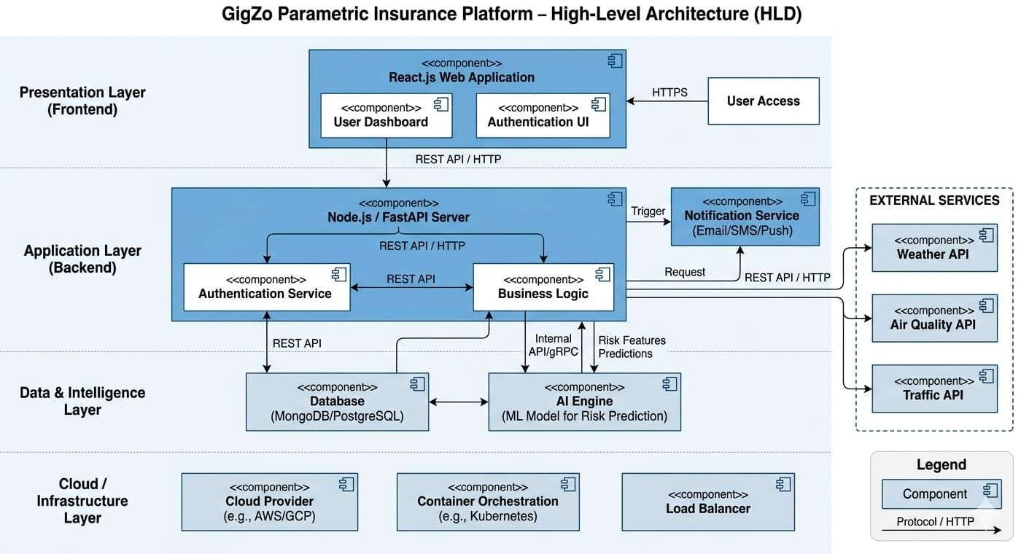
    - Ensures high availability and fault tolerance.

Figure 1 : High Level Design

6.5 Workflow Diagram

The Design focuses on the internal structure of the system, including modules, workflows, and data flow between components. It provides a detailed breakdown of how each functionality is implemented. It defines the interaction between different modules, ensuring efficient communication and seamless data processing within the system. Additionally, it helps in translating high-level architecture into executable components, making the system easier to develop, test, and maintain.
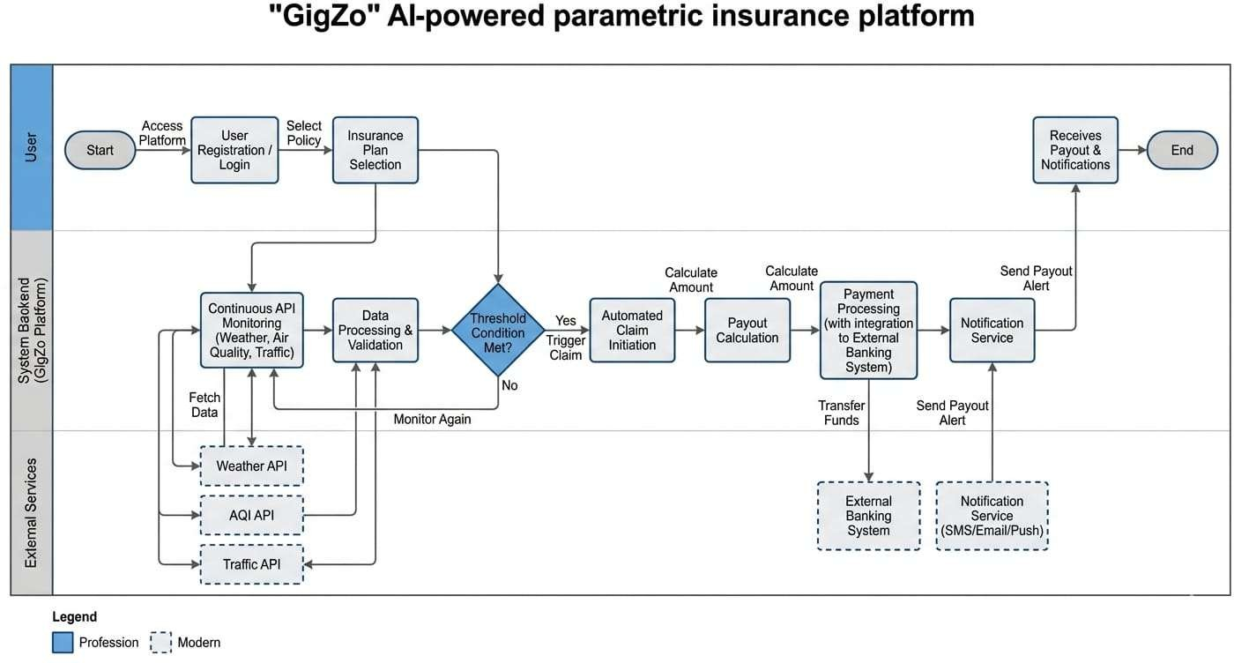
Figure 2: Workflow Diagram

Low Level Design (LLD)

The Low-Level Design focuses on the internal structure of the system, including modules, workflows, and data flow between components. It provides a detailed breakdown of how each functionality is implemented.

Core Modules

The system is divided into multiple functional modules:

    - User Module: Handles user registration, login, authentication and profile management.
    - Plan Module: Manages insurance plans, customization options and user subscriptions.
    - API Monitoring Module: Continuously fetches real-time data from external APIs.
    - Trigger Detection Module: Evaluates data against predefined thresholds to detect events.
    - Claim Automation Module: Automatically initiates claims once trigger conditions are satisfied.
    - Payout Module: Calculates compensation and processes payments to user accounts.
    - Notification Module: Sends real-time alerts regarding triggers, claims, and payouts.

System Workflow

The workflow represents how data flows through the system:

    - User registers and selects an insurance plan.
    - System continuously monitors environmental data via APIs.
    - Incoming data is processed and evaluated by the trigger engine.
    - If conditions meet predefined thresholds, a trigger event is generated.
    - Claim is automatically initiated and processed.
    - Compensation amount is calculated based on predefined rules.
    - Payment is transferred to the user’s account.
    - User is notified through the system dashboard and alerts

Data Flow & Processing

    - Real-time data is fetched → processed → evaluated → stored.
    - Trigger engine acts as the decision-making core.
    - Backend ensures synchronization between modules and database.

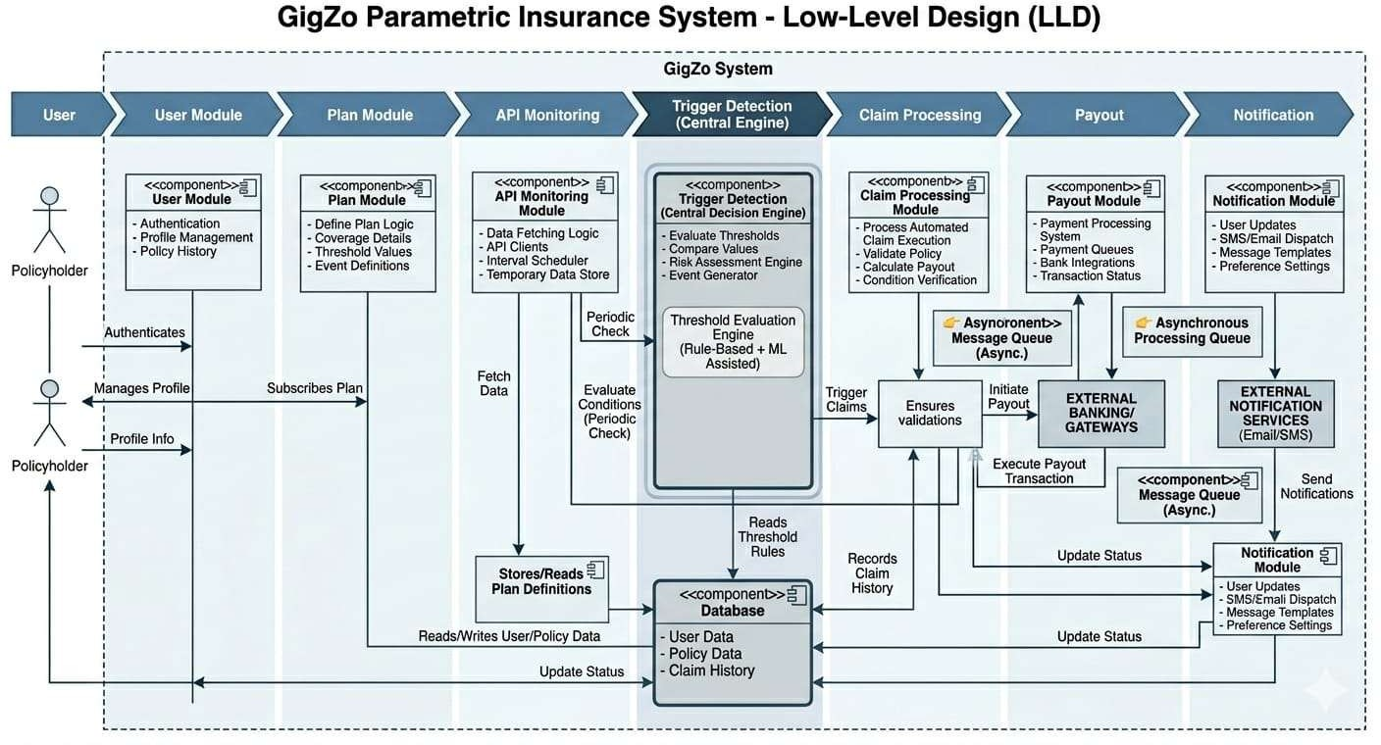

Figure 3: Low Level Design

Advantages & Disadvantages

Advantages:

The GigZo platform introduces a modern approach to insurance by combining automation, real- time data processing, and artificial intelligence. These advantages make the system highly efficient, user-friendly, and scalable in real-world scenarios.
    - Automated Claim Processing: Eliminates manual claim filing, reducing delays and ensuring faster resolution through trigger-based execution.
    - Real-Time Monitoring: Continuous integration with external APIs enables instant detection of environmental disruptions such as weather or pollution.
    - Faster Payouts: Predefined conditions allow immediate compensation once a trigger is activated, improving financial reliability for users.
    - AI-Driven Insights: Predictive models help in identifying potential risks in advance, enhancing system intelligence and decision-making.
    - Improved Transparency: Clear trigger conditions and predefined payout rules reduce ambiguity and build user trust.

Disadvantages:

Despite its innovative approach, the system has certain limitations that must be considered while designing and deploying the platform in real-world environments.
    - Dependency on External APIs: The system heavily relies on third-party data sources, which may affect performance if APIs fail or provide inaccurate data.
    - Prediction Inaccuracies: AI models may not always produce perfectly accurate results, potentially impacting risk assessment and trigger detection.
    - Internet Dependency: Continuous connectivity is required for real-time monitoring and system functionality.
    - Initial System Complexity: Designing and integrating multiple components such as APIs, AI models, and automation workflows can be technically challenging.
    - Data Reliability Issues: Variations in external data quality can lead to inconsistent system behavior.

Conclusion

GigZo represents a next-generation insurtech solution that integrates real-time environmental data monitoring, automated trigger-based claim processing, and predictive risk assessment techniques to provide reliable and timely financial protection for gig workers. By adopting a parametric insurance model, the platform removes traditional inefficiencies associated with conventional insurance systems, such as extensive paperwork, manual verification procedures, delayed claim approvals, and dependency on intermediaries. This enables faster response times and ensures that users receive compensation immediately when predefined disruption conditions are detected.
The platform strengthens operational efficiency through continuous API-based monitoring of external risk factors such as weather conditions, pollution levels, mobility disruptions, and emergency restrictions. These automated trigger mechanisms ensure accuracy, transparency, and consistency in claim settlements while minimizing administrative overhead and human intervention. As a result, GigZo offers a streamlined and dependable alternative to legacy insurance workflows that often fail to meet the urgent needs of gig workers.
Additionally, the system is designed using a modular and scalable architecture that supports future enhancements such as integration with gig-service platforms, mobile application deployment, blockchain-based claim validation, and advanced predictive analytics. This flexibility makes the solution adaptable to evolving market requirements and suitable for large- scale deployment across diverse geographic regions and workforce segments.
Overall, GigZo significantly improves responsiveness, accessibility, and reliability compared to traditional insurance approaches. It contributes meaningfully toward financial inclusion by delivering affordable, automated, and timely protection to gig workers - one of the fastest- growing yet most financially vulnerable segments of the modern digital economy.

Future Improvements & Bottlenecks

Future Improvements

To further enhance the capabilities and real-world applicability of GigZo, several advanced features and technological integrations can be incorporated. These improvements aim to increase transparency, scalability, and user engagement while strengthening the overall system intelligence.
    - Blockchain Integration: Implementing blockchain technology can ensure transparent and tamper-proof claim validation, enhancing trust and auditability in the system
    - Integration with Gig Platforms: Direct integration with platforms such as delivery and freelance services can enable seamless user onboarding and real-time data synchronization
    - Advanced AI Optimization: Enhancing machine learning models for better risk prediction, dynamic premium calculation, and personalized insurance recommendations
    - Multi-Region Expansion: Extending support to multiple geographic regions with localized data models and policies

Potential Bottlenecks

While GigZo offers a robust and innovative solution, certain challenges may arise during implementation and large-scale deployment. Identifying these bottlenecks is essential for improving system reliability and performance.
    - API Failures: Dependence on third-party APIs may lead to system disruptions if data sources become unavailable or unresponsive
    - Data Reliability Issues: Inconsistent or inaccurate external data can impact trigger detection and claim accuracy
    - Payment Processing Delays: Delays in payment gateways or banking systems may affect the timeliness of payouts
    - Security Risks: Protecting sensitive user and financial data from cyber threats remains a critical concern

References

- Swiss Re Institute, “Parametric Insurance: Closing the Protection Gap” Swiss Re, Zurich, Switzerland, 2018.
- World Bank Group, “Financial Protection Against Climate Risks Using Parametric Insurance,” Washington, DC, USA, 2021.
- Amazon Web Services, “AWS Architecture Center,” Available: https://aws.amazon.com/architecture
- Redis Documentation, “Redis Caching System,” Available: https://redis.io/docs
- Node.js Documentation, OpenJS Foundation. Available: https://nodejs.org
- A. Géron, Hands-On Machine Learning with Scikit-Learn, Keras & TensorFlow, 2nd ed. O’Reilly Media, 2019.
- Insurance Regulatory and Development Authority of India (IRDAI), “Report on Innovation in Insurance Sector,” IRDAI, India, 2020.
- OpenWeatherMap, “Weather API Documentation” Available https://openweathermap.org/api

- World Air Quality Index Project, “AQICN Air Quality API,” Available: https://aqicn.org/api/

- Google Developers, “Google Maps Traffic API Documentation,” Available: https://developers.google.com/maps

- Goodfellow, Y . Bengio and A. Courville, Deep Learning. MIT Press, 2016

- React Documentation, Meta Platforms Inc. Available: https://react.dev

