AWS:

1. Wat is cloud  
   Service models -> IaaS, PaaS, SaaS
2. Service Models  
   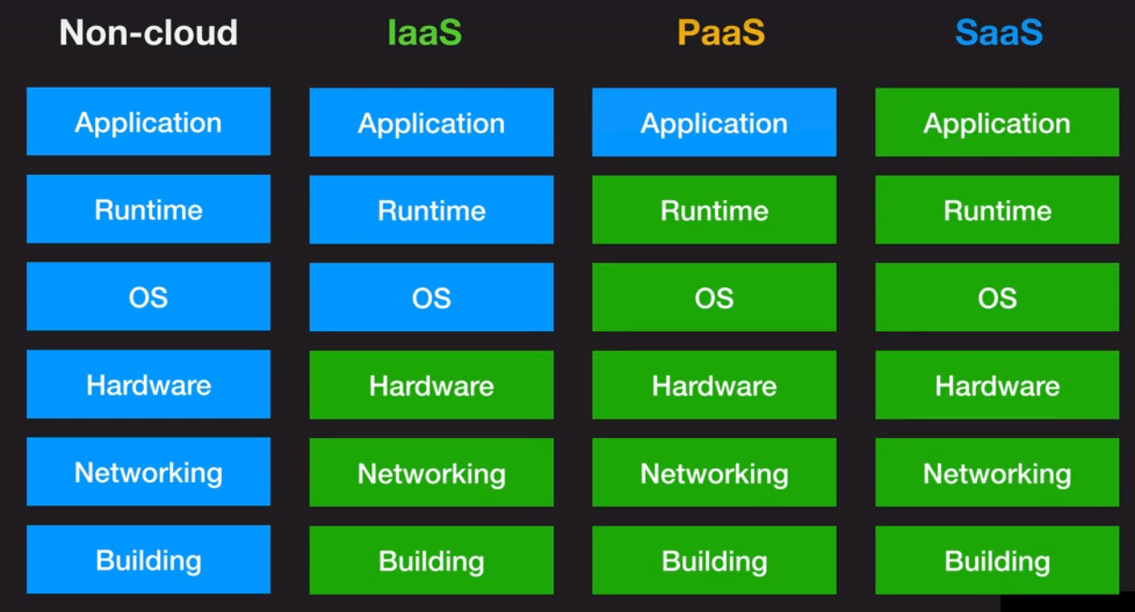
3. 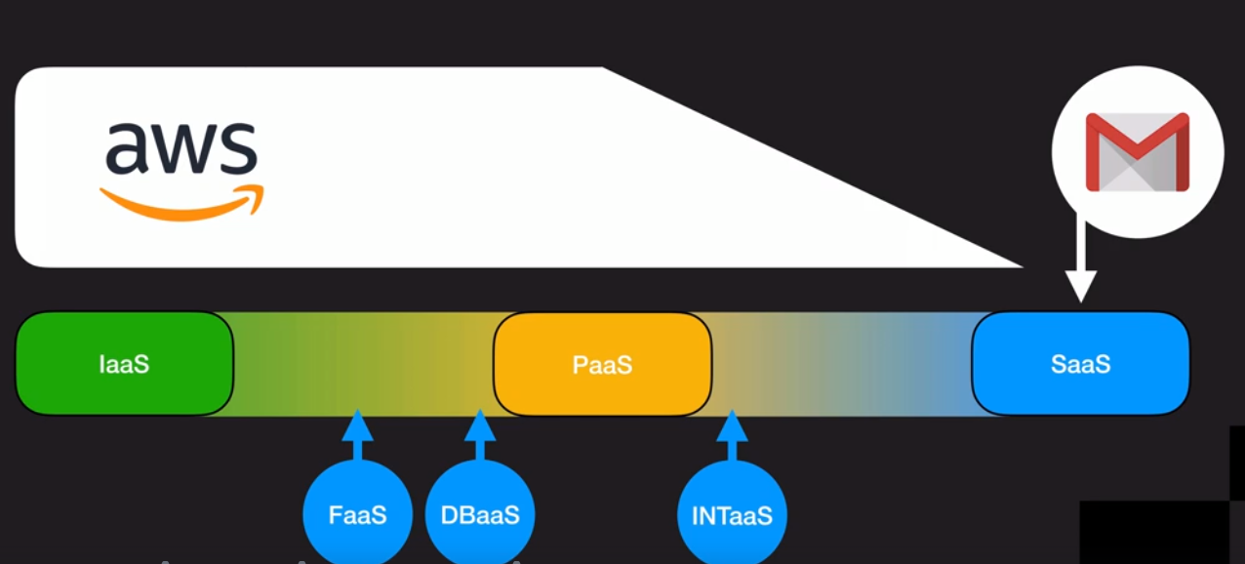
4. Deployment models  
    a. private clouds

b. public clouds  
c. community cloud  
d. hybrid cloud

1. AWS -> Regions-> Availability zones -> edge locations
2. Install AWS command line tools  
   Used to transfer files to and from Amazon S3
3. Aws command line  
   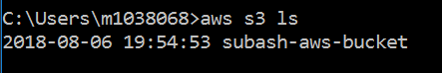 displays the bucket name created by the user
4. Aws S3 -> Simple Storage Service, is a cloud object storage  
   Can be used for backups, storage media files and can store any files
5. 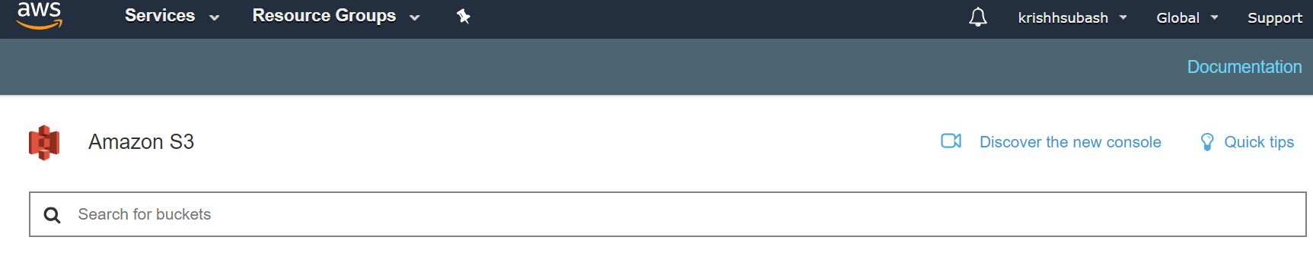

S3 location is Global

1. 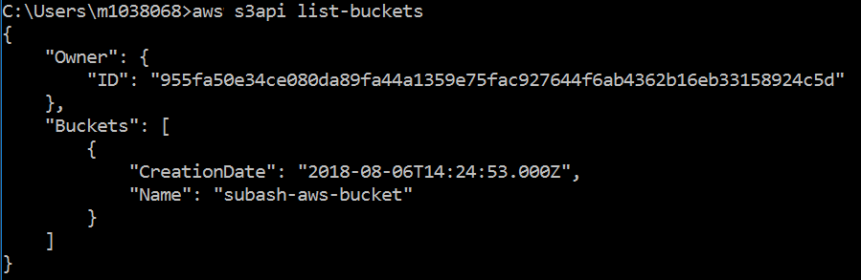
2. 
3. AWS Lambda