1. Docker is a set of containers
2. Containers contains the OS, software under development, dependencies to run software, env variables  
   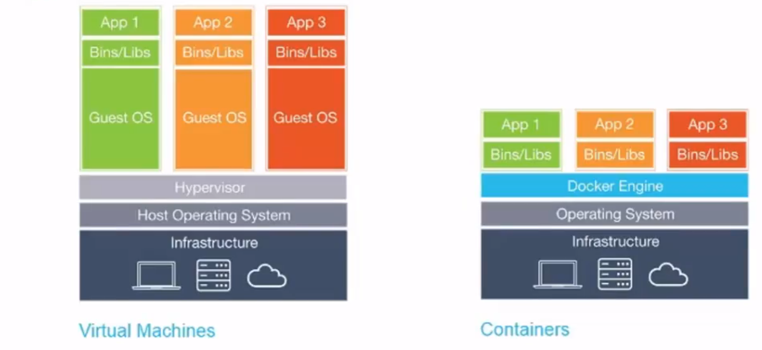  
   Docker engine contains an OS, and shares kernel with other containers
3. Linux containers serve as alternative to VMs as they don’t require Hypervisor’s like  
   Virtual Box  
   KVM  
   XEM
4. Containers> Controlled, isolated and portable OS, containers are sitting in <https://hub.docker.com>
5. Browse the containers using “Kitematic”
6. Docker has git like capabilities for tracking successive versions of a container  
   docker implements git pull like command
7. Windows server 2016 there will be windows server containers, but currently dockers have linux OS
8. Docker Hub -> public
9. Docker cloud -> org
10. Docker compose->
11. Docker Machine
12. Commands in docker  
    Docker –help  
    Docker create  
    Docker pull  
    Docker push  
    Docker ps –a(show all containers)  
    Docker rm  
    Docker stop  
    docker run  
    docker logs
13. Link docker containers  
    
14. Docker compose  
    Cmpose is tool for defining and running multi container docker applications
15. Docker compose commands  
    docker-compose logs  
    docker-compose stop
16. Compose is basically a yaml file(.yml file)

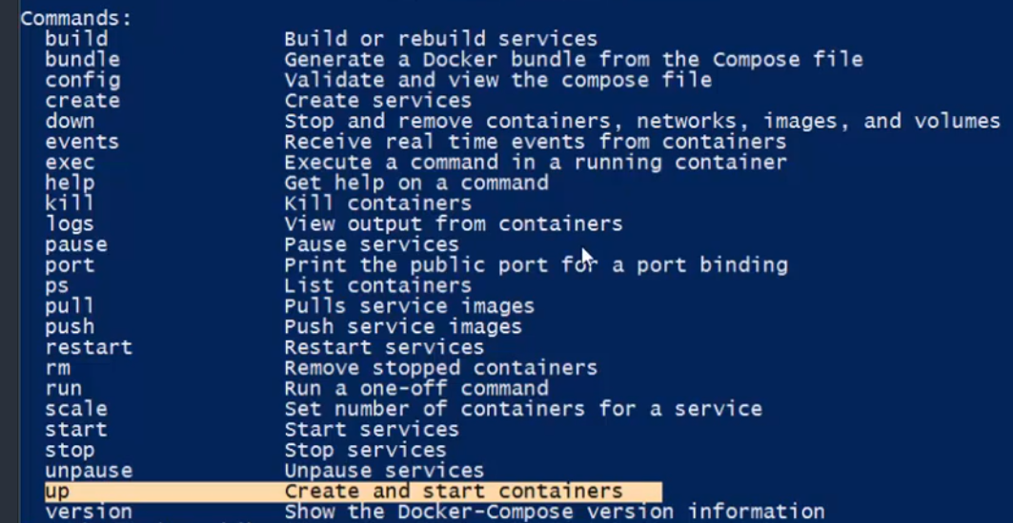

Selenium Grid with Docker

1. 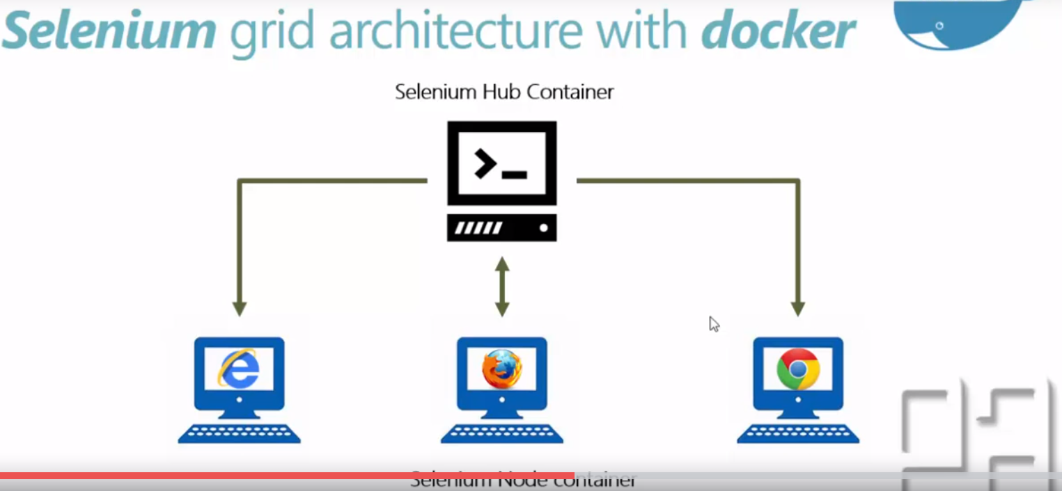
2. Docker pull selenium /hub  
   docker pull seleium/node-firefox  
   docker pull selenium/node-chrome-debug  
   docker pull selenium/node-firefox-debug
3.   
   