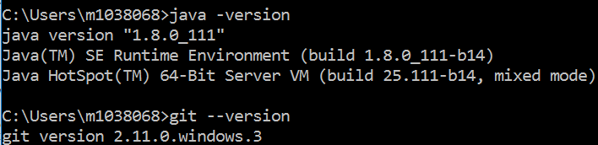

2) Setting up GIt:  
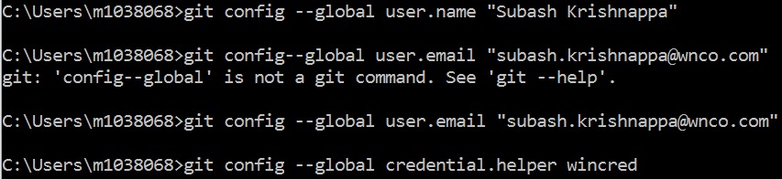

3) Run the command:  
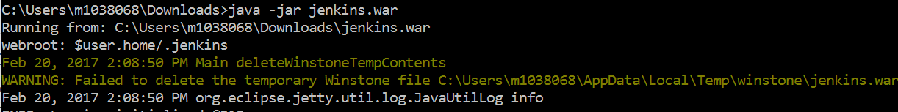

5) If post is already in use, Jenkins does not start up, and an error is thrown, in order to resolve this issue, we need to kill the process PID , will the   
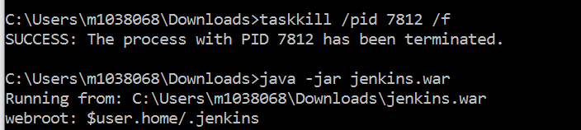  
4) It generates a password as below in console:  
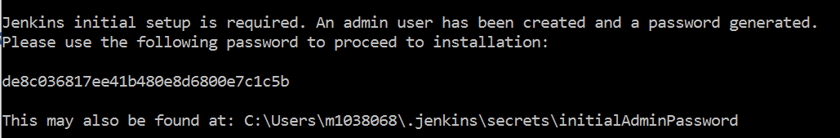  
On successful installation we get a console as below:  
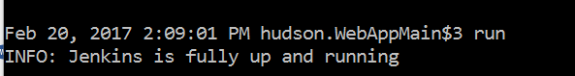

5) Then launch Jenkins in URL as below:  
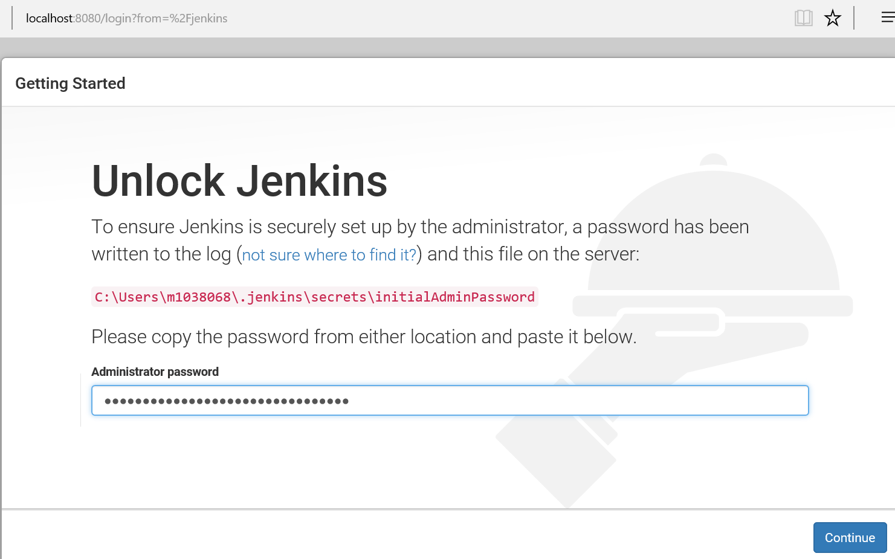

6) after generating the admin password, if we do not login, session gets invalidated and the window displayed as below:  
  
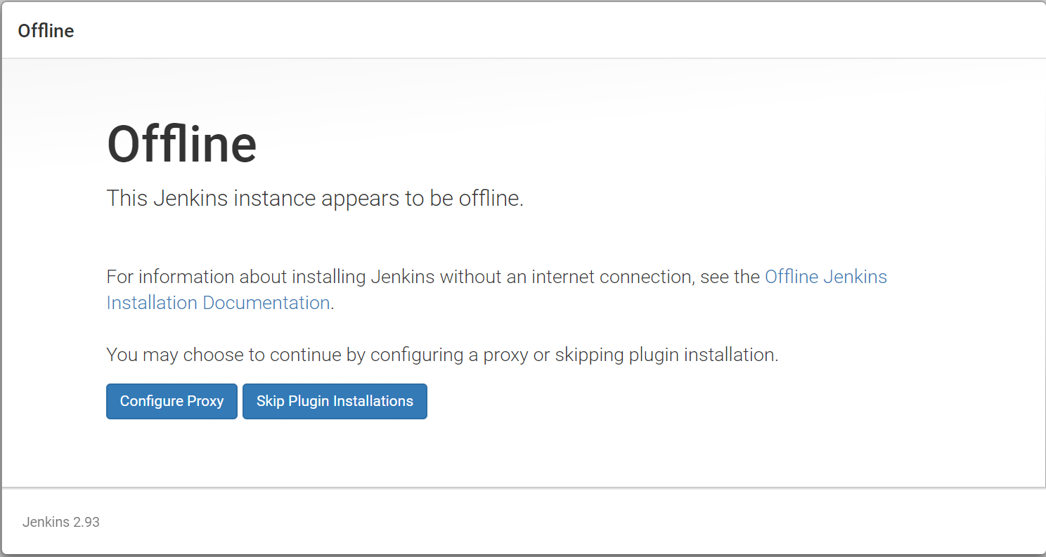

7) Login as admin with the password generated   
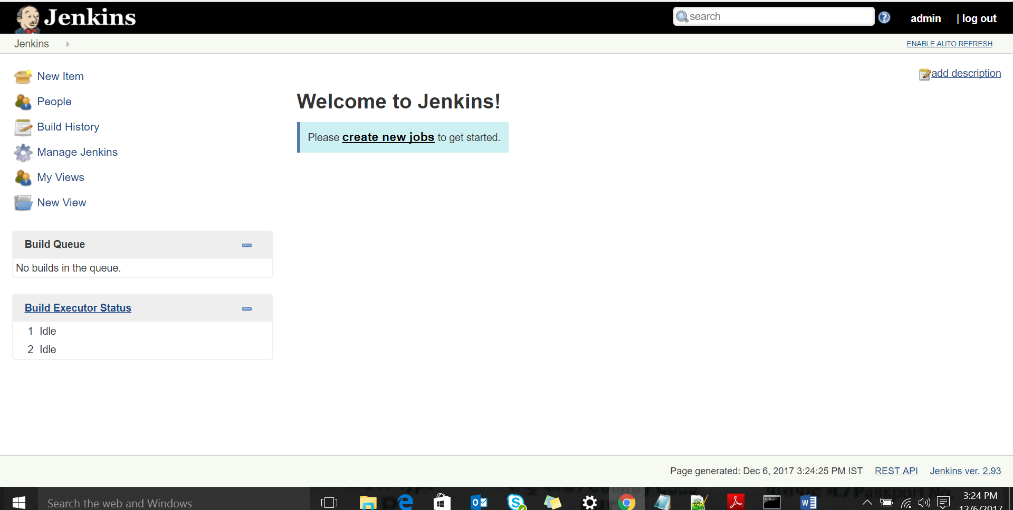

8) Click on Manage Jenkins Hyperlink  
9) Enter Jenkins URL -> if its present in a remote machine, enter the IP address and the port where Jenkins is configured, If Jenkins is configured in local machine, enter localhost:8080  
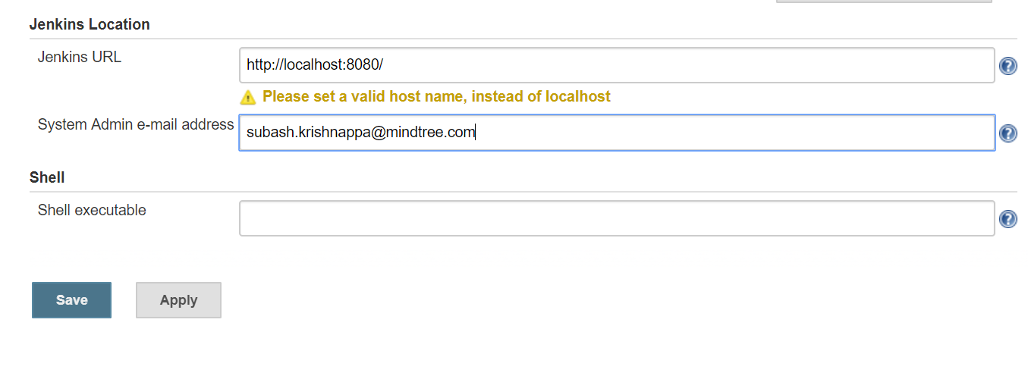

10)