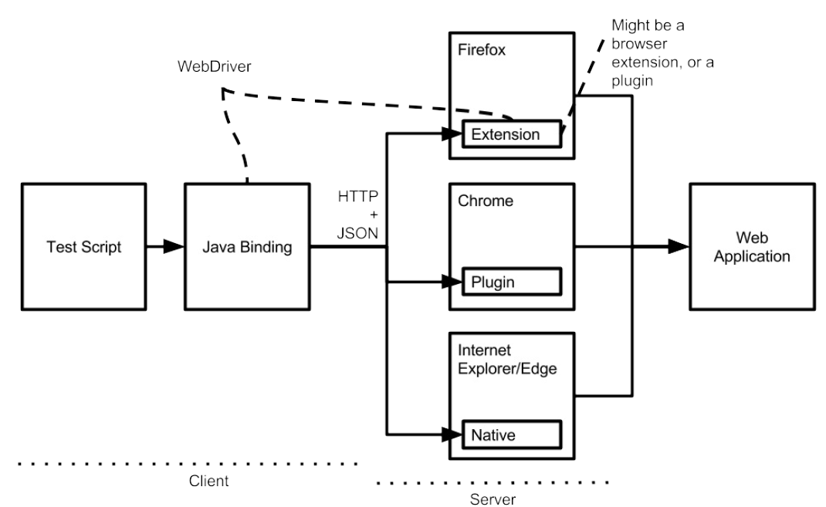

2) TestNG:  
TestNG is similar to Junit for Unit Test and some additional annotations  
TestNg is a testing framework designed for Unit testing(Testing at class level) to Integration testing(testing entire system made up of several class to several packages to several external frameworks)

3) <test name="Regression1" preserve-order="false">

Will execute the tests in random order, else the tests are executed in alphabetical order

4) If any meethods retuurn a value and such methods if they are annotated with @Test, inorder to preserve the value returned, we need to set the flag

|  |
| --- |
| <suite allow-return-values="true"> |

|  |
| --- |
|  |

|  |
| --- |
| or |

|  |
| --- |
|  |

|  |
| --- |
| <test allow-return-values="true"> |

5)