1) Create a Project in maven using the command:  


2) 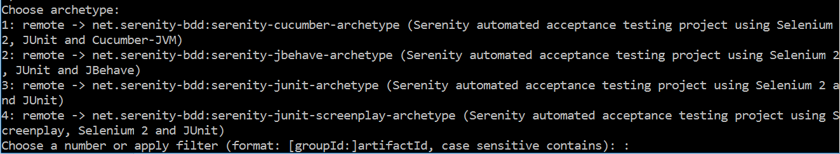  
3) Enter 1 for Serenity cucumber project  
4) Choose latest serenity cucumber version:  
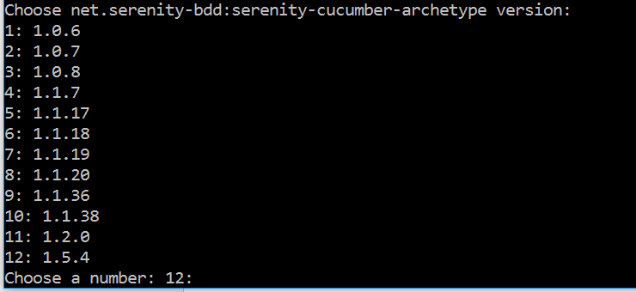  
5) Enter group ID, artifact ID and version and on successful creation of project a notification is displayed for build success:  
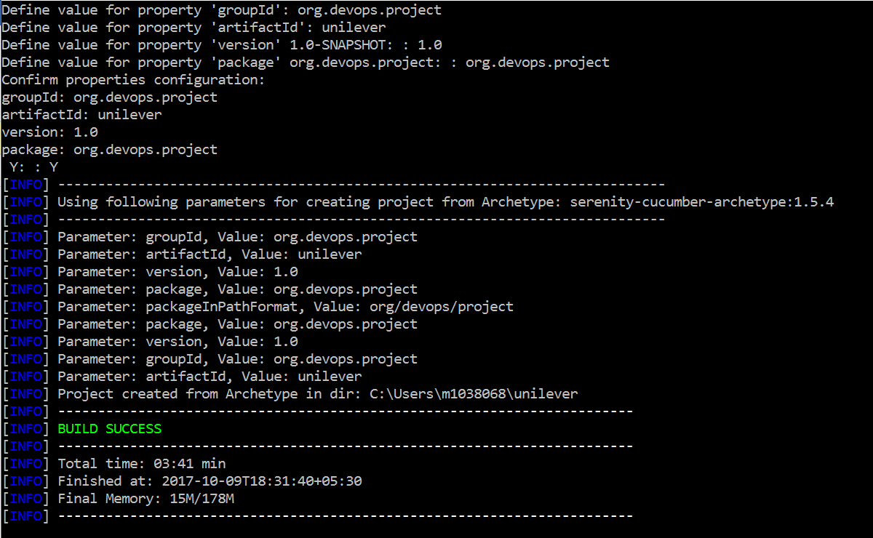  
6) Project gets successfully created and the folder structure is as below  
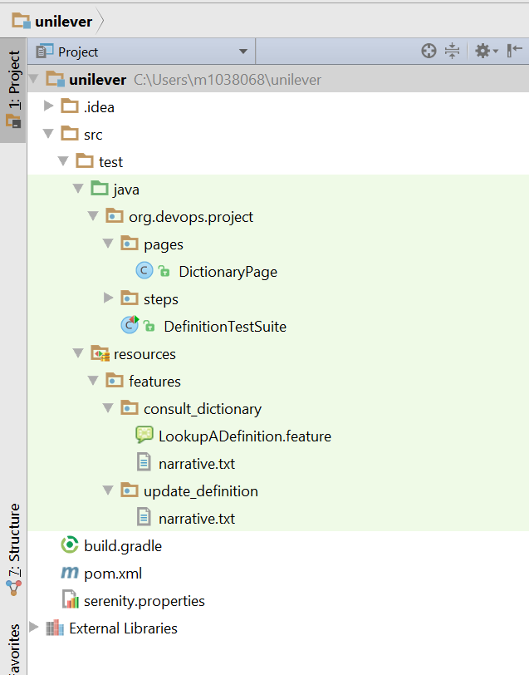

1. Launch IE driver:  
   Syste,.setproperty(“webdriver.ie.driver”,”c:\\IEDriver.exe”);
2. Find Elements in Selenium  
   ID, name, className, tagName, Css Selectors, xpath, link text, partialLinkText  
     
   findElement() throws NoSuchElementFoundException() if no element is found for the locator  
   findElements() returns an empty list of no element is found
3.   
     
     
     
   ancestor  
   descendant  
   following  
   following-sibling  
   preceding  
   preceding-sibling
4. jQuery Selectors