1. Install node.js program
2. 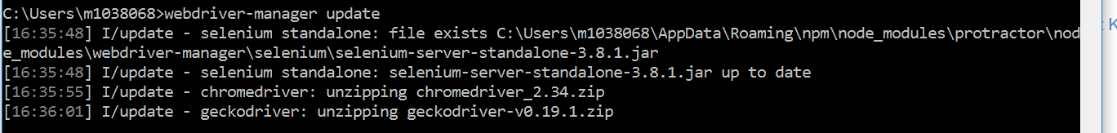
3. Start webdriver manager server  
   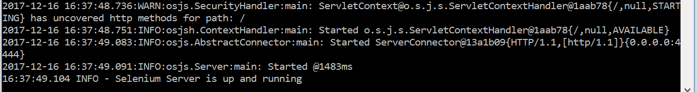
4. 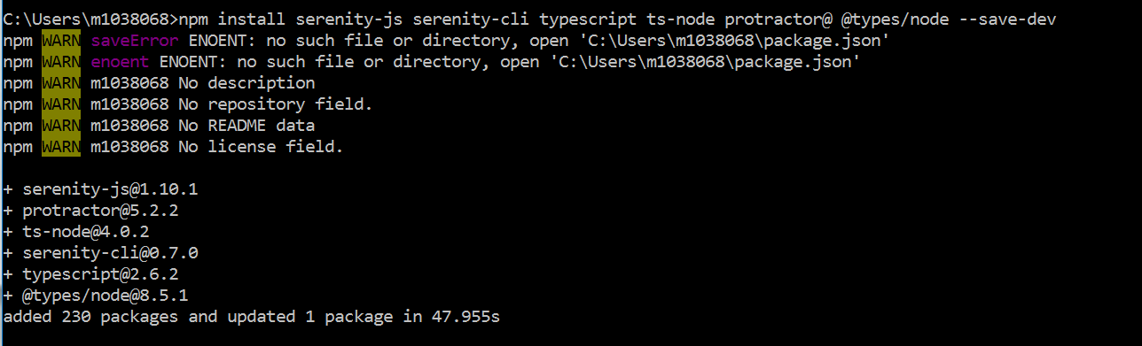
5. 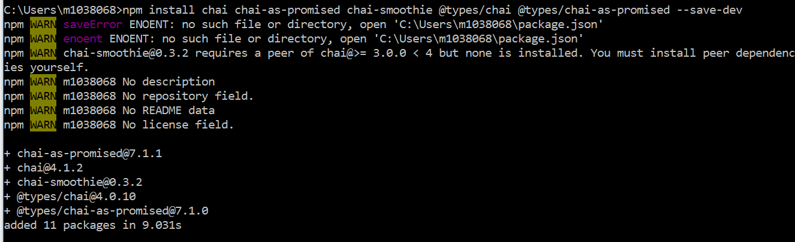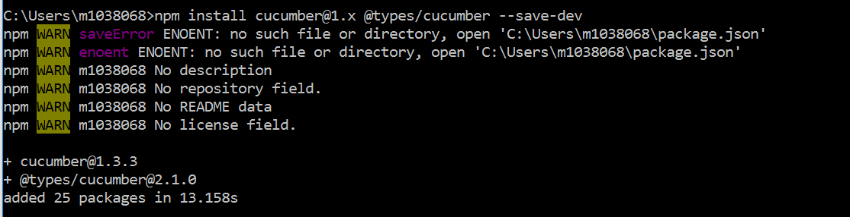
6. 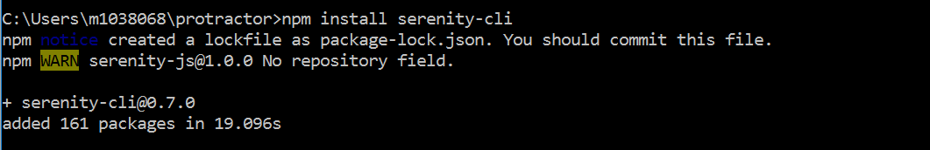
7. 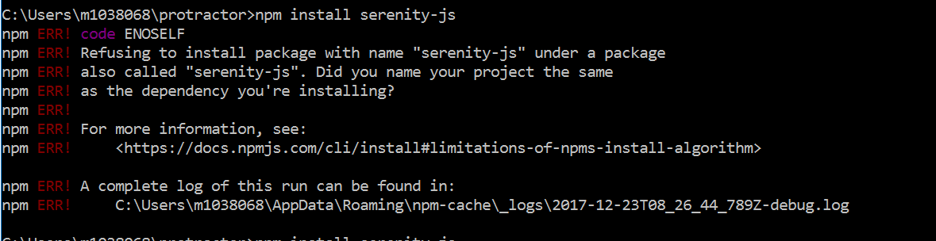  
   If we get an error as above, we need to change the project name under package.json file  
   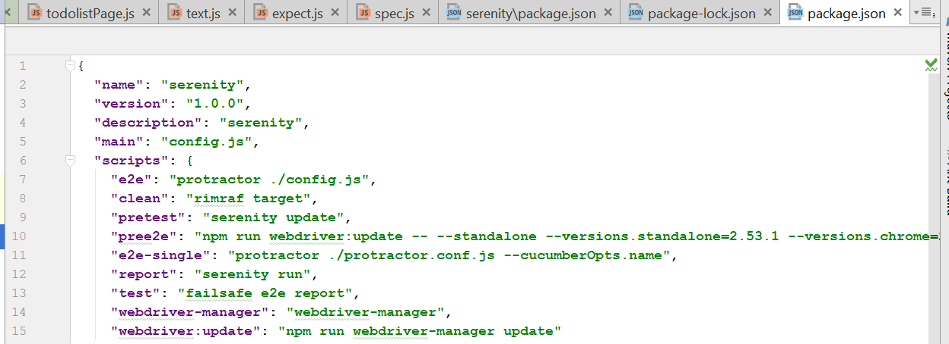
8. 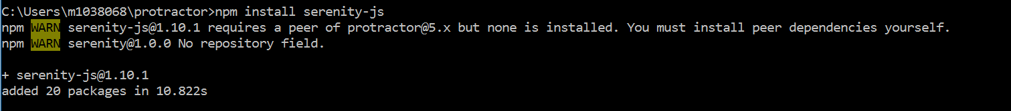
9. 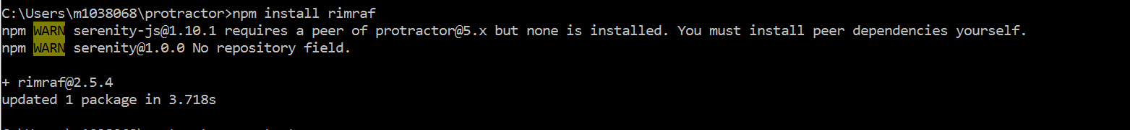
10. 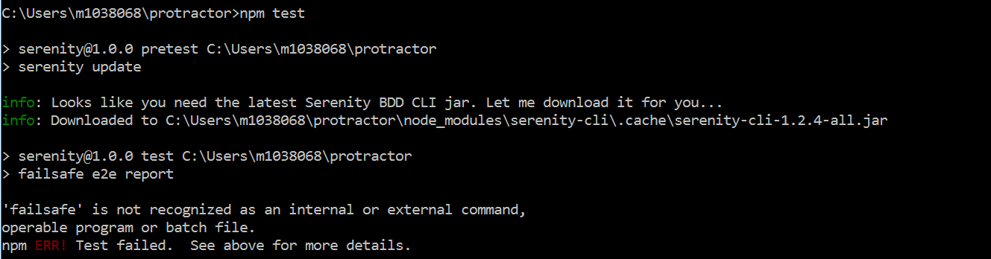
11. If we get an error as above we need to   
    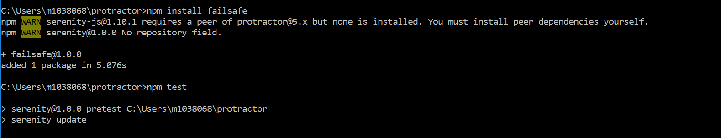
12. 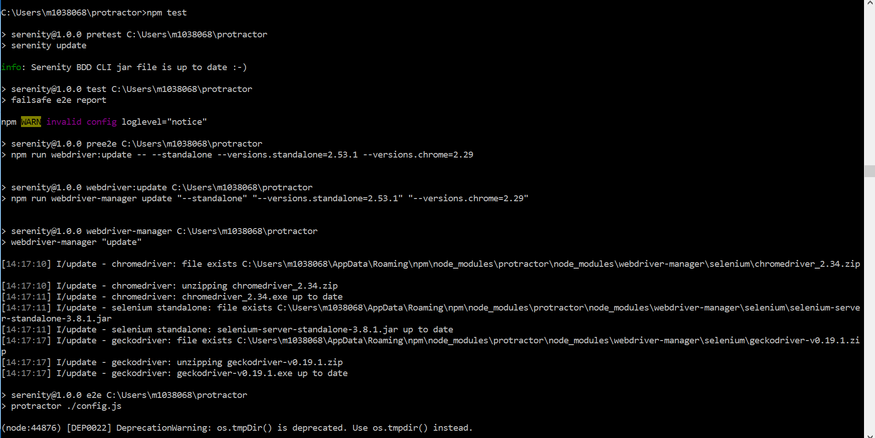
13. 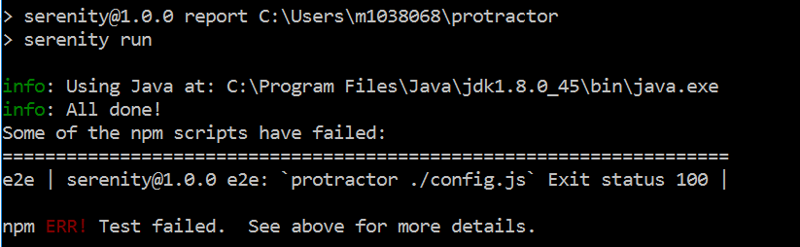
14. 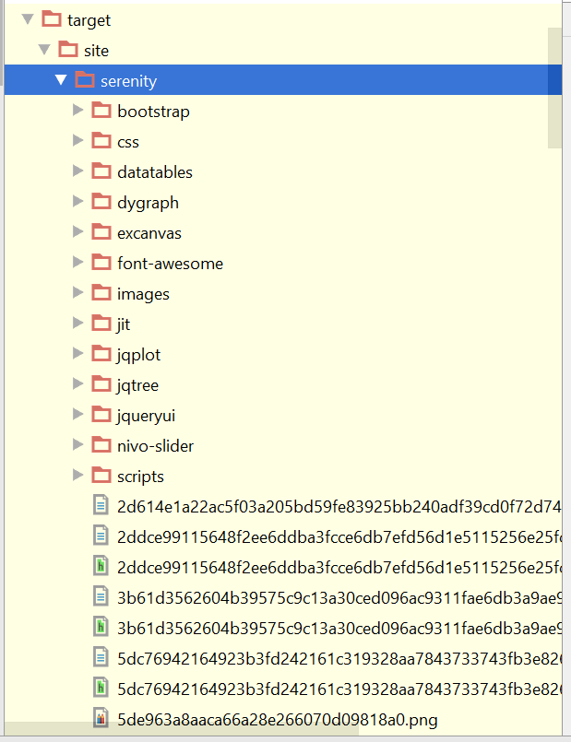
15. Serenity reports are displayed as below  
    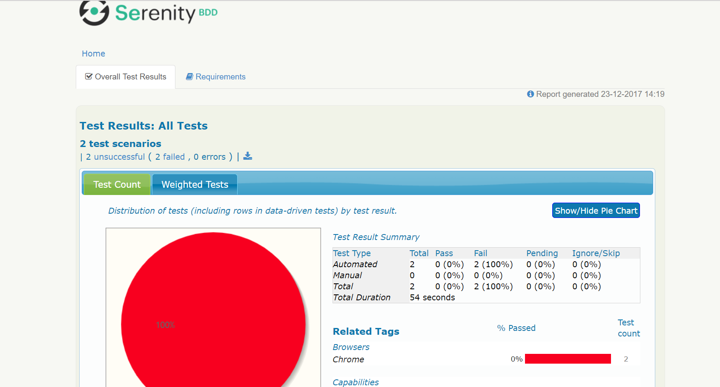  
    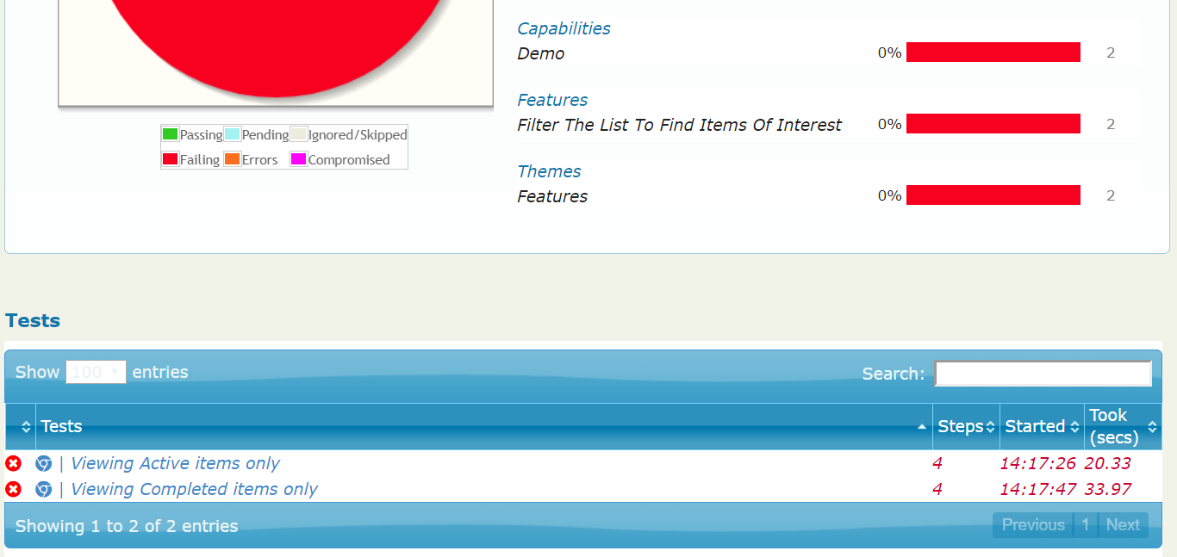
16. All the dependencies are stored in “node_modules” folder  
    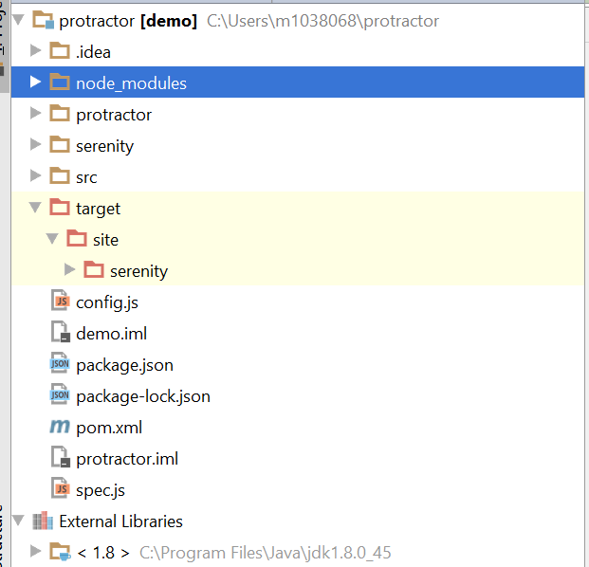
17. Install Cucumber.js plugin for navigation to step definitions
18. Protractor exports a global function element, which takes a locator and returns element finder  
    element and element.all are functions   
    Element finder has a set of methods like click(), getText() and sendKeys() methods which implements element and element.all methods