1. Testing and validating REST APIs can be done using REST ASSURED API which is a stateless communication
2. Web is presentation layer, REST is business logic layer, data for presentation layer is fetched from business logic layer
3. Rest automation is less time consuming than the UI automation  
   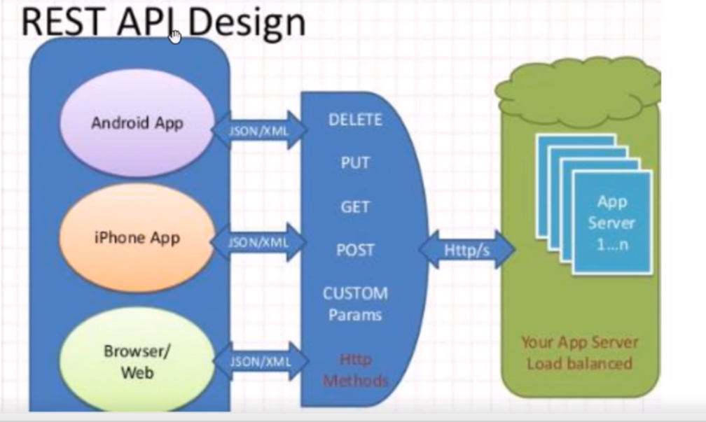
4. REST Api request and response are sent and received in JSON/XML format
5. For Example in User app, we have maps embedded, for this we have “placeSearch” api that is exposed by google that ca be used by uber application to enter place
6. To start rest testing we need to have below info :  
   a) Endpoints -> BaseURI/resources?param=xyz  
    BaseURI -> website  
    Resources -> each file in a website is a resource  
    parameters
7. Tyes of Rest Requests  
    GET  
    POST  
    PUT  
    DELETE
8. GET request is used to retrieve info from server to the user  
   Parameters to be sent as part of GET request as part of end point
9. POST  
   Parameters to be sent in the format of JSON/XML not as part of endpoint  
   parameters/request Body/payload must be sent as JSON/XML
10. PUT -> same as POST, but the only difference is PUT is for update an existing entry
11. DELETE - > delete something from server
12. POSTMAN:  
    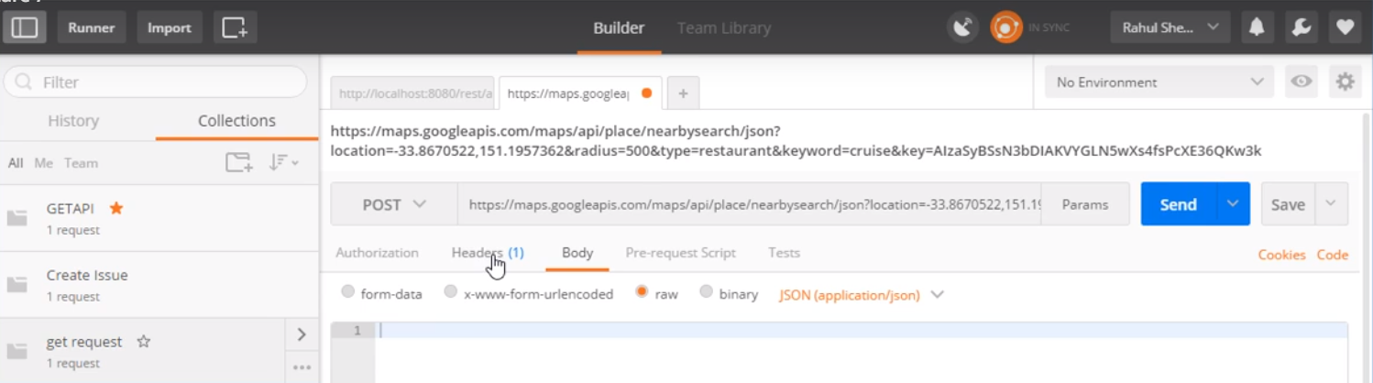
13. Headers are passed as part of REST API requests
14. Google Place Search API:  
    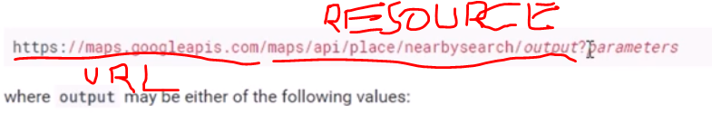  
    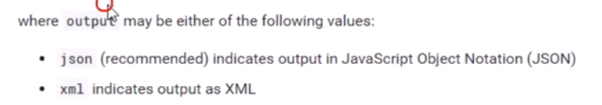
15. Get API Key:  
    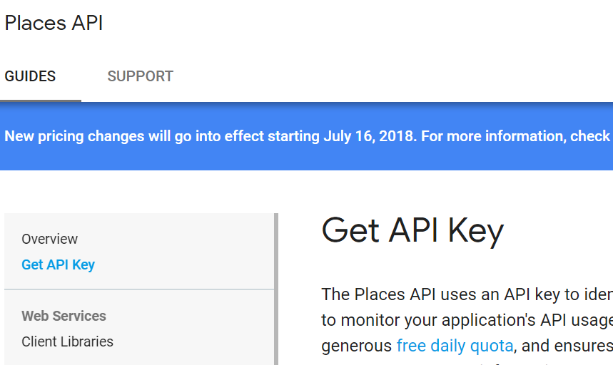
16. If we dot have API key and send a API request, we will get an error as below as KEY is a mandatory parameter  
    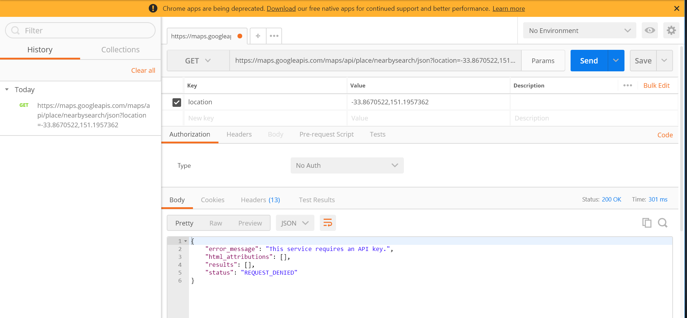
17. TO get output in XML, change parameter to XML:  
    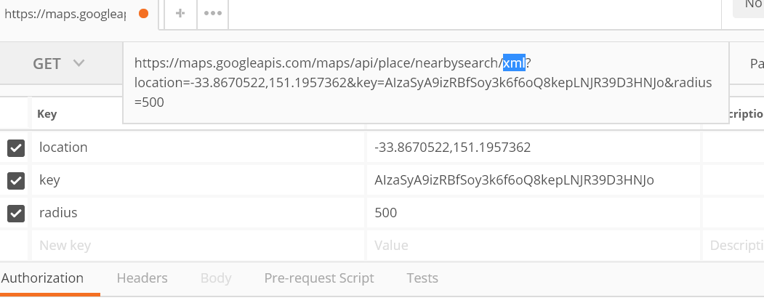
18. For POST request, we are not sending any parameters, we will just send API key, but our parameters will be sent as XML or JSON
19. RESTASSUREDAPI has four blocks given(), when(), then(), extract()
20. Given() ->   
    Requestheaders  
    Parameters  
    request cookies
21. When()  
    GET(resource)  
    POST(resource)  
    PUT(resource)
22. Then()  
    assertions to validate response
23. Extract()  
    1) Rest assured is a java DSL, built on top of Http builder, used for testing rest based services  
    It supports GET, POST, PUT, DELETE, OPTIONS, HEAD, PATCH
24. Type of Parameters  
    Path parameters  
    Query parameters -> passed as part of URL  
    Header Parameter
25. For post request, path parameters are not allowed, and they need to be send only as part of body  
      
    Oauth Authentication access: