1. Set ANDROID_HOME user variable  
   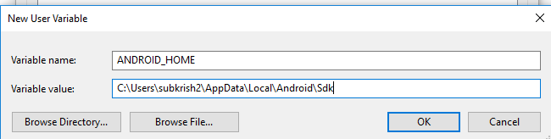
2. Set path variables for tools and platform-tools folder  
   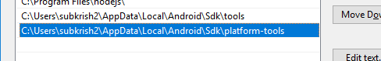
3. After the env variables are set, if we check by executing the below command , it displays the emulator which is running  
   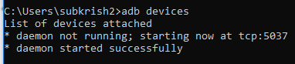
4. Install appium via gradle   
   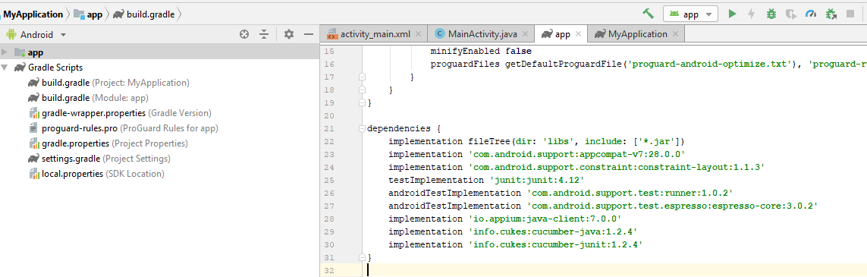
5. 