1. Docker is a platform or ecosystem around creating and running containers  
   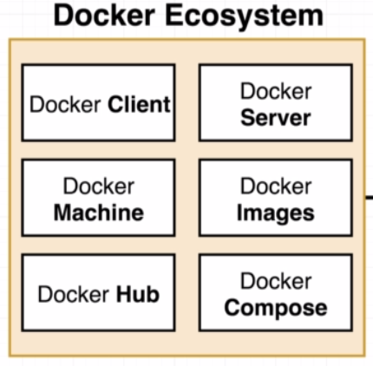
2. Container is an instance of an image(is a single file with all dependency and config to run a program)
3. Docker Client(Docker CLI) --🡪 Docker Server(Docker daemon)
4. Verify docker version  
   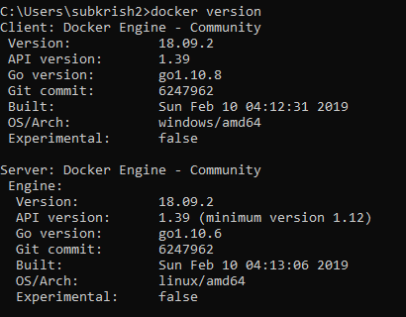
5. For the first time when there is no image for the container, on executing the command docker run, image gets downloaded as below  
   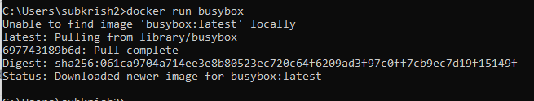
6. 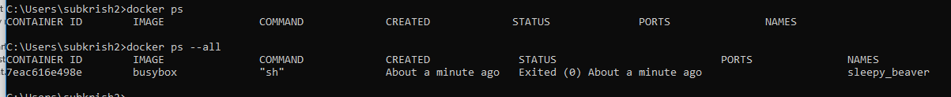
7. Docker run = docker create+ docker start
8. Verify docker-compose  
   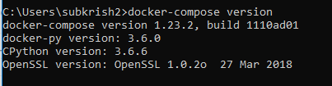  
   Docker-compose is used to connect two containers and start multiple docker containers