1. Spring 5 -> minimum requirement is java 8 and deprecated legacy integrations for Tiles, velocity, portlet, guava
2. 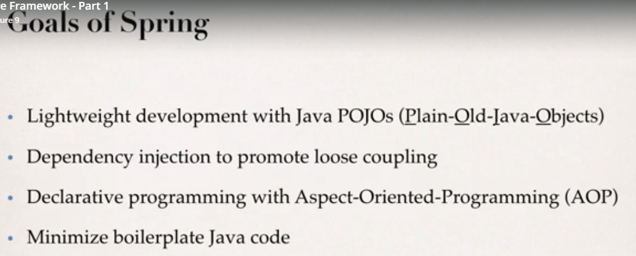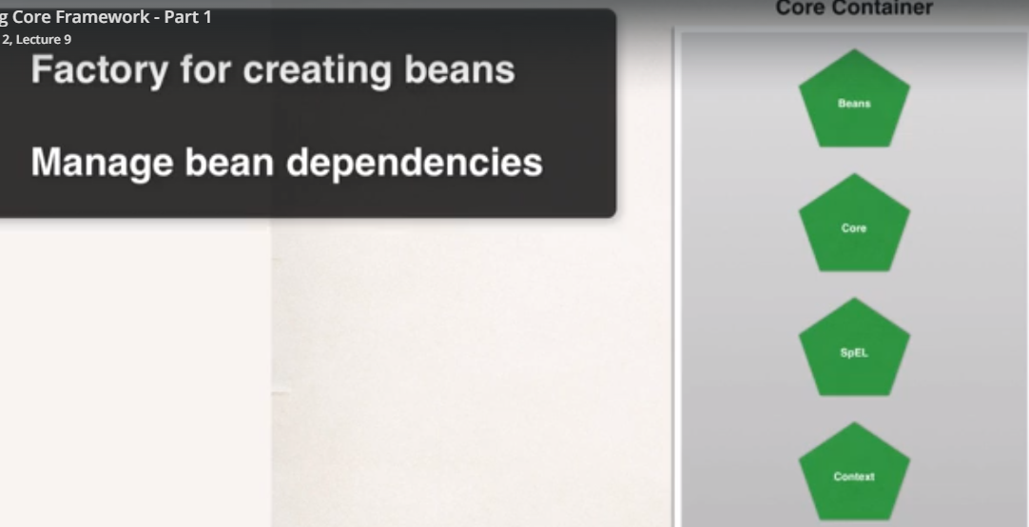
3. 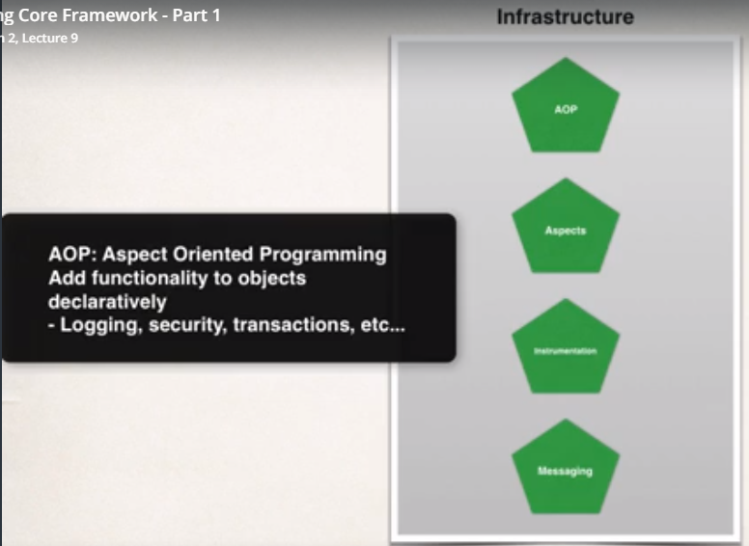
4. 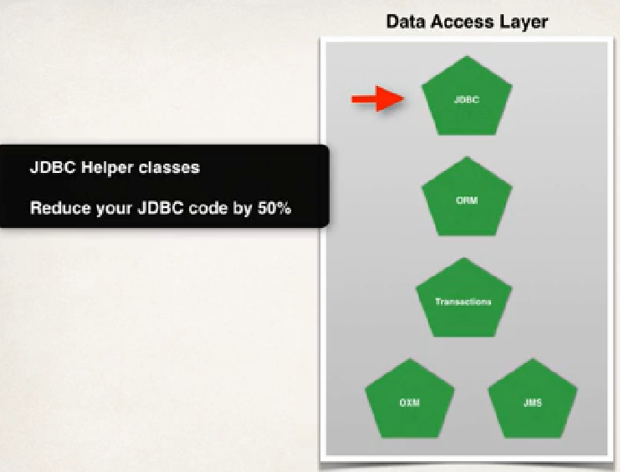
5. 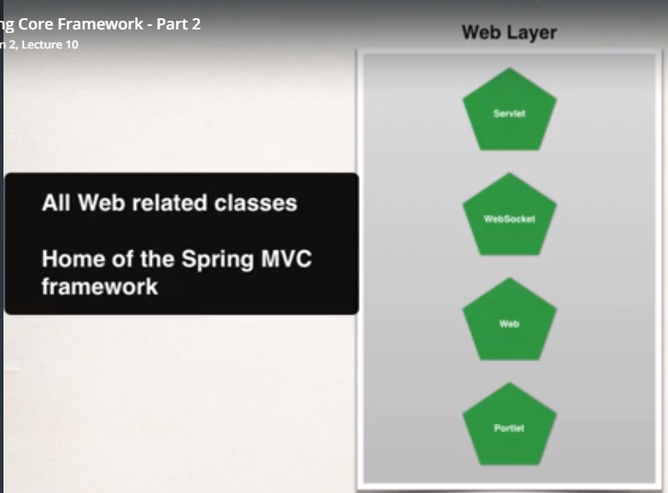
6. 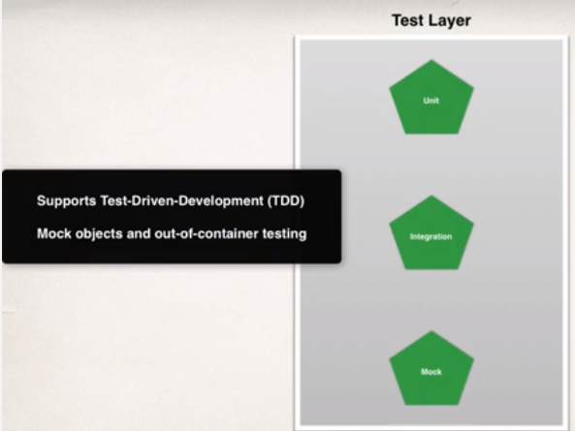
7. Install and run tomcat:  
   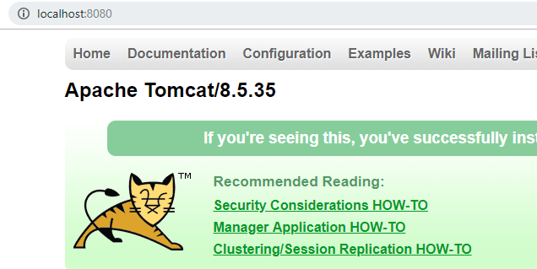
8. Add tomcat server to IDE  
   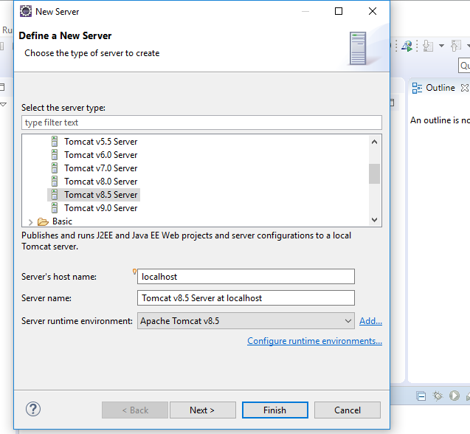
9. 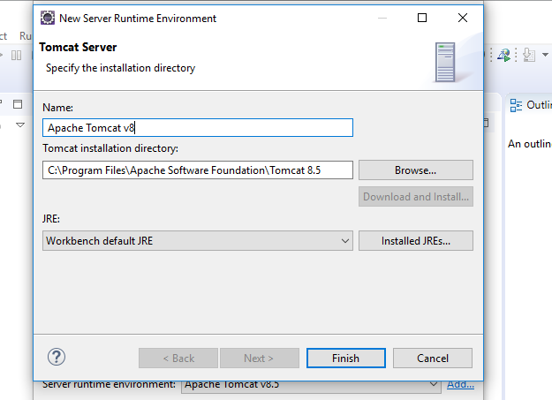
10. 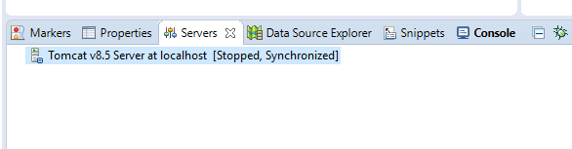  
    Tomcat is added, right click on start or stop the tomcat server
11. Inversion of control: process of externalizing the creation and management of objects