1. Database   
   Collection -> Similar to tables  
   Documents -> records are stored in JSON format
2. Relational database needs to be merged manually
3. 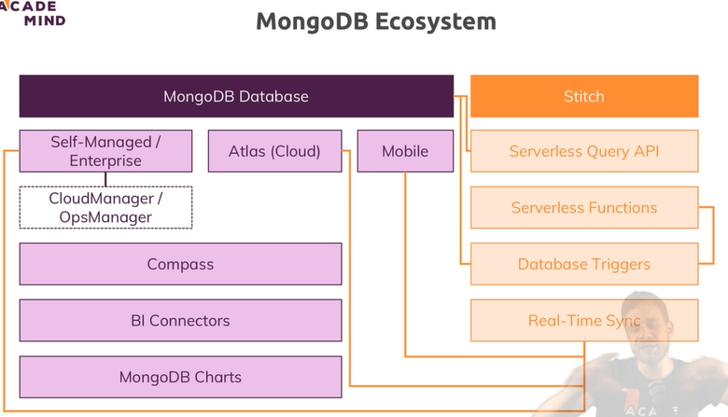
4. C:\Program Files\MongoDB\Server\4.0\bin -> set in env variables
5. 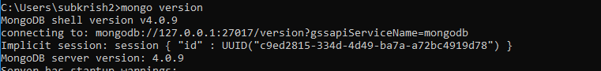
6. Displays DBs

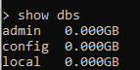

1. Mongo DB uses BSON data -> Binary JSON, drivers converts JSON data to BSON format
2. 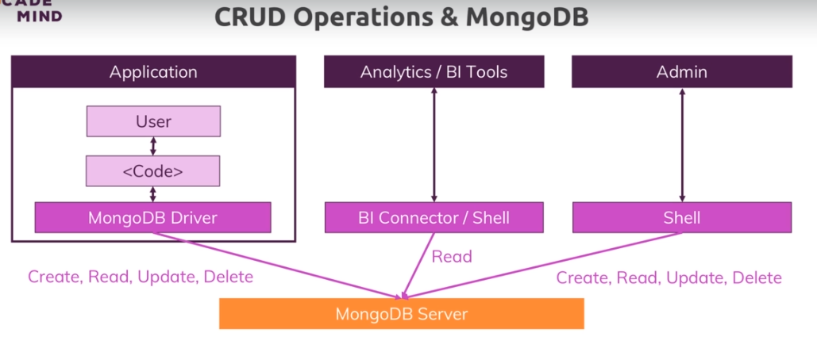
3. 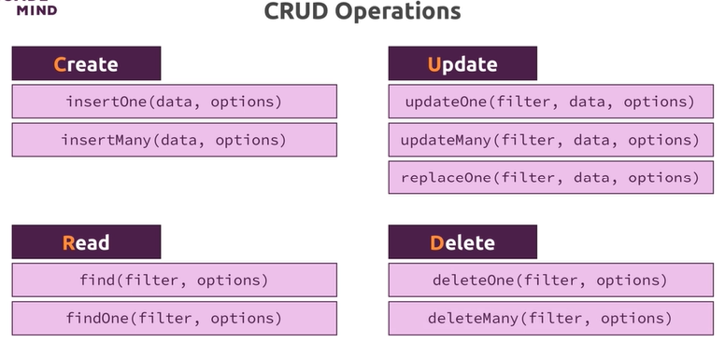
4. find() returns cursor objects, which is an object with metadata