Pl/ sql

1. 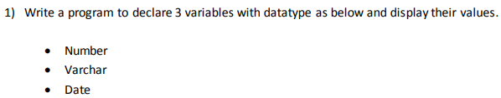  
   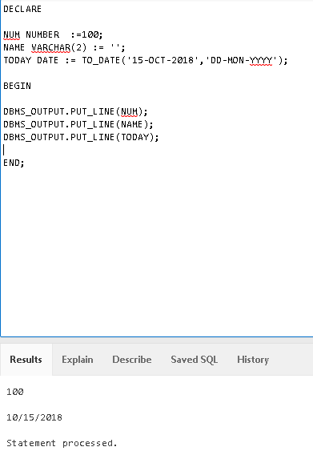
2. 

1. 

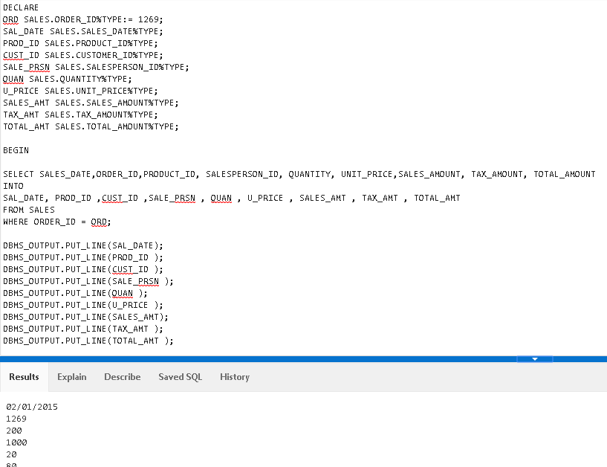

1. pROGRAM TO INSERT DATA INTO SALES TABLE  
   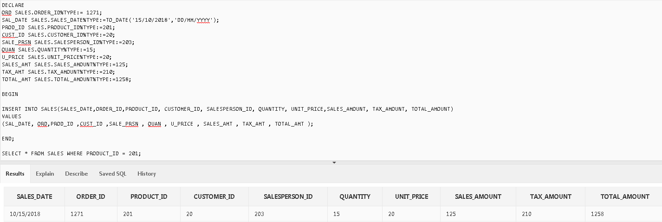
2. program to update data in sales table  
   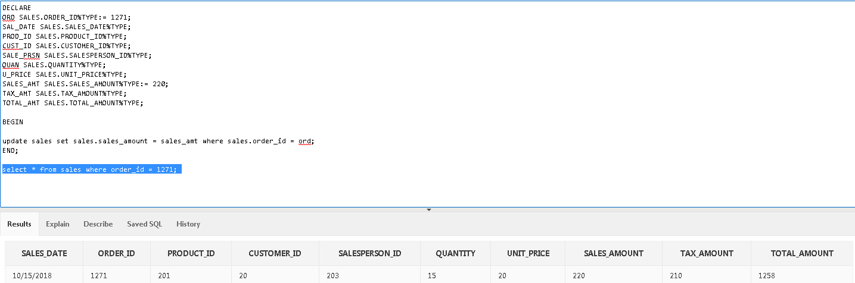
3. PROGRAM TO DELETE DATA FROM TABLE  
   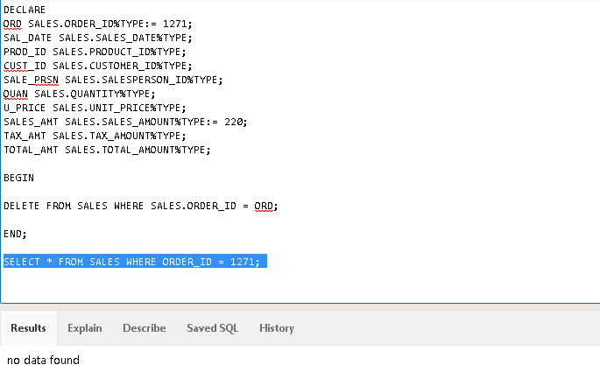
4. Procedures:  
   Set of PL/SQL statements and save it as a name  
     
   MODE:  
   IN -> variable is read Only  
   OUT -> variable is write only  
   IN OUT -> both read and update
5. Cursor’s:  
   Implicit cursor’s  
   Explicit Cursor’s
6. Alter table
7. Update table set <column_name> = ‘value’ where <row_field> = ‘some_value’;
8. Select distinct <col> from <table>
9. Select * from <table> where <field> in (23,24,25)
10. Select * from <table> where <field> between 1 and 100;
11. 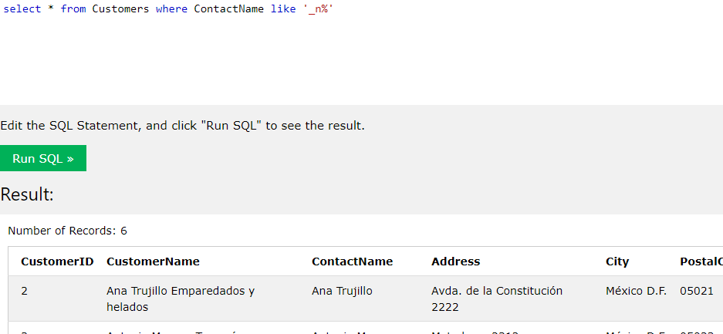
12. 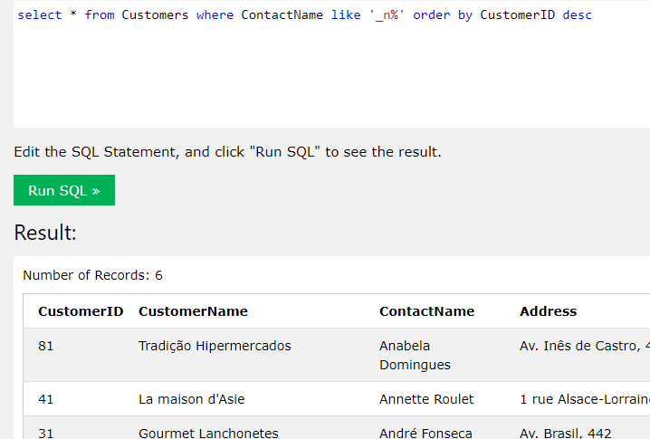
13. GroupBy  
    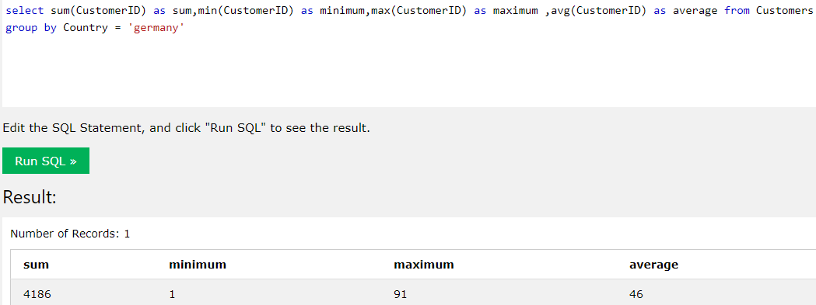
14. Having  
    