1. Postman collection -> is a group of API requests, which can be saved and stored in logical manner
2. 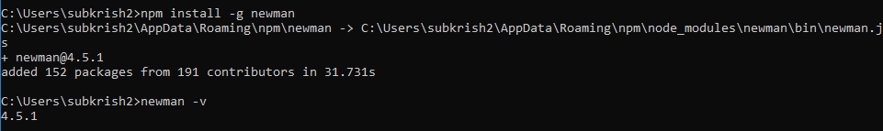
3. Wizdler app parses wsdl file