1. Babel is a compiler:
2. CDN links for react  
   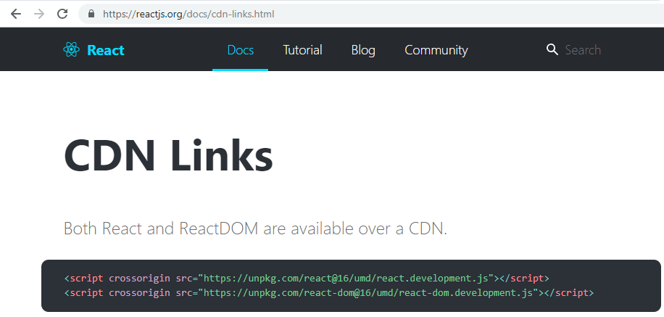
3. Install Babel plugin  
   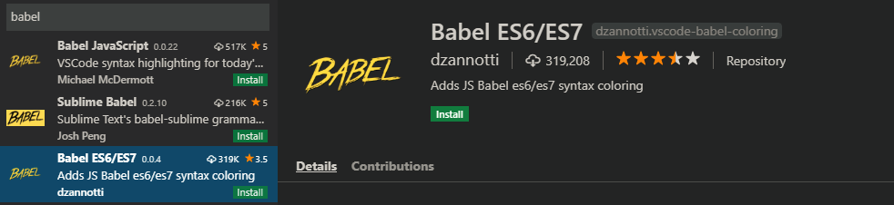
4. JSX -> Javascript XML