1. TestNG dependency in pom.xml  
   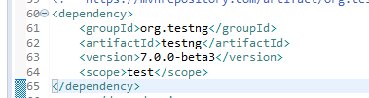
2. TestNG Annotations  
   @BeforeSuite  
   @BeforeClass  
   @BeforeTest  
   @Test  
   @AfterTest  
   @AfterClass  
   @AfterSuite
3. 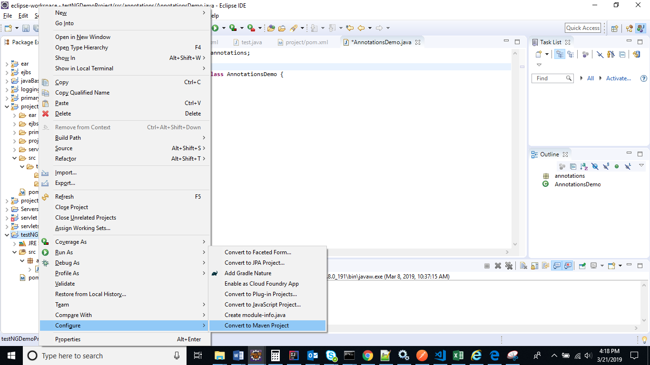
4. 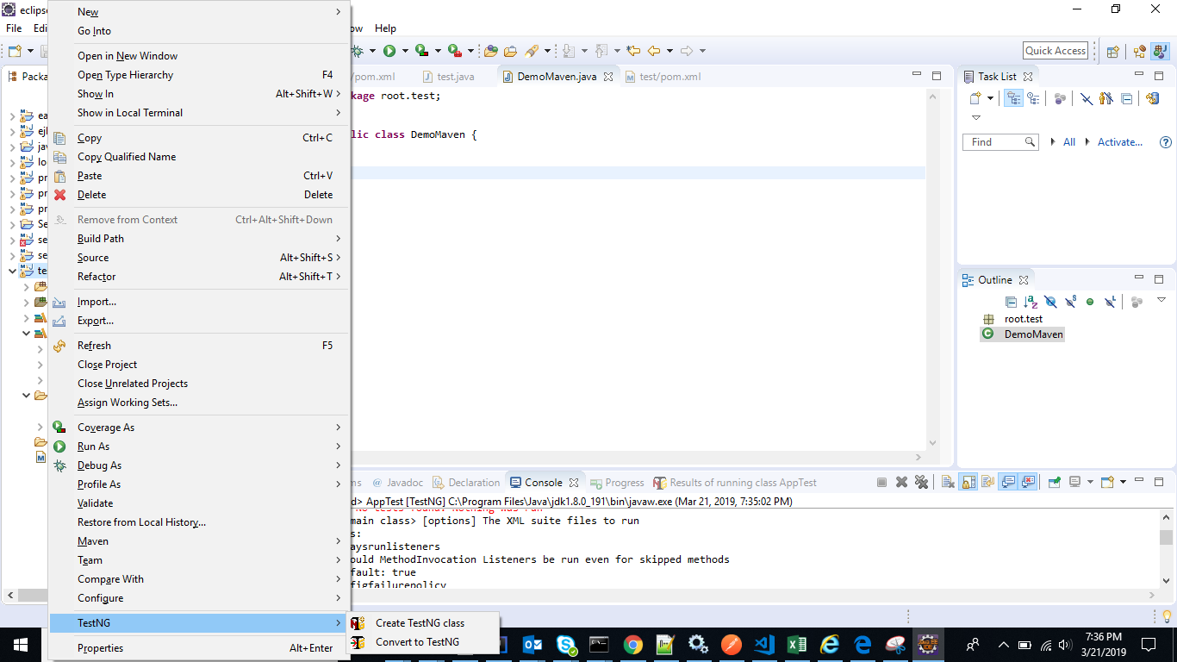
5. Asserts  
   assertEquals  
   assertnotEquals  
   assertTrue  
   assertFalse  
   assertNull  
   assertNotNull  
   assertSame  
   assertNotSame