1. Infrastructure as a Code -> Terraform
2. Terraform automates provisioning infrastructure
3. Set env variable for Terraform  
   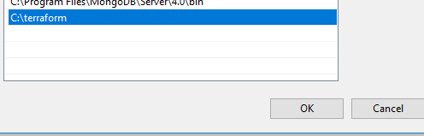
4. 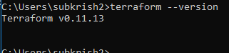
5. 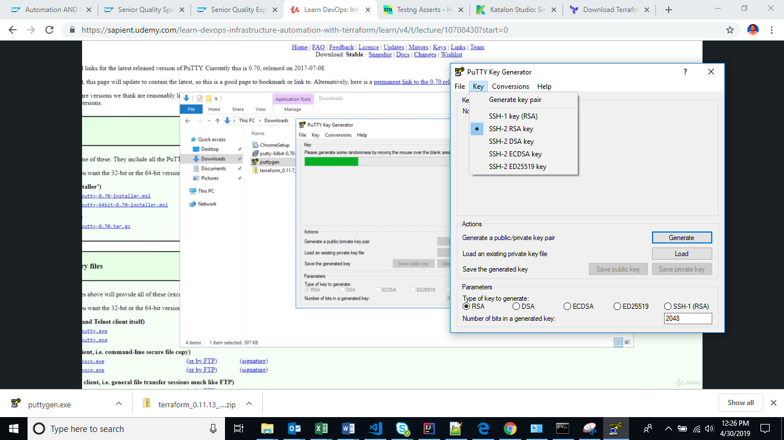
6. Save public key  
   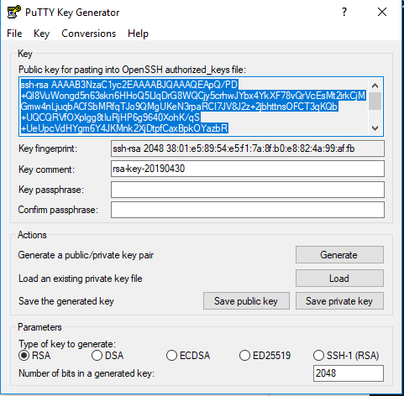
7. Export ssh key  
   