1. Typescript installation:  
   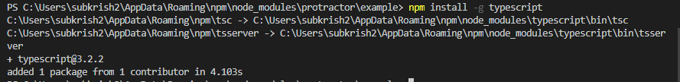
2. Creating package.json file using npm init  
   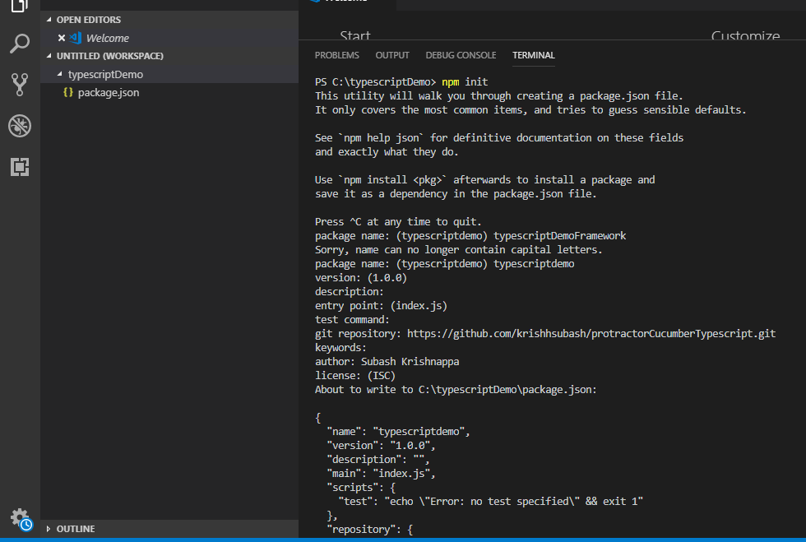
3. Installing typescript from package.json file dependencies  
   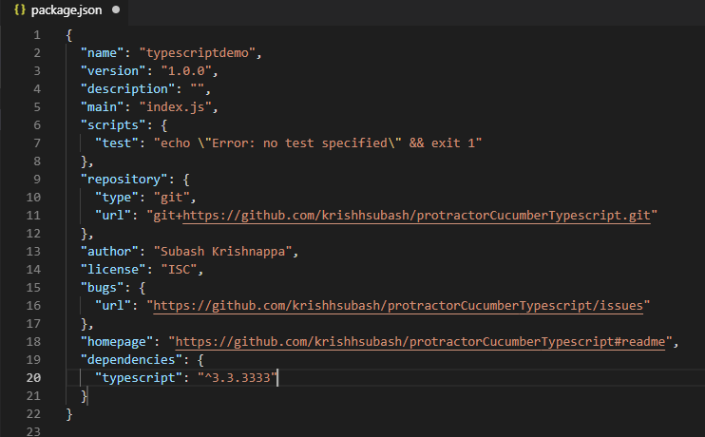  
   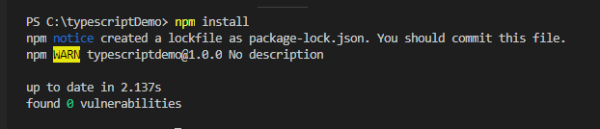
4. Install lite server  
   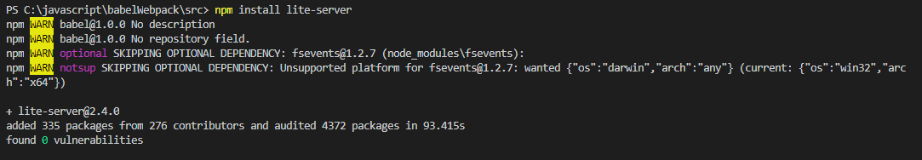
5. 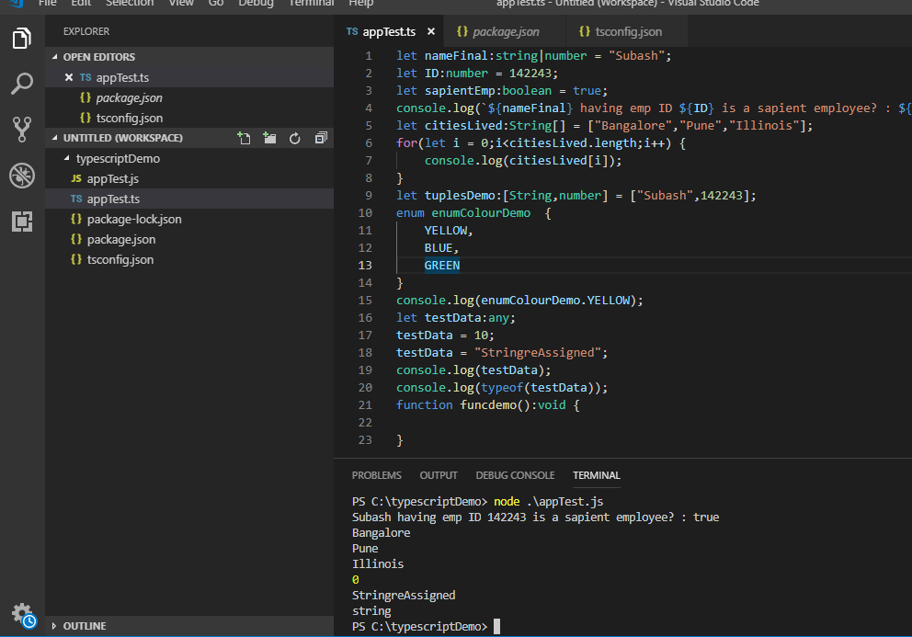
6. Javascript is asynchronous, so javascript execution does not wait until the action to take place  
   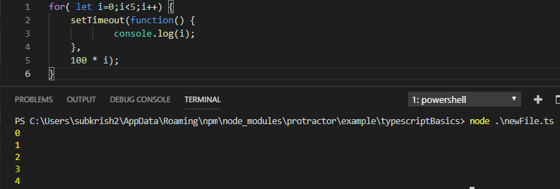
7. 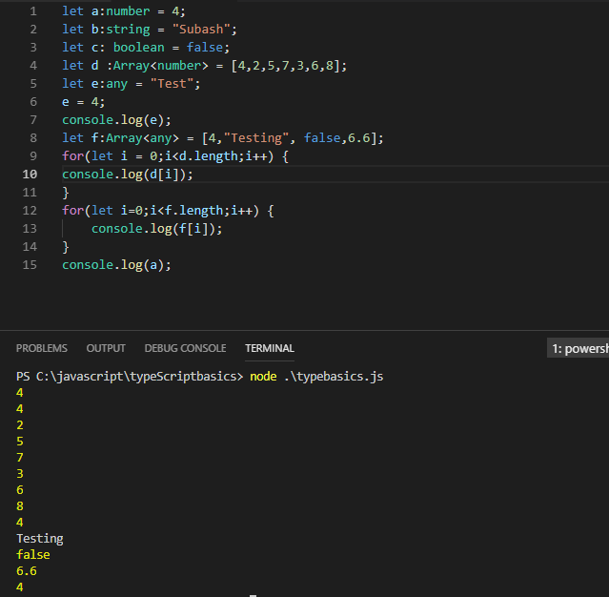
8. 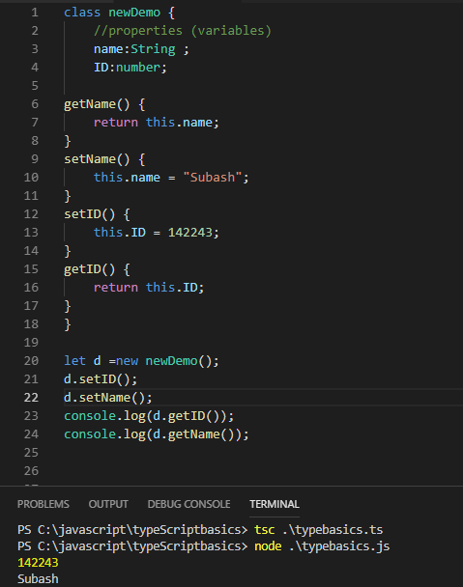
9. Protractor Typescript cucumber framework  
   npm init -> creates package.json file to add all dependencies  
   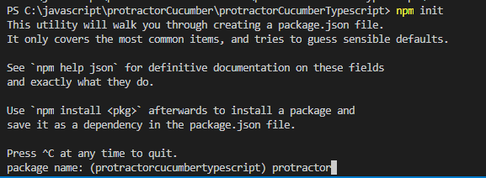
10. Default package.json file  
    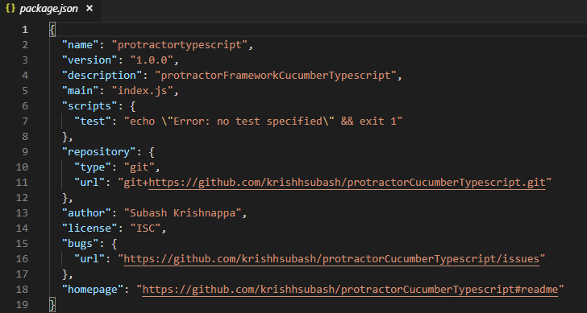
11. Add external dependencies:  
    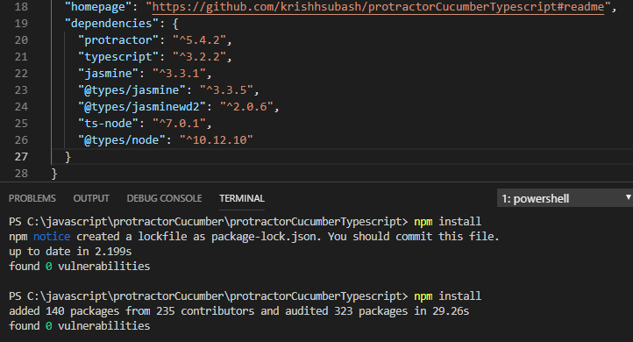
12. Tsc –init creates tsconfig.json file automatically  
    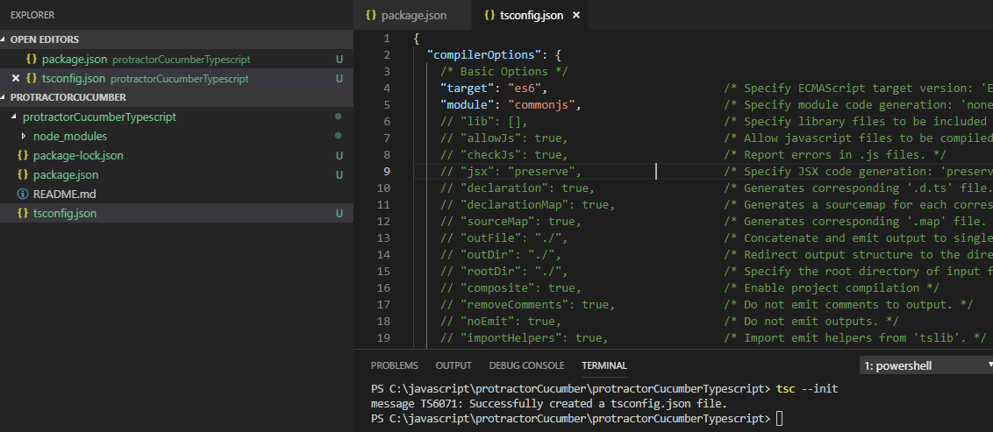
13. 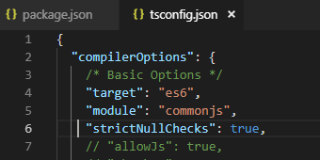  
    checks for the source file and prevents any null assignments
14. 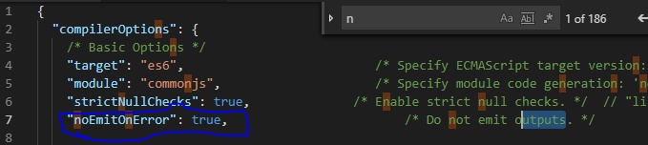  
    does on create javascript file, if there is any error
15. 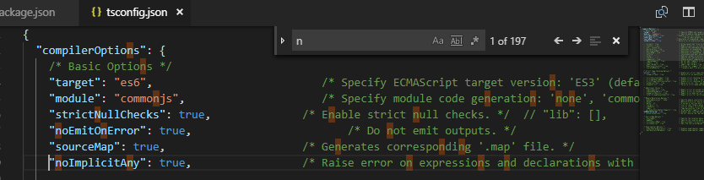  
    creates a map file along with js file, if sourceMap is set to true  
    noImplicitAny when set to true, throws an error when type is set to any
16. 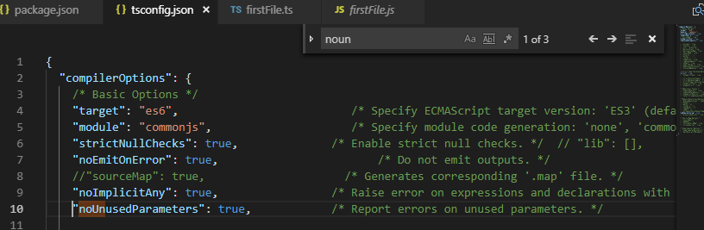  
    throws an error of any parameter is unused
17. Arrow functions:  
    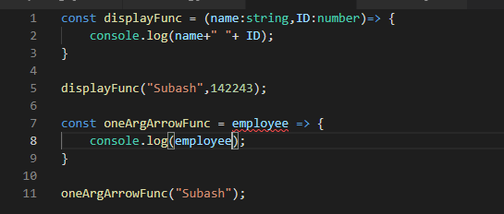
18. Default parameters in a function:  
    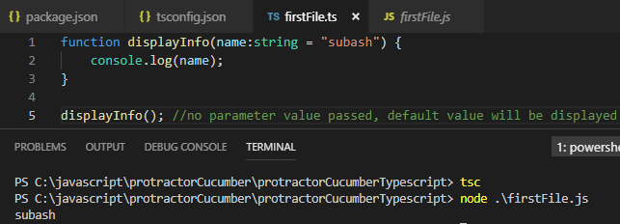
19. Spread and Rest Operators:
20. Destructuring arrays:  
    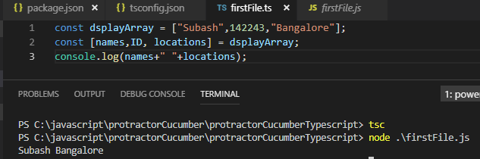
21. Destructing Objects:  
    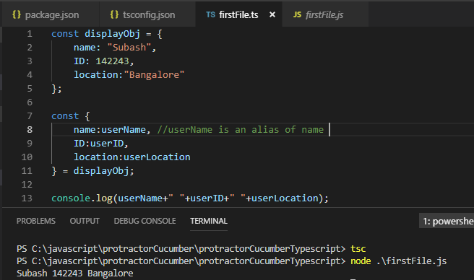
22. Exercises:  
    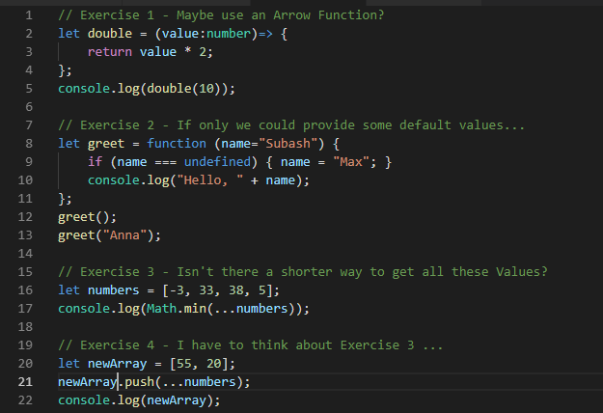  
    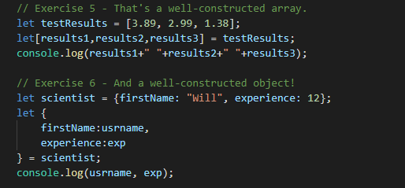
23. Typescript types:  
    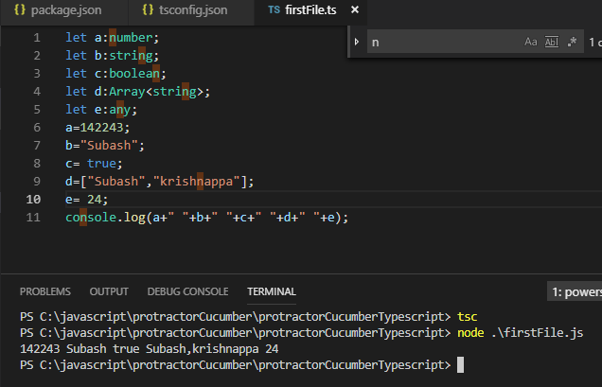
24. Tuples:  
    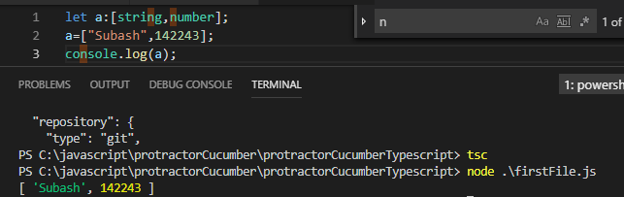
25. Enums:  
    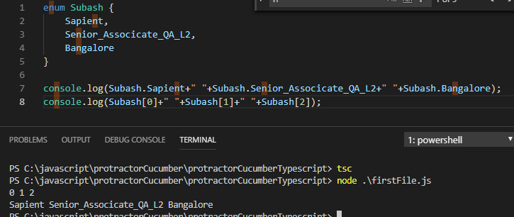
26. Function as arguments and return type  
    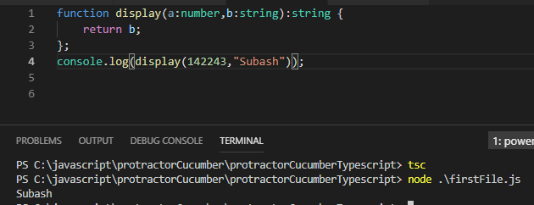
27. Object and types:  
    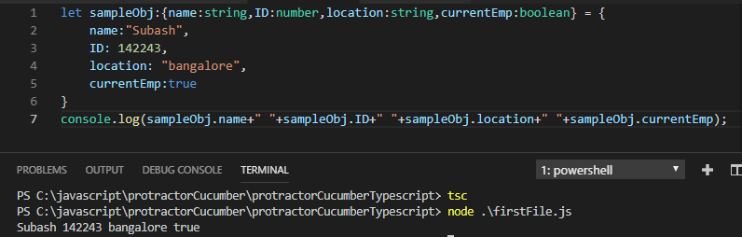
28. Custom Types:  
    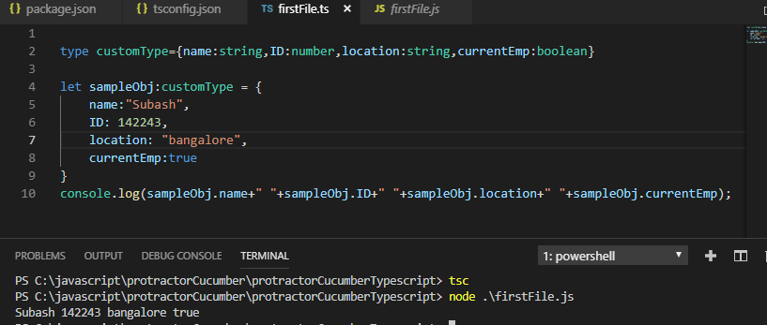
29. Union types:  
    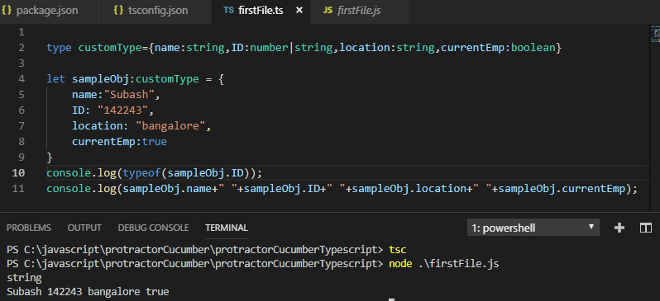
30. 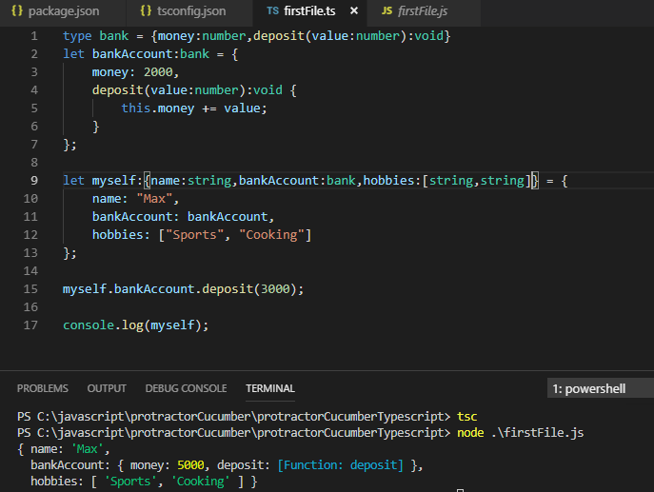
31. Classes:  
    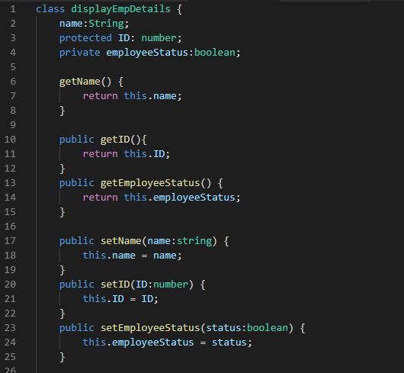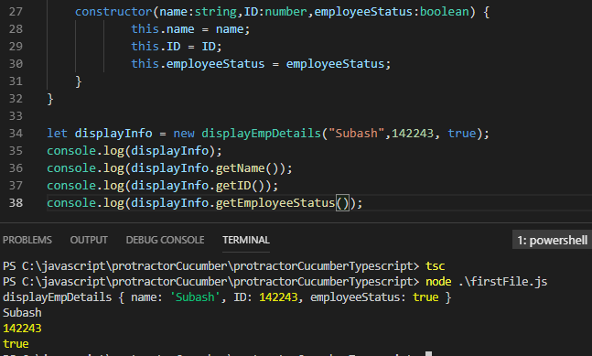
32. Inheritance:  
    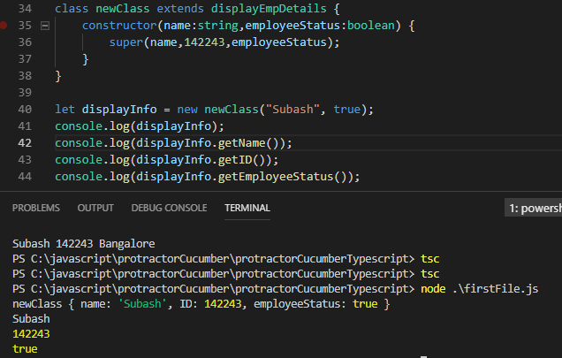
33. Getters and setters  
    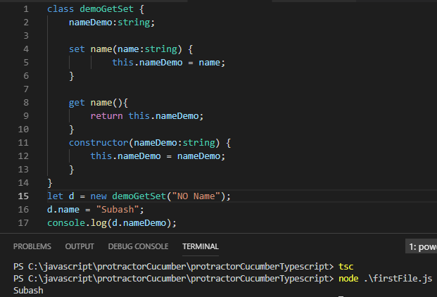
34. Static properties and methods: 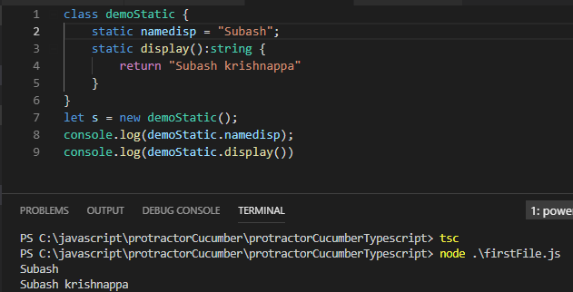
35. Abstract classes  
    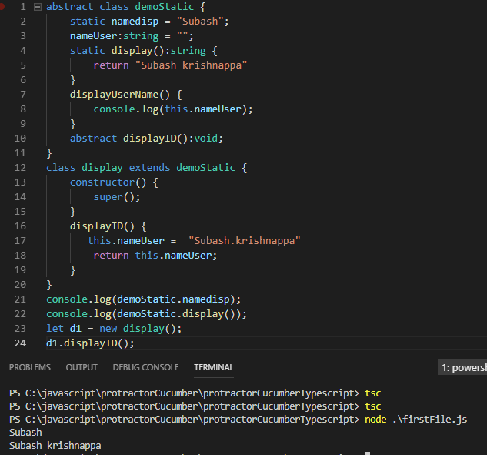
36. Private constructors and singletons
37. ReadOnly property
38. Exercise  
    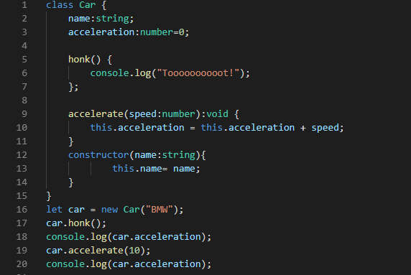  
    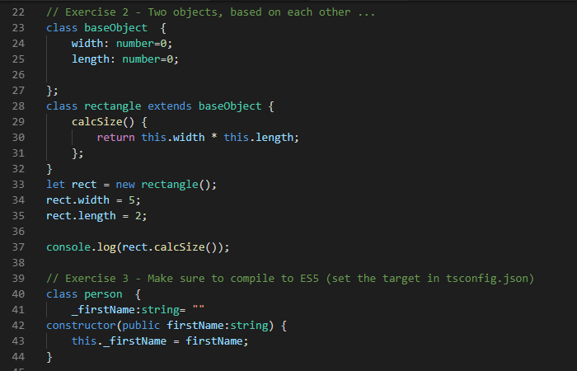  
    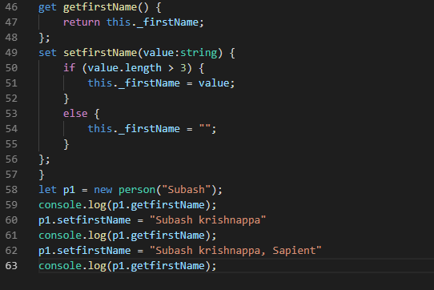  
    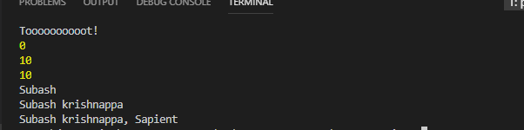
39. Namespace  
    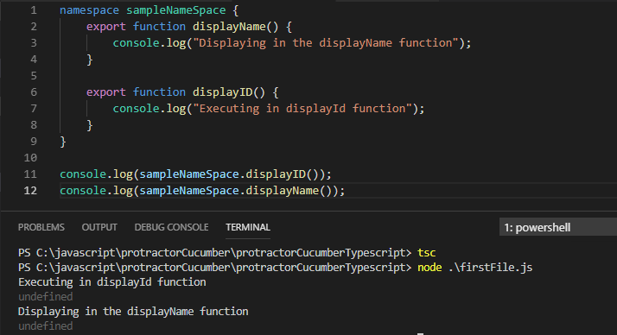
40. Tsc –outFIle “filename”
41. Gulp typescript  
    gulp typescript is a wrapper around typescript, contains typescript compiler  
    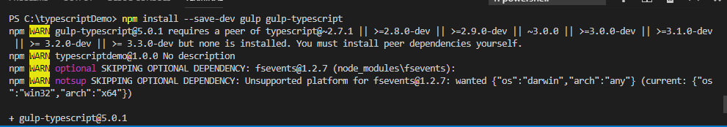
42. Install webpack  
    