1. Since we have Emmet plugin installed, on entering html in the index.html file, editor automatically suggests for boilerplate code as below  
   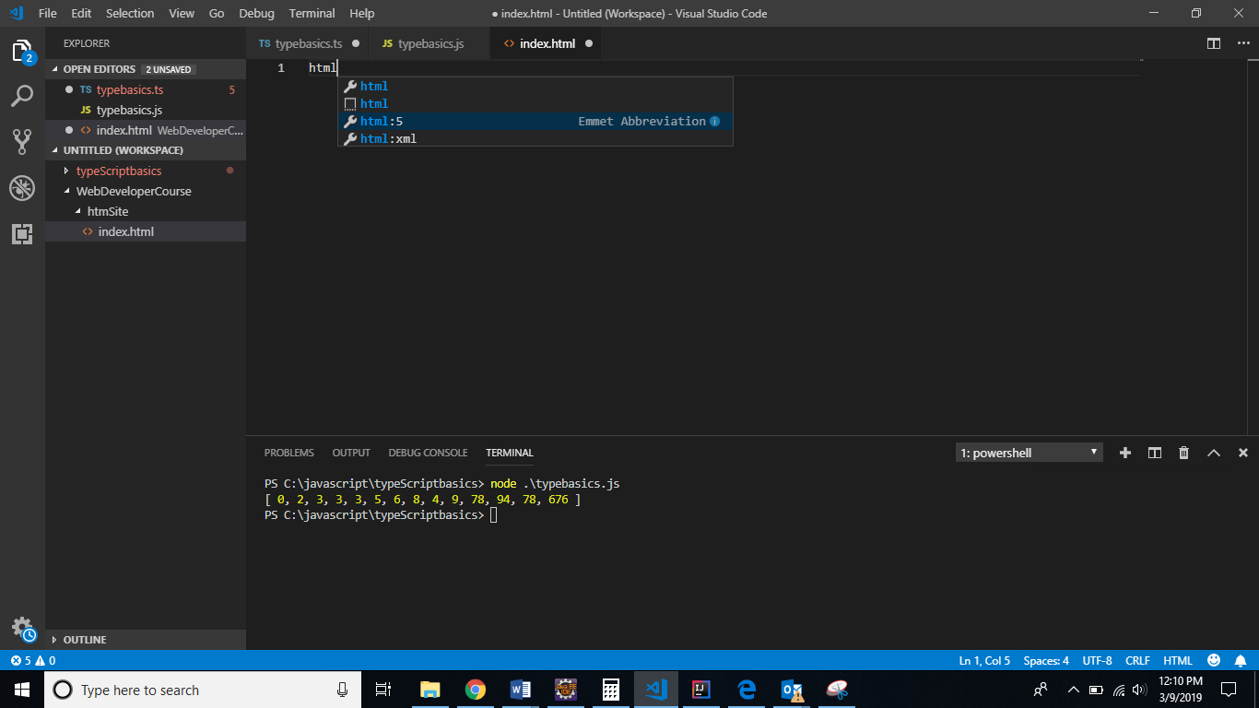  
   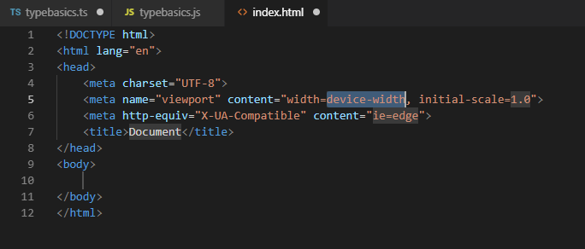
2. HTML tags:  
   <b>, <em>, <strong>, <i>,<p>,<h1-h6>, <br>,<blockquote>  
   <ul> , <ol>, <dl> -> key value pair