1. Check out -> fetch data from repository
2. Check in -> push code to repository
3. Git status  
   git init  
   git add –all  
   git commit –am “test”  
   git pull  
   git push
4. Ssh-keygen –t rsa -> to generate ssh key -> this needs to be uploaded to git account ssh key tab
5. Git config –global user.name “Subash Krishnappa”  
   git config –global user.email “Subash.krishnappa@sapient.com”

TestNG

1. Annotations:  
   @Test  
   @BeforeMethod -> called before executing any test case  
   @AfterMethod -> called after executing any test case  
   @BeforeTest  
   @AfterTest  
   @BeforeSuite  
   @AfterSuite

Jenkins

1. Change default port of Jenkins from 8080 to 9090  
   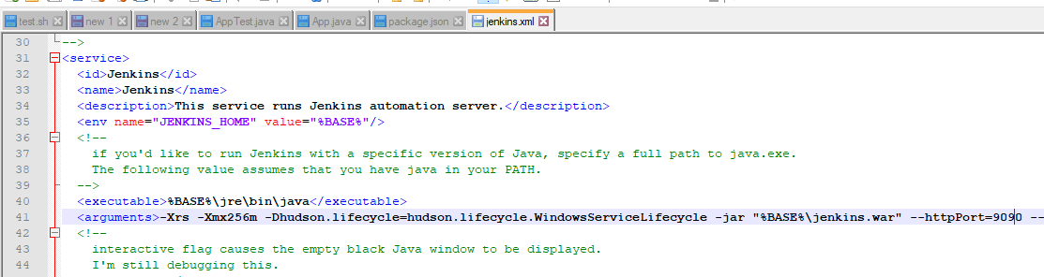
2. 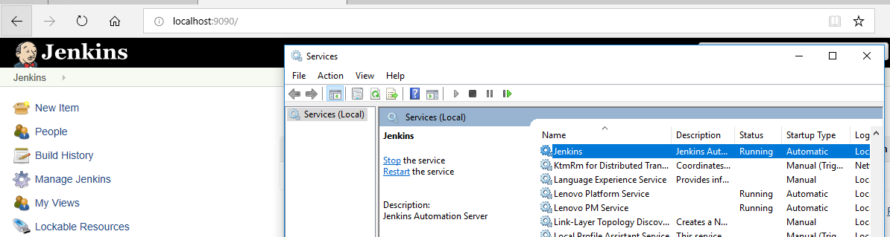
3. Maven:
4. Maven build cycles:  
   a) Clean:

b) default:  
c) site

1. Maven plugins:  
   Clean plugin  
   Compiler Plugin  
   Resources plugin  
   Surefire plugin  
   Maven jar plugin  
   maven default plugin -> goals : deploy:deploy, deploy:deploy-file  
   maven site plugin  
   maven site plugin