Protractor:

1. Used for testing angular applications  
   Webdriver + Angular features -> protractor
2. Protractor is a node.js program built on top of webdriver.js
3. Webdriver js uses Promise Manager to work with asynchronous API
4. Protractor adapts jasmine so that each spec automatically waits until the control flow is empty before exiting
5. Jasmine unit testing framework for protractor, is just like testng for selenium
6. To check if node.js is installed in machine  
   
7. To check if npm is installed  
   
8. Install protractor  
   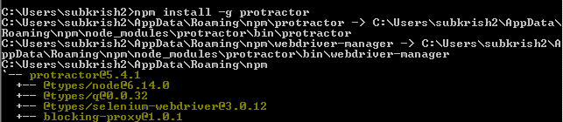  
     
   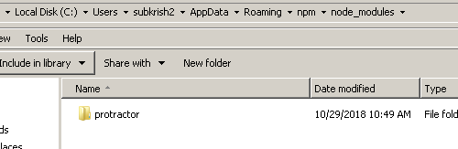  
   This installs two command line tools -> protractor and webdriver-manager
9. Check version of protractor installed  
     
   checks for any updates and downloads latest updates for downloading stand alone server or driver executables  
   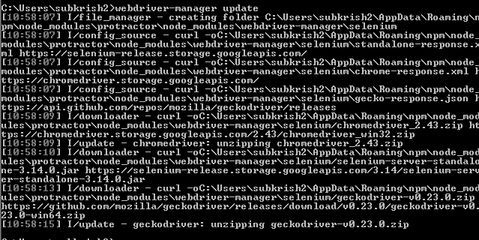
10. By default webdriver server will start on port 4444
11. To start protractor server  
    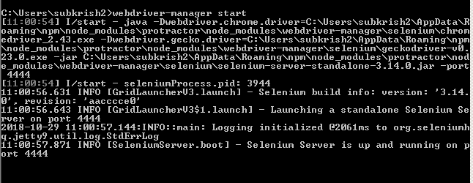
12. Protractor dependencies download from node.js package.json file  
    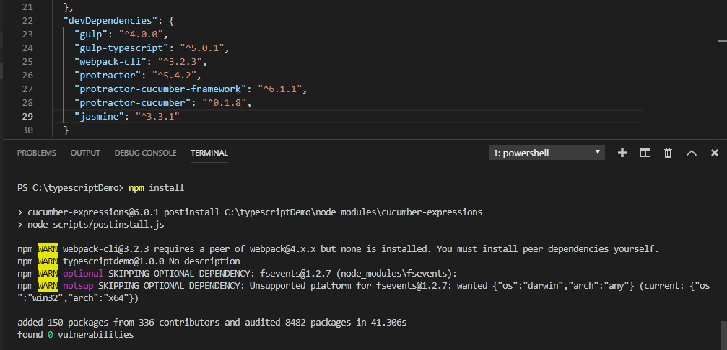
13. Jasmine testing framework  
    describe -> Test Suite  
    it -> test case  
    spec file -> test file  
    every spec file must have describe and it file  
    Protractor by default uses jasmine testing framework for testing its interface  
    jasmine tests can be executed using jasmine spec runner file
14. Protractor --elementExplorer
15. Main file of protractor is cli.js presnt in the following path:  
    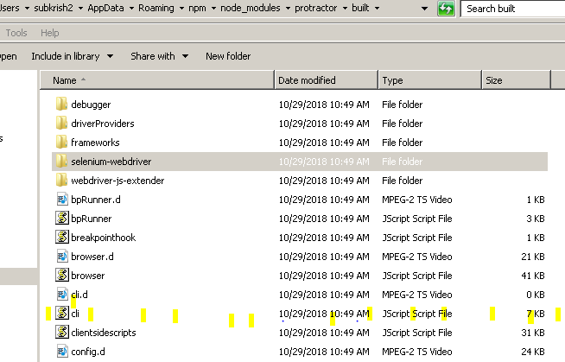
16. Javascript is asynchronous:  
    it executes instructions without waiting for the previous steps to complete
17. Promise states: pending, resolved, Rejected  
    In synchronous execution, unless a statement execution is not completed, compiler doesn’t proceed with next statement, but in case of javascript which is asynch, it proceeds to execute further steps
18. Global Variables:  
    browser:   
    element:   
    by:   
    protractor:
19. Locators:  
    common locators:  
    by.id  
    by.name,  
    by.css  
    by.model  
    by.binding  
      
      
      
    by.id  
    by.className  
    by.linkedText  
    by.xpath  
    by.css  
    by.name  
    by.tagName  
    by.partialLinkedText  
    by.js  
    by.model  
    by.binding  
    by.exactbinding  
    by.buttonText  
    by.partialButtonText  
    by.repeater  
    by.exactrepeater  
    by.addLocator  
    by.cssContaining
20. Installing protractor extensions:  
    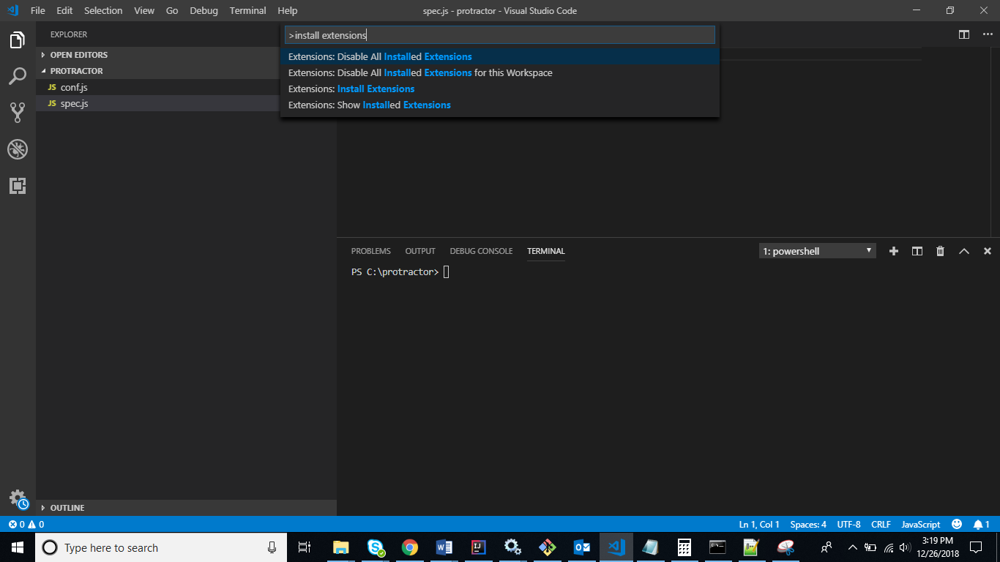
21. 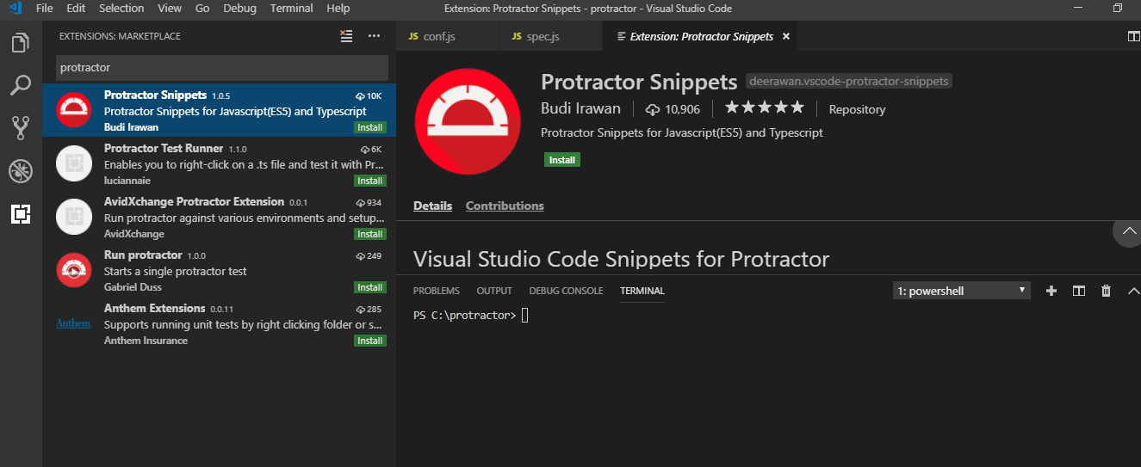
22. When we install protractor, the below is installed at npm folder  
    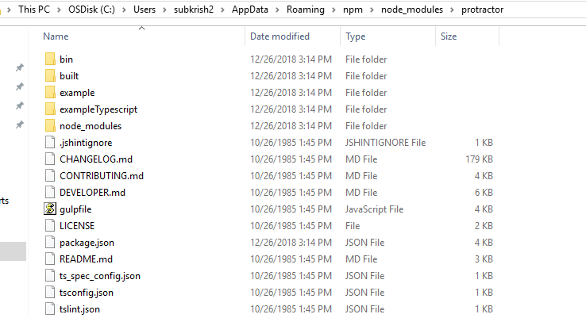  
    Navigate to example section to get a sample spec.js and conf.js
23. 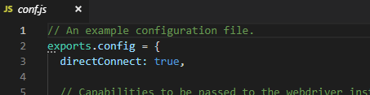

When we provide directConnect: true, protractor will not check whether webdriver manage has been started or not

1. Command to execute protractor tests:  
   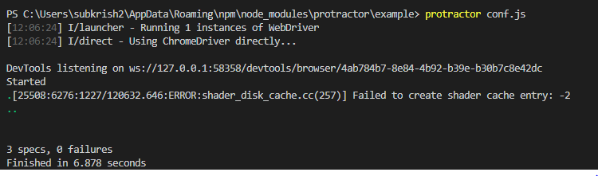
2. To check if a website is angular or not:  
   google news website is not an angular website  
     
   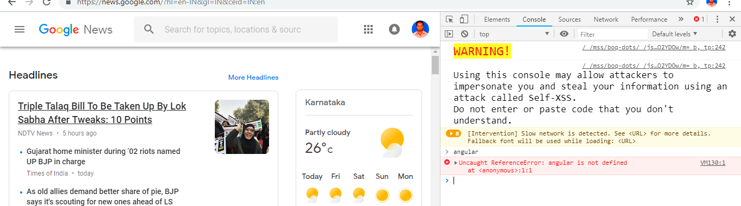
3. Protractor.org website is angular  
   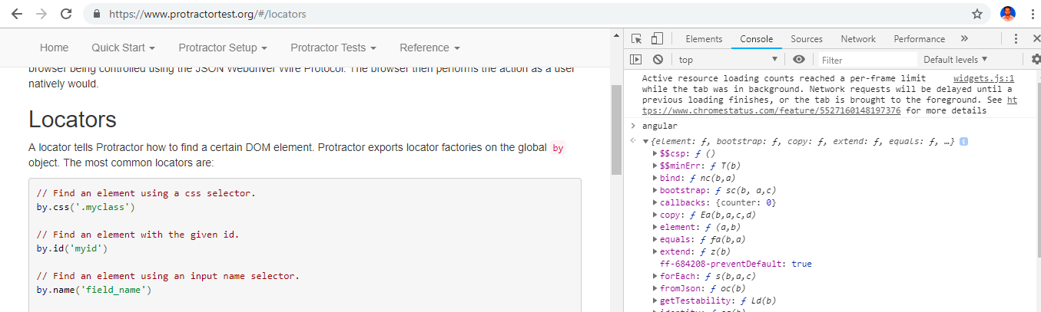
4. Promises: protractor is developed on top of webdriver.js library:
5. Serenity JS

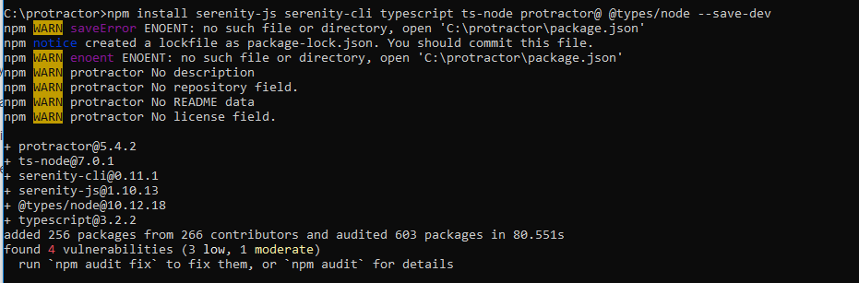

1. Install cucumber with protractor:  
   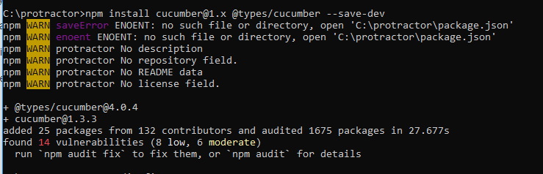
2. Install mocha  
   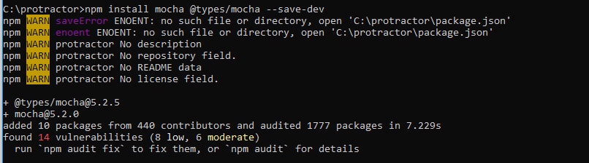
3. Install chai.js  
   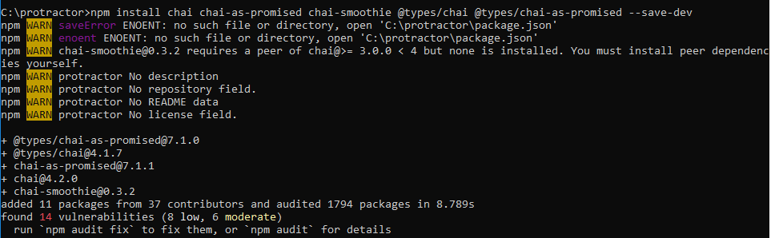
4. Protractor Typescript framework  
   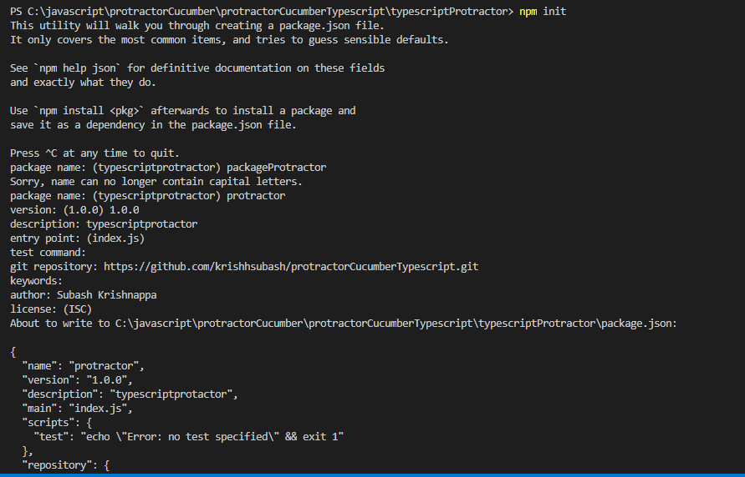  
   Creating package.json file from command prompt using command npm init,
5. Install all protractor dependencies  
   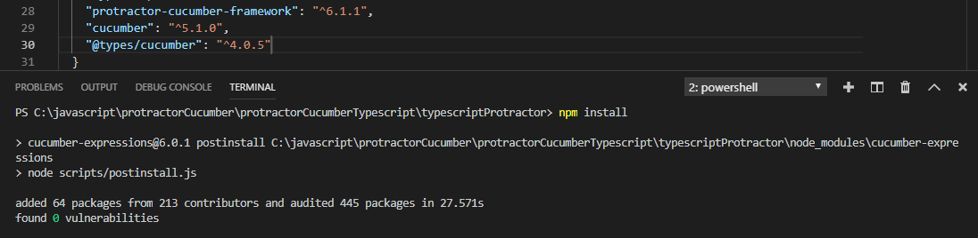
6. Add Cucumber extension to VS Code  
   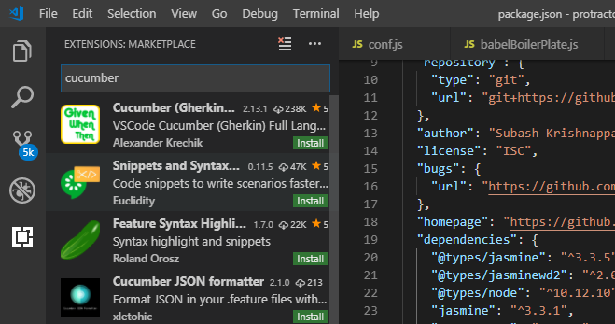
7. Run tests in chrome driver  
   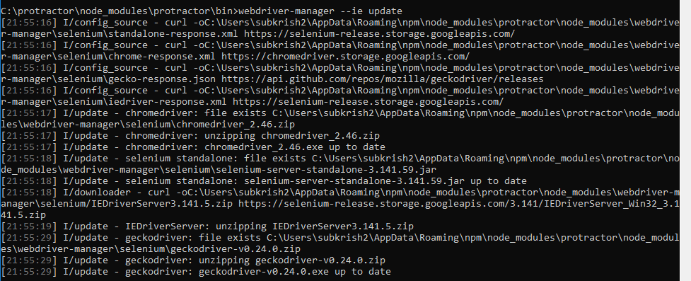
8.   
   to use protractor for non angular websites
9. Capturing logs using Winston in package.json file  
   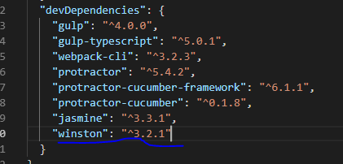
10.   
    will launch tests in chrome y default
11. 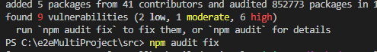
12. Creating tsconfig.json file  
      
    tsconfig.json will compiler ts files and converts to js  
    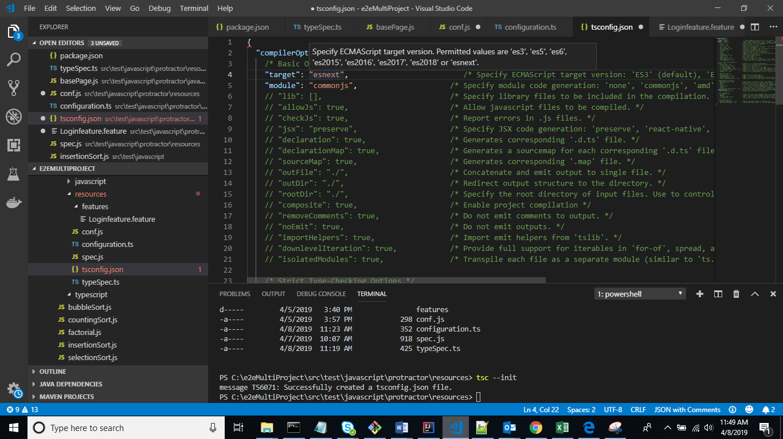
13. Complied files are moved to JSFIles directory  
    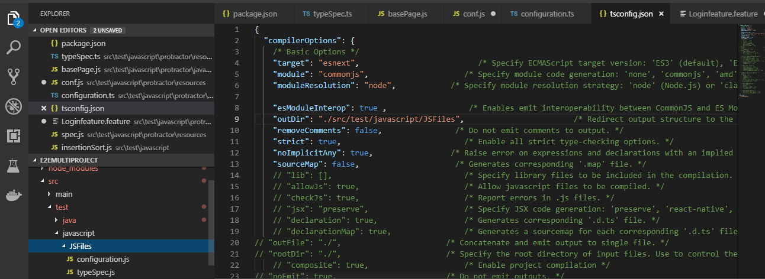
14. Async and await, used as webdriver control flow will be deprecated  
    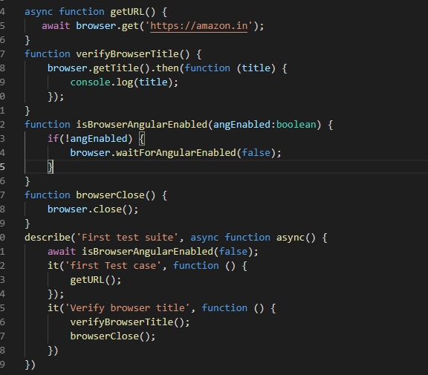
15. To upgrade to latest versions:  
    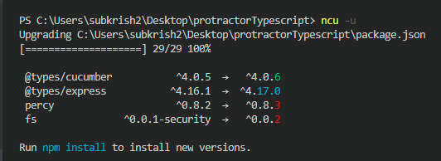
16. 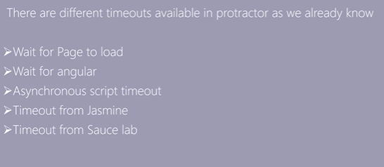  
    By default protractor has 5000 ms timeout