1. 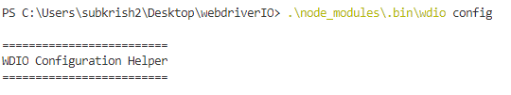
2. 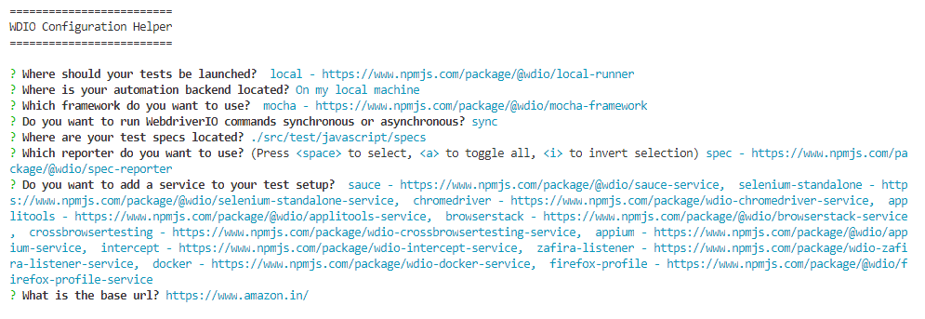
3. 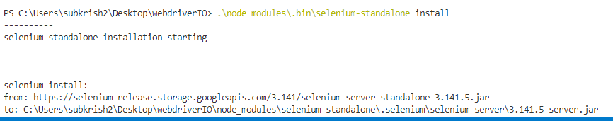
4. Mocha comes bundled with two functions, describe() and it()  
   describe(‘test suite’,callback_function() {  
    it(‘test name’,function(){  
     
     
    });  
   });
5. 